Enabling lower carbon clinical trials: Development and prototype testing of a method to quantify the carbon footprint of clinical trials to inform future lower carbon clinical trial design
Detailed Guidance and method to calculate the carbon footprint of a clinical trial
Background
Around 15 years ago, the Sustainable Trials Study Group concluded that clinical trials contribute substantially to greenhouse gas emissions, notably through energy use in research premises and air travel.
In addition, a study conducted in 2009 of 12 UK pragmatic randomised trials involving an average of 402 participants showed that the average carbon emission generated by the trials was 78.4 tonnes. Multiplying this total by the 350,000 national and international trials registered on ClinicalTrials.gov, this would estimate that emissions attributable to all global clinical trials to be about 27·5 million tonnes of carbon dioxide equivalent.
Since then, the urgency of the threat from the climate crisis has increased exponentially and the World Health Organization calls climate change the single biggest health threat facing humanity. Planned climate action is not sufficient to prevent the current warming predictions; humanity must limit warming to 1.5 degrees and reach net-zero by 2040 to avoid the worst consequences of climate change.
As a first step to reduce the environmental impact of clinical trials, a method to quantify the carbon footprint of a clinical trial and associated processes is required.
Introduction
This guidance provides information on how to carbon footprint a clinical trial for the purposes of the NIHR-funded project ‘enabling lower carbon clinical trials.’
Within the guidance, clinical trial processes have been sub-divided into the following modules:
- Trial set up
- CTU emissions
- Trial specific meetings and travel
- Treatment intervention
- Data collection and exchange
- Trial Supplies and equipment
- Trials specific patient assessments
- Samples
- Laboratory
- Trial close out
The above list is not exhaustive, and it is expected that further activities and modules may need to be added to account for specialist processes in all clinical trial types and as knowledge around life cycle analysis increases.
NB: analysis of data does not need to be calculated separately, it is covered by the emissions attributed to trial staff FTE in “CTU emissions” and calculations included within “Data Collection and exchange”.
Calculating carbon footprint
A carbon footprint is a measure of greenhouse gases, usually quoted in kg or tonnes of carbon dioxide equivalent (CO₂e). To calculate the carbon footprint of a particular clinical trial process, both ‘activity data’ and ‘emission factors’ are required.
An ‘activity’ could be anything from electricity consumption to materials, travel and food. Activity data quantifies the amount of that activity e.g. distance travelled, kWh used etc.
An emission factor, also known as a conversion factor, “is a coefficient which allows you to convert the activity data into greenhouse gas emissions. It is the average emission rate of a given source, relative to units of activity or process/processes.”
To calculate a carbon footprint of a trial, the activity data will need to be provided by the trial management team and multiplied by the emission factors provided in this guidance document. Two types of activity data may be used:
- Primary data: data collected first-hand from specific activities within the studied clinical trial process i.e., the data collected where you can determine the amount of the activity taking place, for example electricity in kWh used by a building or the weight of an IMP shipment and the distance it travels.

- Secondary data: activity data that is not collected from specific activities within the studied clinical trial because you cannot determine or measure the exact quantity of the activity taking place, for example the number of m² occupied by an office worker or hospital worker. Secondary data may take the form of average, or typical, information about an activity from a published study or other source and will be provided in this guidance document e.g., average m² occupied by an office worker or average distance travelled.
Primary activity data are preferred for all activity data used in each module. However, secondary data may be used where primary activity data is unavailable or difficult to obtain.
It is important to avoid double-counting activities i.e., modules must not include activities already covered by other modules in the clinical trial process map. A data collection tool is provided alongside this guidance to aid in this process and help avoid double-counting.
Scope
This guidance describes a method to calculate the carbon footprint of a UK, academic clinical trial.
It can be applied to trials with international participation, however as emission factors vary between countries, and those provided within this guidance are UK-specific, country-specific emission factors may be required. Proxy emission factors which have been approved for use can be used where required and the source country of an emission factor will be stated where applicable.
The tool is intended to calculate the carbon footprint of the processes specific to the clinical trial, defined as the data required to analyse the trial endpoints and the research activities over and above standard of care.
The guidance is intended for use as a tool to inform sustainable decision-making in the design of clinical trials, rather than a tool to calculate the absolute footprint of a clinical trial or compare environmental performance of one trial over another.
Limitations
There are a number of emission factors that can be used for a particular process and activity data can be calculated in a number of ways. Therefore, life cycle analysis produces variation in its results, dependent on choices made by the individual performing the calculations.
We have endeavoured to include an explanation or justification for the choice of emission factors used. In addition, the emission factors have been selected as the most applicable and up to date factors that are freely available for public use. It is important to note that more up to date factors, or forecasted emission factors, may be available, but they are subject to licensing requirements and are not publicly available. The source of all factors used is included for reference.
This guidance accounts only for the greenhouse gas emissions. It does not include other metrics that are also important to consider when evaluating sustainability and the potential trade-offs, for example water use, land use, waste and those relating to social and economic impacts.
Assumptions
- The eventual aim of this tool is to be used prospectively during the design phase of a trial, before trial funding is secured. However, the tool will not capture the carbon footprint associated with work conducted during this period i.e., prior to confirmation of funding award. The tool can also be used retrospectively on clinical trials which are complete.
- The tool only calculates emissions of processes which have been funded and defined within the trial protocol i.e., future planned work which has not yet been funded or that will be defined outside of the protocol are not included.
- The tool only calculates the emissions of patient participation where it exceeds or is additional to routine care, where it is required to establish an endpoint, the patient population or eligibility. Use of the trial SOECAT or the costing included in the initial funding application (if the trial predates use of SOECAT) is encouraged, to consistently define the investigations considered in addition to routine care and/or part of the research question.
- For all translational/optional/research samples and sub studies, the tool does not calculate emissions associated with analysis performed by central laboratories or collaborators, but does calculate emissions for activities defined in the protocol, such as collecting the sample or data from patients, initial processing at participating sites and shipment of samples or data to the site of subsequent analysis.
- This guidance will only appraise trials with UK based trial management (sites may be international but the trial must be overseen by a UK Clinical Trials Unit/Sponsor/ Research team)
- The carbon footprint associated with the manufacture of a trial intervention e.g. IMPs and Medical Devices is not included in this guidance.
- The tool does not calculate the carbon footprint of waste associated with a particular clinical trial. Concerning clinical trial consumables, activity data is based on the quantities purchased. The only exception to this is the destruction of unused IMP at participating sites, as this an activity specifically undertaken for a clinical trial which has an associated carbon footprint.
- With respect to trial specific meetings (eg. IDMC/TMG/TSC groups), the carbon footprint associated with meetings/travel will be calculated but emissions associated with general information flow e.g. emailing, printing for these meetings is not included.
- The tool does not calculate the carbon footprint of hospital and laboratory staff commuting.
- Carbon emissions associated with ethics and regulatory approval are not within the scope of this guidance and will not be calculated.
NB: more module specific assumptions can be found throughout the document where applicable.
- Trial set up
This module includes the following activities:
  - Production of trial documentation to be sent to sites or participants
  - Provision/postage of trial documentation to sites
  - Provision/postage of documentation to participants by CTU or participating sites
  - Provision/postage of incentives to participant
1.1. Production of trial documentation
For production of trial documentation, the carbon footprint of both the printing and materials must be calculated.
Printing: The number of pages must be multiplied by 0.005 to produce a weight in kilograms, and the weight multiplied by the relevant emission factor provided below.
- Black and white: kg (paper) x 0.22438 = kgCO₂e
- Colour: kg (paper) x 0.31786 = kgCO₂e
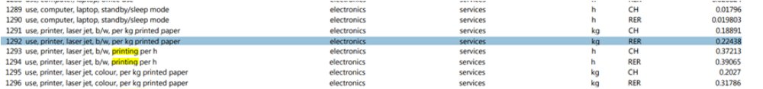
NB: If you are unable to calculate the number of pages, you may assume that there are 150 pages in a small ring binder and 500 pages in a large lever arch folder.
Assumption: 1 piece of paper weighs around 5g/0.005kg
Emission factor source: Ecoinvent, version 2.2, 2011 ⁶ (RER = European emission factor)
Materials (paper): For the carbon footprint of paper production, the number of pages must be multiplied by 0.005 to produce a weight, and the weight multiplied by the emission factor for paper manufacture provided below.
Kg (paper) x 0.919 = kg CO₂e
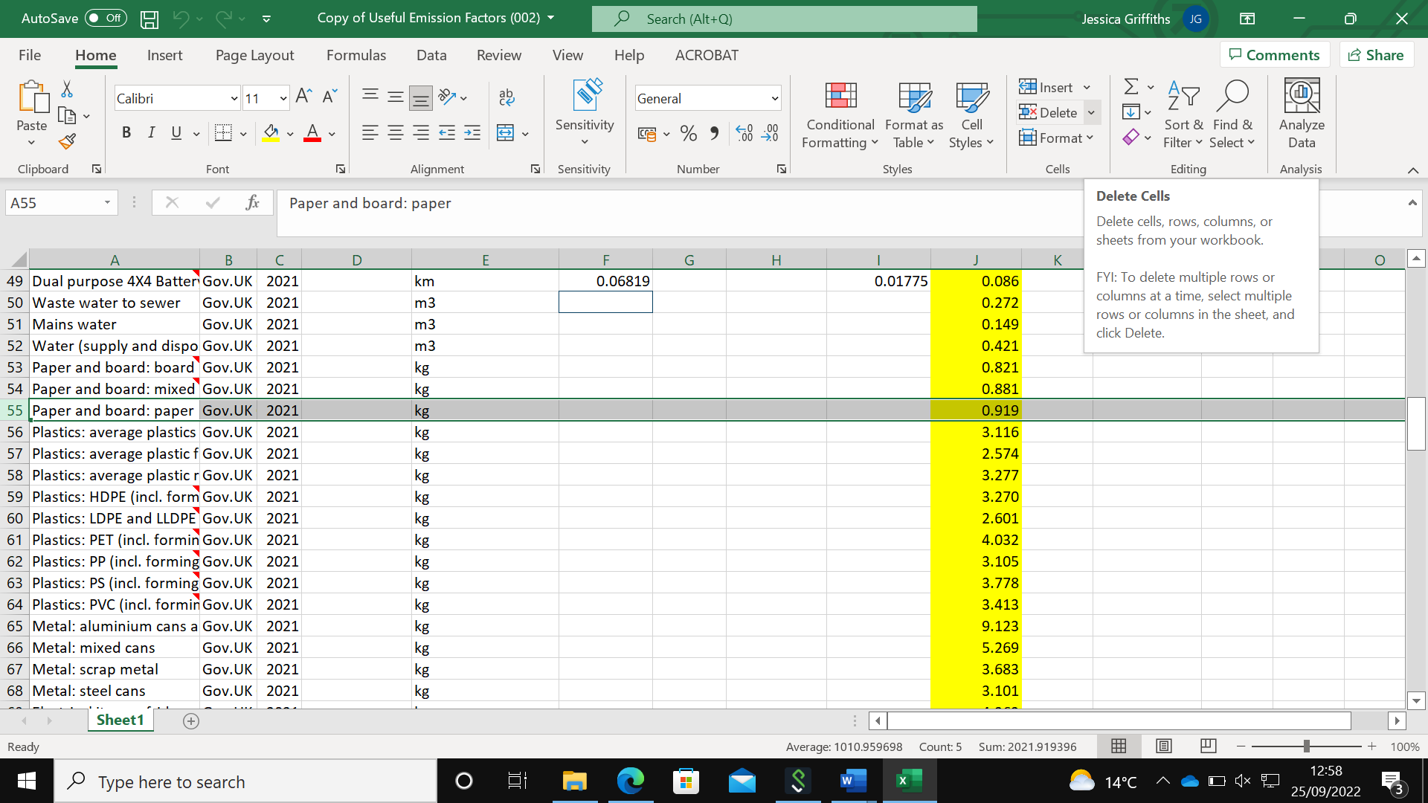
Emission factor source: Greenhouse gas reporting: conversion factors 2021, GOV.UK ⁷
Materials (folders): As trial documentation is often sent to sites in folders, provided below are estimated weights of folders. The total weight in kg will then need be multiplied by the emission factor for cardboard (provided below).
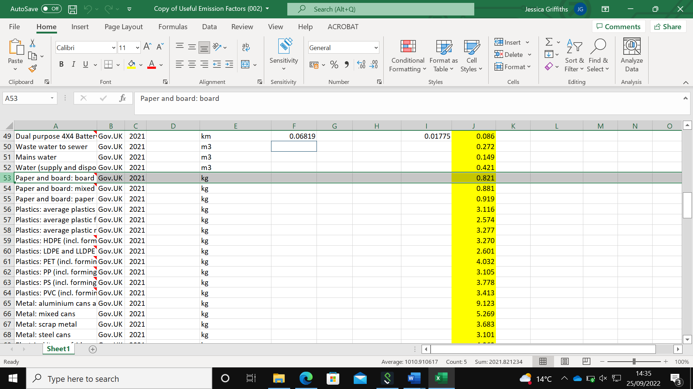
CF of the folder materials = Kg x 0.821 = kg CO₂e
Lever arch: Assumption: Weight of lever arch = 0.5kg
Ring binder: Assumption: Weight of ring binder = 0.3kg Eastlight A4 Black Ring Binder - EA54121 (staples.co.uk)

Emission factor source: Greenhouse gas reporting: conversion factors 2021, GOV.UK ⁷

1.2, 1.3, 1.4 Provision of trial materials
For provision of trial materials to sites by post/courier you will need to calculate the total weight of the materials (in tonnes) and multiply this by the distance they travel (in km) to get tonne.km. The t.km is then multiplied by the emission factor for either road or air freight provided below.
Road freight:
Mass (tonnes) x distance (km) = t.km
t.km x emission factor = (kg CO₂e)
Emission factor for road freight = 0.19443
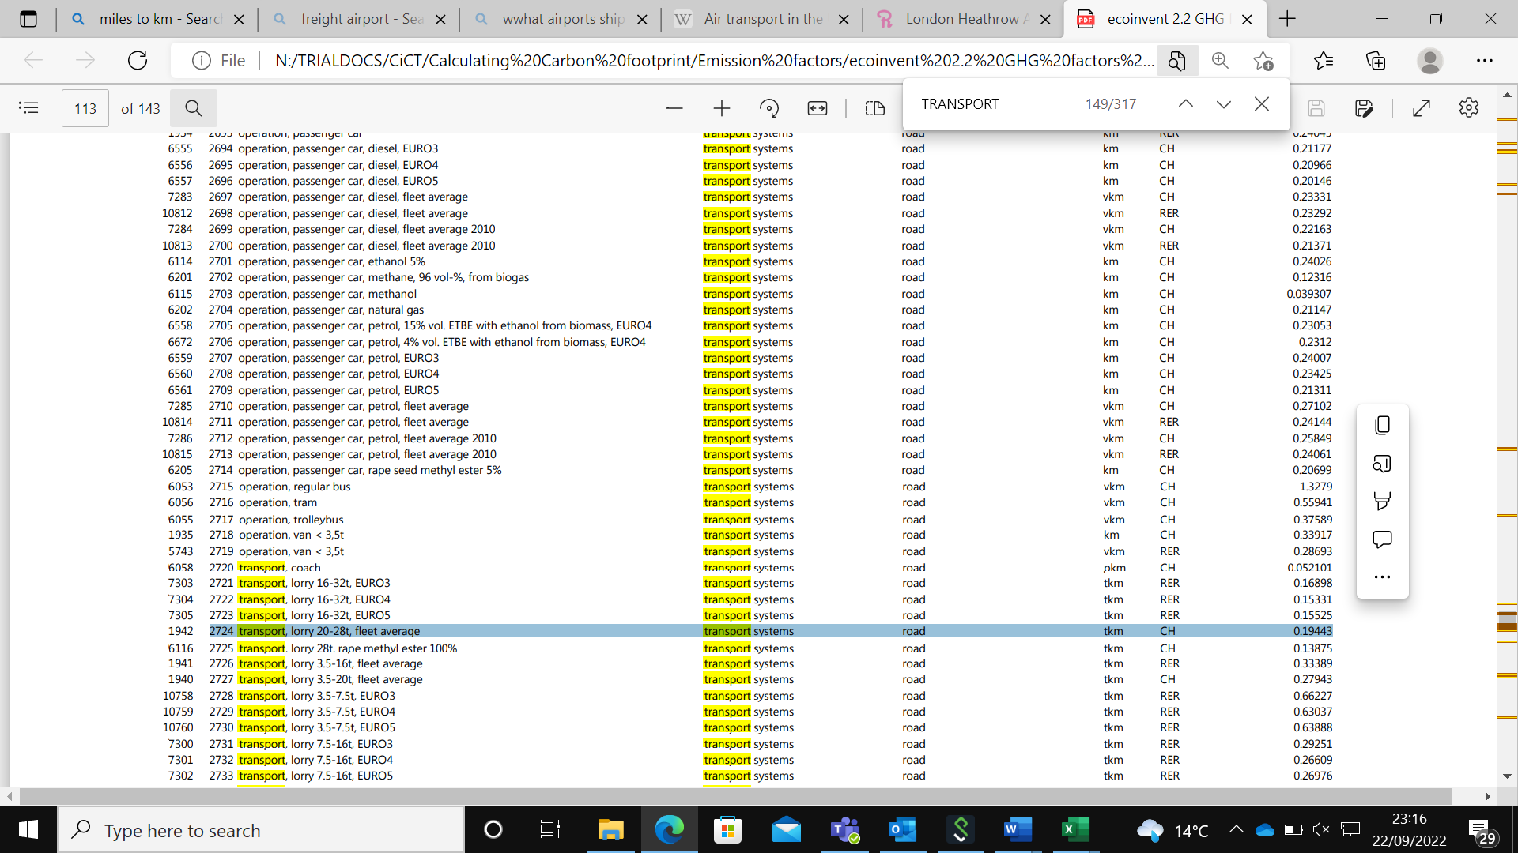
Emission factor source: Ecoinvent, version 2.2, 2011 ⁶

Air freight:
Mass (tonnes) x distance (km) = t.km
t.km x most suitable emission factor from highlighted column = (kg CO₂e)
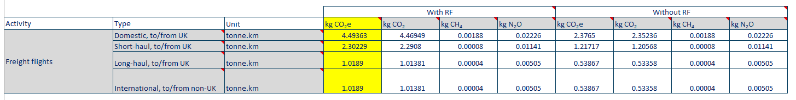
NB: ‘With RF’ values are recommended. RF (combustion and radiative forcing) includes the indirect and direct emissions.
NB: Always use values relating to ‘kgCO₂e’
For air freight you need to add the WTT (well-to-tank) value to get the final total for freight flight. WTT can be calculated by multiplying the t.km used in the first calculation by the correlating WTT conversion factor provided below.
Tonne.km x correlating WTT conversion factor
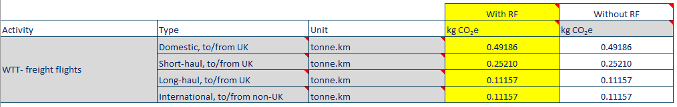
Emission factor source: Greenhouse gas reporting: conversion factors 2021, GOV.UK ⁷
Assumption: If unknown, for delivery of trial supplies to patients or GP, use 17.4km as distance from hospital to patient, or hospital to GP. Source: BMJ 2009;339:b4187 ²

- CTU Emissions
This module includes the following activities:
Energy consumption at CTU
Heating
Trial team commuting
2.1. Energy consumption at CTU (according to staff FTE)

Often, the carbon footprint associated with energy consumption by the CTU cannot be calculated directly because the space or building will be used for other trials not being appraised and non-trial activities. Emissions are therefore estimated based on average per person emissions and the FTE of the trial employees.

According to the UK Employment Destiny Guide, public sector office space is 12 m² per FTE. This is multiplied by 59 kWh/m², the median electricity intensity for offices, to produce a per person per year usage. The emissions attributed to CTU energy consumption can then be calculated by multiplying the per person usage by the electricity emission factor provided. The calculation is exemplified below.

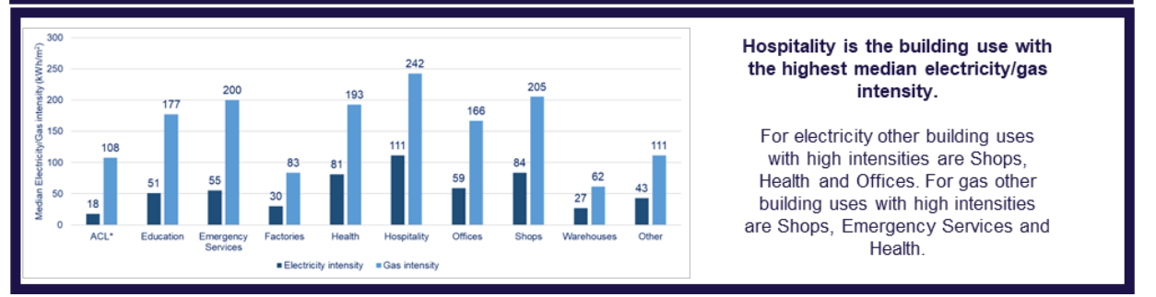
Calculation
12m² x 59 kWh/m² = 708 kWh per FTE per year
Electricity emission factor = 0.273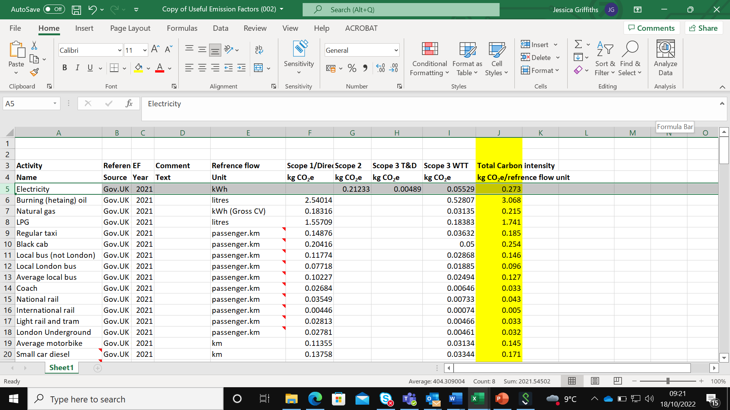
708 kWh x 0.273 = 193.3 kgCO₂e per FTE per year
Finally, multiply 193.3 kgCO₂e by the number of years and FTE applicable.

Assumption: According to the UK EMPLOYMENT DENSITY GUIDE, 3rd edition November 2015, office space per FTE is 12 m² (public sector) ⁸
Office benchmark data source: The Non-Domestic National Energy Efficiency Data-Framework 2022 (England and Wales) (publishing.service.gov.uk)⁹
Electricity emission factor source: Greenhouse gas reporting: conversion factors 2021, GOV.UK ⁷

2.2 Heating
For heating, the calculation follows the same method as above. The 12m² per person is multiplied by the office heating benchmark and then by the natural gas conversion factor provided below.
Office building heating benchmark: 167.27 (kWh/m²)
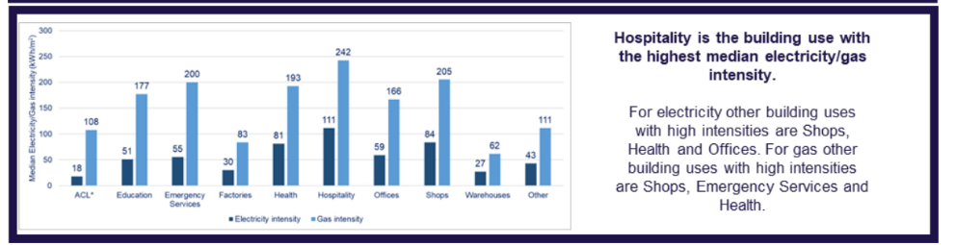
Natural gas conversion factor: 0.215
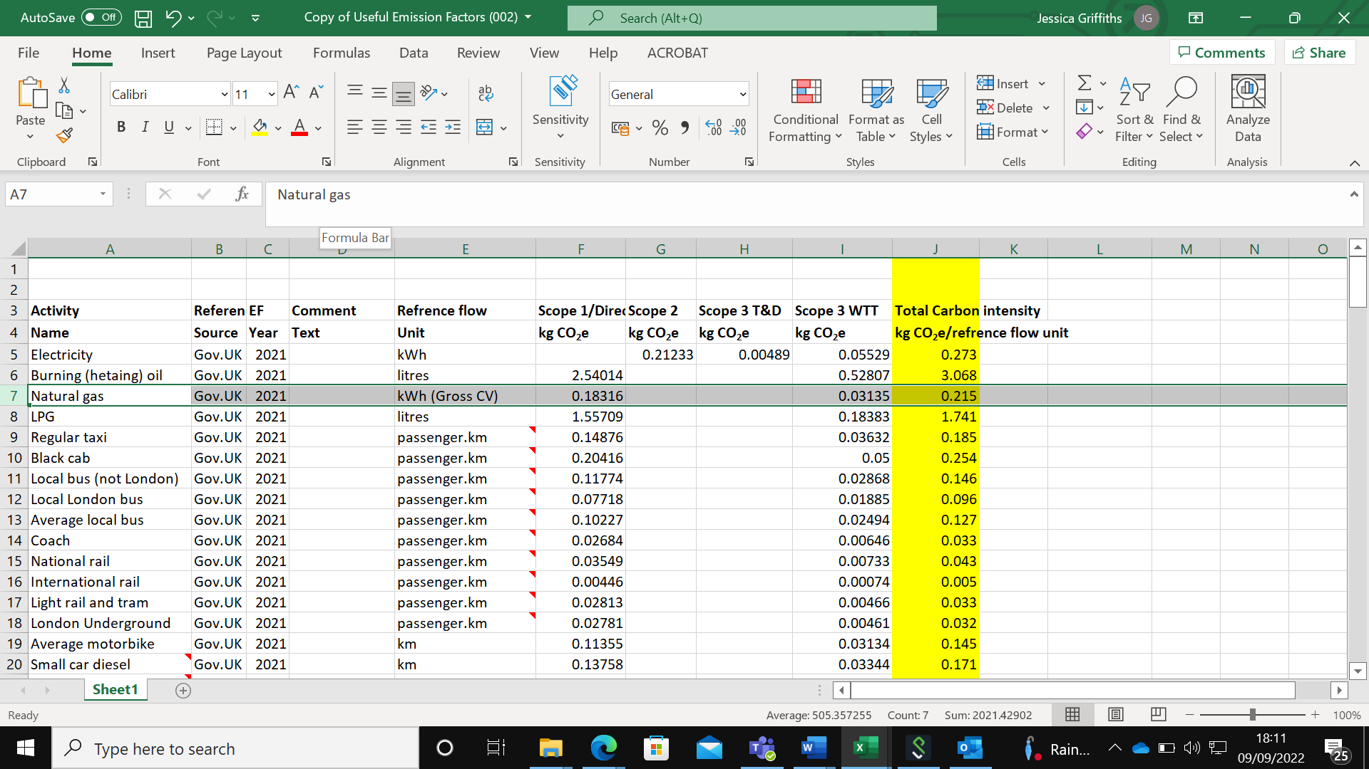
Calculation
- 12 m² x 167.27 kWh/m² = 2007.24 kWh per FTE per year
- 2007.24 kWh x 0.215 = 431.56 kg CO₂e per FTE per year
Multiply 431.56 kg CO₂e by the number of years and FTE applicable
Assumption: If the heating source is unknown, assume that the heating source is natural gas.
Assumption: According to the UK EMPLOYMENT DENSITY GUIDE, 3rd edition November 2015, office space per FTE is 12 m² public sector. ⁸
Office benchmark data source: The Non-Domestic National Energy Efficiency Data-Framework 2022 (England and Wales) (publishing.service.gov.uk) ⁹
Natural gas emission factor source: Greenhouse gas reporting: conversion factors 2021, GOV.UK ⁷
Homeworking

Multiply the total number of FTE working hours by the conversion factor (0.34075) to calculate kgCO₂e (includes electricity use from office equipment and heating).
Emission factor source: Greenhouse gas reporting: conversion factors 2022, GOV.UK ¹⁰

2.3. Trial team commuting
The emissions attributed to the trial team commuting is calculated using average commuting statistics. Using these statistics, the distance travelled by each mode of transport was calculated and multiplied by the relevant emission factor.
The average distance of a commuting journey was 8.8 miles (14km) in 2013/14. Multiplied by 220 commuting days, this results in a total distance of 6160km travelled per year.
Car (used for 68% of the 6160km distance) – 68% of 6160km = 4188.8km
4188.8 x 0.223 = 934.1 kgCO₂e
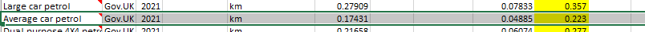
Rail (used for 10% of the 6160km distance) = 616 km x 0.043 = 26.5 kgCO₂e
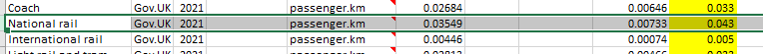
Bus (used for 6% of the 6160km distance): 369.6km x 0.127 = 46.9 kgCO₂e
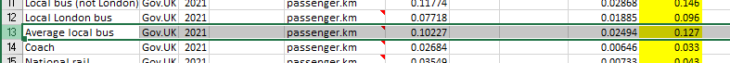
Other (used for 5% of the 6160km distance): Assume 3% cycling so zero emissions, 1% motorbike, 1% taxi
Motorbike: 61.6km x 0.145 = 8.9kgCO₂e
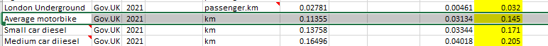
Taxi: 61.6 x 0.185 = 11.4
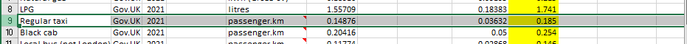
For 1 FTE, emissions attributed to commuting for 1 year= 1027.8 kgCO₂e
Multiply by the number of years and FTE applicable
NB: The WTT (well-to-tank) has been included in the emission factors for all modes of transport and therefore does not need to be added manually in this case.
Assumptions:
- 220 days spent commuting. This was calculated by subtracting 10 days sick and 30 days paid leave from the 260 workdays in a year.
- 6160 km is the total distance an employee will commute per year. This was calculated by multiplying 28km (14km per commuting journey) by 220 days.
Sources:
- Transport Statistics Great Britain: 2021 - GOV.UK (www.gov.uk) ¹¹
- Commuting trends in England 1988 - 2015 (publishing.service.gov.uk) ¹²
- Emission factor source: GOV.UK Greenhouse gas reporting, conversion factors 2021 ⁷

- Trial specific meetings and travel
This module includes the following activities:
  - Visits and travel to site
  - Travel to meetings
  - Hotel stays
  - Sustenance

3.1, 3.2. Visits and travel to site, travel to meetings
For business travel by bus, taxi and rail, the activity data is captured in passenger km (p.km). The number of passengers is multiplied by the distance travelled (km), then by the relevant emission factor.
Number of passengers x total distance (km) = p.km
p.km x suitable emission factor = (kg CO₂e)
Rail
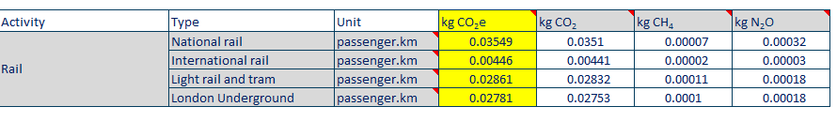
For business travel you need to add the WTT (well-to-tank) value to get the final total. WTT can be calculated by multiplying the p.km used in the first calculation by the correlating WTT conversion factor provided below.
passenger.km x correlating WTT conversion factor
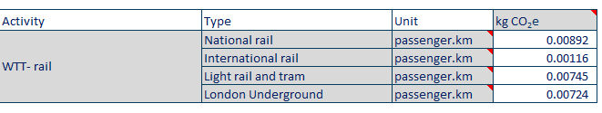
NB: Always use values relating to ‘kgCO₂e’
NB: Distances can be calculated using google maps

Assumption: Distances calculated from CTU to destination

Emission factor source: Greenhouse gas reporting: conversion factors 2021, GOV.UK ⁷
Emission factors for all modes can be found in the orange ‘business travel’ tabs of conversion-factors-2021-full-set-advanced-users.xlsm (live.com)

3.1, 3.2. Visits and travel to site, travel to meetings
For business travel by air, activity data is also captured in passenger km (p.km). The number of passengers is multiplied by the distance travelled (km), then by the relevant emission factor.
Number of passengers x total distance (km) = p.km
p.km x suitable emission factor = (kg CO₂e)
An emission factor must be chosen from the following categories:
- Domestic
- Short Haul International (≤3700 km) – Average/Economy/Business
- Long Haul International (>3700 km) – Average/Economy/Business
- International (travel between non-UK countries)
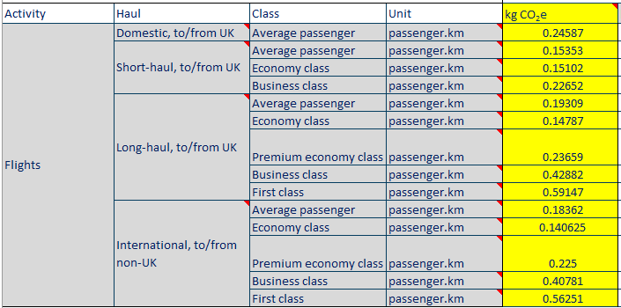
For business travel you need to add the WTT (well-to-tank) value to get the final total. WTT can be calculated by multiplying the p.km used in the first calculation by the correlating WTT conversion factor provided below.
passenger.km x correlating WTT conversion factor
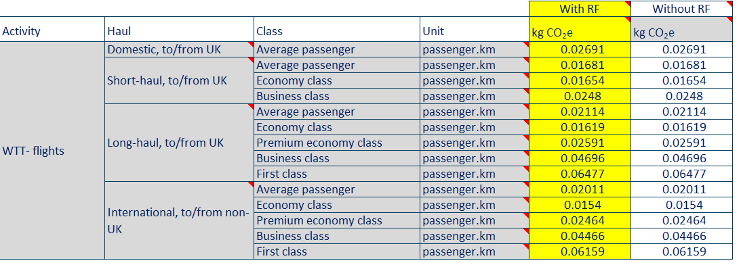
NB: Always use values relating to ‘kgCO₂e’
NB: Distances can be calculated using google maps
NB: ‘With RF’ values are recommended. RF (combustion and radiative forcing) includes the indirect and direct emissions
Assumption: travellers departed from the nearest airport to their place of work and flew directly to the airport of the city to which they were travelling.
Emission factor source: Greenhouse gas reporting: conversion factors 2021, GOV.UK ⁷
Emission factors for all modes can be found in the orange ‘business travel’ tabs of conversion-factors-2021-full-set-advanced-users.xlsm (live.com)

3.2 Travel to meetings
Teleconferencing: for meetings which are conducted by teleconferencing, multiply the number of people and hours by the figure provided below.
A standard videoconferencing service has a carbon footprint of 157 g CO₂e/hr. When the video is switched off, videoconferencing uses 6.9 g CO₂e/hr.
Emission factor source: Turn off that camera during virtual meetings, environmental study says - Purdue University News ¹³

3.3 Hotel Stays
To calculate the emissions attributed to hotel stays, the number of hotel rooms is multiplied by the length of stay (in number of nights) and by the conversion factor for the appropriate country to give the associated emissions.
Each country has a different emission factor. The emission factor for the UK is shown below, other countries can be found at conversion-factors-2021-full-set-advanced-users.xlsm (live.com)
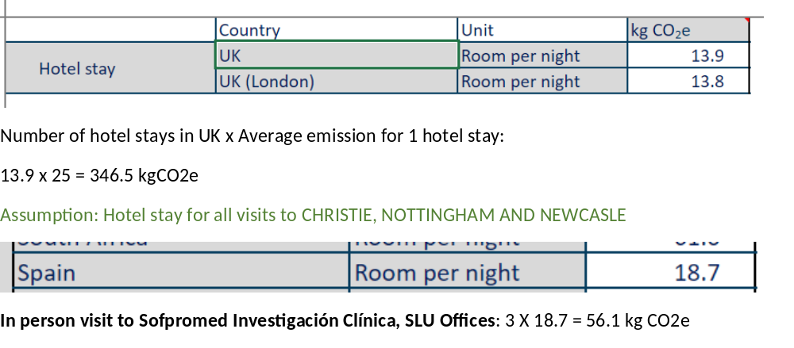
NB: A ‘room per night’ accounts for use of the room and does not differentiate for number of travellers staying in the room.
Source: Greenhouse gas reporting: conversion factors 2021, GOV.UK ⁷
Alternatively, you may use a cost-based method by multiplying the total cost in the funding application by the emission factor below:
Cost (£) x 0.358 = kg CO₂e

Emission factor source: Gov.UK Government conversion factors for company reporting of greenhouse gas emissions 2012 - Annex 13 with consideration of 2020 inflation rates. ¹⁴

3.4. Sustenance
For the carbon footprint associated with meeting lunches or hotel dinners, multiply the quantity by the relevant emission factor provided below.
Meeting lunches or hotel dinners (vegetarian) = 2.6 kgCO₂e per meal per person
Meeting lunches or hotel dinners (meat) = 5.92 kgCO₂e per meal per person
Emission factor source = WWF, 2018 Food_in_a_warming_world_report.PDF ¹⁵

- Intervention
This module includes guidance on the following different types of intervention. Pick the most applicable intervention type from:
  - Physical (IMP)
  - Clinical (Non-IMP)
  - Other (not captured above)

4.1 Physical (an IMP)
4.1.1 Movement of IMP from manufacturing site to distribution/packaging site
4.1.2 Movement of IMP from distribution/packaging site to participating sites or direct to participant
4.1.3 Materials required for the packaging and shipment of IMP
4.1.4 Destruction of overage
Assumptions: Calculations do not include manufacture of IMP.

  - Clinical (non-IMP)
NB: not all calculations will be relevant to all interventions.
    - Movement (shipment) of the intervention, or resources required to deliver the intervention
    - Materials required for the shipment of the intervention
    - Utilities required for delivery of the intervention
    - Activities or resources required/relating to delivery of the intervention
Assumptions: Calculations do not include manufacture of device/machinery/equipment delivering the intervention.

  - Other (Not captured above)
NB: not all calculations will be relevant to all interventions, depending on the specific intervention.
    - Movement of the intervention to the participant or participating site
    - Materials required for packaging and shipment of the intervention
    - Materials or resources required for delivery of the intervention
    - Travel required to facilitate delivery of the intervention

4.1. Physical (an IMP)
4.1.1.,4.1.2. Movement of intervention to participating site or direct to participant
For freight, please refer to section 1.2, 1.3, 1.4 for the calculation and emission factors. If the delivery is not ambient, follow the guidance provided below.
Refrigerated freight
Increase the total kgCO₂e associated with freight by 15% for samples transported at temperatures of 2-8 degrees.
Frozen (dry ice) freight
When calculating the carbon footprint of frozen shipments, make sure to consider the emissions attributable to the dry ice, both in terms of:
- Weight - If the total weight of the posted package is not available, when estimating the weight of the sample and box, make sure to include the additional weight due to the dry ice (add/include in normal calculation of weight x distance x emission factor).
- Emissions of dry ice manufacture: for 1 kg of dry ice, you need to account for 2.22 kg of liquid CO₂ using the Ecoinvent 2.2 data below. E.g., 2.22kg x 0.81605 = 1.81kg CO₂e per 1 kg dry ice produced/used.
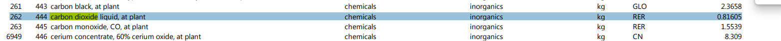
If the amount of dry ice used in frozen shipments is unknown, use an estimated 1kg of dry ice per sample box. Ensure this additional weight is included in the freight calculation and 1.81KgCO₂e in the total carbon footprint of the freight.
Assumption: use 1 kg of dry ice per sample box in the absence of established activity data.
Emission factor source: Consultation /estimation by Environmental Resource Management

4.1.3. Materials involved in the packaging and shipment of the intervention
Shipping boxes
For single use (SU) cold storage boxes multiply the number required by 25.2 kgCO₂e
For reusable cold storage boxes, multiply the number required by 2.2 kgCO₂e
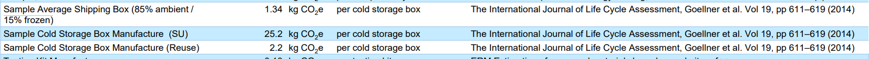
Emission factor source: The International Journal of Life Cycle Assessment, Goellner et al. Vol 19, pp 611-619 (2014) ¹⁶
For cardboard: Kg (cardboard) x 0.821 = kgCO₂e
For polystyrene: kg (polystyrene) x 3.778 = kgCO₂e
Greenhouse gas reporting: conversion factors 2021, GOV.UK ⁷

4.1.4. Destruction of overage
For the destruction of overage, such as the incineration of IMP, multiply the weight in kg of the material being destroyed by the emission factor provided below.
Kg of waste x 2.4252 = kgCO₂e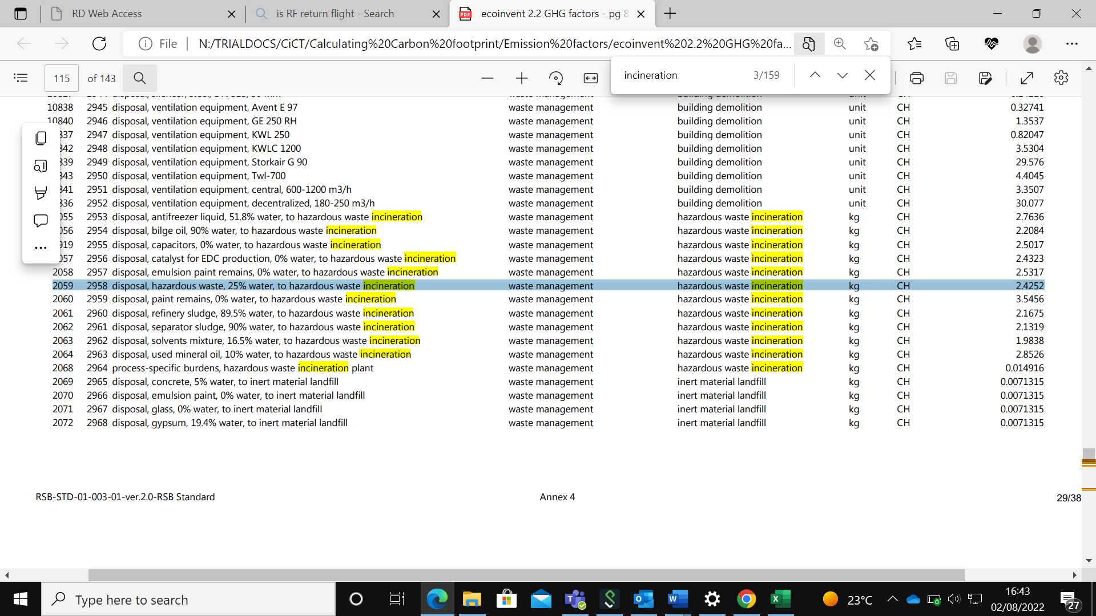
Emission factor source: Ecoinvent, version 2.2, 2011 (CH = SWITZERLAND) ⁶

4.2. Clinical (e.g. radiotherapy, device, surgery)
NB: not all calculations will be relevant to all interventions. This section of the method will be further developed as we carbon footprint more trials, so please inform us if your protocol specifies an activity that has not been included, and we will help to determine the associated carbon footprint.
4.2.1 Movement of intervention, or materials required to deliver the intervention
Please refer to section 1.2 and 4.1.1, 4.1.2.
4.2.2 Materials involved in the shipment of the intervention
Please refer to section 4.1.3.
4.2.3 Utilities required for delivery of the intervention
Please refer to section 7.3 to calculate the emissions attributed to hospital utilities if required to deliver the intervention.
4.2.4 Activities or resources required/relating to delivery of the intervention
Please refer to section 7.2 for consumables, surgery and other activities that may be relevant to the delivery of the intervention, but please take care to avoid double counting.
To calculate the emissions attributed to incineration, please refer to section 4.1.4.
4.3. Other
NB: not all calculations will be relevant to all interventions. This section of the method will be further developed as we carbon footprint more trials, so please inform us if your protocol specifies an activity that has not been included, and we will help to determine the associated carbon footprint.
4.3.1 Movement of intervention, or materials required to deliver the intervention
Please refer to section 1.2 and 4.1.1, 4.1.2.
4.3.2 Materials required for packaging and shipment of the intervention
Please refer to section 4.1.3
4.3.3 Materials or resources required for delivery of the intervention
For printing and paper, please refer to section 1.1.
4.3.4 Travel required to facilitate delivery of the intervention
Please refer to section 3.1, 3.2 for travel.

- Data collection and exchange
This module includes the following activities:
  - Data collection and query exchange between CTU and sites
  - Data sent direct from participants to CTU or participating sites
  - Data from labs to CTU
  - Data from other collaborators to CTU
NB: Analysis of data does not need to be calculated separately, it is covered by the emissions attributed to trial staff FTE in “CTU emissions” and by calculations within “Data Collection and exchange”.

5.1. Data collection and query exchange between CTU and sites
CRFs
For postage of paper CRFs, please refer to section 1.2 (freight).
Web-based data entry at sites, e.g. CRF completion, will be accounted for in the time a hospital worker spends on the trial and the carbon footprint of the trial databases (See 5.2).
Scans copied to CD
To estimate the emissions attributed to copying patient scans to a CD, add the carbon footprint of CD manufacture to the carbon footprint of computer use.
The carbon footprint of manufacturing a CD = 0.83 kg C0₂e per CD (833 g C0₂e)
Source: Journal of Industrial Ecology, “The Energy and Climate Change Impacts Of Different Music Delivery Methods”. Weber et al. Vol 14, Issue 5, pg. 754-769 (2010) ¹⁷
The carbon footprint of copying the scans on to a CD using a computer = 0.18079 kg C0₂e per hour
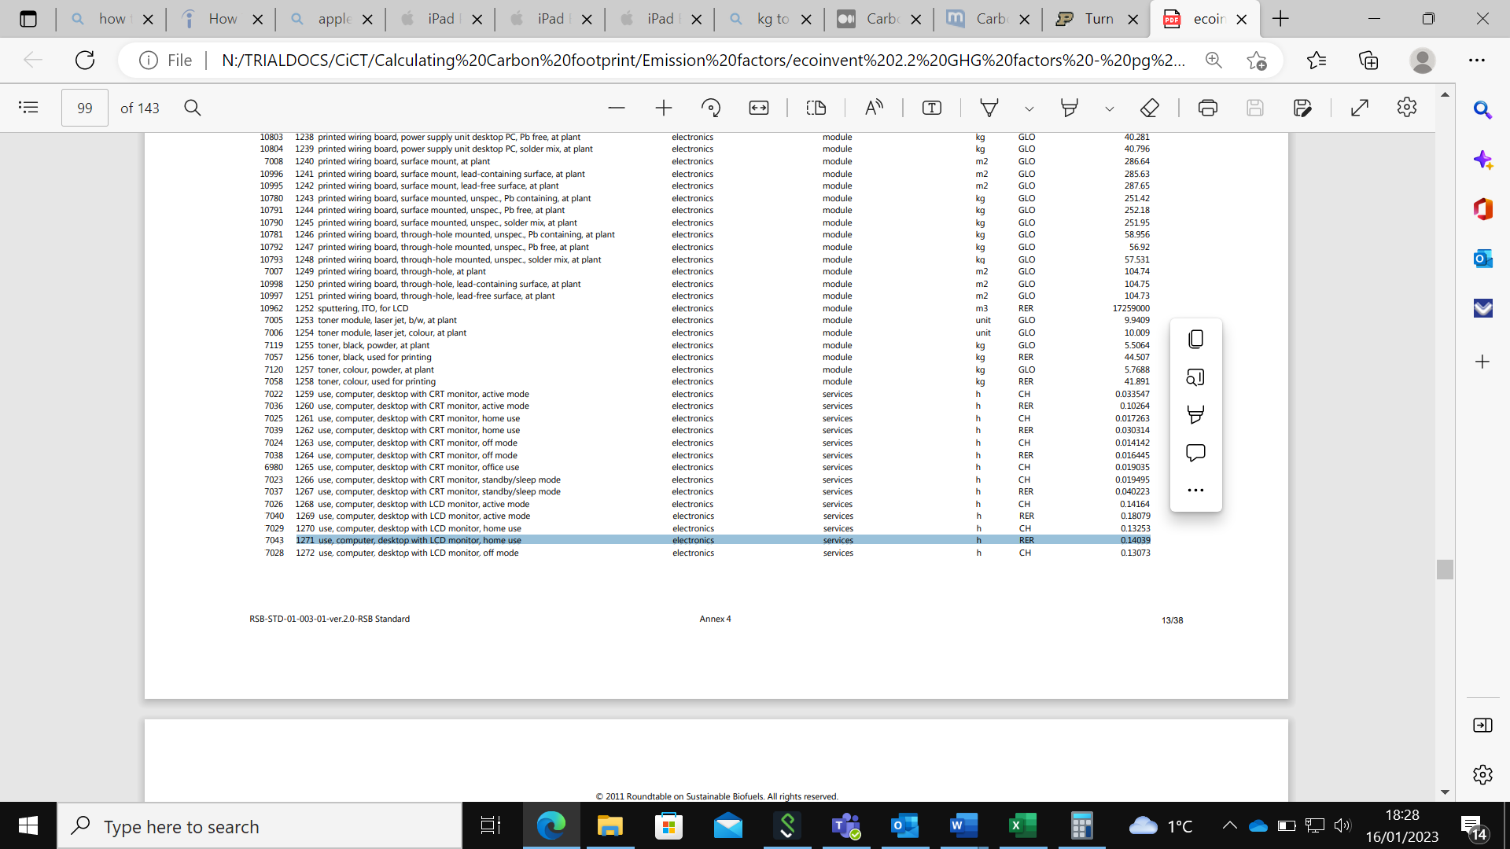
Emission factor source: Ecoinvent, version 2.2, 2011 ⁶
Email traffic
An email without an attachment = 10g CO₂e. Double this for an email with a one-megabyte attachment.
NB: this is an estimate of all emails exchanged between CTU and participating sites throughout the study lifetime, including data query resolution emails.
Source: Carbon footprint of your emails | mail.com blog ¹⁸

5.1. (continued)
Data collection via electronic trial databases/systems
The combination of transmitting data and storing it in a data centre requires between 3 to 7 kWh per gigabyte¹⁹. Therefore multiply 5 kWh by the electricity emission factor (0.273) to calculate the kg CO₂e per GB per year.
5 kwh x 0.273 = 1.365 kg CO₂e per GB per year
Assumption: data storage requires 5 kWh.
Source: Carbon and the Cloud. Hard facts about data storage. | by Stanford Magazine | Stanford Magazine | Medium¹⁹

5.3. Data sent direct from participants to CTU/participating sites
For paper questionnaires, please refer to section 1.1. for the carbon footprint of producing the materials and section 1.2. for postage (freight).
Electronic questionnaire
For completion of an electronic questionnaire, you must account for both the use of a device to complete the questionnaire and the carbon footprint of data storage and transmission associated with web surfing.
For completion using a desktop computer: 0.18079 kg CO₂e per hour
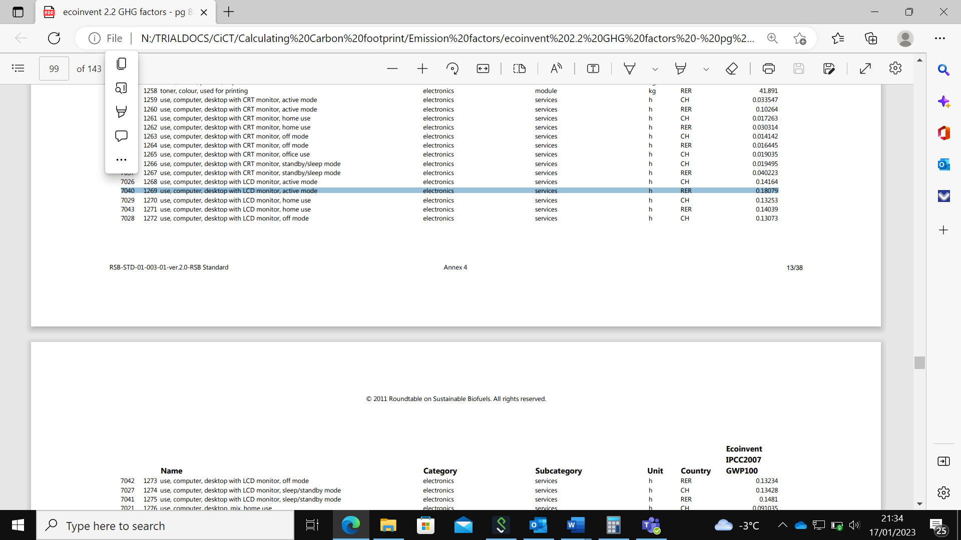
For completion using a laptop: 0.028719 kg CO₂e per hour 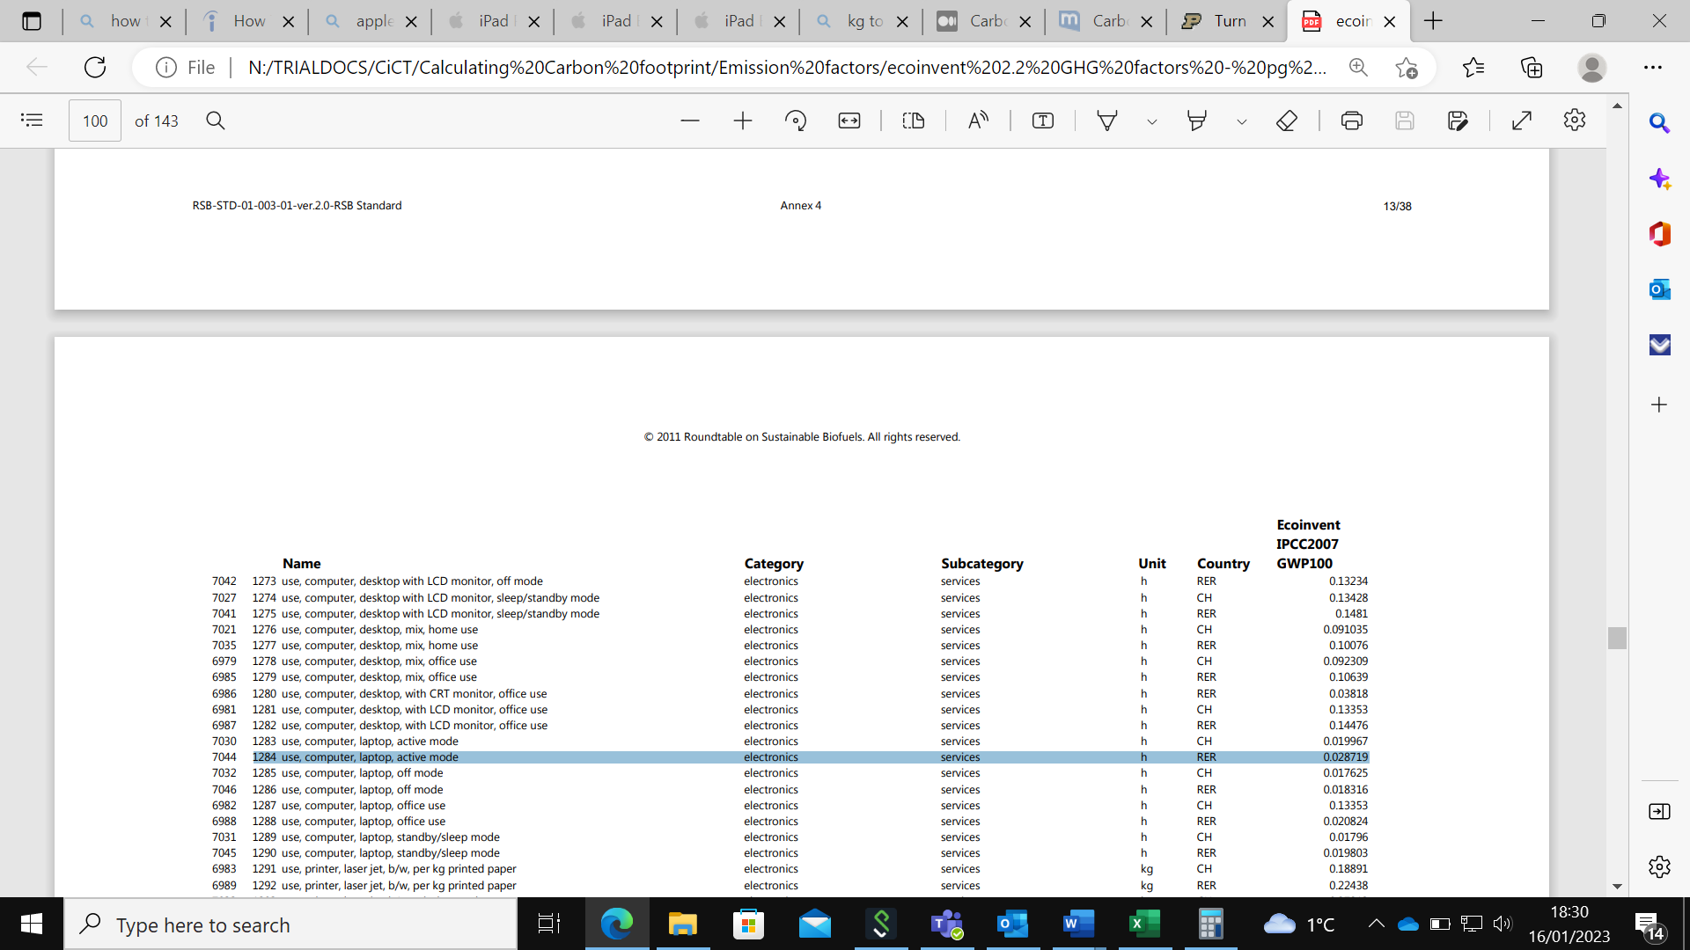
Computer and laptop emission factor source: Ecoinvent, version 2.2, 2011 ⁶
For completion using a tablet: 0.027397 kg CO₂e per hour
For completion using a smartphone: 0.015068 kg CO₂e per hour
Tablet and smartphone emission factor source: Examining the Carbon Footprint of Devices - Sustainable Software (microsoft.com) ²⁰
Web surfing = 9.441 g CO2e/hr (10 mins = 1.57 g CO₂e)
Source: Resources, Conservation and Recycling, “The overlooked environmental footprint of increasing Internet use”. Obringer et al. Vol 167 (2021) ²¹

5.4. Data from labs to CTU
For data collection via electronic trial database systems estimate 1.365 kgCO₂e per GB per year.
Source: Carbon and the Cloud. Hard facts about data storage. | by Stanford Magazine | Stanford Magazine | Medium¹⁹

5.5. Data from other collaborators to CTU
Data linkage
For data linkage, multiple the cost spent by the emission factor provided below.
Computer services – 0.149 x unit (£) = kgCO₂e
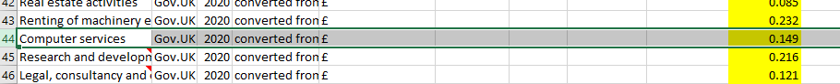
Emission factor source: Gov.UK Government conversion factors for company reporting of greenhouse gas emissions 2012 - Annex 13 with consideration of 2020 inflation rates. ¹³

- Trial supplies and equipment
This module includes the following activities:
  - Equipment used by CTU
  - Equipment and supplies used by participating sites supplied by CTU
  - Equipment and supplies provided to participants specifically for the trial
6.1. Equipment used by CTU
For office machinery and computers purchased for the trial, multiply the cost by the emission factor provided below.
£ x 0.387 = kgCO₂e
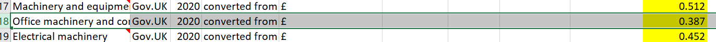
Emission factor source: Gov.UK Government conversion factors for company reporting of greenhouse gas emissions 2012 - Annex 13 with consideration of 2020 inflation rates. ¹³

6.2. Equipment and supplies used by participating sites supplied by CTU
For the shipment of equipment to participating sites, please refer to section 1.2.
For the use of a centrifuge, please refer to section 9.2., for a fridge or freezer please refer to section 9.3.
Please inform us if your protocol specifies any equipment or supplies that have not been included and we will help to determine the associated carbon footprint.

6.3. Equipment and supplies provided to participants specifically for the trial
Smartphone: For a smartphone, account for 55 kgCO₂e from manufacture and add 5.5 kgCO₂e per year of usage.
Source: Examining the Carbon Footprint of Devices - Sustainable Software (microsoft.com) ¹⁹
Tablet: For a tablet, account for 119 kgCO₂e from manufacture and add 10kg CO₂e per year of usage. Assume a maximum lifetime of 3 years, therefore 30 kg CO₂e is the total possible carbon footprint that can be attributed to use.
Source: Examining the Carbon Footprint of Devices - Sustainable Software (microsoft.com) ¹⁹
Wearables/smart watch: For a smart watch, account for 30.1 kg CO₂e for manufacture and add 1.633 kg CO₂e per year of usage. Assume a maximum lifetime of 3 years, therefore 4.9 kg CO₂e is the total possible carbon footprint that can be attributed to use.
Source: Apple Watch SE Product Environmental Report
²²
To calculate the carbon footprint associated with shipment of the devices, please refer to section 1.2.

- Trial specific patient assessments
This module includes the following activities:
  - Travel of patients for study in visits in addition to standard of care (eligibility/screening assessments, trial-specific assessments and procedures)
  - Materials and activities required for study assessments in addition to standard of care
  - Utilities required for study assessments according to trial staff FTE

7.1. Travel of patients for study in visits that are in addition to standard of care (eligibility/screening assessments, trial-specific assessments and procedures)
Patient travel to elective care (e.g. Hospital)
1 journey by patient associated with attendance at elective care = 2.9 kg CO₂e
Therefore 1 visit to elective care (2 journeys – out and back) = 5.8 kgCO₂e
Patient travel to primary care (e.g. GP)
Emissions associated with attendance at GP surgery (journey out and back) = 1.12 kgCO₂e
Emission factors source: SHC care pathway calculator ²³

7.2. Materials and activities required for study assessments that are in addition to standard of care
This includes everything that happens to the patient in the protocol schedule of assessments which is over and above routine care. This is not an exhaustive list; please inform us if your protocol specifies an activity that has not been included, and we will help to determine the associated carbon footprint.
Surgery
A 1-hour surgery = 53 kg CO₂e
A 30-minute surgery = 26.5 kg CO₂e
Emission factor source: SHC care pathway calculator ²³
Bed days
Low intensity (general ward) = 37.9 kg CO₂e
High intensity (ICU) = 103 kg CO₂e
Emission factor source: SHC care pathway calculator ²³
Scans
1 MRI = 24.7 kg CO₂e
Emission factor source: SHC care pathway calculator ²³
1 CT scan = 9.2 kg CO₂e, 1 CXR = 0.8 kgCO₂e
Emission factor source: The carbon footprint of hospital diagnostic imaging in Australia (thelancet.com) ²⁴

7.2. Materials and activities required for study assessments (continued)
Radiotherapy
To calculate the carbon footprint of radiotherapy, multiply the total treatment power in kWh by the electricity emission factor.
Full course of breast radiotherapy (15 sessions) = 5.7 kgCO₂e
Calculation: 1.4 kWh x 0.273 x 15 = 5.7 kgCO₂e
Full course prostate radiotherapy (20 sessions) = 15.3 kgCO₂e
Calculation: 2.8 kWh x 0.273 x 20 = 15.3 kgCO₂e
Assumption: 15 sessions required for breast radiotherapy. Source: Radiotherapy for breast cancer - Macmillan Cancer Support ²⁵
Assumption: 20 sessions required for prostate radiotherapy. Source: Radiotherapy for advanced prostate cancer | Prostate Cancer UK ²⁶
Benchmark data source: PO-1058 Estimating the carbon footprint of the radiotherapy pathway and changes in response to COVID-19 main.pdf (nih.gov) ²⁷
Emission factor source: GOV.UK Greenhouse gas reporting, conversion factors 2021 ⁷
Consumables
For a trial appointment where consumables such as gloves are required, account for 0.30 kgCO₂e per patient per appointment.
Emission factor source: SHC care pathway calculator guidance GP consultation module, 2015 ²⁸
Blood investigations
CO₂ e emissions for haematology tests:
- 82 g/test (95% CI, 73-91 g/test) for coagulation profile
- 116 g/test (95% CI, 101-135 g/test) for full blood examination.

CO₂ e emissions for biochemical tests:
- 0.5 g/test CO₂ e (95% CI, 0.4-0.6 g/test) for C-reactive protein (low because typically ordered with urea and electrolyte assessment)
- 49 g/test (95% CI, 45-53 g/test) for arterial blood gas assessment
- 99 g/test (95% CI, 84-113 g/test) for urea and electrolyte assessment.

NB: These emissions include the materials and consumables required for sample collection, phlebotomy and analysis, as well as power consumption by pathology analysers.

Emission factor sourced from: The carbon footprint of pathology testing. Scott McAlister, Alexandra L Barratt, Katy JL Bell and Forbes McGain. Med J Aust 2020; 212 (8): 377-382.
Published online: 4 May 2020 The carbon footprint of pathology testing - McAlister - 2020 - Medical Journal of Australia - Wiley Online Library ²⁹

7.3. Utilities required for study assessments that are in addition to standard of care
The carbon footprint associated with energy consumption by hospital staff cannot be calculated directly because a hospital and the equipment and staff within in it are used for many other non-trial activities. Emissions are therefore estimated based on average per person emissions and the FTE of the trial hospital staff.
This is calculated by multiplying the average space occupied by a hospital staff member (16.5 m²) by the kWh used per m² of a hospital (81 kWh/m²). The kWh per FTE per year is then multiplied by the electricity emission factor provided below to calculate the carbon footprint attributed per hospital staff FTE. Finally, multiply by the number of years and FTE applicable. The calculation is exemplified below.
Calculation
16.5 m² x 81 kWh/m² = 1336.5 kWh per FTE per year
- Electricity emission factor = 0.273
1336.5 kWh x 0.273 = 364.9 kgCO₂e per FTE per year
Multiply 364.9 kgCO₂e by the number of years and FTE applicable - Use the trial SOECAT or the costing included in the initial funding application (if predates use of SOECAT) to establish the FTE or total number of hours required by hospital staff for the trial. If using the number of hours, please follow the below method to establish the FTE required for the calculation.
Number of hours in SOECAT / 1762.5 = FTE required for trial.
e.g. if 449.25 total hospital staff hours required for trial.
449.25 / 1762.5 = 0.25. Therefore 25% of 1 hospital staff FTE required
364.9 kgCO₂e x 0.25 = 91.2 kgCO₂e
Assumption: The FTE of a nurse/hospital staff is 1762.5 hours. The standard full-time working week for NHS staff is 37.5 hours (1950 hours - 35 days a year off = 1762.5 hours).
Assumption: each health care professional occupies 16.5m² room, source HBN 12 (england.nhs.uk) page 32 ³⁰
Hospital benchmark data source: The Non-Domestic National Energy Efficiency Data-Framework 2022 (England and Wales) (publishing.service.gov.uk). ⁹
Electricity emission factor source: Greenhouse gas reporting: conversion factors 2021, GOV.UK ⁷

7.3. Utilities required for study assessments that are in addition to standard of care (continued)
Heating
For heating, the calculation follows the same method as above. The 16.5m² per person is multiplied by the hospital heating benchmark and then by the natural gas conversion factor provided below.
Hospital building heating benchmark: 193.28 kWh per year per sqm floor area (kWh/m²)
Natural gas conversion factor: 0.215
16.5 x 193.28 = 3189.1 kWh per FTE per year
3189.1 x 0.215 = 685.7 kgCO₂e per FTE per year
Multiply 685.7 kgCO₂e by the number of years and FTE applicable
Assumption: each health care professional occupies 16.5m² room, source HBN 12 (england.nhs.uk) page 32 ³⁰
Assumption: If the heating source is unknown, assume that the heating source is natural gas.
Hospital benchmark data source: The Non-Domestic National Energy Efficiency Data-Framework 2022 (England and Wales) (publishing.service.gov.uk) ⁹
Natural gas emission factor source: Greenhouse gas reporting: conversion factors 2021, GOV.UK ⁷

- Samples
This module includes the following activities:
  - Materials involved
  - Movement of sample kits from manufacturer to CTU
  - Movement of sample kits from CTU/distributor to participating sites
  - Movement of sample from participating sites to central laboratory

8.1. Material involved
The emissions attributed to sample collection consumables for common blood tests are included in the blood investigations section of 7.2.
Below is a list of commonly used materials used in sample collection and distribution and their equivalent emission factor. Multiply the kg of the material by the yellow highlighted number (the emission factor) to produce a kgCO₂e.
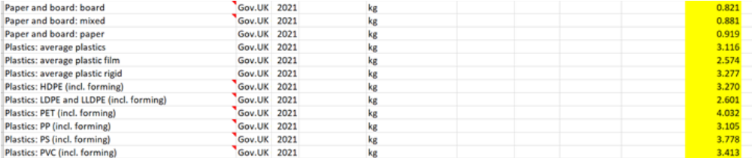

Example: 100 x 10ml PET blood tubes (such as Streck), weight 5kg.
5kg x 4.032 (emission factor for PET) = 20.2 kgCO₂e
Example: 100 slide mailing containers made of polypropene, weight 1.02 kg
1.02kg x 3.105 = 3.2 kgCO₂e

Emission factor source: Greenhouse gas reporting: conversion factors 2021, GOV.UK ⁷

For 8.2., 8.3., and 8.4, please refer to section 1.2. for freight and 4.1.1 for refrigerated or frozen freight.

- Laboratory
This module includes the following activities:
  - Emissions attributed to lab utilities according to staff FTE
  - Materials/equipment/consumables used in processing and analysis of samples
  - Storage of samples e.g., utilities and ultra-low temperature freezer
9.1. Laboratory utilities according to staff FTE
The carbon footprint associated with energy consumption by laboratory staff cannot be calculated directly because a laboratory, and the equipment and staff within in it, are used for many other non-trial activities. Emissions are therefore estimated based on average per person emissions and the FTE of the trial laboratory staff.
This is calculated by multiplying the average space occupied by a laboratory staff member (40 m²) by the kWh used per m² of a laboratory (160 kWh/m²). The kWh per FTE per year is then multiplied by the electricity emission factor provided below to calculate the carbon footprint attributed to 1 FTE for 1 year. Finally, multiply by the number of years and FTE applicable. The calculation is exemplified below. Use the trial SOECAT or the costing included in the initial funding application (if predates use of SOECAT) to establish the FTE or total number of hours required by laboratory staff.
Calculation
40m² x 160kWh = 6400 kWh per FTE per year
- Electricity emission factor = 0.273
6400 kWh x 0.273 = 1747.2 kgCO₂e per FTE per year
Multiply 1747.2 kgCO₂e by the number of years and FTE applicable

Heating
For heating, the calculation follows the same method as above. The 40m² per person is multiplied by the laboratory heating benchmark and then by the natural gas conversion factor provided below.
Laboratory fossil thermal typical benchmark: 160 kWh per year per sqm floor area (kWh/m²)
Natural gas conversion factor: 0.215
40m² x 160kWh = 6400 kWh per FTE per year
6400 kWh x 0.215 = 1376 kgCO₂e per FTE per year
Multiply 1376 kgCO₂e by the number of years and FTE applicable
Assumption: For R&D, 40m² required per FTE according to UK EMPLOYMENT DENSITY GUIDE, 3rd edition November 2015 ⁸
Assumption: If the heating source is unknown, assume that the heating source is natural gas.

Laboratory benchmark data source: Health Technical Memorandum 07-02: EnCO2de 2015 – making energy work in healthcare (england.nhs.uk) ³¹
Emission factor source: Greenhouse gas reporting: conversion factors 2021, GOV.UK ⁷

6400 kWh x 0.215 = 1376 kgCO₂e per FTE per year

9.2. Materials/equipment/consumables used in processing and analysis of samples
To avoid double counting, use of equipment will be included in lab staff FTE if calculated.
However, if the trial does not involve a central lab, but there is still sample processing on site, please see below. For storage of samples, please see section 9.3.
To calculate the emissions of a piece of equipment, multiply the power consumption in Watts by hours used to get a kWh value. Depending on the equipment, this can often be found in the specifications of a listed product. Finally multiply kWh by the electricity emission factor (0.273).
Example: use of a 310-Watt centrifuge for 15 minutes.
310 Watts x 0.25 (hours) = 77.5 kWh
- 77.5 kWh x 0.273 = 21.2 kg CO₂e

Consider the centrifuge capacity and multiply by the number of uses required.

Emission factor source: Greenhouse gas reporting: conversion factors 2021, GOV.UK ⁷

9.3. Storage and destruction of biological samples
For storage of samples in a fridge/-20 freezer or an ultra-low temperature freezer, the kWh usage per day is multiplied by 365 to calculate the kWh per year. This is then multiplied by the electricity emission factor and the number of years the samples are stored. However, you will need to make an assumption about the amount of space in the freezer that the trial samples take up.
Fridge/-20 freezer
- 3kWh/day x 365 days = 1095 kWh per year
- 1095 x 0.273 = 298.9 kgCO₂e per year
- Multiply by number of years stored
- This total is for the whole fridge/-20 freezer for 1 year.

-80 freezer
- 22kWh/day x 365 days = 8030 kWh per year
- 8030 x 0.273 = 2192.2 kgCO₂e per year
- Multiply by number of years stored

This total is for the whole freezer for 1 year. You will need to make an assumption about the amount of space in the freezer that the trial samples take up.
Example: if the samples take up a third of the freezer space - 2192.2 kg CO₂e x 0.333 = 723.4 kg CO₂e
Assumptions: A -80°C freezer uses 22 kWh/day, a -20°C freezer uses 3 kWh/day (Source: Did You Know? - International Laboratory Freezer Challenge) ³²
Emission factor source: Greenhouse gas reporting: conversion factors 2021, GOV.UK ⁷

- Trial close out
This module includes the following activities:
10.1. Storage and archiving of essential trial documentation and data
10.2. Storage and destruction of biological samples
10.3. Return of equipment and supplies from participating sites to CTU

10.1. Storage and archiving of essential trial documentation and data
For the storage of archived documentation, estimate the m² required for archiving. This estimate will then be multiplied by the most suitable energy benchmark from the list provided below; choose the type of building most similar to the one the documents are stored in e.g. office/lab/warehouse/health building. Finally multiply by the electricity emission factor.
Energy benchmarks:
- office = 59 kWh/m²
- laboratory = 160 kWh/m²
- warehouse = 27 kWh/m²
- health building = 81 kWh/m²
Calculation
m² required x benchmark = kWh
- Electricity conversion factor = 0.273
kWh x 0.273 = kg CO₂e for 1 year of storage
Multiply by number of years necessary.
Heating
For heating, use the same method as above. Estimate the m² used and multiply by the corresponding heating benchmark (i.e., if ‘laboratory’ was used above then select the same for this calculation). Multiply by the emission factor for natural gas provided below.
Benchmarks:
- office = 167.27 kWh/m²
- laboratory = 160 kWh/m²
- warehouse = 62 kWh/m²
- health building = 193.28 kWh/m²
Calculation
m² required x benchmark = kWh
- Natural gas conversion factor: 0.215
kWh x 0.215 = kgCO₂e for 1 year of storage
Multiply by number of years necessary.
Assumption: If the heating source is unknown, make assumption the heating source is natural gas.
Benchmark data source: The Non-Domestic National Energy Efficiency Data-Framework 2022 (England and Wales) (publishing.service.gov.uk) ⁹
Emission factor source: Greenhouse gas reporting: conversion factors 2021, GOV.UK ⁷

10.2. Storage and destruction of biological samples
See section 9.3. for storage of refrigerated or frozen samples.
See section 10.1 for storage of ambient samples.

10.1. Storage and archiving of essential trial documentation and data (continued)
For electronic data or documentation storage, estimate 1.365 kgCO₂e per GB per year.
Source: Carbon and the Cloud. Hard facts about data storage. | by Stanford Magazine | Stanford Magazine | Medium¹⁹

10.3. Return of equipment and supplies from participating sites to CTU
See section 1.2. for freight.

References

Sustainable Trials Study Group. Towards sustainable clinical trials. BMJ 2007;334:671
Lyle K, Dent L, Bailey S, et al. Carbon cost of pragmatic randomised controlled trials: retrospective analysis of sample of trials. BMJ 2009;339:b4187
Making clinical trials sustainable [Internet]. The Sustainable Healthcare Coalition. [cited 2023 May 11]. Available from: https://shcoalition.org/clinical-trials/
Climate change and health [Internet]. World Health Organization. 2021 October 30 [cited 2023 May 11]. Available from: https://www.who.int/news-room/fact-sheets/detail/climate-change-and-health
What is an emission factor? [Internet]. Climfoot-project.eu. [cited 2023 May 11]. Available from: https://climfoot-project.eu/en/what-emission-factor ⁶ Ecoinvent, version 2.2. 2011. Available from: https://ecoinvent.org/the-ecoinvent-database/data-releases/ecoinvent-version-2/ ⁷ Greenhouse gas reporting: conversion factors [Internet]. GOV.UK 2021. [cited 2023 May 11]. Available from: https://www.gov.uk/government/publications/greenhouse-gas-reporting-conversion-factors-2021 ⁸ EMPLOYMT DENSITY GUIDE (3rd Edition) [Internet]. Homes & Communities Agency. November 2015 [cited 2023 May 11]. Available from: https://www.kirklees.gov.uk/beta/planning-policy/pdf/examination/national-evidence/NE48_employment_density_guide_3rd_edition.pdf ⁹ The Non-Domestic National Energy Efficiency Data-Framework (England and Wales) [Internet]. Department for Business, Energy & Industrial Strategy. 2022 [cited 2023 May 11]. Available from: https://assets.publishing.service.gov.uk/government/uploads/system/uploads/attachment_data/file/1086903/non_domestic_need_data_framework_2022.pdf ¹⁰ Greenhouse gas reporting: conversion factors 2022 [Internet]. Gov.uk. 2022 [cited 2023 May 11]. Available from: https://www.gov.uk/government/publications/greenhouse-gas-reporting-conversion-factors-2022 ¹¹ Transport Statistics Great Britain: 2021 [Internet]. GOV.UK (www.gov.uk). 2021 December 16 [cited May 11 2023]. Available from: https://www.gov.uk/government/statistics/transport-statistics-great-britain-2021/transport-statistics-great-britain-2021 ¹²Commuting trends in England 1988-2015 [Internet]. GOV.UK. 2017 November 7 [cited 2023 May 11]. Available from: https://www.gov.uk/government/publications/commuting-trends-in-england-1988-to-2015 ¹³ Kayla Wiles. Turn off that camera during virtual meetings, environmental study says [Internet]. Purdue University News. 2021 January 14 [cited 2023 May 11]. Available from: https://www.purdue.edu/newsroom/releases/2021/Q1/turn-off-that-camera-during-virtual-meetings,-environmental-study-says.html ¹⁴ Gov.UK Government conversion factors for company reporting of greenhouse gas emissions 2012 – Annex 13 (with consideration of 2020 inflation rates) ¹⁵ WWF. 2018. Food in a warming world [Internet]. [cited 2023 May 11]. Available from: https://www.wwf.org.uk/sites/default/files/2018-03/Food_in_a_warming_world_report.PDF?source=post_page--------------------------- ¹⁶ Goellner et al. The International Journal of Life Cycle Assessment. Vol 19, pp 611-619 (2014) ¹⁷ Weber et al. Journal of Industrial Ecology, “The Energy and Climate Change Impacts Of Different Music Delivery Methods”. Vol 14, Issue 5, pg. 754-769 (2010) ¹⁸ What’s the carbon footprint of an email? [Internet]. Mail.com blog. 202 April 21 [cited 2023 May 11]. Available from: https://www.mail.com/blog/posts/email-carbon-footprint/9/ ¹⁹Justin Adamson. Carbon and the Cloud. Hard facts about data storage [Internet]. Stanford Magazine. 2017 May 15 [cited 2023 May 11]. Available from: https://medium.com/stanford-magazine/carbon-and-the-cloud-d6f481b79dfe ²⁰ Srilatha Manne. Examining the Carbon Footprint of Devices [Internet]. Microsoft.com. 2020 November 23 [cited 2023 May 11. Available from: https://devblogs.microsoft.com/sustainable-software/examining-the-carbon-footprint-of-devices/ ²¹ Obringer, R., Rachunok, B., Maia-Silva, D., Arbabzadeh, M., Nateghi, R., & Madani, K. (2021). The overlooked environmental footprint of increasing Internet use. Resources, Conservation and Recycling, 167, [105389]. https://doi.org/10.1016/j.resconrec.2020.105389 ²² Apple watch SE. Product Environmental Report – Apple [Internet]. [cited 2023 May 11]. Available from: https://www.apple.com/by/environment/pdf/products/watch/Apple_Watch_SE_PER_sept2020.pdf ²³ Care pathways carbon footprint calculator [Internet]. Sustainable Healthcare Coalition. [cited 2023 May 11]. Available from: https://shcpathways.org/full-calculator/ ²⁴ McAlister S, McGain F, Petersen M, Story D, Charlesworth K, Ison G, Barratt A. The carbon footprint of hospital diagnostic imaging in Australia. Lancet Reg Health West Pac. 2022 May 3;24:100459. doi: 10.1016/j.lanwpc.2022.100459. PMID: 35538935; PMCID: PMC9079346. ²⁵ Radiotherapy for breast cancer [Internet]. Macmillan.org. [cited 2023 May 11]. Available from: https://www.macmillan.org.uk/cancer-information-and-support/treatments-and-drugs/radiotherapy-for-breast-cancer ²⁶ Radiotherapy for advanced prostate cancer [Internet]. Prostate Cancer UK. [cited 2023 May 11]. Available from: https://prostatecanceruk.org/prostate-information-and-support/treatments/radiotherapy-for-advanced-prostate-cancer ²⁷ J. Cummings, C. Taylor, R. Chuter1. PO-1058 Estimating the carbon footprint of the radiotherapy pathway and changes in response to COVID-19. Radiotherapy and oncology. 2022. DOI:10.1016/S0167-8140(22)03022-5 ²⁸ SHC care pathway calculator guidance, GP consultation module, page 18, 2015. Available from: https://shcoalition.org/sustainable-care-pathways-guidance/ ²⁹ McAlister, S., Barratt, A.L., Bell, K.J. and McGain, F. (2020), The carbon footprint of pathology testing. Med. J. Aust., 212: 377-382. https://doi.org/10.5694/mja2.50583 ³⁰ Health Building Note (HBN) 12, page 32. NHS Estates. 2004 [cited 2023 May 11]. Available from: https://www.england.nhs.uk/wp-content/uploads/2021/05/HBN_12.pdf ³¹ Health Technical Memorandum 07-02: EnCO2de 2015 – making energy work in healthcare. Department of Health. 2015 [cited 2023 May 11]. Available from: https://www.england.nhs.uk/wp-content/uploads/2021/05/HTM_07-02_Part_A_FINAL.pdf ³² Freezer challenge blog. Did you know? [Internet]. Freezerchallenge.org. 2020 June 19 [cited 2023 May 11]. Available from: https://www.freezerchallenge.org/fc-blog/did-you-know Acknowledgements This work was produced through funding from the NIHR entitled NIHR Clinical Trials Unit Support Funding Opportunity – Supporting efficient / innovative delivery of NIHR research Authors: Jessica Griffiths, Lisa Fox, Paula Williamson On behalf of the Low Carbon Clinical Trials working group: Fiona Adshead, Rustam Al-Shahi Salman, Craig Anderson, Emma Bedson, Judith Bliss, Ana Boshoff, Xiaoying Chen, Denise Cranley, Peter Doran, Carrol Gamble, Kerenza Hood, Naomi McGregor, Carolyn McNamara, Elis Midha, Keith Moore, Alexis M Perkins, Sarah Pett, Matthew R Sydes. Grateful thanks to Environmental Resources Management for their technical support and expertise in the development of the method.

