Supplementary table 1: The profile of proteins found in the extract of seeds of sacha inchi through PEAKS studio analysis. (UniRef90 taxonomy Viridiplantae)

Protein ID | Accession ID | -10lgP | Coverage (%) | Unique peptide | Avg. Mass | Description
221504 | P83908 | 25.93 | 20 | 1 | 6302 | Cruciferin (Fragments) n=1 Tax=Sinapis alba
221738 | A0A426ZAZ6 | 21.13 | 18 | 1 | 10839 | Uncharacterized protein n=1 Tax=Ensete ventricosum
221808 | A0A6P4AKR9 | 26.07 | 10 | 2 | 11349 | uncharacterized protein LOC107430269 isoform X1 n=3 Tax=Ziziphus jujuba
221493 | A0A5K1FSU4 | 31.29 | 8 | 1 | 12256 | Uncharacterized protein (Fragment) n=1 Tax=Nymphaea colorata
221411 | A0A2C9VQL6 | 46.98 | 15 | 2 | 14103 | Oleosin n=5 Tax=Crotonoideae
221372 | J9S4Z6 | 110.34 | 35 | 6 | 15767 | Oleosin2 n=1 Tax=Plukenetia volubilis
221414 | V4T0S4 | 77.87 | 10 | 1 | 16161 | Uncharacterized protein n=4 Tax=Citrus
221886 | A0A4D6NUV1 | 20.71 | 9 | 1 | 16431 | Uncharacterized protein n=1 Tax=Vigna unguiculata
221503 | A0A087GX22 | 30.65 | 8 | 1 | 16504 | Uncharacterized protein n=1 Tax=Arabis alpina
221965 | A0A1R3INF5 | 28.93 | 10 | 2 | 18501 | Uncharacterized protein n=1 Tax=Corchorus capsularis
221907 | A0A445EXJ8 | 21.96 | 4 | 1 | 19740 | Uncharacterized protein n=2 Tax=Glycine soja
221505 | M4QDQ6 | 26.21 | 6 | 1 | 19940 | NAD(P)H-quinone oxidoreductase subunit 5 chloroplastic (Fragment) n=1 Tax=Dicoma paivae
221506 | A3KDZ1 | 26.21 | 5 | 1 | 22859 | NAD(P)H dehydrogenase subunit 5 (Fragment) n=1 Tax=Ainsliaea heterantha
221569 | B8A178 | 25.19 | 7 | 1 | 23878 | Auxin-responsive protein n=4 Tax=Zea mays
221596 | A0A6P5FYJ5 | 22.02 | 7 | 1 | 24552 | LOB domain-containing protein 12-like n=1 Tax=Ananas comosus
221753 | A0A2Z7A4F3 | 27.22 | 5 | 1 | 24972 | Vesicle transport v-SNARE 13 n=1 Tax=Dorcoceras hygrometricum
222162 | A0A287K1C6 | 21.87 | 7 | 1 | 25844 | Uncharacterized protein n=1 Tax=Hordeum vulgare subsp. vulgare
221473 | Q41164 | 34.45 | 5 | 2 | 26142 | 11S globulin (Fragment) n=2 Tax=Raphanus sativus
221513 | A0A6P4BCN0 | 28.54 | 6 | 1 | 26475 | uncharacterized protein LOC107432249 n=1 Tax=Ziziphus jujuba
221368 | B9SZE5 | 75.7 | 19 | 2 | 27445 | Zeamatin putative n=1 Tax=Ricinus communis
221391 | A0A2C9V239 | 70.79 | 15 | 1 | 27559 | Uncharacterized protein n=2 Tax=Crotonoideae
221392 | A0A6A1VTP5 | 70.79 | 15 | 1 | 27667 | Osmotin-like protein n=3 Tax=Fagales
221579 | B6UAJ1 | 23.63 | 7 | 1 | 27915 | Uncharacterized protein n=3 Tax=Zea mays
221393 | A0A2I4EV90 | 70.79 | 14 | 1 | 28520 | osmotin-like protein n=1 Tax=Juglans regia
221665 | A0A654FBJ0 | 20.97 | 4 | 1 | 29178 | Uncharacterized protein n=1 Tax=Arabidopsis thaliana
222141 | A0A6U0A2W2 | 21.96 | 3 | 1 | 29192 | Uncharacterized protein (Fragment) n=1 Tax=Pycnococcus provasolii
221576 | A0A6V1VI86 | 21.35 | 6 | 1 | 29416 | Uncharacterized protein n=1 Tax=Tetraselmis striata
221577 | A0A6V1VPV7 | 21.35 | 5 | 1 | 29733 | Uncharacterized protein n=2 Tax=Tetraselmis striata
221527 | A0A6U3GDW5 | 24.37 | 5 | 1 | 32129 | Uncharacterized protein (Fragment) n=1 Tax=Mantoniella antarctica
222791 | B9T1S1 | 23.75 | 6 | 1 | 33693 | rRNA N-glycosidase n=2 Tax=Ricinus communis
221394 | A0A438G1Q7 | 70.79 | 12 | 1 | 34282 | Osmotin-like protein n=1 Tax=Vitis vinifera
221418 | A0A5N6QNI5 | 44.46 | 5 | 1 | 35774 | Amidase domain-containing protein n=1 Tax=Carpinus fangiana
233408 | A0A2I4HH27 | 21.18 | 5 | 1 | 35980 | transcription factor PCL1-like n=1 Tax=Juglans regia
201036 | A0A2C9UMP1 | 74.75 | 14 | 3 | 37241 | Glyceraldehyde-3-phosphate dehydrogenase n=61 Tax=Mesangiospermae
221660 | UPI000579DD92 | 21.1 | 4 | 1 | 38855 | mitochondrial chaperone BCS1-like n=1 Tax=Populus euphratica
221822 | A0A2I0AP91 | 24.53 | 5 | 1 | 39117 | Uncharacterized protein n=1 Tax=Apostasia shenzhenica
221565 | UPI000CE1EA3F | 24.06 | 5 | 1 | 40350 | alcohol dehydrogenase-like 1 isoform X1 n=3 Tax=Quercus
222383 | A0A5J5BB82 | 29.45 | 5 | 1 | 40942 | Uncharacterized protein n=1 Tax=Nyssa sinensis
221747 | A0A2Z7B847 | 20.1 | 4 | 1 | 41734 | Protein kinase domain-containing protein n=1 Tax=Dorcoceras hygrometricum
221575 | A0A6A6K8R0 | 30.28 | 5 | 1 | 42635 | Uncharacterized protein n=2 Tax=Hevea brasiliensis
221671 | A0A6U0DKT3 | 21.85 | 4 | 1 | 44303 | Uncharacterized protein n=1 Tax=Micromonas pusilla
221705 | A0A2N9E400 | 20.64 | 3 | 1 | 45042 | Uncharacterized protein n=1 Tax=Fagus sylvatica
201183 | R4I518 | 114.01 | 4 | 3 | 46572 | Legumin B (Fragment) n=1 Tax=Vernicia fordii
222113 | UPI000CE1D8FD | 25.26 | 4 | 1 | 46704 | uncharacterized protein LOC112012193 n=1 Tax=Quercus suber
223360 | A0A2P6SA69 | 21.97 | 3 | 1 | 48264 | Putative lyase n=1 Tax=Rosa chinensis
221512 | A0A6T8S5X6 | 28.65 | 3 | 1 | 48598 | Uncharacterized protein n=1 Tax=Tetraselmis astigmatica
221551 | A0A2R2JFS1 | 24.63 | 3 | 1 | 48665 | SM80.1 Vicilin n=1 Tax=Solanum melongena
221367 | A0A6A6KD91 | 83.09 | 11 | 2 | 49020 | Uncharacterized protein n=3 Tax=Hevea brasiliensis
221756 | A0A6A2XP24 | 21.8 | 2 | 1 | 49896 | RING/U-box superfamily protein isoform 2 n=1 Tax=Hibiscus syriacus
221556 | A0A068UF13 | 22.72 | 3 | 1 | 49962 | PMR5N domain-containing protein n=1 Tax=Coffea canephora
221877 | A0A6J1EDF5 | 22.5 | 3 | 1 | 51171 | coiled-coil domain-containing protein SCD2-like isoform X2 n=2 Tax=Cucurbita
221552 | A0A2C9VU94 | 24.63 | 2 | 1 | 51994 | Uncharacterized protein n=2 Tax=Manihot esculenta
221406 | A0A6A4LW69 | 57.05 | 7 | 1 | 52831 | Uncharacterized protein (Fragment) n=1 Tax=Rhododendron williamsianum
221557 | UPI000F613E4A | 22.72 | 3 | 1 | 53141 | protein ALTERED XYLOGLUCAN 4-like n=1 Tax=Coffea eugenioides
221474 | Q02498 | 34.45 | 3 | 2 | 53256 | Cruciferin PGCRURSE5 n=22 Tax=Brassicaceae
221366 | B9SF35 | 110.86 | 15 | 6 | 53490 | Legumin A putative n=1 Tax=Ricinus communis
221412 | A0A2R6PFB1 | 73.05 | 11 | 2 | 53536 | Vicilin-like seed storage protein n=1 Tax=Actinidia chinensis var. chinensis
221364 | B9SDX6 | 147.67 | 25 | 8 | 53652 | Legumin B putative n=2 Tax=Ricinus communis
221388 | A0A4U5Q0D9 | 58.43 | 7 | 1 | 53754 | Legumin family protein n=4 Tax=Populus
221373 | A0A2C9UPV6 | 78.43 | 10 | 1 | 53821 | Uncharacterized protein n=1 Tax=Manihot esculenta
221537 | V4S993 | 37.11 | 7 | 2 | 53868 | Uncharacterized protein n=5 Tax=Citrus
221682 | A0A6U3I329 | 20.06 | 4 | 1 | 53898 | Uncharacterized protein (Fragment) n=1 Tax=Mantoniella antarctica
221365 | B9SF37 | 108.38 | 23 | 5 | 54064 | Legumin A putative n=3 Tax=Ricinus communis
221820 | A9RSB7 | 27.98 | 3 | 1 | 54420 | Predicted protein (Fragment) n=1 Tax=Physcomitrium patens
221369 | A0A067K2P3 | 80.96 | 13 | 2 | 54585 | Uncharacterized protein n=1 Tax=Jatropha curcas
221371 | A0A2K1R7S3 | 87.16 | 6 | 3 | 54853 | Uncharacterized protein n=3 Tax=Populus trichocarpa
221526 | Q39627 | 28.46 | 3 | 1 | 54947 | Citrin n=1 Tax=Citrus sinensis
221451 | A0A5N5LDY5 | 67.49 | 3 | 1 | 55004 | Uncharacterized protein n=2 Tax=Salix
221525 | V4S3W1 | 28.46 | 3 | 1 | 55031 | Uncharacterized protein n=4 Tax=Citrus
221452 | A0A5J5C8U0 | 67.49 | 3 | 1 | 55319 | Uncharacterized protein n=1 Tax=Nyssa sinensis
221608 | A0A6U2DY66 | 22.13 | 2 | 1 | 55658 | Uncharacterized protein (Fragment) n=1 Tax=Micromonas pusilla
80819 | B9N2L4 | 72.37 | 3 | 2 | 55661 | Uncharacterized protein n=8 Tax=Populus
232698 | A0A6U0I5M6 | 27.45 | 3 | 1 | 55931 | Uncharacterized protein n=1 Tax=Micromonas pusilla
201007 | B9T5E7 | 124.7 | 15 | 6 | 55970 | Glutelin type-A 3 putative n=2 Tax=Ricinus communis
221678 | A0A059AU28 | 20.25 | 3 | 1 | 56304 | Uncharacterized protein n=1 Tax=Eucalyptus grandis
221475 | M5WKU1 | 33.97 | 3 | 1 | 56531 | Uncharacterized protein n=16 Tax=Prunus
221374 | A0A2P5C214 | 60.64 | 4 | 1 | 56731 | Amidase n=2 Tax=Cannabaceae
201190 | A0A5N6QEU2 | 77.25 | 5 | 4 | 56838 | Uncharacterized protein n=1 Tax=Carpinus fangiana
221485 | A0A199VIX0 | 39.08 | 3 | 2 | 57222 | Glutelin type-B 5 n=3 Tax=Ananas comosus
221757 | A0A0D2N4J8 | 21.8 | 2 | 1 | 57254 | RING-type domain-containing protein n=17 Tax=Gossypium
201010 | A0A2C9W805 | 116.38 | 5 | 3 | 57672 | Uncharacterized protein n=1 Tax=Manihot esculenta
221597 | A0A1L6K371 | 34.53 | 3 | 1 | 58056 | 11S globulin n=2 Tax=Juglans
221484 | A0A6T6R2Q6 | 32.5 | 2 | 1 | 59611 | Uncharacterized protein (Fragment) n=1 Tax=Dolichomastix tenuilepis
221389 | A0A6A1UKX5 | 39.72 | 5 | 3 | 60349 | Legumin A n=1 Tax=Morella rubra
221458 | UPI0011D23D90 | 57.27 | 4 | 1 | 60766 | 11S globulin seed storage protein Jug r 4-like n=1 Tax=Syzygium oleosum
221403 | A0A1S3E1N3 | 59.28 | 4 | 1 | 62715 | legumin J n=1 Tax=Cicer arietinum
223361 | A0A2P6SA79 | 21.97 | 2 | 1 | 62852 | Putative lyase n=1 Tax=Rosa chinensis
222172 | A0A6U0FEQ4 | 21.96 | 1 | 1 | 63334 | Uncharacterized protein (Fragment) n=1 Tax=Pycnococcus provasolii
221580 | A0A5J4YAE1 | 23.68 | 1 | 1 | 66651 | 2-isopropylmalate synthase n=1 Tax=Trebouxia sp. A1-2
222114 | A0A250WWU8 | 22.01 | 2 | 1 | 66795 | Uncharacterized protein n=1 Tax=Chlamydomonas eustigma
223362 | A0A2P6SA46 | 21.97 | 2 | 1 | 67108 | Putative lyase n=5 Tax=Rosa chinensis
228050 | A0A2K1IJC6 | 26.32 | 2 | 1 | 67129 | Methyltransferase n=1 Tax=Physcomitrium patens
83227 | A0A218X8G5 | 20.55 | 2 | 1 | 67705 | 11S globulin-like isoform X1 n=1 Tax=Punica granatum
221581 | C5YQI8 | 23.68 | 1 | 1 | 68058 | 2-isopropylmalate synthase n=5 Tax=Andropogoneae
221589 | A0A2R6RFC5 | 22.83 | 3 | 1 | 68664 | Pentatricopeptide repeat-containing protein n=1 Tax=Actinidia chinensis var. chinensis
221821 | A0A2K1KUN6 | 27.98 | 2 | 1 | 69315 | Uncharacterized protein n=1 Tax=Physcomitrium patens
221558 | A0A444GH34 | 34.45 | 3 | 1 | 69741 | Alanine--tRNA ligase (Fragment) n=1 Tax=Ensete ventricosum
221564 | A0A0S1VVN0 | 22.88 | 3 | 1 | 70949 | DEAD box RNA helicase CiRH11 (Fragment) n=1 Tax=Chlamydomonas sp. ICE-L
221573 | A0A6S8GY22 | 24.33 | 2 | 1 | 71058 | Uncharacterized protein n=1 Tax=Dunaliella tertiolecta
221500 | R0HX88 | 27.49 | 2 | 1 | 71095 | PUM-HD domain-containing protein n=1 Tax=Capsella rubella
221535 | A0A6P6TYM1 | 22.72 | 2 | 1 | 71249 | protein ALTERED XYLOGLUCAN 4-like n=2 Tax=Coffea arabica
230318 | F2DIQ5 | 23.62 | 2 | 1 | 71799 | Non-specific serine/threonine protein kinase n=1 Tax=Hordeum vulgare subsp. vulgare
221491 | UPI00053B3CD4 | 27.49 | 2 | 1 | 73214 | pumilio homolog 24 n=3 Tax=Camelina sativa
221680 | A0A6V3EGM8 | 20.01 | 3 | 1 | 74766 | Uncharacterized protein n=1 Tax=Pyramimonas parkeae
221591 | A0A2I0J8H5 | 24.41 | 1 | 1 | 76713 | DYW_deaminase domain-containing protein n=3 Tax=Punica granatum
225529 | UPI0006A6C9ED | 21.01 | 2 | 1 | 81935 | uncharacterized protein LOC106337866 n=1 Tax=Brassica oleracea var. oleracea
221507 | E2I914 | 26.21 | 1 | 1 | 82323 | NAD(P)H dehydrogenase subunit 5 (Fragment) n=1 Tax=Dolichothrix ericoides
221510 | A0A0P1A485 | 26.21 | 1 | 1 | 84037 | NAD(P)H-quinone oxidoreductase subunit 5 chloroplastic n=1 Tax=Sphaeranthus talbotii
221508 | Q71QU2 | 26.21 | 1 | 1 | 84231 | NAD(P)H-quinone oxidoreductase subunit 5 chloroplastic n=1 Tax=Wedelia tegetis
221501 | P51096 | 26.21 | 1 | 1 | 84250 | NAD(P)H-quinone oxidoreductase subunit 5 chloroplastic n=10 Tax=Asteroideae
221509 | Q71QU0 | 26.21 | 1 | 1 | 84258 | NAD(P)H-quinone oxidoreductase subunit 5 chloroplastic n=1 Tax=Zexmenia serrata
225215 | UPI00103FBC84 | 30.06 | 2 | 2 | 84850 | uncharacterized protein LOC114391685 n=1 Tax=Glycine soja
221492 | A0A0K9RD84 | 31.56 | 1 | 1 | 86360 | Uncharacterized protein n=3 Tax=Spinacia oleracea
221610 | A0A388LDJ9 | 20.67 | 2 | 1 | 86636 | Dimer_Tnp_hAT domain-containing protein n=1 Tax=Chara braunii
221578 | A0A118JVT5 | 28.05 | 2 | 1 | 87149 | Mechanosensitive ion channel protein n=2 Tax=Cynara cardunculus var. scolymus
221489 | A9XLF3 | 31.24 | 2 | 1 | 87756 | Uncharacterized protein n=1 Tax=Petunia integrifolia subsp. inflata
116459 | A0A2P6RBG2 | 20.78 | 1 | 1 | 91135 | Putative tetratricopeptide-like helical domain pentacotripeptide-repeat region of PROPR
222186 | A0A1Y5IGR6 | 22.62 | 1 | 1 | 92379 | Sm protein F n=2 Tax=Ostreococcus tauri
221523 | A0A438J4Z4 | 38.23 | 2 | 1 | 93630 | Uncharacterized protein n=1 Tax=Vitis vinifera
225515 | A0A444FHY6 | 20.26 | 2 | 1 | 93988 | Uncharacterized protein n=2 Tax=Ensete ventricosum
221486 | A0A6A4LRN4 | 31.23 | 2 | 1 | 95778 | Uncharacterized protein (Fragment) n=1 Tax=Rhododendron williamsianum
221663 | A0A067FBY2 | 20.97 | 1 | 1 | 98103 | Uncharacterized protein n=6 Tax=Citrus
221929 | A0A4U5P3P4 | 21.72 | 1 | 1 | 99138 | TMV resistance protein N n=1 Tax=Populus alba
221736 | A0A2P6RRA8 | 29.61 | 2 | 1 | 100406 | Putative P-loop containing nucleoside triphosphate hydrolase leucine-rich repeat domain
221743 | A0A287NNX9 | 20.33 | 2 | 1 | 101239 | TOG domain-containing protein n=11 Tax=Triticeae
221941 | A0A388LGZ2 | 21.53 | 1 | 1 | 101580 | RT_RNaseH_2 domain-containing protein n=1 Tax=Chara braunii
83309 | A0A2V0NTL2 | 51.74 | 2 | 4 | 108807 | Heat shock protein 70 kDa n=1 Tax=Raphidocelis subcapitata
221566 | A0A0D2M959 | 24.72 | 2 | 1 | 110145 | Protein PRY1 n=1 Tax=Monoraphidium neglectum
221533 | A0A2U1PSC9 | 25.31 | 1 | 1 | 114036 | Uncharacterized protein n=1 Tax=Artemisia annua
221840 | A0A6U0F6P4 | 23.59 | 1 | 1 | 115165 | Uncharacterized protein (Fragment) n=4 Tax=Ostreococcus mediterraneus
221422 | A0A2C9VD03 | 35.88 | 1 | 1 | 123371 | Uncharacterized protein n=6 Tax=Manihot esculenta
221662 | A0A2Z6MJF1 | 20.87 | 1 | 1 | 123514 | Uncharacterized protein n=1 Tax=Trifolium subterraneum
222258 | A0A2K2BSP4 | 22.62 | 1 | 1 | 124691 | Protein kinase domain-containing protein n=3 Tax=Saliceae
221661 | A0A150GJL7 | 20.11 | 1 | 1 | 135760 | Protein kinase domain-containing protein n=1 Tax=Gonium pectorale
221755 | A0A2I0VNW4 | 27.19 | 1 | 1 | 143813 | Uncharacterized protein n=3 Tax=Dendrobium catenatum
221524 | A0A438E5Y1 | 38.23 | 1 | 1 | 144241 | RING-type domain-containing protein n=10 Tax=Vitis
146186 | A0A388LLK9 | 22.62 | 0 | 1 | 185221 | Uncharacterized protein n=2 Tax=Chara braunii
225669 | A0A6L2KV32 | 20.08 | 1 | 1 | 186019 | Putative ribonuclease H-like domain-containing protein n=1 Tax=Tanacetum cinerariifolium
221603 | A0A2C9V3M8 | 32.11 | 1 | 1 | 187557 | C2 NT-type domain-containing protein n=2 Tax=Manihot esculenta
221562 | A0A388JZZ0 | 30.04 | 1 | 1 | 208268 | Uncharacterized protein n=1 Tax=Chara braunii
221826 | A0A250X496 | 24.41 | 1 | 1 | 214563 | Uncharacterized protein n=1 Tax=Chlamydomonas eustigma
225005 | A0A1Y1HM01 | 20.99 | 1 | 1 | 225069 | USP domain-containing protein n=1 Tax=Klebsormidium nitens
221770 | A0A0D9W543 | 20.78 | 0 | 1 | 274097 | DNA helicase n=1 Tax=Leersia perrieri
222906 | A0A2V0NKY9 | 24.26 | 0 | 1 | 315734 | Uncharacterized protein n=1 Tax=Raphidocelis subcapitata
222125 | V7CWM6 | 23.34 | 1 | 1 | 347955 | Uncharacterized protein n=1 Tax=Phaseolus vulgaris
221606 | A0A2K3DWG3 | 21.51 | 0 | 1 | 713646 | VWFA domain-containing protein n=1 Tax=Chlamydomonas reinhardtii

Supplementary Table 2: The profile of proteins identified in the extract of seeds of sacha inchi through PEAKS studio analysis: (Sacha inchi database).
Protein ID | Accession | -10lgP | Coverage (%) | Unique peptide | Avg. Mass | Description
514291 | A0A291LRE2_9ROSI | 24.94 | 22 | 1 | 7715 | Photosystem II reaction center protein H Tax = Plukenetia volubilis
514267 | A0A291LRL9_9ROSI | 21.93 | 10 | 1 | 8056 | Ribosomal protein S16 Tax = Plukenetia volubilis
514318 | A0A291LRD3_9ROSI | 78.18 | 19 | 2 | 9369 | Cytochrome b559 subunit alpha Tax = Plukenetia volubilis
514268 | A0A8A0XZQ7_9ROSI | 21.93 | 8 | 1 | 10282 | 30S ribosomal protein S16, chloroplastic Tax = Plukenetia volubilis
514241 | A0A291LRH2_9ROSI | 20.11 | 14 | 1 | 10651 | 30S ribosomal protein S15Tax = Plukenetia volubilis
514201 | A0A291LRF6_9ROSI | 33.62 | 56 | 2 | 10858 | 50S ribosomal protein L23, chloroplasticTax = Plukenetia volubilis
514270 | A0A291LRE6_9ROSI | 24.15 | 11 | 1 | 13510 | Ribosomal protein L14Tax = Plukenetia volubilis
514208 | A0A291LRQ5_9ROSI | 33.86 | 18 | 2 | 13580 | Ribosomal protein S12Tax = Plukenetia volubilis
514219 | A0A8A0XYS5_9ROSI | 33.86 | 18 | 2 | 13653 | 30S ribosomal protein S12, chloroplasticTax = Plukenetia volubilis
514269 | J9RZJ1_9ROSI | 31.85 | 11 | 2 | 14862 | Oleosin3Tax = Plukenetia volubilis
514240 | A0A291LRE5_9ROSI | 27.88 | 9 | 1 | 14983 | Ribosomal protein S11Tax = Plukenetia volubilis
514195 | J9S7S3_9ROSI | 37.23 | 20 | 3 | 15279 | Ribosomal protein L16Oleosin1Tax = Plukenetia volubilis
514186 | A0A291LRF3_9ROSI | 45.27 | 41 | 6 | 15549 | Ribosomal protein L16Tax = Plukenetia volubilis
514182 | A0A291LRN1_9ROSI | 31.05 | 20 | 2 | 15604 | Ribosomal protein S8Tax = Plukenetia volubilis
514094 | J9S4Z6_9ROSI | 201.57 | 60 | 19 | 15767 | Oleosin2Tax = Plukenetia volubilis
514169 | A0A1L5YJM2_9PLEO | 20.26 | 9 | 1 | 16393 | Glyceraldehyde 3-phosphate dehydrogenaseTax = Plukenetia volubilis
514200 | A0A8A0Y1Q9_9ROSI | 47.63 | 22 | 3 | 16652 | 50S ribosomal protein L22, chloroplasticTax = Plukenetia volubilis
514168 | A0A291LRF5_9ROSI | 43.65 | 41 | 5 | 17361 | Ribosomal protein S7Tax = Plukenetia volubilis
514221 | A0A1L5YJM9_9PLEO | 33.57 | 42 | 4 | 18061 | Beta-tubulin 1Tax = Plukenetia volubilis
514198 | A0A8A0Y681_9ROSI | 42.56 | 45 | 5 | 19539 | Photosystem I assembly protein Ycf3Tax = Plukenetia volubilis
514282 | A0A3S7PMA5_9ROSI | 26.6 | 9 | 2 | 19930 | Helicase and polymerase containing protein Tax = Plukenetia volubilis
514173 | A0A291LRE9_9ROSI | 47.63 | 18 | 3 | 20338 | 50S ribosomal protein L22, chloroplasticTax = Plukenetia volubilis
514206 | A0A291LRC7_9ROSI | 20.39 | 7 | 1 | 21386 | Photosystem I assembly protein Ycf4Tax = Plukenetia volubilis
514255 | A0A8A0Y6C4_9ROSI | 25.62 | 15 | 2 | 21800 | ATP-dependent Clp protease proteolytic subunitTax = Plukenetia volubilis
514150 | A0A291LRB5_9ROSI | 46.48 | 27 | 5 | 23659 | Ribosomal protein S4Tax = Plukenetia volubilis
514190 | A0A291LRD9_9ROSI | 35.4 | 14 | 2 | 24468 | Cytochrome b6Tax = Plukenetia volubilis
514147 | A0A291LRF2_9ROSI | 64.26 | 33 | 5 | 25143 | 30S ribosomal protein S3, chloroplasticTax = Plukenetia volubilis
514204 | A0A8A0XYQ4_9ROSI | 29.57 | 5 | 1 | 25354 | NAD(P)H-quinone oxidoreductase subunit K, chloroplastic Tax = Plukenetia volubilis
514235 | A0A8A0XWY0_9ROSI | 26.09 | 9 | 1 | 25884 | Cytochrome b6Tax = Plukenetia volubilis
514211 | A0A291LRA2_9ROSI | 33.78 | 15 | 3 | 26832 | Ribosomal protein S2Tax = Plukenetia volubilis
514253 | A0A291LRC4_9ROSI | 21.17 | 6 | 1 | 26859 | Chloroplast envelope membrane proteinTax = Plukenetia volubilis
514210 | A0A182BPB8_9ROSI | 20.29 | 7 | 1 | 28334 | APETALA1Tax = Plukenetia volubilis
514123 | A0A0H3YGY8_9ROSI | 49.53 | 24 | 4 | 30459 | Phospholipase A22Tax = Plukenetia volubilis
514212 | A0A291LRK3_9ROSI | 29.57 | 4 | 1 | 32042 | NADH-quinone oxidoreductase subunit BTax = Plukenetia volubilis
514110 | A0A291LRP8_9ROSI | 71.68 | 36 | 11 | 35308 | Cytochrome fTax = Plukenetia volubilis
514133 | A0A291LRF9_9ROSI | 48.26 | 22 | 6 | 36813 | Cytochrome c biogenesis protein CcsATax = Plukenetia volubilis
514142 | A0A291LRD8_9ROSI | 48.75 | 17 | 6 | 38161 | DNA-directed RNA polymerase subunit alphaTax = Plukenetia volubilis
514199 | A0A291LR92_9ROSI | 36.61 | 17 | 3 | 38935 | Photosystem II protein D1Tax = Plukenetia volubilis
514127 | A0A291LRB7_9ROSI | 62.44 | 12 | 4 | 39549 | Photosystem II D2 proteinTax = Plukenetia volubilis
514151 | A0A8A0Y1R8_9ROSI | 40.15 | 13 | 4 | 40186 | NAD(P)H-quinone oxidoreductase subunit 1, chloroplasticTax = Plukenetia volubilis
514237 | A0A650D5W7_9ROSI | 30.21 | 6 | 2 | 44189 | Fatty acid desaturaseTax = Plukenetia volubilis
514117 | A0A291LRH1_9ROSI | 89.47 | 41 | 12 | 45205 | NADH-quinone oxidoreductase subunit DTax = Plukenetia volubilis
514144 | A0A0H3YHL9_9ROSI | 53.72 | 33 | 10 | 49522 | Elongation factor 1-alphaTax = Plukenetia volubilis
514129 | A0A8A0XWU4_9ROSI | 57.33 | 17 | 7 | 50313 | Photosystem II CP43 reaction center proteinTax = Plukenetia volubilis
514132 | Q3T5B5_9ROSI | 65.94 | 30 | 12 | 51609 | Ribulose bisphosphate carboxylase large chainTax = Plukenetia volubilis
514184 | A0A291LRA3_9ROSI | 26.35 | 6 | 1 | 51839 | ATP synthase CF0 subunit ITax = Plukenetia volubilis
514130 | A0A291LRB4_9ROSI | 57.33 | 17 | 7 | 51878 | Photosystem II CP43 reaction center proteinTax = Plukenetia volubilis
514134 | A0A291LRB8_9ROSI | 65.94 | 29 | 12 | 52670 | Ribulose bisphosphate carboxylase large chainTax = Plukenetia volubilis
514128 | A0A291LRC0_9ROSI | 67.56 | 22 | 9 | 53657 | ATP synthase subunit betaTax = Plukenetia volubilis
514141 | A0A291LRA9_9ROSI | 49.68 | 18 | 8 | 55621 | ATP synthase subunit alphaTax = Plukenetia volubilis
514213 | A0A291LRC1_9ROSI | 39.84 | 16 | 5 | 56036 | Acetyl-coenzyme A carboxylase carboxyl transferase subunit betaTax = Plukenetia volubilis
514181 | A0A291LRM0_9ROSI | 88.56 | 22 | 7 | 56100 | Photosystem II CP47 reaction center proteinTax = Plukenetia volubilis
514149 | A0A291LRE7_9ROSI | 55.51 | 12 | 7 | 58948 | Ribosomal protein L2Tax = Plukenetia volubilis
514115 | A0A291LRG3_9ROSI | 74.85 | 28 | 1 | 59328 | Hypothetical chloroplast RF19Tax = Plukenetia volubilis
514156 | A0A0U5B461_9ROSI | 49.61 | 12 | 5 | 60530 | Maturase KTax = Plukenetia volubilis
514171 | A0A291LR95_9ROSI | 44.96 | 10 | 4 | 60552 | Maturase KTax = Plukenetia volubilis
514172 | A0A3S7PLY7_9ROSI | 44.96 | 10 | 4 | 60561 | Maturase KTax = Plukenetia volubilis
514174 | A0A3S7PLX2_9ROSI | 44.96 | 10 | 4 | 60586 | Maturase KTax = Plukenetia volubilis
514170 | A0A3S7PLX5_9ROSI | 44.96 | 10 | 4 | 60594 | Maturase KTax = Plukenetia volubilis
514111 | A0A8A0Y690_9ROSI | 80.49 | 36 | 17 | 78380 | DNA-directed RNA polymerase subunit betaTax = Plukenetia volubilis
514187 | A0A291LRB1_9ROSI | 40.54 | 4 | 3 | 82436 | Photosystem I P700 chlorophyll a apoprotein A2Tax = Plukenetia volubilis
514205 | A0A291LRB6_9ROSI | 24.25 | 3 | 2 | 83196 | Photosystem I P700 chlorophyll a apoprotein A1Tax = Plukenetia volubilis
514131 | A0A8A0Y0H7_9ROSI | 63.49 | 28 | 12 | 86055 | NAD(P)H-quinone oxidoreductase subunit 5, chloroplasticTax = Plukenetia volubilis
514120 | A0A291LRH6_9ROSI | 68.42 | 18 | 12 | 87996 | NADH-plastoquinone oxidoreductase subunit 2Tax = Plukenetia volubilis
514121 | A0A291LRP4_9ROSI | 65.7 | 13 | 10 | 88811 | NADH-plastoquinone oxidoreductase subunit 2Tax = Plukenetia volubilis
514105 | A0A291LRA6_9ROSI | 96.39 | 29 | 21 | 111331 | DNA-directed RNA polymeraseTax = Plukenetia volubilis
514104 | A0A291LRM9_9ROSI | 103.82 | 30 | 29 | 120694 | DNA-directed RNA polymerase subunit betaTax = Plukenetia volubilis
514096 | A0A8A0Y419_9ROSI | 108.88 | 50 | 54 | 158357 | DNA-directed RNA polymerase subunit betaTax = Plukenetia volubilis
514097 | A0A291LRA8_9ROSI | 108.45 | 49 | 53 | 159682 | DNA-directed RNA polymeraseTax = Plukenetia volubilis
514099 | A0A8A0Y473_9ROSI | 113.14 | 29 | 43 | 225974 | Protein TIC 214Tax = Plukenetia volubilis
514102 | A0A291LRU0_9ROSI | 122.86 | 44 | 84 | 268268 | Protein Ycf2Tax = Plukenetia volubilis

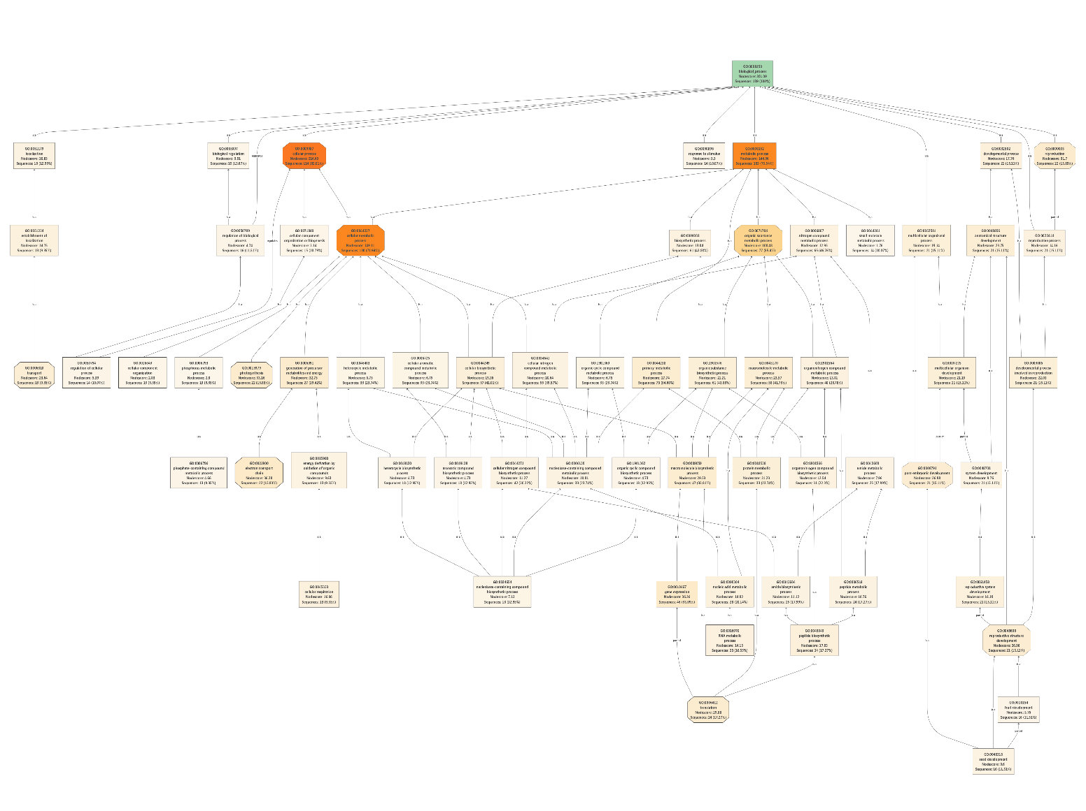
Supplementary Figure 1- GO term chart (Biological process)

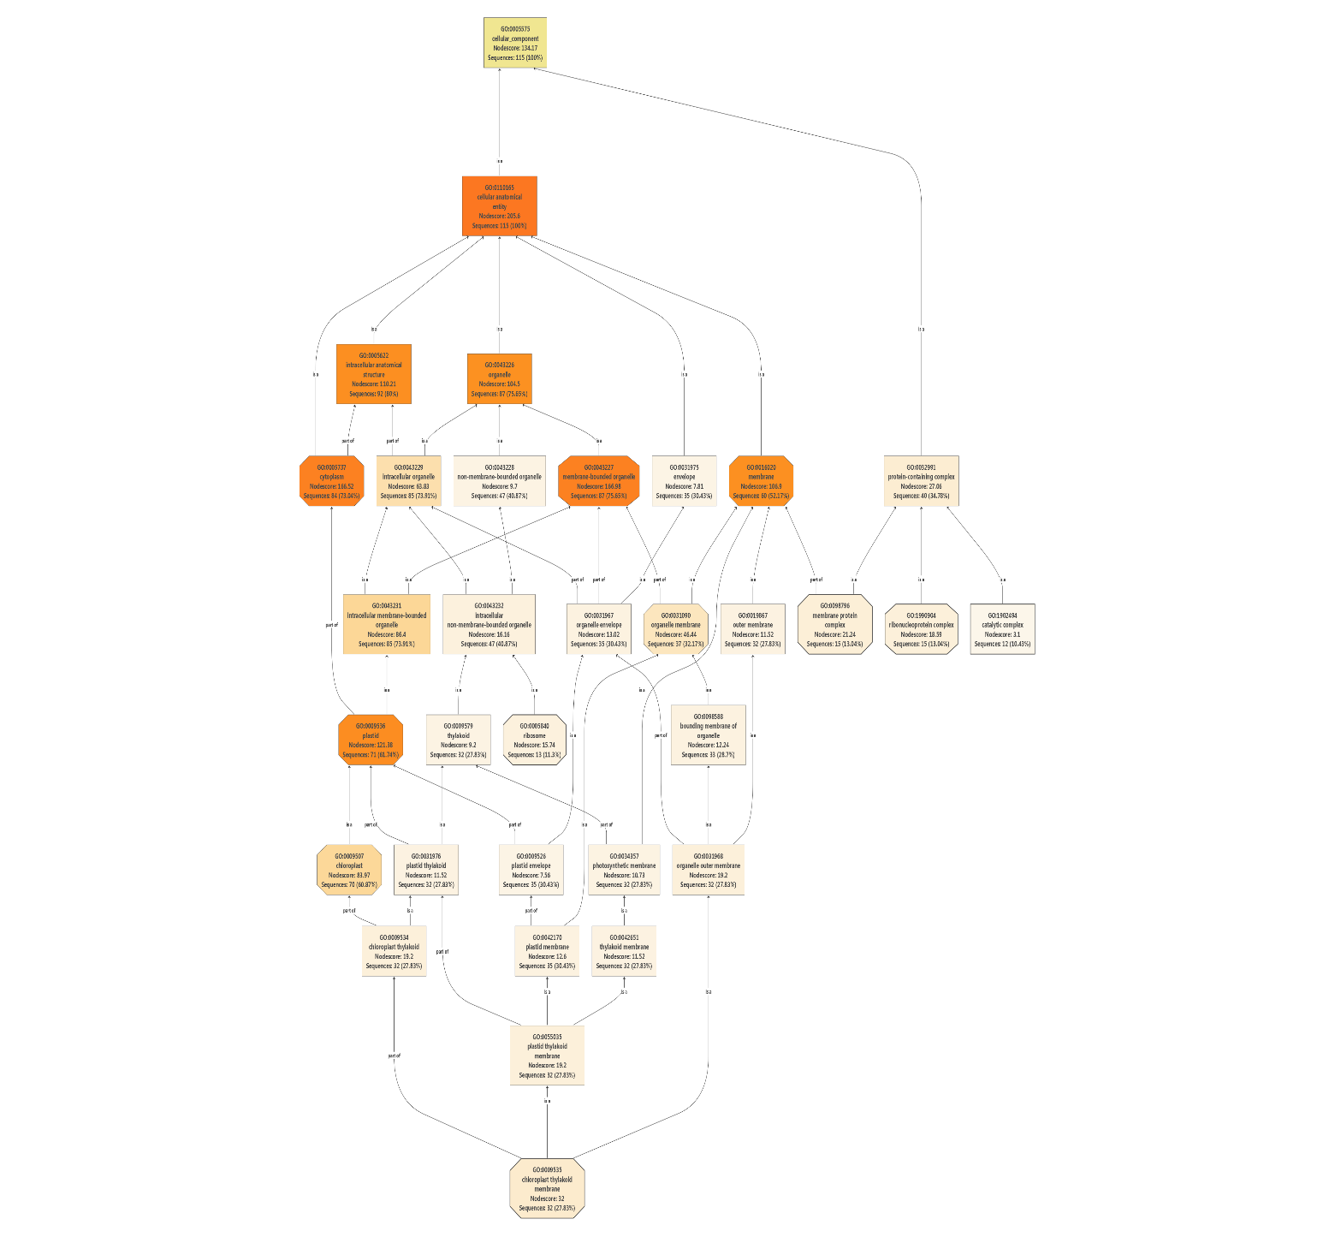
Supplementary Figure 2- GO term chart (cellular component)

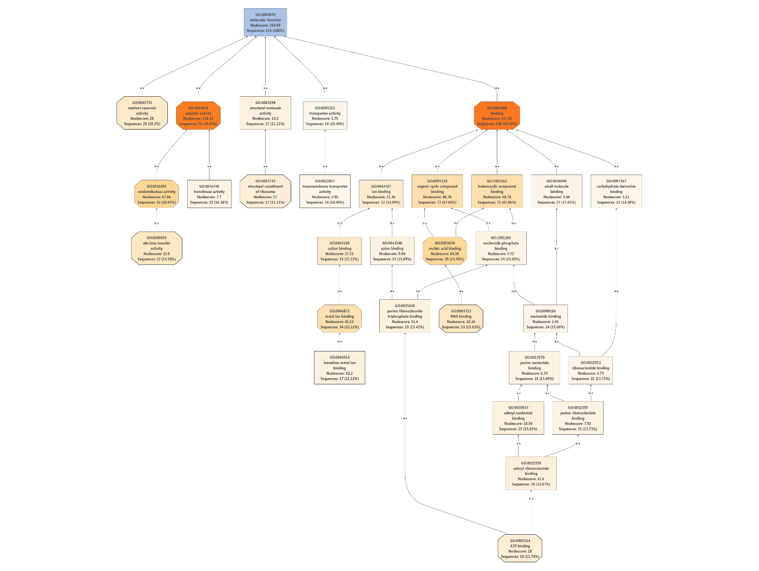
Supplementary Figure 3- GO term chart (molecular function)

