Study on the storage performance of MG30/NRL co-blended latexes

JOURNAL OF POLYMER RESEARCH

Fanfan Chen, Yao Xiao, Sitong Yan, Lin Fang, Zhifen Wang *, Jianhe Liao*

College of Materials Science and Engineering, Hainan University, Haikou, 570228, China;

* Corresponding author: wangzhifen2005@163.com, 990359@hainanu.edu.cn

Table S1 Changes in blended latex’s mechanical stability with storage time
MST/s  sample | storage time/d
MST/s  sample | 0 | 5 | 10 | 15 | 30 | 60
NRL | >1800 | >1800 | >1800 | >1800 | >1800 | >1800
5%MG30 | >1800 | >1800 | >1800 | >1800 | >1800 | >1800
10%MG30 | >1800 | >1800 | >1800 | >1800 | >1800 | >1800
20%MG30 | >1800 | >1800 | >1800 | >1800 | >1800 | >1800
30%MG30 | >1800 | >1800 | >1800 | >1800 | >1800 | >1800
MG30 | >1800 | >1800 | >1800 | >1800 | >1800 | >1800

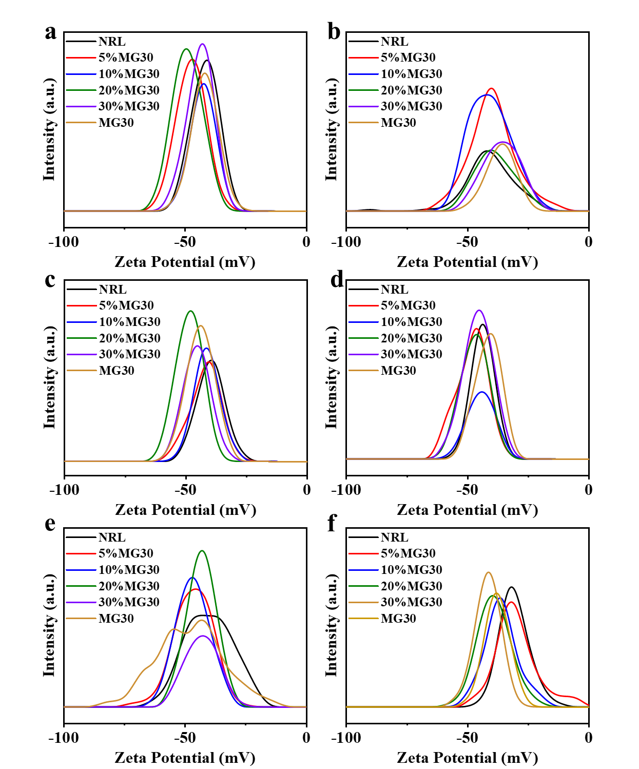
Fig. S1 Zeta Potential of co-blended latexes during storage: a) 0 d; b) 5 d; c) 10 d; d) 15 d; e) 30 d; f) 60 d
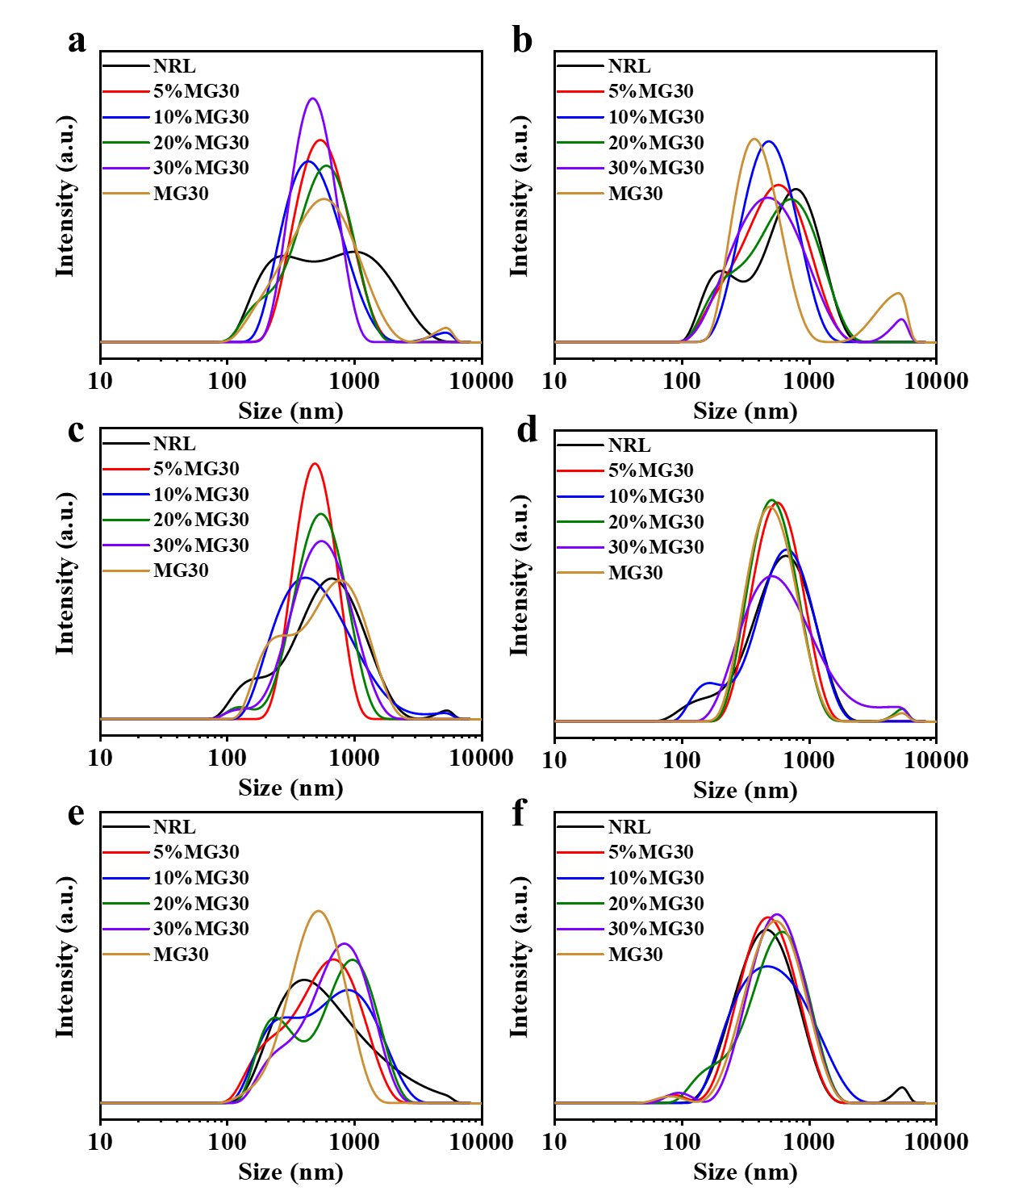
Fig. S2 Particle size distribution of co-blended latexes during storage: a) 0 d; b) 5 d; c) 10 d; d) 15 d; e) 30 d; f) 60 d

Table S2 Latex film vulcanization characteristics parameters
sample | vulcanization characteristics parameters
sample | T10  (min) | T90  (min) | T90-T10 | ML  (dN•m) | MH  (dN•m) | MH-ML
NRL | 1.32 | 6.67 | 5.35 | 1.93 | 2.96 | 1.03
5%MG30 | 1.63 | 6.58 | 4.95 | 2.05 | 3.25 | 1.20
10%MG30 | 2.38 | 7.67 | 5.29 | 2.13 | 3.50 | 1.37
20%MG30 | 2.7 | 8.3 | 5.6 | 2.27 | 3.73 | 1.46
30%MG30 | 2.97 | 8.92 | 5.95 | 2.65 | 4.19 | 1.54
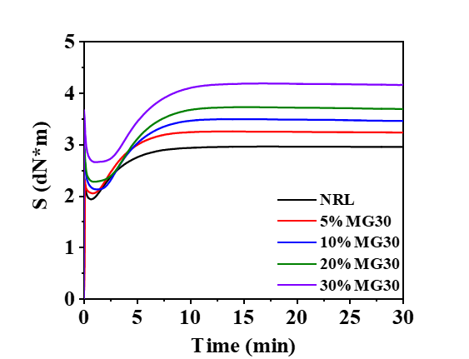
Fig. S3 Latex film vulcanization characteristics curve

