Supplementary Materials for

Regulation of salt-stress mediated apoptosis in rice (Oryza sativa L.) with inoculation of ACC deaminase producing endophytic bacteria

Aritra Roy Choudhury, Pankaj Trivedi, Munusamy Madhaiyan, Jeongyun Choi, Wonho Choi, Jung-Ho Park, Tongmin Sa*

*Corresponding author. Email: tomsa@chungbuk.ac.kr

This PDF file includes:

Supplementary Text
Figs. S1
Tables S1 to S3
References (1 to 9)

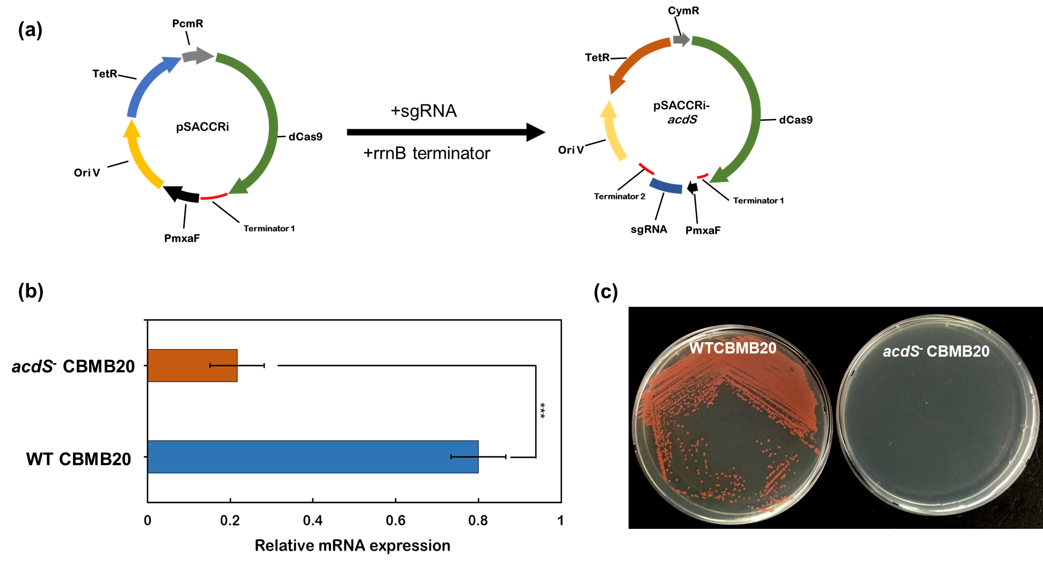

Fig S1: (a) Vector maps of pSACCRi and pSACCRi-acdS, (b) Gene expression profile of acdS gene in wild type M. oryzae CBMB20 and acdS⁻ M. oryzae CBMB20, (c) wild type M. oryzae CBMB20 and acdS⁻ M. oryzae CBMB20 grown in minimal media with ACC as the sole nitrogen source. *** is significant P < 0.001

Table S1. ACC deaminase activities, IAA and cytokinin productions of wild type M. oryzae CBMB20 and acdS⁻ M. oryzae CBMB20. Data presented in mean ± SE of three replicates and different letters indicate significant differences P < 0.05 within the treatments.
Strain | ACC deaminase activity (nmol α-ketobutyrate mg⁻¹ protein h⁻¹) | IAA production  (μg mL⁻¹ of culture) |  | Cytokinin recovered  (ng L⁻¹ of culture)
Strain |  | Trp⁺ | Trp⁻ | iPA | t-ZR | Total
WT CBMB20 | 97.06 ± 8.87 | 2.74 ± 0.37ª | 1.48 ± 0.19ª | 44.83 ± 1.19ª | 36.71 ± 2.43ª | 81.54 ± 1.37ª
acdS⁻ CBMB20 | N.D.* | 2.69 ± 0.44ª | 1.63 ± 0.26ª | 45.73 ± 2.65ª | 35.04 ± 1.88ª | 80.77 ± 1.74ª
*N.D. = Non detectable, Data presented in mean ± SE of three replicates and different letters indicate significant differences P < 0.05 within the treatments.

Table S2. List of primers used in this study
Primers | Sequence (5’-3’) | Remarks | Reference
CRISPRi plasmid
dCtVF | ATTACGCCAAGCTAGCTTCCC | Linearization of pCM80 vector | This study
dCtVR | AACCTGTCGTGCCAGCTG | Linearization of pCM80 vector | This study
dCtIF | CTGGCACGACAGGTTATGGATAAGAAATACTCAATAGGCT | Amplification of dCas9 and rrnB terminator from pSECRi | This study
dCtIR | CTAGCTTGGCGTAATTATAAACGCAGAAAGGCCCACC | Amplification of dCas9 and rrnB terminator from pSECRi | This study
CymVF | TGAGTGAGCTGATACCGC | Linearization of pCM80-dCas9 | This study
CymVR | TAATACGGTTATCCACAGAATCAGG | Linearization of pCM80-dCas9 | This study
CymIF | TGGATAACCGTATTATGCAGCTGGCACGACAGG | Amplification of Pcym from pLC290 | This study
CymIR | GTATCAGCTCACTCAACGCGTAGATCTTCTAGAGGTACC | Amplification of Pcym from pLC290 | This study
sgRNA sequence amplification
sgRNAF | ATACCTGCAGGGCCTCGCCTCGATGCATCCGCAAATAAAACGAAAGGCTCA | Amplification of sgRNA and rrnB terminator sequences | This study
sgRNAR | GAGAGCGTTCACCGACAAACGCCTACGTAGCTCCGCTCCGCCTCTGCGAGGGCT | Amplification of sgRNA and rrnB terminator sequences | This study
(qRT)-PCR
SOSF | TCTAGTCGTTGCCAGGCTTT | SOS1 gene amplification | (1)
SOSR | TCATTGATCATGCTCCCGTA | SOS1 gene amplification | (1)
NHXF | GCTAGATTTGAGCGGCATTC | NHX1 gene amplification | (1)
NHXR | TCAATATCCAATGCATCCATC | NHX1 gene amplification | (1)
MAPKF | AAGTACAAGCCCCCCATCCTC | MAPK6 gene amplification | (2)
MAPKR | AACGTCATTGAATGAATTCC | MAPK6 gene amplification | (2)
ERFF | CTCGTGCGGGTGGCTGCCCGAC | ERF1 gene amplification | (3)
ERFR | GCCACACGCGCGCGCCGTTCTTG | ERF1 gene amplification | (3)
SAPF | TTTCACGGTTCTTATTCTTACTGGA | SAP gene amplification | (4); This study
SAPR | ATAGGTGACAAAGTTAGCCAGATCA | SAP gene amplification | (4); This study
CTRF | ATAGATCTATGAAGGCCGACGCCAAG | CTR2 gene amplificaiton | (5)
CTRR | ATAGATCTTCAAGGGCTCGTATCTTC | CTR2 gene amplificaiton | (5)
ACTF | AGCTATCGTCCACAGGAA | Actin internal control for (qRT)-PCR | (6)
ACTR | ACCGGAGCTAATCAGAGT | Actin internal control for (qRT)-PCR | (6)
ACCDF | GGTGCTCAACGAGGACTACG | M. oryzae CBMB20 acdS gene amplification | This study
ACCDR | CGTGTAGCTGTAGCCGTTCA | M. oryzae CBMB20 acdS gene amplification | This study

Table S3. List of plasmids used in this study
Name | Description | Reference
pSECRi (E1) | rhaP_{BAD}-cas9(D10A, H840A) and constitutive sgRNA (E1) expression cassette | (7)
pLC290 | Cumate inducible expression vector for M. extorquens; Kan^{R}, oriT, pBR322ori, ttrnB | Addgene #44447; (8)
pCM80 | M. extorquens expression vector, mxaF promoter; Tc^{R} | (9)
pCMCas | dCas9; mxaF promoter; Tc^{R} | This study
pSACCRi | CymR promoter; dCas9; mxaF promoter; Tc^{R} | This study
pSACCRi-acdS | pSACCRi expressing sgRNA targeting acdS gene of M. oryzae CBMB20 | This study

References:

- R. Jaemsaeng, C. Jantasuriyarat, A. Thanchaipenet, Molcular interaction of 1-aminocyclopropane-1-carboxylate deaminase (ACCD)-producing endophytic Streptomyces sp. GMKU 336 towards salt-stress resistance of Oryza sative L. cv. KDML105. Sci Rep 8, 1-15 (2018).
- Y. Zhang, Y. Xiong, R. Liu, H.W. Xue, Z. Yang, The Rho-family GTPase OsRac1 controls rice grain size and yield by regulating cell division. Proc Nat Acad Sci 116, 16121-16126 (2019).
- J. Ji, D. Yuan, C. Jin, G. Wang, X. Li, C. Guan, Enhancement of growth and salt tolerance of rice seedlings (Oryza sative L.) by regulating ethylene production with a novel halotolerant PGPR strain Glutamicibacteri sp. YD01 containing ACC deaminase activity. Acta Physiol. Plant. 42, 1-17 (2020).
- M. Ubaidillah, F. A. Safitri, J. Jo, S. Lee, A. Hussain, B. Mun, I. K. Chung, B. Yun, K. Kim, Role of plant hormones and anti-apoptosis genes during drought stress in rice (Oryza sativa L.). 3 biotech. 6, 1-14 (2016).
- Q. Wang, W. Zhang, Z. Yin, Chi. Wen, Rice CONSTITUTIVE TRIPLE-RESPONSE2 is involved in the ethylene-receptor signalling and regulation of various aspects of rice growth and development. J. Exp. Bot. 64, 4863-4875 (2013).
- S. Saeng-ngam, W. Takpirom, T. Buaboocha, S. Chadchawan, The role of the OsCam1-1 salt stress sensor in ABA accumulation and salt tolerance in rice. J. Plant Biol. 55, 198-208 (2012).
- S. K. Kim, G. H, Han, W. Seong, H. Kim, S. W. Kim, D. H. Lee, S. G. Lee, CRISPR interference-guided balancing of a biosynthetic mevalonate pathway increases terpenoid production. Metab. Eng. 38, 228-240 (2016).
- L. M. Chubiz, J. Purswani, S. M. Carrooll, C. J. Marx, A novel pair of inducible expression vectors for use in Methylobacterium extorquens. BMC Res Notes. 6, 183 (2013). [online-only paper; use article number instead of page]
- C. J. Marx, M. E. Lidstrom, Development of improved versatile broad-host-range vectors for use in methylotrophs and other Gram-negative bacteria. Microbiology 147, 2065-2075 (2001).

