Table S1. Characteristics of nine microsatellite loci selected for the study
Locus | Primer sequences (5’ to 3’) | Repeat motif | Ta  (℃) | GenBank Accession No.
AK87 | F: GCAGCCTTATCTTCATTTTGTC  R: CACTTGAGCCACACTTGAACTA | (TG)_{N} | 58 | KP289899
AK171 | F: GGCATTTGAACACTTACACTGA  R: AGATTTTTGTTGGAATCTGCAC | (TG)_{N} | 58 | KP869867
AK173 | F: GAGACTAGCATATACACCATCGG  R: AAGGGAATACACTCAGTCGAGA | (CA)_{N} | 58 | KP289900
AK176 | F: TTACACCGTTAAAAAGGGAATG  R: CTCATGATGTGTAGCCATTTGT | (TG)_{N} | 58 | KP869869
AK240 | F: AGAGAAGGGTCGAGGAATTATC  R: GAAAGTAGCAAGTGTAACTTATGC | (CA)_{N} | 58 | KP869872
AK246 | F: TAGATTGGCATATTGGACATCA  R: ATAGGTTGTTGAGCTGGATGTT | (TG)_{N} | 58 | KP869873
AK247 | F: GGATGGTGCTTTGTTGATATTT  R: AAATGGTTTGAGCAACATTCTT | (TG)_{N} | 58 | KP869874
AK252 | F: TGCATGTTGTTAGTTGGTAAGG  R: TCTAGGTGGAGCAACAAGAGAT | (TG)_{N} | 58 | KP869875
As13 | F: ATGCAAGCAACCATCGATATG  R: GTTTCTTCCATAGAACACCTC | (TG)_{N} | 55 | AB290134
As20 | F: TCTTGCAACGAGGGGATCCATAACCTG  R: CTAAGCATTGAGCCACATAATTC | (TG)_{N} | 55 | AB290136

Table S2. Formulae for the analysis of cone and seed characteristics
Indicator | Computation
SP | $$2 × Fertile scales$$
P-DS | $$\frac{Total developed seeds}{Seed potential} ×100$$
P-DM | $$\frac{Damaged seeds}{Total developed seeds}×100$$
Purity | $$\frac{Weight of pure seeds (g)}{Weight of total developed seeds (g)} ×100$$
GP | $$\frac{Germinated seeds}{Tested seeds} ×100$$
MGT | $$\frac{\sum{}nD}{\sum{}n}$$
GE | $$\frac{Germinated seeds until Day 6}{Tested seeds}×100$$
Viability | $$\frac{Viable Seeds}{Tested Seeds} × 100$$
SP; seed potential, P-DS; percent developed seeds, P-DM; percent damaged seeds, GP; Germination percentage, MGT; mean germination time, D; days from the beginning of the germination test, n; number of seeds newly germinated at time D, GE; germination energy

Table S3. Age estimation from the cores extracted from two trees in different diameter class of the population of A. nephrolepisis at Mt. Hambaeksan, South Korea
Tree No. |  | DBH in 2021 (cm) | Core No. | Height of core extraction (cm) | Calendar year of the first tree ring | Calendar year of the last tree ring | Estimated age
M29 | 15.2 |  | A | 36 | 1971 | 2021 | 51
 |  |  | B | 52 | 1974 | 2021 | 48
M30 | 21.6 |  | A | 71 | 1985 | 2021 | 38
 |  |  | B | 47 | 1976 | 2021 | 46
Core of M29 were extracted near the pith, and cores of M30 were relatively farther from the pith. DBH; diameter at breast height
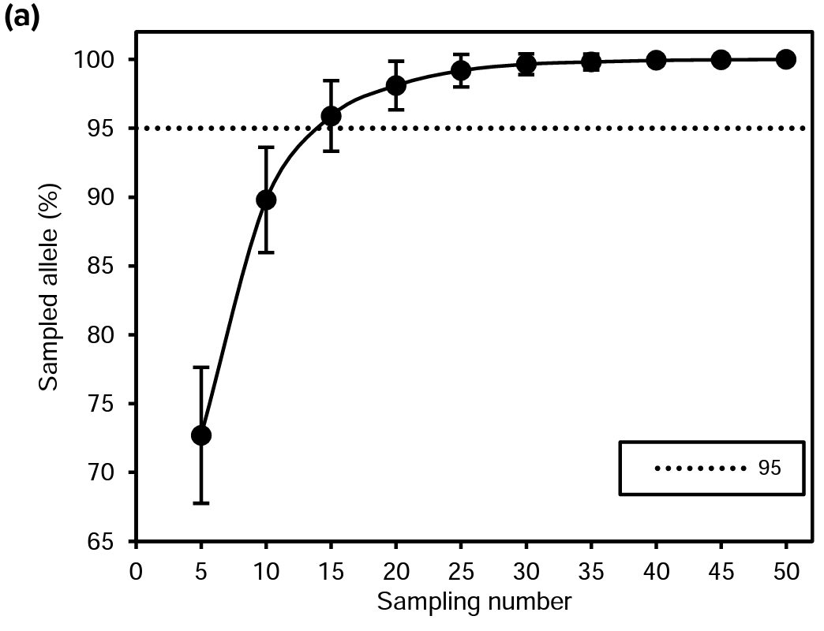
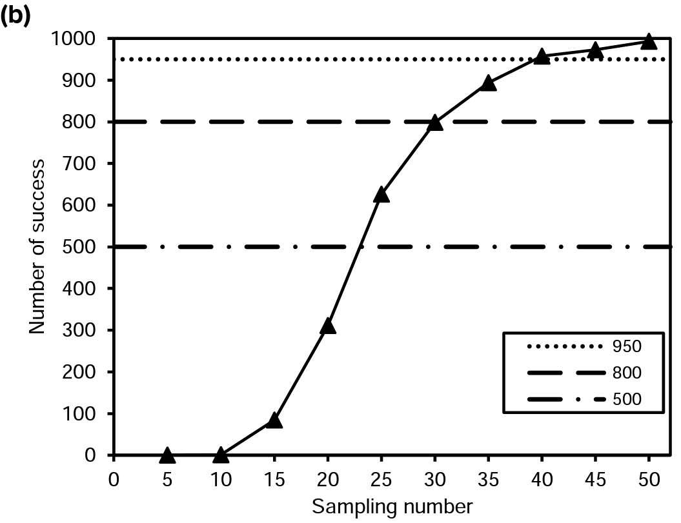
Figure S1. Results of the sampling simulation in the population of A. nephrolepis at Mt. Hambaeksan, South Korea. (a) ‘Sampled allele (%)’ indicates the percentage of sampled common alleles averaged over loci in 1,000 samplings, error bars indicate standard deviations, and (b) ‘Number of success’ represents the number of samplings that included over 95% of the common alleles at every locus.
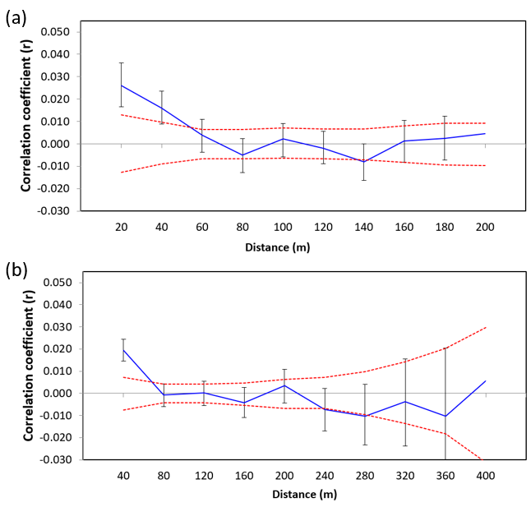
Figure S2. Correlograms of the population of A. nephrolepis at Mt. Hambaeksan, South Korea in 20 m and 40 m distance intervals. The blue line represents values of correlation coefficient (r) with black error bars of 95% confidence interval. The red dotted line indicates the upper and lower limits of the null hypothesis with a 95% confidence interval.

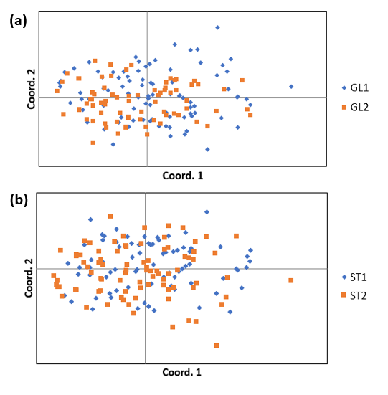
Figure S3. Results of principal coordinate analysis (PCoA) with the results of two Bayesian clustering models in the population of A. nephrolepis at Mt. Hambaeksan, South Korea. (a) a result of PCoA with two clusters estimated from GENELAND, and (b) a result of PCoA with two clusters estimated from STRUCTURE by Evanno’s ΔK method.

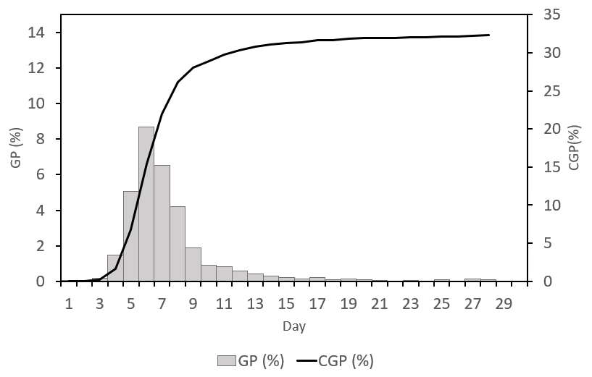
Figure S4. Germination curve of A. nephrolepis seeds from the population at Mt. Hambaeksan, South Korea. GP stands for germination percentage on each day, and GCP stands for cumulative germination percentage

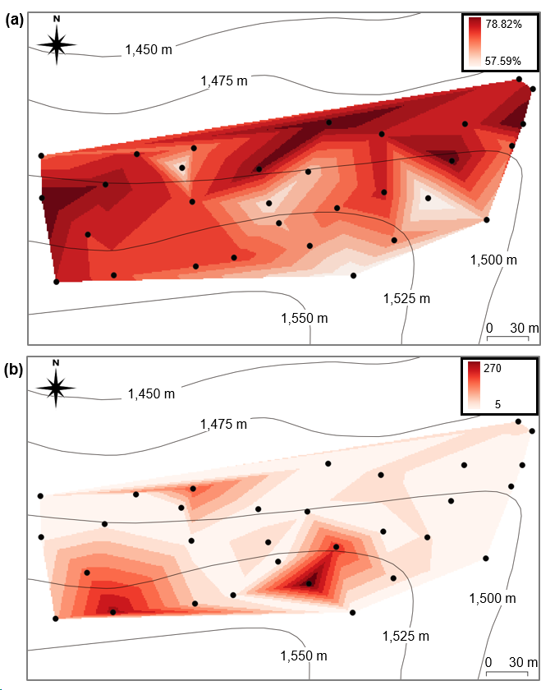
Figure S5. Interpolation of purity and cone abundance over the study plot at Mt. Hambaeksan, South Korea. Map was obtained by triangulated irregular network (TIN) interpolation in QGIS 3.28. (a) map of purity, and (b) map of cone abundance.
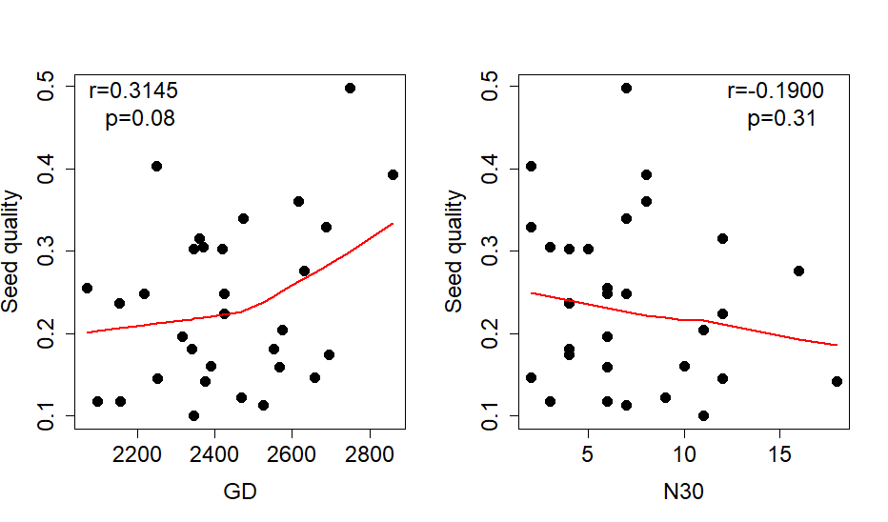
Figure S6. Scatterplots on seed quality and genetic relatedness of the mother trees in the population of A. nephrolepis at Mt. Hambaeksan, South Korea. GD represents the sum of genetic distance to potential pollen donors. N30 represents the square-rooted number of trees within a 30 m radius.

