Supporting Information
Preparation and characterization of novel zwitterionic lignin/Nafion composite membranes

Ji Won Heoª, Liangliang An^{b}, Min Soo Kimª, Duck Hyun Youn^{c,*}, and Yong Sik Kim^{a,*}

ª Department of Paper Science & Engineering, College of Forest and Environmental Sciences, Kangwon National University, Chuncheon 24341, Republic of Korea
^{b} Faculty of Chemical and Engineering, Kunming University of Science and Technology, Kunming, Yunnan, 650500, China
^{c} Department of Chemical Engineering, Department of Integrative Engineering for Hydrogen Safety, Kangwon National University, Chuncheon, 24341, Republic of Korea

∗ Co-corresponding author at the Department of Chemical Engineering, Department of Integrative Engineering for Hydrogen Safety, Kangwon National University
E-mail address: youndh@kangwon.ac.kr (D.H. Youn).
* Corresponding author at the Department of Paper Science & Engineering, College of Forest and Environmental Sciences, Kangwon National University
E-mail address: yongsikk@kangwon.ac.kr (Y.S. Kim).
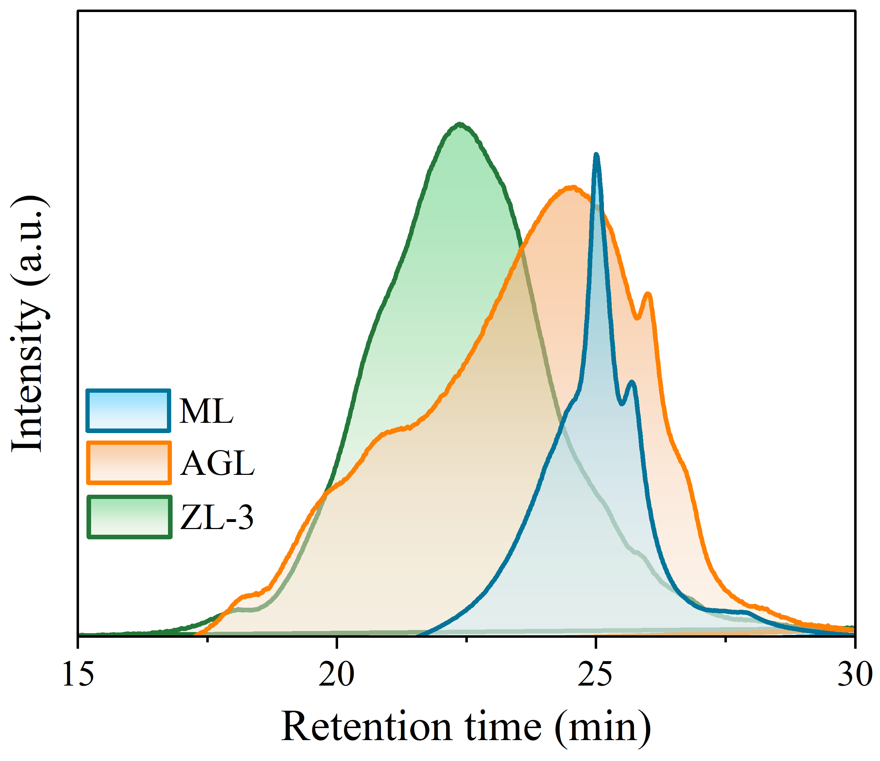
Fig. S1. Molecular weight distribution curves of ML, AGL and ZL-3.
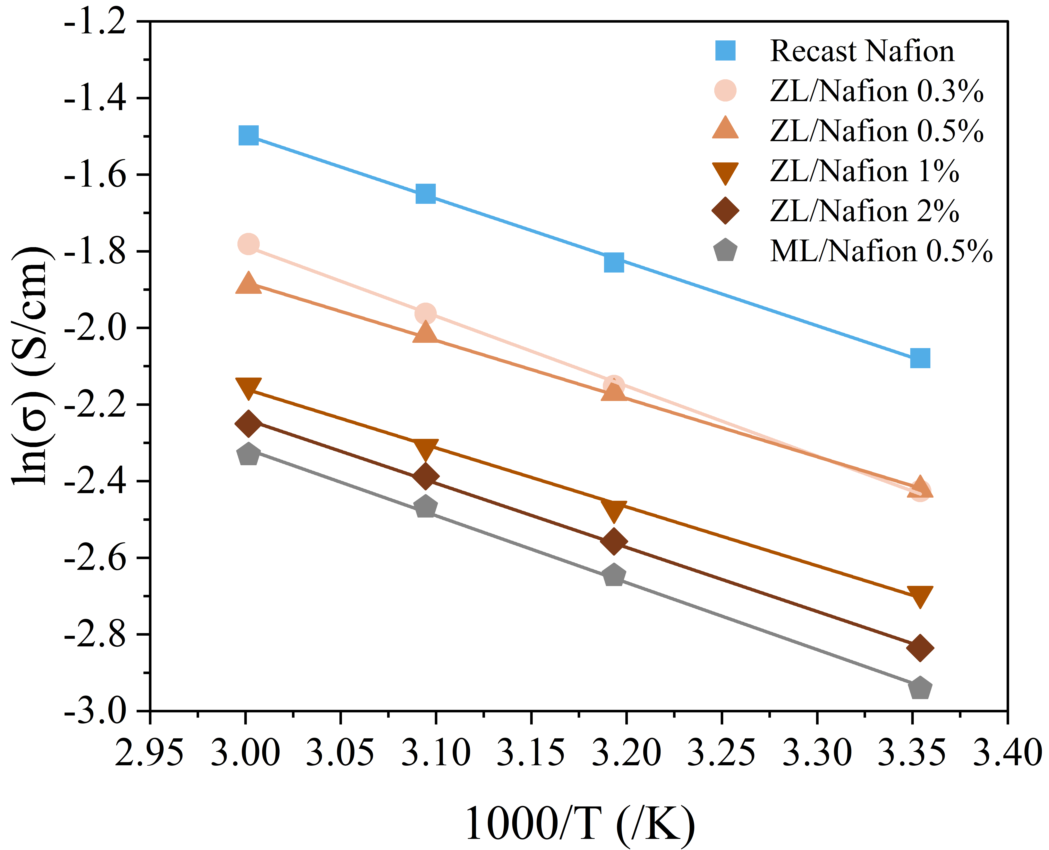
Fig. S2. Arrhenius plot for the proton conductivity of the membranes.
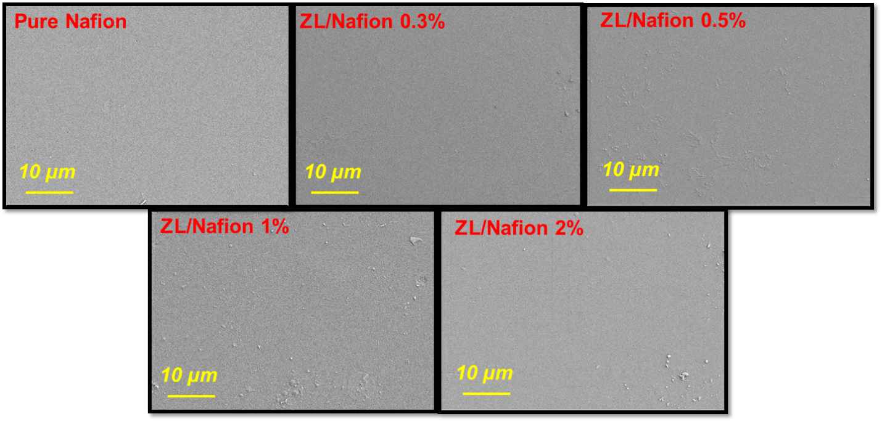 Fig. S3. SEM images of pure Nafion and ZL/Nafion.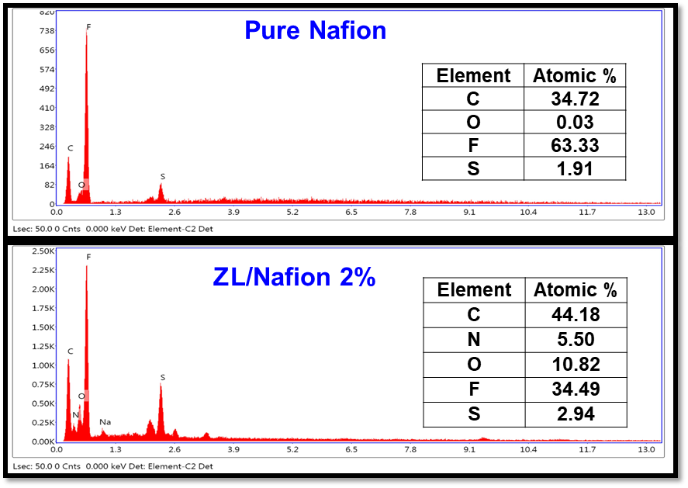
Fig. S4. EDS spectrum of pure Nafion and ZL/Nafion.

