Supplementary Figures

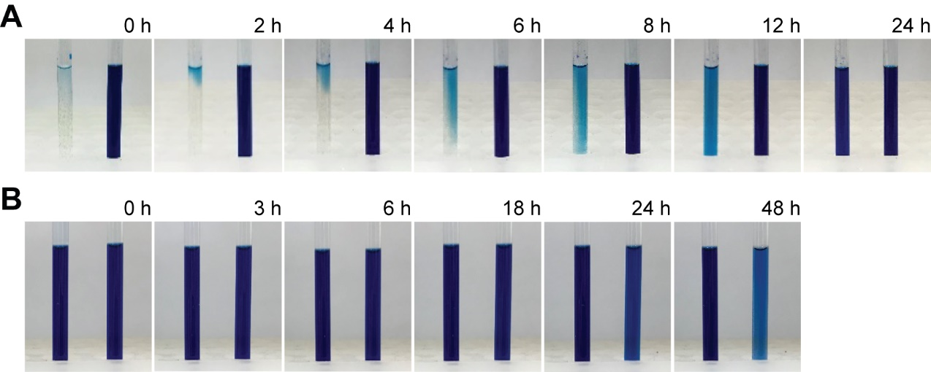

Fig. S1. Monitoring of the color changes of LMTM induced by the air oxidation and NAC. (A) 25 mM LMTM stock solution was preincubated with 25 mM DTT (colorless), and then was diluted to buffer (pH 6.5, 50 mM MES, 50 mM NaCl, 0.5 mM LMTM, and 0.5 mM DTT). The color change was monitored as increasing time at room temperature. The NMR tube was stayed in the rack without agitation. (B) The photos of the NMR tube containing 0.5 mM MT⁺ and 5 mM NAC were taken as increasing incubation time at room temperature. The blue color indicated that majority of MT⁺ remained as an oxidized form until overnight.

Fig. S2. The CSPs of ^{15N}2N4R induced by MB in the presence and absence of TCEP. 0.1 mM ^{15N}2N4R proteins were prepared in buffer (pH 6.5, 50 mM MES and 50 mM NaCl), and the ¹H-¹⁵N HSQC spectra were recorded at 10 °C. (A) The ¹H-¹⁵N HSQC spectrum of ^{15N}2N4R after incubating with 1 mM MB in the absence of TCEP (MT⁺, blue color) for 1 h, is overlaid to that of free ^{15N}2N4R. (B) The blue spectrum in the panel-A is overlaid to that recorded in the presence of 5 mM H₂O₂. (C) The HSQC spectrum was not changed by 1.0 mM MB in the presence of 10 mM TCEP (LMT, colorless). (D) The CSPs of ^{15N}2N4R that were induced by MT⁺ (blue) and by 5 mM H₂O₂ (red), respectively, are represented by the intensity ratios as compared to the native one (I/I₀). On the other hand, the CSP of ^{15N}2N4R was not induced by LMT.

Fig. S3. Kinetic models for the disulfide bond formation of NAC induced by MT⁺, DMSO, H₂O₂, and O₂ alone. (A) The CS changes of NAC as increasing the concentration of MT⁺ and DMSO, respectively. (B) In overall, NAC molecule is oxidized to the end-product (disulfide bonded NAC dimer, NAC_{SS}), in which the rate determining step was assumed to be the formation of NAC-sulfenic acid (NAC^{SOH}), and the next reaction of NAC^{SOH} to form NAC_{SS} with another NAC was assumed to be fast. Equations 1-4. Detailed rate constant was derived for each oxidation condition. The measured oxidation rates of NAC in various conditions were normalized by dividing with the initial concentrations of the reactants; the unit of rate constants (k_{H2O2}, k_{MT+}[O₂], and k_{DMSO}[O₂]) is M⁻¹·sec⁻¹, but that of k_{O2}[O₂] is sec⁻¹.

Fig. S4. The chemical structures of N-acetyl cysteine (NAC) in various oxidation states. The chemical structures of NAC and its covalent Lys complexes mediated by oxidation are shown. The ¹³C-chemical shift values of NAC-C_{β} were predicted by using the web-program (https://www.nmrdb.org/).

Fig. S5. The SEC-MALS analyses of 2N4R and 2N4R-S56C, K18 and dGAE. (A) 2N4R proteins (2 mg/ml) and other tau fragment proteins (5 mg/ml) were incubated in buffer (pH 6.5, 50 mM Na-phosphate, 50 mM NaCl) in the presence of 5 mM DTT (blue) or 5 mM H₂O₂ (red) for 30 min at room temperature, and then the SEC was performed in buffer (pH 6.5, 50 mM Na-phosphate, 100 mM NaCl). The absolute MWs were measured by the online MALS analyses and the estimated values are indicated. (B) The molecular weights of Pep^{AA} and Pep^{KK} were analyzed by ESI MS spectrometry. The Mass peaks of fragments are indicated with stars. The estimated mass of the oxidized peptide showed that one disulfide bond was formed, as it is two less than twice the mass of the monomer.

Fig. S6. Disulfide-bond formation specifically altered the aggregations of 2N4R, K18 and dGAE. The 2N4R^{intraD} (A), K18^{intraDS} (B) and dGAE^{interDS} (C) proteins were prepared by SEC after the treatment of 5 mM H₂O₂. ThT assays were performed in buffer (pH 7.0, 50 mM Na-phosphate, 50 mM NaCl) by shaking with a glass bead. The aggregations of 50 μM 2N4R^{intraDS} and K18^{intraDS} were induced with 20 μM heparin, but 100 μM dGAE^{interDS} spontaneously aggregated. The native proteins of the same concentrations were used as the references of fibrillation. The ThT assay products of (D) K18 and K18^{intraDS}, and (E) dGAE and dGAE^{interDS} were analyzed by TEM.

