Supplementary material
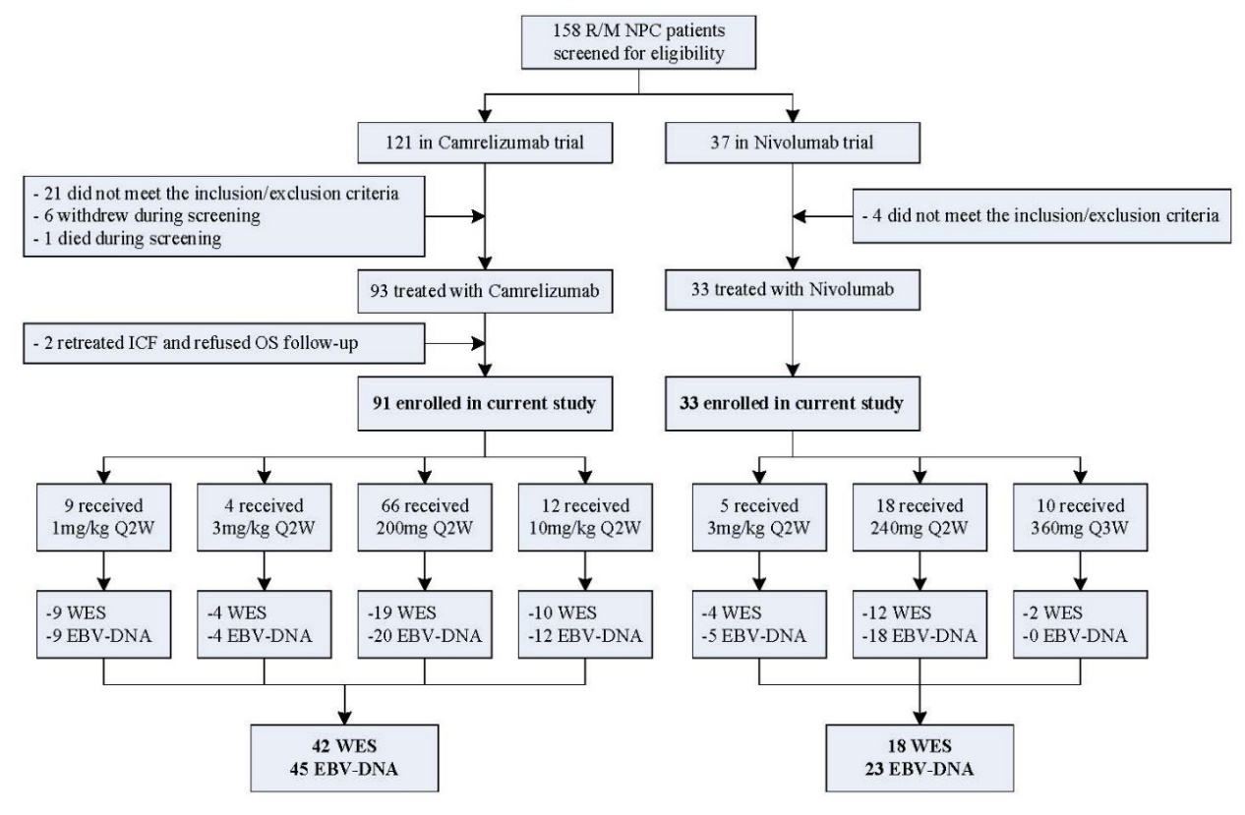
Figure S1. The distribution of treatments and the screen process of participants.
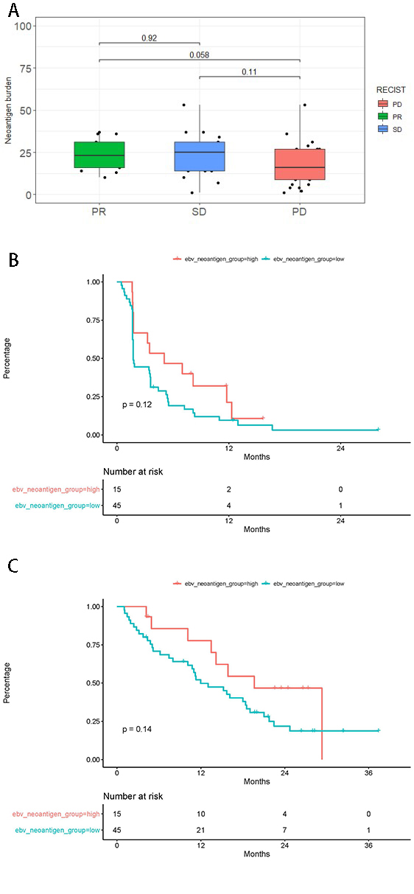
Figure S2. The effect of tumor neoantigen burden (TNB) on patients’ responses and survival. A. Distribution of TNB in 60 patients. PFS (B) and OS (C) curve stratified by median TNB. PD, progression disease; PR, partial remission; SD, stable disease; PFS, progression-free survival; OS, overall survival.

