Supplementary Information
Physiochemical Characteristics and Seasonal Variations in PM_{2.5} in Urban, Industrial, and Suburban Areas in South Korea

Journal name: Clean Technologies and Environmental Policy

Kyucheol Hwang¹, Jeongho Kim², Jae Young Lee³, Jong-Sung Park⁴, Sechan Park¹, Gahye Lee¹, Chang Hyeok Kim⁴, Pilho Kim⁴, Su Hyun Shin⁴, Kwang Yul Lee⁴, Joon-Young An⁴, Jungmin Park⁴, Jong Bum Kim^{1*}

¹Seohaean Research Institute, Chungnam Institute, Hongseong, 32232, Republic of Korea
²R&D center, Korea Environment Science Institution, Wonju, 26493, Republic of Korea
³Department of Environmental and Safety Engineering, Ajou University, Suwon, 16499, Republic of Korea
⁴Climate & Air Quality Research Department, National Institute of Environmental Research, Incheon, 22689, Republic of Korea

*Corresponding author: Jong Bum Kim (kjb0810@cni.re.kr)

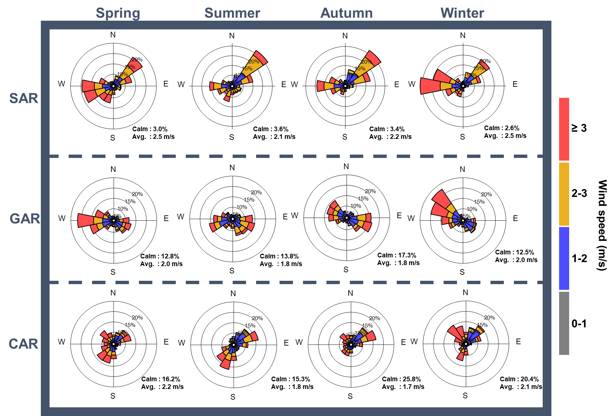

Fig. S1 Wind rose diagrams for each study site for 2021 for each season; Seoul Atmospheric environment Research center (SAR), Gyeonggi Atmospheric environment Research center (GAR), Chungcheong Atmospheric environment Research center (CAR)

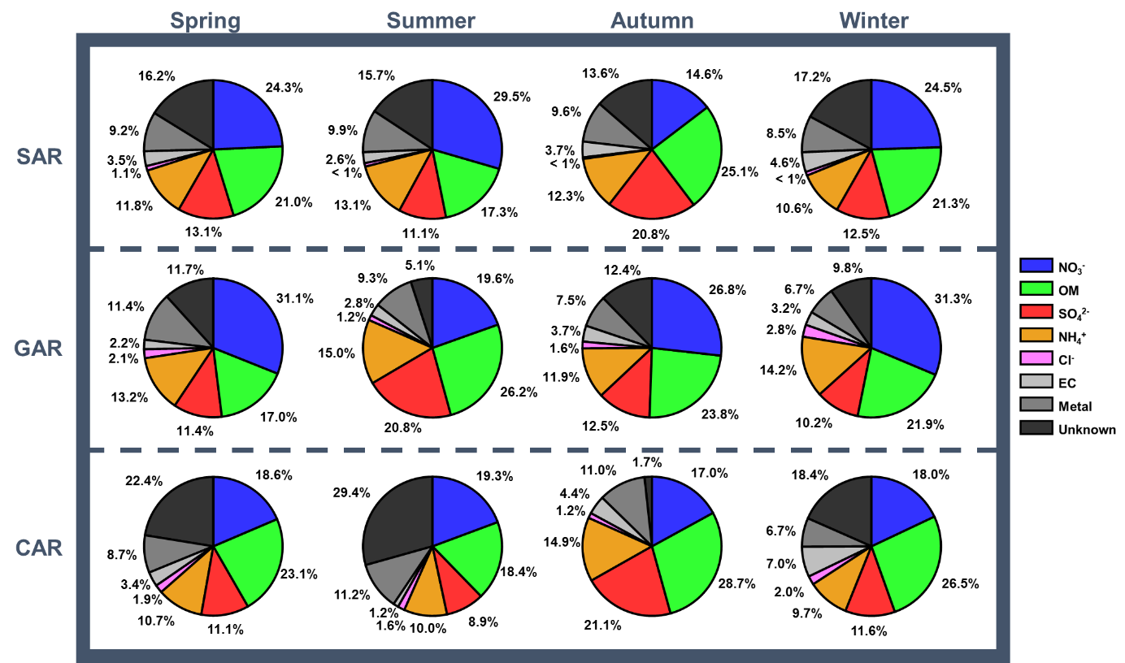
Fig. S2 Seasonal chemical composition of particulate matter (PM_{2.5}) at each site in 2021; organic matter (OM), elemental carbon (EC), Seoul Atmospheric environment Research center (SAR), Gyeonggi Atmospheric environment Research center (GAR), Chungcheong Atmospheric environment Research center (CAR)

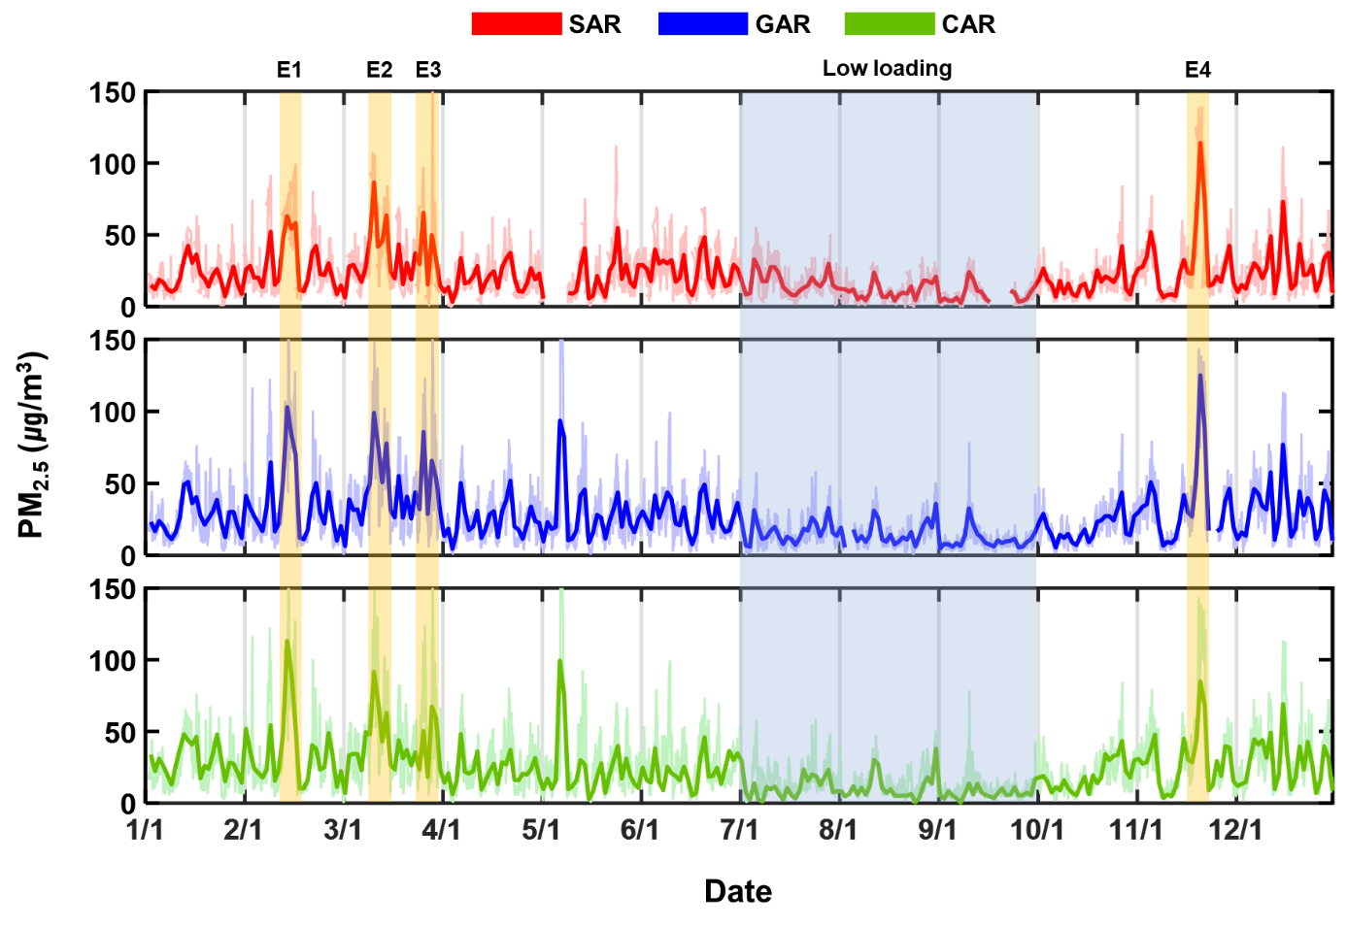Fig. S3 Time series of daily average PM_{2.5} at each site and high-concentration episodes interval (yellow shading); Seoul Atmospheric environment Research center (SAR), Gyeonggi Atmospheric environment Research center (GAR), Chungcheong Atmospheric environment Research center (CAR); Episode 1 (E1, February 12–14, 2021); Episode 2 (E2, March 11–12, 2021); Episode 3 (E3, March 26–29, 2021); Episode 4 (E4, November 19–21, 2021)

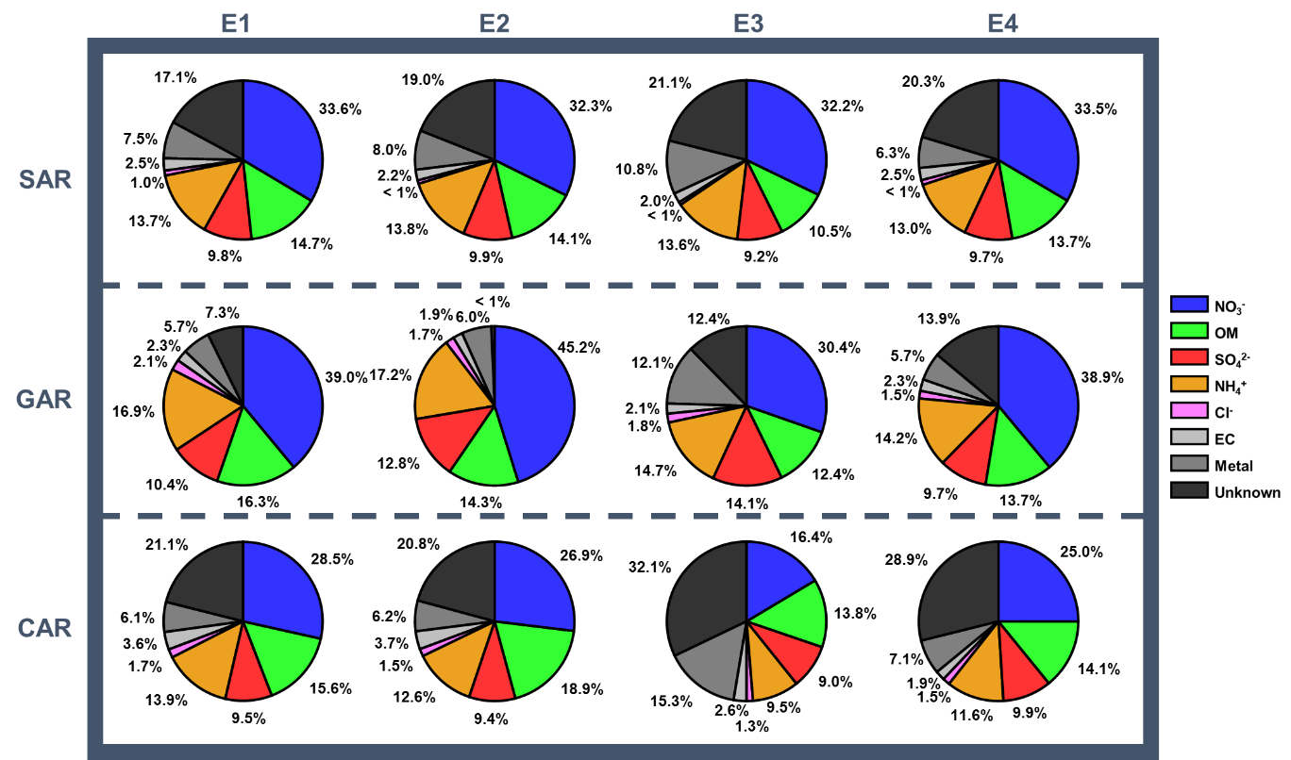
Fig. S4 Chemical composition of PM_{2.5} at each site for Episode 1 (E1, February 12–14, 2021); Episode 2 (E2, March 11–12, 2021); Episode 3 (E3, March 26–29, 2021); Episode 4 (E4, November 19–21, 2021)

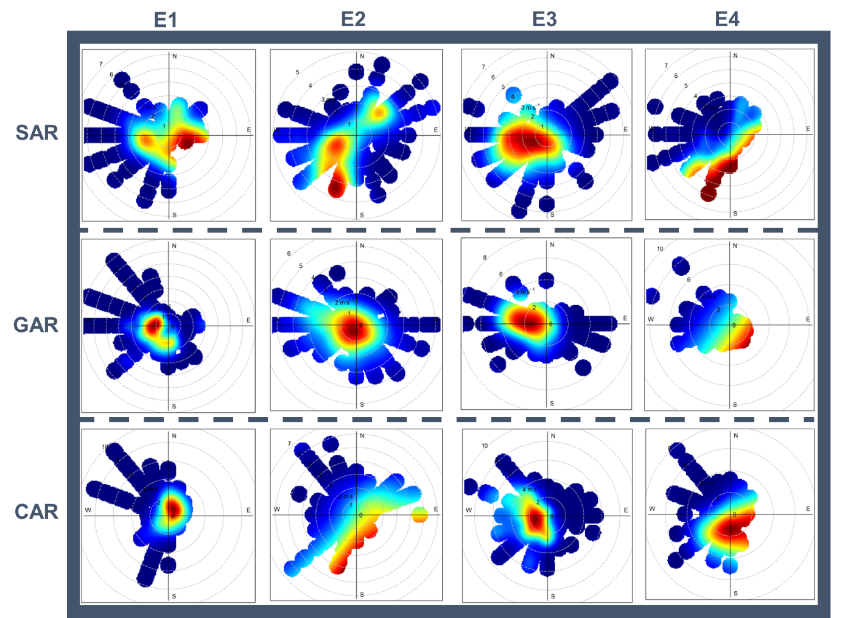
Fig. S5 Conditional bivariate probability function (CBPF) results for PM_{2.5} at each site during episode (E1–E4) period; E1, February 12–14, 2021); Episode 2 (E2, March 11–12, 2021); Episode 3 (E3, March 26–29, 2021); Episode 4 (E4, November 19–21, 2021). Red color represents high potential source areas affecting pollutants concentration; Seoul Atmospheric environment Research center (SAR), Gyeonggi Atmospheric environment Research center (GAR), Chungcheong Atmospheric environment Research center (CAR)

