Supplementary

The questionnaire
The questionnaire (Table 1) described in the methodology is as follows:
Table 1: The questionnaire designed to develop the model
No. | Question | Type | Farmers’ viewpoints | Experts’ viewpoints
1 | How much is the knowledge of the responder/farmer about ways of saving water in the agriculture sector?  (Experts answered this question based on the data extracted from farmers’ solutions regarding ways to reduce water consumption) | Ordinal | 18 good answers  33 moderate answers  35 poor answers  14 very poor/none answers | 0 good answers  3 moderate answers  5 poor answers  17 very poor/none answers
2 | In case of the water price increase, does the responder/ farmer deem the adopted policy unfair? | Binary | 100 Yes answers  0 No answers | 25 Yes answers  0 No answers
3 | In case of endangering the livelihood of farmers due to the water price increase, does the responder/ farmer feel threatened by the circumstances? | Binary | 65 Yes answers  35 No answers | 25 Yes answers  0 No answers
4 | In case of the water price increase, does the responder/farmer identify water theft as a way of securing his/her needs? | Categorical | 29 Yes answers  71 No answers | 25 Yes answers  0 No answers
4 | If the answer to the above question is yes, will the responder/farmer suggest others do that too? | Categorical | 9 Yes answers  20 No answers | 4 Yes answers  21 No answers
5 | If the water efficiency is improved without changing its price, will the responder/farmer keep the area under cultivation unchanged? | Binary | 42 Yes answers  58 No answers | 0 Yes answers  25 No answers
6 | In case of the water price increase and stability of the economic status, will the responder/farmer be inclined towards choosing another career in addition to farming? | Categorical | 81 Yes answers  19 No answers | 18 Yes answers  7 No answers
6 | Farmers: if the answer to the above question is yes, does the responder have any skills that could be used in production or service other than farming?  Experts: if the answer to the above question is yes, considering the farmers’ living conditions and the available facilities, do farmers have the opportunity to learn skills other than traditional farming? | Categorical | 21 Yes answers  60 No answers | 3 Yes answers  15 No answers
7 | In case of free modern farming training courses are offered by the government for the responder/ farmer, will you/he/she attend these courses? | Categorical | 90 Yes answers  10 No answers | 19 Yes answers  6 No answers
7 | If the answer by the responder/farmer is ‎yes, how modern agriculture ‎training is effective in improving irrigation ‎conditions? | Categorical | 57 good answers  21 moderate answers  13 poor answers  0 very poor/ none answers | 0 good answers  5 moderate answers  8 poor answers  6 very poor/ none answers
8 | In current economic conditions and assuming the water price increase, to which of these options is the farmer more inclined?  - Immigration and changing to another career  - Water theft | Optional | 64 chose option one  36 chose option two | 19 chose option one  6 chose option two
9 | Farmers: does the payment of financial aids and low-interest loans motivate the responder/farmer to reduce water consumption in agriculture?  Experts: does the payment of financial aids and low-interest loans for irrigation modernization lead to sustainable water resources operation in agriculture? | Binary | 88 Yes answers  12 No answers | 7 Yes answers  18 No answers
10 | With the water price increase in current conditions and assuming the impossibility of immigration for the responder/farmer, which of these options will he/she prefer?  - Alternative career  - Water theft and pursuit of farming | Categorical | 69 chose option one  31 chose option two | 14 chose option one  11 chose option two
10 | Farmers: if the answer to the above question is option one, which of these options is the closest to your selected career?  - Simple labourer  - Turning to skills other than driving  - Being a salesperson in a shop  - Being a vendor  - Real estate agent  - Being employed in the public or private sector as a guard, for instance  - Investment in a new job  - Driving a taxi or as a transportation agent  Experts: if there is no possibility of water theft for farmers, in which areas will most of them get involved?  - Casual/junk jobs (such as brokers, vendors, etc.)  - Production-oriented jobs  - Jobs requiring specific skills  - Jobs that provide services (such as labourer, salesperson, driver, etc.) | Categorical | 19 chose option one  3 chose option two  7 chose option three  15 chose option four  8 chose option five  1 chose option six  4 chose option seven  12 chose option eight | 9 chose option one  1 chose option two  5 chose option three  10 chose option four
10 | Farmers: if the responder’s choice is option two, will the aggravating economic conditions, in addition to the growing monitoring measures and penalties imposed for water theft, drive the farmers angry towards the government’s actions?  Experts: if there is no possibility of choosing ‎another career, what effect does increase ‎monitoring agencies and imposing ‎significant penalties for crimes such as water ‎theft have on the farmers’ protest threshold?‎  After imposing severe penalties and increasing government monitoring, the public protest (uprising) threshold will:  - Decrease  - Remain the same  - increase |  | 26 Yes answers  5 No answers | 17 chose option one  6 chose option two  2 chose option three
11 | Farmers: in case of the water price increase and ‎the government’s inability to supply subsistence ‎for farmers, will the responder voice his/her ‎objection to his/her conditions and ‎the government’s negligence?‎  Experts: in case of the water price increase in current conditions, will the increasing public discontent following the price increase lead to exceeding the farmers’ protest threshold? | Binary | 61 Yes answers  39 No answers | 21 Yes answers  4 No answers
12 | Farmers: does the government care about the farmers’ protests regarding their livelihood?  Experts: will the continuing protests of farmers in response to the water price increase lead to a halt and failure in implementing the policy?  - Yes  - No  - Depends on the government’s actions in managing the circumstances | Binary / Optional | 13 Yes answers  87 No answers | 6 chose option one  6 chose option two  13 chose option three
13 | In the case of modernizing farming and the decline in traditional farming practices, which of these options is most beneficial for their new career?  - Training for alternative careers  - Training skills related to modern agriculture  - Options one and two | Optional | 19 chose option one  17 chose option two  64 chose option three | 2 chose option one  5 chose option two  18 chose option three
14 | Farmers: considering the climate of developing countries and in the case of modernizing agriculture, which of these critical elements of irrigated/ water-dependent farming is farmers’ most significant concern?  - water resources  - fertile soil  - weather conditions  - taxes and tolls  - seeds  - pests  - Selling agricultural products  - Repair and maintenance of agricultural equipment  - Type of fertilizer and management of its distribution  - Labourers and skilled workforce  Experts: according to farmers’ response and after ‎imposing limitations on the water as the ‎most vital resource required for irrigated farming, will the general ‎satisfaction level of the farmers revert to ‎the previous level (before the price ‎increase) in the face of the government’s ‎measures such as training alternative ‎farming skills and allocating budget for ‎modernization of farming?‎ | Optional / Binary | 61 chose option one  15 chose option two  9 chose option three  8 chose option four  1 chose option five  0 chose option six  4 chose option seven  0 chose option eight  0 chose option nine  2 chose option ten | 1 Yes answer  24 No answers
15 | Farmers: as far as the responder is concerned, in case of the water price increase, which measures will increase farmers’ satisfaction with the government’s actions?  - Payment of financial aids and subsidies to farmers  - Training careers related to modern agriculture or alternative jobs  Experts: which of these options do you consider ‎convincing in increasing public satisfaction?  - Continue to pursue policies of the water price increase and training skills related to alternative careers along with modern agriculture  - Continue to pursue policies of water price increase in addition to payment of subsidies and unemployment insurance to the farmers in need  - Reverting the price to the initial value and intensifying the monitoring measures, imposing maximum penalties on over-consumers and those who commit acts of water theft  - Reverting the price to the initial value to prevent the decline in public satisfaction | Optional | 76 chose option one  24 chose option two | 17 chose option one  5 chose option two  3 chose option three  0 chose option four

Model description (sub-models and variables)

Farmers and change of occupation
The developed SD model is based on the farmers’ preferences collected through the questionnaire. The farmers chose their preferences from the following five options for responding to the increase in agricultural water price:
- Continuing conventional agriculture (i.e. business as usual)
- Continuing conventional agriculture as well as illegal water extraction (e.g. illegally drilled water extraction wells)
- Replacing conventional irrigation methods with modern and sustainable ‎ones
- Leaving the farming industry and taking casual/junk jobs or unemployment
- Leaving the farming industry and taking other occupations
The above five options constitute the main stock variables in the SD model. All individuals ‎in each variable (which is an indicator of farmers’ livelihood) would decide to substitute their ‎occupations based on utility variables of different occupations. The utility of different occupations is defined based on monthly benefit and ‎cost relevant to ‎fundamental variables such as the input costs and final product prices. ‎The SD model considers the effects of the utility decline of occupation ‎and the decline of ‎social satisfaction on individuals. The social satisfaction variable is a function of the utility ‎of people’s occupation as well as an indicator of social discontent. Variations in social ‎satisfaction may trigger public ‎pressure on the authorities to cancel the implemented ‎policies.‎
The SD model also includes the decisions made by policymakers that can directly affect the utility and availability of each subsistence. The ‎following major elements influenced by policy-makers are defined by the SD model as follows:
- Irrigation water price
- Availability of modern irrigation (availability of governmental subsidies and equipment)
- The ratio of irrigation modernization costs covered by governmental subsidies
- Availability of alternative occupations: This variable includes accessibility to the required infrastructure to change ‎livelihood ‎such as education, culture-making, providing conditions for ‎development and ‎prosperity of alternative occupations that can be thoroughly ‎described in this ‎regard:‎
- The level of governmental control on illegal water extraction (water ‎theft)
The SD model also considers a cap for some operational and enforcement measures for detecting illegal water ‎extraction (maximum water theft detection), allocating budget for upgrading irrigation systems ‎(maximum modernization per month) and allocating budget for new occupations ‎‎(maximum employment per month).‎

Key performance indicators
The analyzing policies are evaluated in the developed model through key performance indicators which include total cultivation area, the number of farmers (traditional farmers, farmers shifting to modern irrigation, farmers tending to illegal water extraction), the volume of agricultural water consumption (total agricultural water consumption and ‎illegal water extraction or water theft per year), amount of budget allocated by the authorities (irrigation ‎modernization subsidy, detection of illegal water extraction budget for ‎agricultural use, ‎cost of creating alternative occupations), the number of farmers that shift from farming to other occupations (casual/junk jobs and alternative jobs), public satisfaction during the implementation of the policy of increase in irrigation water price.

Model dynamics
Two types of model dynamics are defined here that are influenced by the system variables under the policies defined in the scenarios. ‎
- Public Satisfaction dynamics
Increasing water price can result in high costs of conventional agricultural products but this can also lead to low profit margin if there is no proportional increase in the product price in the market. Consequently, this can have negative impact on the agricultural business and hence decreasing the public satisfaction level. In particular, this can further be exacerbated if neither modern irrigation nor alternative occupation is ‎available for farmers that have to inevitably either continue agriculture with ‎low profit or leave their jobs and become unemployed. This would lead to a decline in social ‎satisfaction and put more pressure on responsible authorities to revert to its initial price. This can happen when this pressure crosses the threshold of public satisfaction function.‎
- Occupation change dynamics
If the factors affecting the occupation utility change, people with those their ‎occupation may switch to occupations with better utilities in the market. This can result in fluctuating water consumption and governmental ‎fixed costs. Moreover, occupation change would alter the social ‎satisfaction and discontentment, which may trigger "the public satisfaction and pressure ‎on the authorities" dynamics discussed above.

‎Model assumptions

It is supposed to ‎assess the effects of the water price changes on utility of farming and the feasibility of ‎alternative occupations for farmers, affecting agricultural water consumption. For the ‎case of increasing social pressure to more than a specific threshold, the government ‎needs to adjust the price or return it to its initial level. It is also assumed that the authorities here have two choices for adjusting agricultural water price: (1) increasing ‎ to real prices or (2) decreasing or remaining the existing price by allocating agricultural subsidy. The following assumptions are also considered in the SD model:
- 12 monthly time steps are required for the first implementation of agricultural water increase.
- The transition ratio between two occupations is dependent on the ratio of ‎utility of those two occupations.
- The utility of occupation is considered to be equal to the ‎ratio of income on the cost of that livelihood (Other factors like occupation ‎adaptation, occupation simplicity etc. are neglected).
- A threshold is considered for the rate of ‎changing traditional to modern irrigation for agricultural lands (about 3 hectares per month).
- Wheat is assumed to be the principal agricultural product as the main agricultural crop for Iran. Hence, modern ‎irrigation would lead to 43 percent reduction in water demand and 10 percent growth in crop yield.
- The authorities would consider budget‎ to confront illegal water ‎withdrawals (e.g. illegal water wells).
- Regarding the public satisfaction function, the model would continue based on assumed water price or return to its previous price by decreasing the threshold of public satisfaction.

Case Study
The additional information in the case study part is as follows:
Iran is located in the Middle East, surrounded by Persian Gulf and Oman Sea from the south, ‎Turkey and Iraq from the west and Nakhchivan autonomous republic, Armenia, and Republic of ‎Azerbaijan, from the northwest, and Caspian Sea from the north and Turkmenistan from the northeast and Afghanistan and Pakistan from the east, as shown in Figure 1. With an area of 1,648,000 square Kilometers, Iran is ranked as the seventeenth largest country in the world. Except for the western and northern coastal areas, Iran's climate is predominantly arid and semiarid [1,2,3], with rainfall primarily determined by geographical latitude and topographical height [4]. The average annual precipitation in Iran is about 250 mm (Figure 2). The western Mediterranean oscillation's pressure centre has affected most of Iran's precipitation. Due to a lack of precipitation, which resulted in a smaller amount of accessible surface water, groundwater is the primary source of water supply for municipal and agricultural usage, particularly in arid and semi-arid regions [5]. According to the Water Resources Management Company of Iran, the agriculture sector is the largest consumer of water resources in Iran, as seen in Figure 3a. According to the twenty-year average of total water usage, the agriculture sector accounts for 91.15 percent of total water consumption in Iran (this research will challenge these officially-announced statistics). Furthermore, groundwater resources have provided approximately 59 percent of total water use. Figure 3b demonstrates that groundwater has been Iran's primary water supply for household, industrial, and agricultural usage during the last 20 years.
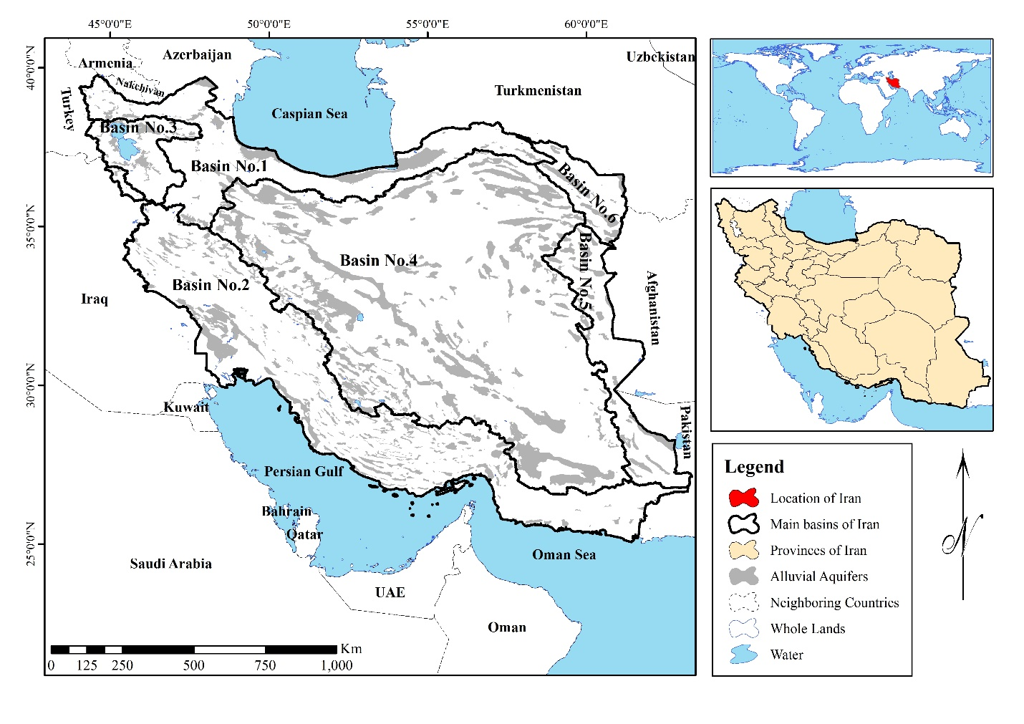
Figure 1: Location of Case Study

Figure 2: Annual precipitation of Iran considering different basins

a) | b)

Figure 3: Water consumption in different main sectors (a) and water use percentage of available water resources (b)

Because Iran is located in an arid region, just 33 percent of the country's total surface area is suitable for farming. However, due to poor soil quality and a lack of appropriate water resources, large areas of eligible land are not under cultivation. The rest of Iran's farmland is rainfed, which is dependent on precipitation [6]. Most efforts for the empowerment of farmers and rural communities guided by populist decision makers – such as major subsidization of water and energy to help farmers – have failed and are being cancelled due to a lack of a long-term comprehensive strategy [7]. In the water year 2014-15, the percentage of irrigated areas equipped with irrigation technology is around 25% of the total, as shown in Figure 4. What is clear is that farmers have lost the desire to increase production efficiency due to free and cheap water [8]. Iran's average irrigation efficiency is between 35 and 40%. [9,10]. Figure 3s depicts the total area of irrigated areas equipped with under-pressure technology from 1993-1994 to 2014-15.

Figure 4: The percentage of Irrigated lands equipped with irrigation technologies compared to traditional irrigation technics‎

Farming is one of the most common vocations in Iran, with over 3.5 million people today employed in farmlands. Figure 5 depicts the population percentage in each employment for Iran's major sectors and basins.

Figure 5: Total areas of Irrigated lands equipped with under-pressure technologies
According to Figure 6, the agriculture industry employs 22.55 percent of the entire employment in Iran.

Figure 6: The percentage of labourers/workers‎ in different sectors of Iran

All data were collected from Iran's Statistical Center [11]. Some assumptions based on Iran's regional situation were made to create the model, as shown in Table 2.

Table 2: the data used for model development
Criteria | Reference crop | Total number of Farmers in irrigated farmlands | Number of farmers in modernized farm fields | Number of farmers in conventional farm fields
measure | Wheat | 3913000 | 313037 | 3599963
Criteria | Total cultivation area under irrigation (ha) | Total cultivation area (ha) | The cost of irrigation modernization (USD per ha) | The price of wheat (USD per Kg)
measure | 6132421 | ‎11837908 | 4062.5 | 0.328
Criteria | The percentage of farmers prone to water theft (%) | The annual average income of each family in the agricultural community ‎(USD per year)‎ | The costs for producing crops (USD per Kg) | The annual average income of wheat cultivation from irrigated farm fields (USD per ha)
measure | 23.26 | 4048 | 0.2188 | 1029.57
Criteria | The amount of wheat production in irrigated farmlands (Kg per ha) | Water consumption in modernized farming (m3 per ha) | Water consumption of traditional agriculture (m3 per ha) | The average number of individuals in each family
measure | 3137.7 | 6000 | 3400 | 4

Reference

[1] Fallah, B., Sodoudi, S., Russo, E., Kirchner, I., & Cubasch, U. (2017). Towards modeling the regional rainfall changes over Iran due to the climate forcing of the past 6000 years. Quaternary International, 429, 119–128.
[2] Mansouri Daneshvar, M. R., Ebrahimi, M., & Nejadsoleymani, H. (2019). An overview of climate change in Iran: facts and statistics. Environmental Systems Research, 8(1), 1–10.
[3] Sodoudi, S., Noorian, A., Geb, M., & Reimer, E. (2010). Daily precipitation forecast of ECMWF verified over Iran. Theoretical and Applied Climatology, 99(1), 39–51.
[4] Razmi, R., Balyani, S., & Mansouri Daneshvar, M. R. (2017). Geo-statistical modeling of mean annual rainfall over the Iran using ECMWF database. Spatial Information Research, 25(2), 219–227.
[5] Jafary, F., & Bradley, C. (2018). Groundwater irrigation management and the existing challenges from the farmers’ perspective in central Iran. Land, 7(1), 15.
[6] Mesgaran, M. B., Madani, K., Hashemi, H., & Azadi, P. (2017). Iran’s land suitability for agriculture. Scientific Reports, 7(1), 7670.
[7] Madani, K. (2016). Editorial.“Water Crisis in Iran: A Desperate Call for Action.” Tehran Times.
[8] Nikouei, A., & Ward, F. A. (2013). Pricing irrigation water for drought adaptation in Iran. Journal of Hydrology, 503, 29–46.
[9] Alizadeh, A., & Keshavarz, A. (2005). Status of agricultural water use in Iran. Water Conservation, Reuse, and Recycling: Proceedings of an Iranian-American Workshop, 4, 94–105. National Academies Press Washington DC, USA.
[10] Nazari, B., Liaghat, A., Akbari, M. R., & Keshavarz, M. (2018). Irrigation water management in Iran: Implications for water use efficiency improvement. Agricultural Water Management, 208, 7–18.
[11] Statistical Center of Iran. Database, https://www.amar.org.ir.

