Supplementary files
Table S1. Geographic distribution records of Libellula angelina used in present study.
Locality/Site | Latitude | Longitude | Basis of records
China: Beijing | 40.0192 | 116.5906 | GBIF
China: Beijing | 40.0671 | 116.4905 | GBIF
South Korea | 37.7676 | 126.7689 | GBIF
China: Beijing | 39.9026 | 116.5037 | GBIF
Korea: Gyeonggi-do | 37.6244 | 126.6751 | GBIF
Korea: Gyeonggi-do | 36.9239 | 127.0764 | GBIF
China: Shandong, Qingdao | 36.2553 | 120.7171 | GBIF
Korea: Jeollanam-do | 34.9719 | 126.6095 | GBIF
Korea: Jeollanam-do | 34.9196 | 126.7964 | GBIF
Korea: Gyeonggi-do | 37.7180 | 126.7180 | iNaturalist
Korea: South Korea | 35.9605 | 128.5755 | iNaturalist
Korea: Chungcheongnam-do | 36.2886 | 126.9950 | iNaturalist
China: Xi'an | 34.2958 | 109.0792 | iNaturalist
South Korea | 37.5529 | 126.8791 | iNaturalist
South Korea | 37.8874 | 126.7486 | iNaturalist
Korea: Incheon | 37.4507 | 126.6778 | iNaturalist
China: Beijing | 39.9145 | 116.4555 | iNaturalist
China: Beijing | 40.1984 | 116.2198 | iNaturalist
China: Beijing | 40.0102 | 116.2886 | iNaturalist
China: Beijing | 40.1976 | 116.3791 | iNaturalist
China: Beijing | 39.9227 | 116.4921 | iNaturalist
China: Beijing | 40.1440 | 116.2099 | iNaturalist
China: Beijing | 40.1410 | 116.3442 | iNaturalist
China: Beijing | 40.0899 | 116.2144 | iNaturalist
China: Beijing | 40.0898 | 116.7936 | iNaturalist
South Korea | 36.0878 | 126.6873 | iNaturalist
China: Beijing | 40.0645 | 116.7583 | iNaturalist
China: Beijing | 40.1993 | 116.7972 | iNaturalist
Korea: Jeollanam-do | 34.6343 | 126.6806 | iNaturalist
Korea: Gyeonggi-do | 37.5039 | 127.1534 | Kim et al. (2019)
Japan: Kobe, Hyogo | 34.7575 | 134.9671 | Artiss, 2004
Japan: Nishi Ward, Kobe, Hyogo | 34.6923 | 134.9922 | Artiss et al. (2001)
South Korea | 37.3645 | 127.2752 | Artiss et al. (2001)
Japan: Shizuoka | 34.9615 | 138.3861 | Karube et al. (2012)
Japan: Shizuoka | 34.9563 | 138.3957 | Karube et al. (2012)
Japan: Shizuoka | 34.9648 | 138.4492 | Karube et al. (2012)
Japan: Shizuoka | 35.0242 | 138.4886 | Karube et al. (2012)
China: Beijing, Shahe, Changping | 40.1549 | 116.2972 | Wu & Zhang, 2011
China: Beijing Botanical Garden | 39.9970 | 116.2176 | Wu & Zhang, 2011
China: Beijing, Huairou reservoir | 40.3154 | 116.6035 | Wu & Zhang, 2011
China: Beijing, Yongding River Basin, Fushi | 39.9311 | 116.2791 | Wu & Zhang, 2011
China: Gansu, Gannan | 35.0107 | 102.8817 | Chen & Luo, 2007
Korea: Seocheon | 36.0273 | 126.7181 | Kim et al. (2020)
Korea: Ansan | 37.2482 | 126.6681 | Kim et al. (2020)
Korea: Gwangmyoung | 37.4585 | 126.8696 | Kim et al. (2020)
China: Hebei, Rongcheng County, Baiyangdian | 38.9899 | 116.0263 | This study
China: Hebei, Xiong an, near Baiyangdian scenic spot | 38.9759 | 115.9628 | This study
China: Hebei, Xiong an, near Baiyangdian scenic area | 38.9857 | 115.9706 | This study
China: Hebei, Xiong an, Baiyang lake corridor | 38.9946 | 115.9748 | This study
China: Hebei, Rongcheng County, Pingwang Townshi | 39.0190 | 116.0396 | This study
Japan: Shizuoka, Iwata City, Okegaya-numa Pond | 34.7401 | 137.8873 | Inoue, 2004
Japan: Oita, Nakatsu City, Noyori-shin Pond | 33.5545 | 131.2695 | Inoue, 2004
Japan: Shizuoka, Iwata City, Okegaidanuma area | 34.7090 | 137.8532 | Takahashi et al. (2009)
Japan: Fukui, Marsh | 36.0641 | 136.2195 | Inoue, 2004
Japan: Kagoshima | 31.7287 | 130.9988 | Takahashi et al. (2009)
Japan: Miyagi Prefecture, Sendai, Aoba Ward | 38.2612 | 140.8257 | Inoue, 2004
Japan: Kitakyushu | 33.8848 | 130.8718 | Inoue, 2004
Japan: Yamaguchi | 34.1797 | 131.4615 | Inoue, 2004
Japan: Saga | 33.2664 | 130.2991 | Inoue, 2004
Japan: Kagoshima, Satsumasendai | 31.8162 | 130.3052 | Inoue, 2004
China: Heilongjiang, Jiamusi, Sanhuanpao National Nature Reserve | 47.2427 | 132.0362 | Shang et al. (2020)
Korea: Gyeonggi-do, Paju-si, Munsan-eup | 37.8713 | 126.7210 | Kim et al. (2019)
Korea: Gyeonggi-do, Ansan-si | 37.2784 | 126.9793 | Kim et al. (2019)
China: Qinghai, Haidong, Xunhua Salar Autonomous County | 35.6841 | 102.1648 | Cai et al. (1985)
China: Zhejiang, Mogan Shan | 30.6297 | 119.8168 | Wu et al. (1992)
China: Hubei, Wuhan, Nanhu | 30.4812 | 114.3774 | Lei et al. (1998)
China: Zhejiang, Lin'an, Tianmu Mountain | 30.3138 | 119.4456 | Fang & Wu, 2001
China: Zhejiang, Fenghua, Ningbo City | 29.5964 | 121.1347 | Fang & Wu, 2001
China: Zhejiang, Zhoushan, Dinghai District | 30.0870 | 121.5615 | Fang & Wu, 2001
China: Zhejiang, Jinhua City | 29.0772 | 119.5081 | Fang & Wu, 2001
China: Zhejiang, Jinhua, Pujiang County | 29.5145 | 119.7726 | Fang & Wu, 2001
China: Zhejiang, Quxian | 29.1764 | 119.1006 | Fang & Wu, 2001
China: Zhejiang, Quzhou, Kaihua County | 29.1957 | 117.2491 | Fang & Wu, 2001
China: Zhejiang, Quzhou, Changshan County | 28.9903 | 118.2307 | Chen & Luo, 2007
China: Tianjin, Zhang Xingzhuang | 39.1975 | 117.1488 | Li et al. (2022)
Japan: Hyogo | 34.9098 | 133.7392 | Takahashi, 2009
Japan: Yamaguchi | 34.2548 | 131.0730 | http://www.biodic.go.jp/ J-IBIS.html
Japan: Fukuoka | 33.5385 | 130.1281 | http://www.biodic.go.jp/ J-IBIS.html
Japan: Saga | 33.2845 | 129.8594 | http://www.biodic.go.jp/ J-IBIS.html
Japan: Oita | 33.2262 | 130.9406 | http://www.biodic.go.jp/ J-IBIS.html
Japan: Nagasaki Prefecture | 33.3271 | 126.8321 | http://www.biodic.go.jp/ J-IBIS.html
Japan: Lin moutian pool, Tama Kawaguchi, Kagoshima | 31.8179 | 130.4639 | Takahashi, 2009
Japan: Iwai, Iwata, Tanigami, Shizuoka Prefecture | 34.7489 | 137.8791 | Takahashi, 2009
Japan: Aichi, Ryugucho, Nagoya | 35.0995 | 136.9019 | Takazaki, 1997
Japan: Sakurachō, Minato Ward, Nagoya | 35.1016 | 136.8835 | Takazaki, 1997
Japan: Aichi, Chunrijing | 35.2530 | 136.9209 | Takazaki, 1997
Japan: Aichi, Nagoya, Tokugawachō, Higashi Ward, | 35.1844 | 136.9334 | Takazaki, 1997
Japan: Aichi Prefecture, Shimbashi City, Muru Town | 34.7556 | 137.3385 | Takazaki, 1997
Japan: Nagoya, Shinan District | 35.0933 | 136.8901 | Takazaki, 1997
Japan: Aichi Prefecture, Nagoya, Tianbai District, | 35.1259 | 136.8489 | Takazaki, 1997
Japan: Aichi Prefecture, Meibin Town, Okuda, Pingshan Chi | 34.7751 | 136.8781 | Takazaki, 1997
Japan: Aichi Prefecture, Changhua City, Otani, Kitahara, Chito Peninsula | 34.8840 | 136.8681 | Takazaki, 1997
Japan: Aichi Prefecture, inazawa City, Grandfather Town | 35.2639 | 136.6803 | Takazaki, 1997
Japan: Aichi, Okazaki | 34.9509 | 137.1218 | Takazaki, 1997
Japan: Aichi, Okazaki Park | 34.9562 | 137.1589 | Takazaki, 1997
Japan: Aichi, Nagoya, Meito Ward, Idakacho Oaza Kamiyashiro, Ikenoomote | 35.1568 | 137.0005 | Takazaki, 1997
Japan: Aichi, Nisshin,Oshimizu Iwafujicho | 35.1510 | 137.0748 | Takazaki, 1997
Japan: Aichi,Nisshin, Shimogo-249-1 Akaikecho | 35.1250 | 137.0146 | Takazaki, 1997
Japan: Aichi, Nagoya, Chikusa Ward, Shirutani Nabeyauenocho, Chayagasaka | 35.1807 | 136.9628 | Takazaki, 1997
Japan: Aichi, Fujiokamachi Fujioka | 36.2539 | 139.5819 | Takazaki, 1997
South Korea: Baocheng County, Jeonnam Road, boknae myeon, Yongjeon RI, | 34.8835 | 127.1436 | Qian & Xu, 2019
Japan: Tokyo, Nerima City, Shakujiimachi, Shakujii Park Memorial Garden | 35.7358 | 139.5872 | Yoshiyuki et al. (2000)
South Korea: Gyeonggi-do, Paju-si, Gunnae-myeon | 37.9547 | 126.6760 | Chung et al. (2000)
South Korea: Gyeongsangbuk-do, Euiseong, Angye-myeon, Bongyang-ri | 36.3898 | 128.7622 | Kim & Xu, 2019
South Korea: Gyeongsangbuk-do, Euiseong, Angye-myeon, Bongyang-ri | 36.8710 | 126.2120 | Kang et al. (2017)
South Korea: Gyeonggi-do, Paju-si, Beobwon-eup, Geumgok-ri | 37.8822 | 126.8699 | Yin et al. (2012)
China: Hebei, Anxin, Baiyang Lake | 38.9838 | 115.9834 | Zhang et al. (2018)
China: Hebei, Anxin, Baiyang Lake | 38.9828 | 116.0163 | Zhang et al. (2018)
China: Tianjin, Beichen district, Chentai Bridge | 39.2143 | 117.1720 | Li et al. (2022)
Japan: Kurihara, Kamihataoka Shikimi-17-2 Wakayanagi, Miyagi Prefecture | 38.7236 | 141.0922 | Ueda et al. (2016)
Japan: Hyogo, Kobe Beach District, rokkosancho, higashiyamanouchi Nishitani, | 34.7414 | 135.2264 | White Paper of Hyôgo-ken, 2014
Japan: Yamaguchi, Yuanbiao, Aiohigashi, qiuzhenting Road | 34.0139 | 131.4355 | Kenichi et al. (2002)
Japan: Yamaguchi, Mine, Shuhocho Beppu | 34.2271 | 131.2348 | Kenichi et al. (2002)
Japan: Kagawa, Ayauta District, Ayagawa, Sogishohigashi | 34.1896 | 133.9995 | Kenichi et al. (2002)
Japan: Hokkaido Tabata Prefecture, Chenpu town | 42.6415 | 140.5077 | Kenichi et al. (2002)
Japan: Yamaguchi Prefecture, Hagi City, Fuku village | 34.3821 | 131.5138 | Kenichi et al. (2002)
Japan: Kanagawa Kazuo | 35.4004 | 139.0956 | Naoka, 2007
Japan: Osaka Prefecture | 34.4961 | 135.4270 | Naoka, 2007
Japan: Nagano Prefecture | 36.1092 | 136.9105 | Red List of Nagano, 2015

Table S2. Environmental variables used for constructing the species distribution models of L. angelina. Variables retained through multicollinearity test and variance inflation factor are shown in bold.
Type | Description | Code | Source | Units
Bioclimatic variables | Annual mean temperature | BIO1 | WorldClim | ℃
 | Mean diurnal range (mean of monthly (max temp - min temp)) | BIO2 | WorldClim | ℃
 | Isothermality (BIO2/BIO7) (* 100) | BIO3 | WorldClim | —
 | Temperature seasonality (standard deviation * 100) | BIO4 | WorldClim | ℃
 | Max temperature of warmest month | BIO5 | WorldClim | ℃
 | Min temperature of coldest month quarter | BIO6 | WorldClim | ℃
 | Temperature annual range (BIO5-BIO6) | BIO7 | WorldClim | ℃
 | Mean temperature of wettest quarter | BIO8 | WorldClim | ℃
 | Mean temperature of driest quarter | BIO9 | WorldClim | ℃
 | Mean temperature of warmest quarter | BIO10 | WorldClim | ℃
 | Mean temperature of coldest quarter | BIO11 | WorldClim | ℃
 | Annual precipitation | BIO12 | WorldClim | mm
 | Precipitation of wettest month | BIO13 | WorldClim | mm
 | Precipitation of driest month | BIO14 | WorldClim | mm
 | Precipitation seasonality (coefficient of variation) | BIO15 | WorldClim | 1
 | Precipitation of wettest quarter | BIO16 | WorldClim | mm
 | Precipitation of driest quarter | BIO17 | WorldClim | mm
 | Precipitation of warmest quarter | BIO18 | WorldClim | mm
 | Precipitation of coldest quarter | BIO19 | WorldClim | mm
Topographic variables | Elevation | ELE | WorldClim | m
 | Global land-cover | Globcover | SEDAC | —
Anthropogenic variables | Human influence index | HII | SEDAC | ―
Note: Worldclim (www.worldclim.org); The Socioeconomic Data and Applications Centre (SEDAC, https://sedac.ciesin.columbia.edu/)

Table S3. Summary of model accuracy for different approaches under different climate scenarios.
Climate period | Metric | Ecological niche model
Climate period | Metric | MaxEnt | RF | BIOCLIM | GAM
Current | AUC | 0.989 | 0.999 | 0.979 | 0.919
Current | TSS | 0.901 | 0.830 | 0.716 | 0.741
2050s RCP4.5 | AUC | 0.991 | 0.987 | 0.959 | 0.956
2050s RCP4.5 | TSS | 0.996 | 0.776 | 0.775 | 0.718
2050s RCP8.5 | AUC | 0.990 | 0.997 | 0.961 | 0.927
2050s RCP8.5 | TSS | 0.905 | 0.808 | 0.706 | 0.717
2070s RCP4.5 | AUC | 0.990 | 0.957 | 0.943 | 0.937
2070s RCP4.5 | TSS | 0.905 | 0.763 | 0.771 | 0.734
2070s RCP8.5 | AUC | 0.990 | 0.996 | 0.975 | 0.913
2070s RCP8.5 | TSS | 0.9964 | 0.802 | 0.728 | 0.765

Table S4. Suitable area of L. angelina based on the consensus model under the different climate scenarios. (Units 10⁴ Km²)
Climate scenario | Suitable area  (0.2–1.0) | Low suitability (0.0–0.2) | General suitability  (0.4–0.6) | Medium suitability  (0.6–0.8) | High suitability  (0.8–1.0)
Current | 13206.37 (–) | 88.20 (–) | 19.01 (–) | 5.68 (–) | 1.57 (–)
2050s RCP4.5 | 13170.00 (-0.28%) | 90.56 (+2.68%) | 16.42 (-13.62%) | 6.30 (+10.92%) | 1.55 (-1.27%)
2050s RCP8.5 | 13187.90 (-0.14%) | 74.49 (-15.54%) | 15.58 (-18.04%) | 5.80 (+2.11%) | 1.13 (-28.03%)
2070s RCP4.5 | 13184.78 (-0.16%) | 76.60 (-13.15%) | 15.71 (-17.36%) | 6.25 (+10.04%) | 1.56 (-0.64%)
2070s RCP8.5 | 13188.66 (-0.13%) | 73.58 (-16.58%) | 15.22 (-19.94%) | 6.08 (+7.04%) | 1.36 (-13.38%)

Table S5. Changes suitable area of L. angelina compared with current potential distribution based on the binary raster files (Units Km²)
Climate scenario | Range expansion | No occupancy | No change | Range contraction
2050s RCP4.5 | 198860.25 (0.15%) | 131523086.80 (98.9%) | 948975.06 (0.71%) | 180856.03 (0.15%)
2050s RCP8.5 | 124983.45 (0.09%) | 131596963.60 (99.06%) | 845798.34 (0.64%) | 283762.75 (0.21%)
2070s RCP4.5 | 153319.97 (0.12%) | 131568627.00 (99.03%) | 844865.51 (0.64%) | 284695.58 (0.21%)
2070s RCP8.5 | 203784.35 (0.15%) | 131518162.70 (98.99%) | 756904.56 (0.57%) | 372656.52 (0.29%)

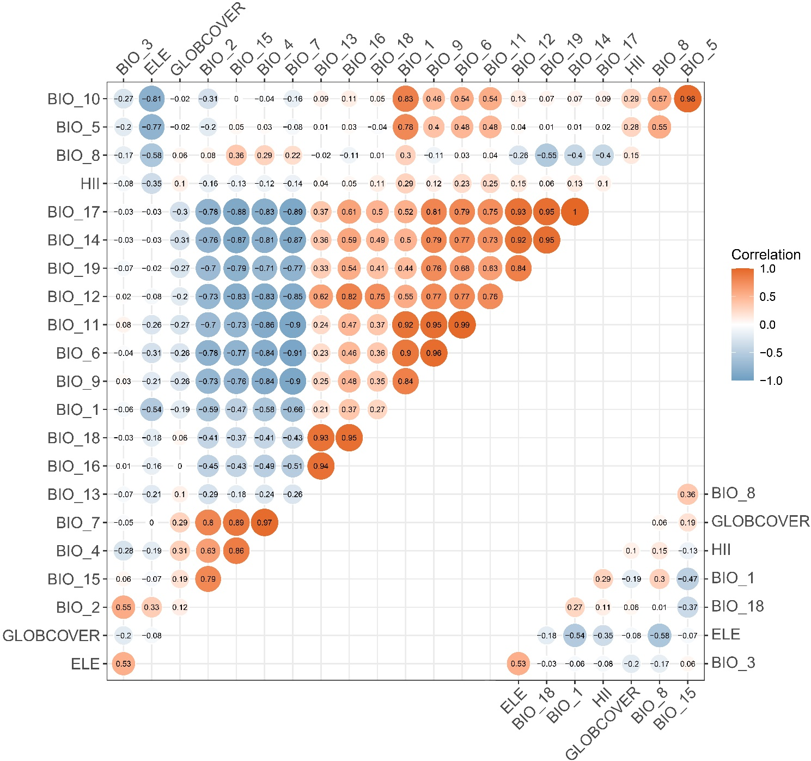
Figure S1. Pearson correlation analysis among different predictors. Note: the upper triangle represents the correlation analysis of all environmental variables, while the lower triangle represents the correlation analysis of environmental variables used to build the final models.

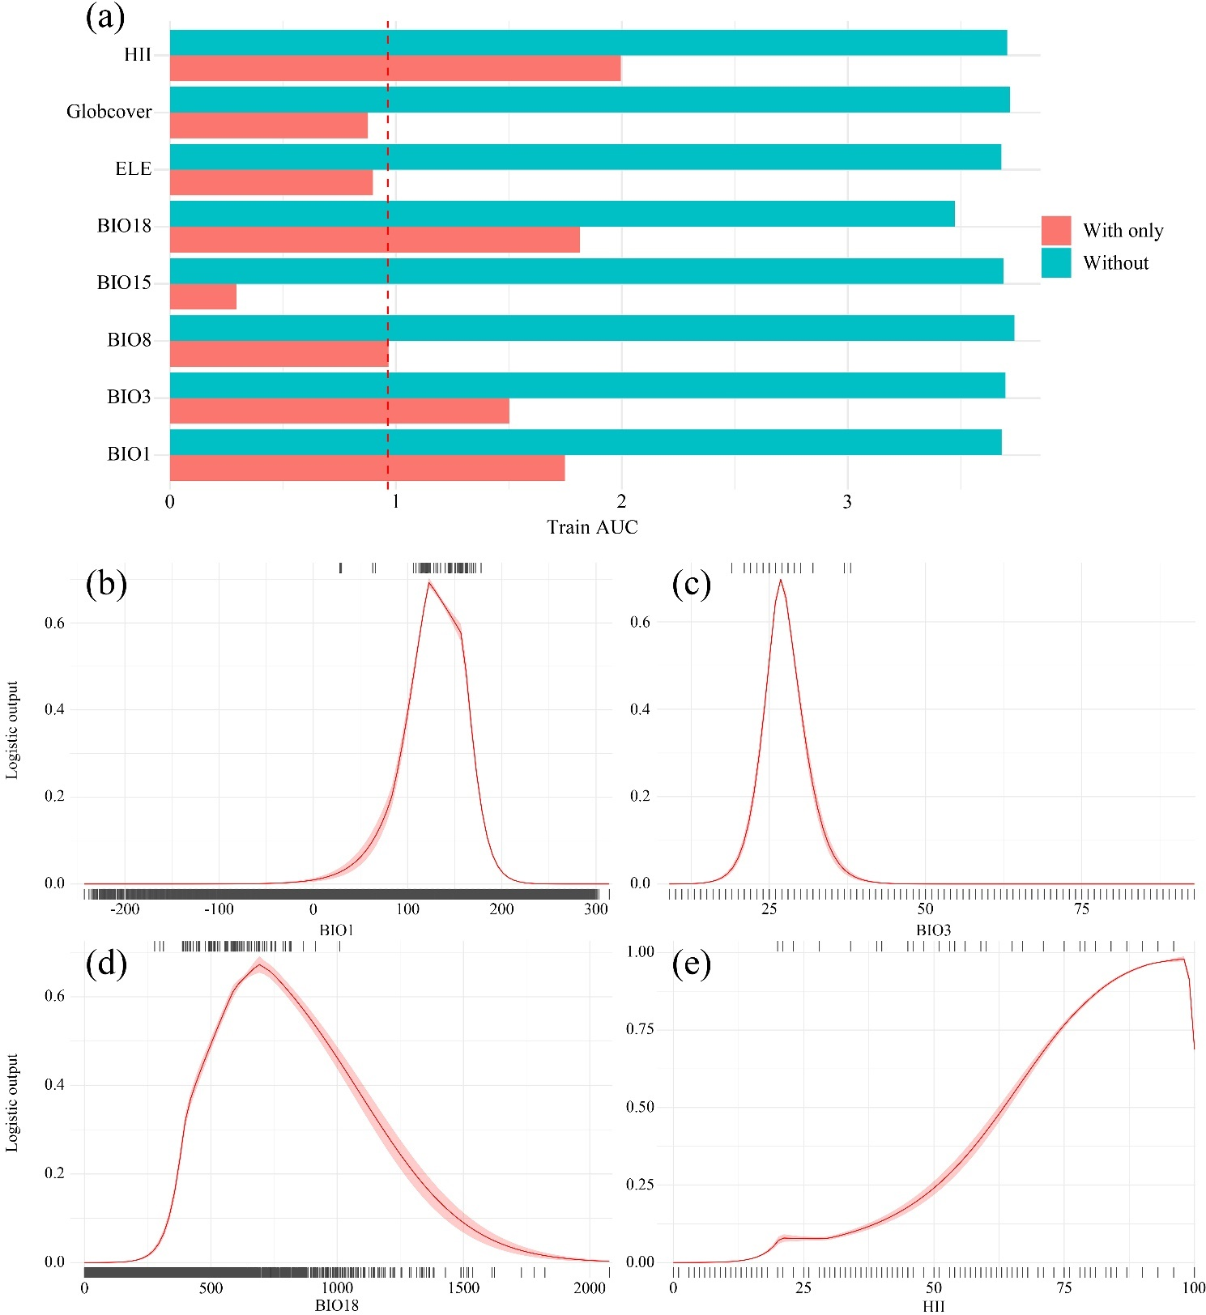
Figure S2. Jackknife test of each predictor and response curves of the most important variables for L. angelina. Values shown are the average over 10 replicates; pink margins represent ± SD calculated over 10 replicates; (a) Jackknife test of all predictors based on MaxEnt v3.4.4; (b) Response curve of annual mean temperature (BIO1); (c) Response curve of isothermality (BIO3); (d) Response curve of precipitation of warmest quarter (BIO18); (e) Response curve of human influence index (HII).

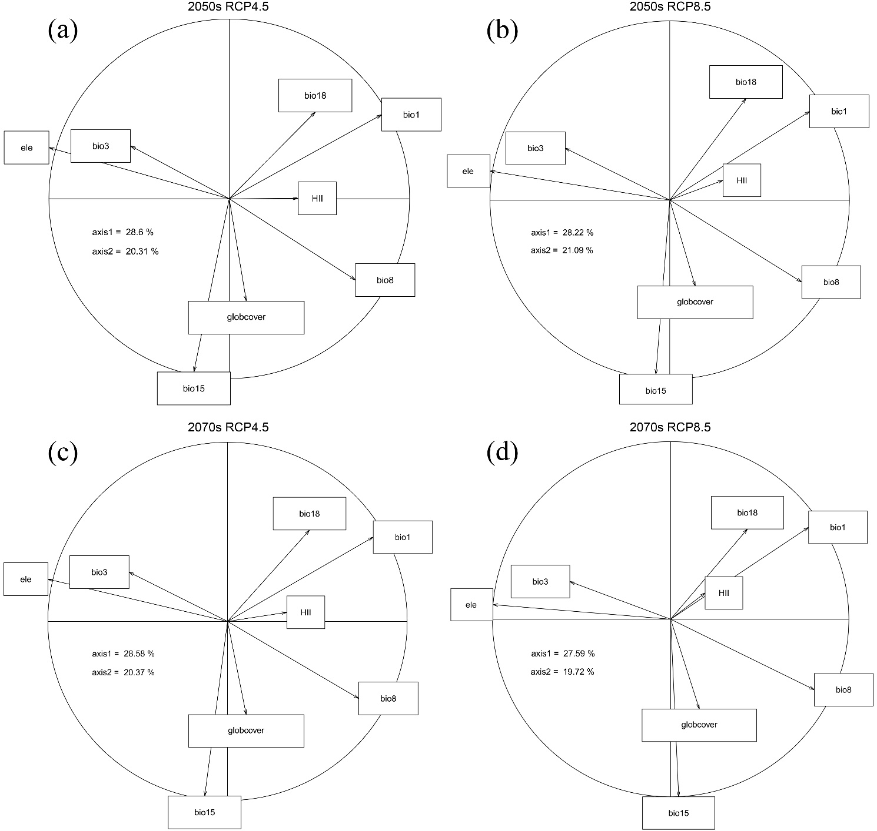
Figure S3. Modified principal component analysis (PCA) based on the filtered environmental variables under different climate scenarios. (a) 2050s RCP4.5; (b) 2050s RCP8.5; (c) 2070s RCP4.5; (d) 2070s RCP8.5.

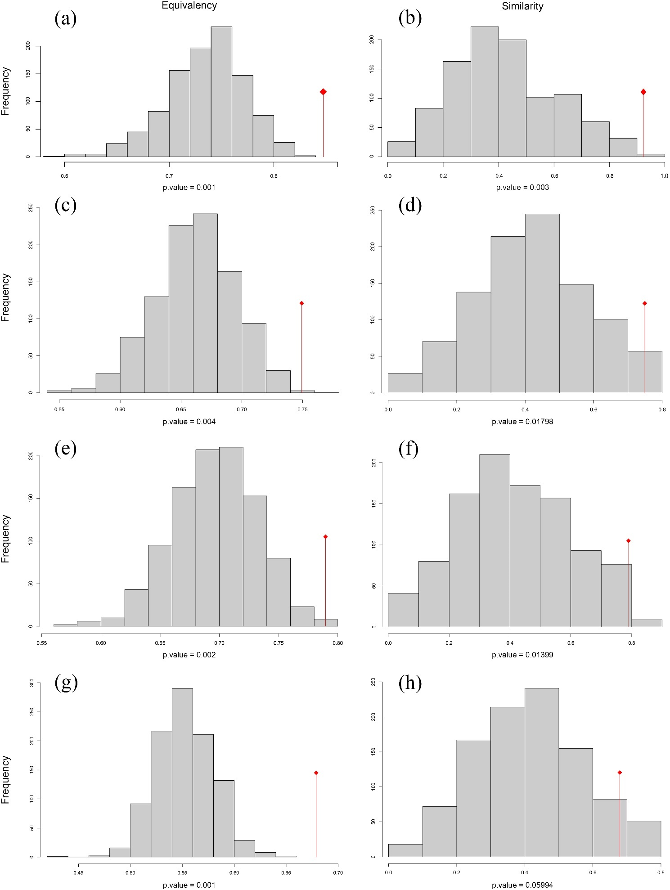
Figure S4. Niche equivalence test and niche similarity test under the future climate scenarios. (a–b) Current vs. 2050s RCP4.5; (c–d) Current vs. 2050s RCP8.5; (e–f) Current vs. 2070s RCP4.5; (g–h) Current vs. 2070s RCP8.5.

