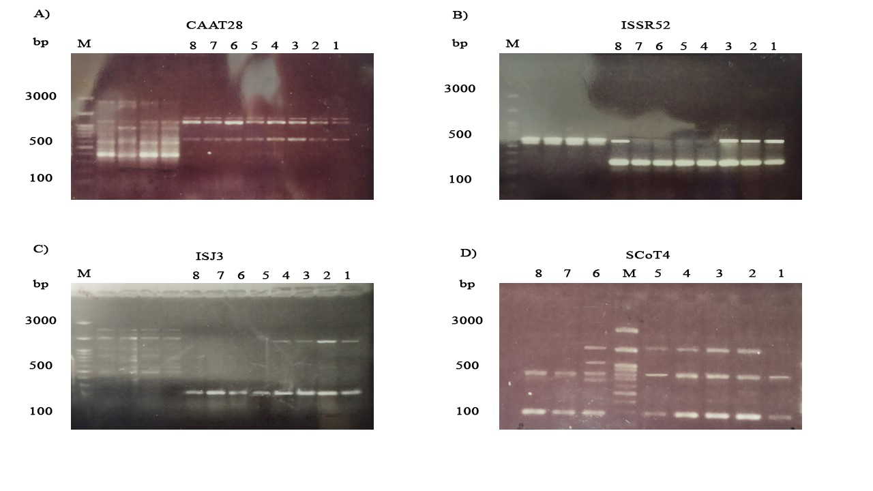

Fig . Photographs of some representative agarose gel electrophoresis of PCR amplicons of A) CAAT, B) ISSR, C) ISJ and D) SCoT primers. M = DNA size marker in bps (Cat. No. DB0103, DNAbiotech, Taiwan). Numbers 1 to 8 are related to parental PCR products.

