Supplemental Material

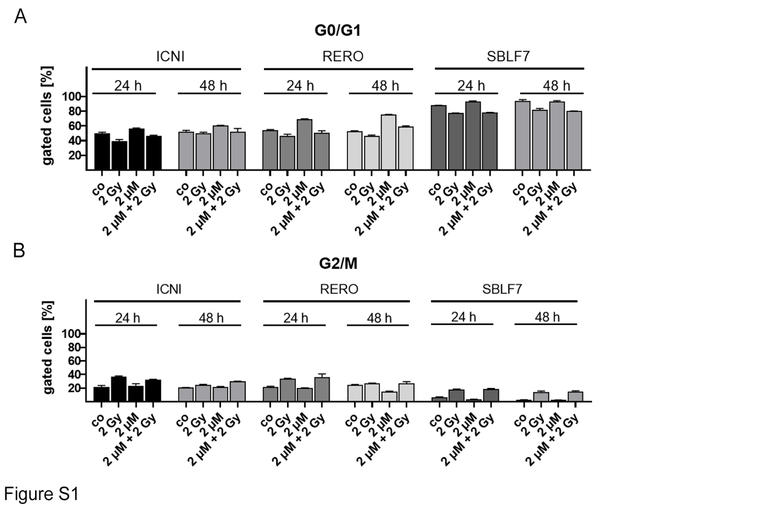
Figure S1: Analysis of cell cycle after 24 h and 48 h of treatment with IR, palbociclib or a combination of both in skin cancer cells and healthy fibroblasts.
Two different malign melanoma cells (ICNI, RERO) as well as healthy control cells (SBLF7) were treated for 24 or 48 hours. Cell cycle distribution was measured using Hoechst staining (33342, Molecular probes) via flow cytometry (Cytoflex, Beckman coulter). A decrease of G0/G1 after 2 Gy IR was detectable, but just slight differences between 24 h and 48 h. Each value represents mean ± SD (n = 2).

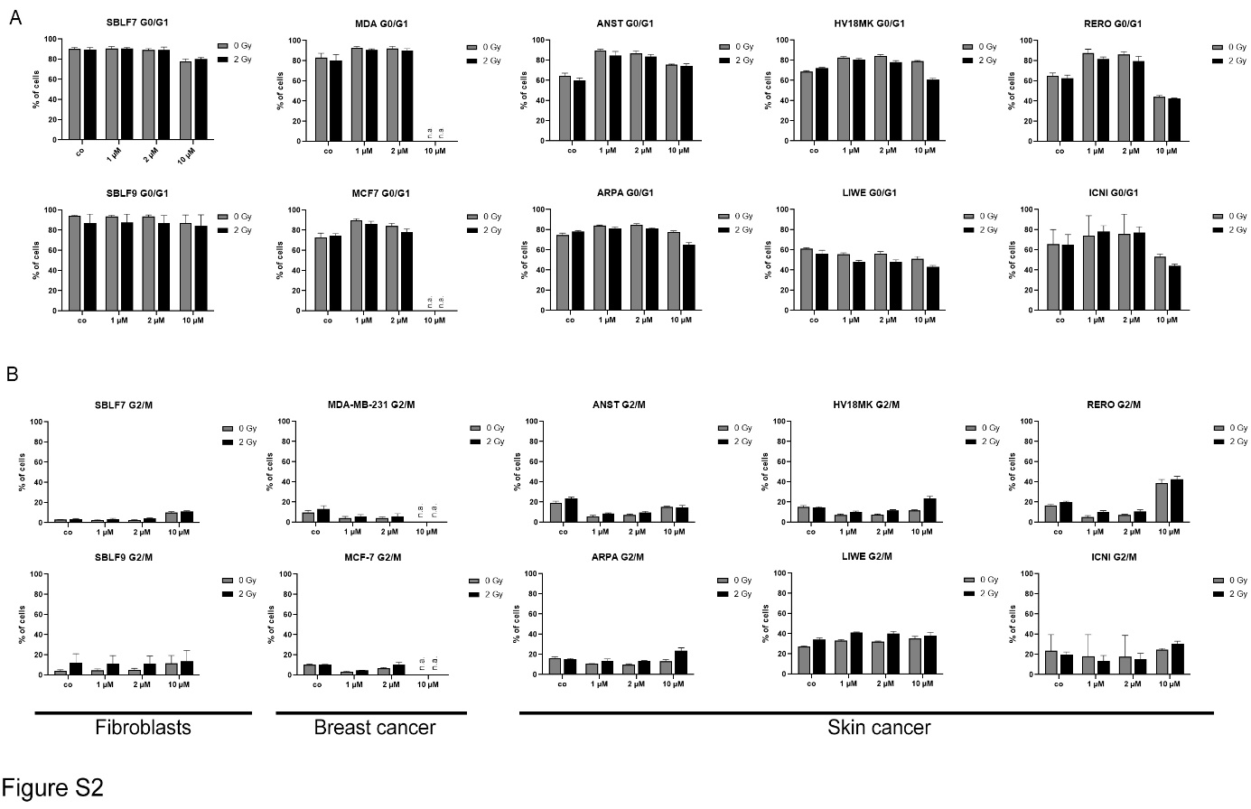
Figure S2: Cell cycle distribution measured in 3 different subgroups (healthy tissue, breast cancer and skin cancer cells) after treatment with palbociclib (1 µmol/L, 2 µmol/L and 10 µmol/L) w/o IR (2 Gy).
Cell populations in (A) G0/G1 and (B) G2/M phase of cell cycle measured in healthy fibroblasts (SBLF7, SBLF9), breast cancer cell lines (MDA-MB-231, MCF-7) and skin cancer cells (ANST, ARPA, HV18MK, LIWE, RERO and ICNI) with varying BRaf status (wt or V600E). Each value represents mean ± SD (n = 4).

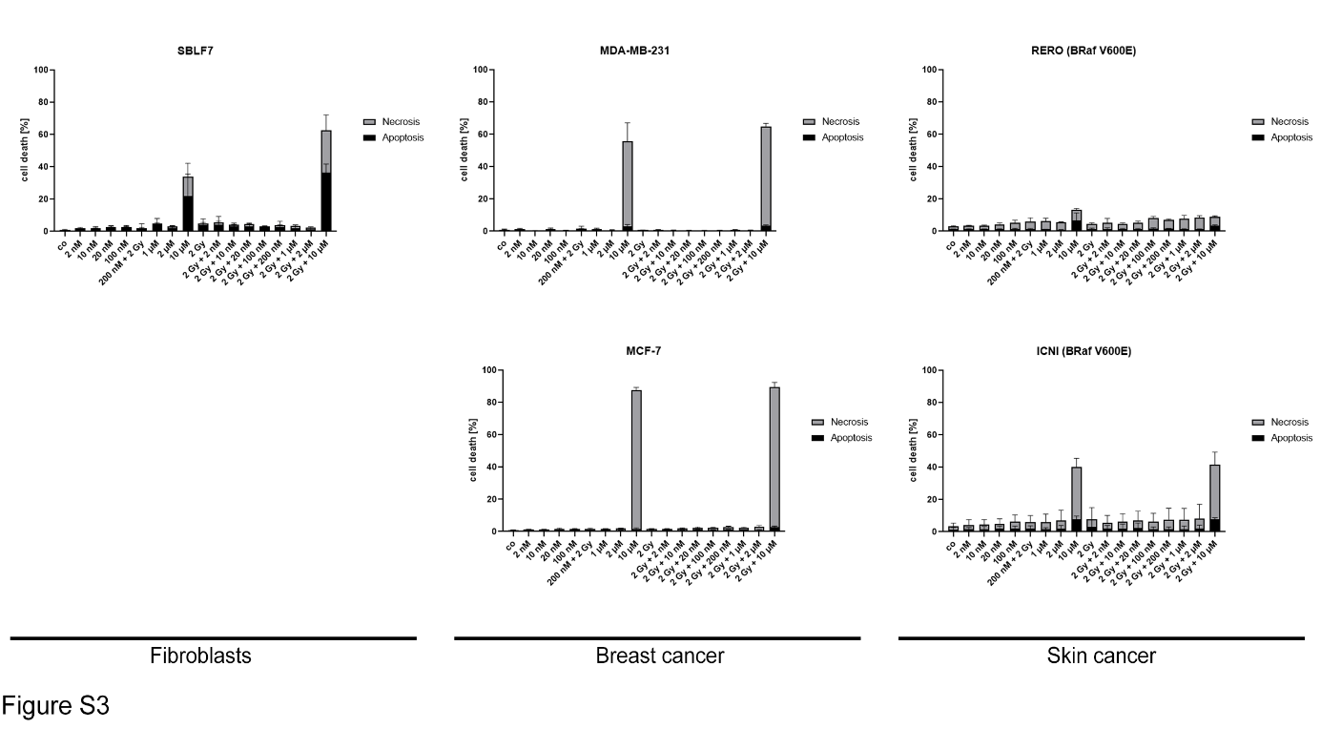
Figure S3: First dose-escalation study of palbociclib using one non-malign and four malign cell lines.
Cells were treated for 48 h with increasing palbociclib concentrations from 2 nmol/L up to 10 µmol/L w/o 2 Gy irradiation. Malign skin cancer cells showed moderate effect (approx. 10 – 15 % cell death), whereas healthy fibroblasts SBLF7 and breast cancer cell lines MDA-MB-231 and MCF-7 showed only response after maximum KI concentration (10 µmol/L).

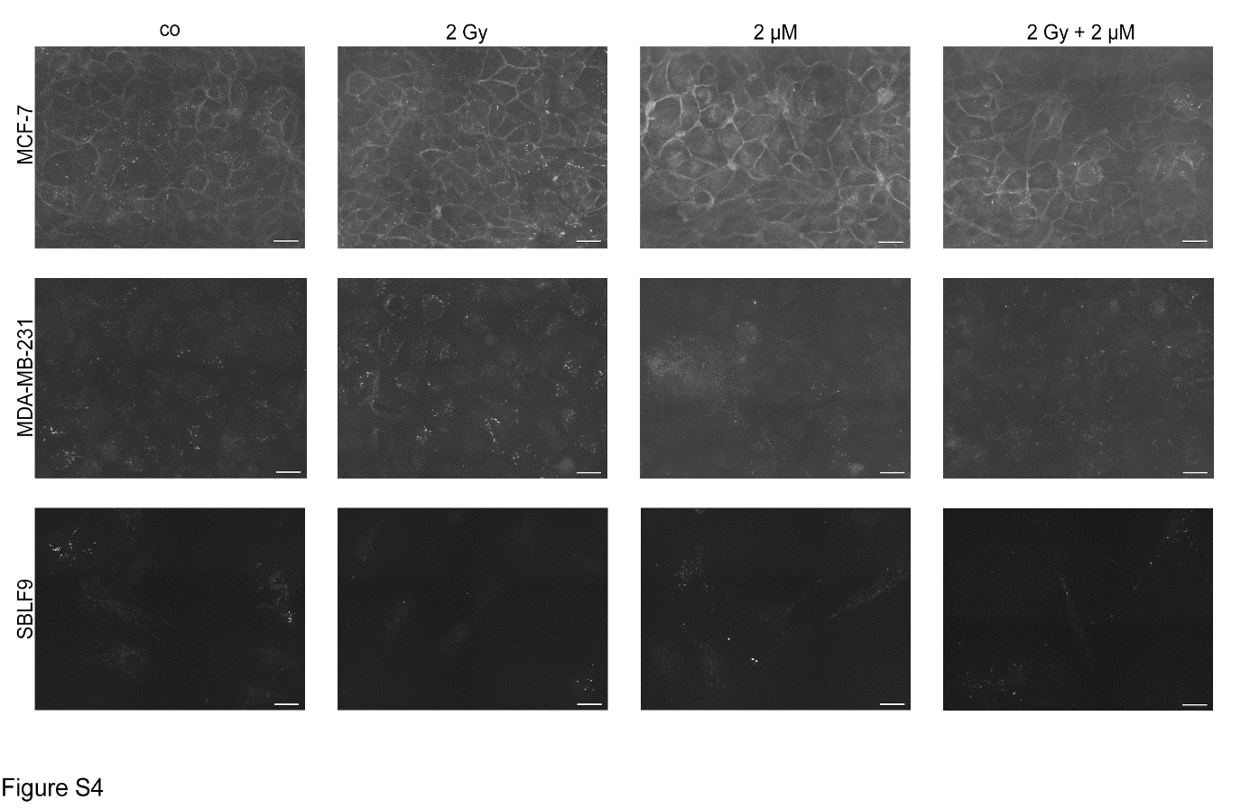
Figure S4: Staining of E-cadherin in untreated (co) and treated (2 Gy, 2 µM and 2 Gy + 2 µM palbociclib) cells.
MCF-7, MDA-MB-231 and SBLF9 were seeded on glass slides (until 80 % confluence) and treated for 48 h. Cells were stained with mouse anti-E-cadherin primary antibody (1:200, #610182, BD, Franklin Lakes, USA) and goat anit-mouse secondary antibody (1:400, #A11001, Invitrogen, Waltham, USA). MCF-7 showed a distinctly higher E-cadherin expression then MDA-MB-231, whereas healthy fibroblasts SBLF9 showed minimal expression of E-cadherin. In all three cases expression of E-cadherin seem to be treatment independent. Scale bars 25 µm.

