Immediate and Long-term Responses of Coastal Vegetation to Extreme Storm Events along the Northern Gulf of Mexico
Camille L. Steenrod ^{1,2} and Loretta L. Battaglia ^{1,3}
¹Southern Illinois University, School of Biological Sciences, Carbondale, IL 62901 USA
²CSS Inc., 10301 Democracy Lane, Suite 300, Fairfax, VA 22030 USA
³Texas A & M University Corpus Christi, Center for Coastal Studies, Corpus Christi, TX 70412 USA
Corresponding author:
Email: Camille.steenrod@noaa.gov
Phone: 252-499-2508
Fax: N/A

Submitted May 13, 2023

Electronic Supplementary Material

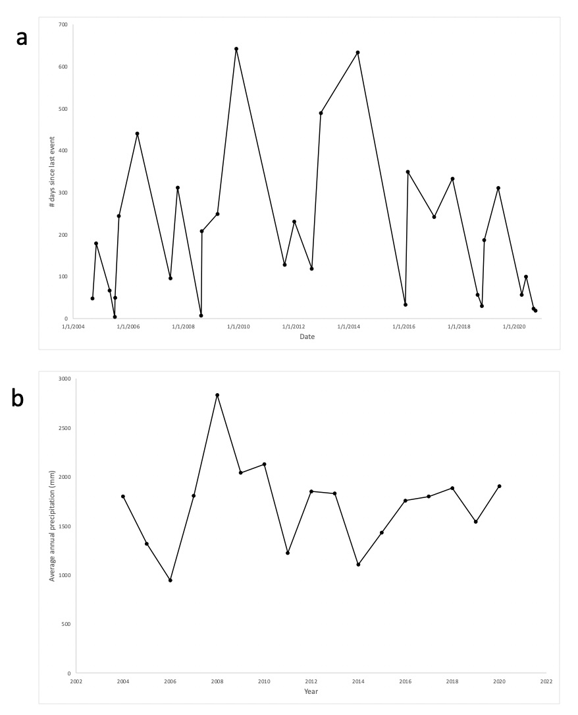
Supplemental Figure 1 (a-b). Average annual precipitation and interval between storms (2004-2020).
Line plot of (a) average annual precipitation and (b) the interval between storms (i.e., potential recovery time) over the study period from 2004 to 2020. For plot (a) year is on the x-axis and average annual precipitation in millimeters on the y-axis, and (b) number of days since last event; no trend line was added for either plot since the linear regression was non-significant (p > 0.05).
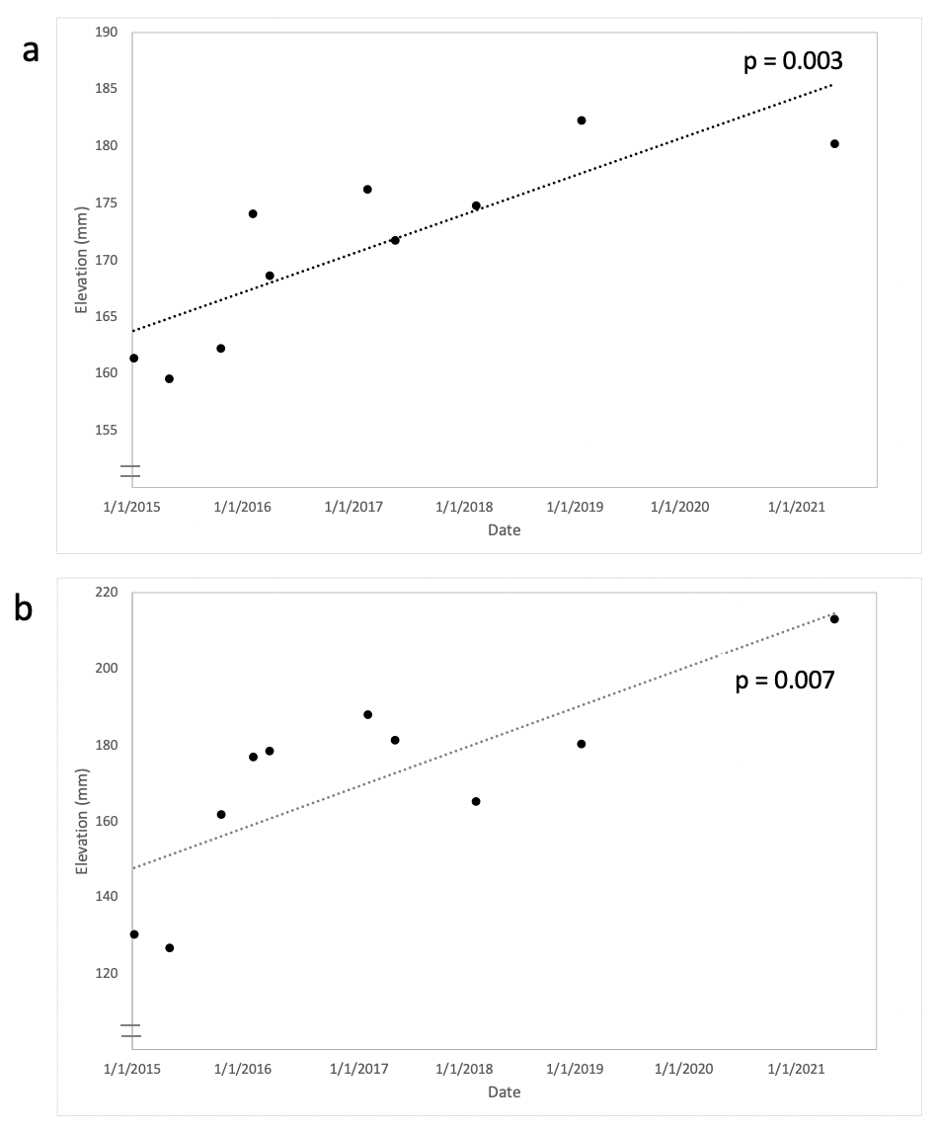
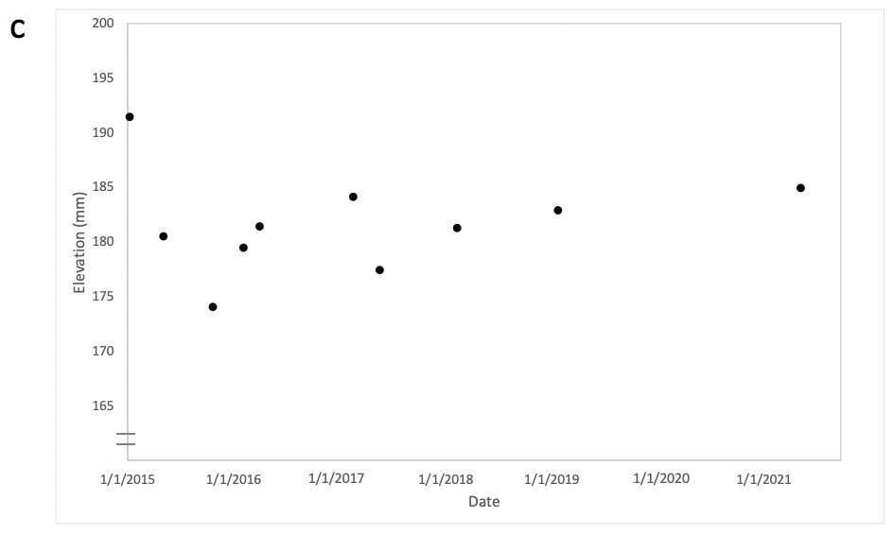
Supplemental Figure 2 (a-c). Elevation changes in three types of wetlands at Weeks Bay, Alabama (2015-2021).
Scatterplots with elevation changes in three types of wetlands as measured by surface elevation tables at Weeks Bay National Estuarine Research Reserve: (a) emergent herbaceous wetlands, (b) herbaceous-woody ecotone, and (c) woody wetlands. Linear trend lines were added for linear regressions which were statistically significant (p < 0.05). Data were provided by the Weeks Bay NERR (S. Phipps, personal communication).

