Supplementary file contains the information about Manhattan and Q-Q plots of the under studied traits.
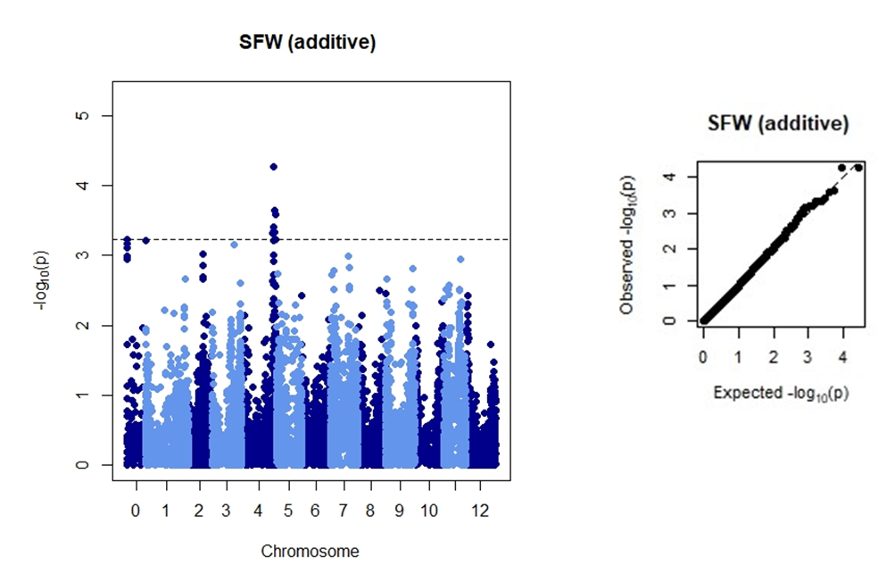

Fig. 1S. Manhattan plot showing significant SNPs associated with stolon fresh weight (left). Q-Q plot depicting the normal distribution of the data (right).
Stolon fresh weight (SFW)

Fig. 2S. Physical position of identified SNPs on the chromosomes.

Fig. 3S. Manhattan plot showing significant SNPs associated with stolon dry weight (left). Q-Q plot depicting the normal distribution of the data (right).
Fig. 4S. Localization of Identified SNPs on the chromosomes. *shows pleiotropic SNPs.
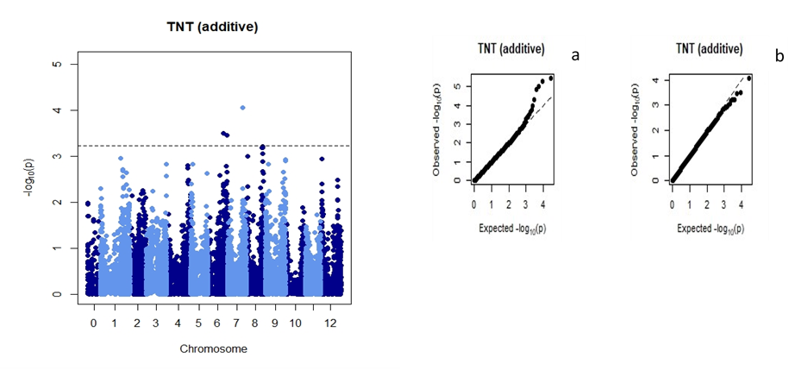
Fig. 5S. Manhattan plot (left) showing significantly associated SNPs (-log10 (P) threshold of 3.23 in blue dotted line) Q-Q plot (right) before (a) and after (b) for total number of tubers (TNT) of potato using BLUPs.
Fig. 6S. Physical chromosomal map exhibiting the localization of significant SNPs linked with TNT along with the corresponding physical distance in base pair (bp). Pleiotropic SNPs are indicated by *
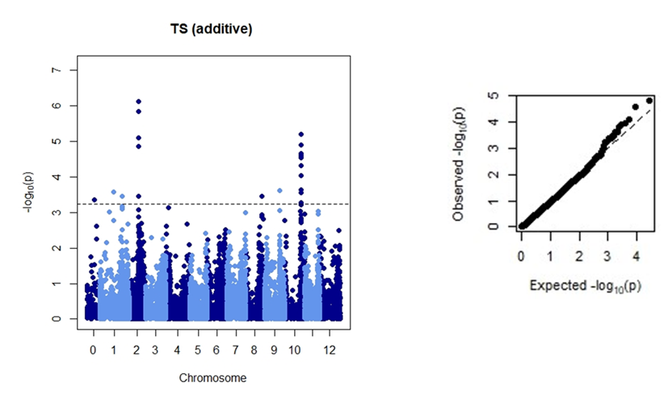
Fig. 7S. Manhattan plot showing significant SNPs associated with stolon fresh weight (left). Q-Q plot depicting the normal distribution of the data (right).

Fig. 8S. Physical position of identified SNPs on the chromosomes.

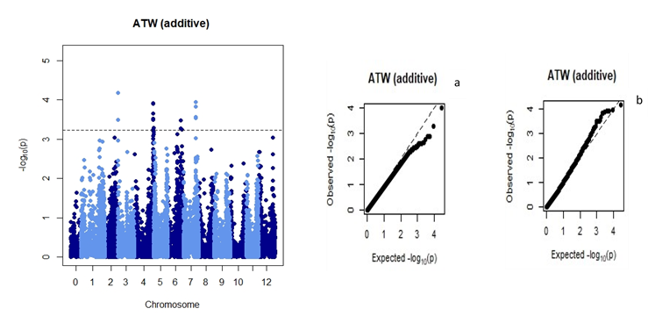
Fig. 9S. Manhattan plot showing significant SNPs associated with average tuber weight (left). Q-Q plot depicting the normal distribution of the data (right).

Fig. 10S. Physical position of identified SNPs on the chromosomes.

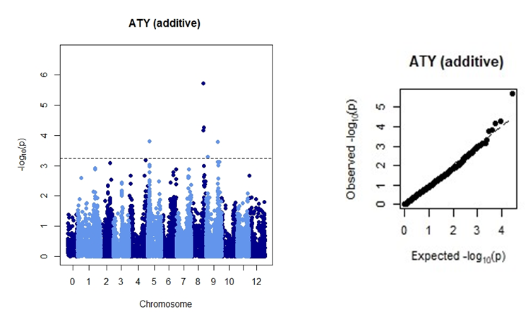
Fig. 9S. Manhattan plot showing significant SNPs associated with average tuber yield (left). Q-Q plot depicting the normal distribution of the data (right).
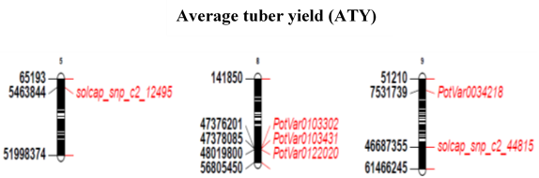
Fig. 12S. Physical position of identified SNPs on the chromosomes.

