Supporting Information

NIR Light-Induced DNA Nanodevice for Amplified mRNA Imaging and Precise Gene Therapy
Miaomiao Xiang¹, Yuelin Jiang¹, Jiajia Zhou², Guochen Bao², Xianzhu Luo¹, Dayong Jin ², Yuezhong Xian^{*,1} and Cuiling Zhang^{*,1}
¹ The Shanghai Engineering Research Center of Molecular Therapeutics and New Drug Development, Department of Chemistry, School of Chemistry and Molecular Engineering, East China Normal University, Shanghai, 200241, China
E-mails: yzxian@chem.ecnu.edu.cn, clzhang@chem.ecnu.edu.cn
² Institute for Biomedical Materials and Devices, School of Mathematical and Physical Sciences, Faculty of Science, University of Technology Sydney, Sydney, NSW, 2007, Australia

Experimental Section
Chemicals: Poly-L-lysine, oleic acid (OA, 90%), hydrogen tetrachloroaurate trihydrate (HAuCl₄·3H₂O), Gel-Red, 1-octadecene (ODE, 95%) and sodium dodecyl sulfate (SDS) were bought from Sigma-Aldrich. LnCl₃·xH₂O (Ln = Y, Yb, and Tm), sodium citrate, NaOH (98%) and NH₄F (98%) were obtained from Aladdin Industrial Co. Ltd. (Shanghai, China). Fetal bovine serum (FBS) and penicillin-streptomycin (P/S) solution were obtained from Dingguo Biotech Co. Ltd. (Shanghai, China). Trypsin, RIPA Lysis Buffer, trizol, lipofectamine 6000, anti-Bcl-2 antibody, anti-GAPDH antibody, annexin V /PI apoptosis assays kit, the CCK-8 reagent and BCA protein assay kit were supplied by Beyotime Biotechnology Co. Ltd. All DNA sequences (Table 1) used in this work were synthesized by Sangon Biotech Co. Ltd. (Shanghai, China). All other reagents in this work were employed as analytical grade without further purification.
Instrumentations: F-7000 (Hitachi, Japan) was employed to measure fluorescence spectra. Kinetics fluorescence and vitro cytotoxicity assays were detected by TECAN Infinite M NANO⁺ (Tecan, Switzerland). UV-2550 spectrophotometer (Shimadzu, Japan) was used to detect UV−vis absorption spectra. TEM images were obtained via HT-7700 (Hitachi, Japan). Zetasizer Nano ZS90 (Malvern, U.K.) was employed to test the size distribution and ζ potential. Confocal fluorescence imaging was conducted at a Nikon C2 confocal laser scanning microscope (Nikon, Japan). Flow cytometry was carried out on the flow cytometer (FACSCanto II). The PAGE characterization was conducted on EPS 300 electrophoresis apparatus (Tanon, Shanghai) and imaged on UV transilluminator of the UVP GelDoc-It 310 Imaging System. In vivo and ex vivo fluorescence images were acquired using an IVIS spectrum system (PerkinElmer, USA).
Fluorescence analysis in solution: In order to assess the feasibility of PLc probe under illumination, the PLc probes were exposed to UV light for 8 min in the buffer solution (20 mM HEPES). Then, the target was added and the fluorescence intensity at 520 nm was measured after reaction at 37 ℃ for 1 h.
PAGE characterization: Different reaction mixtures were loaded into 12% agarose gel. Then the agarose gel electrophoresis was conducted at 110 V for 70 min, further stained using Gel Red for 20 min. Finally, the gel was photographed using electrophoresis system (EPS 300).
Construction of DNA walking system.AuNPs and oligonucleotide functionalized AuNPs were prepared¹. Briefly, trisodium citrate aqueous solution (1% (w/v)) was added to boiled HAuCl₄ solution (0.01% (w/v)), stirring vigorously for 15 min, and then cooled down to room temperature. The obtained colloidal suspension (AuNPs) was filtered with a 0.22 µm sterile syringe filter. The concentration of AuNPs was concentrated to 10 nM by centrifugation. Thiol-modified L and A strands were mixed with AuNPs and the mixture was divided into 10 Eppendorf tubes. All the tubes were placed in a freezer (-20 ℃) for 2 h and then thawed at room temperature. After that, the excess oligonucleotide was further removed by centrifugation and the precipitated AuNPs were resuspended in PBS with 0.01 % Tween-20. Then, the DNA-AuNPs colloidal was mixed with B and C strands, and heated at 65°C for 15 min in the dark. After overnight incubation, the resultant solution was washed and centrifuged at 4°C. Finally, the DNA functionalized AuNPs were dispersed in PBS solution with 0.01% Tween-20.
Evaluation the viability of the DNA Walking System. To investigate the viability of the walking system, the kinetic fluorescence of DNA-AuNPs (0.2 nM) was analyzed in PBS (pH 7.4) containing 5 nM W and 500 nM F. Kinetic fluorescence of the DNA walking system activated by P3 (5 nM) was recorded in a 384-well plate after treatment at 37°C for 5 h via TECAN Infinite M NANO⁺.
Preparation of Core−Shell UCNPs (NaYF₄: Yb/Tm@NaYF₄). According to the previous method reported by the literature², core-shell UCNPs (NaYF₄:20%Yb, 0.5%Tm@NaYF₄) were synthesized. The aqueous lanthanide chloride solution (1.59 mmol YCl₃, 0.40 mmol YbCl₃ and 0.01 mmol TmCl₃) was added to 15 ml oleic acid and 30 ml 1-octadecene. The mixture was heated to 156 °C for 1 h upon argon protection to remove all water. After cooling to room temperature, 8 mmol NH₄F and 5 mmol NaOH were added to methanol solution. After stirring for 2 h, the mixture was heated to 100 °C to remove the methanol and then quickly heated until the system was kept at 300 °C for 1 h and cooled down to room temperature in argon atmosphere. Ethanol was added to precipitate and centrifuge to obtain the product NaYF₄: Yb/Tm UCNPs. The product was washed three times with ethanol and cyclohexane, and finally dispersed in 20 mL of cyclohexane.
NaYF₄: Yb/Tm@NaYF₄ was synthesized by adding YCl₃·6H₂O aqueous solution to 30 mL of 1-octadecene and 15 mL of oleic acid. The mixture was then heated to 156 ℃ for 1 h, Then, the reaction mixture was cooled down to 25 ℃. The prepared NaYF₄: Yb/Tm was added and the cyclohexane was removed by heating system. And then, the methanol solution with NH₄F and NaOH were added. After removing methanol, the system was heated to 300 ℃ for 1 h for shell growth. The post-processing procedure of product NaYF₄: Yb/Tm@NaYF₄ nanocrystals is the same as that of NaYF₄: Yb/Tm UCNPs.

Preparation of CS-UCNPs/PLL/DNA. Ligand-free CS-UCNPs were prepared by removing oleic acid ligand with hydrochloric acid solution. After 10 min of ultrasonic treatment, ligand-free CS-UCNPs and poly-l-lysine (PLL) (mass ratio 2:1) were stirred in PBS buffer solution at room temperature for 24 h. The UCNPs/PLL were harvested by centrifugation, washed and then stored in the HEPES buffer. Then, UCNPs /PLL was mixed with the annealed PLc probes (molar ratio = 40:1). Then the solution was stirred for 2 h and centrifuged to obtain UCNPs /PLc. Lastly, the prepared probes were washed and stored in HEPES buffer at 4℃.
Optimization of NIR illumination Time. Fluorescence intensity was measured in the HEPES buffer. To investigate the optimized exposure time, UCNPs/PLc was treated with NIR illumination for different times (1.2 W/cm², 1 min break after 1 min illumination). With the addition of target mRNA to the solution, the fluorescence intensity was further measured after incubation at 37 °C for 1 h.
Cell culture. HeLa cells were cultured in DMEM with the addition of 100 U/mL penicillin, 10% FBS and 100 μg/mL streptomycin in a humidified atmosphere containing 5% CO₂ at 37℃.
Investigation of the Cell Viability. After being cultured in a 96-well plate for 24 h, HeLa cells (100000 cells/mL) were treated with the NIR-photoactivatable DNA nanodevice (2 nM DNA walking system and 10 nM UCNPs-PLc) for 2 h. Exposed with NIR light for 20 min (1.2 W/cm² ) and incubated for another 24 h, cell viability was assessed using CCK-8 reagent.
Bioimaging of intracellular mRNA. The mRNA imaging was conducted via a Nikon confocal scanning system. The process was as follows: aliquots (500 μL) of DMEM with 10% FBS containing HeLa (1×10⁵ cells per well) were seeded into a 4-chamber glass bottom dish. After incubation for 24 h, the Hela cells were washed three times with PBS. A 2 μL aliquot of Lipofectamine-6000 was diluted in 40 μL Opti-MEM (solution I). Then, 5 μL AuNP-DNA (10 nM) was diluted in 20 μL Opti-MEM (solution II). 2 μL F (20 μM) and 1 μL W (2 μM) were diluted in 20 μL Opti-MEM (solution III). After incubation at room temperature for 10 min, solution II mixed with half of solution I, and solution III mixed with the other half of solution I. After incubation at 37 °C for 20 min, all the solutions were mixed and 400 μL DMEM was added to the mixture. Then, the mixture of the above solution and UCNPs-PLc or UCNPs-Lc was added into each well and incubated at 37 °C in a humidified incubator for 1 h, then irradiated with 980 laser irradiation (1.2 W/cm²) and incubated at 37 ° C for 2 h. After washing three times with PBS, the fluorescence images of the cells were obtained via a Nikon confocal scanning system with a 40× objective.
qRT-PCR analysis. The total RNAs were obtained from HEK-293T, MCF-7 and HeLa cells using a Trizol reagent kit based on the product instruction. RNA was further transformed into cDNA. Relative expression levels of survivin mRNA in three cell lines were detected by using β-actin as an endogenous gene expression and were calculated by 2^{−△△Ct}.
Cell apoptosis analysis. Apoptosis analysis was tested using Annexin V and propyl iodide (PI) assay kits. After washing two times by PBS, the cells were incubated with UCNP-PLc+DNA walker and UCNP-Lc+DNA walker, respectively and subjected to corresponding NIR light treatment. After 2 h culture at 37 ºC, fresh medium was replaced and further incubated for 48 h. The treated cells were stained with 10.0 μL propidium iodide (PI) and 5.0 μL Annexin V for 10 min and subjected to CLSM imaging at room temperature. In addition, the treated cells were collected and suspended in Annexin V binding buffers containing 10.0 μL propidium iodide and 5.0 μL Annexin V. The samples were examined on flow cytometry, and the viability of the cells under different treatments was measured using a CCK-8 kit.
Western blot analysis. After Hela cells were incubated with the same material and exposed to NIR light, fresh medium was replaced and incubated for 48 h. The cells were then lysed in RIPA lysis buffer for 10 min and centrifuged at 4 ºC for 30 min to collect total proteins. All cell proteins were isolated by SDS-PAGE and then transferred to polyvinylidene fluoride (PVDF) membranes. Then, the monoclonal antibody and secondary antibody of Bcl-2 were added successively and co-incubated with PVDF membrane. The protein expression was detected and analyzed by image Lab software (Bio-RAD).
Care and use of animals. All animal investigations were conducted in accordance with the guidelines approved by the Institutional Animal Care and Use Committee of East China Normal University (No. m20221108). Female BALB/c mice aged 6-8 weeks were obtained and maintained in a specific pathogen-free environment. The HeLa bearing mice were obtained by subcutaneously injecting HeLa cells (~2×10⁶ cells/100 μL in PBS/ Matrigel, 1:1 (v/v)) into mice on the right back of the hind leg region.
Ex vivo fluorescence imaging. When the tumor volumes (V=a×b² /2, where a means length and b means width) reached to 100-200 mm³, Cy5-labeled DNA walker system and UCNP-PLc (50 nmol/kg) was injected into the mice intravenously. After 4 h of i.v. injection, the tumors were treated with NIR light for 20 min (1.2 W/cm²). Then, the images were taken on IVIS Spectrum in vivo imaging system at 0, 2, 4, 6 h post-irradiation. After in vivo imaging, tumors and the major organs (heart, liver, spleen, lung, and kidney) were immediately collected and imaged.
Anti-tumor efficacy. When the tumor volumes grew to 100-200 mm³, the mice were randomly divided into 4 groups (n = 6) for the treatment with UCNP-Lc+DNA walker and UCNP-PLc+DNA walker (with DNA dose of 100 nmol/kg), then exposed to the NIR irradiation (1.2 W/cm²) of the tumor region for 20 min. All mice received the treatment at 1, 4 and 7 days, while their tumor sizes and body weights were recorded every two days. After being treated for14 days, mice were sacrificed and their tumors were harvested to obtain the final weights and sizes. The tumors were collected and fixed with 4% paraformaldehyde for 24 h. The H&E staining of slices of tumors was carried out to analyze the therapeutic effect.
Table 1. DNA sequences used in this work.
Name | Sequence(5’-3’)
SR | GTAGAGATGCGGTGGTCCTTGAGAAAGGGCTGC-BHQ1
P1 | FAM-GCAGCCCTTTCT
P2 | CAAGGAC-PC-CACCGCATCTCTACTCAGTCTG
P3 | CACCGCATCTCTACTCAGTCTG
T | GCAGCCCTTTCTCAAGGACCACCGCATCTCTAC
L | SH-TTTTTTTTTTTTTTTTTTTTTTTTT-CAGACTGAGTA
A | SH-TTTTTTTTTT TCTCACTAACTTACGG
B | TCTCCCAGCGTGCGCCATTT
W | GAGATGCGGTGTTTTTTTTTTTTTTTTTTTTTTTTTTTTTTCAGCGTGCGCCATTTATGTC
C | GACATAAATGGCGCACGCTGGGAGACCGTAAGTTAGTGAGA-FAM
F | TAACTTACGGTCTCCCAGCGTGCGCCATTT
P2-nPC | CAAGGACCACCGCATCTCTACTCAGTCTG
SR(2) | GTAGAGATGCGGTGGTCCTTGAGAAAGGGCTGC-BHQ2
P1(2) | TAMRA-GCAGCCCTTTCT
TK1 mRNA | CAGTACAAGTGCCTGGTGATCAAGTATGCCAAA
c-myc mRNA | CCTCAACGTTAGCTTCACCAACAGGAACTATGA
GalNAc-T mRNA | GCTTTCACTATCCGCATAAGACACCCGCCCAAC
miRNA-21 | TAGCTTATCAGACTGATGTTGA
miR-141 | TAA CAC TGT CTG GTA AAG ATG G
miR-222 | CTC AGT AGC CAG TGT AGA TCC T
P1(3) | Cy3-GCAGCCCTTTCT
C(2) | GACATAAATGGCGCACGCTGGGAGACCGTAAGTTAGTGAGA-Cy5
Table S2 Comparison of different signal amplification systems for mRNA detection.

Method | Operation and procedures | Linear range | Ref.
Fluorescence | nonenzymatic hairpin DNA cascade reaction | 0.5 nM-10 nM | ³
Fluorescence | accelerated DNA cascade HCR reaction | 50 pM - 50 nM | ⁴
Fluorescence | MnO₂/Cas12a nanoprobe | 0.2 nM - 50 nM | ⁵
Fluorescence | self-powered DNA motor | 2.5 nM - 20 nM | ⁶
Fluorescence | dual-color encoded DNA nanomachine | 0.1 nM - 10 nM | ⁷
Fluorescence | primer exchange reaction-based DNA machine | 5 pM - 20 nM | ⁸
Fluorescence | NIR light-launched DNA walker nanodevice | 20 pM-5 nM | This work

Figure S1. Investigation the stability of the PLc probe. (a) Fluorescence signal of Lc under different conditions. (b) PAGE characterization of Lc upon the UV illumination. Lc (lane 1), T (lane 2), Lc +UV (lane 3), Lc +T (lane 4), Lc +T+UV (lane 5), respectively.
Figure S2. TEM images of (a) core and (b) CS-UCNPs. Scale bar is 200 nm. (c) The luminescence of core and CS-UCNPs excited at 980 nm, respectively.

Figure S3. Characterization of the assembly process of UCNPs and PLc. (a) The hydrodynamic size distribution and (b) Zeta potential of UCNPs, UCNPs/PLL and UCNPs/PLL/PLc. (c) UV-Vis spectra of UCNPs/PLc and UCNPs.

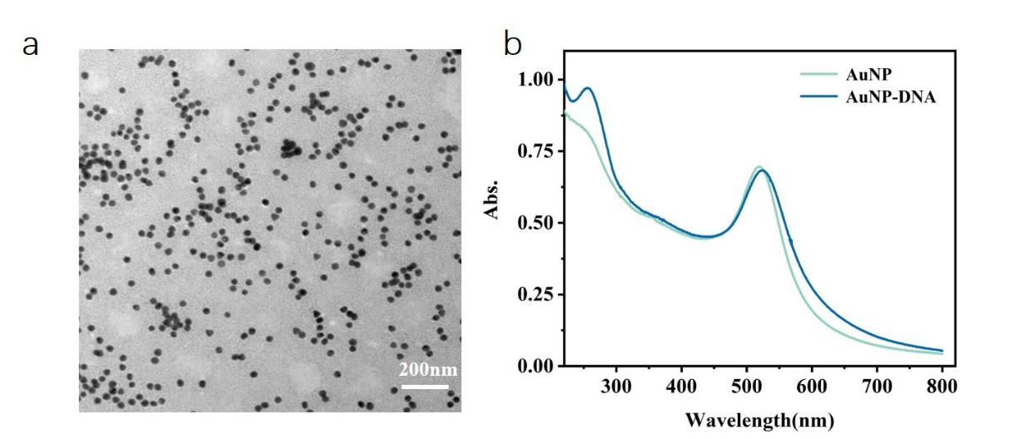
Figure S4. Characterization of AuNPs and AuNPs-DNA. (a) TEM image of AuNPs. (b) UV absorption spectra of AuNPs before and after modified with DNA.

Figure S5. Investigation on the characteristics of DNA walker. (a) Feasibility of the walker system initiated by P3. (b) Polyacrylamide gel electrophoresis for monitoring the catalytic disassembly reaction. F(lane1); C/F (lane 2); AuNPs-DNA, W and T (lane 3); AuNPs-DNA, W and F (lane 4); AuNPs-DNA, T and F (lane 5); AuNPs-DNA, W, T and F (lane 6). (c) Optimization of the concentration of F. (d) Optimization of the concentration of W. (e) Kinetic fluorescence detection with addition of different concentrations P3. (f) Linear responses of the DNA walking system vs P3 based on (e).
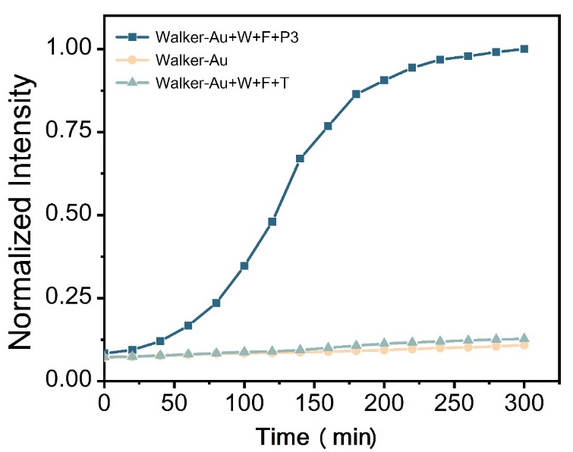
Figure S6. The fluorescence response of DNA walking system activated by P3 compared with target mRNA.

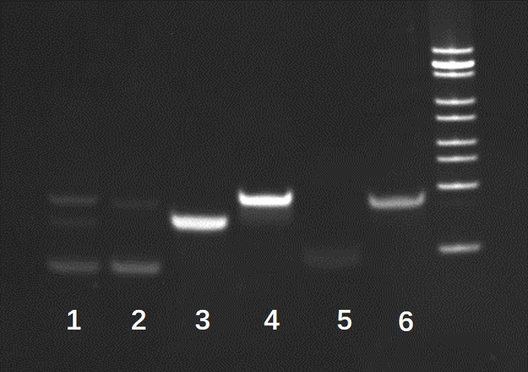

Figure S7. Evaluation of the feasibility of the system via PAGE characterization. The PLc was cleaved by the UV light and P3 was released to activate the DNA walking signal amplification process by adding target mRNA. PLc + T + DNA walker +UV (lane 1); PLc + T + DNA walker (lane 2); SR/T (lane 3); C/F (lane 4); T (lane 5); PLc (lane 6), respectively.

Figure S8. The stability of UCNP-PLc (a) and DNA walker system (b) against Cell lysis and DNase I.

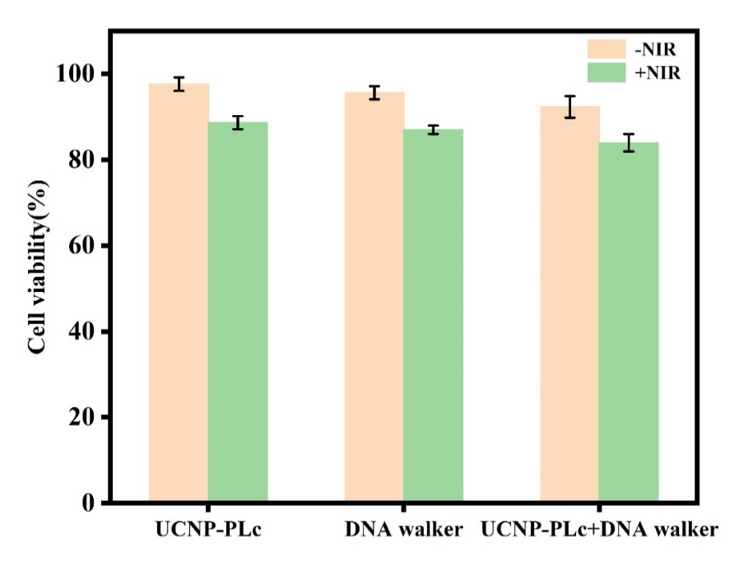
Figure S9. The viability of HeLa cells treated with UCNP-PLc (1), DNA walker (2), UCNP-PLc+DNA walker (3) with or without NIR irradiation.

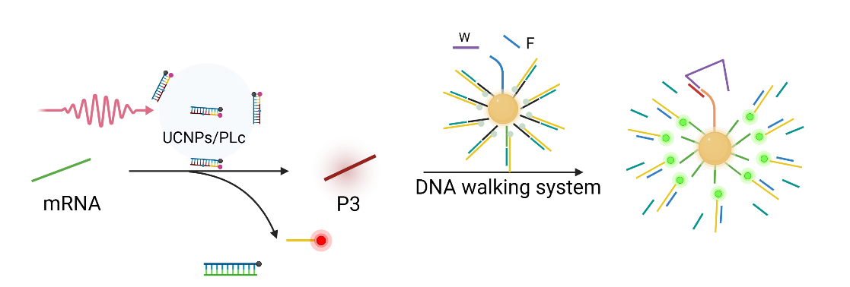
Figure S10. Simplified sensing performance of intracellular survivin mRNA with the NIR-photoactivatable DNA nanodevice.

Figure S11. Confocal fluorescence images of HeLa cells treated with UCNP-PLc and DNA walker with NIR illumination. Scale bar = 50 µm.

References
1 C. P. Liang, et al. Rational engineering of a dynamic, entropy‐driven DNA nanomachine for intracellular microRNA imaging.Angew. Chem. Int. Ed. 56, 9077-9081 (2017).
2 H. Chu, J. Zhao, Y. Mi, Y. Zhao&L. Li, Near-infrared light-initiated hybridization chain reaction for spatially and temporally resolved signal amplification. Angew. Chem. Int. Ed. 58, 14877-14881(2019).
3 C. Wu, S. et al. A nonenzymatic hairpin DNA cascade reaction provides high signal gain of mRNA imaging inside live cells. J. Am. Chem. Soc. 137, 4900-4903(2015).
4 K. Ren, Y. Xu, Y. Liu, M. Yang&H. Ju, A responsive “nano string light” for highly efficient mRNA imaging in living cells via accelerated DNA cascade reaction. ACS Nano 12, 263-271(2018).
5 D. Wang et al. MnO₂ nanosheets as a carrier and accelerator for improved live-cell biosensing application of CRISPR/Cas12a. Chem. Sci., 13, 4364–4371(2022).
6 J. Wang, D. Wang, A. Tang&D. Kong, Highly integrated, biostable, and self-powered DNA motor enabling autonomous operation in living bodies. Anal. Chem. 91, 5244-5251 (2019).
7 C. Zhao et al. Simultaneous imaging and visualizing the association of survivin mRNA and telomerase in living cells by using a dual-color encoded DNA nanomachine. Anal. Chem., 95, 1498-1504 (2023).
8 J. Zhang et al. Biomineralized metal–organic framework nanoparticles enable a primer exchange reaction-based DNA machine to work in living cells for imaging and gene therapy. Chem. Sci. 11,7092-7101(2020).

