Supplementary material
Green and facile synthesis of N,S co-doped carbon quantum dots with a high product yield for selective detection of Hg²⁺ in aqueous system

Haitao Ren¹ ⋅ Abdelkader Labidi¹ ⋅ Jinhua Sun² ⋅ Ahmed A. Allam³ ⋅ Jamaan S. Ajarem⁴ ⋅ Mostafa R Abukhadra⁵ ⋅ Chuanyi Wang^{1,*}

¹School of Environmental Science and Engineering, Shaanxi University of Science and Technology, Xi'an 710021, P. R. China
²Division of Materials and Manufacture, Department of Industrial and Materials Science, Chalmers University of Technology, 41296 Göteborg, Sweden
³Zoology Department, Faculty of Science, Beni-Suef University, Beni-suef 65211, Egypt
⁴Zoology Department, College of Science, King Saud University, Riyadh 11451, Saudi Arabia
⁵Materials Technologies and their Applications Lab, Geology Department, Faculty of Science, Beni-Suef University, Beni-Suef City 65211, Egypt

*Corresponding author. E-mail address: wangchuanyi@sust.edu.cn

Materials
CaCl₂, La(NO₃)₃·6H₂O, Cu(NO₃)₂·3H₂O, Zr(NO₃)₄·5H₂O, ZnSO₄·7H₂O, Mg(NO₃)₂·6H₂O, Pb(NO₃)₂, Fe(NO₃)₃·9H₂O, Ba(NO₃)₂, and Al(NO₃)₃·9H₂O were purchased from Macklin Reagent Co., Ltd. (Shanghai, China). Hg(NO₃)₂·2H₂O, Methyl orange, Sr(NO₃)₂, Co(NO₃)₂·6H₂O, Cr(NO₃)₂·9H₂O, NaCl, KCl, AgNO₃, HCl, Mn(NO₃)₂·4H₂O, NaOH, and Cd(NO₃)₂·4H₂O were obtained from Aladdin Industrial Corp. (Shanghai, China). 3-(4,5-dimethyl-2-thiazoyl)-2,5-diphenyl tetrazolium bromide (MTT, 98%) was purchased from Beijing Solarbio Science & Technology Co., Ltd. (China). Cell lines A549 were obtained from the Shanghai Saibaikang Biological Technology Co., Ltd. (China). All chemical reagents used in this work were of analytical grade and used without any further purification.
Instruments
High-resolution transmission electron microscope (HR-TEM) and selected area electron diffraction (SAED) patterns were performed on a FEI Talos F200i field emission electron microscope operating at a voltage of 200 kV. X-ray diffraction (XRD) patterns (2θ scans) were recorded using a Smartlab 9 kW advance powder diffractometer with Cu Kα radiation. Raman spectrum was recorded on a HORIBA LabRAM HR Evolution Raman Spectrometer with a 532 nm laser. Fourier transform infrared (FTIR) spectra was carried out in the KBr medium on a Brucker (Verte70 V) spectrometer. X-ray photoelectron spectra (XPS) were performed on a Thermo Scientific K-Alpha spectrometer using Al Kα X-ray beam of 250 W as the excitation source. Zeta potential measurement was conducted on a Malvern Zetasizer Nano ZS90. Ultraviolet-visible (UV-vis) absorption spectrum was measured using a Cary 5000 UV-vis spectrophotometer. The PL spectra were acquired using an Edinburgh Instruments FS5 spectrofluorometer; lifetime measurements were performed on the same FS5 Edinburgh Instruments equipped with an EPLED-340 pulsed source.
Calculation of the PL quantum yield

The absolute quantum yield (QY) was measured with an Edinburgh FS5 fluorescence spectroscope. The excitation wavelength was 330 nm, and the solvent in this experiment was ultrapure water. The QY of N,S-CQDs was determined by using the following equation (Liu et al. 2017):

$$QY=\frac{emission}{solvent-sample}$$

where Ι_{emission} is the PL emission of N,S-CQDs, Ι_{solvent} is the spectrum of the light used for excitation in the presence of solvent only, Ι_{sample} is the spectrum of the light used to excite the N,S-CQDs. They were collected by using the integrating sphere.
Energy level measurement
To determine the lowest unoccupied molecular orbital (LUMO) energy level of N.S-CQDs, the cyclic voltammetry (CV) was measured by using a conventional three-electrode system on an IGS4030 electrochemical workstation (Guangzhou, China), which consists of a N,S-CQDs coated glassy carbon electrode as the working electrode, a platinum wire as the counter electrode, and an Ag/AgCl electrode as the reference electrode. All electrodes were put in an electrolytic cell containing 0.1 M PBS buffer solution (pH = 7.0). CV curves were conducted at a scan rate of 100 mV/s in the voltage range of -2.1 to 1.6 V.
XPS and FT-IR Characterization
The surface groups of N,S-CQDs were determined by FT-IR spectrum. As displayed in Fig. S7 (a), two absorption peaks at 3418 and 3346 cm⁻¹ are designated as the vibrations of the O–H and N–H bonds, respectively. The absorption bands at 1040, 1398, 1548, 1714, and 2976 cm⁻¹ are assigned to the vibrations of C–O–C, C–N, C=C, C=O, and C–H bonds, individually. Then, the peak appearing at 1250 cm⁻¹ suggests the formation of C-S bonds in the obtained CQDs. Moreover, the presence of two peaks at 607 and 970 cm⁻¹ implies the existence of C–S bond. These findings confirm that the CQDs backbone is heavily doped by N and S. Furthermore, XPS technology was utilized to explore the chemical compositions of the obtained N,S-CQDs. Fig. S7 (b) displays the XPS survey spectrum of N,S-CQDs containing four representative peaks at 284.8, 531.1, 400.1 and 164.2 eV, which respectively correspond to C1s, O1s, N1s, and S2p. The atomic content of C, O, N, and S are 68.11%, 21.41%, 8.10%, and 2.38%, respectively. The C1s spectrum of N,S-CQDs (Fig. S7c) exhibits three different peaks appear at 284.8, 286.1 and 288.4 eV, which are assigned to different atoms bonds such as C=C/C–C, C–N/C–O/C–S and C=O, respectively. The O1s spectrum of N,S-CQDs (Fig. S7d) exhibits two peaks appear at 531.2 and 532.8 eV, corresponding to C=O and C–OH/C–O–C bonds. The N1s spectrum of the synthesized N,S-CQDs (Fig. S7e) reveals three typical peaks appear at 399.3, 400.3, and 401.8 eV, which are assigned to C–N–C, N–(C)₃ and N–H bonds, respectively. The S2p spectrum of N,S-CQDs (Fig. S7f) displays two distinct peaks appear at 167.4 and 168.9 eV, implying the formation of S–C and S–(O)₃ bonds in the prepared CQDs. To sum up, the synthesized CQDs are not only doped by N and S, but also have N, S, and O-containing groups on its surface. These functional groups ensure CQDs good monodispersity and water solubility and facilitate their application in sensing detection.

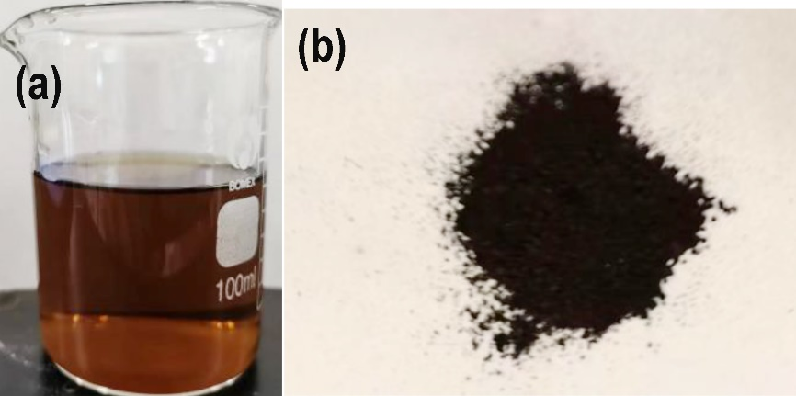

Fig. S1 Appearance pictures of as-obtained N,S-CQDs suspension (a) and powder (b)

Fig. S2 Possible formation mechanism of N,S-CQDs from MO

Fig. S3 Raman spectrum of N,S-CQDs

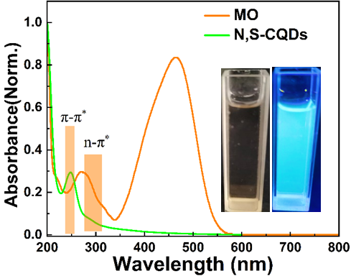

Fig. S4 UV-vis spectra of MO and N,S-CQDs (Insets show photographs of the N,S-CQDs suspension under sunlight and UV illumination)
Fig. S5 a PL excitation and emission spectra; b calculated Commission Internationale del’Eclairage (CIE) coordinates from the PL spectra of N,S-CQDs; c schematic mechanism diagram of the excitation-dependent PL characteristic

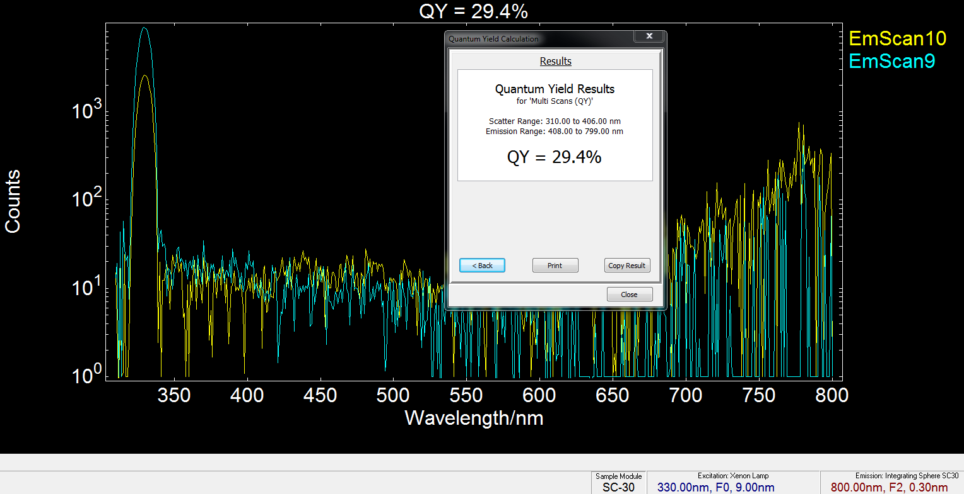

Fig. S6 Calculation of PL quantum yield of N,S-CQDs

Fig. S7 a FT-IR spectra of MO and N,S-CQDs; b Survey XPS spectrum; c C1s; d O1s; e N1s and f S2p spectrum of as-obtained N,S-CQDs

Fig. S8 Effect of different ions on N,S-CQDs PL intensity

Fig. S9 Zeta potential curves of N,S-CQDs (a) and N,S-CQDs + Hg²⁺ (b)

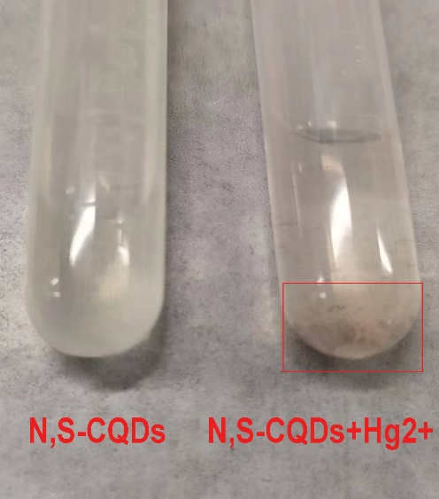

Fig. S10 Image of brown aggregation formed after addition of Fe³⁺ in CQDs suspension

Table S1 Comparison of the CQDs properties derived from other precursors and methods
Precursor | Synthetic method | Wavelength/nm | Quantum yield/% | Production yield/% | Ref.
Ethanolamine, phosphoric acid | Microwave hydrothermal | 340/417 | 20.5 | 15.0 | (Jiang et al. 2018)
Fructose | Micro-plasma treatment | 370/450 | 0.9 | 16.6 | (Kurniawan et al. 2022)
Fresh lemon juice | Hydrothermal treatment | 410/482 | 13.6 | 0.1 | (He et al. 2018)
Chitosan | Dissolved with HNO₃  and hydrothermal | 320/400 | 10.0 | NA | (Liang et al. 2016)
Ethylene gas | Plasma assisted deposition | 360/420 | 13.5 | 10.0 | (Park et al. 2019)
Poplar leaves | One-step hydrothermal | 460/510 | 10.64 | NA | (Li et al. 2019)
C60 | Thermal decomposition | 400/510 | 7.4 | 15.0 | (Chen et al. 2016)
Cranberry beans | Hydrothermal treatment | 380/450 | 10.85 | NA | (Zulfajri et al. 2019)
Egg | Plasma-induced method | 360/420 | 8.0 | 5.96 | (Wang et al. 2012)
Bee pollen waste | Hydrothermal method | 365/440 | 4.8 | NA | (Shan et al. 2022)
Food wastes, ethanol | Ultrasound irradiation | 330/400 | 2.85 | 0.12 | (Park et al. 2014)
Succinic acid, trisamine | Microwave-assisted synthesis | 340/422 | 49.9 | 17.3 | (Chae et al. 2017)
Lysine | Microwave pyrolysis | 360/432 | 23.3 | 30.0 | (Choi et al. 2017)
Methyl orange | One-step hydrothermal | 330/447 | 29.4 | 75.6 | This work
NA: Not Available

Table S2 Examples and comparison of the reported CQDs in the literature used to detect Hg²⁺
Probe | Linear Range | LOD | Ref.
N-CQDs from sodium citrate and urea | 0.001–5 µM | 0.65 μM | (Ren et al. 2018)
CQDs from citric acid and melamine | 2–14 μM | 440 nM | (Pajewska et al. 2020)
CQDs from graphene | 2.5–800 μM | 2.5 μM | (Liu et al. 2019)
Cellulose-derived CQDs | 6–80 μM | 1.0 μM | (Wang et al. 2016)
Sugarcane based CQDs | 25–100 μM | 0.1 μM | (Kasinathan et al. 2020)
S, N-GQDs from citric acid and thiourea | 12–125 μM | 9.14 μM | (Sharma et al. 2019)
CQDs from diethylenetriamine and citric acid | 0–80 μM | 201 nM | (Wang et al. 2017)
S-CQDs from Na₂S and citric acid | 0.5–180 μM | 222 nM | (Wang et al. 2019)
N,S-CQDs from methyl orange | 0.5–30 μM | 237 nM | This work

Table S3 PL lifetime components of obtained CQDs with double exponential fit decay curves in the absence and presence of Hg²⁺ ions (τ = lifetime, A = relative amplitude)
Sample τ₁ (ns) A₁ (%) τ₂ (ns) A₂ (%) τ_{avg}
N,S-CQDs 2.360 51.77 11.73 48.23 6.902
N,S-CQDs+100 μM Hg²⁺ 2.190 49.79 11.80 50.21 7.010
The fitting formula is:
where τ is time, B₁, B₂, B₃, and B₄ are fractional intensities, τ₁, τ₂, τ₃, and τ₄ are PL lifetime, the parameters obtained from iterative reconvolution of the decay with the instrument response function (IRF). The excitation wavelength in this measurement was 330 nm.

The average PL lifetime (τ_{avg}) can be calculated by the following equation:

$$τ_{avg}=A_{1}τ_{1}+A_{ 2}τ_{2}$$
τ_{avg} represents the overall emission decay behavior.

References
Liu Y, Duan W, Song W, Liu JJ, Ren C, Wu J, Liu D, Chen HL (2017) Red Emission B, N, S-co-Doped Carbon Dots for Colorimetric and Fluorescent Dual Mode Detection of Fe³⁺ Ions in Complex Biological Fluids and Living Cells. ACS Appl Mater Interfaces 9: 12663–12672.
Jiang K, Wang Y, Gao X, Cai C, Lin H (2018) Facile, Quick, and Gram-Scale Synthesis of Ultralong Room Temperature Phosphorescent Carbon Dots by Microwave Irradiation. Angew Chem Int Ed 57: 6216–6220.
Kurniawan D, Sharma N, Rahardja MR, Cheng Y-Y, Chen Y-T, Wu G-X, Yeh Y-Y, Yeh P-C, Ostrikov KK, Chiang W-H (2022) Plasma Nanoengineering of Bioresource-Derived Graphene Quantum Dots as Ultrasensitive Environmental Nanoprobes. ACS Appl Mater Interfaces 14: 52289–52300.
He M, Zhang J, Wang H, Kong Y, Xiao Y, Xu W (2018) Material and Optical Properties of Fluorescent Carbon Quantum Dots Fabricated from Lemon Juice via Hydrothermal Reaction. Nanoscale Res Lett 13:175.
Liang Z, Kang M, Payne GF, Wang X, Sun R (2016) Probing energy and electron transfer mechanisms in fluorescence quenching of biomass carbon quantum dots. ACS Appl Mater Interfaces 8: 17478–17488.
Park J, Bazylewski P, Wong V, Shah H, Fanchini G (2019) Solvent-free growth of carbon dots by sputter-plasma assisted chemical vapour deposition over large areas. Carbon 146: 28–35.
Li W, Liu Y, Wang B, Song H, Liu Z, Lu S, Yang B (2019) Kilogram-scale synthesis of carbon quantum dots for hydrogen evolution, sensing and bioimaging. Chin Chem Lett 30: 2323.
Chen G, Wu S, Hui L, Zhao Y, Ye J, Tan Z, Zeng W, Tao Z, Yang L, Zhu Y (2016) Assembling carbon quantum dots to a layered carbon for high-density supercapacitor electrodes. Sci Rep 6:19028.
Zulfajri M, Gedda G, Chang C-J. Chang Y-P, Huang GG (2019) Cranberry beans derived carbon dots as a potential fluorescence sensor for selective detection of Fe³⁺ ions in aqueous solution. ACS Omega 4:15382.
Wang J, Wang C-F, Chen S (2012) Amphiphilic Egg-Derived Carbon Dots: Rapid Plasma Fabrication, Pyrolysis Process, and Multicolor Printing Patterns. Angew Chem Int Ed 51: 9297–9301.
Shan F, Fu L, Chen X, Xie X, Liao C, Zhu Y, Xia H, Zhang J, Yan L, Wang Z, Yu X (2022) Waste-to-wealth: Functional biomass carbon dots based on bee pollen waste and application. Chin Chem Lett 33: 2942–294.
Park SY, Lee HU, Park ES, Lee SC, Lee JW, Jeong SW, Kim CH, Lee YC, Huh YS, Lee J (2014) Photoluminescent Green Carbon Nanodots from Food-Waste-Derived Sources: Large-Scale Synthesis, Properties, and Biomedical Applications. ACS Appl Mater Interfaces 6: 3365–3370.
Chae A, Choi Y, Jo S, Nur'aeni Paoprasert P, Park SY, In. I (2017) Microwave-assisted synthesis of fluorescent carbon quantum dots from an A₂/B₃ monomer set. RSC Adv 7: 12663–12669.
Choi Y, Thongsai N, Chae A, Jo S, Kang EB, Paoprasert P, Park SY, In I (2017) Microwave-assisted synthesis of luminescent and biocompatible lysine-based carbon quantum dots. J Ind Eng Chem 47: 329–335.
Ren EG, Meng Y, Zhang Q, Tang M, Zhu B, Chai F, Wang C, Su Z (2018) Nitrogen-Doped Carbon Dots for the Detection of Mercury Ions in Living Cells and Visualization of Latent Fingerprints. New J Chem 42: 6824–6830.
Pajewska-Szmyt M, Buszewski B, Gadzała-Kopciuch R (2020) Carbon dots as rapid assays for detection of mercury (II) ions based on turn-off mode and breast milk. Spectrochim Acta Part A 236:118320.
Liu Y, Tang X, Deng M, Cao Y, Li Y, Zheng H, Li F, Yan F, Lan T, Shi L, Gao L, Huang L, Zhu T, Lin H, Bai Y, Qu D, Huang X, Qiu F (2019) Nitrogen doped graphene quantum dots as a fluorescent probe for mercury (II) ions. Microchim Acta 186: 140.
Wang C, Wang C, Xu P, Li A, Chen Y, Zhuo K (2016) Synthesis of cellulose-derived carbon dots using acidic ionic liquid as a catalyst and its application for detection of Hg²⁺. J Mater Sci 51: 861–867.
Kasinathan K, Samayanan S, Marimuthu K, Yim J-H (2022) Green synthesis of multicolour fluorescence carbon quantum dots from sugarcane waste: Investigation of mercury (II) ion sensing, and bio-imaging applications. Appl Surf Sci 601:154266.
Sharma E, Vashisht D, Vashisht A, Vats VK, Mehta SK, Singh K (2019) Facile synthesis of sulfur and nitrogen codoped graphene quantum dots for optical sensing of Hg and Ag ions. Chem Phys Lett 730: 436–444.
Wang J, Li RS, Zhang HZ, Wang N, Zhang Z, Huang CZ (2017) Highly fluorescent carbon dots as selective and visual probes for sensing copper ions in living cells via an electron transfer process. Biosens Bioelectron 97 :157–163.
Wang C, Wang Y, Shi H, Yan Y, Liu E, Hu X, Fan J (2019) A strong blue fluorescent nanoprobe for highly sensitive and selective detection of mercury (II) based on sulfur doped carbon quantum dots. Mater Chem Phys 232: 145–151.

