Supporting information

A Novel Approach for Classifying Battery and Pseudocapacitor Materials Using Capacitive Tendency and Supervised Machine Learning

  - Siraprapha Deebansok,ª Jie Deng,^{b} Etienne Le Calvez,^{c,d} Yachao Zhu,^{e} Olivier Crosnier,^{c,d} Thierry Brousse,^{c,d} Olivier Fontaine^{*a,f}
ª Molecular Electrochemistry for Energy laboratory, VISTEC, Institute of Science and Technology, Rayong, 21210, Thailand.
^{b} Institute for Advanced Study & College of Food and Biological Engineering, Chengdu 610106, China
^{c} Nantes Université, CNRS, Institut des Matériaux de Nantes Jean Rouxel, IMN, 44000 Nantes, France
^{d} Réseau sur le Stockage Électrochimique de l’Énergie (RS2E), CNRS FR 3459, 33 rue Saint Leu, 80039 Amiens, France
^{e} ICGM, Université de Montpellier, CNRS, 34293 Montpellier, France.
^{f} Institut Universitaire de France, 75005 Paris, France.
* Corresponding author. Email: Olivier Fontaine: olivier.fontaine@vistec.ac.th

Table of Contents

1. The architectures for classification and image recognition 3
1.1 ResNet50 3
1.2 Xception 4
1.3 VGG-16 4
1.4 MobileNetV2 5
1.5 8-layer CNN 5
2. Evaluations 6
3. Loss curves 8
4. Machine-learning for CV/GCD classification 14
5. Code and dataset accessibility on Github repository 16
6. The website description 19
6.1 Home page 19
6.2 T.B Robot page 22
6.2.1 GCD classification page 24
6.2.2 CV classification page 25
6.3 Special issues 25
6.3.1 GCD classification 26
6.3.2 CV classification 29
7. Prediction using electrochemical data from recent paper 32
8. Data sets used in title correlation vs, GCD and CV classification (DOI) 33
8.1 Pseudocapacitor (Correlated) 33
8.2 Pseudocapacitor (Non-correlated) 40
8.3 Pseudocapacitor (Confused) 43
8.4 Battery (Correlated) 44
8.5 Battery (Non-correlated) 51
8.6 Battery (Confused) 59
9. References 61

The architectures for classification and image recognition

  - ResNet50
Residual Network (ResNet) was built by Kaiming He et al. for the competition in the ILSVRC (ImageNet Large Scale Visual Recognition Challenge) 2015 challenge, in 2015. ResNet has many variants that run on the same concept but have different numbers of layers. Resnet50 is denoted as ResNet architecture with 50 neural network layers. The advantage of this architecture is the ability to train a deep network by skip connections (also called shortcut connections) when the output of the previous layer is injected into the deeper layer as illustrated in Figure ESI 1^{.[1]}
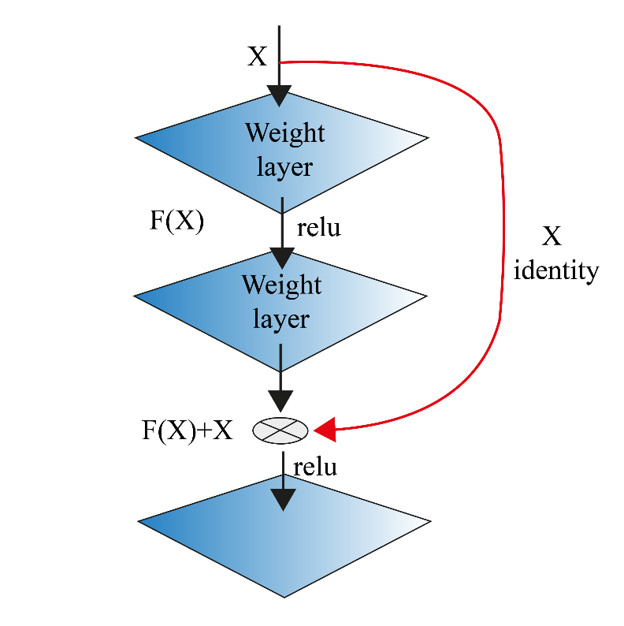
Figure ESI 1 | Residual learning; a building block.^{[1]}
  - Xception
Xception or Extreme version of Inception is a convolutional neural network that contains 71 layers deep developed by Google. With a modified depthwise separable convolution, it is more efficient than Inception-v3 (also by Google, 1st Runner Up in ILSVRC 2015) for both ImageNet ILSVRC and JFT datasets.^{[2]}

  - VGG-16
VGG-16 is a convolutional neural network containing 16 layers deep that won the ILSVR(Imagenet) competition in 2014. This model can classify images as 1000 different types even with the pretrained network. VGG-16 architecture is composed of 16 convolution layers and 3 fully connected layers.^{[3]}

  - MobileNetV2
MobileNetV2 is based on an inverted residual structure where the thin bottleneck structure in the model. This thin bottleneck is the input and output of the residual blocks compared to the conventional in which the expanded input is used. The model uses 3 × 3 depthwise separable convolutions. Consequently, the smaller computational cost than that of standard convolutions.^{[4]}

  - 8-layer CNN
The component of a CNN contains three main types of layers including pooling, convolution, and the fully connected layers. The features can be extracted by pooling, convolution, while the fully connected block provide the output when the extracted features is mapped on the output as shown in Figure ESI 2.^{[5]}
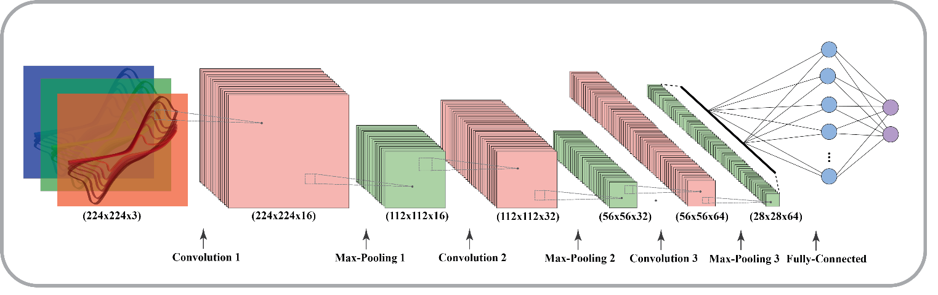
Figure ESI 2 | The convolutional layers of 8-layer CNN architecture.^{[5]}

- Convolutional layer
This layer is where the feature extraction takes place by the linear or non-linear operation. Here, kernel or filter that act as the operator applies to the input. The type of input is the image which will be transformed into the arrays of number called tensor.^{[5]}

- Pooling layer
Pooling layer is the layer in CNN where reduced a matrix (or matrices) is created to reduce the dimensionality of the feature matrix. Pooling normally composed of filter size, stride, and padding operator. It also includes taking either the maximum or average value across the pooled area. This layer subsequently deceases the learnable parameter.

- Fully connected layers
A fully connected layer is also known as a dense layer. It is a hidden layer in which each node of the input is connected to every node of the output in the subsequent hidden layer and followed by the non-linear function, for example, ReLU (Rectified linear unit).^{[5]}

Evaluations
The evaluation values were calculated as Accuracy, Sensitivity, Specificity, Precision, and F-Score, which describes in the following part based on the confusion matrix as shown in Figure ESI 3.
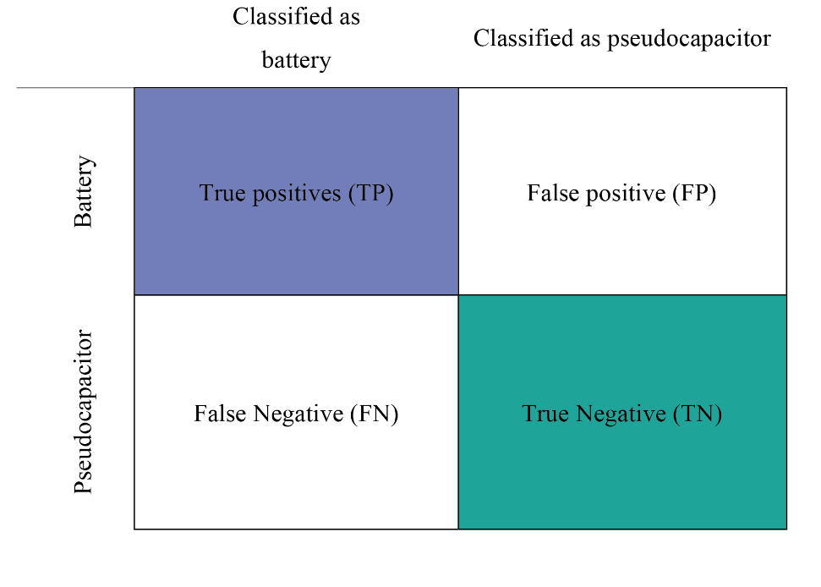
Figure ESI 3 | Confusion matrix. True Positive, False Positive, False Negative, and True Negatives are defined based on the classification results (classified battery and classified pseudocapacitor) and the set of references (battery and pseudocapacitor)
Eq. ESI 1,
where accuracy is the ratio of correctly predicted observation (TP+TN) compared to the total observations (TP+TN+FP+FN),
Eq. ESI 2,
where precision is the fraction of relevant instances (TP) among the retrieved instances (TP+FP),
Eq. ESI 3,
where recall/sensitivity (SE) is the fraction of relevant instances on battery that have been retrieved over total relevant instances in the image. It is based on an understanding and measuring of relevance,
Eq. ESI 4,
where specificity (SP) is the fraction of relevant instances on pseudocapacitor that have been retrieved over total relevant instances in the image. It is based on an understanding and measuring of relevance,
Eq. ESI 5,
where F1-score is harmonic mean of precision and recall. As a result, a high F1-score can only be obtained with both high recall and high precision are high.^{[6]}

Loss curves

Training loss and validation loss were plotted in order to determine the number of loop that optimized the prediction with highest accuracy and lowest Loss Value.^{[7]} In this work, the loss curves (Figure ESI4- ESI8) were used to validate the best architecture to be used for the classification with our datasets.
Figure ESI 4 | Loss curves of the training and validation loss for GCD and CV classification by using model ResNet50.

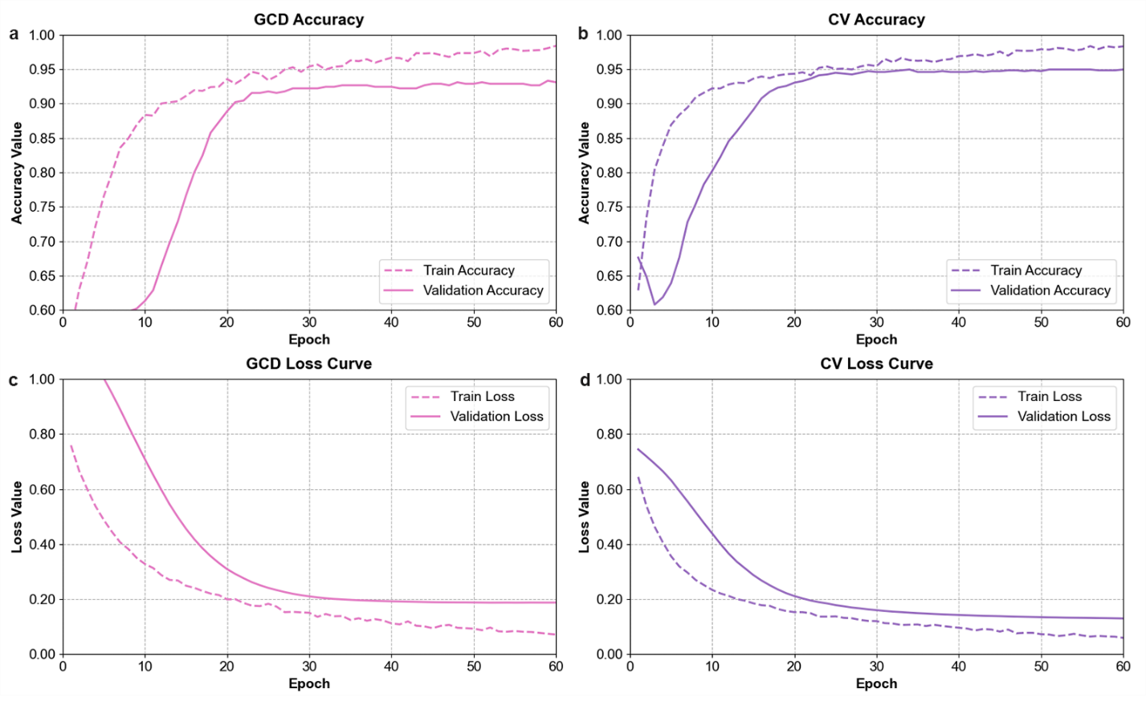
Figure ESI 5 | Loss curves of the training and validation loss for GCD and CV classification by using MobileNetV2 architecture.

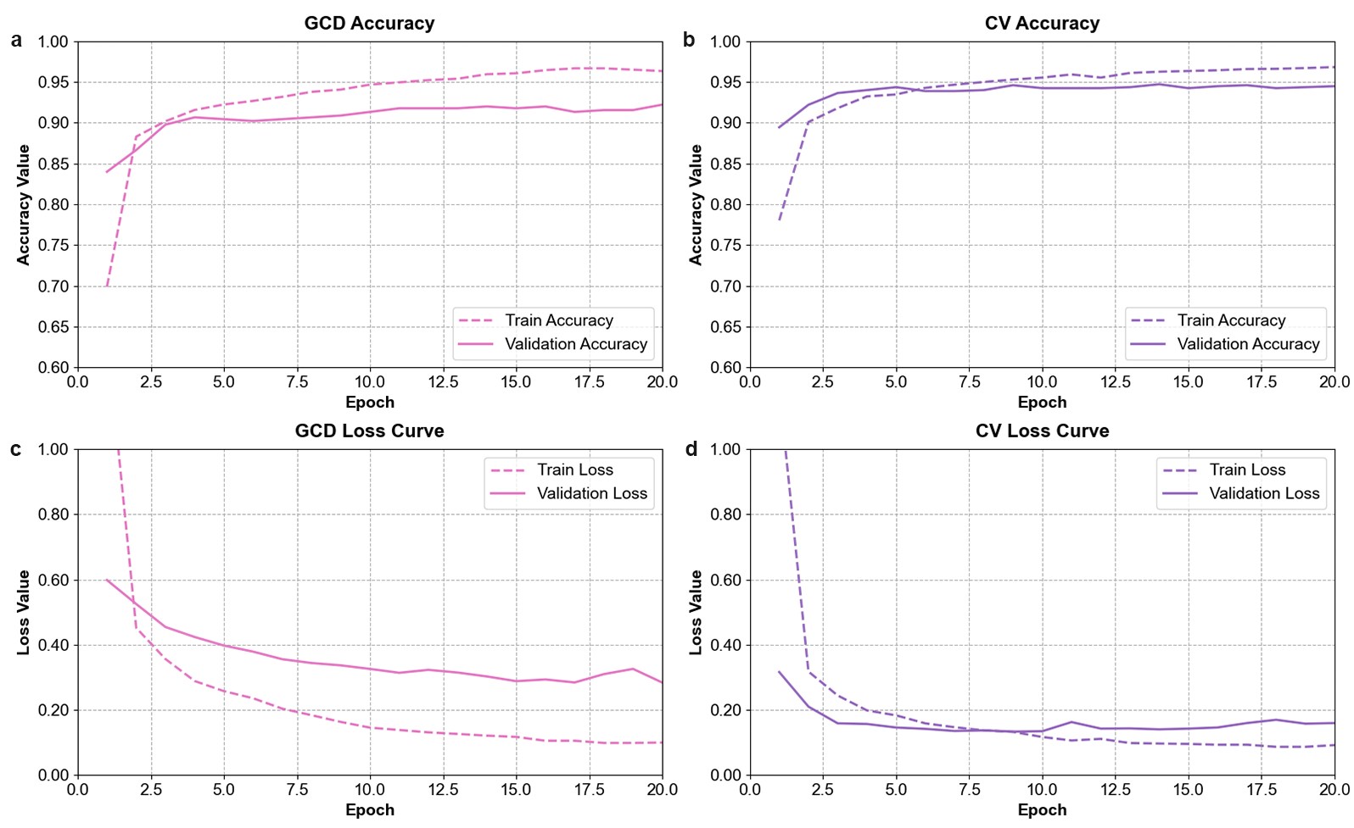
Figure ESI 6 | Loss curves of the training and validation loss for GCD and CV classification by using VGG16 architecture.

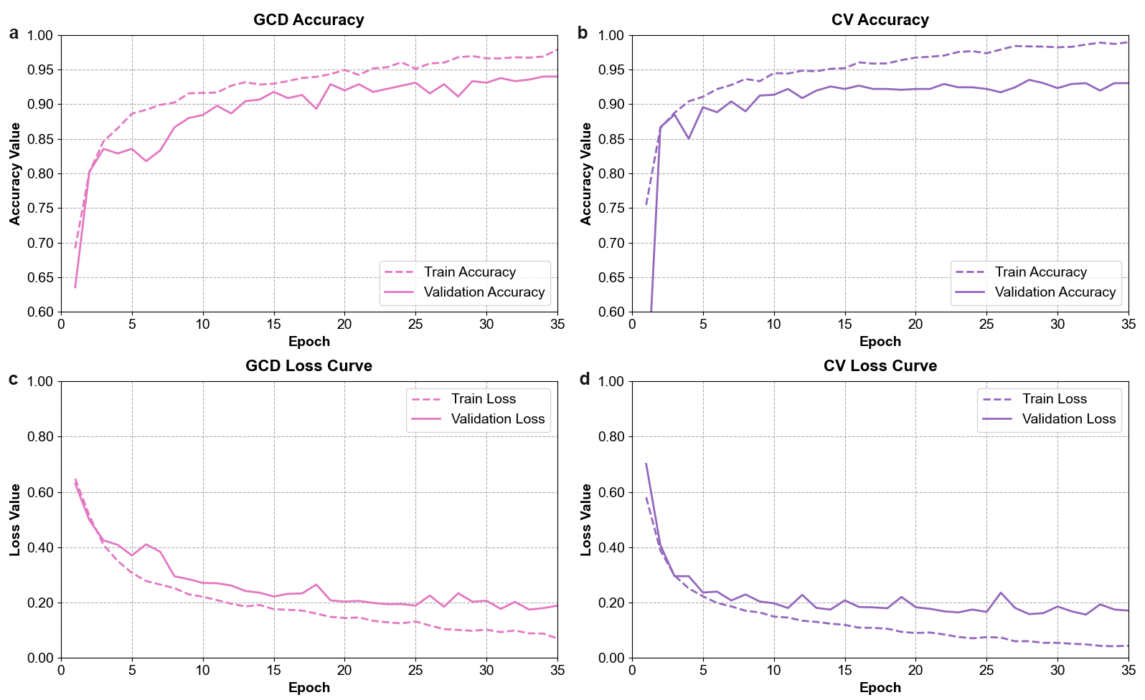
Figure ESI 7 | Loss curves of the training and validation loss for GCD and CV classification by using Xception architecture.

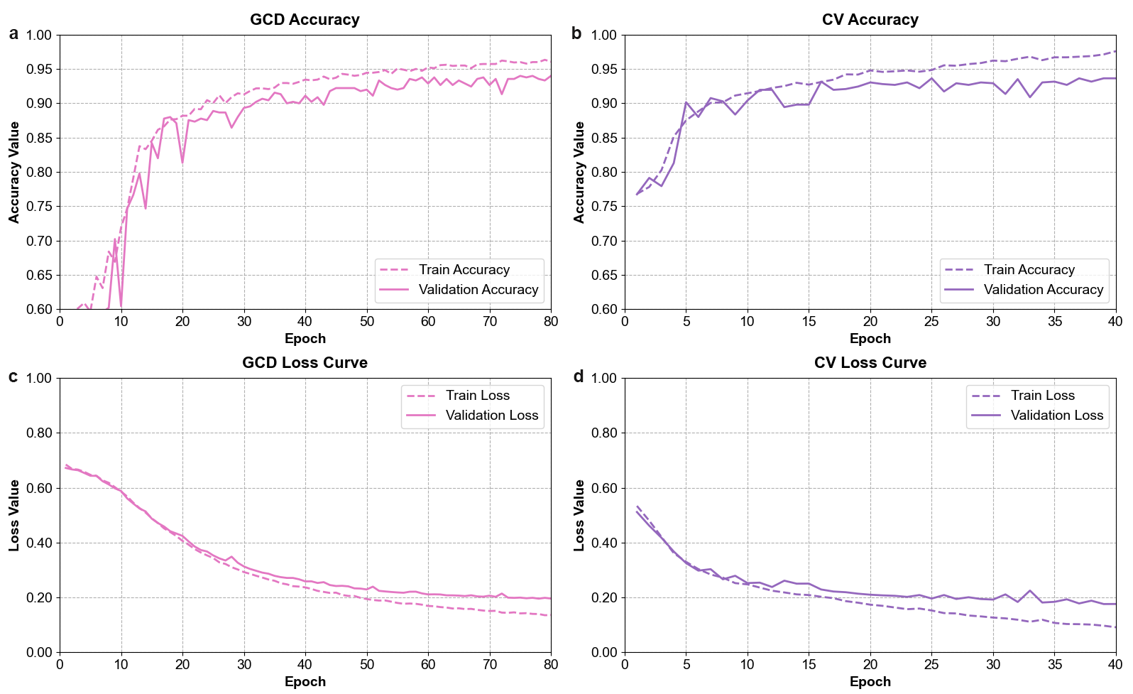
Figure ESI 8 | Loss curves of the training and validation loss for GCD and CV classification by using 8-Layer CNN architecture.

Machine-learning for CV/GCD classification

Table ESI 1 | The models used with various sets of inputs and outputs based on ResNet50 architecture.
Process | Input | Output | Output data
1 | Image | 1 | Other image, CV, GCD (%confidence)
2 | GCD | 2 | Battery, Pseudocapacitor (%confidence)
3 | CV | 3 | Battery, Pseudocapacitor (%confidence)
4 | CV of Battery | 4 | Capacitive tendency (0-50 %)
5 | CV of Pseudocapacitor | 5 | Capacitive tendency (50-100 %)

Table ESI 2 | GCD and CV classification comparison based on evaluation values obtained from five different architectures; ResNet50, MobileNetV2, VGG16, Xception, and 8-Layer CNN.
CNN-Model | Accuracy  (%) | Sensitivity  (%) | Specificity (%) | Precision (%) | F1 -Score
GCD
ResNet50 | 94.22 | 93.84 | 94.45 | 94.16 | 93.99
MobileNetV2 | 93.11 | 92.56 | 93.07 | 93.12 | 92.82
VGG16 | 92.22 | 92.24 | 94.61 | 91.78 | 91.99
Xception | 93.77 | 93.98 | 96.49 | 93.33 | 93.60
8-Layer CNN | 94.00 | 93.73 | 94.77 | 93.82 | 93.78
CV
ResNet50 | 95.80 | 93.52 | 96.74 | 94.65 | 94.07
MobileNetV2 | 94.64 | 92.62 | 96.42 | 93.24 | 92.92
VGG16 | 94.36 | 93.12 | 97.13 | 91.53 | 92.28
Xception | 93.04 | 88.87 | 94.35 | 91.31 | 90.00
8-Layer CNN | 93.65 | 89.08 | 94.26 | 92.77 | 90.74

Figure ESI 9 | The distribution of classification efficiency on a) GCD, and b) CV classification using Process 2, and 3, respectively.
Figure ESI 9 shows the results of classification using ResNet50 architecture with two type of input data including GCDs (Fig ESI 9a) and CVs (Fig ESI9b). It shows percentage of input CV/GCD images (y-axis) were classified as battery or pseudocapacitor with respect to the percentage of confidence (x-axis). The result shows that more than 80% of testing input was classified with 100% confidence.

Code and dataset accessibility on Github repository
To access and run scripts with our codes and datasets, user can clone out repository from Github following this instruction:
5.1) Clone the repository
By going to the website (https://github.com/ice555mee/TB-robot_code-data) or using this command
git clone https://github.com/ice555mee/TB-robot_code-data.git

5.2) Repository branches
This project has two branches: main, master, which can be explained here
- Main: contains aggregate codes and datasets
- Master: additionally contains codes that user can use for test running. All models (including file.py, file.h5, file.json) are located in master branch of this repository since the large files are only store in master branch.
5.3) Installation/running
You may need to install the libraries/packages according to Python requirments.txt file.
- Code location
Codes for prediction test are located in folder named 'Test_prediction' in main branch, where all model files are located in master branch following to the structure below:
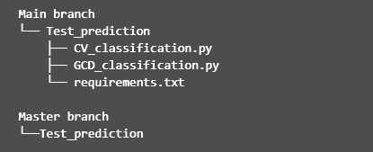
  - File named ‘CV_classification.py’ or ‘GCD_classification.py’ are for the classification test for CV and GCD, respectively.
  - File named ‘requirements.txt’ contains all requirements of packages and versions to be installed.
- Install the requirements by this following command
pip install -r requirements.txt

- Run prediction
  - Run files named ‘CV_classification.py’ or ‘GCD_classification.py’
  - Before running, edit file paths for the testing images (line 49) and the directory (line 51), where the user wants to put the results:
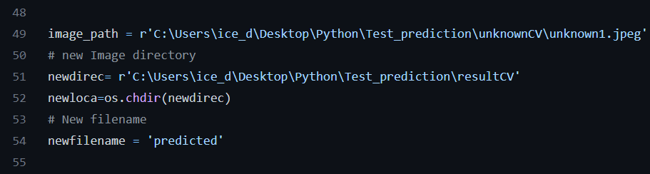
- Results
The result will show in the terminal with percentage confident of {type of material as Battery or pseudocapacitor}. For example,
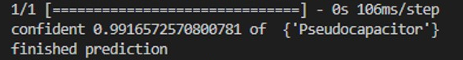
, while the predicted CV or GCD images will be saved in the location as programed as shown below.
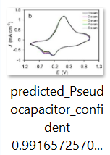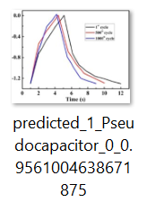

The website description

In this work, the website (http://supercapacitor-battery-artificialintelligence.vistec.ac.th) was built as an online tool for any users to classify CV or GCD based on our model. By simply importing CV or GCD, the user can determine the confidence of classification as well as the tendency of the material to behave as battery or pseudocapacitor.

6.1 Home page

The Home Page consists of short introduction of the concept of the website as well as the objective of website, graphical demonstration of the ideal of our classification, and navigation bar that provides links to other pages including T.B Robot Page that will provide CV/GCD classifier, About us Page, and Contact us Page as shown in Figure ESI 10.
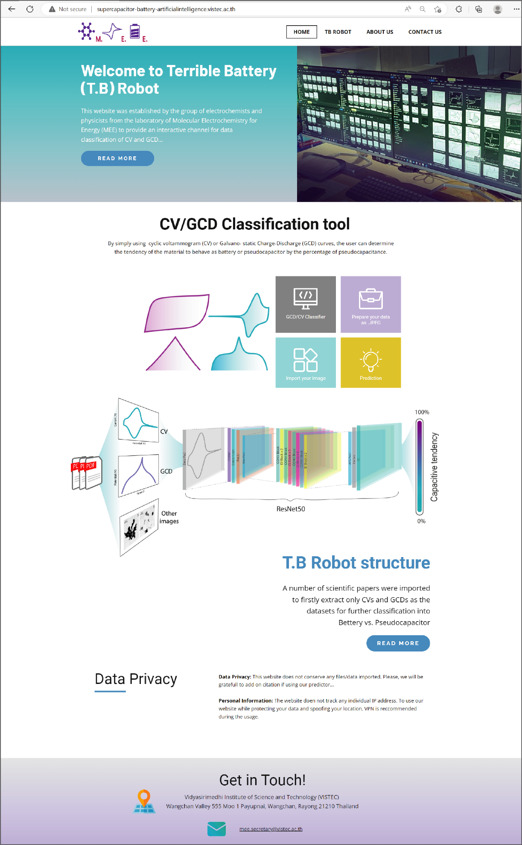
Figure ESI 10 | The Home page of the website for CV/GCD classification.

6.2 T.B Robot page

This page consists of the idea of T.B Robot that is merged from well-established pseudocapacitance concept. Moreover, matching results predicted by our model was demonstrated on this page as well as CNNs concept. From this page, the user can click on ‘GCD’ or ‘CV’ button to start the classifications.

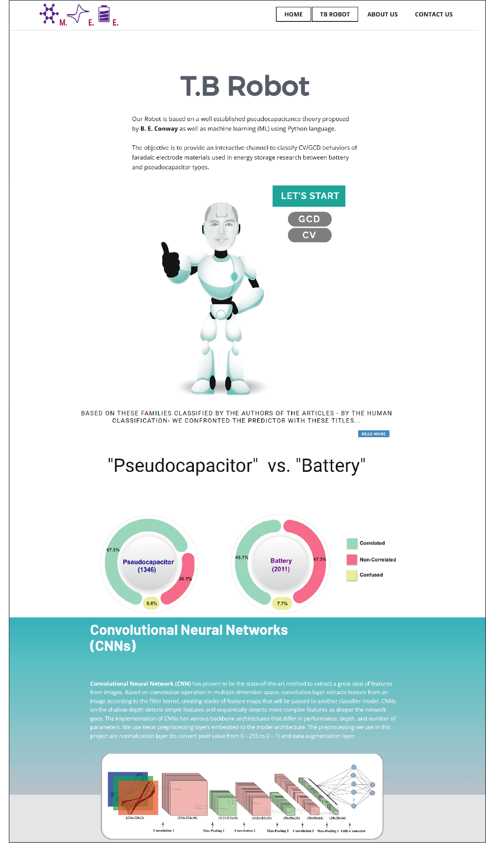
Figure ESI 11 | T.B Robot page

6.2.1 GCD classification page

This page consists of web application for classifying GCD into battery or pseudocapacitor types where the prediction result will appear with the value of % confidence that the picture is battery or pseudocapacitor.
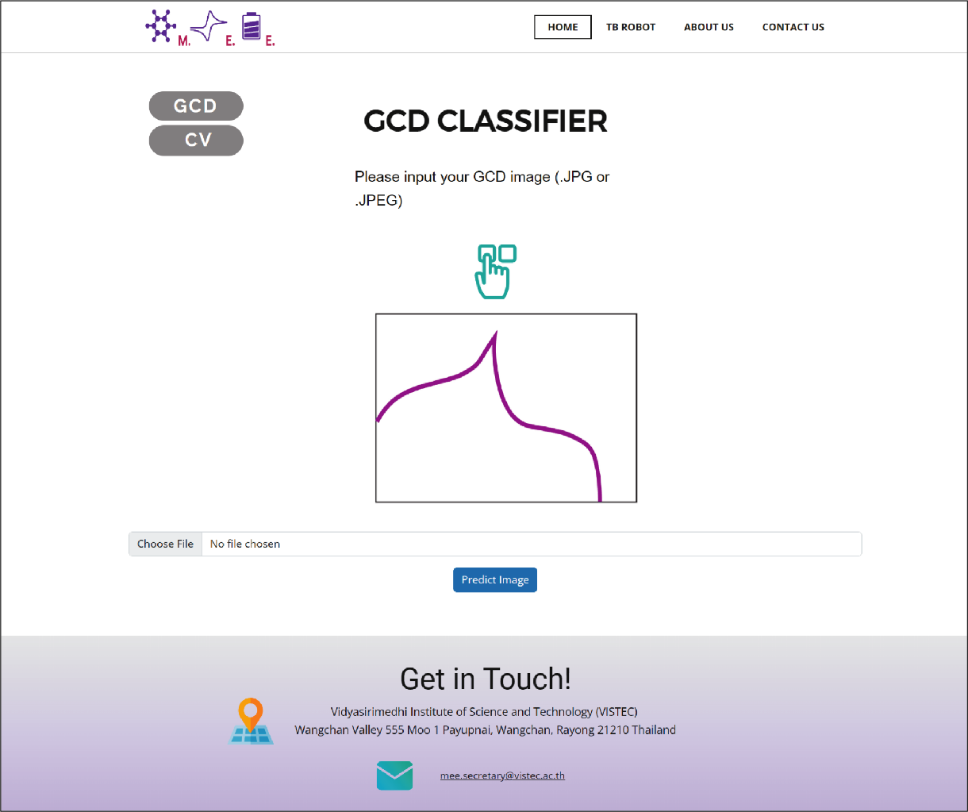
Figure ESI 12 | GCD classification page

6.2.2 CV classification page

This page consists of web application for classifying CV into battery or pseudocapacitor types where the prediction result will appear with the value of capacitive tendency of an input CV.
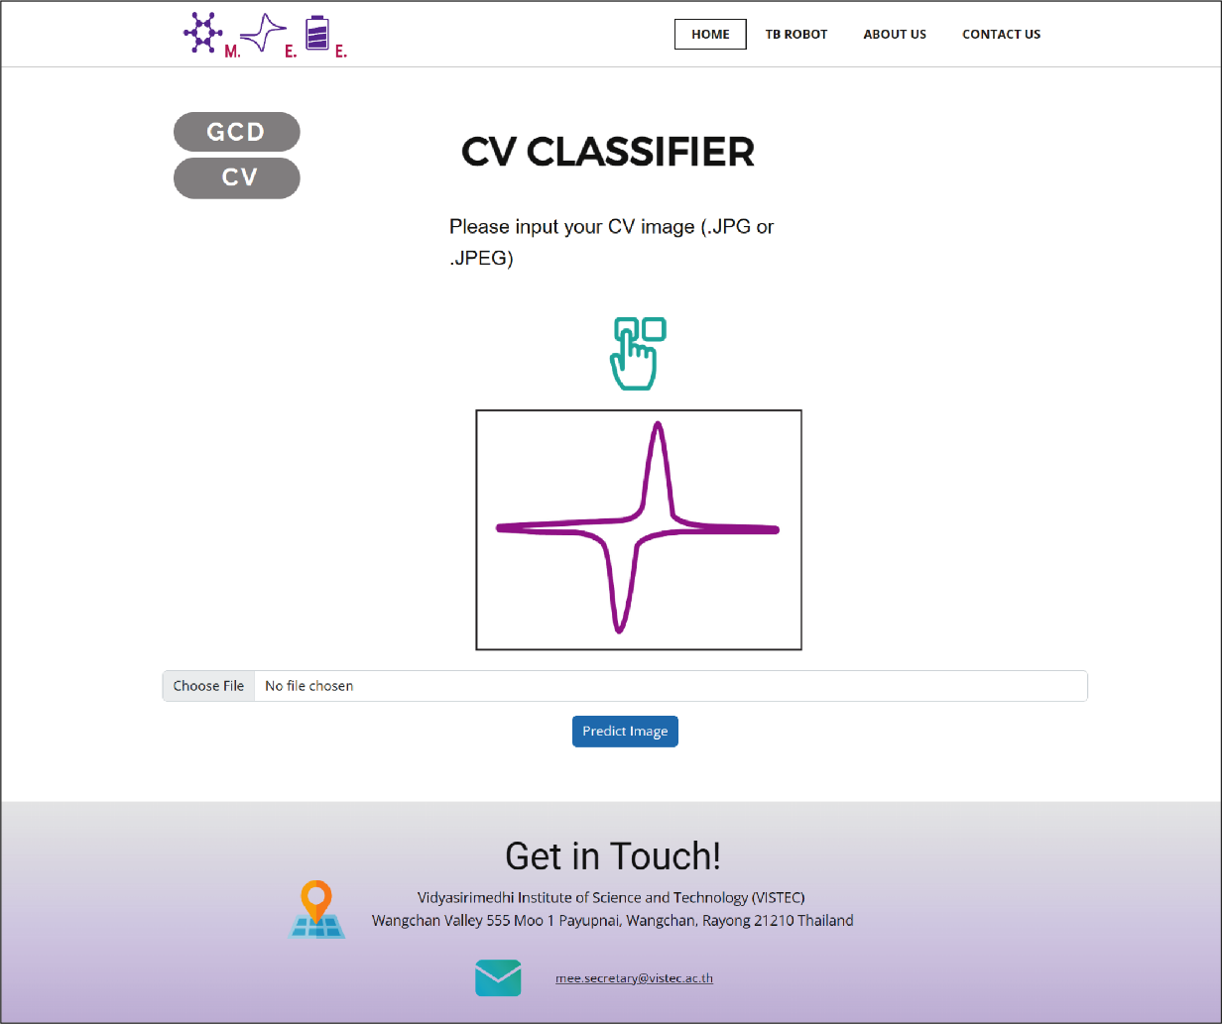
Figure ESI 13 | CV classification page

6.3 Special issues

The possible issues under the usage of our model are clarified in this section where random pictures besides GCD/CV were input in the model. The predicted results with either % confidence or capacitive tendency from those unrelated inputs are demonstrated as shown in Figure ESI 14-17.

6.3.1 GCD classification

Figure ESI 14 and ESI 15 show two pictures classified as if it is pseudocapacitor with 87.42% confidence, and battery with 93.93% confidence, respectively. This result could be explained by the reason that this model based on binary classification where any type of input picture can give the prediction as either 1 or 0 (pseudocapacitor or battery), not else. The consequence is that the predictor finds its way to predict with certain value of confidence.
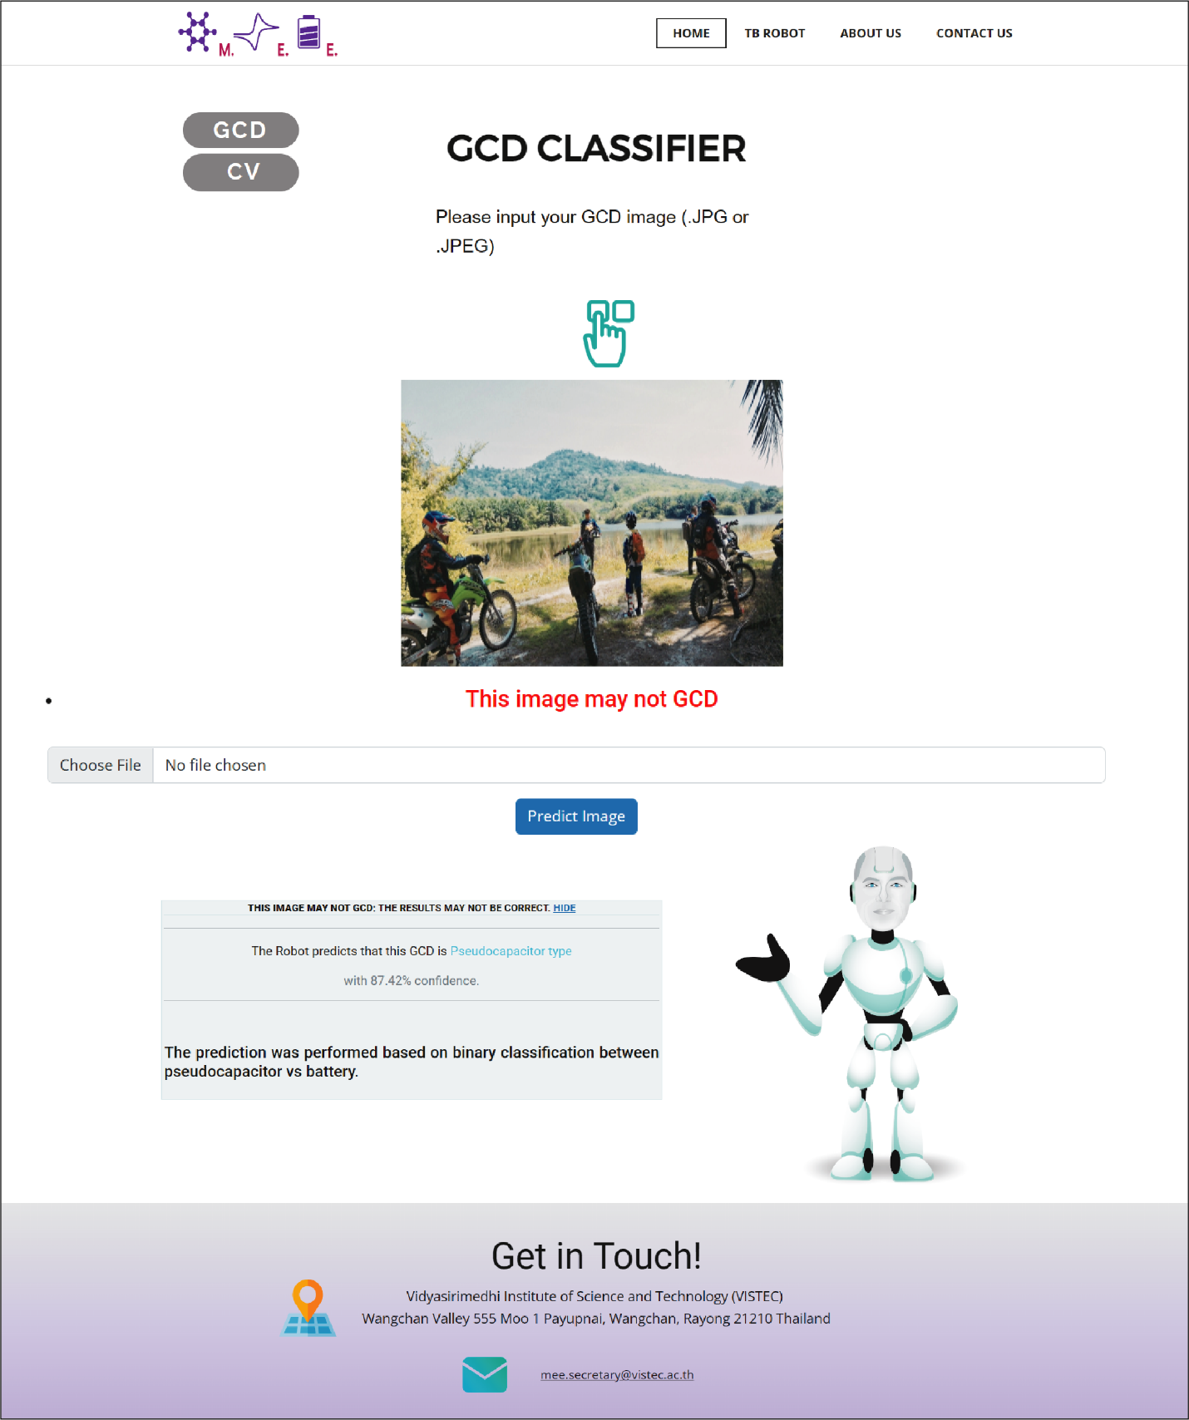
Figure ESI 14 | Non-GCD input with the prediction as pseudocapacitor

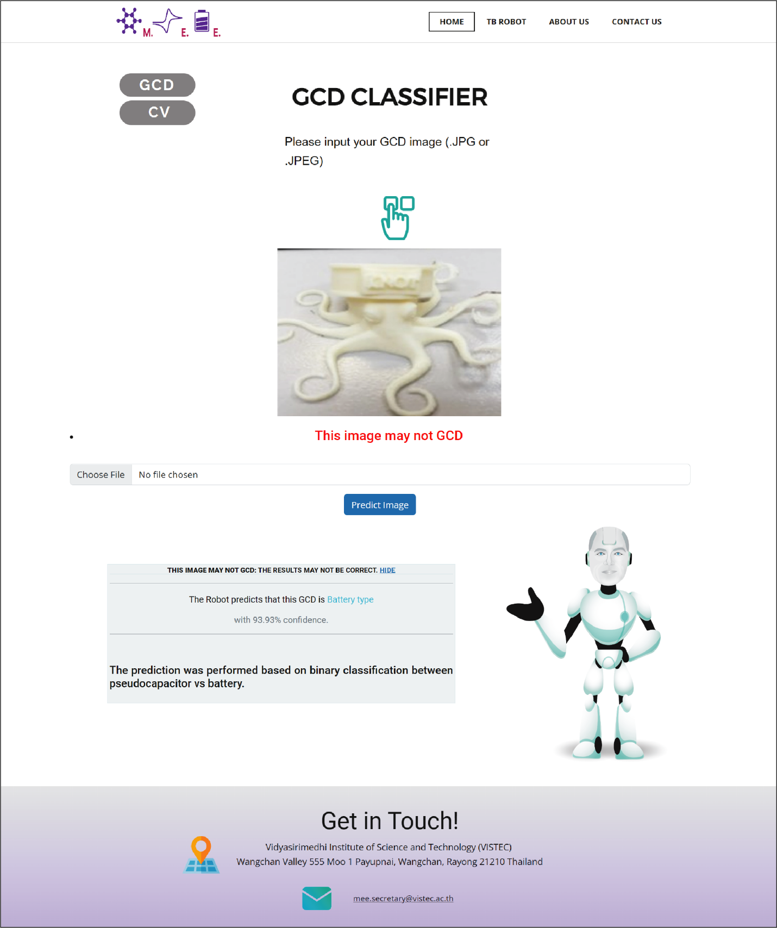
Figure ESI 15 | Non-GCD input with the prediction as battery.

6.3.2 CV classification

Figure ESI 16 and ESI 17 show two pictures classified as if it is pseudocapacitor with 96.19 capacitive tendency, and battery with 26.24 capacitive tendency, respectively. This result could be explained by the reason that this model based on binary classification where any type of input picture can give the prediction as either 1 or 0 (pseudocapacitor or battery). The consequence is that the predictor finds its way to predict with certain value of capacitive tendency.
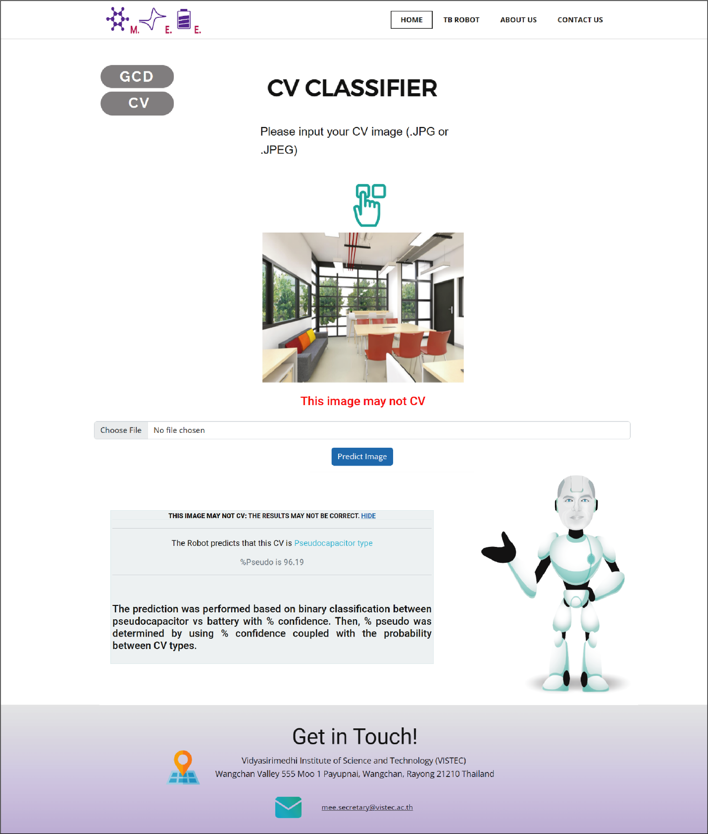
Figure ESI 16 | Non-CV input with the prediction as a pseudocapacitor.

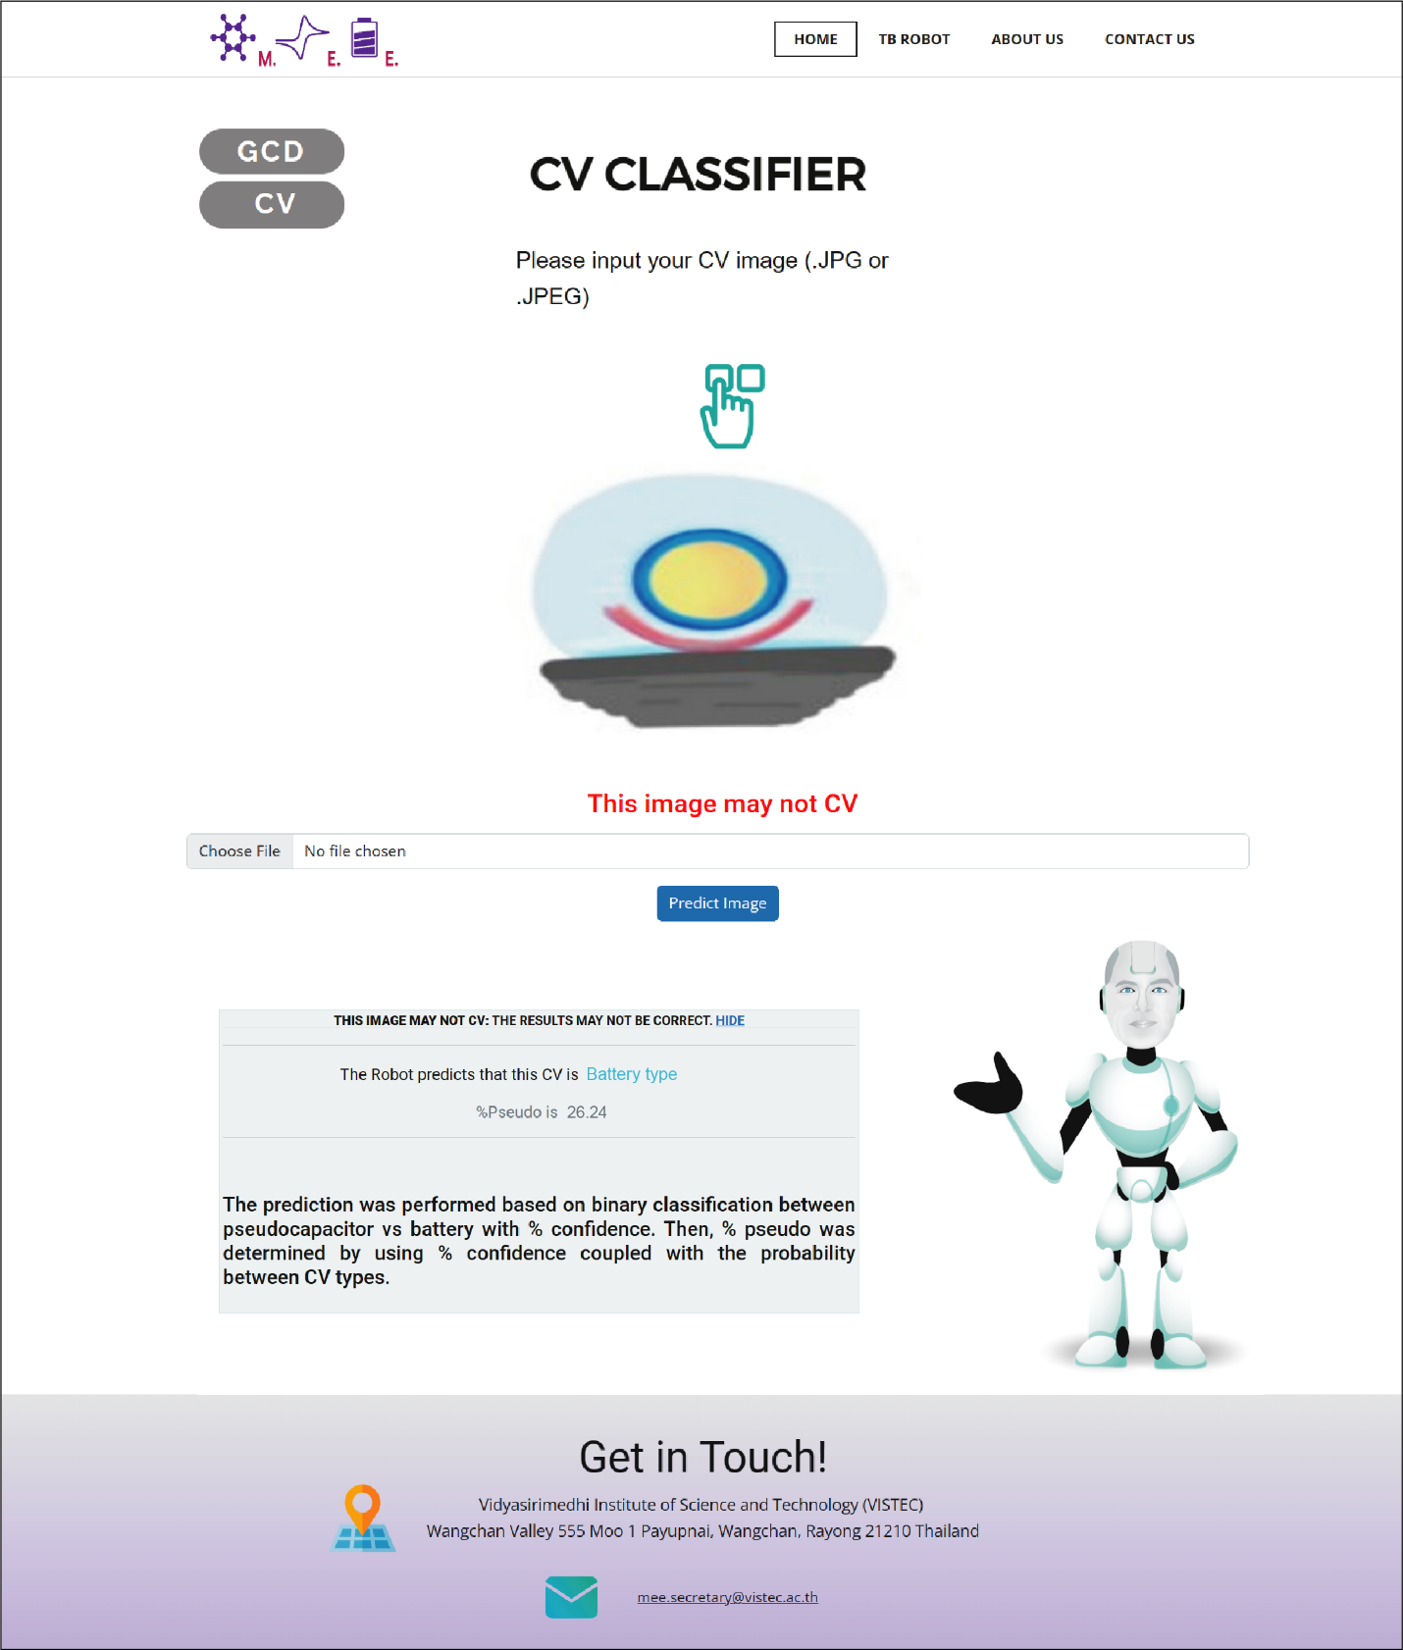
Figure ESI 17 | Non-CV input with the prediction as a battery.

Prediction using electrochemical data from recent paper

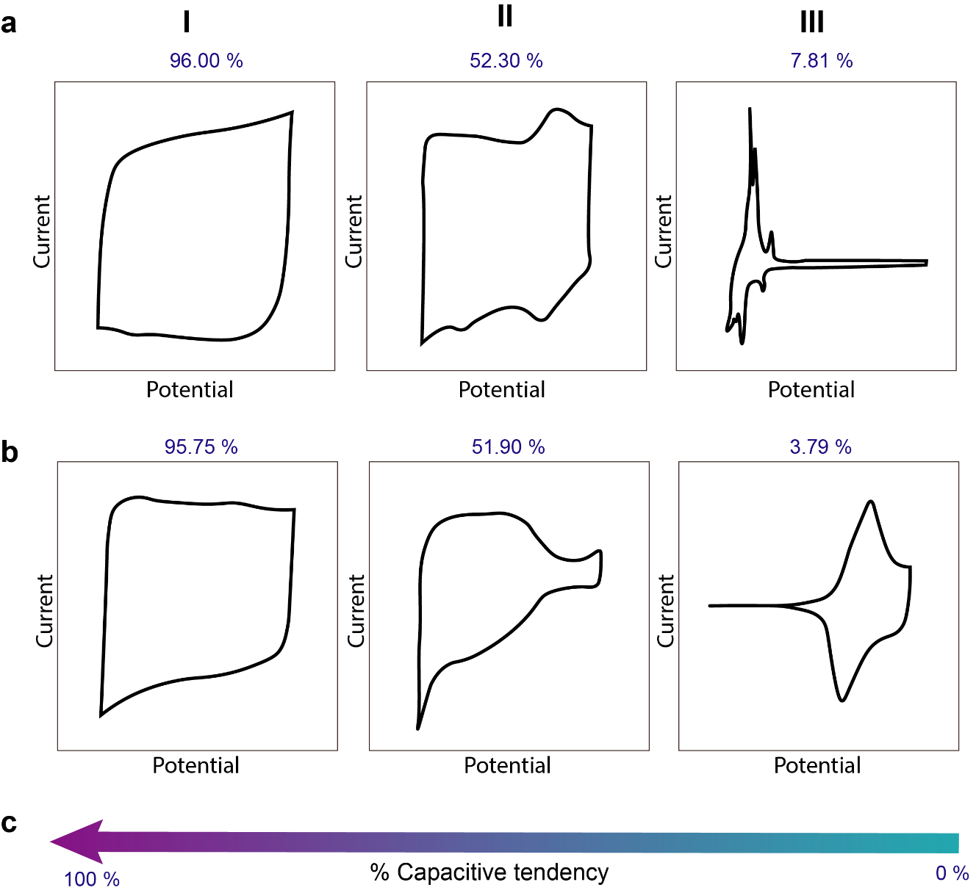

Figure ESI 18 | The predicted representative electrochemical signals (from Nature Energy, Fleischmann et al.^{[8]}): a-I) porous carbon with solvated ion adsorption, a-II) porous carbon with partially solvated ion adsorption, a-III) graphite with desolvated Li⁺ intercalation, b-I) MXene with hydrated Li⁺ adsorption, b-II) MXene with partially desolvated Li⁺ intercalation, b-III) layered LiNi_{1/3}Mn_{1/3}Co_{1/3}O₂, NMC with desolvated L^{i+} intercalation, and c) % capacitive tendency.

8. Data sets used in title correlation vs, GCD and CV classification (DOI)

8.1 Pseudocapacitor (Matched)

10.1002-9783527639496.ch8
10.1002-9783527646661.ch3
10.1002-9783527690312.ch6
10.1002-9783527818556.ch5
10.1002-adfm.201202682
10.1002-adfm.201203418
10.1002-adfm.201301747
10.1002-adfm.201501709
10.1002-adfm.201503662
10.1002-adfm.201504849
10.1002-adfm.201603933
10.1002-adfm.201803695
10.1002-adfm.201804306
10.1002-adfm.201909546
10.1002-adfm.202002019
10.1002-adfm.202007351
10.1002-adfm.202100880
10.1002-adfm.202102184
10.1002-adfm.202106438
10.1002-adma.201400447
10.1002-adma.201402041
10.1002-adma.201505644
10.1002-adma.201602960
10.1002-adma.201604167
10.1002-adma.201606499
10.1002-adma.201704754
10.1002-adma.201705477
10.1002-adma.201706640
10.1002-adma.201800658
10.1002-adma.201806128
10.1002-adma.201907289
10.1002-adma.202104039
10.1002-admi.201500761
10.1002-admt.201600167
10.1002-admt.202100501
10.1002-advs.201500067
10.1002-advs.201500319
10.1002-advs.201700003
10.1002-advs.201802067
10.1002-aelm.201900844
10.1002-aenm.201301788
10.1002-aenm.201500772
10.1002-aenm.201501115
10.1002-aenm.201601873
10.1002-aenm.201602725
10.1002-aenm.201602880
10.1002-aenm.201700700
10.1002-aenm.201701681
10.1002-aenm.201702930
10.1002-aenm.201703043
10.1002-aenm.201802917
10.1002-aenm.201903136
10.1002-aenm.201903848
10.1002-anie.201407365
10.1002-anie.202105725
10.1002-anie.202106481
10.1002-app.43315
10.1002-app.46948
10.1002-app.50234
10.1002-asia.201402369
10.1002-asia.201801749
10.1002-bkcs.12263
10.1002-celc.201402359
10.1002-celc.201500005
10.1002-celc.201600588
10.1002-celc.201700923
10.1002-celc.201801207
10.1002-celc.201900291
10.1002-celc.201900601
10.1002-celc.201901549
10.1002-celc.201901680
10.1002-celc.202100641
10.1002-chem.201604878
10.1002-chem.201700017
10.1002-chem.201905689
10.1002-chem.202002311
10.1002-cnma.201600117
10.1002-cphc.201402625
10.1002-cssc.201402520
10.1002-cssc.201403477
10.1002-cssc.201600024
10.1002-cssc.201601310
10.1002-cssc.201701215
10.1002-cssc.201901015
10.1002-cssc.201901412
10.1002-cssc.201902339
10.1002-eem2.12094
10.1002-elan.201500012
10.1002-elan.202100177
10.1002-ente.201300193
10.1002-ente.201600726
10.1002-ente.201700568
10.1002-ente.201800157
10.1002-ente.201901319
10.1002-er.4561
10.1002-er.6243
10.1002-er.6434
10.1002-ese3.50
10.1002-fuce.201000029
10.1002-fuce.201000032
10.1002-jctb.6166
10.1002-pat.4624
10.1002-ppsc.201400066
10.1002-ppsc.201900344
10.1002-pssb.201451742
10.1002-slct.201600481
10.1002-slct.201601348
10.1002-slct.201601421
10.1002-slct.201901366
10.1002-slct.202001305
10.1002-slct.202001879
10.1002-slct.202101216
10.1002-smll.201201336
10.1002-smll.201402222
10.1002-smll.201701744
10.1002-smll.201704410
10.1002-smll.201704508
10.1002-smll.201803716
10.1002-smll.201900721
10.1002-smll.201900862
10.1002-smll.201902649
10.1002-smll.201906131
10.1002-smll.202002806
10.1002-smtd.201800318
10.1002-smtd.201800341
10.1002-tcr.201800112
10.1007-978-3-030-43009-2_1
10.1007-978-3-030-43009-2_13
10.1007-978-3-030-43009-2_9
10.1007-s00289-018-2492-x
10.1007-s10008-010-1072-2
10.1007-s10008-012-1691-x
10.1007-s10008-012-1979-x
10.1007-s10008-016-3487-x
10.1007-s10008-017-3557-8
10.1007-s10008-017-3770-5
10.1007-s10008-018-3976-1
10.1007-s10008-020-04616-z
10.1007-s10800-017-1098-6
10.1007-s10800-018-1158-6
10.1007-s10853-015-9199-2
10.1007-s10853-017-1119-1
10.1007-s10853-020-05056-w
10.1007-s10853-021-06254-w
10.1007-s10854-015-2698-8
10.1007-s10854-017-7958-3
10.1007-s10854-019-02198-9
10.1007-s10854-019-02313-w
10.1007-s10854-020-03267-0
10.1007-s10904-020-01593-8
10.1007-s10904-021-01899-1
10.1007-s11431-015-5915-z
10.1007-s11431-021-1835-8
10.1007-s11581-012-0726-8
10.1007-s11581-015-1444-9
10.1007-s11581-016-1811-1
10.1007-s11581-017-2183-x
10.1007-s11581-018-2459-9
10.1007-s11581-018-2602-7
10.1007-s11581-018-2809-7
10.1007-s11581-019-02995-6
10.1007-s11581-019-03249-1
10.1007-s11581-019-03400-y
10.1007-s11581-020-03874-1
10.1007-s11581-021-03938-w
10.1007-s11581-021-04208-5
10.1007-s11581-021-04208-5
10.1007-s11664-020-08550-8
10.1007-s11665-020-05261-3
10.1007-s11706-013-0220-x
10.1007-s11814-019-0364-1
10.1007-s12034-020-02249-6
10.1007-s12274-014-0612-y
10.1007-s12274-016-1047-4
10.1007-s12274-021-3462-4
10.1007-s40242-014-4109-8
10.1007-s40820-020-00567-2
10.1016-B978-0-12-809597-3.00247-9
10.1016-B978-0-12-814134-2.00019-X
10.1016-j.apcatb.2020.119635
10.1016-j.apmt.2017.11.011
10.1016-j.apsusc.2016.02.199
10.1016-j.apsusc.2017.03.282
10.1016-j.apsusc.2017.06.259
10.1016-j.apsusc.2017.08.127
10.1016-j.apsusc.2017.12.021
10.1016-j.apsusc.2018.01.025
10.1016-j.apsusc.2018.02.277
10.1016-j.apsusc.2018.05.088
10.1016-j.apsusc.2018.06.243
10.1016-j.apsusc.2018.10.209
10.1016-j.apsusc.2019.03.259
10.1016-j.apsusc.2019.143700
10.1016-j.apsusc.2020.146259
10.1016-j.apsusc.2020.146640
10.1016-j.apsusc.2020.148037
10.1016-j.apsusc.2020.148448
10.1016-j.apsusc.2020.148913
10.1016-j.apsusc.2021.149789
10.1016-j.apsusc.2021.150199
10.1016-j.cap.2016.11.028
10.1016-j.carbon.2015.08.052
10.1016-j.carbon.2017.01.005
10.1016-j.carbon.2017.02.050
10.1016-j.carbon.2019.10.048
10.1016-j.carbon.2020.11.010
10.1016-j.carbon.2020.11.097
10.1016-j.carbon.2021.01.155
10.1016-j.carbon.2021.08.060
10.1016-j.carbpol.2019.115455
10.1016-j.cclet.2018.09.013
10.1016-j.cclet.2019.04.006
10.1016-j.cclet.2020.02.050
10.1016-j.cej.2016.01.069
10.1016-j.cej.2017.06.171
10.1016-j.cej.2017.07.066
10.1016-j.cej.2018.08.141
10.1016-j.cej.2019.122305
10.1016-j.cej.2019.123153
10.1016-j.cej.2019.123598
10.1016-j.cej.2019.123972
10.1016-j.cej.2020.126352
10.1016-j.cej.2021.128491
10.1016-j.cej.2021.128638
10.1016-j.cej.2021.129515
10.1016-j.cej.2021.130304
10.1016-j.cej.2021.130606
10.1016-j.cej.2021.131431
10.1016-j.cej.2021.131868
10.1016-j.ceramint.2013.08.065
10.1016-j.ceramint.2014.12.064
10.1016-j.ceramint.2017.08.006
10.1016-j.ceramint.2017.11.017
10.1016-j.ceramint.2018.03.138
10.1016-j.ceramint.2018.10.100
10.1016-j.ceramint.2019.02.092
10.1016-j.ceramint.2019.09.042
10.1016-j.ceramint.2020.04.066
10.1016-j.ceramint.2020.06.016
10.1016-j.ceramint.2021.05.181
10.1016-j.ces.2016.05.034
10.1016-j.ces.2019.04.039
10.1016-j.chempr.2017.01.004
10.1016-j.colsurfa.2017.12.069
10.1016-j.colsurfa.2021.126232
10.1016-j.cplett.2021.138666
10.1016-j.diamond.2017.03.016
10.1016-j.diamond.2019.04.023
10.1016-j.elecom.2010.11.007
10.1016-j.elecom.2015.09.004
10.1016-j.elecom.2016.05.017
10.1016-j.electacta.2003.08.013
10.1016-j.electacta.2004.02.056
10.1016-j.electacta.2005.03.006
10.1016-j.electacta.2008.08.041
10.1016-j.electacta.2008.08.072
10.1016-j.electacta.2008.12.042
10.1016-j.electacta.2010.04.047
10.1016-j.electacta.2011.05.008
10.1016-j.electacta.2012.01.104
10.1016-j.electacta.2012.12.052
10.1016-j.electacta.2013.01.125
10.1016-j.electacta.2013.02.056
10.1016-j.electacta.2013.08.095
10.1016-j.electacta.2013.10.173
10.1016-j.electacta.2013.12.040
10.1016-j.electacta.2014.07.077
10.1016-j.electacta.2014.09.102
10.1016-j.electacta.2014.11.132
10.1016-j.electacta.2014.11.187
10.1016-j.electacta.2015.03.107
10.1016-j.electacta.2015.07.044
10.1016-j.electacta.2015.08.099
10.1016-j.electacta.2015.10.028
10.1016-j.electacta.2015.11.067
10.1016-j.electacta.2015.12.076
10.1016-j.electacta.2016.01.174
10.1016-j.electacta.2016.02.157
10.1016-j.electacta.2016.03.190
10.1016-j.electacta.2016.03.204
10.1016-j.electacta.2016.04.036
10.1016-j.electacta.2016.04.058
10.1016-j.electacta.2016.04.187
10.1016-j.electacta.2016.05.105
10.1016-j.electacta.2016.06.038
10.1016-j.electacta.2016.07.027
10.1016-j.electacta.2016.10.181
10.1016-j.electacta.2016.10.182
10.1016-j.electacta.2016.12.057
10.1016-j.electacta.2017.07.010
10.1016-j.electacta.2017.07.043
10.1016-j.electacta.2017.07.077
10.1016-j.electacta.2017.12.031
10.1016-j.electacta.2018.03.116
10.1016-j.electacta.2018.04.009
10.1016-j.electacta.2018.04.022
10.1016-j.electacta.2018.04.149
10.1016-j.electacta.2018.04.219
10.1016-j.electacta.2018.07.061
10.1016-j.electacta.2018.07.177
10.1016-j.electacta.2018.10.193
10.1016-j.electacta.2018.11.116
10.1016-j.electacta.2018.12.123
10.1016-j.electacta.2018.12.129
10.1016-j.electacta.2019.01.185
10.1016-j.electacta.2019.02.009
10.1016-j.electacta.2019.03.174
10.1016-j.electacta.2019.04.108
10.1016-j.electacta.2019.04.179
10.1016-j.electacta.2019.05.073
10.1016-j.electacta.2019.06.007
10.1016-j.electacta.2019.06.163
10.1016-j.electacta.2019.134640
10.1016-j.electacta.2019.134645
10.1016-j.electacta.2019.134865
10.1016-j.electacta.2019.134879
10.1016-j.electacta.2019.134935
10.1016-j.electacta.2019.135279
10.1016-j.electacta.2019.135557
10.1016-j.electacta.2020.135827
10.1016-j.electacta.2020.136369
10.1016-j.electacta.2020.136669
10.1016-j.electacta.2020.136730
10.1016-j.electacta.2020.136736
10.1016-j.electacta.2020.136844
10.1016-j.electacta.2020.136898
10.1016-j.electacta.2020.136898
10.1016-j.electacta.2020.137628
10.1016-j.electacta.2021.138353
10.1016-j.electacta.2021.138713
10.1016-j.electacta.2021.138822
10.1016-j.electacta.2021.138959
10.1016-j.energy.2017.11.026
10.1016-j.ensm.2015.05.001
10.1016-j.ensm.2019.12.040
10.1016-j.ensm.2020.08.029
10.1016-j.est.2018.03.015
10.1016-j.est.2019.100949
10.1016-j.est.2019.101055
10.1016-j.est.2019.101114
10.1016-j.est.2020.102068
10.1016-j.est.2021.102291
10.1016-j.est.2021.102311
10.1016-j.est.2021.102611
10.1016-j.est.2021.102757
10.1016-j.est.2021.103019
10.1016-j.flatc.2020.100212
10.1016-j.flatc.2020.100212
10.1016-j.ijhydene.2014.07.026
10.1016-j.ijhydene.2015.09.127
10.1016-j.ijhydene.2015.10.041
10.1016-j.ijhydene.2017.05.193
10.1016-j.jallcom.2015.01.089
10.1016-j.jallcom.2015.06.111
10.1016-j.jallcom.2016.03.179
10.1016-j.jallcom.2016.07.234
10.1016-j.jallcom.2017.01.136
10.1016-j.jallcom.2017.02.189
10.1016-j.jallcom.2017.05.094
10.1016-j.jallcom.2017.11.041
10.1016-j.jallcom.2018.04.031
10.1016-j.jallcom.2018.06.192
10.1016-j.jallcom.2018.08.011
10.1016-j.jallcom.2019.02.321
10.1016-j.jallcom.2019.03.237
10.1016-j.jallcom.2019.06.284
10.1016-j.jallcom.2019.152089
10.1016-j.jallcom.2019.152135
10.1016-j.jallcom.2019.153385
10.1016-j.jallcom.2020.154118
10.1016-j.jallcom.2020.154749
10.1016-j.jallcom.2020.154838
10.1016-j.jallcom.2020.155556
10.1016-j.jallcom.2020.156992
10.1016-j.jallcom.2020.157771
10.1016-j.jallcom.2021.159128
10.1016-j.jallcom.2021.159541
10.1016-j.jallcom.2021.159702
10.1016-j.jallcom.2021.159886
10.1016-j.jallcom.2021.159920
10.1016-j.jallcom.2021.160384
10.1016-j.jallcom.2021.160822
10.1016-j.jallcom.2021.161376
10.1016-j.jcis.2016.06.013
10.1016-j.jcis.2016.11.024
10.1016-j.jcis.2016.11.072
10.1016-j.jcis.2016.12.003
10.1016-j.jcis.2017.05.117
10.1016-j.jcis.2017.08.098
10.1016-j.jcis.2017.10.046
10.1016-j.jcis.2020.01.117
10.1016-j.jcis.2021.01.042
10.1016-j.jcis.2021.09.011
10.1016-j.jechem.2017.09.034
10.1016-j.jechem.2018.02.015
10.1016-j.jechem.2020.04.019
10.1016-j.jechem.2020.05.045
10.1016-j.jechem.2020.07.011
10.1016-j.jechem.2020.07.032
10.1016-j.jechem.2020.12.036
10.1016-j.jechem.2021.07.007
10.1016-j.jelechem.2009.12.009
10.1016-j.jelechem.2013.06.020
10.1016-j.jelechem.2014.07.014
10.1016-j.jelechem.2014.09.011
10.1016-j.jelechem.2015.04.013
10.1016-j.jelechem.2015.07.047
10.1016-j.jelechem.2015.08.038
10.1016-j.jelechem.2015.10.038
10.1016-j.jelechem.2016.12.027
10.1016-j.jelechem.2019.02.024
10.1016-j.jelechem.2020.113825
10.1016-j.jelechem.2020.113958
10.1016-j.jelechem.2020.113958
10.1016-j.jelechem.2020.114473
10.1016-j.jelechem.2021.115005
10.1016-j.jeurceramsoc.2019.03.020
10.1016-j.jiec.2017.06.022
10.1016-j.jiec.2019.06.009
10.1016-j.jiec.2020.02.014
10.1016-j.jiec.2021.02.005
10.1016-j.jmrt.2021.04.017
10.1016-j.jmst.2016.06.012
10.1016-j.jmst.2019.08.013
10.1016-j.joule.2018.09.020
10.1016-j.jpcs.2021.110257
10.1016-j.jpowsour.2007.07.061
10.1016-j.jpowsour.2007.09.117
10.1016-j.jpowsour.2007.12.032
10.1016-j.jpowsour.2008.08.017
10.1016-j.jpowsour.2008.08.033
10.1016-j.jpowsour.2009.02.047
10.1016-j.jpowsour.2009.08.047
10.1016-j.jpowsour.2010.09.078
10.1016-j.jpowsour.2012.10.064
10.1016-j.jpowsour.2012.10.067
10.1016-j.jpowsour.2013.01.165
10.1016-j.jpowsour.2013.02.054
10.1016-j.jpowsour.2013.02.087
10.1016-j.jpowsour.2013.04.105
10.1016-j.jpowsour.2013.06.055
10.1016-j.jpowsour.2013.06.059
10.1016-j.jpowsour.2013.09.068
10.1016-j.jpowsour.2014.02.094
10.1016-j.jpowsour.2014.03.144
10.1016-j.jpowsour.2014.10.018
10.1016-j.jpowsour.2015.05.054
10.1016-j.jpowsour.2015.10.035
10.1016-j.jpowsour.2015.11.064
10.1016-j.jpowsour.2015.11.088
10.1016-j.jpowsour.2016.04.095
10.1016-j.jpowsour.2016.05.112
10.1016-j.jpowsour.2017.03.138
10.1016-j.jpowsour.2017.05.008
10.1016-j.jpowsour.2017.06.023
10.1016-j.jpowsour.2017.12.022
10.1016-j.jpowsour.2018.08.090
10.1016-j.jpowsour.2019.01.031
10.1016-j.jpowsour.2019.02.079
10.1016-j.jpowsour.2019.227028
10.1016-j.jpowsour.2019.227162
10.1016-j.jpowsour.2019.227278
10.1016-j.jpowsour.2019.227507
10.1016-j.jpowsour.2019.227616
10.1016-j.jpowsour.2020.227766
10.1016-j.jpowsour.2020.228323
10.1016-j.jpowsour.2021.229639
10.1016-j.jsamd.2019.08.005
10.1016-j.jtice.2018.09.017
10.1016-j.jtusci.2015.07.004
10.1016-j.matchemphys.2005.09.079
10.1016-j.matchemphys.2014.10.051
10.1016-j.matchemphys.2018.05.024
10.1016-j.matchemphys.2018.12.077
10.1016-j.matchemphys.2020.123907
10.1016-j.matdes.2018.04.074
10.1016-j.materresbull.2017.01.014
10.1016-j.materresbull.2017.09.022
10.1016-j.materresbull.2018.04.023
10.1016-j.matlet.2011.08.028
10.1016-j.matlet.2011.10.096
10.1016-j.matlet.2012.07.103
10.1016-j.matlet.2015.10.150
10.1016-j.matlet.2019.03.028
10.1016-j.matlet.2019.06.033
10.1016-j.matlet.2019.126589
10.1016-j.matlet.2021.129727
10.1016-j.matlet.2021.129838
10.1016-j.matlet.2021.129859
10.1016-j.matlet.2021.130450
10.1016-j.matt.2019.07.017
10.1016-j.mattod.2018.01.035
10.1016-j.molstruc.2021.129991
10.1016-j.mseb.2016.09.004
10.1016-j.mseb.2020.114637
10.1016-j.mtadv.2020.100072
10.1016-j.mtcomm.2015.08.005
10.1016-j.mtener.2017.08.004
10.1016-j.mtener.2017.10.009
10.1016-j.mtener.2020.100429
10.1016-j.mtener.2020.100461
10.1016-j.nanoen.2013.10.001
10.1016-j.nanoen.2014.03.011
10.1016-j.nanoen.2014.08.001
10.1016-j.nanoen.2014.08.018
10.1016-j.nanoen.2014.10.015
10.1016-j.nanoen.2014.11.064
10.1016-j.nanoen.2015.05.029
10.1016-j.nanoen.2016.10.018
10.1016-j.nanoen.2017.03.036
10.1016-j.nanoen.2018.01.015
10.1016-j.nanoen.2019.04.095
10.1016-j.nanoen.2019.104010
10.1016-j.nanoen.2019.104022
10.1016-j.nanoen.2019.104200
10.1016-j.nanoen.2020.104838
10.1016-j.nanoen.2020.104971
10.1016-j.nanoen.2020.105276
10.1016-j.nanoen.2020.105592
10.1016-j.nanoen.2021.105955
10.1016-j.orgel.2013.09.037
10.1016-j.orgel.2017.10.012
10.1016-j.orgel.2019.06.025
10.1016-j.pmatsci.2020.100637
10.1016-j.polymer.2018.01.024
10.1016-j.rinp.2017.02.013
10.1016-j.rser.2018.10.026
10.1016-j.rser.2021.110798
10.1016-j.rser.2021.110854
10.1016-j.scriptamat.2011.05.034
10.1016-j.scriptamat.2019.08.020
10.1016-j.sna.2020.111886
10.1016-j.snb.2018.07.131
10.1016-j.solidstatesciences.2018.07.017
10.1016-j.ssi.2010.05.006
10.1016-j.ssi.2013.10.003
10.1016-j.ssi.2013.10.010
10.1016-j.ssi.2016.11.010
10.1016-j.ssi.2018.11.014
10.1016-j.synthmet.2008.09.005
10.1016-j.synthmet.2012.05.028
10.1016-j.synthmet.2015.07.001
10.1016-j.tsf.2015.08.068
10.1016-j.tsf.2020.138214
10.1016-j.ultsonch.2013.08.009
10.1016-j.vacuum.2017.05.028
10.1016-S0022-3093(98)00011-8
10.1016-S0378-7753(00)00526-7
10.1016-S0378-7753(01)00915-6
10.1016-S0378-7753(02)00053-8
10.1016-S0378-7753(03)00600-1
10.1016-S2095-4956(14)60127-3
10.1021-acs.accounts.5b00349
10.1021-acs.accounts.7b00481
10.1021-acs.accounts.7b00481
10.1021-acs.chemmater.5b01128
10.1021-acs.chemmater.6b03933
10.1021-acs.chemmater.6b05485
10.1021-acs.chemrev.0c00170
10.1021-acs.chemrev.8b00116
10.1021-acs.energyfuels.0c02199
10.1021-acs.energyfuels.0c02773
10.1021-acs.energyfuels.0c03580
10.1021-acs.jpcc.5b02335
10.1021-acs.jpcc.7b08357
10.1021-acs.jpcc.8b08348
10.1021-acs.jpclett.0c00583
10.1021-acs.jpclett.8b00200
10.1021-acs.langmuir.0c03056
10.1021-acs.langmuir.7b01110
10.1021-acs.langmuir.8b02485
10.1021-acs.macromol.0c02433
10.1021-acs.nanolett.5b02489
10.1021-acs.nanolett.5b02642
10.1021-acsaem.0c00095
10.1021-acsaem.0c00295
10.1021-acsaem.0c00314
10.1021-acsaem.0c00314
10.1021-acsaem.0c00314
10.1021-acsaem.0c00510
10.1021-acsaem.0c02196
10.1021-acsaem.0c02325
10.1021-acsaem.1c00142
10.1021-acsaem.8b00191
10.1021-acsaem.9b00075
10.1021-acsaem.9b01558
10.1021-acsaem.9b02239
10.1021-acsaem.9b02404
10.1021-acsami.0c04481
10.1021-acsami.0c05507
10.1021-acsami.0c11862
10.1021-acsami.0c15511
10.1021-acsami.1c02102
10.1021-acsami.1c04231
10.1021-acsami.5b04672
10.1021-acsami.5b04672
10.1021-acsami.5b12784
10.1021-acsami.5b12784
10.1021-acsami.6b03463
10.1021-acsami.6b03569
10.1021-acsami.6b04883
10.1021-acsami.6b06579
10.1021-acsami.6b06579
10.1021-acsami.6b06579
10.1021-acsami.6b06579
10.1021-acsami.6b06579
10.1021-acsami.6b06579
10.1021-acsami.6b06579
10.1021-acsami.7b04180
10.1021-acsami.7b07794
10.1021-acsami.7b09813
10.1021-acsami.7b16416
10.1021-acsami.8b03725
10.1021-acsami.8b07397
10.1021-acsami.8b08408
10.1021-acsami.8b14138
10.1021-acsami.8b19592
10.1021-acsami.8b20494
10.1021-acsami.9b04884
10.1021-acsami.9b05240
10.1021-acsami.9b07845
10.1021-acsami.9b10671
10.1021-acsami.9b14098
10.1021-acsami.9b22766
10.1021-acsanm.0c02903
10.1021-acsanm.9b02297
10.1021-acsanm.9b02297
10.1021-acsenergylett.6b00225
10.1021-acsenergylett.9b02299
10.1021-acsnano.6b07274
10.1021-acsnano.7b00790
10.1021-acsnano.8b02273
10.1021-acsnano.8b08645
10.1021-acsnano.9b03351
10.1021-acsnano.9b04301
10.1021-acsomega.0c02740
10.1021-acsomega.7b01091
10.1021-acssuschemeng.6b00755
10.1021-acssuschemeng.6b01991
10.1021-acssuschemeng.6b02363
10.1021-acssuschemeng.8b04265
10.1021-acssuschemeng.9b00441
10.1021-acssuschemeng.9b06999
10.1021-am1009887
10.1021-am302738r
10.1021-am4005557
10.1021-am4013165
10.1021-am402436q
10.1021-am4027482
10.1021-am404769z
10.1021-am406032y
10.1021-am502173x
10.1021-am502173x
10.1021-am504333z
10.1021-am504756u
10.1021-am505747w
10.1021-ar300167h
10.1021-cm071527e
10.1021-ie500850v
10.1021-jacs.0c10849
10.1021-jacs.1c03039
10.1021-jacs.8b07365
10.1021-jacs.8b11181
10.1021-jp0543330
10.1021-jp076730b
10.1021-jp108969s
10.1021-jp202041g
10.1021-jp203345s
10.1021-jp209165v
10.1021-jp304809r
10.1021-jp403402k
10.1021-jp405300p
10.1021-jp4081756
10.1021-jp501047j
10.1021-jp805960j
10.1021-jp806454r
10.1021-jp8084149
10.1021-jz301422r
10.1021-la102495t
10.1021-nl101723g
10.1021-nl203600x
10.1021-nl300779a
10.1021-nl300984y
10.1021-nl400921p
10.1021-nl400921p
10.1021-nl504764m
10.1021-nl903949m
10.1021-nn1030719
10.1021-nn203085j
10.1021-nn300920e
10.1021-nn301454q
10.1021-nn400768p
10.1021-nn500007c
10.1021-nn500386u
10.1021-sc400338c
10.1038-nature13970
10.1038-ncomms13370
10.1038-ncomms15194
10.1038-ncomms7929
10.1038-ncomms8040
10.1038-s41467-019-10621-2
10.1038-s41598-017-12375-7
10.1038-s41598-017-16604-x
10.1038-s41699-019-0126-2
10.1038-srep17629
10.1038-srep20021
10.1038-srep20973
10.1038-srep21177
10.1038-srep21717
10.1039-b915370e
10.1039-c0jm00652a
10.1039-c0nr00555j
10.1039-c1ee01032h
10.1039-c1jm14513d
10.1039-c1jm14804d
10.1039-c2cp00019a
10.1039-c2jm16057a
10.1039-c2jm31080e
10.1039-c2jm32456c
10.1039-c2jm33111j
10.1039-c2jm33558a
10.1039-c2nr30936j
10.1039-c2nr31215h
10.1039-c2nr32175k
10.1039-c2ta00622g
10.1039-c3ee41182f
10.1039-c3ee43979h
10.1039-c3nr06675d
10.1039-c3nr33674c
10.1039-c3ra41257a
10.1039-c3ra44935a
10.1039-c3ra44941f
10.1039-c3ra45140b
10.1039-c3ta00499f
10.1039-c3ta13102e
10.1039-c3ta13382f
10.1039-c3ta14941b
10.1039-c4cc01195c
10.1039-c4ce00660g
10.1039-c4cp01200c
10.1039-c4nr02204a
10.1039-c4ra03089c
10.1039-c4ra10165k
10.1039-c4ra10165k
10.1039-c4ta00534a
10.1039-c4ta00875h
10.1039-c4ta00965g
10.1039-c4ta00969j
10.1039-c4ta02026j
10.1039-c5cc00728c
10.1039-c5cp03366g
10.1039-c5cs00303b
10.1039-c5cs00303b
10.1039-c5nr04087f
10.1039-c5ra00407a
10.1039-c5ra00665a
10.1039-c5ra03564c
10.1039-c5ra03564c
10.1039-c5ra15967a
10.1039-c5ra15967a
10.1039-c5ra15967a
10.1039-c5ta03334a
10.1039-c5ta03334a
10.1039-c5ta03334a
10.1039-c5ta05523g
10.1039-c5ta05678k
10.1039-c6dt01202g
10.1039-c6dt01202g
10.1039-c6nj03828j
10.1039-c6nr07921k
10.1039-c6ra11399k
10.1039-c6ra28580e
10.1039-c6ra28580e
10.1039-c6ra28580e
10.1039-c6ra28580e
10.1039-c6ta03408j
10.1039-c6ta03408j
10.1039-c6ta06326h
10.1039-c6ta07833h
10.1039-c6ta07833h
10.1039-c6ta07833h
10.1039-c6ta07833h
10.1039-c6ta07833h
10.1039-c6ta07833h
10.1039-c7nr06234f
10.1039-c7nr07533b
10.1039-c7ra07901j
10.1039-c7ra07901j
10.1039-c7ta01758h
10.1039-c8nj02843e
10.1039-c8nj03965h
10.1039-c8nj06143b
10.1039-c8nr05242e
10.1039-c8qi00849c
10.1039-c8ra07032f
10.1039-c8se00123e
10.1039-c8ta02068j
10.1039-c8ta05050c
10.1039-c8ta05706k
10.1039-c8ta11854j
10.1039-c9cp04254g
10.1039-C9DT00410F
10.1039-c9nj00980a
10.1039-c9nr05398k
10.1039-c9nr10750a
10.1039-c9qi01588d
10.1039-c9ra10285j
10.1039-c9ta01973a
10.1039-c9ta04503a
10.1039-c9ta06094d
10.1039-c9ta08227a
10.1039-c9ta09233a
10.1039-c9ta11386j
10.1039-c9ta11594c
10.1039-c9ta12097a
10.1039-d0cs00721h
10.1039-d0ma00518e
10.1039-d0ma00701c
10.1039-d0na00372g
10.1039-d0se01852j
10.1039-d0ta00689k
10.1039-d0ta00697a
10.1039-d0ta03678a
10.1039-d0ta07553a
10.1039-d0ta11794c
10.1039-d1nj02845f
10.1039-d1ta00652e
10.1049-mnl.2017.0714
10.1049-mnl.2017.0714
10.1063-1.4964787
10.1063-1.4964787
10.1063-1.4964787
10.1063-5.0057082
10.1080-02773813.2017.1310900
10.1080-02773813.2017.1310900
10.1080-14658011.2020.1859875
10.1080-1536383X.2017.1396974
10.1088-1361-6528-ab5baf
10.1088-1742-6596-421-1-012007
10.1088-2053-1591-3-6-065001
10.1093-nsr-nww072
10.1093-nsr-nwx009
10.1103-PhysRevB.95.115423
10.1109-ICEPT50128.2020.9202478
10.1109-SICE.2015.7285494
10.1126-sciadv.aau6261
10.1134-S1023193512030159
10.1134-S1023193513030087
10.1134-S1023193519020022
10.1134-S1087659616060134
10.1134-S1087659617030130
10.1134-S1087659619040072
10.1142-S1793292020500514
10.1142-S1793604715500472
10.1149-1.1346536
10.1149-1.1432245
10.1149-1.1605744
10.1149-1.1861050
10.1149-1.1861050
10.1149-1.2188307
10.1149-1.2188307
10.1149-1.2388743
10.1149-1.2903345
10.1149-1.2955861
10.1149-1.3072896
10.1149-1.3561427
10.1149-1.3601862
10.1149-1.3601862
10.1149-1945-7111-ab6722
10.1149-2.0091505jes
10.1149-2.0091505jes
10.1149-2.0101511jes
10.1149-2.0141505jes
10.1149-2.025210jes
10.1149-2.036201jes
10.1149-2.0601609jes
10.1149-2.0981807jes
10.1149-2.1351704jes
10.1166-jnn.2010.1995
10.1166-jnn.2017.15067
10.1177-0954008319856664
10.1186-s11671-019-3054-3
10.1186-s11671-019-3054-3
10.1371-journal.pone.0166529
10.1515-chem-2021-0059
10.1515-ntrev-2019-0057
10.20964-2020.07.90
10.3389-fchem.2019.00025
10.3389-fmats.2018.00083
10.3389-fmats.2018.00083
10.3390-coatings10030200
10.3390-jcs4030087
10.3390-ma13061417
10.3390-ma9080615
10.3390-magnetochemistry7020019
10.3390-nano10020345
10.3390-nano10030475
10.3390-nano10061141
10.3390-nano11030717
10.3390-nano7040081
10.3390-nano7080198
10.3390-nano7120409
10.3390-nano7120409
10.3390-polym8110401
10.3866-PKU.WHXB201602222
10.3938-jkps.72.1198
10.4028-www.scientific.net-JNanoR.59.112
10.4028-www.scientific.net-SSP.266.105
10.5796-electrochemistry.20-63005

8.2 Pseudocapacitor (Mismatched)

10.1002-adfm.201401216
10.1002-adfm.201600079
10.1002-adfm.201600264
10.1002-adma.201104295
10.1002-adma.201303317
10.1002-adma.201700515
10.1002-admi.201900670
10.1002-aenm.201601985
10.1002-aenm.201701063
10.1002-aenm.201801392
10.1002-anie.201511452
10.1002-asia.201801203
10.1002-celc.201700023
10.1002-celc.201801852
10.1002-celc.201901204
10.1002-chem.201403991
10.1002-chem.201504569
10.1002-chem.202100265
10.1002-cnma.201600039
10.1002-cplu.201200102
10.1002-cssc.201400148
10.1002-ente.202001136
10.1002-er.7101
10.1002-pssa.201532131
10.1002-slct.201904944
10.1002-smll.201900379
10.1002-smll.201904740
10.1007-s10008-014-2595-8
10.1007-s10008-015-3022-5
10.1007-s10008-017-3712-2
10.1007-s10008-021-05013-w
10.1007-s10800-015-0822-3
10.1007-s10800-018-1279-y
10.1007-s10853-017-0755-9
10.1007-s10853-020-04884-0
10.1007-s10854-019-02304-x
10.1007-s10854-020-04316-4
10.1007-s10854-020-04929-9
10.1007-s10854-021-05529-x
10.1007-s10854-021-05769-x
10.1007-s10854-021-05970-y
10.1007-s10854-021-06039-6
10.1007-s10854-021-06248-z
10.1007-s10904-019-01360-4
10.1007-s10948-018-4963-6
10.1007-s10971-017-4504-y
10.1007-s11581-016-1887-7
10.1007-s11581-017-2412-3
10.1007-s11581-018-2771-4
10.1007-s11581-019-03201-3
10.1007-s11581-021-03945-x
10.1007-s11581-021-04208-5
10.1007-s11696-020-01420-x
10.1007-s12034-021-02392-8
10.1007-s12274-011-0179-9
10.1007-s12588-019-09250-7
10.1007-s13391-013-0043-z
10.1007-s40843-020-1362-1
10.1016-j.apsusc.2015.01.159
10.1016-j.apsusc.2015.05.084
10.1016-j.apsusc.2015.08.048
10.1016-j.apsusc.2015.11.018
10.1016-j.apsusc.2016.12.106
10.1016-j.apsusc.2017.05.088
10.1016-j.apsusc.2017.06.334
10.1016-j.apsusc.2017.12.013
10.1016-j.apsusc.2018.01.276
10.1016-j.apsusc.2018.01.312
10.1016-j.apsusc.2018.07.215
10.1016-j.apsusc.2019.03.259
10.1016-j.apsusc.2019.05.252
10.1016-j.apt.2019.09.014
10.1016-j.cej.2016.04.069
10.1016-j.cej.2016.09.056
10.1016-j.cej.2017.02.004
10.1016-j.cej.2019.01.156
10.1016-j.cej.2019.122061
10.1016-j.cej.2019.122695
10.1016-j.ceramint.2016.06.142
10.1016-j.ceramint.2017.01.022
10.1016-j.ceramint.2017.06.089
10.1016-j.ceramint.2017.10.032
10.1016-j.ceramint.2018.05.254
10.1016-j.ceramint.2018.11.104
10.1016-j.ceramint.2019.01.005
10.1016-j.ceramint.2019.04.182
10.1016-j.ceramint.2020.03.096
10.1016-j.ceramint.2020.06.034
10.1016-j.ceramint.2021.01.081
10.1016-j.cis.2016.09.001
10.1016-j.clay.2017.03.031
10.1016-j.cossms.2021.100922
10.1016-j.cplett.2013.01.023
10.1016-j.cplett.2017.03.084
10.1016-j.diamond.2020.107913
10.1016-j.electacta.2011.11.039
10.1016-j.electacta.2014.02.082
10.1016-j.electacta.2014.03.138
10.1016-j.electacta.2014.04.056
10.1016-j.electacta.2014.06.138
10.1016-j.electacta.2014.07.063
10.1016-j.electacta.2014.11.040
10.1016-j.electacta.2015.01.018
10.1016-j.electacta.2015.02.081
10.1016-j.electacta.2015.09.024
10.1016-j.electacta.2016.02.054
10.1016-j.electacta.2016.04.068
10.1016-j.electacta.2016.06.118
10.1016-j.electacta.2016.08.138
10.1016-j.electacta.2017.02.076
10.1016-j.electacta.2017.05.098
10.1016-j.electacta.2017.06.075
10.1016-j.electacta.2017.08.015
10.1016-j.electacta.2017.10.195
10.1016-j.electacta.2017.11.013
10.1016-j.electacta.2017.11.073
10.1016-j.electacta.2018.01.162
10.1016-j.electacta.2018.04.075
10.1016-j.electacta.2018.05.100
10.1016-j.electacta.2019.06.164
10.1016-j.electacta.2019.07.033
10.1016-j.electacta.2020.135897
10.1016-j.electacta.2021.137794
10.1016-j.electacta.2021.138973
10.1016-j.ensm.2021.09.004
10.1016-j.est.2020.101485
10.1016-j.est.2020.101562
10.1016-j.est.2020.101621
10.1016-j.est.2021.102629
10.1016-j.est.2021.102986
10.1016-j.est.2021.103003
10.1016-j.flatc.2017.09.001
10.1016-j.ijhydene.2017.04.109
10.1016-j.ijhydene.2020.05.061
10.1016-j.ijhydene.2020.11.133
10.1016-j.jallcom.2012.09.028
10.1016-j.jallcom.2014.04.131
10.1016-j.jallcom.2014.05.043
10.1016-j.jallcom.2015.05.227
10.1016-j.jallcom.2015.10.007
10.1016-j.jallcom.2016.03.056
10.1016-j.jallcom.2017.01.357
10.1016-j.jallcom.2017.02.099
10.1016-j.jallcom.2017.04.197
10.1016-j.jallcom.2017.06.061
10.1016-j.jallcom.2017.06.249
10.1016-j.jallcom.2017.07.328
10.1016-j.jallcom.2018.01.069
10.1016-j.jallcom.2018.07.188
10.1016-j.jallcom.2018.08.212
10.1016-j.jallcom.2018.09.108
10.1016-j.jallcom.2018.12.044
10.1016-j.jallcom.2019.151830
10.1016-j.jallcom.2019.152253
10.1016-j.jallcom.2019.152421
10.1016-j.jallcom.2019.153057
10.1016-j.jallcom.2020.153885
10.1016-j.jallcom.2020.154921
10.1016-j.jallcom.2020.156469
10.1016-j.jallcom.2020.157718
10.1016-j.jallcom.2021.160627
10.1016-j.jallcom.2021.160886
10.1016-j.jcis.2014.12.026
10.1016-j.jcis.2017.01.097
10.1016-j.jcis.2017.03.001
10.1016-j.jcis.2017.04.014
10.1016-j.jcis.2017.07.001
10.1016-j.jcis.2017.10.076
10.1016-j.jcis.2018.09.037
10.1016-j.jcis.2018.11.088
10.1016-j.jcis.2020.11.056
10.1016-j.jcis.2021.03.031
10.1016-j.jelechem.2018.08.025
10.1016-j.jmst.2019.12.027
10.1016-j.jmst.2020.07.004
10.1016-j.jpcs.2016.01.022
10.1016-j.jpcs.2021.109981
10.1016-j.jpowsour.2012.09.016
10.1016-j.jpowsour.2013.10.108
10.1016-j.jpowsour.2013.12.092
10.1016-j.jpowsour.2014.05.092
10.1016-j.jpowsour.2014.10.179
10.1016-j.jpowsour.2015.01.017
10.1016-j.jpowsour.2015.05.004
10.1016-j.jpowsour.2015.11.031
10.1016-j.jpowsour.2016.08.008
10.1016-j.jpowsour.2016.09.153
10.1016-j.jpowsour.2019.03.101
10.1016-j.jre.2019.07.017
10.1016-j.jsamd.2019.04.003
10.1016-j.jssc.2018.05.038
10.1016-j.jssc.2018.10.016
10.1016-j.materresbull.2019.02.007
10.1016-j.matlet.2012.03.023
10.1016-j.matlet.2013.09.107
10.1016-j.matlet.2014.07.063
10.1016-j.matlet.2016.07.007
10.1016-j.matlet.2016.11.082
10.1016-j.matlet.2017.05.052
10.1016-j.matlet.2017.07.033
10.1016-j.matlet.2018.02.084
10.1016-j.matlet.2019.126742
10.1016-j.matlet.2021.130139
10.1016-j.molliq.2019.02.067
10.1016-j.mtchem.2021.100448
10.1016-j.mtchem.2021.100507
10.1016-j.mtener.2021.100754
10.1016-j.nanoen.2013.05.002
10.1016-j.nanoen.2013.08.003
10.1016-j.nanoen.2015.05.021
10.1016-j.nanoen.2015.10.035
10.1016-j.nanoen.2016.05.042
10.1016-j.nanoen.2020.104727
10.1016-j.poly.2016.01.046
10.1016-j.scib.2020.01.011
10.1016-j.surfin.2021.101282
10.1016-j.susmat.2021.e00302
10.1016-j.ultsonch.2014.06.014
10.1016-S2095-4956(15)60281-9
10.1021-acs.chemmater.5b01128
10.1021-acs.inorgchem.9b00937
10.1021-acs.jpcc.5b00641
10.1021-acs.macromol.8b00599
10.1021-acs.macromol.8b01688
10.1021-acsaem.0c02266
10.1021-acsaem.1c00314
10.1021-acsaem.7b00070
10.1021-acsaem.8b02128
10.1021-acsaem.9b01117
10.1021-acsami.0c10235
10.1021-acsami.0c19622
10.1021-acsami.1c02038
10.1021-acsami.1c04525
10.1021-acsami.5b01163
10.1021-acsami.5b04672
10.1021-acsami.6b03569
10.1021-acsami.6b14100
10.1021-acsami.8b12106
10.1021-acsami.8b19035
10.1021-acsami.9b06867
10.1021-acsenergylett.9b02299
10.1021-acsnano.6b02608
10.1021-acsomega.7b00709
10.1021-acssuschemeng.1c01490
10.1021-acssuschemeng.1c03483
10.1021-acssuschemeng.7b00322
10.1021-am200294k
10.1021-am404995h
10.1021-am5010199
10.1021-am501988s
10.1021-am504530e
10.1021-cm500786a
10.1021-ja102267j
10.1021-jacs.5b02465
10.1021-jp4066955
10.1021-jp501047j
10.1021-la900290b
10.1021-nl102203s
10.1021-nl403372n
10.1021-nl404199v
10.1021-nl5014579
10.1038-ncomms3431
10.1038-s41467-019-09384-7
10.1038-s41598-019-53364-2
10.1038-srep08624
10.1038-srep09277
10.1039-c0jm02784g
10.1039-c1jm12734a
10.1039-c1ra00342a
10.1039-c2ra01220k
10.1039-c2ra22963c
10.1039-c2ta00055e
10.1039-c3ce41214h
10.1039-c3ce41214h
10.1039-c3nj00890h
10.1039-c3nr05477b
10.1039-c3nr06031d
10.1039-c3ra00079f
10.1039-c3ra23286g
10.1039-c3ra42091d
10.1039-c3ta10954b
10.1039-c3ta11755c
10.1039-c3ta12736b
10.1039-c3ta14694d
10.1039-c3ta15034h
10.1039-c4ce00380b
10.1039-c4ce00660g
10.1039-c4ce00660g
10.1039-c4cp01200c
10.1039-c4nr02204a
10.1039-c4ra01793e
10.1039-c4ra03037k
10.1039-c4ra04827j
10.1039-c4ra06601d
10.1039-c4ra10165k
10.1039-c4ta00963k
10.1039-c4ta01152j
10.1039-c4ta02486a
10.1039-c4ta02486a
10.1039-c4ta02486a
10.1039-c5cc00728c
10.1039-c5cs00303b
10.1039-c5nj01017a
10.1039-c5nr04087f
10.1039-c5nr05643h
10.1039-c5nr09145d
10.1039-c5ra02739j
10.1039-c5ta03334a
10.1039-c5ta05678k
10.1039-c6dt01202g
10.1039-c6ra28083h
10.1039-c6ra28580e
10.1039-c6ta03408j
10.1039-c6ta03408j
10.1039-c6ta07833h
10.1039-c7ta09517a
10.1039-c8cc02475h
10.1039-c8nj01684d
10.1039-c8nr06458j
10.1039-c8qi00247a
10.1039-c8ta00044a
10.1039-c8ta06965d
10.1039-c8ta09080g
10.1039-c9dt02423a
10.1039-c9ra07024a
10.1039-c9sc01662g
10.1039-d0nr02990d
10.1080-1536383X.2017.1396974
10.1088-0957-4484-26-49-494001
10.1088-1361-6528-28-4-045603
10.1088-1361-6528-aafe42
10.1088-1755-1315-585-1-012200
10.1088-2053-1583-2-1-014007
10.1088-2053-1591-ab3cae
10.1109-NEMS.2013.6559873
10.1111-jace.14997
10.1115-IMECE2015-50850
10.1142-S1793292016501198
10.1149-2.0981807jes
10.1166-jnn.2017.13428
10.1186-s11671-019-2912-3
10.1186-s11671-019-3054-3
10.1515-msp-2017-0015
10.1680-jemmr.16.00151
10.3389-fchem.2020.00577
10.3389-fenrg.2017.00033
10.3390-ma13061417
10.3390-ma8041369
10.3390-polym9040150
10.3866-PKU.WHXB201312233
10.4028-www.scientific.net-MSF.975.127

8.3 Pseudocapacitor (Unidentified)

10.1002-admi.202000831
10.1002-advs.201801365
10.1002-bkcs.12202
10.1002-chem.201905105
10.1002-cplu.201402214
10.1007-s10008-016-3373-6
10.1007-s10853-020-05214-0
10.1007-s10965-018-1531-5
10.1007-s12274-011-0121-1
10.1007-s12598-020-01630-y
10.1007-s13538-020-00845-9
10.1007-s40843-017-9138-1
10.1016-B978-0-12-813794-9.00008-9
10.1016-j.apsusc.2017.03.297
10.1016-j.apsusc.2019.03.345
10.1016-j.apsusc.2019.06.238
10.1016-j.apsusc.2019.143872
10.1016-j.apsusc.2020.147978
10.1016-j.cej.2017.08.089
10.1016-j.cej.2020.124119
10.1016-j.cej.2020.126632
10.1016-j.colsurfa.2019.124039
10.1016-j.elecom.2014.03.001
10.1016-j.electacta.2015.02.185
10.1016-j.electacta.2017.05.064
10.1016-j.electacta.2017.08.084
10.1016-j.electacta.2019.06.112
10.1016-j.electacta.2019.135061
10.1016-j.electacta.2021.137774
10.1016-j.ijhydene.2014.04.202
10.1016-j.ijhydene.2016.05.157
10.1016-j.inoche.2020.107885
10.1016-j.jallcom.2015.09.221
10.1016-j.jallcom.2017.07.316
10.1016-j.jallcom.2019.03.014
10.1016-j.jallcom.2021.161435
10.1016-j.jcis.2016.09.001
10.1016-j.jcis.2017.06.086
10.1016-j.jechem.2021.03.045
10.1016-j.jelechem.2016.12.027
10.1016-j.jelechem.2018.08.025
10.1016-j.jiec.2016.03.025
10.1016-j.jpowsour.2018.11.074
10.1016-j.matchemphys.2020.123581
10.1016-j.matlet.2021.130013
10.1016-j.mee.2019.111205
10.1016-j.mtener.2018.09.006
10.1016-j.nanoen.2014.11.015
10.1016-j.nanoen.2015.06.018
10.1016-j.surfin.2018.11.006
10.1016-j.vacuum.2019.108965
10.1016-S0378-7753(01)00862-X
10.1021-acs.chemmater.5b04343
10.1021-acs.jpcc.7b06958
10.1021-acsaem.0c00314
10.1021-acsaem.0c00510
10.1021-acsaem.0c03218
10.1021-acsnano.8b06381
10.1021-acsomega.7b01762
10.1021-am5077183
10.1021-nn305750s
10.1021-sc400472z
10.1038-ncomms12122
10.1038-s41563-021-00954-z
10.1038-srep00981
10.1039-c1ee02293h
10.1039-c2jm30243h
10.1039-c3nr02958a
10.1039-c3ra42610f
10.1039-c5cc00728c
10.1039-c5ra15967a
10.1039-c5ra15967a
10.1039-c5ta02876k
10.1039-c7ta07795e
10.1039-c8ta01379a
10.1039-c9ra05858c
10.1039-c9ta05180e
10.1039-c9ta05926a
10.1039-d0ta08600b
10.1063-1.4964787
10.1142-S1793604714300011
10.1680-jemmr.16.00151
10.3389-fenrg.2015.00039
10.3390-jcs4030087
10.3866-PKU.WHXB201611012
10.4028-www.scientific.net-SSP.266.105

8.4 Battery (Matched)

10.1002-adfm.201604307
10.1002-adma.201701968
10.1002-adma.201701972
10.1002-adma.201702707
10.1002-adma.201805574
10.1002-adma.201807789
10.1002-adma.202000315
10.1002-adma.202001741
10.1002-adma.202002168
10.1002-adsu.201700078
10.1002-advs.201900151
10.1002-aenm.201401156
10.1002-aenm.201500858
10.1002-aenm.201601481
10.1002-aenm.201602014
10.1002-aenm.201900694
10.1002-aenm.202002440
10.1002-anie.200500946
10.1002-anie.201807034
10.1002-anie.201912203
10.1002-app.51180
10.1002-batt.201900017
10.1002-cctc.201500228
10.1002-celc.201402210
10.1002-celc.201600343
10.1002-celc.201600828
10.1002-celc.201700048
10.1002-celc.201700816
10.1002-celc.201700882
10.1002-celc.201701004
10.1002-celc.201900658
10.1002-celc.201901896
10.1002-celc.202001035
10.1002-chem.200800286
10.1002-chem.201600757
10.1002-chem.202001282
10.1002-cjoc.200990245
10.1002-cphc.201500599
10.1002-cssc.201200101
10.1002-cssc.201601104
10.1002-cssc.201902784
10.1002-cssc.201903529
10.1002-cssc.202100077
10.1002-ejoc.201801877
10.1002-ente.201500305
10.1002-ente.201600056
10.1002-ente.201600211
10.1002-ente.201700855
10.1002-ente.201700929
10.1002-ente.201801001
10.1002-er.1927
10.1002-er.3625
10.1002-er.4083
10.1002-er.4564
10.1002-er.4575
10.1002-er.4938
10.1002-er.5179
10.1002-er.5644
10.1002-er.5906
10.1002-er.6546
10.1002-er.6596
10.1002-er.7189
10.1002-jccs.201200266
10.1002-jccs.201400065
10.1002-jccs.201700445
10.1002-open.201600155
10.1002-pc.24674
10.1002-pssa.201330537
10.1002-slct.201802529
10.1002-slct.202001529
10.1002-smll.201702669
10.1002-smll.201905842
10.1007-BF02382818
10.1007-s00339-014-8776-6
10.1007-s00706-019-2360-x
10.1007-s10008-006-0173-4
10.1007-s10008-008-0509-3
10.1007-s10008-010-1114-9
10.1007-s10008-011-1383-y
10.1007-s10008-011-1462-0
10.1007-s10008-011-1514-5
10.1007-s10008-011-1593-3
10.1007-s10008-012-1659-x
10.1007-s10008-012-1776-6
10.1007-s10008-012-1930-1
10.1007-s10008-013-2006-6
10.1007-s10008-013-2196-y
10.1007-s10008-013-2203-3
10.1007-s10008-013-2241-x
10.1007-s10008-013-2301-2
10.1007-s10008-013-2315-9
10.1007-s10008-013-2351-5
10.1007-s10008-013-2358-y
10.1007-s10008-014-2475-2
10.1007-s10008-014-2507-y
10.1007-s10008-014-2707-5
10.1007-s10008-014-2734-2
10.1007-s10008-015-2958-9
10.1007-s10008-016-3164-0
10.1007-s10008-016-3248-x
10.1007-s10008-017-3824-8
10.1007-s10008-018-3886-2
10.1007-s10008-018-3905-3
10.1007-s10008-018-3934-y
10.1007-s10008-018-4053-5
10.1007-s10008-019-04265-x
10.1007-s10008-020-04783-z
10.1007-s10562-018-2589-8
10.1007-s10570-014-0274-7
10.1007-s10800-012-0398-0
10.1007-s10800-012-0434-0
10.1007-s10800-012-0505-2
10.1007-s10800-014-0675-1
10.1007-s10800-014-0717-8
10.1007-s10800-017-1135-5
10.1007-s10800-018-1227-x
10.1007-s10800-021-01582-w
10.1007-s10853-016-0579-z
10.1007-s10853-017-1738-6
10.1007-s10854-015-4194-6
10.1007-s10854-016-4933-3
10.1007-s10854-016-5270-2
10.1007-s10854-016-6238-y
10.1007-s10854-017-8019-7
10.1007-s10854-018-0210-y
10.1007-s10854-018-9429-x
10.1007-s10854-018-9722-8
10.1007-s10854-019-01135-0
10.1007-s10854-019-02561-w
10.1007-s10854-020-04052-9
10.1007-s10854-020-04820-7
10.1007-s10904-021-02039-5
10.1007-s10953-015-0315-3
10.1007-s10971-013-3148-9
10.1007-s10971-015-3672-x
10.1007-s11051-012-1206-9
10.1007-s11051-015-3154-7
10.1007-s11164-020-04128-5
10.1007-s11172-020-2905-5
10.1007-s11426-011-4296-9
10.1007-s11581-006-0056-9
10.1007-s11581-007-0073-3
10.1007-s11581-007-0139-2
10.1007-s11581-007-0166-z
10.1007-s11581-009-0374-9
10.1007-s11581-009-0399-0
10.1007-s11581-011-0521-y
10.1007-s11581-014-1227-8
10.1007-s11581-014-1308-8
10.1007-s11581-015-1414-2
10.1007-s11581-015-1467-2
10.1007-s11581-015-1536-6
10.1007-s11581-016-1786-y
10.1007-s11581-016-1966-9
10.1007-s11581-017-2000-6
10.1007-s11581-017-2040-y
10.1007-s11581-017-2225-4
10.1007-s11581-017-2226-3
10.1007-s11581-017-2423-0
10.1007-s11581-018-2458-x
10.1007-s11581-018-2470-1
10.1007-s11581-018-2499-1
10.1007-s11581-018-2547-x
10.1007-s11581-018-2612-5
10.1007-s11581-018-2754-5
10.1007-s11581-019-02988-5
10.1007-s11581-019-03099-x
10.1007-s11581-019-03274-0
10.1007-s11581-019-03341-6
10.1007-s11581-020-03621-6
10.1007-s11581-020-03631-4
10.1007-s11581-020-03652-z
10.1007-s11581-020-03692-5
10.1007-s11581-020-03796-y
10.1007-s11581-020-03808-x
10.1007-s11581-020-03845-6
10.1007-s11581-021-03950-0
10.1007-s11581-021-04102-0
10.1007-s11664-013-2588-x
10.1007-s11664-014-3117-2
10.1007-s11664-020-08445-8
10.1007-s11664-021-09037-w
10.1007-s11665-020-04825-7
10.1007-s11706-020-0523-7
10.1007-s11814-020-0537-y
10.1007-s12039-020-1755-x
10.1007-s12598-013-0126-x
10.1007-s12678-019-00540-7
10.1007-s13369-014-1180-x
10.1007-s13369-014-1192-6
10.1007-s13391-013-3030-5
10.1007-s13391-014-4153-z
10.1007-s40195-014-0181-9
10.1007-s40242-015-4367-0
10.1007-s40242-015-4421-y
10.1007-s40831-021-00393-9
10.1007-s42452-020-03607-z
10.1016-j.apenergy.2018.08.047
10.1016-j.apenergy.2018.10.033
10.1016-j.apenergy.2019.02.051
10.1016-j.apenergy.2020.115235
10.1016-j.apmt.2021.101139
10.1016-j.apsadv.2021.100090
10.1016-j.apsusc.2013.11.094
10.1016-j.apsusc.2015.11.156
10.1016-j.apsusc.2016.12.220
10.1016-j.apsusc.2017.12.060
10.1016-j.apsusc.2018.12.189
10.1016-j.apsusc.2019.03.132
10.1016-j.apsusc.2019.04.123
10.1016-j.apsusc.2020.146628
10.1016-j.apt.2019.11.015
10.1016-j.cap.2019.09.014
10.1016-j.carbon.2010.10.022
10.1016-j.carbon.2011.04.045
10.1016-j.carbon.2013.04.038
10.1016-j.carbon.2015.01.026
10.1016-j.carbon.2017.11.013
10.1016-j.carbon.2017.11.054
10.1016-j.carbpol.2014.03.052
10.1016-j.cej.2013.08.119
10.1016-j.cej.2017.09.070
10.1016-j.cej.2018.09.069
10.1016-j.cej.2019.122681
10.1016-j.cej.2019.122701
10.1016-j.cej.2019.122935
10.1016-j.cej.2020.125627
10.1016-j.cej.2020.125955
10.1016-j.cej.2020.126325
10.1016-j.cej.2020.126823
10.1016-j.ceramint.2013.07.024
10.1016-j.ceramint.2013.12.032
10.1016-j.ceramint.2014.06.078
10.1016-j.ceramint.2015.08.104
10.1016-j.ceramint.2016.07.193
10.1016-j.ceramint.2017.03.013
10.1016-j.ceramint.2017.06.101
10.1016-j.ceramint.2017.09.180
10.1016-j.ceramint.2018.01.114
10.1016-j.ceramint.2018.05.148
10.1016-j.ceramint.2018.07.087
10.1016-j.ceramint.2018.11.019
10.1016-j.ceramint.2018.12.222
10.1016-j.ceramint.2019.06.002
10.1016-j.ceramint.2019.06.196
10.1016-j.ceramint.2019.12.176
10.1016-j.ceramint.2020.07.238
10.1016-j.ceramint.2020.08.125
10.1016-j.ceramint.2020.09.225
10.1016-j.commatsci.2017.11.022
10.1016-j.diamond.2021.108413
10.1016-j.elecom.2010.09.013
10.1016-j.elecom.2011.06.022
10.1016-j.elecom.2015.07.013
10.1016-j.electacta.2005.04.061
10.1016-j.electacta.2006.02.051
10.1016-j.electacta.2006.10.010
10.1016-j.electacta.2006.12.078
10.1016-j.electacta.2007.01.019
10.1016-j.electacta.2007.04.027
10.1016-j.electacta.2007.06.077
10.1016-j.electacta.2007.09.051
10.1016-j.electacta.2008.02.087
10.1016-j.electacta.2008.04.040
10.1016-j.electacta.2008.10.043
10.1016-j.electacta.2009.03.063
10.1016-j.electacta.2009.06.091
10.1016-j.electacta.2010.02.080
10.1016-j.electacta.2010.07.033
10.1016-j.electacta.2010.09.003
10.1016-j.electacta.2011.02.079
10.1016-j.electacta.2011.02.083
10.1016-j.electacta.2011.03.122
10.1016-j.electacta.2011.06.098
10.1016-j.electacta.2011.11.009
10.1016-j.electacta.2011.12.077
10.1016-j.electacta.2012.02.003
10.1016-j.electacta.2012.04.082
10.1016-j.electacta.2012.06.065
10.1016-j.electacta.2012.07.004
10.1016-j.electacta.2012.07.086
10.1016-j.electacta.2012.08.034
10.1016-j.electacta.2012.08.062
10.1016-j.electacta.2012.08.119
10.1016-j.electacta.2012.08.128
10.1016-j.electacta.2012.09.014
10.1016-j.electacta.2012.10.021
10.1016-j.electacta.2013.01.106
10.1016-j.electacta.2013.03.083
10.1016-j.electacta.2013.03.153
10.1016-j.electacta.2013.05.044
10.1016-j.electacta.2013.06.104
10.1016-j.electacta.2013.07.026
10.1016-j.electacta.2013.07.031
10.1016-j.electacta.2013.08.125
10.1016-j.electacta.2013.08.156
10.1016-j.electacta.2013.09.081
10.1016-j.electacta.2013.10.087
10.1016-j.electacta.2013.10.189
10.1016-j.electacta.2013.11.023
10.1016-j.electacta.2013.11.090
10.1016-j.electacta.2013.12.038
10.1016-j.electacta.2013.12.121
10.1016-j.electacta.2013.12.148
10.1016-j.electacta.2014.01.008
10.1016-j.electacta.2014.02.116
10.1016-j.electacta.2014.04.127
10.1016-j.electacta.2014.06.006
10.1016-j.electacta.2014.06.099
10.1016-j.electacta.2014.06.142
10.1016-j.electacta.2014.09.045
10.1016-j.electacta.2014.09.063
10.1016-j.electacta.2014.09.131
10.1016-j.electacta.2014.10.133
10.1016-j.electacta.2014.11.060
10.1016-j.electacta.2014.12.101
10.1016-j.electacta.2014.12.153
10.1016-j.electacta.2015.01.188
10.1016-j.electacta.2015.03.040
10.1016-j.electacta.2015.06.097
10.1016-j.electacta.2015.09.052
10.1016-j.electacta.2015.09.105
10.1016-j.electacta.2015.10.008
10.1016-j.electacta.2015.10.023
10.1016-j.electacta.2015.12.175
10.1016-j.electacta.2016.01.007
10.1016-j.electacta.2016.01.196
10.1016-j.electacta.2016.08.014
10.1016-j.electacta.2016.08.030
10.1016-j.electacta.2016.09.071
10.1016-j.electacta.2016.09.131
10.1016-j.electacta.2016.10.018
10.1016-j.electacta.2016.10.036
10.1016-j.electacta.2016.10.062
10.1016-j.electacta.2016.10.137
10.1016-j.electacta.2016.12.180
10.1016-j.electacta.2016.12.195
10.1016-j.electacta.2017.01.102
10.1016-j.electacta.2017.03.039
10.1016-j.electacta.2017.04.107
10.1016-j.electacta.2017.07.018
10.1016-j.electacta.2018.01.037
10.1016-j.electacta.2018.06.076
10.1016-j.electacta.2018.11.172
10.1016-j.electacta.2018.12.094
10.1016-j.electacta.2019.01.140
10.1016-j.electacta.2019.03.008
10.1016-j.electacta.2019.03.166
10.1016-j.electacta.2019.05.027
10.1016-j.electacta.2019.05.064
10.1016-j.electacta.2019.134647
10.1016-j.electacta.2019.134692
10.1016-j.electacta.2019.134817
10.1016-j.electacta.2019.135008
10.1016-j.electacta.2019.135054
10.1016-j.electacta.2019.135320
10.1016-j.electacta.2020.135642
10.1016-j.electacta.2020.135646
10.1016-j.electacta.2020.136189
10.1016-j.electacta.2020.136486
10.1016-j.electacta.2020.136543
10.1016-j.electacta.2020.137569
10.1016-j.electacta.2021.137724
10.1016-j.electacta.2021.138451
10.1016-j.electacta.2021.138620
10.1016-j.electacta.2021.138847
10.1016-j.energy.2016.04.075
10.1016-j.energy.2018.03.024
10.1016-j.ensm.2018.01.009
10.1016-j.ensm.2018.05.006
10.1016-j.ensm.2018.07.018
10.1016-j.ensm.2018.07.022
10.1016-j.ensm.2019.05.015
10.1016-j.ensm.2019.07.005
10.1016-j.ensm.2019.11.021
10.1016-j.ensm.2020.02.027
10.1016-j.ensm.2020.11.011
10.1016-j.ensm.2020.12.022
10.1016-j.est.2018.05.009
10.1016-j.est.2018.12.008
10.1016-j.est.2019.100908
10.1016-j.est.2019.100947
10.1016-j.est.2019.100967
10.1016-j.est.2019.101108
10.1016-j.est.2019.101142
10.1016-j.est.2019.101158
10.1016-j.est.2020.101325
10.1016-j.est.2020.101925
10.1016-j.est.2021.102529
10.1016-j.ijhydene.2010.06.096
10.1016-j.ijhydene.2013.12.070
10.1016-j.ijhydene.2014.01.099
10.1016-j.ijhydene.2016.03.097
10.1016-j.ijhydene.2016.05.197
10.1016-j.ijhydene.2016.08.004
10.1016-j.ijhydene.2017.05.049
10.1016-j.ijhydene.2017.05.111
10.1016-j.ijhydene.2020.04.292
10.1016-j.ijhydene.2021.07.014
10.1016-j.inoche.2020.107953
10.1016-j.isci.2019.100797
10.1016-j.jallcom.2006.08.247
10.1016-j.jallcom.2008.08.011
10.1016-j.jallcom.2008.10.077
10.1016-j.jallcom.2009.01.013
10.1016-j.jallcom.2009.03.033
10.1016-j.jallcom.2009.08.144
10.1016-j.jallcom.2010.04.181
10.1016-j.jallcom.2010.12.025
10.1016-j.jallcom.2013.01.186
10.1016-j.jallcom.2013.03.136
10.1016-j.jallcom.2013.03.139
10.1016-j.jallcom.2013.03.276
10.1016-j.jallcom.2013.03.291
10.1016-j.jallcom.2013.09.098
10.1016-j.jallcom.2014.03.089
10.1016-j.jallcom.2014.04.161
10.1016-j.jallcom.2014.05.034
10.1016-j.jallcom.2014.05.103
10.1016-j.jallcom.2014.09.098
10.1016-j.jallcom.2014.09.099
10.1016-j.jallcom.2015.01.182
10.1016-j.jallcom.2015.07.264
10.1016-j.jallcom.2015.12.180
10.1016-j.jallcom.2016.02.221
10.1016-j.jallcom.2016.02.264
10.1016-j.jallcom.2016.03.003
10.1016-j.jallcom.2016.11.237
10.1016-j.jallcom.2017.05.328
10.1016-j.jallcom.2017.07.254
10.1016-j.jallcom.2017.09.020
10.1016-j.jallcom.2017.09.106
10.1016-j.jallcom.2018.01.026
10.1016-j.jallcom.2018.07.157
10.1016-j.jallcom.2018.10.273
10.1016-j.jallcom.2019.01.253
10.1016-j.jallcom.2019.06.051
10.1016-j.jallcom.2021.158972
10.1016-j.jallcom.2021.160174
10.1016-j.jcis.2016.05.056
10.1016-j.jcis.2016.07.059
10.1016-j.jcis.2019.10.002
10.1016-j.jclepro.2018.06.214
10.1016-j.jechem.2016.04.002
10.1016-j.jechem.2016.04.002
10.1016-j.jechem.2019.08.011
10.1016-j.jechem.2020.03.032
10.1016-j.jechem.2020.12.033
10.1016-j.jechem.2021.01.004
10.1016-j.jelechem.2015.08.012
10.1016-j.jelechem.2016.07.017
10.1016-j.jelechem.2016.09.025
10.1016-j.jelechem.2016.10.038
10.1016-j.jelechem.2017.01.019
10.1016-j.jelechem.2017.05.007
10.1016-j.jelechem.2017.08.052
10.1016-j.jelechem.2018.05.015
10.1016-j.jelechem.2018.06.010
10.1016-j.jelechem.2018.12.049
10.1016-j.jelechem.2020.113971
10.1016-j.jelechem.2020.114284
10.1016-j.jelechem.2020.114284
10.1016-j.jelechem.2021.115309
10.1016-j.jiec.2017.09.043
10.1016-j.jiec.2019.05.043
10.1016-j.jiec.2021.01.048
10.1016-j.jiec.2021.04.043
10.1016-j.jmps.2019.05.003
10.1016-j.jmst.2013.06.003
10.1016-j.jmst.2018.04.017
10.1016-j.joule.2018.07.005
10.1016-j.joule.2019.09.003
10.1016-j.jpcs.2004.07.018
10.1016-j.jpcs.2005.11.008
10.1016-j.jpowsour.2004.01.045
10.1016-j.jpowsour.2004.05.043
10.1016-j.jpowsour.2004.11.044
10.1016-j.jpowsour.2005.01.019
10.1016-j.jpowsour.2005.03.048
10.1016-j.jpowsour.2005.03.115
10.1016-j.jpowsour.2005.03.163
10.1016-j.jpowsour.2005.04.017
10.1016-j.jpowsour.2005.08.026
10.1016-j.jpowsour.2005.10.033
10.1016-j.jpowsour.2005.10.057
10.1016-j.jpowsour.2006.04.027
10.1016-j.jpowsour.2006.08.021
10.1016-j.jpowsour.2006.10.049
10.1016-j.jpowsour.2007.01.019
10.1016-j.jpowsour.2007.04.089
10.1016-j.jpowsour.2007.06.022
10.1016-j.jpowsour.2007.06.112
10.1016-j.jpowsour.2007.06.124
10.1016-j.jpowsour.2007.06.142
10.1016-j.jpowsour.2007.09.073
10.1016-j.jpowsour.2007.09.108
10.1016-j.jpowsour.2007.10.014
10.1016-j.jpowsour.2007.12.099
10.1016-j.jpowsour.2008.01.004
10.1016-j.jpowsour.2008.03.023
10.1016-j.jpowsour.2008.04.003
10.1016-j.jpowsour.2008.07.053
10.1016-j.jpowsour.2008.08.014
10.1016-j.jpowsour.2008.09.055
10.1016-j.jpowsour.2008.10.044
10.1016-j.jpowsour.2008.11.059
10.1016-j.jpowsour.2008.12.093
10.1016-j.jpowsour.2009.02.056
10.1016-j.jpowsour.2009.04.033
10.1016-j.jpowsour.2009.05.017
10.1016-j.jpowsour.2010.01.019
10.1016-j.jpowsour.2010.01.038
10.1016-j.jpowsour.2010.02.005
10.1016-j.jpowsour.2011.02.046
10.1016-j.jpowsour.2011.03.079
10.1016-j.jpowsour.2011.05.012
10.1016-j.jpowsour.2011.05.013
10.1016-j.jpowsour.2011.09.053
10.1016-j.jpowsour.2011.09.100
10.1016-j.jpowsour.2011.10.061
10.1016-j.jpowsour.2012.05.117
10.1016-j.jpowsour.2012.07.010
10.1016-j.jpowsour.2012.07.026
10.1016-j.jpowsour.2012.12.115
10.1016-j.jpowsour.2013.01.073
10.1016-j.jpowsour.2013.01.097
10.1016-j.jpowsour.2013.01.135
10.1016-j.jpowsour.2013.03.002
10.1016-j.jpowsour.2013.04.140
10.1016-j.jpowsour.2013.07.097
10.1016-j.jpowsour.2013.09.018
10.1016-j.jpowsour.2013.09.074
10.1016-j.jpowsour.2013.10.143
10.1016-j.jpowsour.2014.01.018
10.1016-j.jpowsour.2014.01.060
10.1016-j.jpowsour.2014.01.063
10.1016-j.jpowsour.2014.01.091
10.1016-j.jpowsour.2014.07.005
10.1016-j.jpowsour.2014.07.098
10.1016-j.jpowsour.2014.09.041
10.1016-j.jpowsour.2014.09.101
10.1016-j.jpowsour.2014.10.202
10.1016-j.jpowsour.2014.11.143
10.1016-j.jpowsour.2015.01.011
10.1016-j.jpowsour.2015.01.124
10.1016-j.jpowsour.2015.02.049
10.1016-j.jpowsour.2015.03.019
10.1016-j.jpowsour.2015.03.148
10.1016-j.jpowsour.2015.04.048
10.1016-j.jpowsour.2015.04.074
10.1016-j.jpowsour.2015.06.016
10.1016-j.jpowsour.2015.06.146
10.1016-j.jpowsour.2015.11.023
10.1016-j.jpowsour.2016.02.005
10.1016-j.jpowsour.2016.02.081
10.1016-j.jpowsour.2016.03.084
10.1016-j.jpowsour.2016.05.052
10.1016-j.jpowsour.2016.06.125
10.1016-j.jpowsour.2016.10.107
10.1016-j.jpowsour.2016.11.049
10.1016-j.jpowsour.2017.03.022
10.1016-j.jpowsour.2017.04.076
10.1016-j.jpowsour.2017.07.020
10.1016-j.jpowsour.2017.08.075
10.1016-j.jpowsour.2017.10.002
10.1016-j.jpowsour.2017.11.032
10.1016-j.jpowsour.2017.12.046
10.1016-j.jpowsour.2017.12.047
10.1016-j.jpowsour.2018.01.079
10.1016-j.jpowsour.2018.03.045
10.1016-j.jpowsour.2018.04.019
10.1016-j.jpowsour.2019.01.079
10.1016-j.jpowsour.2019.226990
10.1016-j.jpowsour.2019.227114
10.1016-j.jpowsour.2020.227959
10.1016-j.jpowsour.2020.227997
10.1016-j.jpowsour.2020.228068
10.1016-j.jpowsour.2020.228590
10.1016-j.jpowsour.2020.229411
10.1016-j.jpowsour.2021.229658
10.1016-j.jre.2018.05.004
10.1016-j.matchemphys.2006.01.031
10.1016-j.matchemphys.2007.03.034
10.1016-j.matchemphys.2008.07.003
10.1016-j.matchemphys.2010.01.038
10.1016-j.matchemphys.2012.09.072
10.1016-j.matchemphys.2019.03.069
10.1016-j.matchemphys.2020.123484
10.1016-j.materresbull.2005.04.022
10.1016-j.materresbull.2013.02.031
10.1016-j.materresbull.2013.04.053
10.1016-j.materresbull.2014.09.020
10.1016-j.matlet.2018.11.102
10.1016-j.matlet.2019.03.045
10.1016-j.matlet.2021.130681
10.1016-j.molliq.2020.114017
10.1016-j.mseb.2005.12.008
10.1016-j.mseb.2018.12.021
10.1016-j.mssp.2017.06.003
10.1016-j.mtener.2018.12.007
10.1016-j.nanoen.2015.04.032
10.1016-j.nanoen.2018.06.052
10.1016-j.nanoen.2018.12.020
10.1016-j.partic.2016.05.008
10.1016-j.poly.2020.114360
10.1016-j.polymer.2019.121601
10.1016-j.polymer.2020.122427
10.1016-j.polymer.2020.123167
10.1016-j.powtec.2012.10.042
10.1016-j.powtec.2015.09.031
10.1016-j.scriptamat.2008.05.020
10.1016-j.solidstatesciences.2011.03.015
10.1016-j.ssc.2008.02.006
10.1016-j.ssi.2006.05.017
10.1016-j.ssi.2007.06.010
10.1016-j.ssi.2008.04.010
10.1016-j.ssi.2012.10.027
10.1016-j.ssi.2014.03.022
10.1016-j.ssi.2015.10.005
10.1016-j.ssi.2016.01.003
10.1016-j.ssi.2017.02.018
10.1016-j.ssi.2017.04.014
10.1016-j.ssi.2017.06.012
10.1016-j.ssi.2019.04.003
10.1016-j.ssi.2019.115065
10.1016-j.ssi.2019.115220
10.1016-j.supflu.2019.03.006
10.1016-j.surfcoat.2016.01.015
10.1016-j.surfcoat.2016.01.015
10.1016-j.susmat.2021.e00296
10.1016-j.synthmet.2011.07.018
10.1016-j.tsf.2013.05.002
10.1016-j.tsf.2021.138532
10.1016-S0013-4686(02)00505-4
10.1016-S0013-4686(02)00726-0
10.1016-S0022-0728(02)01437-7
10.1016-S0167-2738(02)00064-4
10.1016-S0167-2738(02)00071-1
10.1016-S0254-0584(00)00479-X
10.1016-S0378-7753(00)00640-6
10.1016-S0378-7753(01)00724-8
10.1016-S0378-7753(02)00260-4
10.1016-S0378-7753(02)00296-3
10.1016-S0378-7753(03)00176-9
10.1016-S0924-0136(03)00327-3
10.1016-S1001-0521(07)60042-4
10.1016-S1001-0521(07)60046-1
10.1016-S1001-0521(07)60243-5
10.1016-S1002-0721(10)60499-1
10.1016-S1002-0721(14)60171-X
10.1016-S1003-6326(07)60071-5
10.1016-S1003-6326(09)60187-4
10.1016-S1003-6326(09)60255-7
10.1016-S1388-2481(02)00392-2
10.1021-acs.cgd.8b01904
10.1021-acs.chemmater.0c04454
10.1021-acs.chemmater.6b02343
10.1021-acs.chemmater.7b03847
10.1021-acs.chemmater.8b01114
10.1021-acs.chemmater.8b03409
10.1021-acs.chemmater.9b01456
10.1021-acs.chemmater.9b03933
10.1021-acs.energyfuels.9b03736
10.1021-acs.inorgchem.0c00060
10.1021-acs.inorgchem.1c01184
10.1021-acs.inorgchem.5b00900
10.1021-acs.jpcc.0c02881
10.1021-acs.jpcc.5b02673
10.1021-acs.jpcc.8b02506
10.1021-acs.jpcc.8b10598
10.1021-acs.jpcc.9b01807
10.1021-acs.jpclett.0c00149
10.1021-acs.langmuir.0c00853
10.1021-acs.nanolett.9b01403
10.1021-acsaem.0c00935
10.1021-acsaem.0c01479
10.1021-acsaem.0c02188
10.1021-acsaem.0c02350
10.1021-acsaem.1c00024
10.1021-acsaem.1c00560
10.1021-acsaem.1c01133
10.1021-acsaem.8b01682
10.1021-acsaem.8b01874
10.1021-acsaem.8b02158
10.1021-acsaem.9b02376
10.1021-acsami.0c20388
10.1021-acsami.7b06243
10.1021-acsami.7b10886
10.1021-acsami.7b18252
10.1021-acsami.8b02553
10.1021-acsami.8b15176
10.1021-acsami.8b16116
10.1021-acsami.9b03279
10.1021-acsami.9b03359
10.1021-acsami.9b05159
10.1021-acsami.9b08962
10.1021-acsami.9b13329
10.1021-acsanm.9b00703
10.1021-acsenergylett.6b00225
10.1021-acsenergylett.9b02048
10.1021-acsmacrolett.0c00677
10.1021-acsnano.0c01281
10.1021-acsnano.7b03322
10.1021-acsnano.7b05350
10.1021-acsnano.8b07843
10.1021-acsnano.9b00375
10.1021-acsnano.9b04916
10.1021-acsomega.9b02941
10.1021-acssuschemeng.5b00890
10.1021-acssuschemeng.7b02752
10.1021-acssuschemeng.8b00273
10.1021-acssuschemeng.8b03193
10.1021-acssuschemeng.8b05568
10.1021-acssuschemeng.9b07244
10.1021-am200421h
10.1021-am301688h
10.1021-am302731y
10.1021-am4047552
10.1021-am502387z
10.1021-am505416m
10.1021-am5060959
10.1021-am508593s
10.1021-cm0523891
10.1021-cm063052h
10.1021-cm301661y
10.1021-cm3031818
10.1021-cm402567e
10.1021-cm8020098
10.1021-jacs.9b00617
10.1021-jp0521813
10.1021-jp0758014
10.1021-jp1087509
10.1021-jp2034906
10.1021-jp2039256
10.1021-jp4099478
10.1021-jp4119106
10.1021-jp5121178
10.1021-jp804182z
10.1021-nl303965a
10.1021-nl403674a
10.1038-s41467-018-03116-z
10.1038-s41467-018-04949-4
10.1038-s41467-020-15044-y
10.1038-s41598-018-34195-z
10.1038-s41598-019-51412-5
10.1038-s42004-021-00523-0
10.1038-srep11257
10.1039-c0dt01477j
10.1039-c1ee01776d
10.1039-c1jm13911h
10.1039-c1nr10401b
10.1039-c2jm30989k
10.1039-c2jm31053h
10.1039-c2jm32936k
10.1039-c2ra00943a
10.1039-c2ra20962d
10.1039-c3ra44731f
10.1039-c3ra45484c
10.1039-c3ta10464h
10.1039-c3ta13306k
10.1039-c3ta14920j
10.1039-c4ce01882f
10.1039-c4cp00365a
10.1039-c4py01353k
10.1039-c4ra02318h
10.1039-c4ra04943h
10.1039-c4ra09813g
10.1039-c4ra09813g
10.1039-c4ta02563f
10.1039-c5nj02626a
10.1039-c5ra03680a
10.1039-c5ra06271c
10.1039-c5ra06336a
10.1039-c5ra12410g
10.1039-c5ra14376d
10.1039-c5ra25289j
10.1039-c5ta00208g
10.1039-c5ta00528k
10.1039-c5ta02674a
10.1039-c5ta02674a
10.1039-c6ra03712g
10.1039-c6ra05244d
10.1039-c6ra11800c
10.1039-c7nr09058g
10.1039-c7ra02503c
10.1039-c7ra04842d
10.1039-c7ra05136k
10.1039-c7ra06306g
10.1039-c7ra08062j
10.1039-c7ra08622a
10.1039-c7ra10608d
10.1039-c7ra12613a
10.1039-c7ta03922k
10.1039-c7ta03922k
10.1039-c8ee02892c
10.1039-c8ra01380b
10.1039-c8ra07953f
10.1039-c9cp00548j
10.1039-c9qi01606f
10.1039-c9ra10527a
10.1039-c9ta03271a
10.1039-d0dt00268b
10.1039-d0ra06851a
10.1039-d0ta08690h
10.1039-d1dt00686j
10.1039-d1ta04111h
10.1051-metal-2018002
10.1063-5.0024425
10.1080-00032719.2010.539728
10.1080-00914037.2013.812087
10.1080-00914037.2013.812087
10.1080-15533174.2015.1068808
10.1088-1361-6528-ab7047
10.1088-2053-1591-3-12-125008
10.1126-sciadv.aao1761
10.1134-S1070427216070193
10.1142-S0256767906001333
10.1142-S1793604714500507
10.1149-1.1448501
10.1149-1.1526514
10.1149-1.1536475
10.1149-1.1648021
10.1149-1.1740781
10.1149-1.1815158
10.1149-1.1819861
10.1149-1.1852438
10.1149-1.1940490
10.1149-1.2030063
10.1149-1.2140615
10.1149-1.2163808
10.1149-1.2163808
10.1149-1.2349490
10.1149-1.2730727
10.1149-1.2908859
10.1149-1.2940311
10.1149-1.3374666
10.1149-1.3519070
10.1149-1.3519070
10.1149-1945-7111-ab9050
10.1149-1945-7111-ab9ccd
10.1149-1945-7111-aba33a
10.1149-2.0061712jes
10.1149-2.0071511jes
10.1149-2.0111908jes
10.1149-2.0121506jes
10.1149-2.0121506jes
10.1149-2.0151601jes
10.1149-2.0301713jes
10.1149-2.033206esl
10.1149-2.0611706jes
10.1149-2.0621714jes
10.1149-2.0671414jes
10.1149-2.0681903jes
10.1149-2.0721915jes
10.1149-2.0771704jes
10.1149-2.085302jes
10.1149-2.0861605jes
10.1149-2.0911709jes
10.1149-2.091206jes
10.1149-2.0991816jes
10.1149-2.1131816jes
10.1166-jnn.2006.356
10.1166-jnn.2013.7233
10.1166-jnn.2013.7379
10.1166-jnn.2014.8742
10.1166-jnn.2014.9561
10.1166-jnn.2018.13953
10.1166-jnn.2020.17833
10.1166-mex.2014.1166
10.1179-1432891715Z.0000000001324
10.1179-1753555713Y.0000000106
10.1186-s11671-017-2172-z
10.14710-ijred.9.2.151-157
10.1515-msp-2015-0087
10.1557-jmr.2011.406
10.1557-jmr.2013.7
10.1557-jmr.2014.343
10.1557-jmr.2018.238
10.1557-jmr.2019.48
10.1557-jmr.2019.48
10.1680-jemmr.19.00069
10.20964-2016.10.24
10.20964-2017.08.62
10.3390-app9183671
10.3390-batteries4040060
10.3390-batteries4040060
10.3390-batteries6030038
10.3390-coatings11020138
10.3390-en9060424
10.3390-ma11071162
10.3390-ma11071162
10.3390-membranes11030186
10.3390-membranes11030224
10.3390-nano11020541
10.3390-polym12061372
10.3390-polym12122816
10.3762-bjnano.10.113
10.3762-bjoc.11.128
10.3866-PKU.WHXB201204013
10.3866-PKU.WHXB201309241
10.3866-PKU.WHXB201312201
10.3866-PKU.WHXB201406172
10.3866-PKU.WHXB201407101
10.3866-PKU.WHXB201410132
10.5006-2160
10.5796-electrochemistry.69.21

8.5 Battery (Mismatched)

10.1002-adfm.201303080
10.1002-adfm.201702046
10.1002-adfm.201703857
10.1002-adfm.201805371
10.1002-adfm.201807331
10.1002-adma.201402484
10.1002-adma.201604108
10.1002-adma.201700989
10.1002-adma.201802074
10.1002-adma.201904320
10.1002-admi.201600369
10.1002-advs.201700634
10.1002-aenm.201500772
10.1002-aenm.201602923
10.1002-aenm.201702314
10.1002-aenm.201702779
10.1002-aenm.201703155
10.1002-aenm.201901065
10.1002-aenm.201901864
10.1002-aenm.202001825
10.1002-anie.200603699
10.1002-anie.201209689
10.1002-anie.201611160
10.1002-anie.201811080
10.1002-anie.201814653
10.1002-anie.202016233
10.1002-app.29877
10.1002-app.33311
10.1002-app.41526
10.1002-asia.201402849
10.1002-batt.202000005
10.1002-batt.202000252
10.1002-celc.201500023
10.1002-celc.201500570
10.1002-celc.202001297
10.1002-chem.200901294
10.1002-chem.201300097
10.1002-chem.201600224
10.1002-chem.201700281
10.1002-chem.201704079
10.1002-cnma.201500208
10.1002-cphc.201400054
10.1002-cphc.201402680
10.1002-cplu.201300331
10.1002-cplu.201900563
10.1002-cssc.201301045
10.1002-cssc.201701109
10.1002-cssc.201800157
10.1002-cssc.201903045
10.1002-cssc.201903543
10.1002-elan.201100181
10.1002-elan.202060239
10.1002-ente.201600205
10.1002-ente.201600459
10.1002-ente.201600712
10.1002-ente.201800769
10.1002-ente.201800960
10.1002-ente.201900843
10.1002-ente.201901319
10.1002-ente.202000189
10.1002-er.3690
10.1002-er.4618
10.1002-er.4705
10.1002-er.5835
10.1002-er.6850
10.1002-er.7234
10.1002-est2.152
10.1002-macp.201400045
10.1002-marc.202000725
10.1002-pat.259
10.1002-pola.27716
10.1002-sia.6586
10.1002-slct.201702132
10.1002-slct.201800728
10.1002-slct.201800759
10.1002-slct.201801510
10.1002-slct.201900897
10.1002-smll.200600148
10.1002-smll.201500919
10.1002-smll.201905289
10.1002-smll.202100778
10.1002-smtd.202000556
10.1007-BF02430244
10.1007-BF02430253
10.1007-s00289-016-1796-y
10.1007-s00289-020-03360-8
10.1007-s00289-020-03478-9
10.1007-s00339-020-03513-6
10.1007-s00542-019-04368-5
10.1007-s10008-004-0628-4
10.1007-s10008-005-0087-6
10.1007-s10008-007-0278-4
10.1007-s10008-008-0547-x
10.1007-s10008-010-1254-y
10.1007-s10008-011-1391-y
10.1007-s10008-011-1520-7
10.1007-s10008-012-1669-8
10.1007-s10008-013-2310-1
10.1007-s10008-013-2338-2
10.1007-s10008-013-2350-6
10.1007-s10008-013-2370-2
10.1007-s10008-013-2372-0
10.1007-s10008-014-2445-8
10.1007-s10008-014-2497-9
10.1007-s10008-014-2526-8
10.1007-s10008-014-2732-4
10.1007-s10008-016-3355-8
10.1007-s10008-016-3374-5
10.1007-s10008-016-3466-2
10.1007-s10008-017-3529-z
10.1007-s10008-017-3658-4
10.1007-s10008-017-3811-0
10.1007-s10008-017-3843-5
10.1007-s10008-017-3847-1
10.1007-s10008-018-3958-3
10.1007-s10008-019-04342-1
10.1007-s10008-019-04381-8
10.1007-s10008-020-04853-2
10.1007-s10008-021-04900-6
10.1007-s10008-021-04919-9
10.1007-s100080000157
10.1007-s10800-004-2726-5
10.1007-s10800-004-2726-5
10.1007-s10800-013-0548-z
10.1007-s10800-015-0787-2
10.1007-s10800-015-0834-z
10.1007-s10800-016-0960-2
10.1007-s10800-017-1129-3
10.1007-s10800-020-01462-9
10.1007-s10800-020-01490-5
10.1007-s10853-012-7094-7
10.1007-s10853-013-7336-3
10.1007-s10853-017-1547-y
10.1007-s10853-020-04910-1
10.1007-s10853-020-05021-7
10.1007-s10853-020-05203-3
10.1007-s10853-020-05658-4
10.1007-s10853-021-06285-3
10.1007-s10854-015-3091-3
10.1007-s10854-018-9649-0
10.1007-s10854-019-01778-z
10.1007-s10854-021-05484-7
10.1007-s10854-021-05484-7
10.1007-s10876-017-1170-8
10.1007-s10971-016-3956-9
10.1007-s11356-015-4348-3
10.1007-s11356-016-6640-2
10.1007-s11356-017-0181-1
10.1007-s11434-011-4575-z
10.1007-s11434-012-5302-0
10.1007-s11581-012-0720-1
10.1007-s11581-012-0783-z
10.1007-s11581-014-1221-1
10.1007-s11581-014-1258-1
10.1007-s11581-014-1331-9
10.1007-s11581-015-1369-3
10.1007-s11581-015-1560-6
10.1007-s11581-015-1606-9
10.1007-s11581-016-1943-3
10.1007-s11581-017-2150-6
10.1007-s11581-018-2593-4
10.1007-s11581-018-2746-5
10.1007-s11581-019-02849-1
10.1007-s11581-019-02995-6
10.1007-s11581-019-03111-4
10.1007-s11581-019-03142-x
10.1007-s11581-019-03230-y
10.1007-s11581-019-03392-9
10.1007-s11581-020-03512-w
10.1007-s11581-020-03628-z
10.1007-s11581-020-03671-w
10.1007-s11581-021-03901-9
10.1007-s11581-021-04044-7
10.1007-s11581-021-04128-4
10.1007-s11595-005-2234-4
10.1007-s11664-014-3117-2
10.1007-s11664-014-3117-2
10.1007-s11771-010-0513-5
10.1007-s11837-018-2943-8
10.1007-s12034-014-0021-6
10.1007-s12034-014-0710-1
10.1007-s12034-020-02244-x
10.1007-s12540-011-6022-8
10.1007-s12598-011-0434-y
10.1007-s12598-014-0423-z
10.1007-s12633-018-9946-5
10.1007-s12666-019-01718-9
10.1007-s13204-014-0291-8
10.1007-s13391-018-0085-3
10.1007-s40242-015-4421-y
10.1007-s42247-018-00021-5
10.1007-s42452-019-0302-1
10.1016-j.apsusc.2012.12.150
10.1016-j.apsusc.2014.02.061
10.1016-j.apsusc.2014.03.101
10.1016-j.apsusc.2014.08.075
10.1016-j.apsusc.2016.01.095
10.1016-j.apsusc.2016.07.135
10.1016-j.apsusc.2016.10.107
10.1016-j.apsusc.2017.02.115
10.1016-j.apsusc.2017.11.272
10.1016-j.apsusc.2018.06.079
10.1016-j.apsusc.2021.149029
10.1016-j.apt.2019.09.020
10.1016-j.apt.2021.01.036
10.1016-j.arabjc.2015.08.016
10.1016-j.arabjc.2018.11.017
10.1016-j.cap.2012.02.059
10.1016-j.carbon.2021.09.006
10.1016-j.cclet.2019.11.002
10.1016-j.cej.2015.02.077
10.1016-j.cej.2017.03.146
10.1016-j.cej.2017.09.092
10.1016-j.cej.2018.06.023
10.1016-j.cej.2018.09.131
10.1016-j.cej.2019.122455
10.1016-j.cej.2019.122588
10.1016-j.cej.2019.123839
10.1016-j.cej.2020.124407
10.1016-j.cej.2020.125054
10.1016-j.cej.2020.126241
10.1016-j.cej.2021.128491
10.1016-j.cej.2021.129131
10.1016-j.cej.2021.132395
10.1016-j.ceramint.2012.03.019
10.1016-j.ceramint.2015.05.071
10.1016-j.ceramint.2015.06.113
10.1016-j.ceramint.2016.10.178
10.1016-j.ceramint.2016.11.028
10.1016-j.ceramint.2017.01.052
10.1016-j.ceramint.2017.03.195
10.1016-j.ceramint.2017.09.159
10.1016-j.ceramint.2017.11.152
10.1016-j.ceramint.2018.04.179
10.1016-j.ceramint.2018.09.143
10.1016-j.ceramint.2019.09.066
10.1016-j.ceramint.2020.04.248
10.1016-j.ceramint.2020.09.001
10.1016-j.ceramint.2020.09.264
10.1016-j.ceramint.2021.09.074
10.1016-j.chempr.2020.09.015
10.1016-j.coco.2021.100674
10.1016-j.compscitech.2006.12.008
10.1016-j.cplett.2015.06.072
10.1016-j.cplett.2016.08.045
10.1016-j.diamond.2016.06.013
10.1016-j.diamond.2016.06.013
10.1016-j.elecom.2003.09.004
10.1016-j.elecom.2006.10.008
10.1016-j.elecom.2006.11.031
10.1016-j.elecom.2010.05.045
10.1016-j.elecom.2012.01.002
10.1016-j.elecom.2015.01.016
10.1016-j.elecom.2015.08.027
10.1016-j.elecom.2016.02.009
10.1016-j.elecom.2016.07.014
10.1016-j.elecom.2021.107009
10.1016-j.electacta.2003.10.014
10.1016-j.electacta.2004.01.128
10.1016-j.electacta.2004.05.016
10.1016-j.electacta.2004.10.061
10.1016-j.electacta.2005.03.003
10.1016-j.electacta.2005.07.027
10.1016-j.electacta.2005.07.045
10.1016-j.electacta.2005.10.040
10.1016-j.electacta.2006.01.008
10.1016-j.electacta.2006.02.053
10.1016-j.electacta.2007.04.012
10.1016-j.electacta.2007.10.015
10.1016-j.electacta.2007.10.020
10.1016-j.electacta.2007.11.064
10.1016-j.electacta.2007.12.067
10.1016-j.electacta.2008.01.014
10.1016-j.electacta.2008.06.025
10.1016-j.electacta.2008.07.057
10.1016-j.electacta.2008.08.066
10.1016-j.electacta.2008.11.019
10.1016-j.electacta.2008.11.039
10.1016-j.electacta.2009.01.030
10.1016-j.electacta.2009.02.053
10.1016-j.electacta.2009.05.051
10.1016-j.electacta.2009.07.082
10.1016-j.electacta.2009.11.019
10.1016-j.electacta.2009.11.070
10.1016-j.electacta.2009.12.022
10.1016-j.electacta.2010.01.043
10.1016-j.electacta.2010.02.018
10.1016-j.electacta.2010.03.019
10.1016-j.electacta.2010.03.043
10.1016-j.electacta.2010.04.095
10.1016-j.electacta.2010.07.087
10.1016-j.electacta.2010.07.090
10.1016-j.electacta.2010.11.093
10.1016-j.electacta.2011.04.130
10.1016-j.electacta.2011.05.057
10.1016-j.electacta.2011.05.069
10.1016-j.electacta.2011.10.093
10.1016-j.electacta.2011.11.042
10.1016-j.electacta.2011.12.131
10.1016-j.electacta.2012.01.066
10.1016-j.electacta.2012.04.136
10.1016-j.electacta.2012.05.099
10.1016-j.electacta.2012.06.057
10.1016-j.electacta.2012.08.001
10.1016-j.electacta.2012.10.011
10.1016-j.electacta.2012.10.018
10.1016-j.electacta.2012.10.154
10.1016-j.electacta.2012.11.110
10.1016-j.electacta.2013.01.111
10.1016-j.electacta.2013.02.055
10.1016-j.electacta.2013.03.195
10.1016-j.electacta.2013.04.162
10.1016-j.electacta.2013.04.176
10.1016-j.electacta.2013.06.084
10.1016-j.electacta.2013.07.060
10.1016-j.electacta.2013.07.088
10.1016-j.electacta.2013.09.035
10.1016-j.electacta.2013.12.064
10.1016-j.electacta.2014.02.095
10.1016-j.electacta.2014.03.120
10.1016-j.electacta.2014.03.185
10.1016-j.electacta.2014.04.117
10.1016-j.electacta.2014.05.043
10.1016-j.electacta.2014.05.081
10.1016-j.electacta.2014.05.103
10.1016-j.electacta.2014.06.097
10.1016-j.electacta.2014.06.110
10.1016-j.electacta.2014.07.069
10.1016-j.electacta.2014.08.028
10.1016-j.electacta.2014.11.018
10.1016-j.electacta.2014.11.038
10.1016-j.electacta.2015.02.057
10.1016-j.electacta.2015.02.184
10.1016-j.electacta.2015.02.187
10.1016-j.electacta.2015.03.081
10.1016-j.electacta.2015.03.109
10.1016-j.electacta.2015.03.118
10.1016-j.electacta.2015.06.032
10.1016-j.electacta.2015.06.049
10.1016-j.electacta.2015.08.019
10.1016-j.electacta.2015.08.066
10.1016-j.electacta.2015.08.100
10.1016-j.electacta.2015.10.004
10.1016-j.electacta.2015.10.059
10.1016-j.electacta.2015.11.007
10.1016-j.electacta.2016.01.039
10.1016-j.electacta.2016.03.019
10.1016-j.electacta.2016.04.041
10.1016-j.electacta.2016.07.080
10.1016-j.electacta.2016.09.088
10.1016-j.electacta.2016.10.112
10.1016-j.electacta.2016.10.133
10.1016-j.electacta.2016.12.030
10.1016-j.electacta.2017.01.114
10.1016-j.electacta.2017.05.029
10.1016-j.electacta.2017.09.078
10.1016-j.electacta.2017.09.128
10.1016-j.electacta.2017.10.034
10.1016-j.electacta.2017.11.149
10.1016-j.electacta.2017.12.031
10.1016-j.electacta.2018.02.005
10.1016-j.electacta.2018.03.182
10.1016-j.electacta.2018.04.149
10.1016-j.electacta.2018.06.040
10.1016-j.electacta.2018.06.066
10.1016-j.electacta.2018.09.046
10.1016-j.electacta.2018.11.109
10.1016-j.electacta.2019.01.076
10.1016-j.electacta.2019.04.069
10.1016-j.electacta.2019.04.190
10.1016-j.electacta.2019.05.126
10.1016-j.electacta.2019.134722
10.1016-j.electacta.2019.134723
10.1016-j.electacta.2019.134902
10.1016-j.electacta.2019.134926
10.1016-j.electacta.2019.134960
10.1016-j.electacta.2019.135422
10.1016-j.electacta.2019.135469
10.1016-j.electacta.2020.135691
10.1016-j.electacta.2020.135767
10.1016-j.electacta.2020.136122
10.1016-j.electacta.2020.136566
10.1016-j.electacta.2020.136760
10.1016-j.electacta.2020.136993
10.1016-j.electacta.2020.137077
10.1016-j.electacta.2020.137097
10.1016-j.electacta.2021.137990
10.1016-j.electacta.2021.138300
10.1016-j.electacta.2021.139104
10.1016-j.energy.2020.117047
10.1016-j.ensm.2016.10.009
10.1016-j.ensm.2018.08.002
10.1016-j.ensm.2019.04.037
10.1016-j.ensm.2019.07.001
10.1016-j.ensm.2020.02.004
10.1016-j.ensm.2020.03.003
10.1016-j.est.2016.08.008
10.1016-j.est.2017.07.008
10.1016-j.est.2017.11.015
10.1016-j.est.2018.03.022
10.1016-j.est.2018.12.025
10.1016-j.est.2019.101055
10.1016-j.est.2020.102225
10.1016-j.est.2021.102848
10.1016-j.est.2021.103025
10.1016-j.est.2021.103046
10.1016-j.ijhydene.2012.12.051
10.1016-j.ijhydene.2014.01.098
10.1016-j.ijhydene.2014.08.080
10.1016-j.ijhydene.2015.07.014
10.1016-j.ijhydene.2016.02.093
10.1016-j.ijhydene.2016.03.200
10.1016-j.ijhydene.2016.03.202
10.1016-j.ijhydene.2016.05.193
10.1016-j.ijhydene.2019.03.050
10.1016-j.ijhydene.2020.11.055
10.1016-j.jallcom.2004.11.007
10.1016-j.jallcom.2005.05.053
10.1016-j.jallcom.2005.10.034
10.1016-j.jallcom.2008.01.143
10.1016-j.jallcom.2008.11.159
10.1016-j.jallcom.2009.07.063
10.1016-j.jallcom.2009.11.029
10.1016-j.jallcom.2010.11.156
10.1016-j.jallcom.2012.01.143
10.1016-j.jallcom.2012.04.086
10.1016-j.jallcom.2013.12.029
10.1016-j.jallcom.2014.06.119
10.1016-j.jallcom.2015.03.100
10.1016-j.jallcom.2015.04.113
10.1016-j.jallcom.2015.09.170
10.1016-j.jallcom.2015.09.208
10.1016-j.jallcom.2016.05.097
10.1016-j.jallcom.2017.01.089
10.1016-j.jallcom.2017.03.094
10.1016-j.jallcom.2017.04.103
10.1016-j.jallcom.2017.05.145
10.1016-j.jallcom.2017.06.239
10.1016-j.jallcom.2018.01.051
10.1016-j.jallcom.2018.06.233
10.1016-j.jallcom.2018.09.261
10.1016-j.jallcom.2019.01.195
10.1016-j.jallcom.2019.03.237
10.1016-j.jallcom.2019.03.257
10.1016-j.jallcom.2019.03.331
10.1016-j.jallcom.2019.04.326
10.1016-j.jallcom.2019.07.148
10.1016-j.jallcom.2020.154306
10.1016-j.jallcom.2020.155529
10.1016-j.jallcom.2020.157288
10.1016-j.jallcom.2020.157792
10.1016-j.jallcom.2020.157962
10.1016-j.jece.2020.104689
10.1016-j.jechem.2016.04.002
10.1016-j.jechem.2020.03.073
10.1016-j.jechem.2020.04.071
10.1016-j.jechem.2020.05.011
10.1016-j.jechem.2020.11.010
10.1016-j.jechem.2020.11.039
10.1016-j.jelechem.2012.10.014
10.1016-j.jelechem.2013.09.022
10.1016-j.jelechem.2016.02.029
10.1016-j.jelechem.2017.03.020
10.1016-j.jelechem.2017.07.037
10.1016-j.jelechem.2017.09.050
10.1016-j.jelechem.2017.09.050
10.1016-j.jelechem.2017.10.065
10.1016-j.jelechem.2017.11.062
10.1016-j.jelechem.2019.113669
10.1016-j.jelechem.2020.113967
10.1016-j.jeurceramsoc.2010.07.010
10.1016-j.jhazmat.2019.121112
10.1016-j.jiec.2013.02.003
10.1016-j.jiec.2016.10.021
10.1016-j.jiec.2018.03.032
10.1016-j.jiec.2019.08.006
10.1016-j.jiec.2020.09.021
10.1016-j.jiec.2021.04.002
10.1016-j.jmst.2021.01.076
10.1016-j.jpowsour.2003.09.079
10.1016-j.jpowsour.2003.12.036
10.1016-j.jpowsour.2004.07.032
10.1016-j.jpowsour.2004.10.004
10.1016-j.jpowsour.2004.11.018
10.1016-j.jpowsour.2005.02.013
10.1016-j.jpowsour.2005.02.028
10.1016-j.jpowsour.2005.03.116
10.1016-j.jpowsour.2005.10.095
10.1016-j.jpowsour.2005.10.100
10.1016-j.jpowsour.2006.01.034
10.1016-j.jpowsour.2006.03.004
10.1016-j.jpowsour.2006.04.054
10.1016-j.jpowsour.2006.04.124
10.1016-j.jpowsour.2006.08.020
10.1016-j.jpowsour.2006.09.051
10.1016-j.jpowsour.2006.09.098
10.1016-j.jpowsour.2006.10.084
10.1016-j.jpowsour.2006.11.010
10.1016-j.jpowsour.2007.01.010
10.1016-j.jpowsour.2007.01.070
10.1016-j.jpowsour.2007.05.099
10.1016-j.jpowsour.2007.08.009
10.1016-j.jpowsour.2007.12.012
10.1016-j.jpowsour.2008.01.039
10.1016-j.jpowsour.2008.02.022
10.1016-j.jpowsour.2008.03.009
10.1016-j.jpowsour.2008.03.025
10.1016-j.jpowsour.2008.04.016
10.1016-j.jpowsour.2008.05.054
10.1016-j.jpowsour.2008.08.015
10.1016-j.jpowsour.2008.08.020
10.1016-j.jpowsour.2008.10.041
10.1016-j.jpowsour.2008.10.081
10.1016-j.jpowsour.2009.02.074
10.1016-j.jpowsour.2009.02.096
10.1016-j.jpowsour.2009.06.093
10.1016-j.jpowsour.2009.10.086
10.1016-j.jpowsour.2009.11.061
10.1016-j.jpowsour.2010.01.015
10.1016-j.jpowsour.2010.07.068
10.1016-j.jpowsour.2010.07.073
10.1016-j.jpowsour.2010.11.058
10.1016-j.jpowsour.2010.12.040
10.1016-j.jpowsour.2011.03.039
10.1016-j.jpowsour.2011.03.066
10.1016-j.jpowsour.2011.08.086
10.1016-j.jpowsour.2011.12.006
10.1016-j.jpowsour.2012.05.022
10.1016-j.jpowsour.2012.05.080
10.1016-j.jpowsour.2012.07.065
10.1016-j.jpowsour.2013.03.031
10.1016-j.jpowsour.2013.03.139
10.1016-j.jpowsour.2013.04.077
10.1016-j.jpowsour.2013.05.136
10.1016-j.jpowsour.2013.09.050
10.1016-j.jpowsour.2013.09.138
10.1016-j.jpowsour.2014.02.038
10.1016-j.jpowsour.2014.04.141
10.1016-j.jpowsour.2014.05.012
10.1016-j.jpowsour.2014.05.063
10.1016-j.jpowsour.2014.05.073
10.1016-j.jpowsour.2014.07.059
10.1016-j.jpowsour.2014.07.145
10.1016-j.jpowsour.2014.09.055
10.1016-j.jpowsour.2014.11.008
10.1016-j.jpowsour.2015.02.007
10.1016-j.jpowsour.2015.02.013
10.1016-j.jpowsour.2015.04.011
10.1016-j.jpowsour.2015.04.077
10.1016-j.jpowsour.2015.05.003
10.1016-j.jpowsour.2015.05.011
10.1016-j.jpowsour.2015.05.075
10.1016-j.jpowsour.2015.07.018
10.1016-j.jpowsour.2015.07.084
10.1016-j.jpowsour.2015.09.017
10.1016-j.jpowsour.2015.10.045
10.1016-j.jpowsour.2015.11.060
10.1016-j.jpowsour.2016.03.050
10.1016-j.jpowsour.2016.08.057
10.1016-j.jpowsour.2016.09.078
10.1016-j.jpowsour.2016.10.078
10.1016-j.jpowsour.2016.11.077
10.1016-j.jpowsour.2016.12.080
10.1016-j.jpowsour.2016.12.115
10.1016-j.jpowsour.2016.12.119
10.1016-j.jpowsour.2017.06.071
10.1016-j.jpowsour.2017.09.062
10.1016-j.jpowsour.2017.11.092
10.1016-j.jpowsour.2018.08.090
10.1016-j.jpowsour.2018.10.038
10.1016-j.jpowsour.2018.11.061
10.1016-j.jpowsour.2019.01.073
10.1016-j.jpowsour.2019.227111
10.1016-j.jpowsour.2020.228159
10.1016-j.jpowsour.2020.228389
10.1016-j.jpowsour.2020.229393
10.1016-j.jssc.2020.121568
10.1016-j.matchemphys.2007.04.004
10.1016-j.matchemphys.2008.08.015
10.1016-j.matchemphys.2008.09.035
10.1016-j.matchemphys.2011.01.051
10.1016-j.matchemphys.2012.04.043
10.1016-j.matchemphys.2012.08.012
10.1016-j.matchemphys.2018.06.076
10.1016-j.matchemphys.2020.122952
10.1016-j.matchemphys.2021.124824
10.1016-j.matchemphys.2021.125105
10.1016-j.matdes.2019.108440
10.1016-j.materresbull.2014.08.008
10.1016-j.materresbull.2014.12.061
10.1016-j.materresbull.2015.09.025
10.1016-j.materresbull.2016.03.021
10.1016-j.materresbull.2016.09.032
10.1016-j.matlet.2013.06.067
10.1016-j.matlet.2013.06.094
10.1016-j.matlet.2013.12.027
10.1016-j.matlet.2014.02.012
10.1016-j.matlet.2014.07.010
10.1016-j.matlet.2014.07.042
10.1016-j.matlet.2014.09.110
10.1016-j.matlet.2015.04.016
10.1016-j.matlet.2016.04.026
10.1016-j.matlet.2019.02.052
10.1016-j.matlet.2019.03.069
10.1016-j.mattod.2018.01.035
10.1016-j.micromeso.2012.05.030
10.1016-j.mseb.2006.04.008
10.1016-j.mseb.2006.04.029
10.1016-j.mseb.2010.10.008
10.1016-j.mseb.2015.08.008
10.1016-j.mtener.2020.100396
10.1016-j.nanoen.2018.07.014
10.1016-j.nanoen.2020.104573
10.1016-j.nanoen.2020.105294
10.1016-j.nanoen.2020.105654
10.1016-j.physe.2013.05.012
10.1016-j.polymer.2016.05.044
10.1016-j.powtec.2017.09.004
10.1016-j.powtec.2018.06.044
10.1016-j.powtec.2018.06.044
10.1016-j.renene.2019.03.077
10.1016-j.sna.2019.04.035
10.1016-j.spmi.2015.12.012
10.1016-j.ssc.2008.02.006
10.1016-j.ssi.2004.05.001
10.1016-j.ssi.2004.08.027
10.1016-j.ssi.2007.01.029
10.1016-j.ssi.2008.01.049
10.1016-j.ssi.2008.11.012
10.1016-j.ssi.2011.11.020
10.1016-j.ssi.2014.04.016
10.1016-j.ssi.2014.11.008
10.1016-j.ssi.2015.12.017
10.1016-j.ssi.2016.02.014
10.1016-j.ssi.2016.05.020
10.1016-j.ssi.2016.10.015
10.1016-j.ssi.2017.06.013
10.1016-j.ssi.2017.12.023
10.1016-j.ssi.2018.03.027
10.1016-j.ssi.2018.05.020
10.1016-j.ssi.2018.07.021
10.1016-j.ssi.2019.01.024
10.1016-j.ssi.2019.115017
10.1016-j.ssi.2020.115499
10.1016-j.ssi.2021.115708
10.1016-j.surfcoat.2007.01.009
10.1016-j.synthmet.2012.01.021
10.1016-j.synthmet.2020.116324
10.1016-j.tsf.2009.03.007
10.1016-j.tsf.2014.08.019
10.1016-j.vacuum.2018.03.043
10.1016-S0013-4686(00)00702-7
10.1016-S0013-4686(02)00099-3
10.1016-S0167-2738(02)00608-2
10.1016-S0360-3199(00)00046-X
10.1016-S0378-7753(00)00531-0
10.1016-S0378-7753(00)00672-8
10.1016-S0378-7753(01)00481-5
10.1016-S0378-7753(01)00780-7
10.1016-S0378-7753(01)00786-8
10.1016-S0378-7753(01)00934-X
10.1016-S0378-7753(02)00019-8
10.1016-S0378-7753(02)00190-8
10.1016-S0378-7753(02)00360-9
10.1016-S0378-7753(02)00531-1
10.1016-S0378-7753(03)00113-7
10.1016-S0378-7753(03)00130-7
10.1016-S1001-0521(07)60002-3
10.1016-S1003-6326(09)60217-X
10.1016-S1388-2481(01)00303-4
10.1016-S2095-4956(14)60120-0
10.1016-S2095-4956(15)60321-7
10.1021-acs.chemmater.8b00462
10.1021-acs.energyfuels.0c02819
10.1021-acs.energyfuels.1c00378
10.1021-acs.inorgchem.6b00450
10.1021-acs.jpcc.0c02881
10.1021-acs.jpcc.0c08466
10.1021-acs.jpcc.5b01178
10.1021-acs.jpcc.5b11911
10.1021-acs.jpcc.6b12221
10.1021-acs.jpcc.9b06338
10.1021-acs.langmuir.0c03056
10.1021-acs.nanolett.7b04889
10.1021-acs.nanolett.8b04957
10.1021-acs.nanolett.9b03824
10.1021-acsaem.0c00935
10.1021-acsaem.0c01254
10.1021-acsaem.1c00685
10.1021-acsaem.1c00799
10.1021-acsaem.1c01046
10.1021-acsaem.9b01205
10.1021-acsaem.9b01922
10.1021-acsami.0c10609
10.1021-acsami.0c21328
10.1021-acsami.1c04069
10.1021-acsami.1c10540
10.1021-acsami.5b01452
10.1021-acsami.5b03364
10.1021-acsami.5b03953
10.1021-acsami.5b03953
10.1021-acsami.5b08037
10.1021-acsami.6b01683
10.1021-acsami.6b03944
10.1021-acsami.6b03944
10.1021-acsami.7b11620
10.1021-acsami.7b17893
10.1021-acsami.7b18645
10.1021-acsami.7b18798
10.1021-acsami.8b03722
10.1021-acsami.8b21893
10.1021-acsami.9b08539
10.1021-acsami.9b23028
10.1021-acsanm.0c02997
10.1021-acsanm.9b00703
10.1021-acsenergylett.8b02376
10.1021-acsnano.0c03432
10.1021-acsnano.0c03432
10.1021-acsnano.0c07658
10.1021-acsnano.1c00849
10.1021-acsnano.5b06672
10.1021-acsnano.7b01165
10.1021-acsnano.7b09003
10.1021-acsnano.8b02273
10.1021-acsnano.9b03330
10.1021-acsomega.7b00143
10.1021-acsomega.7b00833
10.1021-acssuschemeng.5b00439
10.1021-acssuschemeng.5b00890
10.1021-acssuschemeng.6b00114
10.1021-acssuschemeng.8b00090
10.1021-acssuschemeng.8b05635
10.1021-acssuschemeng.8b06351
10.1021-am200592r
10.1021-am3002742
10.1021-am400579q
10.1021-am401501a
10.1021-cm011076c
10.1021-cm0348287
10.1021-cm9007014
10.1021-ic300357d
10.1021-ie102267x
10.1021-ja405079s
10.1021-ja8062343
10.1021-jacs.8b03106
10.1021-jp204656v
10.1021-jp300787p
10.1021-jp300955r
10.1021-jp3053949
10.1021-jp305744c
10.1021-jp306680f
10.1021-jp306718v
10.1021-jp404049f
10.1021-jp4119106
10.1021-jp908090s
10.1021-la015553h
10.1021-la061213q
10.1038-am.2016.195
10.1038-s41467-018-04190-z
10.1038-s41467-019-11925-z
10.1038-s41467-019-13739-5
10.1038-s41560-018-0309-7
10.1038-s41563-019-0536-8
10.1038-s41598-017-16711-9
10.1038-srep07659
10.1038-srep27896
10.1039-b914650d
10.1039-b9nj00481e
10.1039-c0jm04139d
10.1039-c0jm04140h
10.1039-c0jm04275g
10.1039-c1jm10902b
10.1039-c2jm31969a
10.1039-c2ta00105e
10.1039-c3ce40087e
10.1039-c3ce40642c
10.1039-c3ce40722e
10.1039-c3nr05676g
10.1039-c3nr05676g
10.1039-c3ra48034h
10.1039-c3ta13616g
10.1039-c4ra05620e
10.1039-c4ra06673a
10.1039-c4ra06673a
10.1039-c4ra13336f
10.1039-c4ra16817h
10.1039-c4ta06622g
10.1039-c4ta07220k
10.1039-c5nj00791g
10.1039-c5nj01300c
10.1039-c5nj01300c
10.1039-c5ra00845j
10.1039-c5ra02956b
10.1039-c5ra03680a
10.1039-c5ra06336a
10.1039-c5ra18074k
10.1039-c5ra21449a
10.1039-c5ra25289j
10.1039-c6ee03033e
10.1039-c6nr00825a
10.1039-c6ra05244d
10.1039-c6ra05244d
10.1039-c6ta01177b
10.1039-c6ta01177b
10.1039-c6ta01177b
10.1039-c7ee01047h
10.1039-c7ee02723k
10.1039-c7gc02831h
10.1039-c7ra01081h
10.1039-c7ra07660f
10.1039-c8cc06248j
10.1039-c8nj01957f
10.1039-c8qm00568k
10.1039-c8ra01940a
10.1039-c8ra02745e
10.1039-c8ta04558e
10.1039-c9ee03682b
10.1039-c9ra05618a
10.1039-c9ta06734e
10.1039-d0cp01255f
10.1039-d0cp01576h
10.1039-d0ma00926a
10.1039-d0ra07741k
10.1039-d0se00981d
10.1039-d1ta03518e
10.1049-mnl.2011.0378
10.1049-mnl.2018.5502
10.1051-metal-2018002
10.1080-00032719.2013.777920
10.1080-00032719.2013.777920
10.1080-10584587.2016.1174918
10.1080-10667857.2019.1629059
10.1080-10667857.2019.1629059
10.1080-10667857.2019.1629059
10.1080-10667857.2019.1629059
10.1080-15435075.2017.1317254
10.1080-21870764.2018.1439784
10.1088-0957-4484-25-50-504008
10.1088-1361-6528-aabb83
10.1088-1361-6641-ab708d
10.1088-2053-1583-2-2-024002
10.1088-2053-1591-3-12-125008
10.1126-sciadv.aax4279
10.1134-S1023193506040100
10.1134-S1023193515070083
10.1134-S1023193515080042
10.1134-S102319351706012X
10.1134-S1023193519020010
10.1134-S1023193519070073
10.1142-S0218625X1001376X
10.1142-S1793604713500124
10.1142-S179360471350029X
10.1142-S1793604714500106
10.1149-1.1448501
10.1149-1.1488646
10.1149-1.1525267
10.1149-1.1563094
10.1149-1.1563094
10.1149-1.1760576
10.1149-1.1854618
10.1149-1.1854618
10.1149-1.2128121
10.1149-1.2140615
10.1149-1.2163808
10.1149-1.2163808
10.1149-1.2201337
10.1149-1.2730727
10.1149-1.2752025
10.1149-1.2815675
10.1149-1.2826278
10.1149-1.2826278
10.1149-1.2908859
10.1149-1.3257978
10.1149-1.3519070
10.1149-1945-7111-ab7573
10.1149-1945-7111-ab9a04
10.1149-1945-7111-ab9cc8
10.1149-1945-7111-ab9e84
10.1149-2.0011501jes
10.1149-2.0021509jes
10.1149-2.002204esl
10.1149-2.0061712jes
10.1149-2.0071609jes
10.1149-2.008302eel
10.1149-2.009202eel
10.1149-2.009310ssl
10.1149-2.0111603jes
10.1149-2.0131601jes
10.1149-2.0171906jes
10.1149-2.0221902jes
10.1149-2.0311414jes
10.1149-2.0481706jes
10.1149-2.0501506jes
10.1149-2.0721915jes
10.1149-2.074207jes
10.1149-2.0751802jes
10.1149-2.075205jes
10.1149-2.0771609jes
10.1149-2.0851610jes
10.1149-2.091206jes
10.1149-2.0991605jes
10.1149-2.100311jes
10.1149-2.1021713jes
10.1149-2.1131816jes
10.1149-2.1191814jes
10.1149-2.1271906jes
10.1155-2014-734751
10.1166-jnn.2004.045
10.1166-jnn.2012.5745
10.1166-jnn.2013.7431
10.1166-jnn.2015.11291
10.1166-jnn.2015.11433
10.1166-jnn.2015.9174
10.1166-jnn.2016.11786
10.1166-jnn.2020.16953
10.1177-0954008318756495
10.1179-1753555714Y.0000000192
10.1179-1753555714Y.0000000192
10.1179-1753555714Y.0000000192
10.1186-s11671-015-1103-0
10.1246-cl.180496
10.1557-adv.2017.176
10.1680-jsuin.17.00036
10.1680-jsuin.18.00041
10.3103-S106837552004002X
10.3389-fchem.2018.00442
10.3389-fmats.2018.00063
10.3389-fmats.2019.00249
10.3390-cryst11040334
10.3390-en10081215
10.3390-en13061429
10.3390-en13102480
10.3390-ijms21134723
10.3390-jcs5030069
10.3390-ma11071162
10.3390-ma14030679
10.3390-ma14051071
10.3390-molecules26154531
10.3390-nano11020302
10.3390-nano11040966
10.3390-polym12030555
10.3390-polym12122816
10.3762-bjnano.8.204
10.3762-bjoc.11.128
10.3762-bjoc.11.128
10.3866-PKU.WHXB201410132
10.3866-PKU.WHXB201410132
10.5229-JECST.2013.4.3.108
10.5796-electrochemistry.82.566
10.5796-electrochemistry.82.906
10.5796-electrochemistry.85.179

8.6 Battery (Unidentified)

10.1002-batt.202000306
10.1002-celc.201901171
10.1002-er.5546
10.1002-slct.201600388
10.1002-slct.201702197
10.1007-s10008-011-1543-0
10.1007-s10008-012-1831-3
10.1007-s10008-014-2571-3
10.1007-s10008-016-3240-5
10.1007-s10008-016-3456-4
10.1007-s10008-019-04240-6
10.1007-s10800-004-2726-5
10.1007-s10800-013-0539-0
10.1007-s11581-015-1531-y
10.1007-s11581-016-1882-z
10.1007-s11581-018-2674-4
10.1007-s11581-020-03650-1
10.1007-s11581-021-04086-x
10.1007-s11595-012-0439-x
10.1007-s12598-012-0479-6
10.1016-j.apsusc.2014.03.035
10.1016-j.apsusc.2019.03.053
10.1016-j.cej.2017.05.046
10.1016-j.cej.2017.10.183
10.1016-j.cej.2019.123652
10.1016-j.cej.2019.123838
10.1016-j.ceramint.2016.12.018
10.1016-j.ceramint.2020.10.102
10.1016-j.elecom.2004.03.014
10.1016-j.electacta.2005.03.014
10.1016-j.electacta.2008.01.082
10.1016-j.electacta.2009.11.082
10.1016-j.electacta.2010.09.103
10.1016-j.electacta.2013.02.100
10.1016-j.electacta.2013.03.168
10.1016-j.electacta.2014.12.145
10.1016-j.electacta.2015.08.149
10.1016-j.electacta.2015.09.155
10.1016-j.electacta.2015.12.046
10.1016-j.electacta.2016.06.056
10.1016-j.electacta.2016.10.026
10.1016-j.electacta.2017.03.118
10.1016-j.electacta.2017.03.178
10.1016-j.electacta.2017.05.155
10.1016-j.electacta.2017.08.016
10.1016-j.electacta.2018.02.063
10.1016-j.electacta.2018.05.151
10.1016-j.electacta.2019.01.037
10.1016-j.electacta.2019.135143
10.1016-j.electacta.2020.137125
10.1016-j.electacta.2020.137687
10.1016-j.electacta.2021.139162
10.1016-j.est.2021.102377
10.1016-j.ijhydene.2009.01.033
10.1016-j.ijhydene.2017.03.034
10.1016-j.jallcom.2006.03.003
10.1016-j.jallcom.2011.12.092
10.1016-j.jallcom.2013.04.197
10.1016-j.jallcom.2013.06.042
10.1016-j.jallcom.2014.05.027
10.1016-j.jallcom.2015.02.032
10.1016-j.jallcom.2015.05.051
10.1016-j.jallcom.2016.12.225
10.1016-j.jallcom.2018.07.151
10.1016-j.jallcom.2019.04.075
10.1016-j.jallcom.2020.154899
10.1016-j.jpowsour.2005.03.184
10.1016-j.jpowsour.2005.03.231
10.1016-j.jpowsour.2005.10.074
10.1016-j.jpowsour.2006.08.033
10.1016-j.jpowsour.2007.10.061
10.1016-j.jpowsour.2007.12.088
10.1016-j.jpowsour.2008.04.015
10.1016-j.jpowsour.2008.04.019
10.1016-j.jpowsour.2009.02.041
10.1016-j.jpowsour.2009.02.082
10.1016-j.jpowsour.2009.11.041
10.1016-j.jpowsour.2010.01.068
10.1016-j.jpowsour.2010.10.021
10.1016-j.jpowsour.2012.05.116
10.1016-j.jpowsour.2012.06.072
10.1016-j.jpowsour.2013.06.037
10.1016-j.jpowsour.2013.08.001
10.1016-j.jpowsour.2014.01.067
10.1016-j.jpowsour.2014.04.068
10.1016-j.jpowsour.2014.10.130
10.1016-j.jpowsour.2016.05.006
10.1016-j.jpowsour.2017.02.015
10.1016-j.jpowsour.2018.05.021
10.1016-j.jpowsour.2018.10.028
10.1016-j.jpowsour.2018.11.074
10.1016-j.jssc.2013.03.036
10.1016-j.matchemphys.2005.05.019
10.1016-j.matchemphys.2005.11.014
10.1016-j.matchemphys.2010.09.002
10.1016-j.matchemphys.2010.12.057
10.1016-j.matchemphys.2014.12.047
10.1016-j.matlet.2016.08.118
10.1016-j.ssi.2016.04.024
10.1016-j.synthmet.2009.02.026
10.1016-j.synthmet.2010.11.015
10.1016-j.tsf.2013.01.015
10.1016-S0013-4686(02)00649-7
10.1016-S0378-7753(01)00833-3
10.1016-S0925-8388(03)00649-2
10.1021-acs.jpcc.0c08934
10.1021-acs.jpcc.0c11364
10.1021-acs.jpcc.9b05535
10.1021-acsami.5b08037
10.1021-acsami.9b04861
10.1021-acsenergylett.8b00565
10.1021-acsnano.9b06484
10.1021-acsomega.0c03956
10.1021-am5089742
10.1021-jp2073914
10.1021-jp300950m
10.1021-ma702576z
10.1038-srep27896
10.1039-c2nr32758a
10.1039-c3ta11796k
10.1039-c5ra02129d
10.1039-c5ra19751a
10.1039-c6ra05244d
10.1039-c6ra25164a
10.1039-c7cp02581e
10.1039-c7ra12630a
10.1039-c7ta07951f
10.1039-c8ee02825g
10.1039-c8ta00464a
10.1039-c8ta03408g
10.1039-c8ta11426a
10.1039-c9ee03702k
10.1039-d1ta02870g
10.1039-d1ta04111h
10.1071-CH15154
10.1088-2053-1591-ab2e59
10.1142-S1793604719500413
10.1149-1.2750227
10.1149-1.3374666
10.1149-1945-7111-ab7879
10.1149-1945-7111-aba36d
10.1149-2.002310jes
10.1149-2.0221902jes
10.1149-2.0351708jes
10.1149-2.0531811jes
10.1149-2.0531811jes
10.1149-2.0801704jes
10.1149-2.082212jes
10.1149-2.1021713jes
10.1149-2.1231712jes
10.1166-jnn.2017.13919
10.3390-batteries4040060
10.3390-molecules26082227
10.5796-electrochemistry.83.730

9. References

1. He, K., et al., Deep Residual Learning for Image Recognition. 2016. 770-778.
2. Chollet, F. Xception: Deep Learning with Depthwise Separable Convolutions. in 2017 IEEE Conference on Computer Vision and Pattern Recognition (CVPR). 2017.
3. Simonyan, K. and A. Zisserman Very Deep Convolutional Networks for Large-Scale Image Recognition. 2014. arXiv:1409.1556.
4. Sandler, M., et al., MobileNetV2: Inverted Residuals and Linear Bottlenecks. 2018. 4510-4520.
5. Yamashita, R., et al., Convolutional neural networks: an overview and application in radiology. Insights into Imaging, 2018. 9(4): p. 611-629.
6. Lever, J., M. Krzywinski, and N. Altman, Classification evaluation. Nature Methods, 2016. 13(8): p. 603-604.
7. Zhang, Z. and M.R. Sabuncu. Generalized Cross Entropy Loss for Training Deep Neural Networks with Noisy Labels. in NeurIPS. 2018.
8. Fleischmann, S., et al., Continuous transition from double-layer to Faradaic charge storage in confined electrolytes. Nature Energy, 2022. 7(3): p. 222-228.

