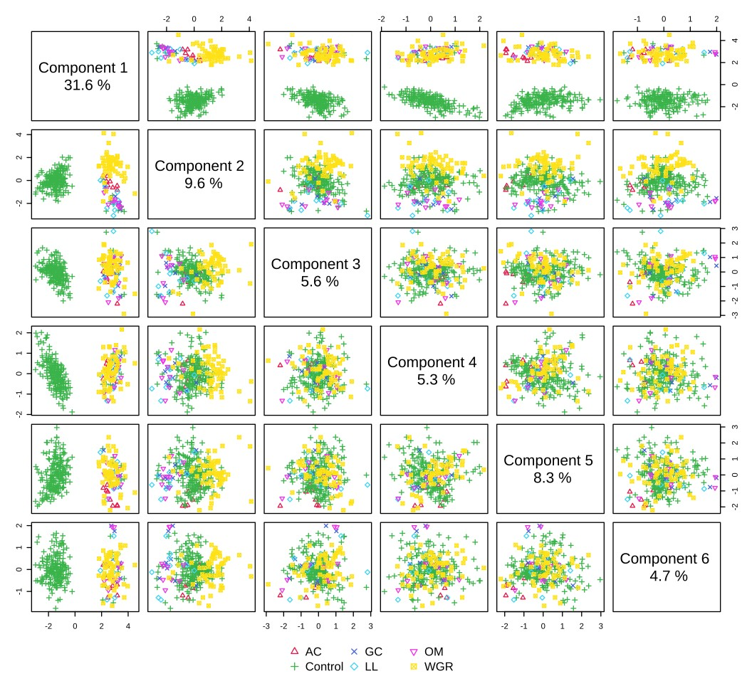
Figure S1. Partial Least Squares Discriminant Analysis (PLS-DA) representation of metabolites of lodgepole pine (Pinus contorta var. latifolia) infected with different pathogenic fungal species. WGR = Endocronartium harknessii, AC = Atropellis piniphila, GC= Grosmannia clavigera, LL= Leptographium longiclavatum, OM = Ophiostoma montium. This model was cross validated by leave-one-out cross-validation method in Fig. S2.
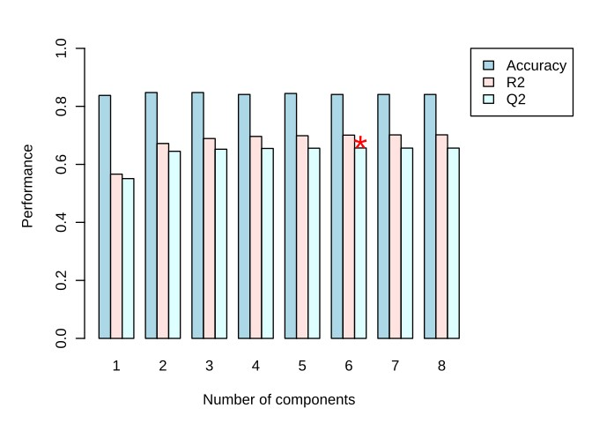
Figure S2. Cross-validation of Partial Least Squares Discriminant Analysis (PLS-DA) model by the Leave-one-out cross-validation method. Here, Q² is an estimate of the predictive ability of the model. The highest accuracy was observed with six components.
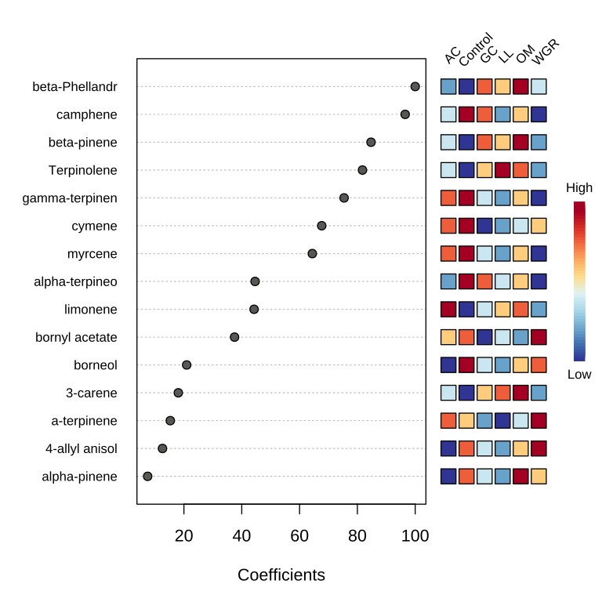
Figure S3. Important features identified by Partial Least Squares Discriminant Analysis (PLS-DA) based on coefficient scores of non-infected control treatment. Here, colored boxes show the relative concentrations of the corresponding metabolite under various conditions denoted by the scale on the right hand (darkest red= highest concentration and darkest blue= lowest concentration). Here, WGR = Endocronartium harknessii, AC = Atropellis piniphila, GC= Grosmannia clavigera, LL= Leptographium longiclavatum, OM = Ophiostoma montium.
Table S1: Presence/absence of metabolites in samples with and without infection of five native pathogens of lodgepole pine (Pinus contorta var. latifolia). The presence and absence of all chemical compounds were detected from the extraction and identifications by gas chromatograph-mas spectrometry in the majority of the 302 samples. The compounds present in the treatments are denoted by “x” and the absent by “−”.

Chemical compounds | Atropellis piniphila | Endocronartium harknessii | Grosmannia clavigera |  | Leptographium longiclavatum | Ophiostoma montium |  | P. contorta control
Monoterpenes
β-Phellandrene | x | x | x |  | x | x |  | x
α-Pinene | x | x | x |  | x | x |  | x
Camphene | x | x | x |  | x | x |  | x
β-Pinene | x | x | x |  | x | x |  | x
Myrcene | x | x | x |  | x | x |  | x
3-Carene | x | x | x |  | x | x |  | x
Limonene | x | x | x |  | x | x |  | x
Thujene | x | − | − |  | − | − |  | −
β-Ocimene | x | − | x |  | x | x |  | −
Tricyclene | x | − | − |  | − | − |  | −
α-Terpinene | x | x | − |  | − | − |  | x
p-Cymene | x | x | x |  | x | x |  | x
γ-Terpinene | x | x | x |  | x | x |  | x
Terpinolene | x | x | x |  | x | x |  | x
Sabinene | x | − | − |  | − | − |  | −
Oxygenated monoterpenes
Geranyl acetate | x | − | x |  | x | x |  | −
α-Terpineol | x | x | x |  | x | x |  | x
p-Cymen-8-ol | x | − | − |  | − | − |  | −
Terpinen-4-ol | x | − | x |  | x | x |  | −
Ascaridole | x | − | − |  | − | − |  | −
Bornyl acetate | x | x | x |  | x | x |  | x
Camphor | − | − | x |  | x | x |  | −
Borneol | x | x | x |  | x | x |  | x
Linalool | x | − | − |  | − | − |  | −
Cuminal | x | − | − |  | − | − |  | −
Endo-Borneol | x | − | − |  | − | − |  | −
Car-3-en-5-one | x | − | − |  | − | − |  | −
Pinocarvone | x | − | − |  | − | − |  | −
Citronellyl acetate | x | − | − |  | − | − |  | −
Sesquiterpenes
α-Farnesene | x | − | − |  | − | − |  | −
Germacrene D | x | − | − |  | − | − |  | −
cis-Muurola- 3.5- diene | x | − | − |  | − | − |  | −
α-Muurolene | x | − | − |  | − | − |  | −
β-Curcumene | x | − | − |  | − | − |  | −
Aromadendrene | x | − | − |  | − | − |  | −
β-Elemene | x | − | − |  | − | − |  | −
γ-Cadinene | x | − | − |  | − | − |  | −
Cubenene | x | − | − |  | − | − |  | −
β-Farnesene | x | − | − |  | − | − |  | −
β-trans-Farnesene | x | − | − |  | − | − |  | −
α-Bisabolol | x | − | − |  | − | − |  | −
Nerolidol | x | − | − |  | − | − |  | −
tau-Cadinol | x | − | − |  | − | − |  | −
tau-Muurolol | x | − | − |  | − | − |  | −
α-Cadinol | x | − | − |  | − | − |  | −
Germacrene D4-ol | x | − | x |  | x | x |  | −
Farnesol | x | − | − |  | − | − |  | −
β-Caryophyllene | − | − | x |  | x | x |  | −
γ-Elemene | x | − | − |  | − | − |  | −
Diterpenes
13-Epi-manool | x | − | x |  | x | x |  | x
Agathadiol | x | − | − |  | − | − |  | −
Cembrene | x | − | − |  | − | − |  | −
Levopimaral | x | − | − |  | − | − |  | −
Abietal | x | − | − |  | − | − |  | −
Sandaracopimaral | x | − | − |  | − | − |  | −
Kaurenal | x | − | − |  | − | − |  | −
Isopimaral | x | − | − |  | − | − |  | −
Isopimarol | x | − | − |  | − | − |  | −
Manoyl oxide | x | − | − |  | − | − |  | −
Torulosol | x | − | − |  | − | − |  | −
Others
Pinosylvin dimethyl ether | x | − | − | − |  |  | − |  | −
Linalyl cinnamate | x | − | − | − |  |  | − |  | −
4-Allylanisole | x | x | x | − |  |  | − |  | x
β-Sitosterol | x | − | − | − |  |  | − |  | −
4-Ethoxy ethylbenzoate | x | − | − | − |  |  | − |  | −

Table S2: Comparison between healthy and infected lodgepole pine (Pinus contorta var. latifolia) trees. Results reported from One-way ANOVA; Fisher’s LSD post hoc multiple comparisons were conducted between healthy and infected trees. Comparisons were based on concentrations of individual compounds.

Chemicals | F-value | p-value | False Discovery Rate
β-Phellandrene | 130.01 | <0.0001 | <0.0001
Camphene | 97.02 | <0.0001 | <0.0001
β-Pinene | 82.78 | <0.0001 | <0.0001
Terpinolene | 63.11 | <0.0001 | <0.0001
α-Terpinene | 38.94 | <0.0001 | <0.0001
γ-Terpinene | 35.74 | <0.0001 | <0.0001
Cymene | 27.11 | <0.0001 | <0.0001
Myrcene | 22.29 | <0.0001 | <0.0001
Limonene | 16.34 | <0.0001 | <0.0001
α-Terpineol | 8.88 | <0.0001 | <0.0001
Bornyl acetate | 8.47 | <0.0001 | <0.0001
3-Carene | 8.10 | <0.0001 | <0.0001
Borneol | 4.38 | 0.0007 | 0.0008
4-Allylanisole | 3.97 | 0.0017 | 0.0018
α-Pinene | 1.67 | 0.1418 | -

Table S3: Coefficient scores of metabolites from infected by various biotic stress agents and non-infected lodgepole pine (Pinus contorta var. latifolia) phloem analyzed by Partial Least Squares Discriminant Analysis (PLS-DA).

Compounds | coef.mean | AC | Control | GC | LL | OM | WGR
Camphene | 29.65 | 7.71 | 96.53 | 8.99 | 8.84 | 9.28 | 46.58
β-Phellandrene | 27.96 | 8.02 | 100 | 7.24 | 6.62 | 6.92 | 38.96
α-Terpinene | 27.25 | 0.59 | 15.28 | 18.26 | 22.02 | 23.33 | 84.02
β-Pinene | 26.40 | 6.69 | 84.71 | 8.15 | 8.08 | 8.49 | 42.29
Terpinolene | 22.28 | 6.45 | 81.76 | 5.44 | 4.84 | 5.06 | 30.12
γ-Terpinene | 21.72 | 5.89 | 75.40 | 5.89 | 5.54 | 5.81 | 31.83
Myrcene | 19.92 | 4.94 | 64.40 | 6.01 | 5.95 | 6.26 | 31.90
Bornyl acetate | 19.87 | 2.58 | 37.51 | 9.65 | 11.01 | 11.65 | 46.82
Cymene | 18.74 | 5.23 | 67.66 | 4.68 | 4.26 | 4.46 | 26.15
Limonene | 17.27 | 3.18 | 44.27 | 6.77 | 7.34 | 7.75 | 34.33
α-Terpineol | 16.08 | 3.22 | 44.61 | 5.81 | 6.17 | 6.52 | 30.13
3-Carene | 13.98 | 0.90 | 18.05 | 7.85 | 9.27 | 9.83 | 37.96
4-Allylanisole | 10.85 | 0.44 | 12.58 | 6.23 | 7.42 | 7.88 | 30.53
Borneol | 9.49 | 1.18 | 20.95 | 4.07 | 4.59 | 4.88 | 21.31
α-Pinene | 7.87 | 0 | 7.45 | 4.68 | 5.65 | 6.02 | 23.42
Here, coef.mean= mean of coefficient scores of all treatments, WGR = Endocronartium harknessii, AC = Atropellis piniphila, GC= Grosmannia clavigera, LL= Leptographium longiclavatum, OM = Ophiostoma montium.

