Significance of micro-EGFR T790M mutations on EGFR-tyrosine kinase inhibitor efficacy in non-small cell lung cancer: The WJOG 13119L study
Takeshi Masudaª, Satoru Miura^{b*}, Yuki Sato^{c}, Motoko Tachihara^{d}, Akihiro Bessho^{e}, Atsushi Nakamura^{f}, Taichi Miyawaki^{g}, Kohei Yoshimine^{h}, Masahide Mori^{i}, Hideaki Shiraishi^{j}, Kosuke Hamai^{k}, Koji Haratani^{l}, Sumiko Maeda^{m}, Eriko Tabata^{n}, Chiyoe Kitagawaº, Junko Tanizaki^{p}, Takumi Imai^{q}, Shouhei Nogami^{r}, Nobuyuki Yamamoto^{s}, Kazuhiko Nakagawa^{l}, Noboru Hattoriª

ªDepartment of Respiratory Medicine, Hiroshima University Hospital, Hiroshima 734-8551, Japan
^{b}Department of Internal Medicine, Niigata Cancer Center Hospital, Niigata 951-8566, Japan
^{c}Department of Respiratory Medicine, Kobe City Medical Center General Hospital, Kobe 650-0047, Japan
^{d}Division of Respiratory Medicine, Department of Internal Medicine, Kobe University Graduate School of Medicine, Kobe 650-0017, Japan
^{e}Department of Respiratory Medicine, Japanese Red Cross Okayama Hospital, Okayama 700-8607, Japan
^{f}Department of Pulmonary Medicine, Sendai Kousei Hospital, Sendai 980-0873, Japan
^{g}Division of Thoracic Oncology, Shizuoka Cancer Center, Shunto-gun, 411-8777, Japan
^{h}Department of Respiratory Medicine, Iizuka Hospital, Iizuka 820-8505, Japan
^{i}Department of Thoracic Oncology, National Hospital Organization, Osaka Toneyama Medical Center, Toyonaka 560-8552, Japan
^{j}Department of Respiratory Medicine, Mitsui Memorial Hospital, Tokyo 101-8643, Japan
^{k}Department of Respiratory Medicine, Hiroshima Prefectural Hospital, Hiroshima 734-8530, Japan
^{l}Department of Medical Oncology, Kindai University Faculty of Medicine, Higashiosaka 577-8502, Japan
^{m}Department of General Thoracic Surgery, Dokkyo Medical University, Shimotsuga-gun 321-0293, Japan
^{n}Department of Respiratory Medicine, Ikeda City Hospital, Ikeda 563-8510, Japan
ºDepartment of Respiratory Medicine and Medical Oncology, National Hospital Organization Nagoya Medical Center, Nagoya, 460-0001, Japan
^{p}Department of Medical Oncology, Kishiwada City Hospital, Kishiwada 596-8501, Japan
^{q}Department of Medical Statistics, Osaka Metropolitan University Graduate School of Medicine, Osaka 558-8585, Japan
^{r}Genome Research Group, Genome Analysis Department, Medical Solution Segment, LSI Medience Corporation, Tokyo 101-8517, Japan
^{s}Department of Internal Medicine III, Wakayama Medical University, Wakayama 641-8509, Japan

*Corresponding author: Satoru Miura
Department of Internal Medicine, Niigata Cancer Center Hospital, 2-15-3 Kawagishi-cho, Niigata 951-8566, Japan
Tel: +81-25-266-5111
Fax: +81-25-266-5112
Email: miusat1118@niigata-cc.jp

Supplementary Figures
Figure S1. Comparison of the T790M mutation ratio via droplet digital PCR in T790M-positive or -negative cases using the Cobas method and samples obtained after acquired resistance to epidermal growth factor receptor-kinase inhibitors.

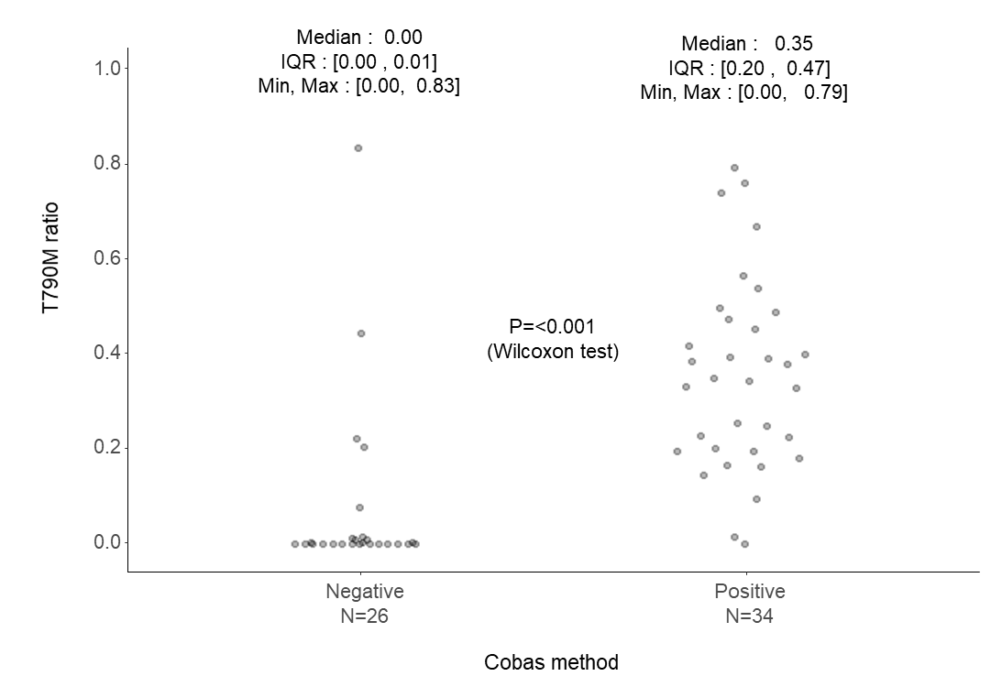

PCR, polymerase chain reaction; IQR, interquartile range; min, minimum; max, maximum

Figure S2. Sensitivity analysis for time-to-treatment failure in 1G, 2G, and 3G EGFR-TKI patients in the micro-EGFR T790M-positive and -negative groups in the context of T790M ratio cut-off.

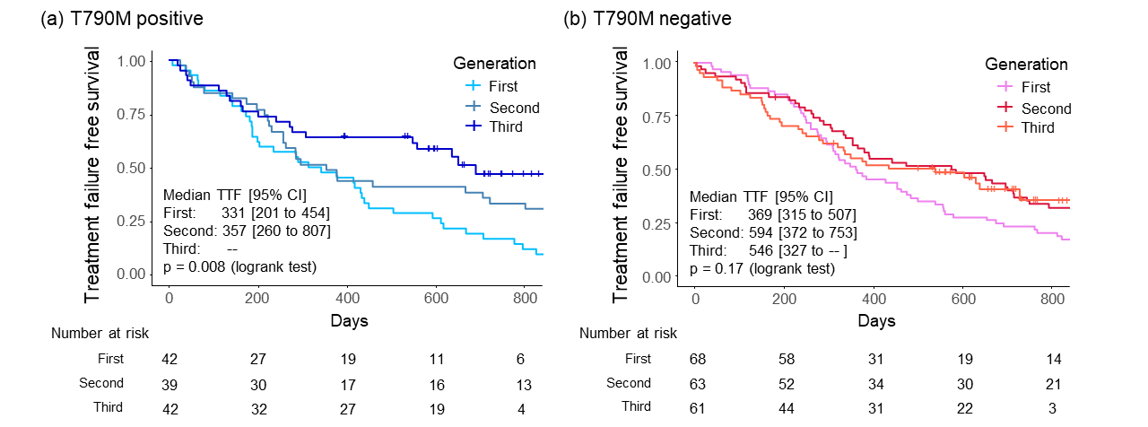

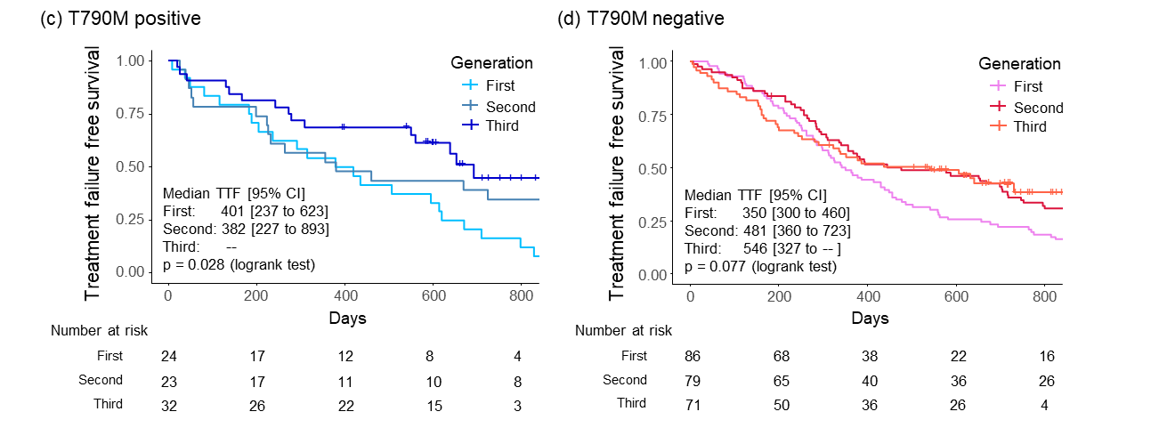

Analysis for differences in TTF among treatment generations (T790M ratio cut-off; 0.001) in the (a) micro-EGFR T790M-positive group and (b) -negative group. The analysis for differences in TTF among treatment generations (T790M ratio cut-off; 0.003) in the (c) micro-EGFR T790M-positive group and (d) -negative group.
EGFR, epidermal growth factor receptor; 1G, first-generation; 2G, second-generation; 3G, third generation; EGFR-TKI, epidermal growth factor receptor-kinase inhibitors; TTF, time-to-treatment failure; CI, confidence interval

Figure S3. Comparison between the T790M mutation ratio detected via ddPCR in pretreatment samples in T790M-positive and -negative cases using the Cobas method and samples obtained after acquired resistance.
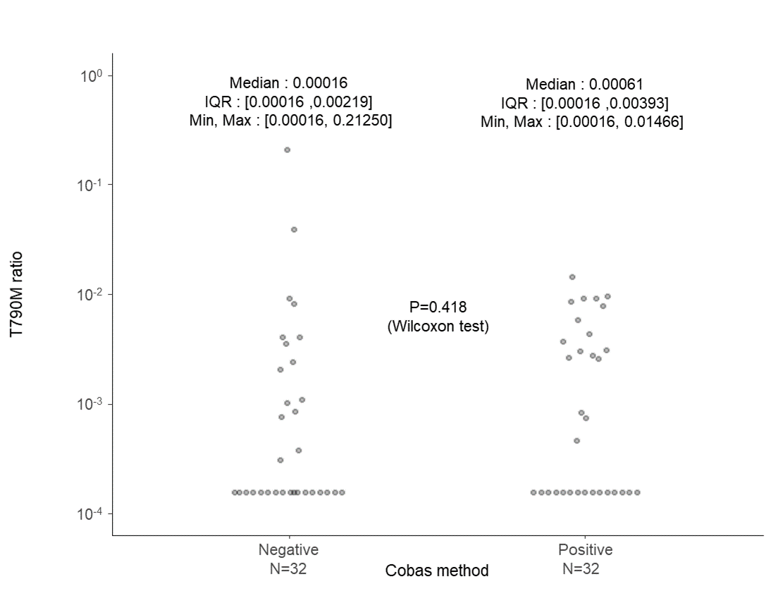

IQR, interquartile range; ddPCR, droplet digital polymerase chain reaction; min, minimum; max, maximum

Figure S4. Relationship between micro-T790M values and hazards for treatment failure via Cox proportional hazards analyses.
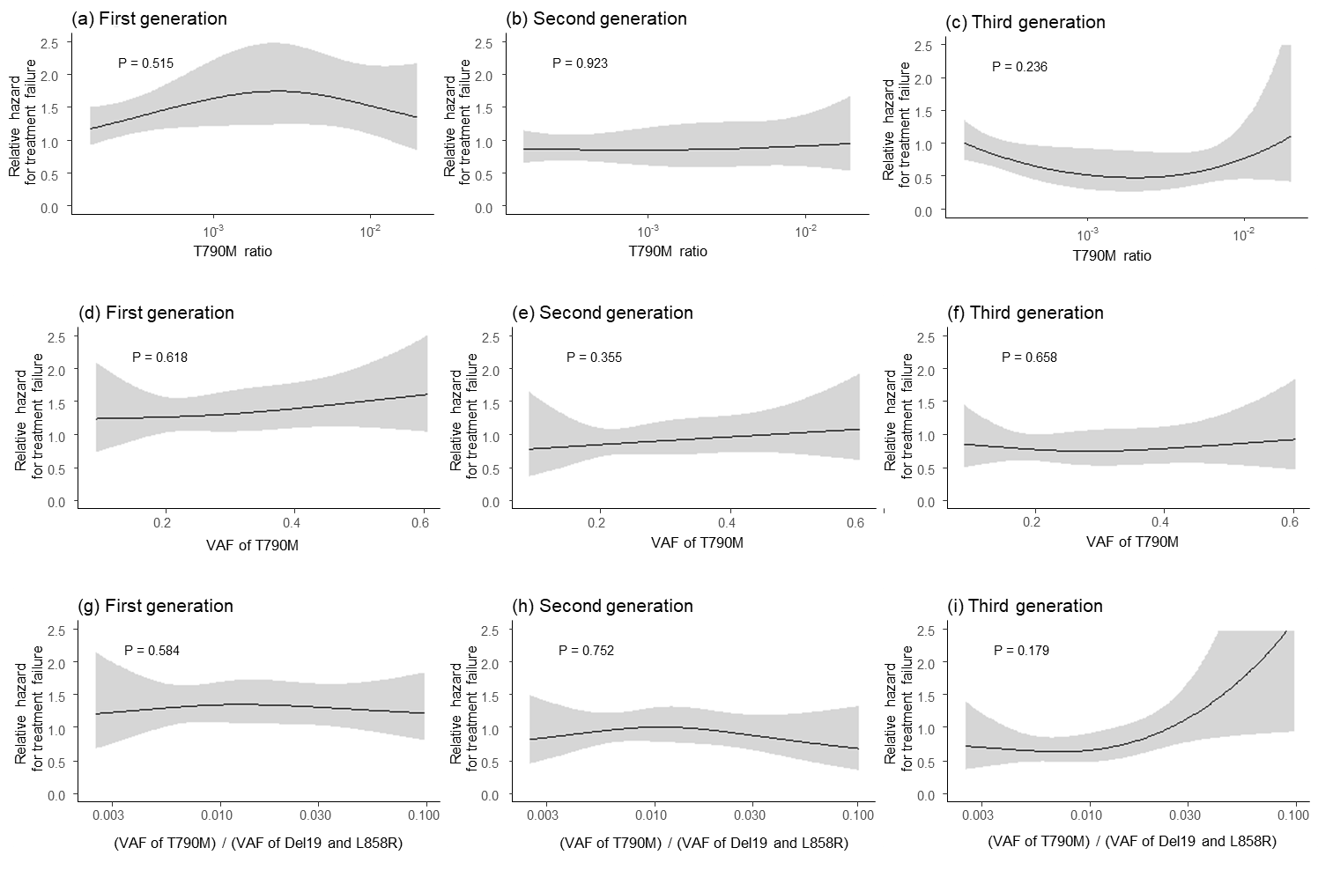

Relationship between (a) T790M ratio, (b) VAF of T790M, (c) (VAF of T790M)/(VAF of Del19 and L858R), and the hazards for treatment failure
VAF, variant allele frequency

Figure S5. Correlation between the concentration of T790M in the sample and the measured T790M mutation using droplet digital PCR.

PCR, polymerase chain reaction

Figure S6. Flowchart of sample selection criteria.

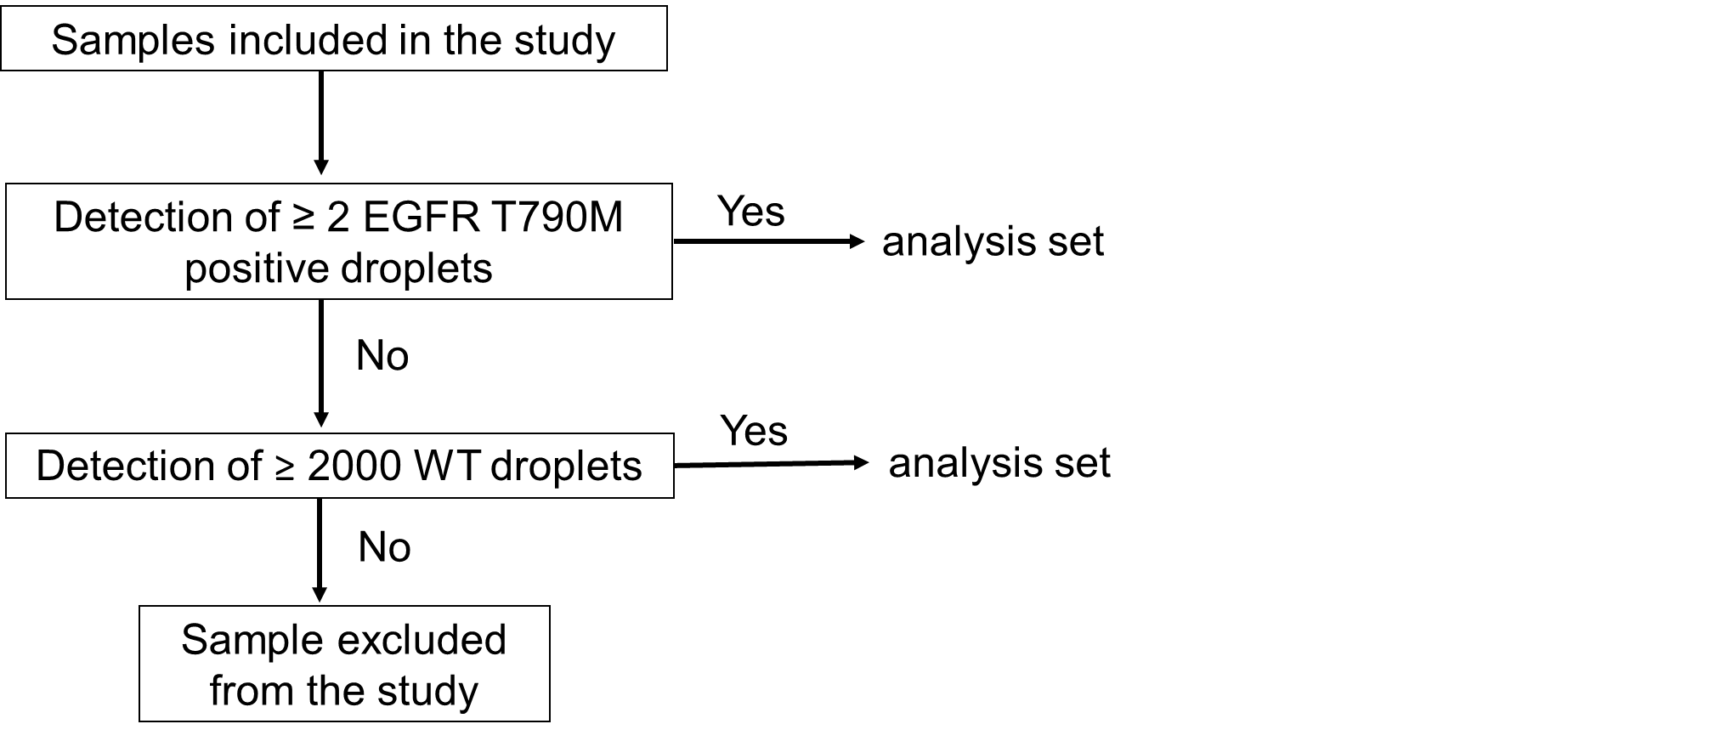
EGFR, epidermal growth factor; WT, wild type

Figure S7. Copy number of samples using droplet digital PCR.

PCR, polymerase chain reaction

Supplementary Tables
Table S1. Clinical characteristics of micro-T790M-positive and -negative patients with the Del19 mutation.
 |  | First generation |  |  | Second generation |  |  | Third generation
 |  | T790M- positive  N=23 | T790M- negative N=26 | P value | T790M- positive  N=30 | T790M- negative N=40 | P value | T790M- positive  N=28 | T790M- negative N=24 |  | P value
Age (years) |  | 66.96 ± 11.39 | 72.12 ± 11.30 | 0.119 | 64.83 ± 12.07 | 67.70 ± 8.81 | 0.277 | 71.57 ± 8.01 | 70.54 ± 10.55 |  | 0.698
PS | 0 | 6 (26.1%) | 14 (53.8%) | 0.016 | 12 (40.0%) | 21 (52.5%) | 0.546 | 17 (60.7%) | 11 (45.8%) |  | 0.467
 | 1 | 11 (47.8%) | 11 (42.3%) |  | 15 (50.0%) | 17 (42.5%) |  | 10 (35.7%) | 10 (41.7%)
 | 2 | 5 (21.7%) | 0 (0.0%) |  | 2 (6.7%) | 2 (5.0%) |  | 1 (3.6%) | 1 (4.2%)
 | 3 | 0 (0.0%) | 1 (3.8%) |  | 0 (0.0%) | 0 (0.0%) |  | 0 (0.0%) | 2 (8.3%)
 | 4 | 0 (0.0%) | 0 (0.0%) |  | 1 (3.3%) | 0 (0.0%) |  | 0 (0.0%) | 0 (0.0%)
 | Missing | 1 (4.4%) | 0 (0.0%) |  | 0 (0.0%) | 0 (0.0%) |  | 0 (0.0%) | 0 (0.0%)
Sex | Male | 9 (39.1%) | 8 (30.8%) | 0.564 | 17 (56.7%) | 16 (40.0%) | 0.227 | 11 (39.3%) | 11 (45.8%) |  | 0.779
 | Female | 14 (60.9%) | 18 (69.2%) |  | 13 (43.3%) | 24 (60.0%) |  | 17 (60.7%) | 13 (54.2%)
Smoking | Never | 11 (47.8%) | 16 (61.5%) | 0.187 | 12 (40.0%) | 22 (55.0%) | 0.465 | 19 (67.9%) | 13 (54.2%) |  | 0.453
 | Former | 12 (52.2%) | 8 (30.8%) |  | 12 (40.0%) | 13 (32.5%) |  | 6 (21.4%) | 9 (37.5%)
 | Current | 0 (0.0%) | 2 (7.7%) |  | 6 (20.0%) | 5 (12.5%) |  | 3 (10.7%) | 2 (8.3%)
Histological type | Adenocarcinoma | 23 (100.0%) | 26 (100.0%) | 1.000 | 30 (100.0%) | 40 (100.0%) | 1.000 | 28 (100.0%) | 24 (100.0%) |  | 1.000
 | Other | 0 (0.0%) | 0 (0.0%) |  | 0 (0.0%) | 0 (0.0%) |  | 0 (0.0%) | 0 (0.0%)
Stage | III | 2 (8.7%) | 2 (7.7%) | 0.817 | 2 (6.7%) | 3 (7.5%) | 1.000 | 1 (3.6%) | 3 (12.5%) |  | 0.214
 | IV | 16 (69.6%) | 16 (61.5%) |  | 21 (70.0%) | 27 (67.5%) |  | 17 (60.7%) | 17 (70.8%)
 | Relapse | 5 (21.7%) | 8 (30.8%) |  | 7 (23.3%) | 10 (25.0%) |  | 10 (35.7%) | 4 (16.7%)
Brain metastasis | Yes | 8 (34.8%) | 4 (15.4%) | 0.183 | 5 (16.7%) | 9 (22.5%) | 0.764 | 9 (32.1%) | 7 (29.2%) |  | 1.000
 | No | 15 (65.2%) | 22 (84.6%) |  | 25 (83.3%) | 31 (77.5%) |  | 19 (67.9%) | 17 (70.8%)
EGFR-TKI treatment | Gefitinib | 13 (56.5%) | 22 (84.6%) | 0.055 | — | — |  | — | —
 | Erlotinib | 10 (43.5%) | 4 (15.4%) |  | — | — |  | — | —
Treatment line | First line | 23 (100.0%) | 23 (88.5%) | 0.237 | 30 (100.0%) | 39 (97.5%) | 1.000 | 28 (100.0%) | 24 (100.0%) |  | 1.000
 | Second line | 0 (0.0%) | 3 (11.5%) |  | 0 (0.0%) | 1 (2.5%) |  | 0 (0.0%) | 0 (0.0%)
EGFR exon 19 deletion | Positive | 23 (100.0%) | 26 (100.0%) | 1.000 | 30 (100.0%) | 40 (100.0%) | 1.000 | 28 (100.0%) | 24 (100.0%) |  | 1.000
 | Negative | 0 (0.0%) | 0 (0.0%) |  | 0 (0.0%) | 0 (0.0%) |  | 0 (0.0%) | 0 (0.0%)
EGFR exon 21 L858R | Positive | 0 (0.0%) | 0 (0.0%) | 1.000 | 0 (0.0%) | 0 (0.0%) | 1.000 | 0 (0.0%) | 0 (0.0%) |  | 1.000
 | Negative | 23 (100.0%) | 26 (100.0%) |  | 30 (100.0%) | 40 (100.0%) |  | 28 (100.0%) | 24 (100.0%)
Data are presented as mean ± standard deviation or number (percentage).
Abbreviations: EGFR-TKI: epidermal growth factor receptor - tyrosine kinase inhibitor: PS, performance status

Table S2. Clinical characteristics of micro-T790M-positive and -negative patients with the L858R mutation.
 |  | First generation |  |  | Second generation |  |  | Third generation
 |  | T790M- positive  N=30 | T790M- negative N=31 | P value | T790M- positive  N=18 | T790M- negative N=14 | P value | T790M- positive  N=21 | T790M- negative N=30 |  | P value
Age (years) |  | 74.70 ± 7.46 | 74.84 ± 8.62 | 0.947 | 69.28 ± 5.63 | 64.57 ± 9.10 | 0.105 | 72.57 ± 9.18 | 70.63 ± 9.10 |  | 0.460
PS | 0 | 14 (46.7%) | 10 (32.3%) | 0.271 | 11 (61.1%) | 8 (57.1%) | 0.926 | 9 (42.9%) | 13 (43.3%) |  | 0.860
 | 1 | 13 (43.3%) | 15 (48.4%) |  | 5 (27.8%) | 4 (28.6%) |  | 11 (52.4%) | 13 (43.3%)
 | 2 | 2 (6.7%) | 6 (19.4%) |  | 1 (5.6%) | 2 (14.3%) |  | 1 (4.8%) | 3 (10.0%)
 | 3 | 0 (0.0%) | 0 (0.0%) |  | 0 (0.0%) | 0 (0.0%) |  | 0 (0.0%) | 1 (3.3%)
 | 4 | 0 (0.0%) | 0 (0.0%) |  | 1 (5.6%) | 0 (0.0%) |  | 0 (0.0%) | 0 (0.0%)
 | Missing | 1 (3.3%) | 0 (0.0%) |  | 0 (0.0%) | 0 (0.0%) |  | 0 (0.0%) | 0 (0.0%)
Sex | Male | 13 (43.3%) | 10 (32.3%) | 0.434 | 8 (44.4%) | 3 (21.4%) | 0.266 | 11 (52.4%) | 14 (46.7%) |  | 0.779
 | Female | 17 (56.7%) | 21 (67.7%) |  | 10 (55.6%) | 11 (78.6%) |  | 10 (47.6%) | 16 (53.3%)
Smoking | Never | 14 (46.7%) | 22 (71.0%) | 0.112 | 9 (50.0%) | 10 (71.4%) | 0.459 | 16 (76.2%) | 16 (53.3%) |  | 0.236
 | Former | 12 (40.0%) | 5 (16.1%) |  | 7 (38.9%) | 4 (28.6%) |  | 3 (14.3%) | 11 (36.7%)
 | Current | 4 (13.3%) | 4 (12.9%) |  | 2 (11.1%) | 0 (0.0%) |  | 2 (9.5%) | 3 (10.0%)
Histological type | Adenocarcinoma | 30 (100.0%) | 31 (100.0%) | 1.000 | 18 (100.0%) | 13 (92.9%) | 0.438 | 20 (95.2%) | 29 (96.7%) |  | 1.000
 | Other | 0 (0.0%) | 0 (0.0%) |  | 0 (0.0%) | 1 (7.1%) |  | 1 (4.8%) | 1 (3.3%)
Stage | III | 2 (6.7%) | 3 (9.7%) | 0.651 | 2 (11.1%) | 1 (7.1%) | 0.856 | 3 (14.3%) | 2 (6.7%) |  | 0.592
 | IV | 19 (63.3%) | 22 (71.0%) |  | 13 (72.2%) | 9 (64.3%) |  | 11 (52.4%) | 19 (63.3%)
 | Relapse | 9 (30.0%) | 6 (19.4%) |  | 3 (16.7%) | 4 (28.6%) |  | 7 (33.3%) | 9 (30.0%)
Brain metastasis | Yes | 14 (46.7%) | 8 (25.8%) | 0.114 | 6 (33.3%) | 3 (21.4%) | 0.694 | 4 (19.0%) | 11 (36.7%) |  | 0.221
 | No | 16 (53.3%) | 23 (74.2%) |  | 12 (66.7%) | 11 (78.6%) |  | 17 (81.0%) | 19 (63.3%)
EGFR-TKI treatment | Gefitinib | 19 (63.3%) | 22 (71.0%) | 0.592 | — | — |  | — | —
 | Erlotinib | 11 (36.7%) | 9 (29.0%) |  | — | — |  | — | —
Treatment line | First line | 30 (100.0%) | 31 (100.0%) | 1.000 | 16 (88.9%) | 12 (85.7%) | 1.000 | 20 (95.2%) | 30 (100.0%) |  | 0.412
 | Second line | 0 (0.0%) | 0 (0.0%) |  | 2 (11.1%) | 2 (14.3%) |  | 1 (4.8%) | 0 (0.0%)
EGFR exon 19 deletion | Positive | 0 (0.0%) | 0 (0.0%) | 1.000 | 0 (0.0%) | 0 (0.0%) | 1.000 | 0 (0.0%) | 0 (0.0%) |  | 1.000
 | Negative | 30 (100.0%) | 31 (100.0%) |  | 18 (100.0%) | 14 (100.0%) |  | 21 (100.0%) | 30 (100.0%)
EGFR exon 21 L858R | Positive | 30 (100.0%) | 31 (100.0%) | 1.000 | 18 (100.0%) | 14 (100.0%) | 1.000 | 21 (100.0%) | 30 (100.0%) |  | 1.000
 | Negative | 0 (0.0%) | 0 (0.0%) |  | 0 (0.0%) | 0 (0.0%) |  | 0 (0.0%) | 0 (0.0%)
Data are presented as mean ± standard deviation or number (percentage).
Abbreviations: EGFR-TKI: epidermal growth factor receptor - tyrosine kinase inhibitor, PS: performance status

Table S3. Multivariate Cox regression analysis of time to treatment failure in Del19- and L858-positive groups.
 |  | Hazard ratio | 95% CI | P value
Del19-positive group
PS 2–4 (ref. 0–1) |  | 2.323 | [1.249 to 4.323] | 0.008
Male (ref. Female) |  | 0.788 | [0.509 to 1.218] | 0.283
Current or past smoker (ref. Non-smoker) |  | 1.531 | [1.001 to 2.342] | 0.049
TNM III or IV (ref. others) |  | 2.235 | [1.396 to 3.580] | 0.001
Brain metastasis |  | 1.456 | [1.081 to 1.961] | 0.013
T790M Positive vs, Negative (ref.) | First generation | 1.242 | [0.654 to 2.358] | 0.508
T790M Positive vs. Negative (ref.) | Second generation | 0.783 | [0.454 to 1.348] | 0.377
T790M Positive vs. Negative (ref.) | Third generation | 0.388 | [0.152 to 0.990] | 0.048
Second generation vs. First generation (ref.) | T790M Negative | 1.084 | [0.633 to 1.857] | 0.768
Third generation vs. First generation (ref.) | T790M Negative | 0.739 | [0.360 to 1.515] | 0.408
Third generation vs. second generation (ref.) | T790M Negative | 0.681 | [0.348 to 1.334] | 0.263
Second generation vs. First generation (ref.) | T790M Positive | 0.684 | [0.362 to 1.289] | 0.240
Third generation vs. First generation (ref.) | T790M Positive | 0.231 | [0.097 to 0.549] | 0.001
Third generation vs. second generation (ref.) | T790M Positive | 0.337 | [0.142 to 0.800] | 0.014
L858R-positive group
PS 2–4 (ref. 0–1) |  | 1.490 | [0.816 to 2.724] | 0.195
Male (ref. Female) |  | 1.005 | [0.608 to 1.661] | 0.985
Current or past smoker (ref. Non-smoker) |  | 1.038 | [0.622 to 1.730] | 0.887
TNM III or IV (ref. others) |  | 1.716 | [1.079 to 2.729] | 0.023
Brain metastasis |  | 1.219 | [0.776 to 1.918] | 0.390
T790M Positive vs. Negative (ref.) | First generation | 1.148 | [0.658 to 2.003] | 0.627
T790M Positive vs. Negative (ref.) | Second generation | 0.952 | [0.432 to 2.097] | 0.904
T790M Positive vs. Negative (ref.) | Third generation | 1.339 | [0.669 to 2.677] | 0.409
Second generation vs. First generation (ref.) | T790M Negative | 0.695 | [0.350 to 1.379] | 0.298
Third generation vs. First generation (ref.) | T790M Negative | 0.831 | [0.463 to 1.492] | 0.536
Third generation vs. Second generation (ref.) | T790M Negative | 1.196 | [0.566 to 2.530] | 0.639
Second generation vs. First generation (ref.) | T790M Positive | 0.576 | [0.292 to 1.137] | 0.112
Third generation vs. First generation (ref.) | T790M Positive | 0.969 | [0.491 to 1.912] | 0.928
Third generation vs. second generation (ref.) | T790M Positive | 1.682 | [0.778 to 3.635] | 0.186
Abbreviations: CI: confidence interval, PS: performance status, TNM: tumor node metastasis classification, EGFR: epidermal growth factor receptor

TableS 4. Droplet digital PCR for T790M using normal genomic DNA derived from healthy human peripheral blood or commercially available DNA.
Sample | Target | Copies per  20-uL well | Fractional  Abundance (%) | Positives | Negatives | Mutant+, Wild+ | Mutant+, Wild- | Mutant-, Wild+ | Mutant-, Wild-
 |  |  |  |  |  | FAM+HEX+ | FAM+HEX- | FAM-HEX+ | FAM-HEX-
1 | Mutant | 6.8 | 0.050 | 3 | 10370 | 3 | 0 | 4373 | 5997
1 | Wild | 12900 | 0.050 | 4376 | 5997 | 3 | 0 | 4373 | 5997
2 | Mutant | 5 | 0.035 | 3 | 14221 | 3 | 0 | 6485 | 7736
2 | Wild | 14340 | 0.035 | 6488 | 7736 | 3 | 0 | 6485 | 7736
3 | Mutant | 1.4 | 0.012 | 1 | 15694 | 1 | 0 | 6340 | 9354
3 | Wild | 12180 | 0.012 | 6341 | 9354 | 1 | 0 | 6340 | 9354
4 | Mutant | 5 | 0.037 | 3 | 14273 | 3 | 0 | 6188 | 8085
4 | Wild | 13380 | 0.037 | 6191 | 8085 | 3 | 0 | 6188 | 8085
5 | Mutant | 8.6 | 0.070 | 6 | 16402 | 6 | 0 | 6999 | 9403
5 | Wild | 13100 | 0.070 | 7005 | 9403 | 6 | 0 | 6999 | 9403
6 | Mutant | 9 | 0.070 | 5 | 13200 | 5 | 0 | 5789 | 7411
6 | Wild | 13600 | 0.070 | 5794 | 7411 | 5 | 0 | 5789 | 7411
7 | Mutant | 7.2 | 0.050 | 4 | 13149 | 4 | 0 | 5945 | 7204
7 | Wild | 14160 | 0.050 | 5949 | 7204 | 4 | 0 | 5945 | 7204
8 | Mutant | 8.2 | 0.070 | 5 | 14483 | 5 | 0 | 5775 | 8708
8 | Wild | 11980 | 0.070 | 5780 | 8708 | 5 | 0 | 5775 | 8708
9 | Mutant | 3.6 | 0.023 | 2 | 12855 | 1 | 1 | 6323 | 6532
9 | Wild | 15920 | 0.023 | 6324 | 6533 | 1 | 1 | 6323 | 6532
10 | Mutant | 1.8 | 0.012 | 1 | 12487 | 1 | 0 | 5956 | 6531
10 | Wild | 15260 | 0.012 | 5957 | 6531 | 1 | 0 | 5956 | 6531
11 | Mutant | 1.6 | 0.054 | 1 | 15195 | 1 | 0 | 1807 | 13388
11 | Wild | 2980 | 0.054 | 1808 | 13388 | 1 | 0 | 1807 | 13388
12 | Mutant | 0 | 0 | 0 | 14915 | 0 | 0 | 1797 | 13118
12 | Wild | 3020 | 0 | 1797 | 13118 | 0 | 0 | 1797 | 13118
Sample 1–8; 50 ng DNA from healthy human peripheral blood
Sample 9, 10; 50 ng commercially available DNA
Sample 11, 12; 10 ng commercially available DNA
PCR: polymerase chain reaction

Table S5. Droplet digital PCR for F795F using normal genome DNA derived from healthy human peripheral blood.
Sample | Target | Copies per  20-uL well | Fractional  Abundance (%) | Positives | Negatives | Mutant+, Wild+ | Mutant+, Wild- | Mutant-, Wild+ | Mutant-, Wild-
 |  |  |  |  |  | FAM+HEX+ | FAM+HEX- | FAM-HEX+ | FAM-HEX-
1 | Mutant | 4.4 | 0.032 | 3 | 16248 | 2 | 1 | 7174 | 9074
1 | Wild | 13700 | 0.032 | 7176 | 9075 | 2 | 1 | 7174 | 9074
2 | Mutant | 3 | 0.020 | 2 | 16192 | 2 | 0 | 7505 | 8687
2 | Wild | 14660 | 0.020 | 7507 | 8687 | 2 | 0 | 7505 | 8687
3 | Mutant | 6 | 0.045 | 4 | 15692 | 4 | 0 | 6823 | 8869
3 | Wild | 13440 | 0.045 | 6827 | 8869 | 4 | 0 | 6823 | 8869
4 | Mutant | 4.2 | 0.035 | 3 | 17206 | 2 | 1 | 6783 | 10423
4 | Wild | 11800 | 0.035 | 6785 | 10424 | 2 | 1 | 6783 | 10423
5 | Mutant | 0 | 0 | 0 | 14785 | 0 | 0 | 6699 | 8086
5 | Wild | 14200 | 0 | 6699 | 8086 | 0 | 0 | 6699 | 8086
6 | Mutant | 3.2 | 0.025 | 2 | 14722 | 2 | 0 | 6148 | 8574
6 | Wild | 12720 | 0.025 | 6150 | 8574 | 2 | 0 | 6148 | 8574
PCR: polymerase chain reaction

Supplementary Documents
Droplet digital polymerase chain reaction (ddPCR)
Genomic DNA extraction was conducted using the QIAamp DNA Micro Kit (Qiagen, Hilden, Germany) according to the manufacturer's recommendations. Extracted DNA was quantified using a NanoDrop ND-1000 spectrophotometer (Thermo Fisher Scientific, Cleveland, OH, USA). The presence of the EGFR mutation was assessed using QX200 AutoDG ddPCR System (Bio-Rad, Hercules, CA, USA). Forward and reverse gene-specific primers and fluorescent hydrolysis probes for either the mutant (Del19, L858R, and T790M-FAM) or wild type (WT) (WT Del19, L858R, and T790-HEX) sequences were obtained from Bio-Rad. The reactions were emulsified using an auto droplet generator, transferred to 96-well plates, and amplified using the following cycling conditions: 95 ℃ for 10 min; 40 cycles of 94 ℃ for 30 sec, and 55 ℃ for 1 min; 98 ℃ for 10 min. After amplification, plates were read, and fluorescence signals of individual sample droplets were analyzed with a QX200 droplet reader (Bio-Rad). The copy number of the mutant allele frequency relative to that of WT was determined using QuantaSoft V.1.7.4 software (Bio-Rad) by applying a correction based on the Poisson distribution to the number of droplets positive for either mutant or WT DNA. We defined a FAM+ and HEX-, or FAM+ and HEX+ drop as a T790M-positive drop.
The criteria of EGFR gene amplification
The number of EGFR Del19 or L858R mutant copies was detected 2×10⁷, which is the quantitative upper limit of the QX200 Digital Droplet PCR system, in the six samples, and these samples were considered to have EGFR gene amplification. The copy number divided by the amount of DNA templates of the 450 samples used in this study is shown in the Supplementary Figure 2. The EGFR gene copy number of the six samples predicted to have EGFR gene amplification was 1×10⁴ (1.0E+04) copy/ng or more. In contrast, On the other hand, the mean copy number of the EGFR gene in the samples excluding these six samples was 5.2×10 (5.2E + 01) copy/ng, and the mean copy of EGFR gene in genomic DNA derived from healthy human blood cells used for control was 2.7×10² (2.7E + 02) copy/ng. From these results, we decided the six samples have EGFR gene amplification, and excluded from this analysis.
Primer and probes for mutant F795F or WT F795F
The sequence was as follows: F795F-FAM; Forward AGGCAGC+C+AAAGGG, WT F795-HEX, A

