SUPPLEMENTARY

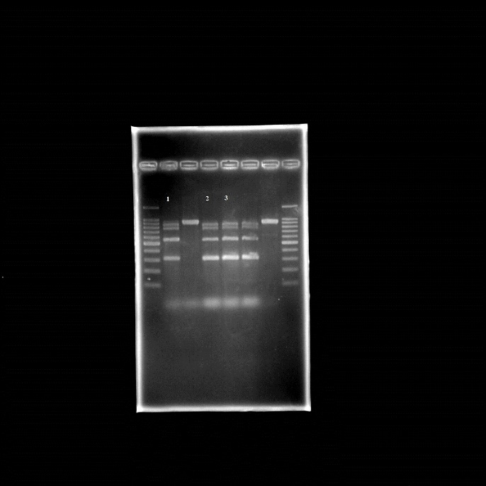
Figure 1 Original uncropped image of multiplex PCR performed on V. cholerae with three repetitions (1-3) *red line indicates where the image was cropped; the second well was cropped due to gel leakage during electrophoresis
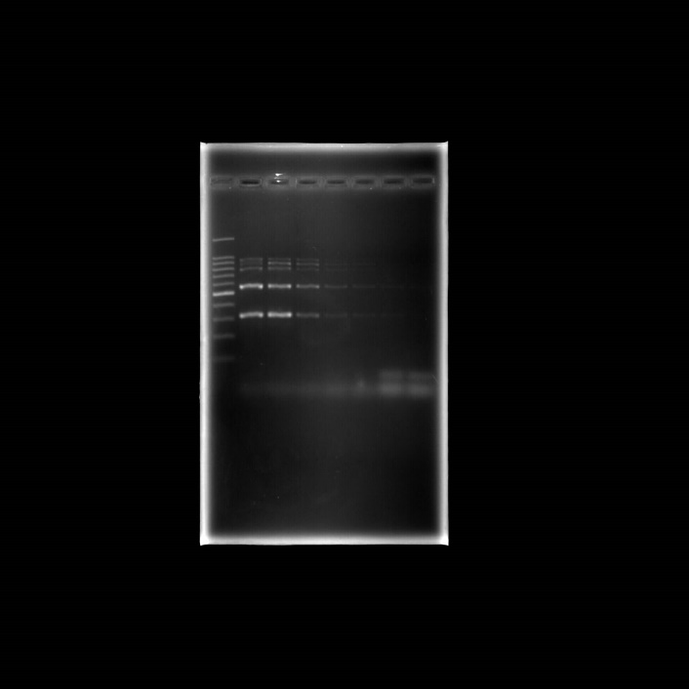
Figure 2 Original uncropped image of multiplex PCR sensitivity evaluation was performed on V. cholerae with serial of delution of DNA template (1-5) *red line indicates where the image was cropped.
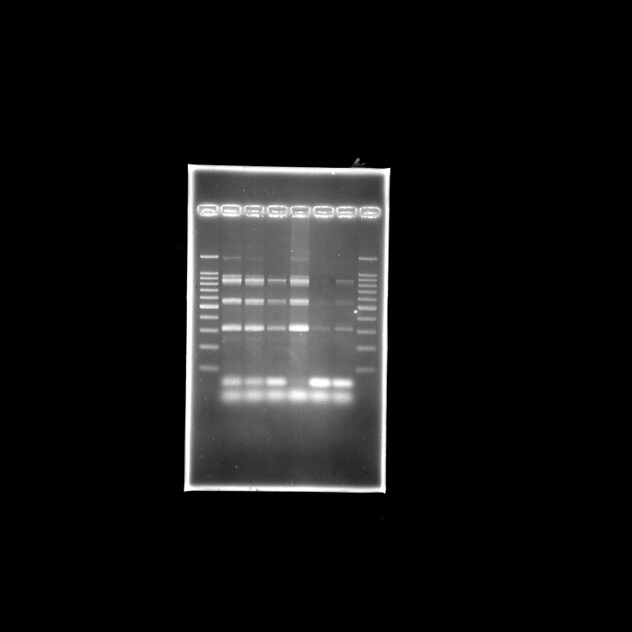
Figure 3 Original uncropped image of multiplex PCR of V. cholerae with direct method *red line indicates where the image was cropped.
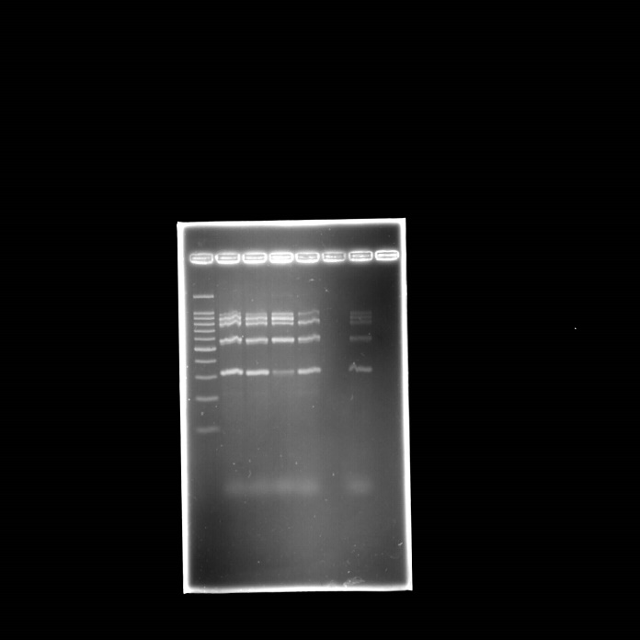
Figure 4 Original uncropped image of multiplex PCR of V. cholerae with indirect method *red line indicates where the image was cropped.
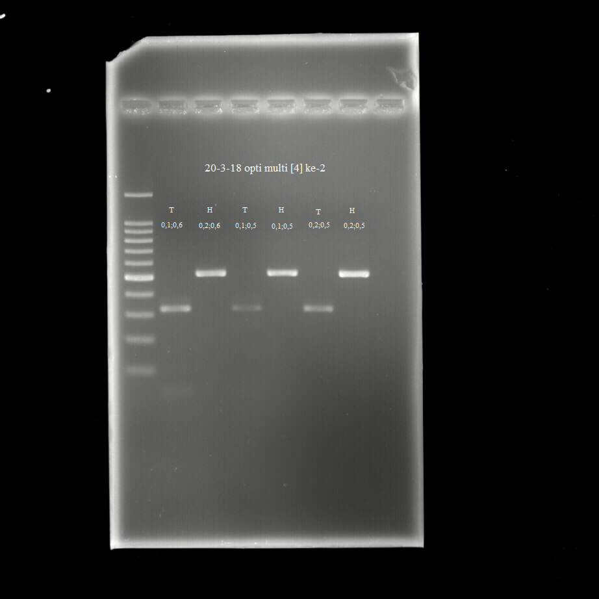
Figure 5 Original uncropped image of multiplex PCR performed on ETEC (1, 3, and 5) and EHEC (2, 4, and 6) with three repetitions *red line indicates where the image was cropped.

