Adaptable bio-based dynamically cross-linked networks via disrupting physical cross-linking and chain entanglement for electromagnetic interference shielding materials

Yun Huª, Lei Chen^{b}, Puyou Jia^{a*}, Yufeng Ma^{b}, Qin Huang^{c}, Lihong Huª, Yonghong Zhou^{a*}

ª Institute of Chemical Industry of Forest Products, Chinese Academy of Forestry (CAF), Key Lab of Biomass Energy and Materials, Jiangsu Co-Innovation Center of Efficient Processing and Utilization of Forest Resources, Jiangsu Province, 16 Suojin North Road, Nanjing 210042, China
^{b} College of Materials Science and Engineering, Nanjing Forestry University, 159 Longpan Road, Nanjing 210037, China.
^{c} Key Laboratory of Chemistry and Engineering of Forest Products, State Ethnic Affairs Commission, Guangxi Key Laboratory of Chemistry and Engineering of Forest Products, Guangxi Minzu University, Nanning 530006, China

(*Corresponding Authors: E-mail: jiapuyou@icifp.cn (P. J.); zyh@icifp.cn (Y.Z)).

Characterization
Fourier transform infrared spectrometry (FT-IR) spectra were taken on a PerkinElmer spectrum 100 FT-IR spectrometer. 300 MHz ¹H NMR spectra were recorded on a Bruker Avance III HD 300 spectrometer using CDCl₃ as the solvent with tetramethylsilane (TMS) as an internal reference. Thermogravimetric analysis (TGA) was carried out on a Q5000 TGA system (TA Instruments), ramping from 40 to 600 °C at a heating rate of 10 °C min⁻¹ under a nitrogen flow at 25 mL min⁻¹. Glass transition temperature (T_{g}) was recorded through differential scanning calorimetry (DSC) conducted on a DSC 2000 instrument (TA Instruments). Crosslinking density of polymers were tested with dynamic mechanical analysis (DMA) using a Q800 DMA (TA Instruments, New Castle, DE) with a frequency of 1 Hz in a dual cantilever mode under N₂ atmosphere. The temperature ranged from -80 to 140 °C at a heating rate of 3 °C/min. Tensile tests were taken on an E43.104 Universal Testing Machine (MTS Instrument Crop., China). Dog-bone shaped samples with a length of 20 mm and a width of 5.0 mm were tested at room temperature with a crosshead speed of 20 mm/min. Five replicate samples were used to obtain an average value for each sample. The water contact angle was measured using a contact angle meter (SL2008 solon contact angle meter, China) with a 3 µL water droplet. The average value of five specimens and deviation were calculated. Optical microscopy was obtained from a Leica metallographic microscope (Germany) to calculate the self-healing efficiency. Solvent resistance was investigated by immersing the samples in deionized water, ethanol, tetrahydrofuran, ethyl acetate, 20 wt% sulfuric acid solution, 1 M NaOH solution, petroleum ether, and dimethyl formamide (DMF) for 48h h at 25 °C. FLIR thermal imager 3rd generation FLIR one Pro mobile phone external probe infrared thermal imager one pro (Android version -20–400 ℃). The electrical performance uses Unilever UTP3315TFL DC regulated power supply (0-32 V, Korea). The EMI SE performance of composites was measured using a Agilent PNA-N5244A vector network analyzer within 8.2–12.4 GHz in X band. The corresponding dimension of samples was 20 × 10 × 1 mm³.

Tung oil (TO), ethanolamides of tung oil fatty chains (ET), tung oil based UV-curable prepolymer (MET composition), and PNMET0, PNMET1~3 were synthesized (Fig S1a & b) and characterized by FT-IR and ¹H NMR (Fig. S2 a & b). In the FT-IR spectrum of ET, a peak at 3315 and 1662 cm⁻¹ corresponding to the OH/NH and carbonyl group appeared, and the peak at 1745 cm⁻¹ attributing to the ester bond of triglyceride of tung oil cannot be observed [1]. In the FT-IR of MET, the peak at 3315 cm⁻¹ showed stronger compared with ET, and the peaks at 1742 and 852 cm⁻¹ were attributed to the formation of the ester bond and double bond of methacrylic acid after esterfication, respectively. In the FT-IR of PNMET0, the disappearance of double bonds of methacrylic acid and conjugated double bond at 852, 3020 and 1012 cm⁻¹ indicated that active double bonds participated in the reaction under UV conditions and PNMET0 was successfully fabricated. In the ¹H NMR spectrum of TO, the signals at 4.2 and 5.3 ppm were assigned to protons of methylene from triglycerides [2]. In the ¹H NMR spectrum of ET, the absorption peak at 3.3 ppm was assigned to protons of OH/NH. In the ¹H NMR of MET, the new absorption peaks at 11.0 and 12.0 ppm were assigned to protons of double bond from methacrylic acid, and the peak at 9.0 ppm was attributed to the protons on the carboxyl of methacrylic acid. Combining these results of FT-IR and ¹H NMR, it can be confirmed the successful preparation of MET composition and PNMET0.

Fig. S1 (a) Synthetic route of PNMET0; (2) Synthetic route of PNMET1~3.

Fig. S2 (a) FT-IR spectra of TO, ET, MET, and PNMET0; (b) ¹H NMR spectra of TO, ET, and MET.

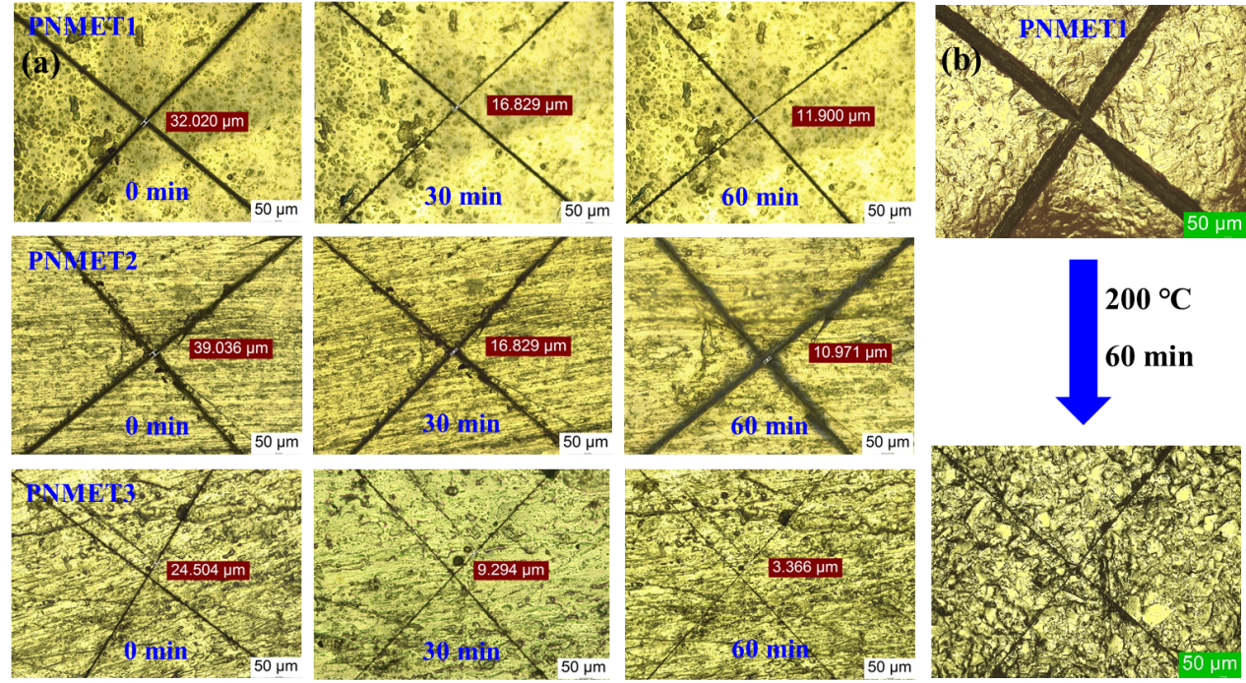
Fig. S3. (a) Self-healing of PNMET1, PNMET2, and PNMET3 at 80 ºC for 30 min and 60 min, respectively; (b) Self-healing of PNMET1 at 200 ºC for 60 min.

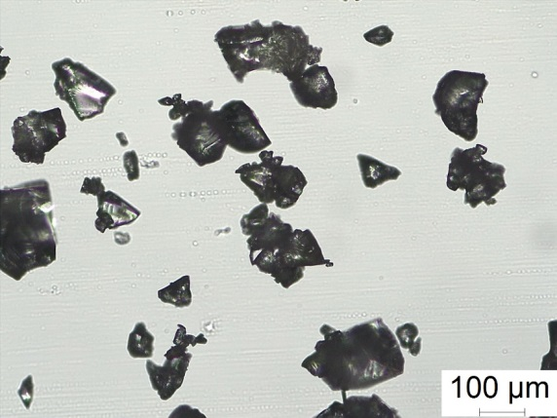
Fig. S4. Microstructure of PNMET1 powder.

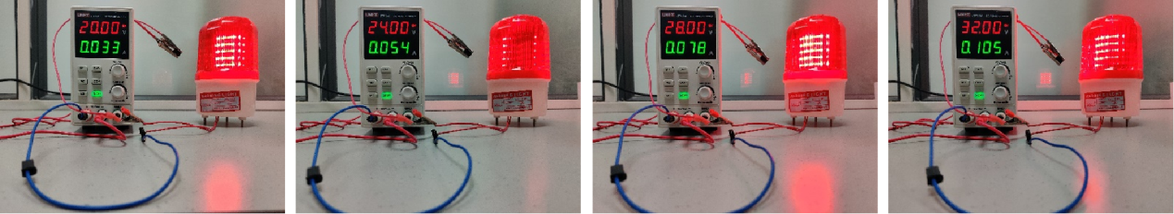
Fig. S5. Conductivity of the PNMET/MWCNT@Fe₃O₄

Table S1. Formulations of PNMET0 and PNMET1~3.
Samples | MET/g | n-allylurea/g | Irgacue-819/g
PNMET0 | 4 | 0 | 0.20
PNMET1 | 4 | 0.25 | 0.21
PNMET2 | 4 | 0.50 | 0.23
PNMET3 | 4 | 1.00 | 0.25

Table S2 T₅, T₅₀, and R₆₀₀ of PNMET0 and PNMET1~3.
Samples | T₅/ºC | T₅₀/ºC | T_{p}/ºC | R₆₀₀/% | T_{gDCS}/℃
PNMET0 | 223.2 | 411.9 | 447.1 | 8.3 | -
PNMET1 | 204.8 | 408.1 | 441.6 | 4.8 | -21.8
PNMET2 | 186.5 | 403.7 | 439.1 | 7.4 | -25.8
PNMET3 | 175.6 | 388.7 | 438.9 | 5.6 | -26.4

Table S3 Thermal properties of PNMET0 and PNMET1~3.
Samples | E₂₅/MPa | T_{g}/℃ | E_{Tg+30}/MPa | v_{e}/mol·m⁻³
PNMET0 | 242.2 | 58.4 | 4.1 | 460.3
PNMET1 | 638.4 | 67.8 | 6.9 | 751.1
PNMET2 | 134.3 | 48.3 | 3.1 | 350.3
PNMET3 | 23.3 | 28.6 | 2.7 | 328.7

Table S4 Mechanical parameters of PNMET0 and PNMET1~3.
Samples | Tensile strength/MPa | Young’s modulus /MPa | Tensile breaking strain/% | Toughness /MJ/m³
PNMET0 | 16.4 ± 2.5 | 162.7 ± 20.3 | 12.4 ± 3.1 | 1.13 ± 0.1
PNMET1 | 13.1 ± 1.8 | 120.6 ± 12.1 | 13.0 ± 2.6 | 0.92 ± 0.1
PNMET2 | 8.8 ± 1.6 | 77.9 ± 8.9 | 28.9 ± 4.1 | 2.12 ± 0.7
PNMET3 | 2.3 ± 0.6 | 12.4 ± 3.1 | 68.8 ± 5.9 | 1.03 ± 0.1

1. Kou Z, Hu Y, Ma Y, Yuan L, Hu L, Zhou Y, Jia P (2023) Bio-based dynamically crosslinked networks/Fe₃O₄ nanoparticles composites with self-healing ability driven by multiple stimuli for non-contact welding. Ind Crop Prod 195: 116401
2. Song F, Zou X, Yuan L, Sha Y, Zhao Q, Zhang M, Hu L, Zhu X, Jia P, Zhou Y (2022) Facile and fast preparation of a tung oil-based bendable transparent electrode with mechanical strength and environmental stability via infiltration of silver nanowires into oxygen-inhibited surface layers. J Mater Chem A 10: 15766-15775

