Table 1. Count of competencies by area and 75% consensus reached (yes or no) for purview, concordance and importance
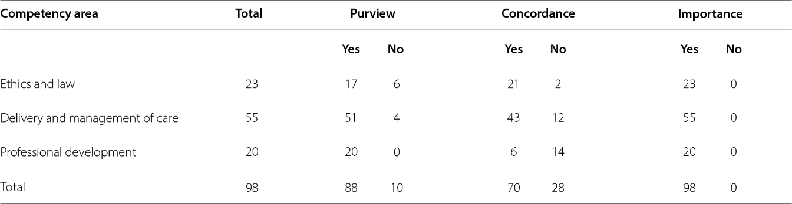Source: Authors et al., 2021.
Table 2. Rejected competencies in ethics and law and parameters for which they failed to reach 75% consensus
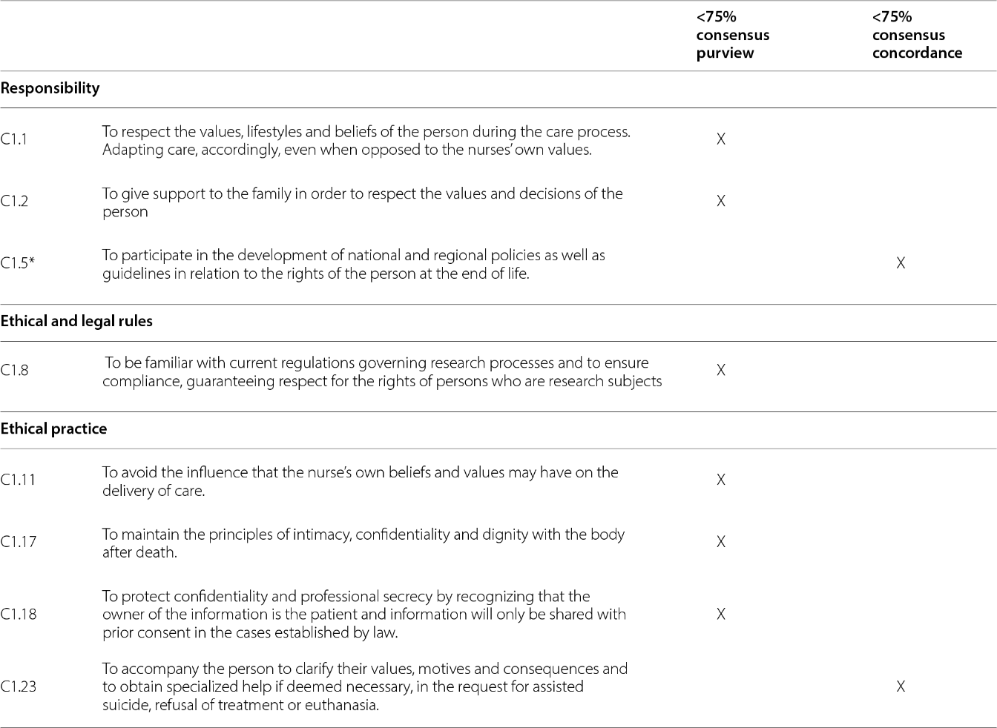Source: Authors [15]. *Competency was accidentally left off the nominal group discussion guide and therefore was not discussed by participants.
Table 3. Rejected competencies in care delivery and management and parameters for which they failed to reach 75% consensus
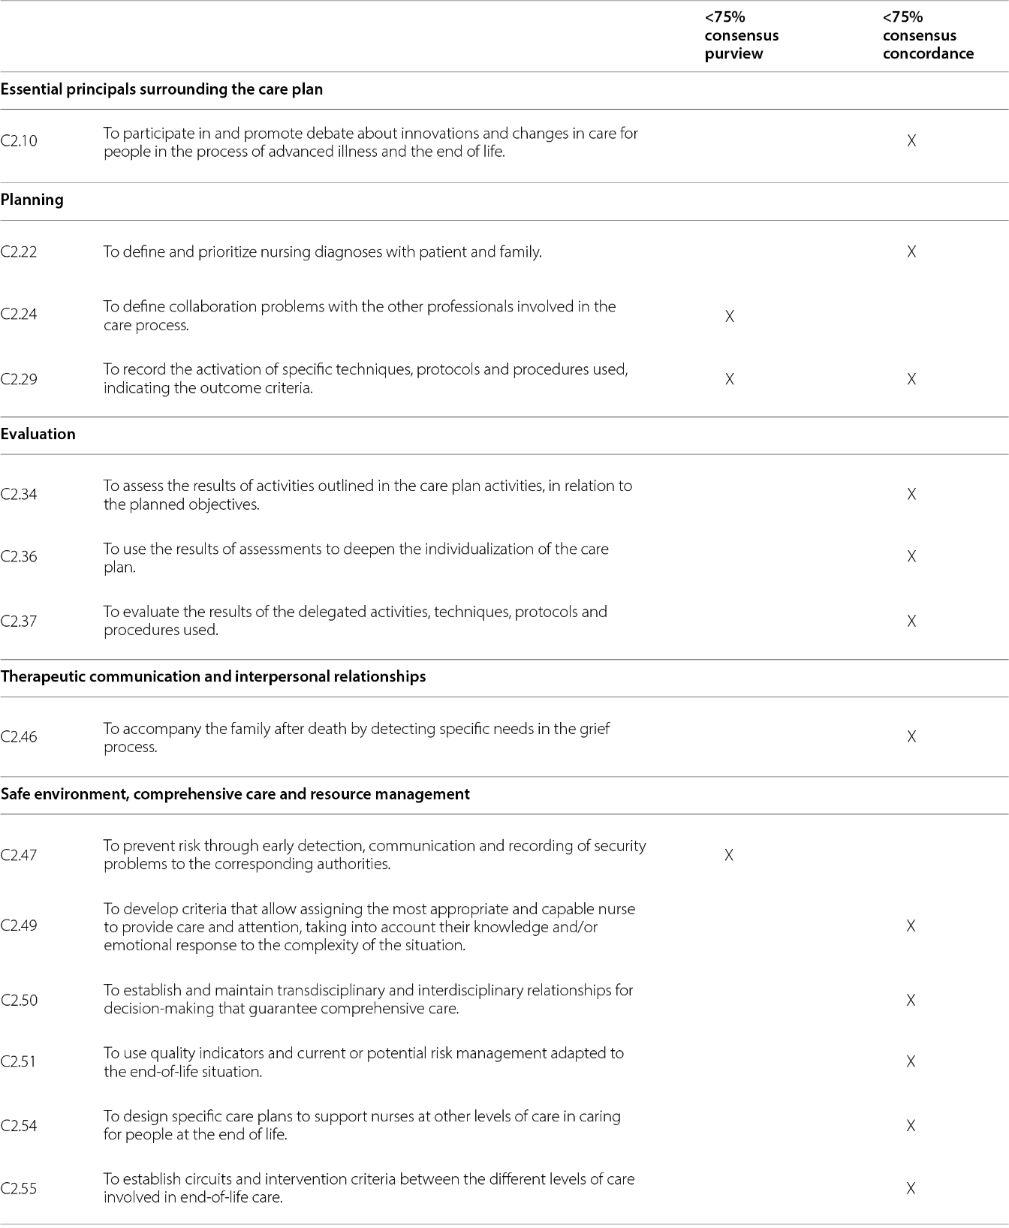Source: Authors et al., 2021.
Table 4. Rejected competencies in professional development and the parameters for which they failed to reach 75% consensus
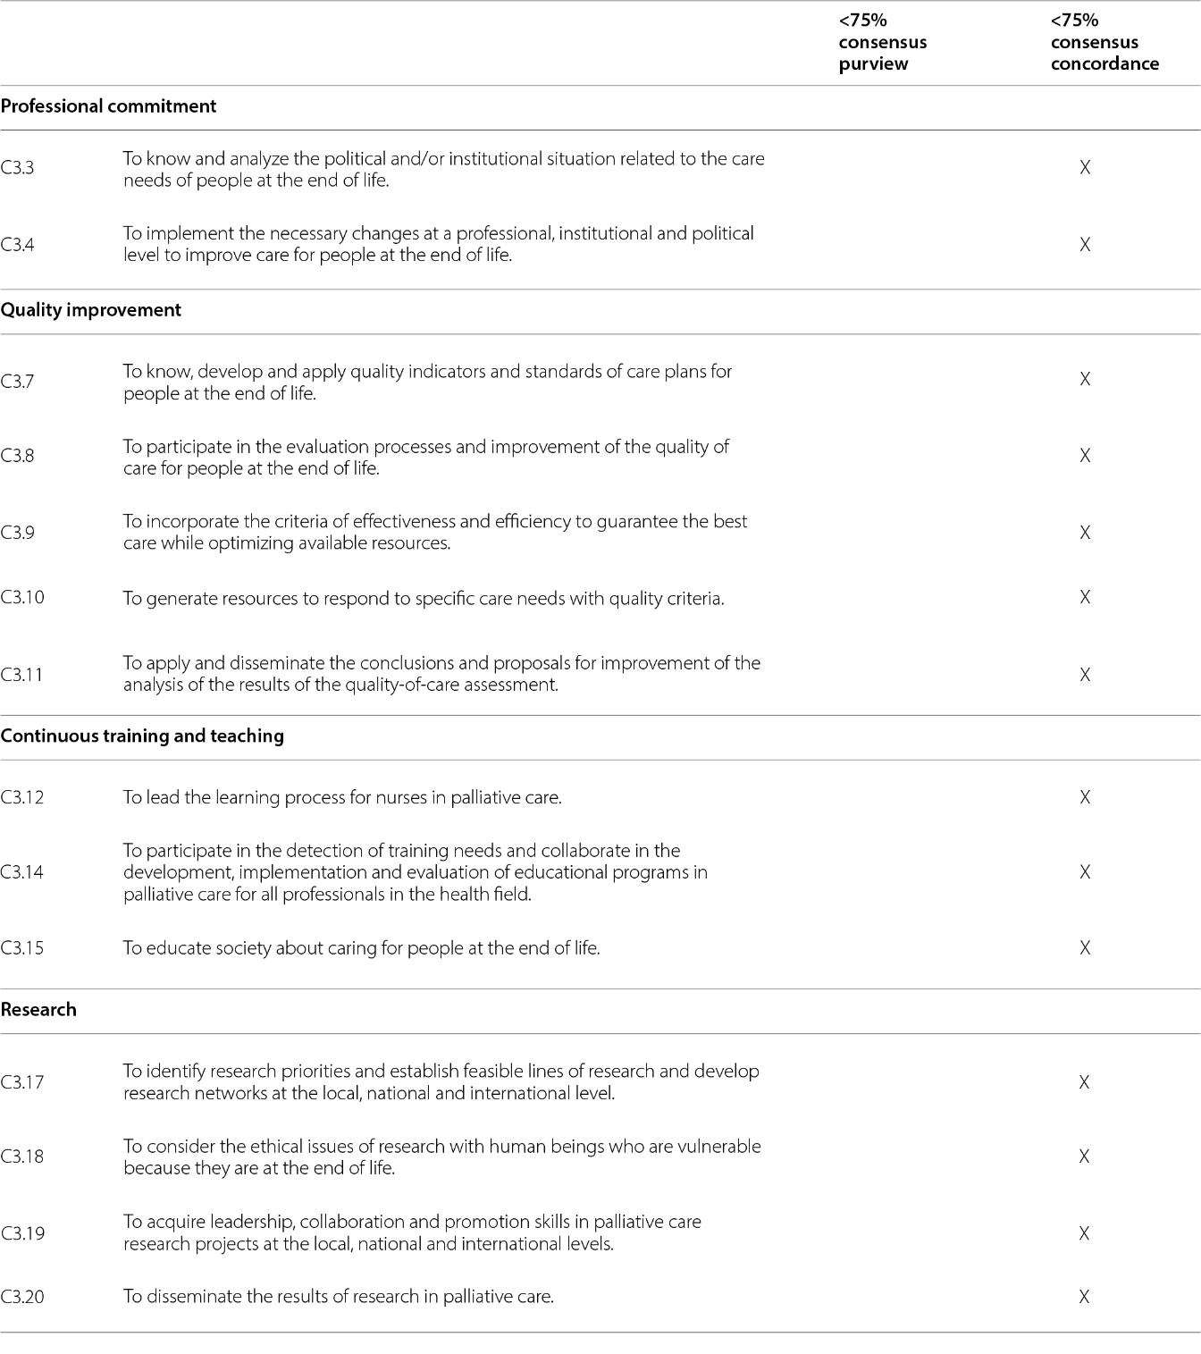Source: Authors et al., 2021.
Table 5. Order of discussion in both nominal groups (May and July 2018) and questions from the discussion about rejected competencies
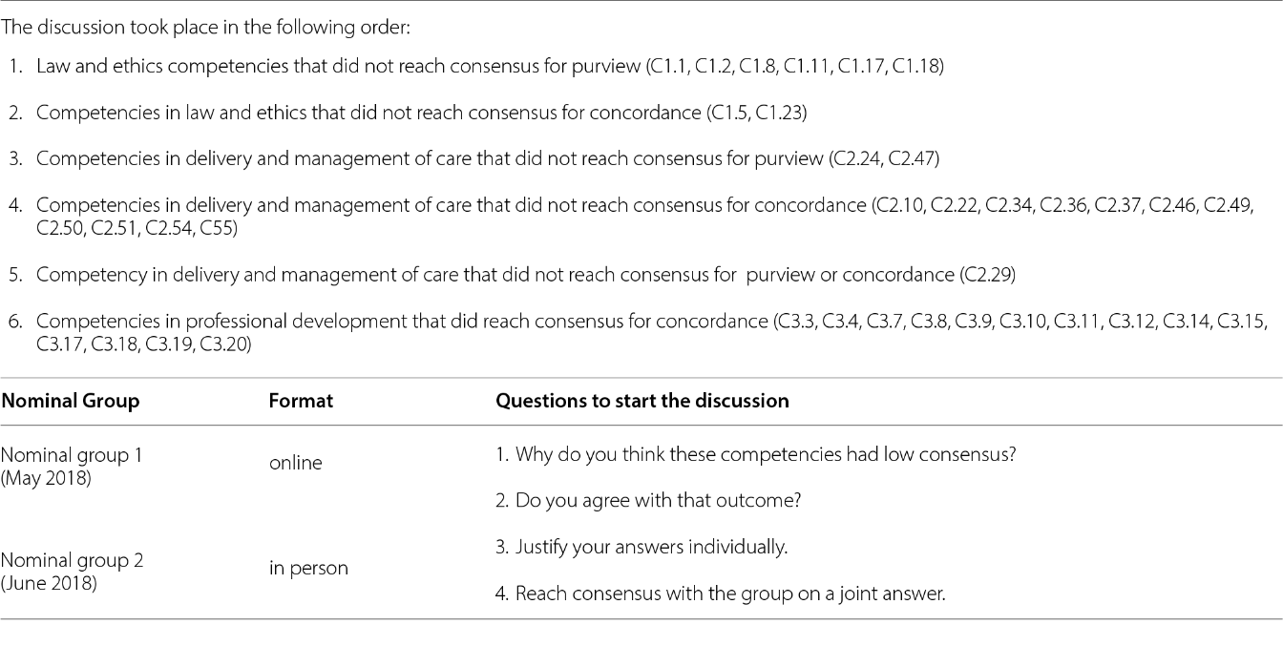

Table 6. The reasons for low consensus and competency areas
