Extended data

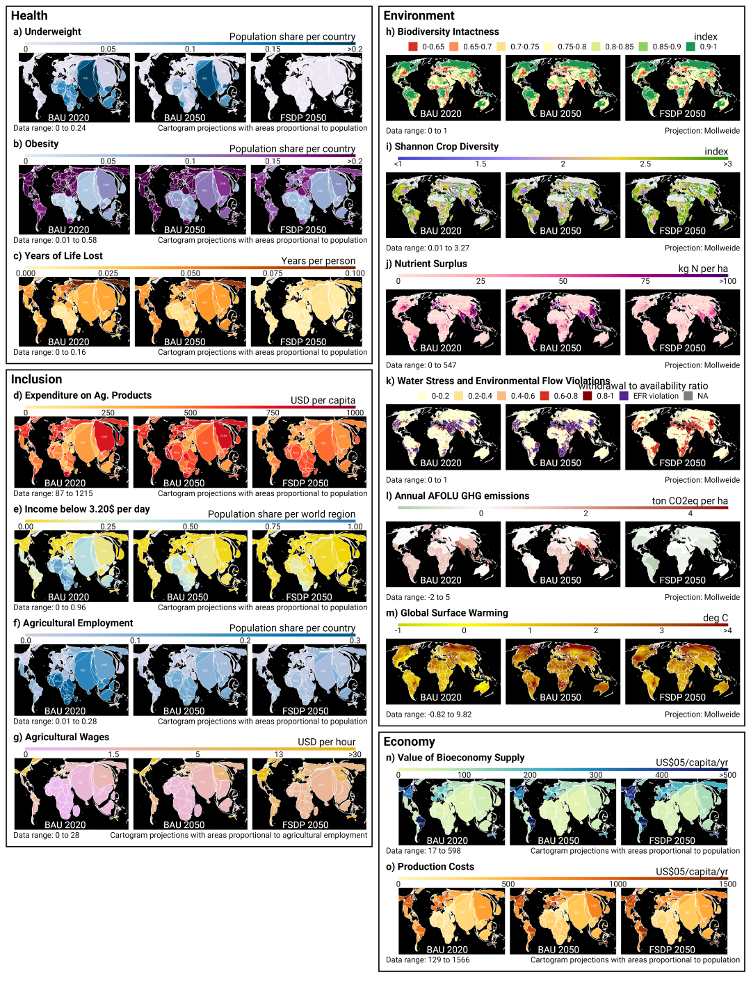
Extended Data Figure 1: Spatial patterns of the 15 food system outcome indicators - grouped by health, inclusion, environment and economy - for the reference BASE_{SSP2} scenario in 2020 and 2050, and the food system transformation pathway FST_{SDP} in 2050. Spatial resolution differs by indicator (Extended Data Table 2), and we use a Mollweide projection (area-preserving projection) for environmental indicators, and a Cartogram projection (areas proportional to population or agricultural workers) for health, inclusion and economy indicators.

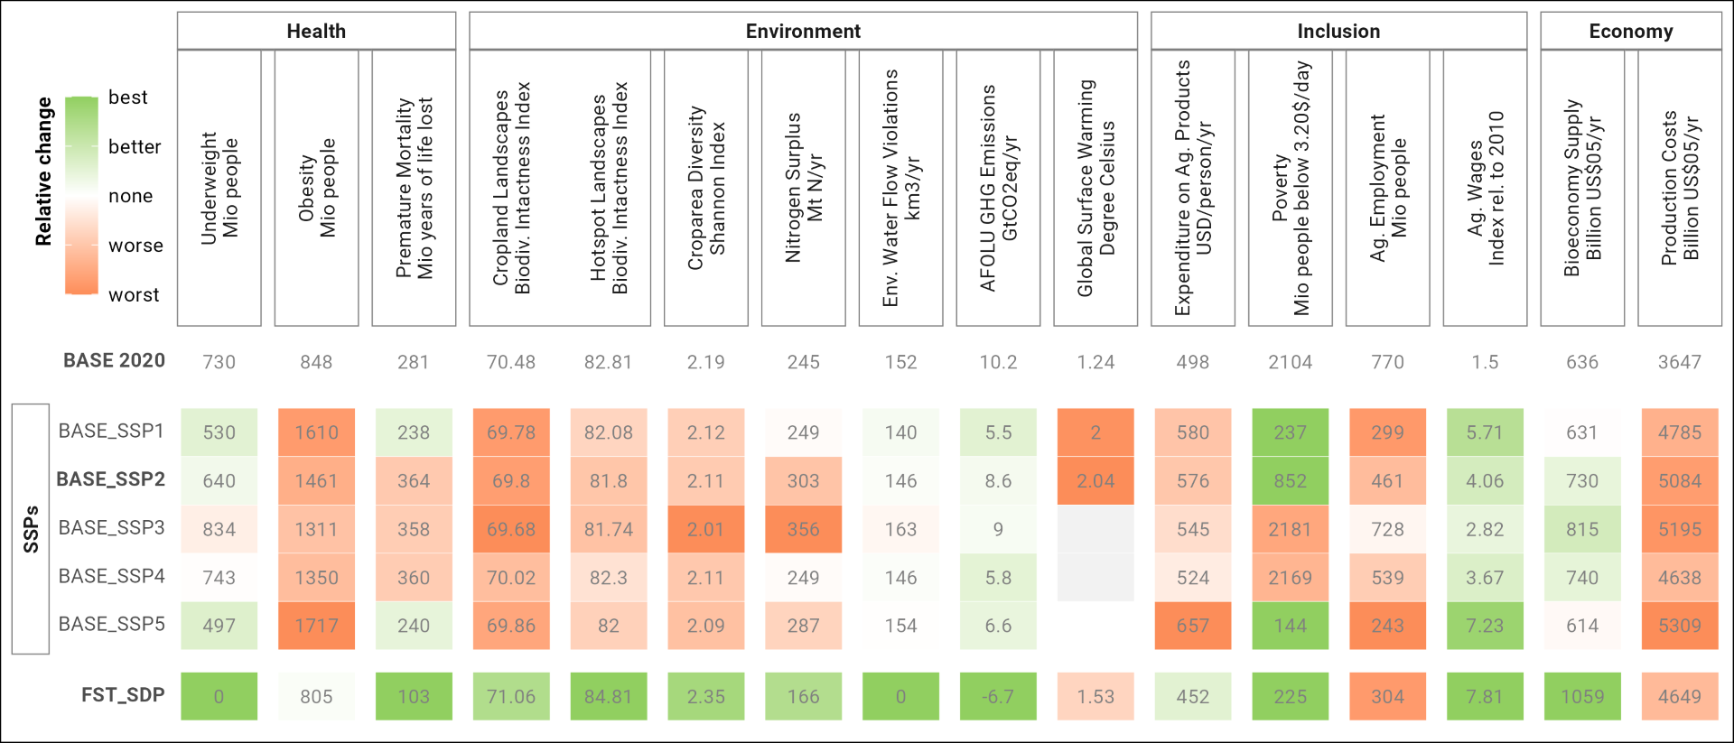Extended Data Figure 2: Projections for the five baseline pathways of the Shared Socioeconomic Pathways (BASE_{SSPs}) and for the Food-system Sustainable-Development-Pathway (FST_{SDP}), relative to the state in the year 2020. Coloring indicates desirable developments since the year 2020 in green and undesirable in red.

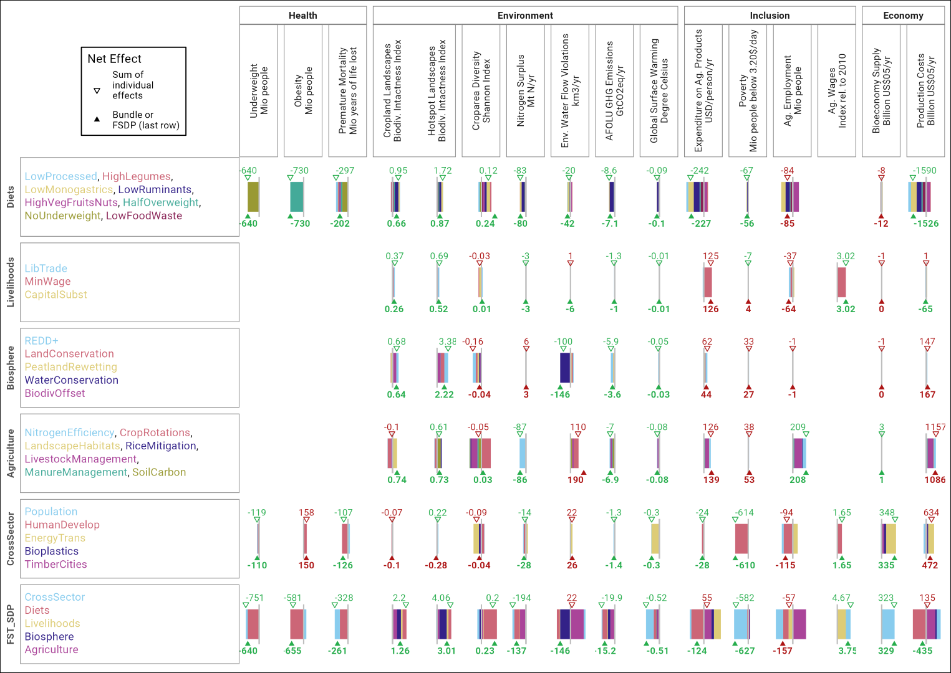Extended Data Figure 3: Interaction effect of combining measures in packages. Bars show the individual outcomes of the measures. The upper number with the empty triangle shows the sum of the individual effects of measures. The lower number with the solid triangle shows the combined effect of a package. Green numbers are co-benefits, red numbers are trade-offs. Synergies occur when the combined effect is positive and larger than the sum of the individual effects, dampening when it is smaller than the sum.

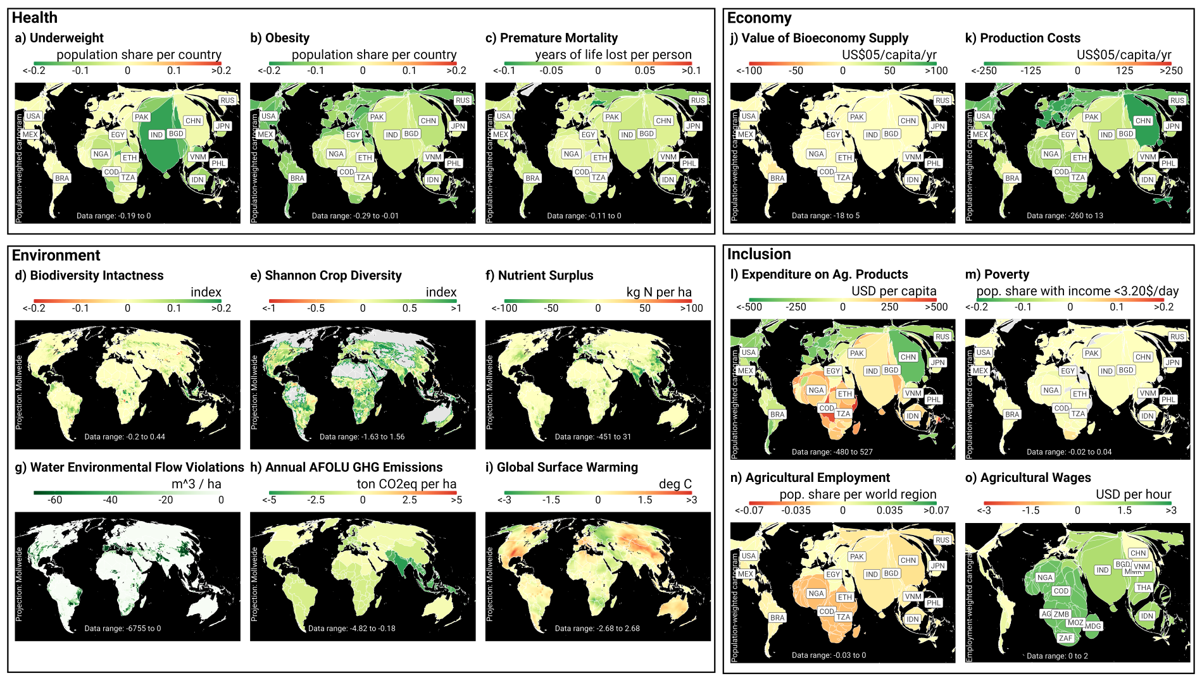Extended Data Figure 4: A food system transformation has co-benefits (green) and trade-offs (red). This plot shows the combined effect of 23 food system measures on 15 outcome indicators. It is calculated as the difference between FST_{SSP2} and BASE_{SSP2} scenarios, not including the CrossSector transformation impacts. Spatial resolution differs by indicator (Extended Data Table 2), and we use a Mollweide projection (area-preserving projection, per-ha values are per total cell area) for environmental indicators, and a Cartogram projection (areas proportional to population or agricultural workers) for health, inclusion and economy indicators.

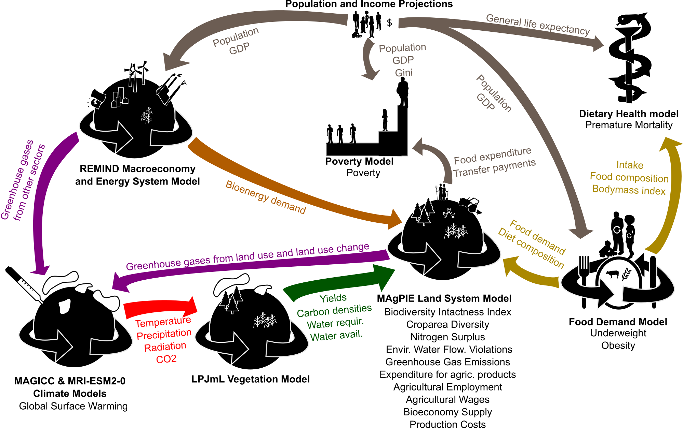Extended Data Figure 5: Illustration of the Potsdam Integrated Assessment Modeling framework (PIAM) and further models integrated for this study. Arrows indicate the parameters exchanged between models, black font indicated model names as well as the core outcome indicators each model estimates. Note that information between soft-linked PIAM models is not necessarily exchanged during run time but is taken from consistent offline simulations.

FSM name | Description
LowProcessed | The intake of sugars is capped at the recommended intake by the planetary health diet^{6,7}, while the intake of plant-based oils and fats are converged towards the planetary health diet. Alcohol consumption was limited to a maximum of 1.4% of calorie intake⁶⁰. In the health model we assume that grains are consumed as wholegrains. The consumption of staple foods (cereals, roots, tubers) is adjusted to keep total food calorie intake constant.
HighLegumes | The intake of legumes is increased to the recommendation by the planetary health diet^{6,7} in countries where these values are not already fulfilled. The consumption of staple foods (cereals, roots, tubers) is reduced to keep total food calorie intake constant.
LowMonogastrics | The intake of poultry meat, monogastric meat and eggs is capped at the recommended intake of the planetary health diet^{6,7}. The consumption of staple foods (cereals, roots, tubers) is adjusted to keep total food calorie intake constant.
LowRuminants | The intake of ruminant meat and milk products is capped at the recommended intake of the planetary health diet^{6,7}. The consumption of staple foods (cereals, roots, tubers) is adjusted to keep total food calorie intake constant.
DietVegFruisNutsSeeds | The intake of vegetables, fruits, nuts and seeds is increased to levels recommended by the planetary health diet^{6,7}. The consumption of staple foods (cereals, roots, tubers) is adjusted to keep total food calorie intake constant.
HalfOverweight | Calorie intake is reduced to achieve a reduction of overweight and obesity by 50% relative to the BASE scenario. Calorie reduction is BMI-class, country, age-group and sex specific. Intake of half of the people overweight or obese (BMI>25 for adults, BMI +/-1STD for children) is reduced to intake recommended for a healthy BMI (20-25, BMI <+1STD). Relative dietary composition is not affected. Intake of people in other BMI-classes is not affected.
NoUnderweight | Calorie intake is increased in line with a complete eradication of underweight until 2050 for all age cohorts and sex classes in all countries. Calorie increase is BMI-class, country, age-group and sex specific. Caloric intake of adults with BMI<20 and children with BMII < -1STD is increased to the intake recommended for a healthy BMI (20-25, BMI <+1STD). Relative dietary composition is not affected. Intake of people in other BMI-classes is not affected.
LowFoodWaste | Food waste in households and retail (difference between calorie intake and FAO food availability) is reduced to a maximum of 20% of intake.
LibTrade | Trade is less oriented along historical trade patterns and more along relative competitiveness. MAgPIE uses two trade pools⁶¹: The "historic trade pool" is based on historical trade patterns, with importing countries importing a constant share of their domestic demand, and exporting countries providing a constant share of global trade. This reflects historical trade distortions and dependencies. The "liberal trade pool" is based on relative cost-competitiveness, in terms of production and trade margins and tariffs. In the LibTrade scenario, the share of the liberal trade pool is increased from 20% to 30% for crops, and from 10 to 20% for livestock and secondary products.
MinWage | A global minimum wage increases wages in the lower income countries. The minimum wage scenario increases wages to at least 3 USD05MER by 2050. In the model, it raises production costs, causes a labor substitution by capital, and increases nominal incomes.
CapitalSubst | In countries with high capital intensity, capital is substituted by labor. We set a global target for the labor:capital share of 80:20. If countries exceed the capital share, we reduce the difference to this target by 50% until 2050. Substituting capital by labor increases employment but comes at additional production costs.
REDD+ | Deforestation is disincentivized and regeneration of original vegetation is incentivized through a carbon price on C in aboveground vegetation in non-agricultural land. The “REDD+” scenario provides carbon-price induced incentives for reducing deforestation and for the regeneration of original vegetation⁶². Regeneration uses growth curves and carbon stocks of natural vegetation based on LPJmL. The growth curves are parameterized based on Braakhekke et al.⁶³.
LandConservation | By 2030, the ~15% of global land area under protection are doubled to 30%. We assume that the enlargement of protected areas includes both a reactive and proactive component ^{41,64}. The reactive component focuses on biodiversity hotspots (BH), the proactive component considers large areas (>500 km2) of unprotected intact forest landscapes (IFL), mainly in the Amazon and Congo basins and in the boreal zone.
PeatlandRewetting | Drainage of intact peatland is disincentivized and rewetting of drained peatlands is incentivized through the AFOLU GHG price. GHG emissions from drained und rewetted peatlands are estimated based on IPCC wetland GHG emissions factors⁶⁵. Drainage of peatlands is linked to the expansion manged lands (cropland, pasture, forestry). Likewise, rewetting of peatlands is linked to the reduction of managed lands.
WaterConservation | Spatially explicit minimum environmental water flow requirements⁶⁶ have to be maintained and cannot be withdrawn (for irrigation or non-agricultural usage).
BiodivOffset | The Biodiversity Intactness Index (BII) in each biome of each world region cannot decrease after 2020. BII reduction at one place can be compensated by increasing BII values in other places under the condition that they belong to the same biome in the same world region.
NitrogenEff | Nitrogen uptake efficiency is increased through technical measures such as improved land manure application, spreader maintenance, improved agronomic practices, sub-optimal fertilizer applications, nitrification inhibitors and fertilizer free zones. We use maximum mitigation rates and the associated costs⁶⁷, increasing labor and capital demand based on general regional cost shares in agricultural production. Mitigation rates are translated to changes in soil nitrogen uptake efficiency to improve the consistency with our nitrogen budgets.
CropRotations | Crop rotations are incentivized with payments. Exceeding typical rotation lengths is priced to account for the external costs of less diverse agriculture. For the tax rate of rotation length exceedance, see supplementary data spreadsheet.
LandscapeHabitats | Permanent habitats are established within agricultural landscapes. Cropland expansion per cluster is constrained to 80% of the available potential cropland⁶⁸. This aims at conserving at least 20% permanent semi-natural habitats at the landscape level (e.g. for pollination, pest control, soil protection). Semi-natural habitats include forest, non-forest and grassland habitats that can maintain and restore native species diversity.
RiceMitigation | Technical measures such as direct seeding, improved residue management, alternated flooding and drainage, and changed fertilization. We a the marginal mitigation cost curve⁶⁷ to reduce baseline emissions.
LivestockManagement | Livestock systems are intensified in particular in low-income countries, resulting in a more efficient conversion of feed into products. In addition, emissions from enteric fermentation are mitigated via the full set of technical measures and associated costs⁶⁷. Intensification of livestock systems is represented via exogenously assuming improved future livestock productivity developments and related changes in feed baskets towards more concentrate feeds, using SSP1 instead of SSP2 parametrization^{69,70}.
ManureManagement | Improved animal waste management reduces losses and emissions during collection and storage of manure using a set of measures at additional costs. 50% of manure excreted in confinements is managed in anaerobic digesters, while the remainder is still managed according to the current mix. Anaerobic digesters are assumed to have a 90% recycling rate of manure, accounting for some remaining losses in stables and waste collection⁵¹.
SoilCarbon | Soil carbon degradation is disincentivized and soil carbon sequestration is incentivized through a carbon price on C in soil carbon (including litter layer). Disincentivized measures include transition of natural land or pasture to cropland, incentivized measures include irrigation or perennial crops.
Population | Population growth is reduced, in particular in low-income countries, switching population projections⁷¹ and built-up area projections⁷² from SSP2 to SSP1.
HumanDevelop | Human development is fairer, with higher social justice and better institutions and education. Switch from SSP2 to SSP1 projections (A) for per-capita gross domestic product and Gini-coefficient, which implies fast economic growth in particular in low-income regions, and a more equal income distribution between countries and within countries; (B) for non-food related health risks; (C) for the parametrization of the diet model, choosing a different functional form for the regressions which leads e.g. to a slight decline of animal product demand when income levels become very high (similar to Bodirsky et al⁷³) (D) for risk premiums on interest rates for long-term investments (e.g. irrigation, yield-increasing technological change) due to poor institutions⁷⁴ in low-income regions by 4 percentage points and to a lesser extent in middle-income regions. (E) for the technological progress of the base soil nitrogen uptake efficiency, increasing it by 5 percentage points in all countries with an upper limit of 75% for each country.
EnergyTrans | Sustainable development in energy, transport, urbanization. Bioenergy switched to SDP900Gt scenario²⁵, non-ag water demand changes from SSP2 to SSP1⁷⁵, active transportation changes physical activity levels from sedentary to moderate activity²
Bioplastics | Of the projected total plastic demand (675 Mt by 2050 (OECD, 2022)), 30% is replaced by bioplastics. Bioplastics require bio-materials as substrates.
TimberCities | Wood is used as construction material for cities. We assume that 50% of new urban dwellers (after 2020) are housed in buildings made of engineered wood to replace carbon-intensive steel and concrete housing construction⁷⁶. This increases future timber demand by 2212 million m3 (compared to 2020) and thereby increases the need for increased harvesting from forests.

Extended Data Table 1: Description of all Food System Measures (FSMs) assessed in this study.

Limitations | Unit | Definition and unit | Level of aggregation, timely resolution.
Underweight | Million people | Number of adults with a BMI <18.5 (for people older 15 years) and children and adolescents with a BMI that is 2SD below normal (0-14 years). | Country level, by age cohorts and sex, for a specific year.
Obesity | Million people | Number of adults with a BMI >30 (for people older 15 years) and children and adolescents with a BMI that is 2SD above normal (0-14 years). | Country level, by age cohorts and sex, for a specific year.
Premature Mortality | Years of Life Lost (YLL) | Years of life lost (YLL) is a measure of premature mortality that takes into account both the frequency of deaths and the age at which it occurs, using the "Global Burden of Disease standard abridged life table" to represent the standard life expectancy. Definition: One YLL represents the loss of one year of life. | Country-level, by sex, for a specific year.
Cropland Landscapes | Biodiversity Intactness Index | The Biodiversity Intactness index (BII) accounts for net changes in the abundance of organisms based on the loss of forest and non-forest vegetation cover and age class of natural vegetation, which are expressed relative to a reference land-use class (forested or non-forested vegetation) and weighted by a spatially explicit range-rarity layer (unitless). The reference land use (BII = 1) is assumed to have no human land use. For the cropland landscape BII, only cells which contain at least 100 ha of cropland are considered. | 0.5°x0.5°, for a specific year.
Hotspot Landscapes | Biodiversity Intactness Index | The Biodiversity Intactness index (BII) accounts for net changes in the abundance of organisms based on the loss of forest and non-forest vegetation cover and age class of natural vegetation, which are expressed relative to a reference land-use class (forested or non-forested vegetation) and weighted by a spatially explicit range-rarity layer (unitless). The reference land use (BII = 1) is assumed to have no human land use. For the key conservation landscapes, we considered only cells in biodiversity hotspots (BH) intact forest landscapes (IFL). | 0.5°x0.5°, for a specific year.
Croparea Diversity | Shannon Index | Measure of crop diversity that takes into account the richness and abundance of different crop groups. The shannon crop diversity index $H_{crop}$ is calculated by $H_crop = - \sum_{k} p_{k} \cdot \log p_{k}$, where $p$ is the share of crop $k$ in the total cropland area in each spatial cluster. Our Croparea Diversity index is based on 6 aggregated croparea classes (see S2.2.4). | 0.5°x0.5°, for a specific year.
Nitrogen Surplus | Million tons nitrogen per year | Nitrogen surplus in croplands, pastures, natural vegetation and animal waste management in Tg Nr. Nitrogen surpluses in croplands and pastures are the difference between organic and inorganic nutrient inputs and withdrawals by the harvest/grazing. In natural vegetations we assume a stable state where fixation equals surpluses. In animal waste management, surpluses are total excretion minus recycled manure. | 0.5°x0.5°, for a specific year.
Environmental Water Flow Violations | km^3 per year | Water withdrawals exceeding the volume that could be withdrawn when taking minimum environmental flow requirements of aquatic and riverine ecosystems into account, in km³ | 0.5°x0.5°, for a specific year.
Greenhouse Gas Emissions | Gt CO2eq per year | Greenhouse gas emissions from land use and land-use change in Gt CO2 equivalents using a 100 year global warming potential (GWP100 based on AR6). | World region level for a specific year.
Global Surface Warming | Degree Celsius | Degrees Celsius warming of global mean surface temperature (relative to 1951-1980) | Global, for a specific year.
Expenditure on Agricultural Products | USD per person per year | Expenditures in USD05 MER per capita per year for agricultural commodities dedicated for food use, excluding the value-added in the supply chain. Estimated as the country-level per-capita food use multiplied with the shadow price (LaGrange Multiplier) of providing one additional unit of food in a world region. | Country-level, for a specific year.
Poverty | Million people living below 3.20$ a day | Number of people in millions with a per capita daily income below 3.20 USD11 PPP in each country, based on poverty lines estimated by the World Bank | Country-level, for a specific year.
Agricultural Employment | Million people | People working in agriculture (crop and livestock production), in million people | World region level, for a specific year.
Agricultural Wages | Index relative to 2020 | Index describing the development of wages relative to 2020, ratio. As wages we define the mean nominal hourly labor cost per employee, including e.g. remuneration of work performed and payment in kind, social security expenditures and welfare services. | Country-level, for a specific year. Aggregation to global level using constant 2010 country-level population data.
Bioeconomy Supply | Billion USD05/yr | Value stream from food and land system to other economic sectors, including the value of bioenergy, bioplastics, timber and material use of products at fixed prices of 2010. Food demand is considered internal to food system. | World region level, for a specific year.
Production Costs | Billion USD05/yr | Value stream from other economic sectors to food and land system, including labor and capital for agricultural production, R&D expenditures, land expansion expenditures, transport costs, in USD05MER/year. Rents, e.g. land scarcity rents or water scarcity rents, are excluded from costs as they are a transfer payment. Similarly, the difference between minimum wage and labor productivty is excluded as a transfer payment which does not reduce the production capacity of the country. | World region level, for a specific year.

Extended Data Table 2: Food system outcome indicators

