Supplementary Information for the Article
A food system transformation can enhance global health, environmental conditions and social inclusion
Benjamin Leon Bodirsky^{1,2}, Felicitas Beier^{1,3}, Florian Humpenöder¹, Debbora Leip^{1,3}, Michael Crawford¹, David Meng-Chuen Chen^{1,3,10}, Marco Springmann¹⁶, Bjoern Soergel¹, Zebedee Nicholls^{6,7,8,9}, Jessica Strefler¹, Jared Lewis^{6,8,9}, Jens Heinke¹, Christoph Müller¹, Patrick von Jeetze^{1,3}, Kristine Karstens^{1,3}, Isabelle Weindl¹, Miodrag Stevanović¹, Pascal Führlich¹, Abhijeet Mishra^{1,3,14}, Edna J. Molina Bacca^{1,3}, Alexandre C. Köberle^{1,12,13}, Xiaoxi Wang^{1,11}, Vartika Singh^{1,3,4,5}, Claudia Hunecke¹, Quitterie Collignon¹, Pepijn Schreinemachers², Simon Dietz¹⁶, Ravi Kanbur¹⁷, Jan Philipp Dietrich¹, Hermann Lotze-Campen^{1,3,10}, Alexander Popp^{1,18}

- Potsdam Institute for Climate Impact Research, Leibniz Association, Potsdam, Germany
- World Vegetable Center, Tainan, Taiwan
- Humboldt University, Berlin, Germany
- Indian Institute of Management, Ahmedabad, India
- International Food Policy Research Institute, New Delhi, India
- International Institute for Applied System Analysis, IIASA, Laxenburg, Austria
- Melbourne Climate Futures, University of Melbourne, Melbourne, Victoria, Australia
- School of Geography, Earth and Atmospheric Sciences, University of Melbourne, Melbourne, Victoria, Australia
- Climate Resource, Northcote, VIC, Australia
- Integrative Research Institute for Transformations of Human-Environment Systems (IRI THESys), Humboldt-Universität zu Berlin, Berlin, Germany
- China Academy for Rural Development, School of Public Affairs, Zhejiang University, Hangzhou, China
- Grantham Institute for Climate Change and Environment, Imperial College London, United Kingdom
- Centre for Climate Finance and Investment, Imperial College Business School, United Kingdom
- International Food Policy Research Institute, Washington, District of Columbia, United States of America
- University of Oxford and London School of Hygiene and Tropical Medicine, UK
- London School of Economics, London, UK
- Cornell University, New York, USA
- Faculty of Organic Agricultural Sciences, University of Kassel, Witzenhausen, Germany

* Corresponding author
bodirsky@pik-potsdam.de

S1: Supplementary Methods

S1.1: Extended MAgPIE description

S1.1.1 Spatial Resolution
MAgPIE operates at different spatial resolutions. Food demand is estimated on the country level, while international trade and technological progress are estimated on the level of world regions, and land allocation, crop production and nitrogen budgets on the level of 59199 0.5°x0.5° grid cells. For computational reasons of the non-linear optimization algorithm, land allocation cannot be optimized on the level of 0.5°x0.5° grid cells. Instead, an aggregation algorithm¹¹² conjoins the grid cells to cluster with similar biophysical and socio-economic conditions. After optimization, these clusters are again disaggregated to 0.5° cells using high-resolution data such as historical land use or crop yield potentials. World regions and clusters are flexible. In the model-setup applied for this assessment we use 14 world regions (see Supplementary Figure 1) and simulate all scenarios for both 200 and 1000 cluster cells. For computational reasons, the 200 cluster cell run is used to derive international trade-patterns which are then fixed for the parallel optimization of the world regions in the 1000 cluster setup. All results are reported for the 1000 cluster setup.
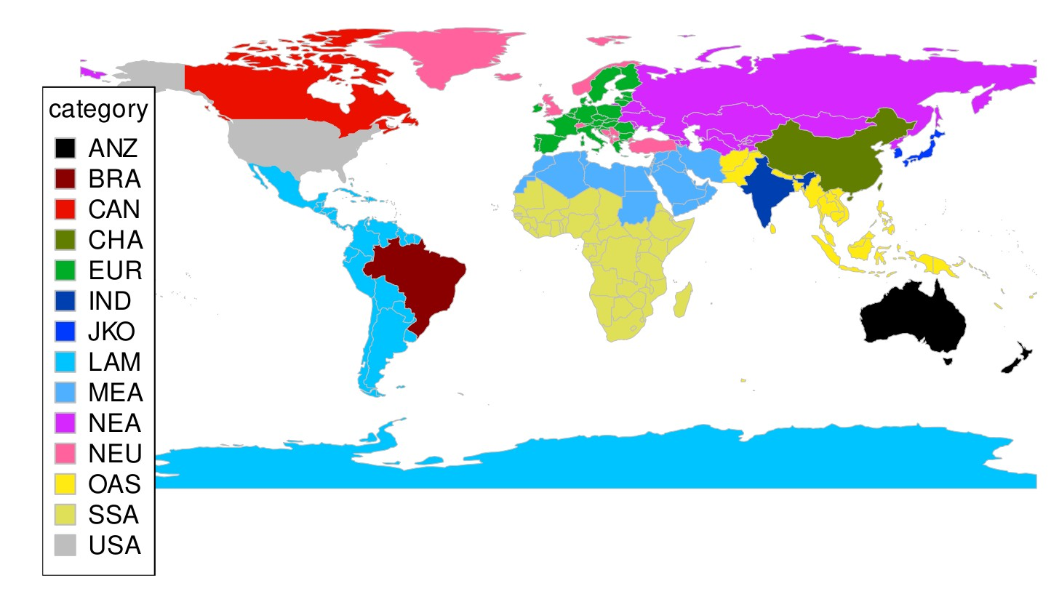

Supplementary Figure 1: Map with world regions used for the MAgPIE simulations in this assessment. Regional abbreviations are in the Supplementary Table 1.

For presenting the results, the 14 world regions are aggregated based on current per-capita income into Low-income regions (LIR), Middle-income regions (MIR), and High-income regions (HIR). This aggregation is static over time, so countries do not move from one region to another when their income changes.

ANZ | Australia & New Zealand | High-income region(HIR)
BRA | Brazil | Middle-income region (MIR)
CAN | Canada | High-income region (HIR)
CHN | China | Middle-income region (MIR)
EUR | European Union | High-income region (HIR)
IND | India | Low-income region (LIR)
JKO | Japan & South Korea | High-income region (HIR)
LAM | Latin America (excl. Brazil) | Middle-income region (MIR)
MEA | Middle East & North Africa | Middle-income region (MIR)
NEA | Northern Eurasia | Middle-income region (MIR)
NEU | Europe (Non-EU) | High-income region (HIR)
OAS | Other Asia | Middle-income region (MIR)
SSA | Sub-Saharan Africa | Low-income region (LIR)
USA | United States of America | High-income region (HIR)

Supplementary Table 1: World regions used for MAgPIE simulations and their classification into low-income, middle-income, and high-income.

S1.1.2 Material and bioenergy demand: 1st generation bioenergy, 2nd generation bioenergy, bioplastics, other materials.
Additional to the food demand, there is also a historically considerably smaller demand for other usage of agricultural products. The FAOSTAT¹¹³ estimate of this “other usage” was split into 1st generation bioenergy usage (ethanol, biodiesel) and other material demand using the World Energy Balances¹¹⁴. The other material demand was further split into a fraction used for bioplastics and a fraction used for other material purposes (e.g. industrial starch, cosmetics) using estimates by the Institute for Bioplastics and Biocomposites¹¹⁵. 1st generation bioenergy usage was projected into the future using country-specific bioenergy targets⁸¹. Additional to first generation bioenergy demand, there is demand for 2nd generation bioenergy made from cellulosic fast-growing grasses and trees. While these 2nd generation bioenergy crops have no significant market share today, they are projected to have large relevance for the future. Scenarios for 2nd generation bioenergy crops were derived from a previous model exercise²⁵, where the MAgPIE model was iterated with the REMIND energy and macroeconomy model (see Methods section Macro-Economy and Energy Model (REMIND)).
The production of bioplastics requires biomass in the form of oils, sugar, starch, glycerol, or cellulose. We assume that for future projections, the composition between different sources for bioplastic production stays constant based on current shares¹¹⁶. Glycerol is assumed to be sufficiently available as a byproduct from other production (e.g. biodiesel). Oils and sugar are included in MAgPIE as processed goods, while starch and cellulose demand was translated to primary agricultural products using conversion factors from literature^{115,117–119}. For all biomass sources we assume the same conversion factor to bioplastic, which we keep constant over time¹¹⁶. The demand for bioplastics depends on scenario assumptions (see section FSMs and section SSPs).
The Bioplastics FSM assumes that 30% of the projected plastic demand by 2050 is replaced by bioplastics. Total plastic demand is assumed to increase to 675 Mt¹²⁰.

S1.1.3 Livestock management and feed demand
Livestock production requires feed, which is estimated as the product of regional livestock production and regional feed baskets that vary by modeled livestock commodity^{69,70}. The feed baskets comprise food and forage crops cultivated on cropland, by-products from food processing such as oilcakes, crop residues as well as grazed biomass. They were derived from feed energy balances for different animal food systems (beef cattle, dairy cattle, pigs, broilers and laying hens), using feed energy requirements per output for each animal food system¹²¹. Feed energy requirements cover growth, maintenance, lactation, reproduction, other basic biological functions of the animals as well as a general allowance for temperature effects and basic activity.
To project future developments of region- and product-specific feed baskets over time, we calculated feed conversion and feed composition for future time steps (e.g. the share of concentrates in the feed mix) based on exogenous scenario assumptions about future regional trajectories of livestock productivity (annual production per animal [ton/animal/year]), using non-linear regression models for feed conversion and feed composition with livestock productivity as predictor^{69,70}. As a result, feed baskets shift towards more concentrate feeds and feed conversion improves, as livestock productivity increases. Region- and product-specific livestock productivity is derived from the FAOSTAT database¹¹³ for historical time steps. For future time steps, the development of livestock productivity over time is aligned with the SSP narratives⁸.
The LivestockManagement FSM assumes higher livestock productivity increases and associated changes in feed baskets compared to the baseline, especially in low-income regions, realized via a shift from SSP2 to SSP1 parametrization^{69,70}.

S1.1.4 Food processing
Our food processing implementation is aligned with the FAOSTAT¹¹³ database. As such, only the primary processing stage is explicitly captured by the model. This includes milling of cereals, pressing of oil crops into oils and oilcakes, refining of sugarcane, sugarbeet and maize into sugars and glucose syrup, as well as alcohol fermentation and distillation. Additionally, ethanol production for biofuels is estimated, resulting in the byproduct of distillers grains for feed. The couple products of processing often cause the relatively inelastic demand within MAgPIE to diverge between the two couple products. To avoid that couple products are wasted, we allow for substitution of oilcakes by oilcrops in the case of excess oilcakes, or for an elastic demand for ethanol and oil for materials at a low price. This can cause fluctuations of the bioeconomy supply even when the scenarios do not address bioeconomy directly.
Further processing in FAOSTAT is implicit to the conversion ratio of agricultural raw products being used as food to final calories available for consumers. It represents all conversions and losses between agricultural markets and the retail level, while retail losses and household waste are still included in the caloric food supply estimates by FAOSTAT. Our current model does not allow for changes in secondary and tertiary food processing.

S1.1.5 Trade
Agricultural demand has to be met by agricultural production via trade. The model reflects two types of trade; intra-regional transport with the costs of transporting a product to the next population center with >40 000 inhabitants, and international trade between major world regions simulated based on a two-pool model⁶¹: the first trade pool is traded according to historical trade patterns, such that importing countries have to import a fixed fraction of the first pool, while exporting countries have to satisfy a fixed share of global net-exports. The second, “free trade pool” is traded according to relative competitiveness, such that all countries export or import based on equal marginal costs. Trade costs include export and import tariffs as well as trade margins (transport and administrative costs). Trade costs were derived from the GTAP 7 database¹²². In the LibTrade scenario, the share of the free trade pool is increased from 20% to 30% for crops, and from 10 to 20% for livestock and secondary products.

S1.1.6 Agricultural production, labor and capital requirements
Agricultural production requires inputs of land, labor, capital, nitrogen, water, and sinks for environmental pollution.
Labor and capital requirements for crop and livestock production are calculated based on overall value of production and respective cost shares. In a first step, regional factor requirements (i.e. the sum of labor and capital requirements) for crop production are estimated as given shares of the crop specific FAOSTAT¹¹³ production value. The regional factor cost shares are based on a USDA dataset on total agricultural production costs by cost type^{123,124}. For livestock production, factor requirements are estimated based on a regression with livestock yields^{69,70}. In a second step, factor requirements for crop and livestock production are disaggregated into labor and capital requirements based on the labor-to-capital ratio reported by the USDA¹²⁴. In future projections, the labor-to-capital ratio of crop and livestock production is modeled as a function of per-capita income.
To meet total capital requirements in crop production, which are derived from production quantities and labor-to-capital ratio, the model requires a spatially-explicitly available capital stock. If the capital stock is not sufficiently available in a simulation unit, investments are required to top up the capital stock. The capital stock depreciates at a yearly rate of 5%. The spatial explicit capital stocks lead to higher investment costs in a growing agricultural sector in a simulation unit, and no investment costs in an agricultural sector in a simulation unit shrinking faster than the depreciation rate. It thereby also reduces the adaptation speed to changing market conditions.
Employment in crop and livestock production is estimated based on total annual labor costs, agricultural wages (in the model represented by the mean nominal hourly labor cost per worker) and the average hours worked per person in a year:
$$employment = \frac{total annual labor costs}{hours per year ⋅ hourly labor costs}$$
Total annual labor costs are derived from labor requirements and production quantities. The average hours worked in a year are based on country-specific average weekly working hours from ILOSTAT¹²⁵, and are kept constant for future years. Hourly labor costs¹²⁵ are considered to reflect labor productivity in an inverse relationship. They are projected using a regression with per-capita income and calibrated on country level to be consistent with the historic datasets on employment¹²⁵, hours worked¹²⁵ and labor cost (based on value of production data by FAOSTAT¹¹³ and labor cost shares by USDA¹²⁵) for the calibration year 2010.
In the MinWage FSM, we calibrate a Cobb-Douglas production function with a substitution elasticity of 0.3 to match the above long-term labor-to-capital ratio and labor productivity in a baseline scenario. We define a global minimum wage of 3 USD_{05MER}/h to be reached by 2050. To meet this target, we accelerate the increase of agricultural wages in low-income countries between 2020 and 2050 compared to scenarios without minimum wage.The minimum wage leads to higher production costs and a substitution of labor by capital.
In the CapitSubst FSM, we assume that in regions with high capital intensities, capital is replaced by labor to reduce the loss of employment. The global target for the capital share (ie.e the capital requirement share out of factor requirements) in crop production is set to 20% by 2050. If countries exceed this capital share, we reduce the gap between the baseline labor share and the target share by 50%. Setting the resulting capital shares as a constraint leads to substitution of capital by labor; the use of the above Cobb-Douglas production function leads then to an increase in total factor costs.

S1.1.7 Nitrogen Budgets
Nitrogen fertilization requirements are derived based on the soil nitrogen uptake (SNU), divided by the soil nitrogen uptake efficiency (SNUpE) to account for the losses during fertilization ⁵¹. The SNU is equivalent to the nitrogen within the harvested biomass and the above- and below-ground crop residues, multiplied with 1 minus the percentage of plant N derived from N₂ fixation (%ndfa) and minus the nitrogen in seeds which are merged into the plant biomass. Nitrogen fertilization requirements can be settled using soil nitrogen inputs (SNI). They include N in manure and crop residues, atmospheric deposition, and N from free-living nitrogen-fixing bacteria, inorganic fertilizers, as well as reactive nitrogen (Nr) released from soil organic matter after land conversion⁵¹. SNU, SNI and SNUpE are estimated separately for croplands and pastures. The SNUpE is estimated based on a historical nitrogen budget; for future scenarios, the SNUpE is the composite of a baseline pathway component and a mitigation component (1-SNUpE) = (1-SNUpE_{base})*(1-SNUpE_{mit}). SNUpE_{base} includes modest improvements that depend on assumptions on technological progress on the basis of the Shared Socioeconomic Pathways (see section S1.3). SNUpE_{mit} is parametrized proportional to the mitigation potential of the marginal abatement cost curves⁶⁷, and connects technical mitigation activity to additional production costs. Measures include improved land manure application, spreader maintenance, improved agronomic practices, sub-optimal fertilizer applications, nitrification inhibitors and fertilizer free zones. Nitrogen surpluses from agricultural soils are estimated as the difference between nitrogen inputs in the form of organic and inorganic fertilizers, and the withdrawals in the form of harvested biomass. This budget approach, which provides the total quantity of Nr leached, volatilized or denitrified as the Nitrogen Surplus from Agricultural Soils, can be considered a robust estimate of the various forms of nitrogen pollution on an aggregated scale⁴³.
Nitrogen excretion by livestock is estimated as the N in feed minus the N in the slaughtered animal. Due to lack of data on the relative proportion of manure recycled on grasslands versus croplands, manure from grass is assumed to be excreted on grasslands or recycled back on grasslands, while manure from concentrate feed is assumed to be excreted in confinements. The manure in confinements is separated between nine different animal waste management systems based on regional shares, each with different recycling and emission fractions.
For (semi-) natural vegetation (i.e. forests and other land), we assume a nitrogen budget that is roughly in a steady-state, such that nitrogen surplus equals the biological nitrogen fixation and the atmospheric deposition. However, the totals are reduced if semi-natural lands are reduced because of the expansion of agricultural or urban land.
Global Nitrogen Surplus is estimated as the sum of the nitrogen surpluses in croplands, pastures, animal waste management and natural vegetation. This more comprehensive coverage of nitrogen surpluses also explains our higher estimates when compared to other estimates^{43,126,127} (see S2.2.5).
The NitrogenEff scenario assumes the application of all technical mitigation measures in croplands and pastures. In the ManureManagement scenario, we assume that 50% of the manure excreted in confinements is going into anaerobic digesters with 90% N recycling rate, while the remaining manure is managed according to historical fractions.

S1.1.8 Land requirements
Land pools are distinguished into croplands, pastures, timber plantations, natural forests (primary and secondary forests), urban (built-up) land, and other land (residual land category comprising unmanaged non-forest natural land).
Cropland requirements depend on the production and on crop-specific yields. Yield levels on 0.5° grid scale are provided by the LPJmL crop model under various scenarios of climate change, and are calibrated to meet FAO yields at world region level in the historical period.
To increase agricultural production, the cost-optimization algorithm finds an equilibrium between three options to manage land scarcity when faced with increasing demand or reduced yields: Crop yields can be increased by investments into agricultural research and development⁸⁵; agricultural land can be expanded, yet also requiring additional land expansion costs; and crop yields can also be increased by changing the spatial patterns of agricultural production, placing crops on the most productive areas. This can happen either between world regions via international trade, or within a world region through adaptation of cropping patterns between the simulation clusters. However, more monotonous cropping patterns or the reduction of fallow periods come at the expense of ecosystem services, which have to be substituted by additional management like pest control^{128,129}. This is simulated by additional production costs if cropping patterns exceed typical rotation lengths or forgo fallow periods^{130–132} (see SI spreadsheet).
Future urban land development is exogenously prescribed and based on SSP projections⁷². At the cluster level, urban land may deviate from prescribed levels when there is very high competition from other uses, i.e. at very high cost. Regional sums of urban level do not deviate. Urban land reduces the amount of land available for other uses.
Timber plantation area requirements are simulated based on the forestry module⁸³. For each timestep, the model assumes that a certain share of the future wood demand will be fulfilled from timber plantations, which are planted under consideration of climate-specific rotation lengths. Timber plantation and natural forest yields are estimated based on LPJmL carbon estimates and growth curves⁶³ passing through different age-classes. Once established, timber plantations cannot be harvested until they reach age-classes equivalent to rotation lengths. Age-class restriction for harvesting does not exist in harvesting natural forests in MAgPIE⁸³.
The CropRotations FSM simulates a tax for the violation of crop rotations, incentivizing short fallow periods, the inclusion of pulses into crop rotations, more diversity of cereals in crop rotations and lower fraction of cereals within the crop rotation. Moreover, we incentivize that bioenergy crops such as fast-growing trees, oil palms or sugarcane are not cultivated in agglomeration but dispersed (e.g. as agroforestry systems). Similarly, we incentivize the widespread instead of agglomerated cultivation of minor crops such as vegetables and fruits.
The LandConservation FSM simulates a doubling of protected areas by 2030, such that they rise from currently about 15% to 30% of the global land surface. We assume that the enlargement of protected areas includes both a reactive and proactive component^{41,64}. In the reactive component the focus is on biodiversity hotspots (BH). Biodiversity hotspots harbor nearly 43% of the world's bird, mammal, reptile and amphibian species and more than half of the world's plant species as endemics, and they are characterized by a loss of native habitat of >70%. The proactive component considers large areas (>500 km2) of unprotected intact forest landscapes (IFL) that have so far been spared from substantial human alteration, mainly in the Amazon and Congo basins in Latin America and Africa and in the boreal zone across North America and Asia. These areas are excluded from conversion into agricultural land or forestry.
In the TimberCities FSM, we assume an upscaling of global demand for timber as construction wood. Demand for engineered wood to be used in construction of mid-rise urban buildings is derived as a function of the new influx in urban population, woody biomass demand per capita and amount of peak population expected to live in cities⁷⁶. We assume that by the end of this century, 50% of people newly moving into cities after 2020 could be housed in buildings made of engineered wood rather than conventional cement and steel structures. MAgPIE also tracks the long-term carbon storage in harvested wood products (HWPs) based on the IPCC tier 1 guideline¹³³. MAgPIE also accounts for the slow release of CO₂ from existing pools of carbon stored in harvested wood products into the atmosphere from decay. The additional demand for industrial roundwood for manufacturing engineered wood, would more than double the current demand for industrial roundwood by 2100 compared to 2020.

All scenarios include land-based Nationally Determined Contributions (NDCs) in support of the Paris Agreement goals, which includes for example a strong afforestation program in China.

S1.1.9 Biodiversity
Land-use impacts on terrestrial biodiversity are captured by the Biodiversity Intactness Index (BII) ^{27,134,135}, which is based on a two-step approach. In a first step, net changes in abundance within species assemblages are computed as a function of recent human land use. In a second step, the compositional similarity between sites is compared to a reference land-use class, for which primary vegetation is used (space-for-time approach). As a result, land with low human interference, such as primary forest, typically has a BII of 1, whereas secondary forest and agricultural land exhibit lower BII values (e.g. 0.5-0.7 for cropland). The BII can therefore be used to track changes among different land-use classes at a given site in an aggregated way. It is worth noting, however, that various other important land-use related drivers of biodiversity change, such as interactions among land uses, habitat location, habitat connectivity, habitat quality and land management are not covered by the BII. Based on our spatially-explicit outputs, our outcome indicators highlight two focal areas of biodiversity change, namely biodiversity hotspots, due to their overwhelming global importance for biodiversity conservation, on the one hand, and farmed landscapes, on the other hand, where ongoing biodiversity change has undermined many critical ecosystem functions that sustain land productivity. Thus the Hotspot Landscapes BII reports area-weighted BII values in areas that are covered by the biodiversity hotspots definition⁴¹. The Cropland Landscapes BII aggregates spatially-explicit BII values in grid cells with more than 100 Mha of cropland, and is thereby sensitive to agglomeration of crop areas that can prevent landscape heterogeneity. During aggregation, the Cropland Landscapes BII is weighted based on the cropland area in each grid cell. Therefore, the Cropland Landscapes BII decreases with increasing cropland concentration (landscape simplification) and increases when land use in cropland grid-cells becomes more diverse.
The LandscapeHabitats FSM restricts cropland area to 80% of the potential cropland area¹³⁶ to support native species diversity in cropland landscapes and to sustain a stable supply of critical ecosystem services that underpin land productivity¹³⁷.
The BiodiversityOffset FSM does not allow a net decrease of aggregated BII values in each biome type of each world region¹³⁸ as compared to 2020. Any BII reduction (e.g. through cropland expansion) at the biome level must therefore be compensated by increasing the land area of land types with higher BII values (e.g. forest and other natural vegetation).

S1.1.10 Land use change greenhouse gas emissions
CO₂ emissions from land-use change and CO₂ removals from land management are based on carbon stock changes between time steps. Carbon stocks for vegetation are obtained by multiplying land areas with corresponding carbon densities from the LPJmL model. In case of deforestation or conversion of other natural land or pastures, aboveground vegetation carbon is immediately released to the atmosphere. In case of re/afforestation or succession of natural vegetation, carbon is gradually sequestered based on an age-class growth model. Carbon emissions from the removal of aboveground vegetation are based on a carbon budget using carbon densities from the LPJmL model. Once forests or other land is deforested, the carbon is assumed to be instantly released into the air. A separate pool for carbon stored in harvested wood products is also used to account for long term carbon storage in wood which is not used as fuel^{76,83}. Nitrogen and methane emissions from forest and savanna fires¹³⁹ are not accounted for in MAgPIE.

Soil carbon emissions from converting land into croplands are estimated using the IPCC 2019 guidelines for national GHG inventories¹³³. They derive long-term equilibrium values for different climates, land types and management regimes. The estimation of long-term soil equilibria requires a reference soil carbon stock under natural vegetation, which we derive using the LPJmL model. Next, we apply modifiers of carbon densities in the first 30cm of the soil profile¹³³ based on landuse type (perennials, annual crops, paddy rice and fallow), tillage, and the quantity of inputs which are all climate-dependent. Climate classes are derived using the Koeppen-Geiger zones. For tillage and inputs, we use the default values for each climate class due to lack of data. For the “landuse type”, we take into account that perennial crops, irrigated land and rice paddies have a higher soil carbon. As the loss and build-up of soil organic matter requires time, we assume that every year 15% of the difference between current carbon stocks and the long-term equilibrium values are built up, which results in a 96% closure within the 20 year period suggested to use by the IPCC¹³³. Based on a fixed C:N ratio, the depletion of soil organic matter also releases Nr that fertilizes crops for the nitrogen budget, a dynamic that is used e.g. in shifting cultivation systems.

GHG emissions from drained peatlands are estimated based on IPCC wetland GHG emission factors and a map of drained peatlands⁶⁵. CO₂ from degrading peat is by far the most important GHG from drained peatlands. Future drainage of intact peatland is linked to the expansion of managed land (cropland, pasture, forestry). Likewise, the rewetting of drained peatlands requires that managed land is retired. Rewetted peatlands have considerably lower CO₂ emissions than drained peatlands. While CH₄ emissions due to anaerobic conditions are higher in rewetted compared to drained peatlands, the net effect of peatland rewetting is a reduction of GHG emissions¹⁴⁰.

In the FSMs REDD+ , PeatlandRewetting and SoilCarbon, a carbon price is included to disincentivize CO₂ emissions from land-use change, and to incentivize re/afforestation or peatland rewetting, either targeting above-ground or below-ground carbon pools. Re/afforestation is incentivized via a reward on expected, discounted future carbon sequestration⁶². For wetlands, also methane and nitrous oxide emissions are priced, adapting the CO₂ price via the GWP100⁶⁵.

S1.1.11 Agricultural greenhouse gas emissions
Methane (CH₄) emissions from enteric fermentation are estimated based on the amount and composition of feed provided to ruminants, using the Tier II method of the IPCC national guidelines for emission inventories¹⁴¹ and feed baskets^{69,70}. Emissions can be reduced via technical measures at additional production costs using marginal abatement cost curves⁶⁷, which include the measures of improved genetic selection, health monitoring, addition of tannins and nitrate, grain processing and extension of productive life⁶⁷. CH₄ emissions from manure management are accounted for through emission factors per managed manure from FAOSTAT¹¹³. These emissions can be reduced at additional production costs via decreased manure storage time, manure storage covers, digesters, manure acidification, as well as improved housing and bedding⁶⁷.
CH₄ emissions from paddy rice cultivation are derived using emission factors per cultivated rice area from FAOSTAT¹¹³. These emissions can be reduced via technical measures such as direct seeding, improved residue management, alternated flooding and drainage, and changed fertilization via a marginal abatement cost curve⁶⁷.
Nitrous oxide (N₂O) emission from soils and manure management are estimated based on the nitrogen budgets (SI section S1.1.7) using emission factors of the IPCC¹⁴¹. The original IPCC emission factors, which are dependent on fertilization rather than surpluses, violate mass balances for high nitrogen uptake efficiencies (NUE), as they would assume emissions even for a hypothetical system with a NUE of 1 where inputs only replace harvested Nr. Emission factors were therefore rescaled to account for the large variations in regional soil nitrogen uptake efficiencies, assuming that N₂O emissions are proportional to total cropland nitrogen surplus. Emission factors therefore also decrease when NUE improves through improved management (see S1.1.7).

The RiceMitigation, LivestockManagement and ManureManagement FSMs activate the technical mitigation measures for methane mitigation of the respective emission sources. LivestockManagement additionally changes feed baskets and livestock productivity in line with a shift from SSP2 to SSP1 parametrization, leading to a reduction of overall feed requirements but to an increase of concentrate feeds such as cereals or oilcakes^{69,70}. All other feedbacks of technical mitigation measures are only considered via abatement costs, but not via other model parameters such as livestock productivity, water requirements, crop yields and feed baskets.

S1.1.12 Irrigation
MAgPIE models irrigation and irrigation expansion endogenously. To which extent cropland is irrigated depends on the yield gain that can be achieved through irrigation in a specific location for the respective crop, unit costs for irrigation area expansion, as well as water demand for irrigation. Irrigation water demand, in turn, depends on local water availability in the growing period in the respective simulation cluster, crop irrigation water requirements, and regionally-specific irrigation efficiency⁶¹. Water availability for irrigation in the growing period as well as crop-specific irrigation water requirements per hectare of irrigated land are derived using the global vegetation, hydrology, and crop-growth model LPJmL^{31,32}.
To derive irrigation water availability at the aggregated resolution of 1000 spatial clusters, monthly basin runoff at 0.5° spatial resolution, as provided by LPJmL, is allocated to its respective river basin grid cells using monthly discharge as allocation weight and then aggregated to the spatial cluster unit used in MAgPIE⁴⁵. Exogenous non-agricultural water demand is provided by the WATERGAP model⁷⁵ and prioritized due to a higher marginal value for industry, manufacturing, and households.
To assess the environmental impact of water withdrawals, we calculate Environmental Water Flow Violations as the volume of water withdrawn that exceeds a sustainable level in each simulation cluster. To derive the environmental flow requirement volume, we use monthly discharge at 0.5° spatial resolution provided by LPJmL using the Smakthin method⁶⁶ and aggregate the respective water volume reserved for the environment to the simulation cluster level⁴⁵. Due to the temporal and spatial aggregation, variations may be averaged out and violations underestimated, such that our estimate of the global environmental flow violation (EFV) volume is conservative. The water scarcity index (used in Extended Data Figure 1) is calculated as the ratio of water withdrawals to water availability.
In the WaterConservation FSM, we do not allow agricultural water withdrawals that violate the EFR volumes in a given area.
In the EnergyTrans cross-sector measure, we switch the non-agricultural water demand from SSP2 to SSP1⁷⁵.

S1.2: Extended REMIND description
Section S1.2 describes the REMIND model methodology as it was applied previously, and therefore also contains worldly text elements from these papers^{25,142,143}.
REMIND calculates CO₂ emissions from fuel combustion and industrial processes, CH₄ emissions from fossil fuel extraction and residential energy use, and N₂O emissions from energy supply by source using region- and fuel-specific emission factors. REMIND uses an econometric estimate for CO₂ emissions from cement production as well as CH₄ and N₂O emissions from waste handling. In both cases, the driver of emissions depends on the development of population and GDP (as a proxy for waste production) or capital investment (as a proxy for cement production in infrastructure). REMIND uses exogenous baselines for N₂O emissions from transport and industry. CH₄ and N₂O emissions from open burning are assumed to remain constant at their 2005 levels. Emissions of other GHGs (i.e. F-gases, Montreal gases) are exogenous and are taken from the SSP scenario data set from the IMAGE model¹⁴⁴. REMIND does not represent abatement options for these gases; therefore, emissions from the corresponding SSP/RCP scenario best matching the target of the specific model simulation are used. For pollutant emissions of SO₂, black carbon (BC), organic carbon (OC), NOx, CO, volatile organic compounds (VOC) and NH₃ related to the combustion of fossil fuels, REMIND considers time- and region-specific emissions factors coupled to model-endogenous activity data. Emission factors for SO₂, BC, and OC are assumed to decline over time according to air pollution policies^{145,146}. Current near-term policies are enforced in high-income countries, with gradual strengthening of goals over time. Low-income countries do not fully implement near-term policies, but gradually improve over the century. Emissions from international shipping and aviation and waste of all species are from an exogenous dataset¹⁴⁷.
In all scenarios simulating the cross-sectoral impacts of an energy transformation (EnergyTrans), a carbon price on all sectors is introduced in 2025, but at different levels reflecting the regions’ different abilities to pay. The carbon prices in high-income regions increase linearly until the budget is reached, while lower-income regions initially face substantially lower prices. Linearly increasing CO₂ prices, in contrast to the more common exponentially rising CO₂ prices with a growth rate equaling the social discount rate, increase the near-term ambition of climate policy but limit the price increases at a later stage. After the peak budget has been reached, the CO₂ price increase flattens off to US$3 per ton CO₂ per yr, which is sufficient to ensure that the GMT increase declines from its peak to values consistent with the 1.5 °C target with at least 67% probability by the end of the century. Non-CO₂ GHGs are priced according to their 100-yr global warming potentials (using IPCC Fifth Assessment Report values), where in the land-use sector prices for CH₄ and N₂O are capped once further price increases no longer provide additional abatement options¹⁴⁸. The carbon prices are adapted to limit global cumulative CO₂ emissions to a peak budget of 610 Gt CO₂ from 2018 onwards, consistent with at least a 50% chance of low overshoot (<0.1 °C) of 1.5°C¹⁴⁹. Regional annual CCS deployment is limited to 0.5% of total storage capacity. This limits total global CCS use to about 20 Gt CO₂/yr.

S1.3: SSP scenarios
The Shared Socioeconomic Pathways (SSPs) provide a set of baseline scenarios describing plausible alternative future evolutions of society and natural systems over the 21st century and reflecting alternative reference assumptions about future socio-economic development ^{8,21,150}. The scenarios have been adopted widely in the climate change community, but also by other assessments of global change (https://ciesin.columbia.edu/data/ssp-literature-database-v2-2020-2021/).
SSP1 represents a green growth future in which lifestyles of people are less material-intensive, innovation towards more efficient technologies is fast, and human development is characterized by higher equity. SSP2 describes a middle-of-the-road pathway, in which human development, lifestyles, economic growth, and technological development remains very much within currently observed trends. SSP3 describes a scenario characterized by regional rivalry, impeding fast economic and technological growth. SSP4 is a highly unequal world, in which some world regions can achieve high economic progress, while others stay behind. Also inequality within countries is very high, and technological progress is very unequal. SSP5 depicts a fossil-fueled economic development scenario leading to high socioeconomic development but also high environmental degradation¹⁵⁰.
In addition to a narrative storyline, the SSPs provide quantified development indicators, which include drivers such as GDP or population growth rates^{71,111}. GDP projections were updated to include the macro-economic downturn due to the Corona pandemic ¹⁵¹ (Koch and Leimbach 2023); they do not yet account for the effects of Russia’s invasion of Ukraine. They moreover provide qualitative statements on the development of demographics, human development, economic development, lifestyles, technology and natural resources, which were translated into modeling parameters by different IAM teams including REMIND-MAgPIE⁸. These scenario switches assume - in line with the respective storyline - different trends for intensified livestock management^{69,70}, account for more or less material-intensive consumption patterns in the projections of food demand, different degrees of trade liberalization⁸, different non-agricultural water demand⁷⁵ and manure management⁵¹. To account for the new implementation of nitrogen budgets in this assessment, the baseline soil nitrogen uptake efficiency trajectory (SNUPE_{base}) - reflecting technological progress in absence of nitrogen mitigation policy - was chosen in line with the qualitative SSP storylines¹⁵⁰, assuming no improvement in SSP3, modest improvement of 5 percentage points in SSP2 and in the high-tech but material-intensive scenario SSP5, and 10 percentage points in the scenarios SSP1 and SSP4 that are supposed to have a high mitigation potential. Moreover, the maximum SNUPE was limited to 55% in SSP3, 65% in SSP2 and 75% in the storylines SSP1,4 and 5 that assume rapid progress in technology, in order to avoid unrealistically high SNUPEs in countries which already today have high efficiencies.
In the Population scenario we switch the population and demographic structure from SSP2 to SSP1. In the HumanDevelop scenario that includes a more equal economic development, better functioning and more inclusive institutions, we assume a switch from SSP2 to SSP1 for the settings of per-capita income and urbanization scenarios, dietary preferences, and SNUPE_{base} development.

S2: Supplementary Results and Discussion

S2.1: Validation of core model indicators

Historical data for our core outcome indicators (Figure 1 main manuscript) were derived as follows. Agricultural products expenditures were estimated for each product by multiplying FAO food demand with a global producer price (averaged by demand). The poverty headcount of people living with less than 3$20 per day was from the World Bank database¹⁵², which contains country-level data from 1967 to 2020. The downloaded version still did not include the COVID impacts on poverty in the year 2020, which explains why our 5-yearly estimates diverge from the trend. To derive a global total for poverty numbers¹⁵², missing data were filled either by linearly interpolating existing data for the specific country or, where interpolation was not possible, by using average regional shares of the population living under the poverty line. Agricultural employment is based on a dataset by ILOSTAT¹²⁵ reporting aggregated employment in agriculture, forestry, and fishery, which was disaggregated based on employment shares from a more detailed but incomplete ILOSTAT dataset¹²⁵. Agricultural wages are calculated by dividing total labor costs in agricultural production (based on value of production data by FAO¹¹³, and labor cost shares¹²⁵) by total hours worked (based on agricultural employment and average weekly working hours¹²⁵). Gaps in the resulting dataset were filled based on a regression between hourly labor costs in agriculture¹²⁵ and per-capita income. The historical BII estimate¹⁵³ differs from our estimate due to a lower estimate of forests in their land use patterns (see also Supplementary Figure 2 d,e). Historical Croparea Diversity was estimated by applying the Shannon Index on the historical landuse patterns from LUH2v2⁷² for 4 crop groups, which were further downscaled to MAgPIE crop groups by country-level data from FAOSTAT assuming national relative area shares at sub-country level which partly explains the slightly higher values than our estimates.
Historic nitrogen surpluses were estimated based on the same method as in the MAgPIE model, yet using historical activity numbers for crop and livestock production, land areas, atmospheric deposition, and fertilizer consumption. Cumulative greenhouse gas emissions are based on FAOSTAT¹⁵⁴. Global surface warming is based on the IPCC AR6 Summary for Policymakers Global Surface Temperature Anomalies (GSTA) time series relative to 1850-1900⁴⁹, which uses the observations of HadCRUT4.6.
Supplementary Figure 2 provides further central model indicators and compares them to historical trends.

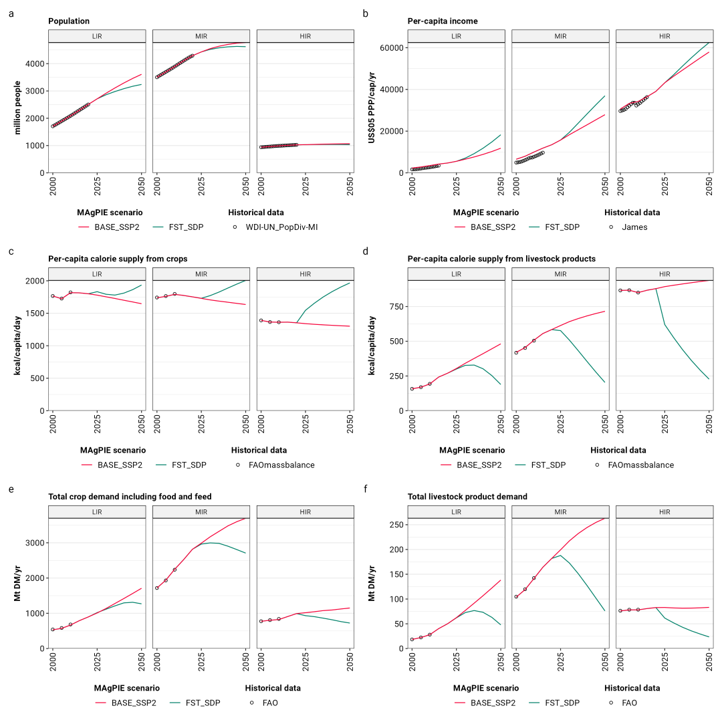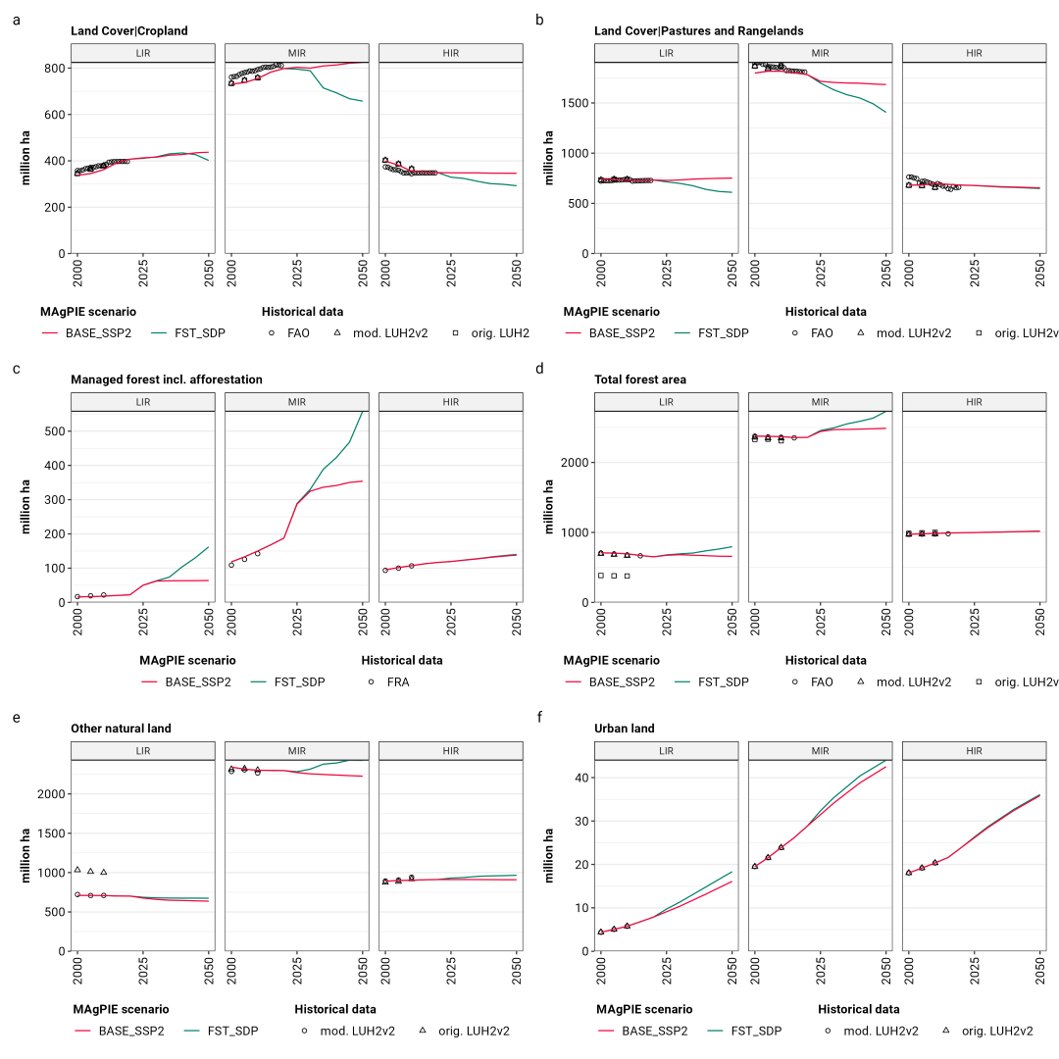

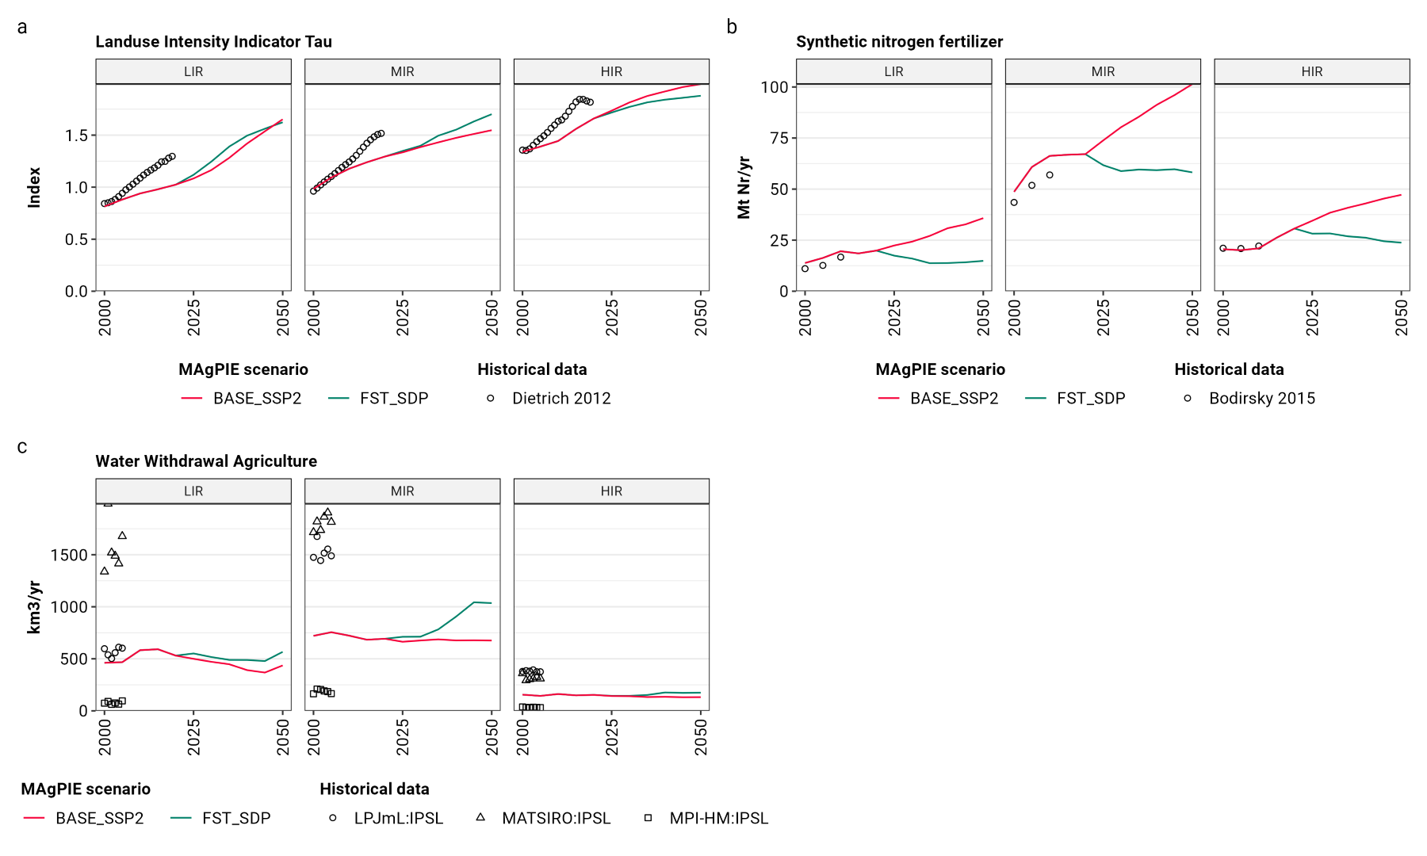
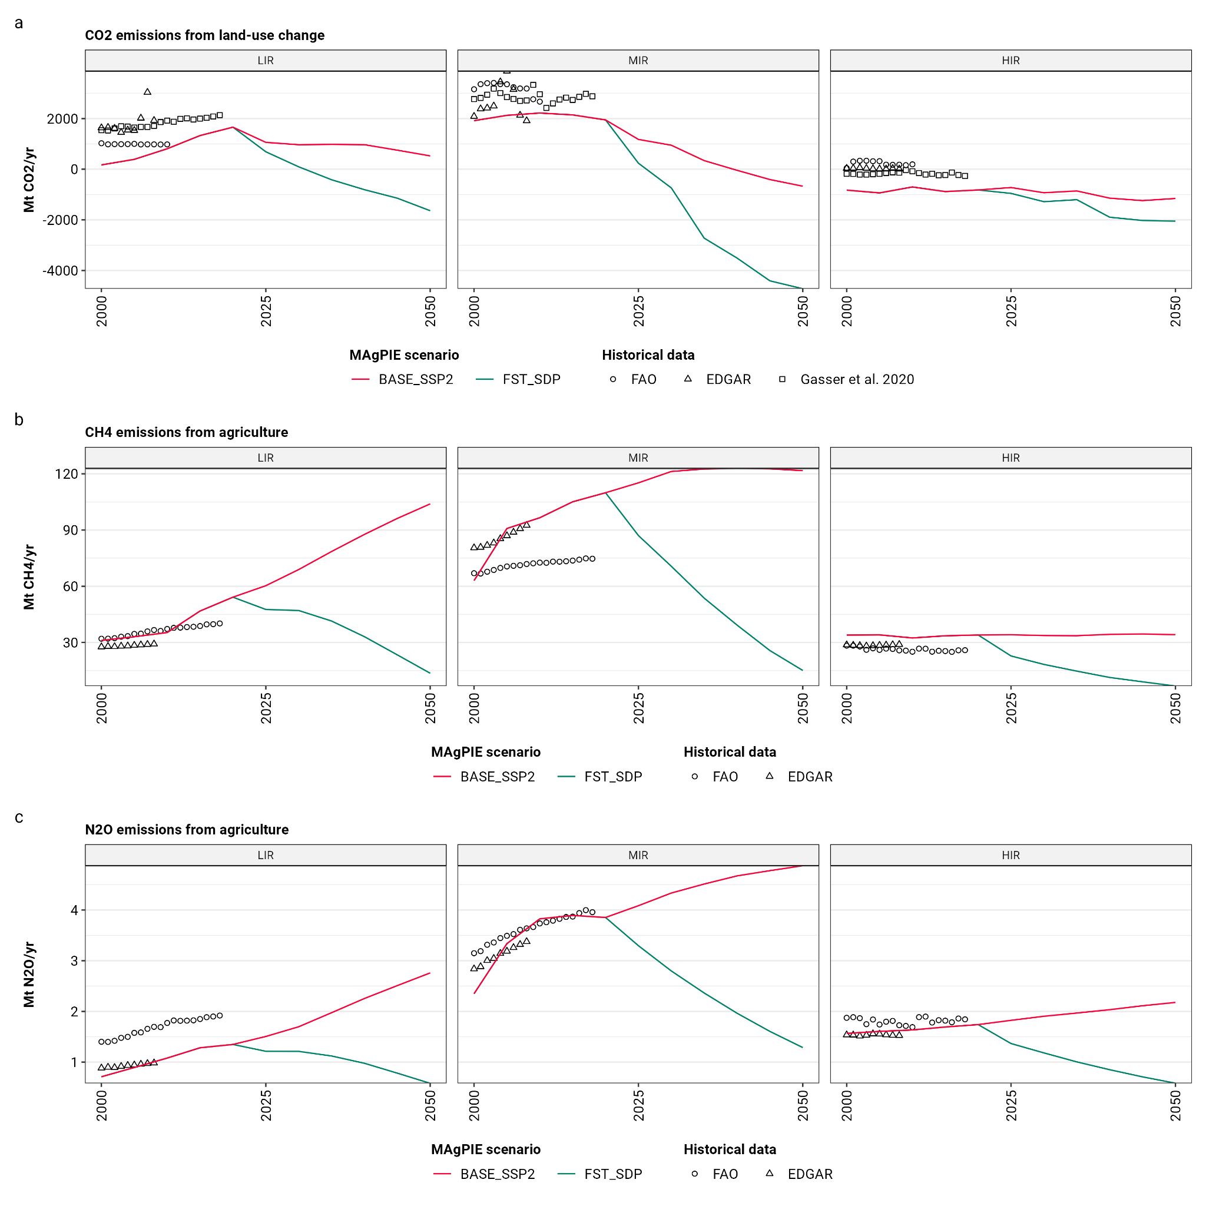

Supplementary Figure 2: Comparison of central model indicators with historical trends for current low-income, middle-income, and high-income regions (see S1.1.1).

S2.2 Intermediate results

S2.2.1 Demand
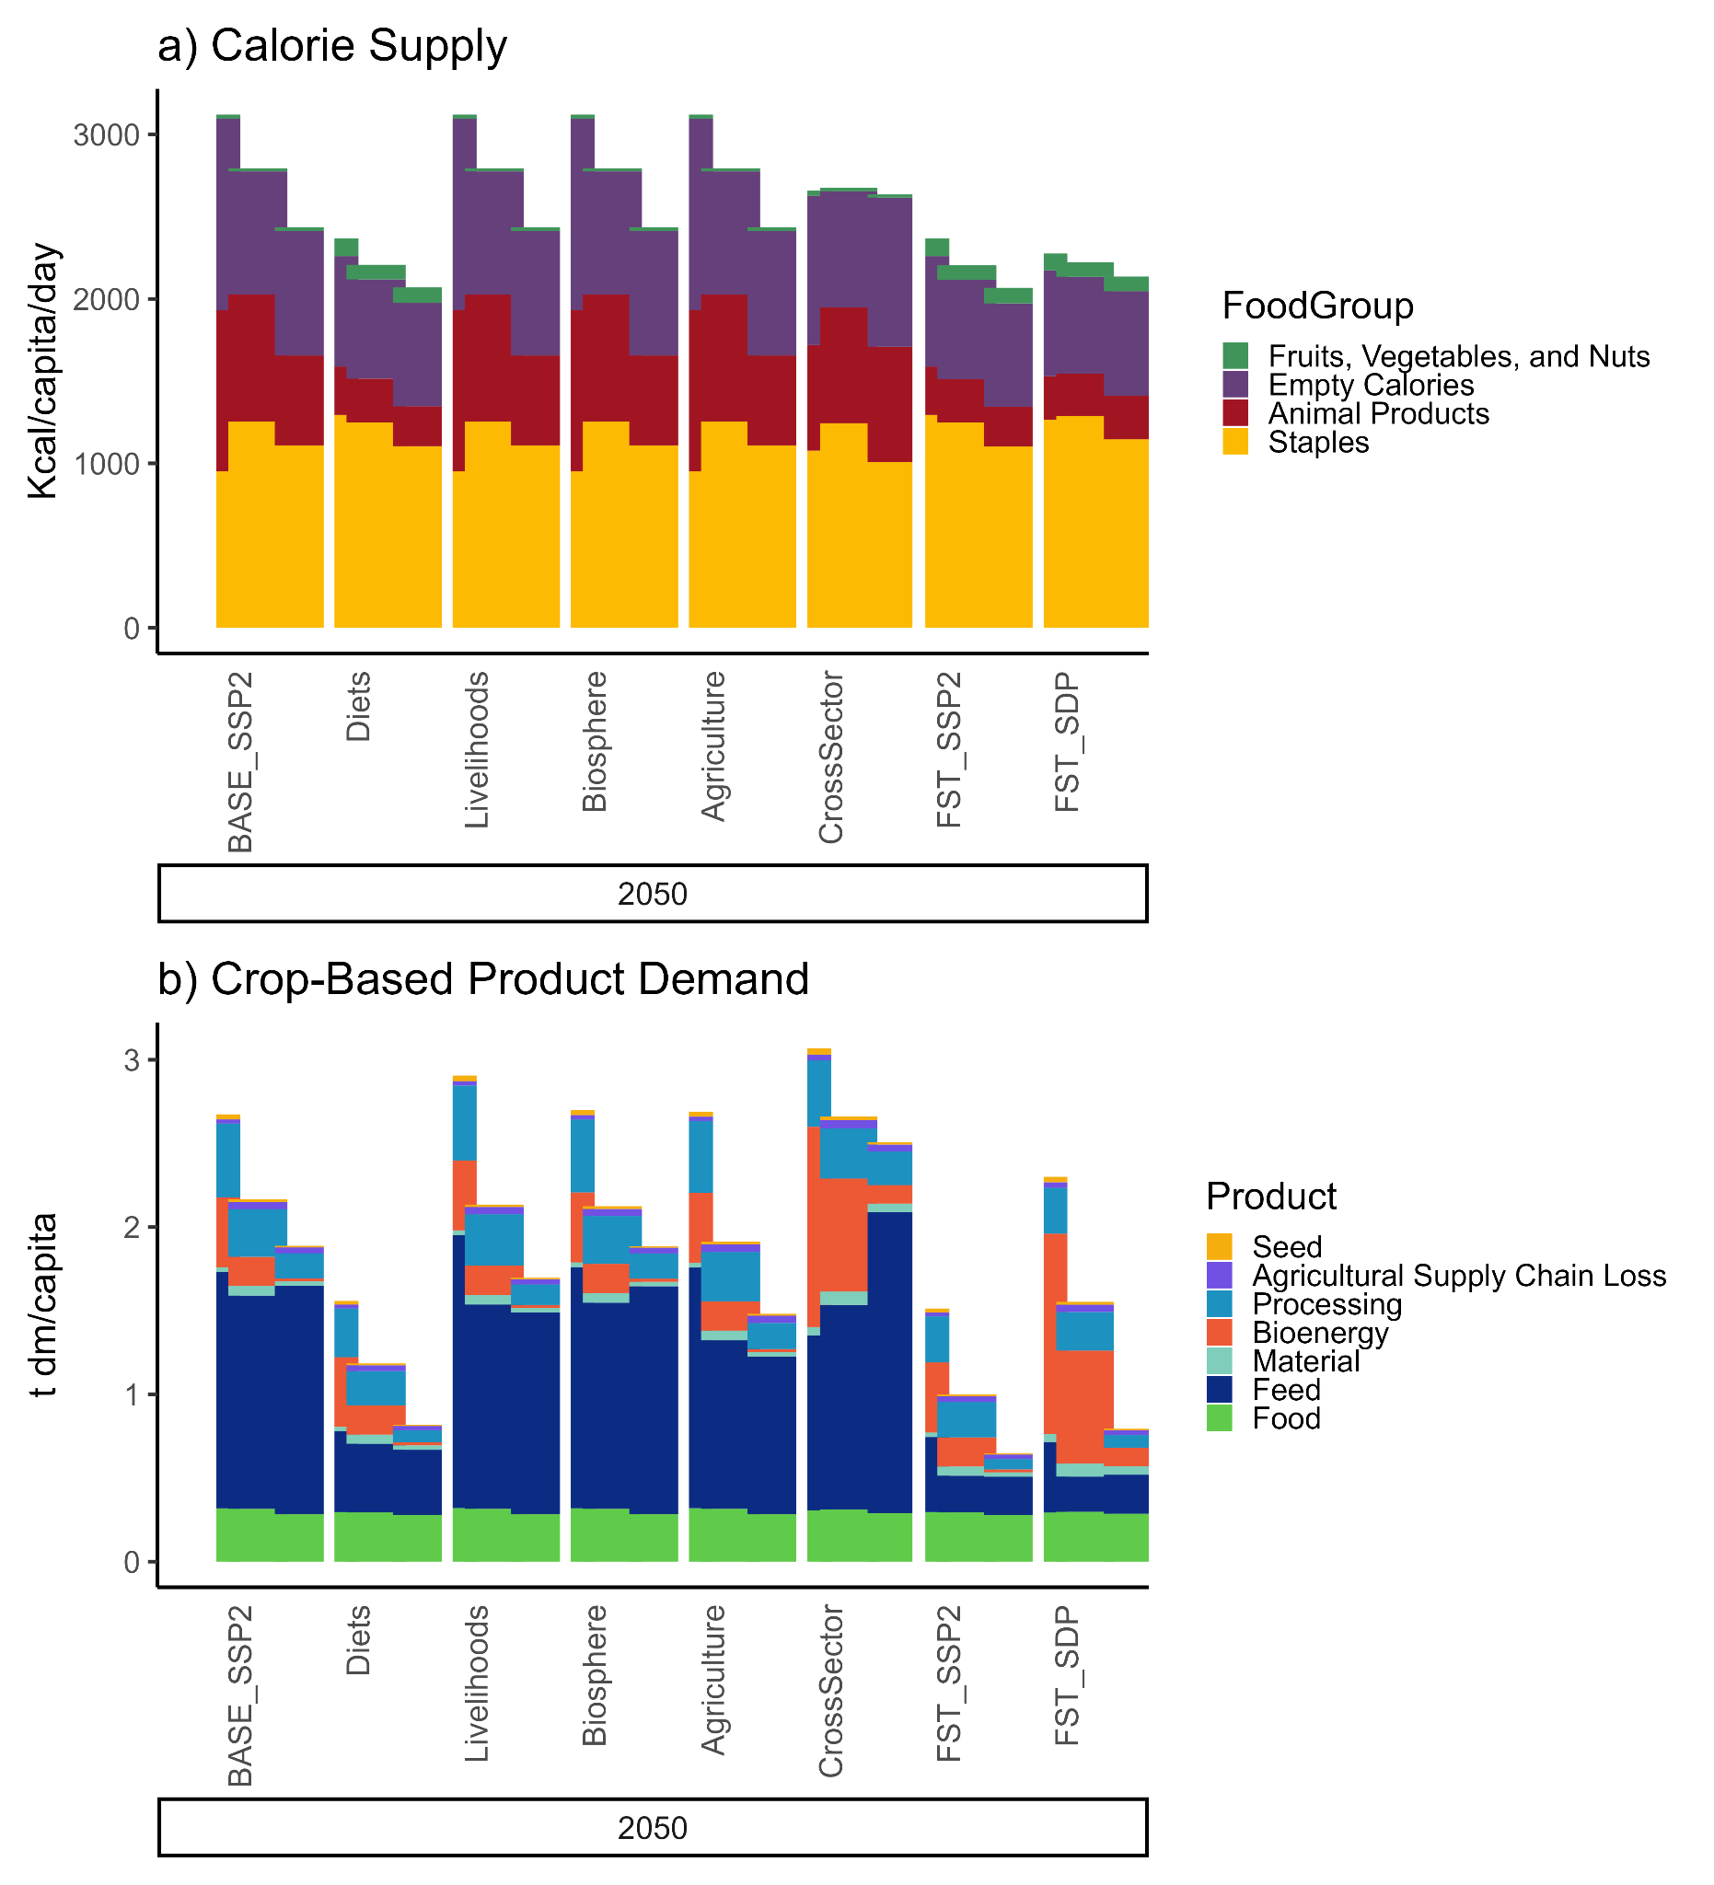

Supplementary Figure 3: a) Per-capita food demand by product in kcal per capita per day and b) crop-based product demand by utilization category in t DM per capita per year. Grouped bars include, from left to right, the average values for current low-income, middle-income, and high-income world regions (see S1.1.1). Bar width indicates the population size of these groups. Grouped bars are arranged by scenario and year.

S2.2.2 Diets and Health
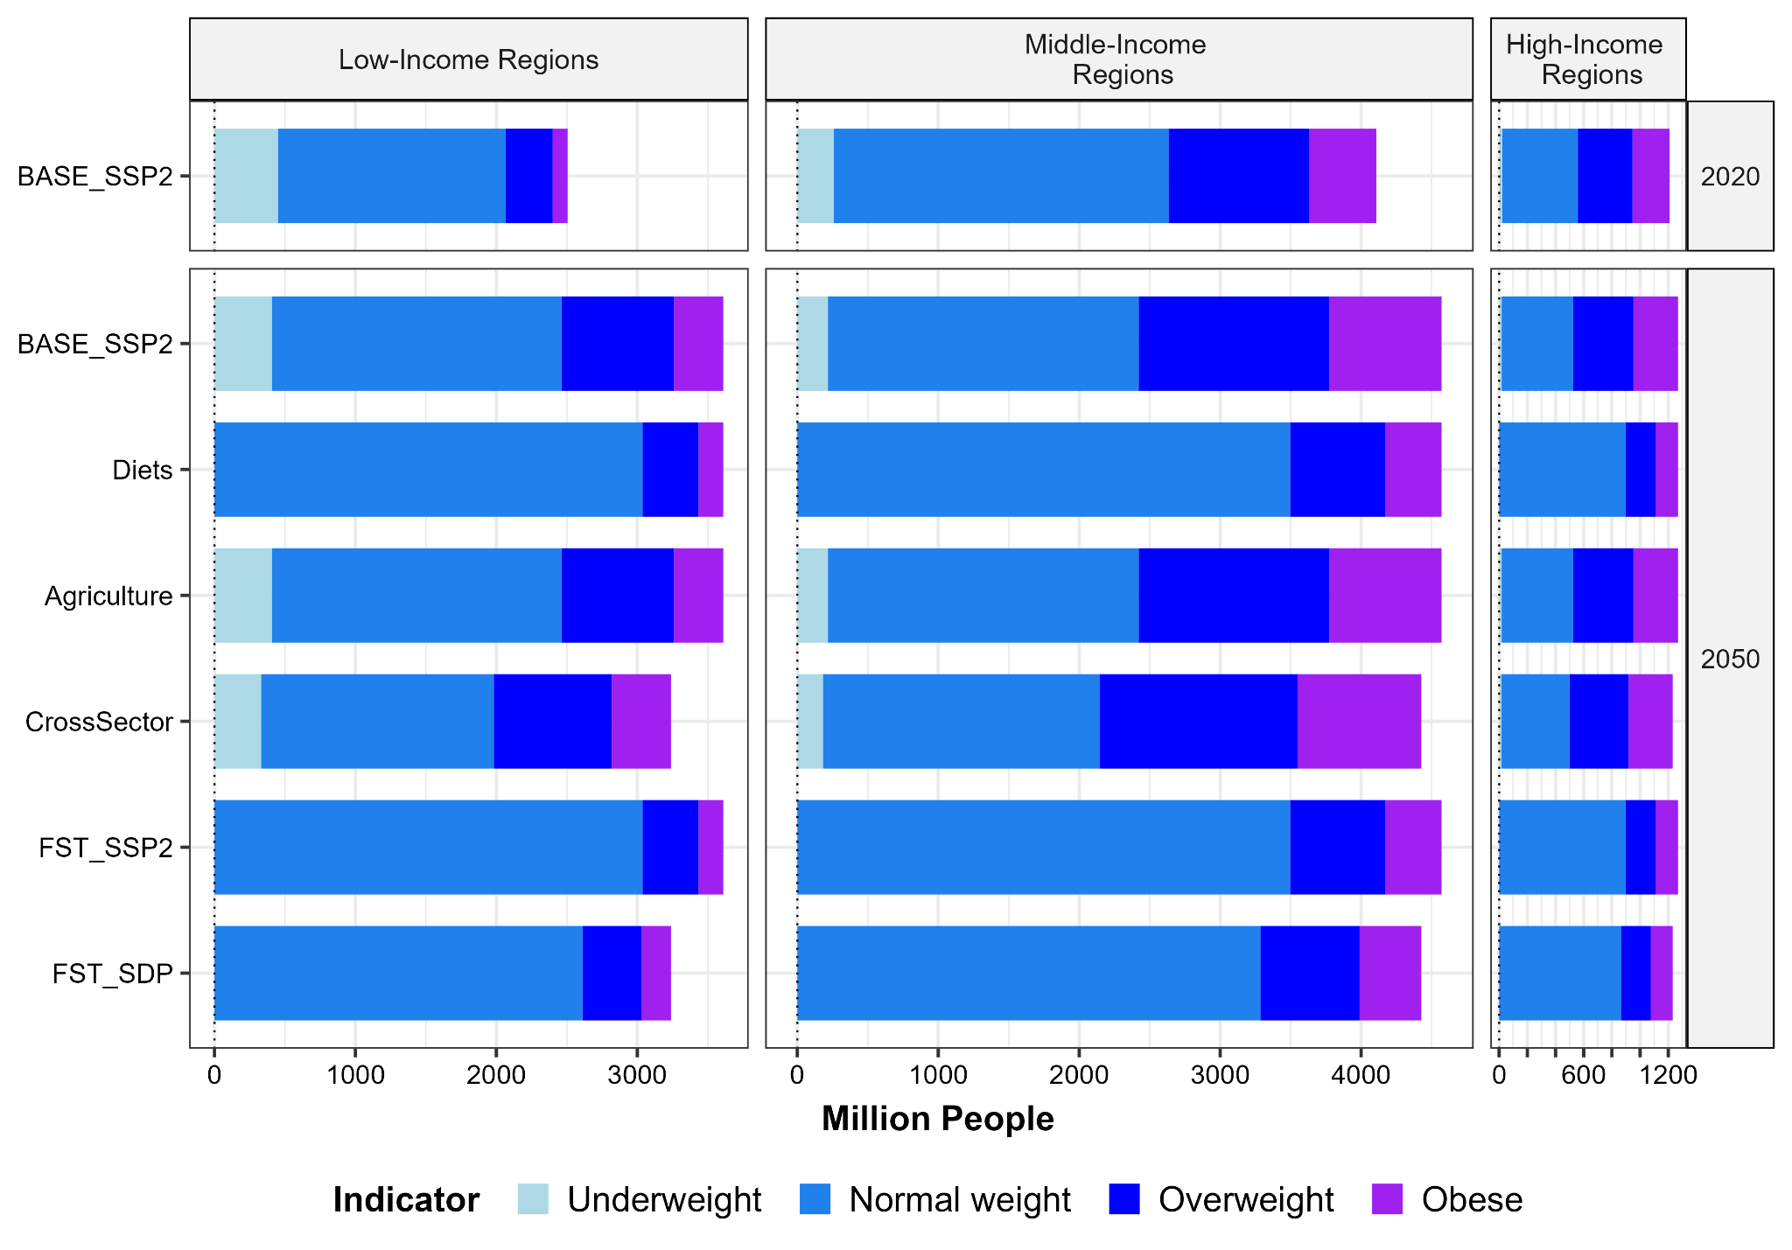Supplementary Figure 4: Population in million people by weight class for current low-income regions, middle-income, and high-income regions (see S1.1.1).

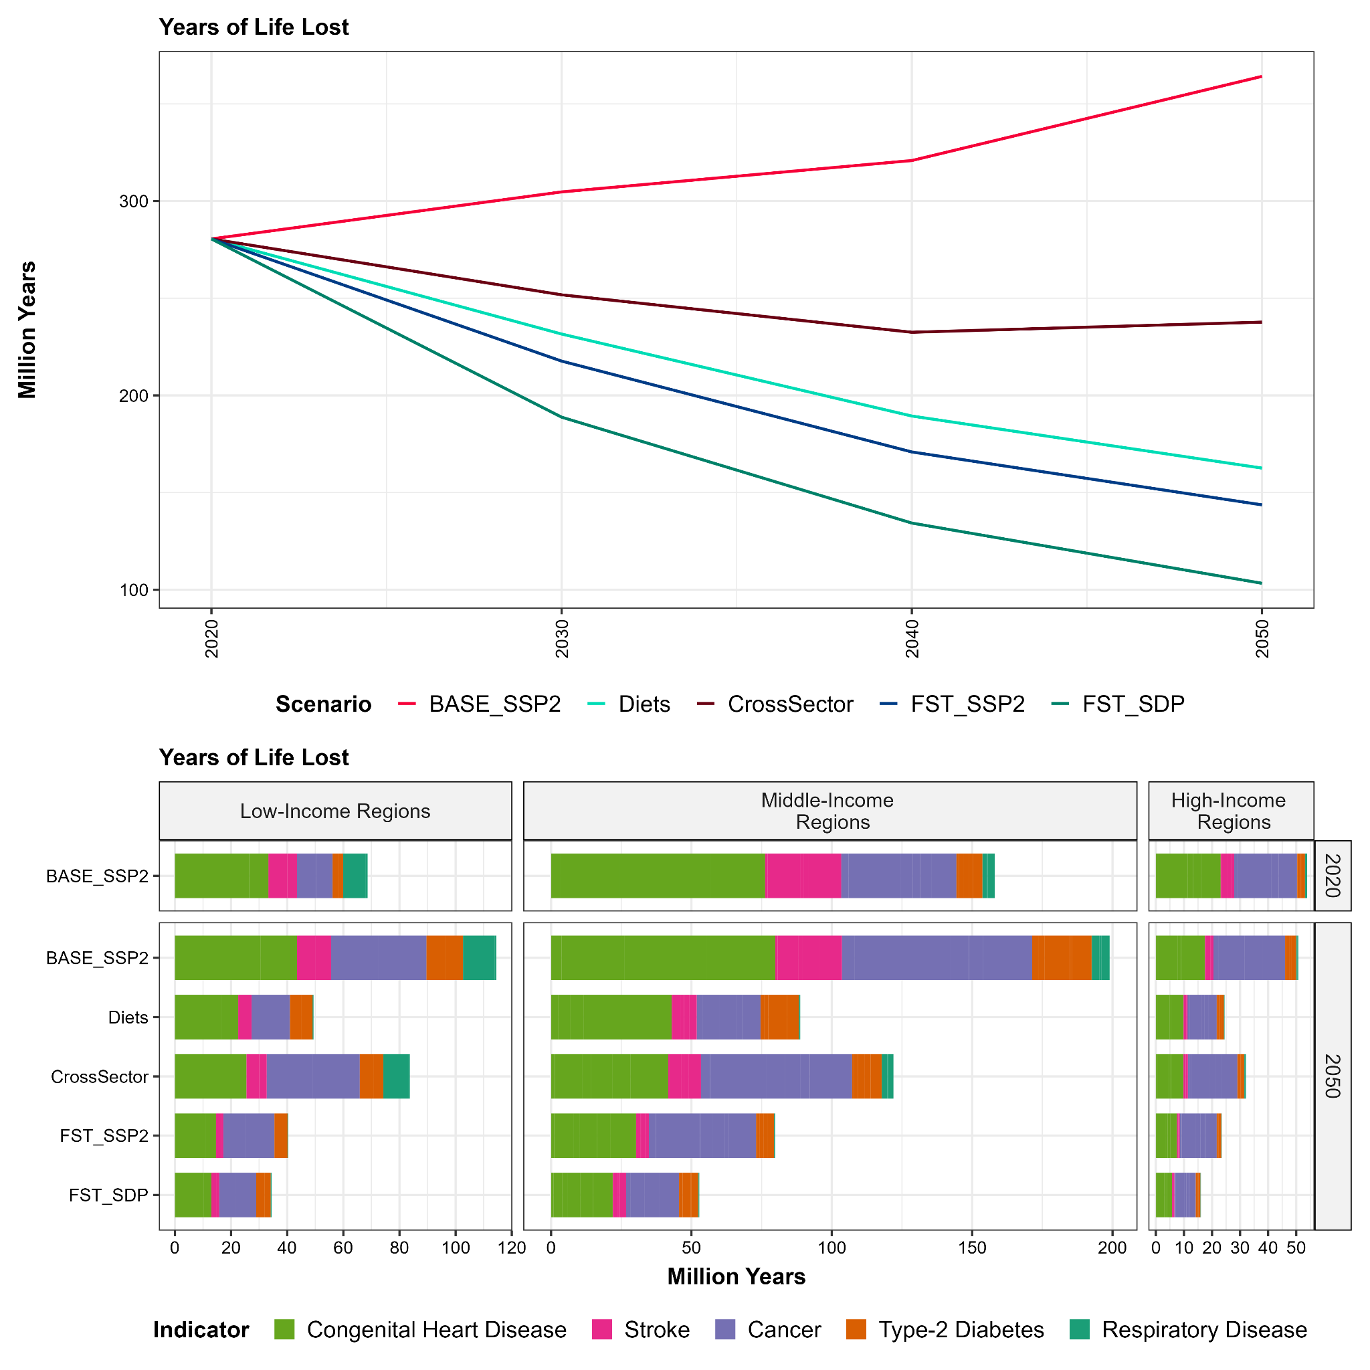

Supplementary Figure 5: a) Total years of life lost by scenario over time. b) Years of life lost by year and scenario for current low-income regions, middle-income, and high-income regions (see S1.1.1).

S2.2.3 Land-use change

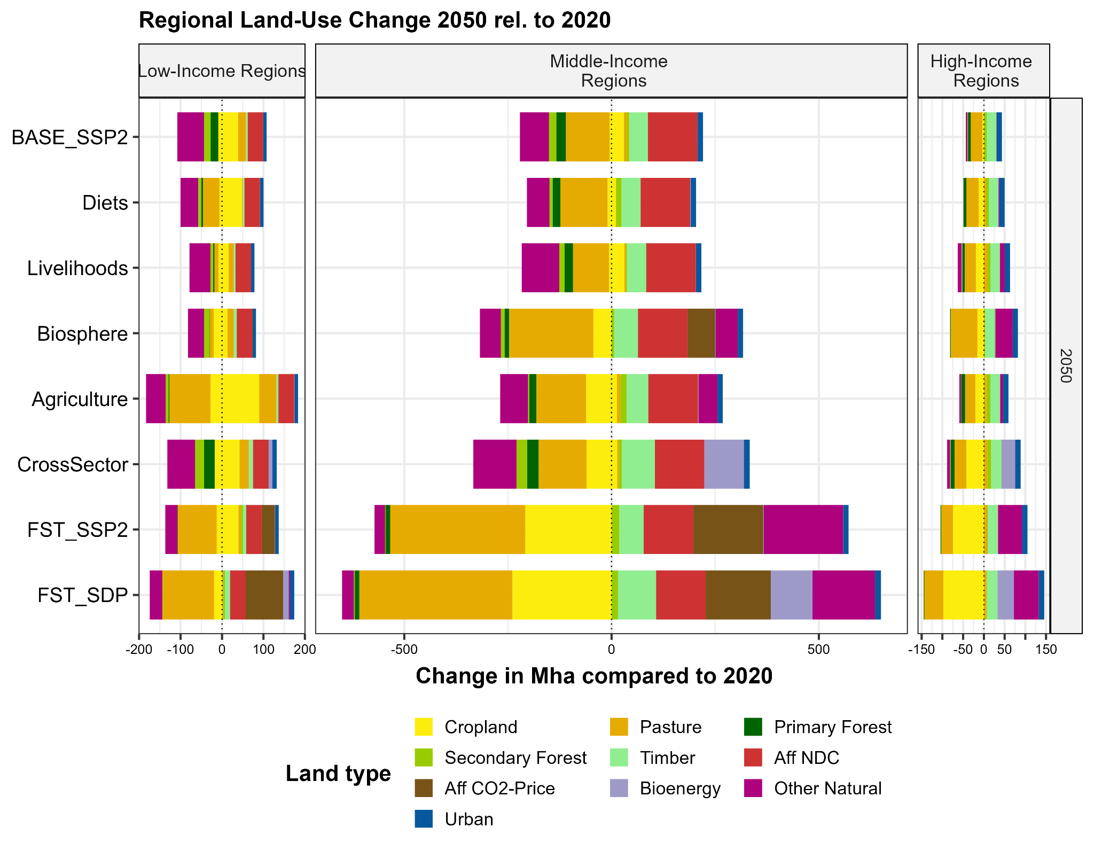

Supplementary Figure 6: Land use change from 2020 to 2050 in million hectares divided into different land types and scenarios, divided by current low- , middle and high-income regions (see S1.1.1).

S2.2.4 Croparea
a | 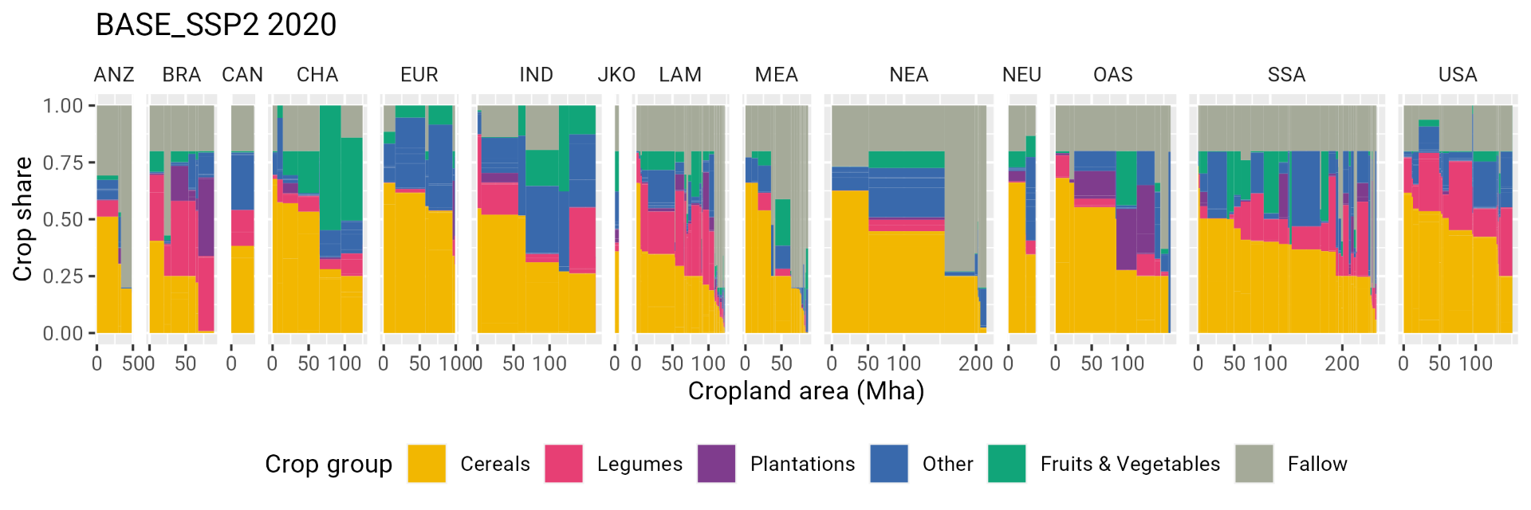
b | 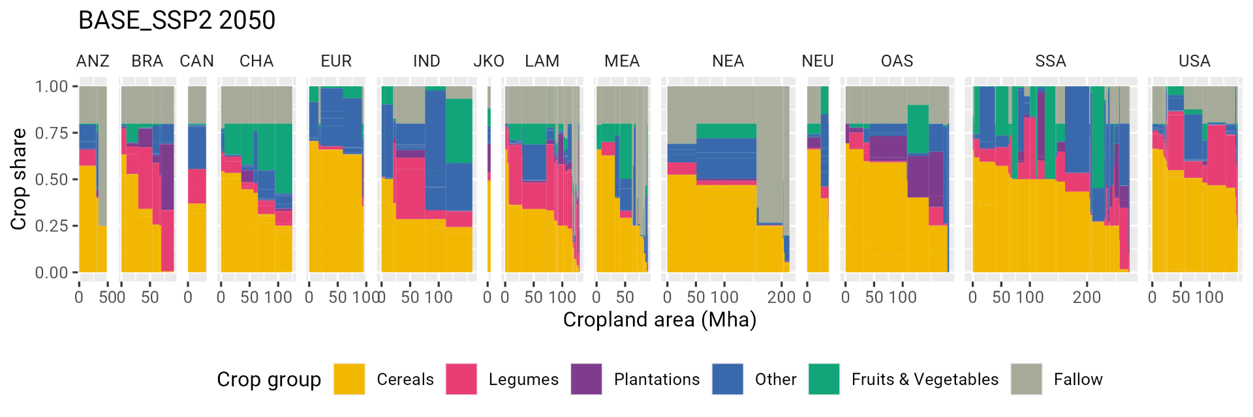
c | 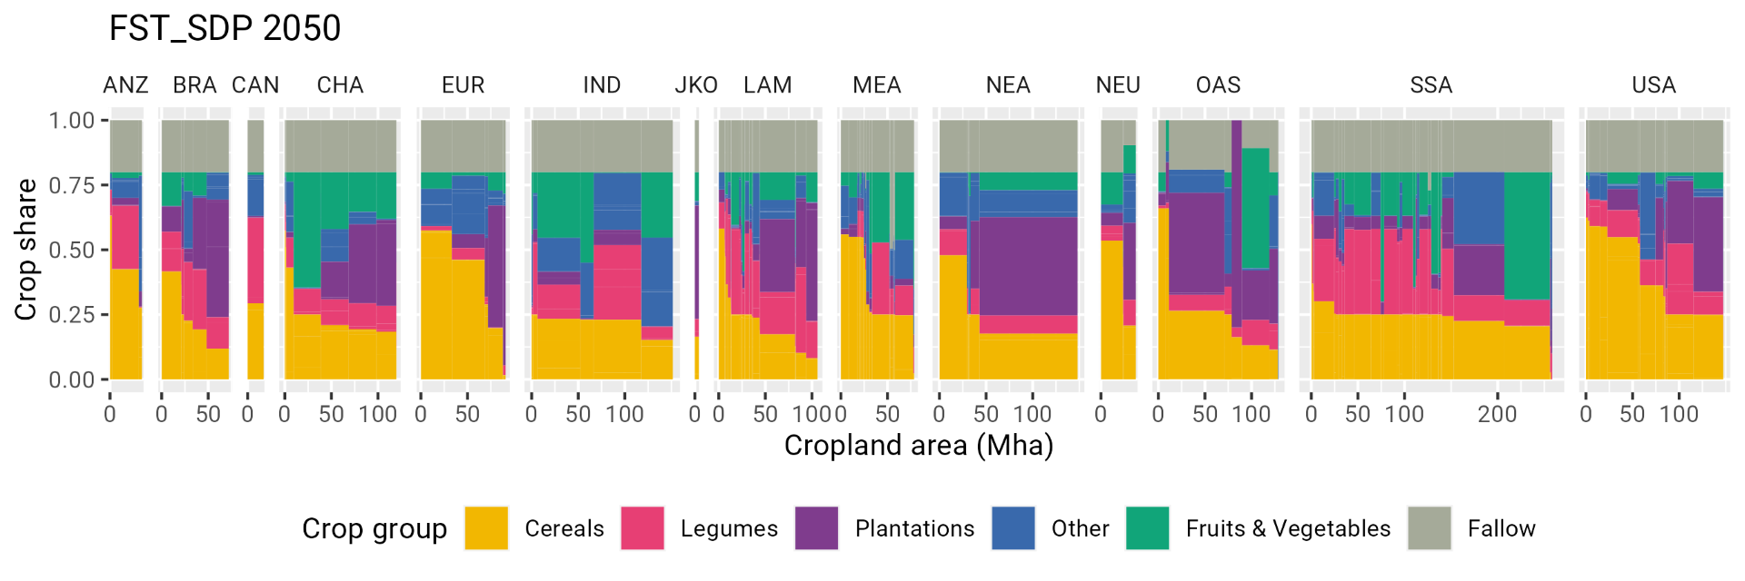

Supplementary Figure 7: Croparea composition for (a) the scenario BASE_{SSP2} in the year 2020, (b) in the year 2050, and (c) for the scenario FST_{SDP} in the year 2050. Y-axis shows the shares of major crop groups within the crop area of a cluster cell, and x-Axis shows the size of a cluster cell within major world regions (see section S1.1.1). Plantations include grassy and woody cellulosic bioenergy plants, oilpalms and sugar cane. Other crops include for example roots and forage crops.
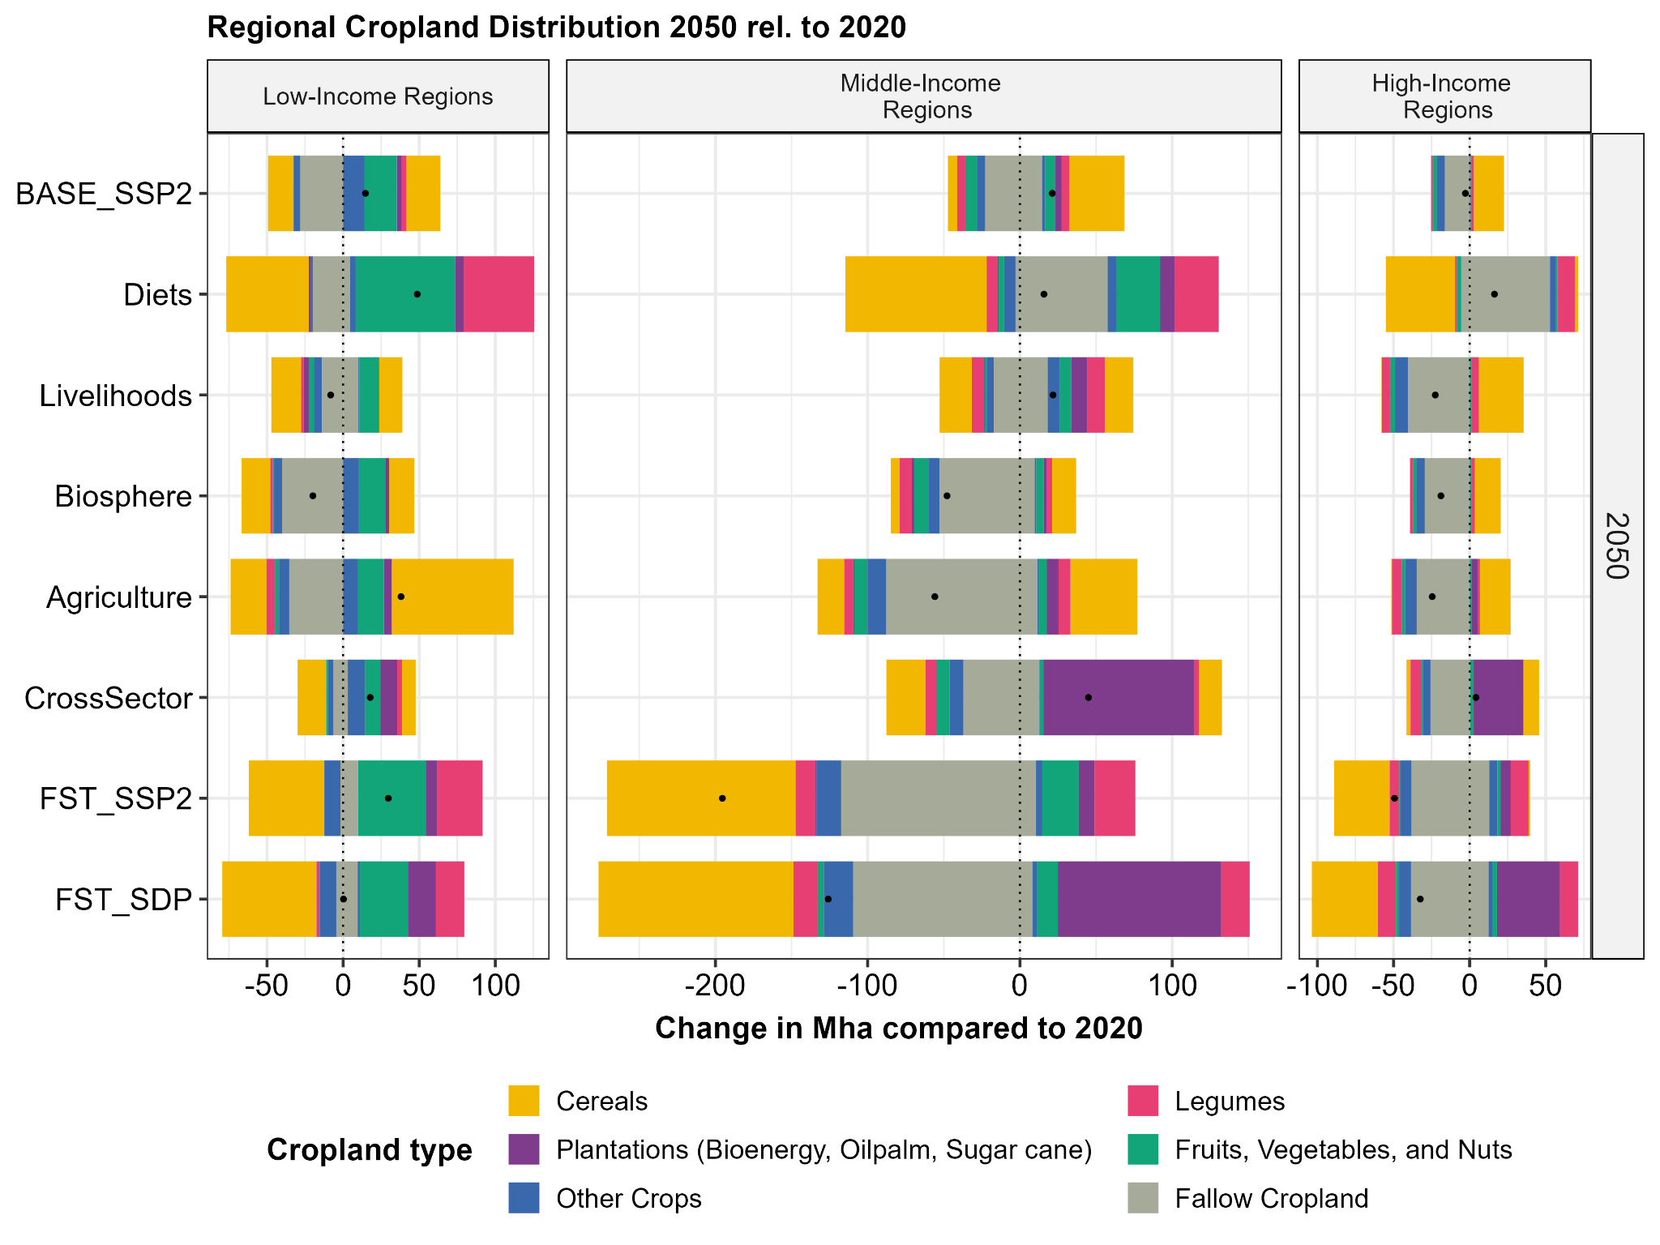

Supplementary Figure 8: Croparea change for major crop groups.

S2.2.5 Nitrogen
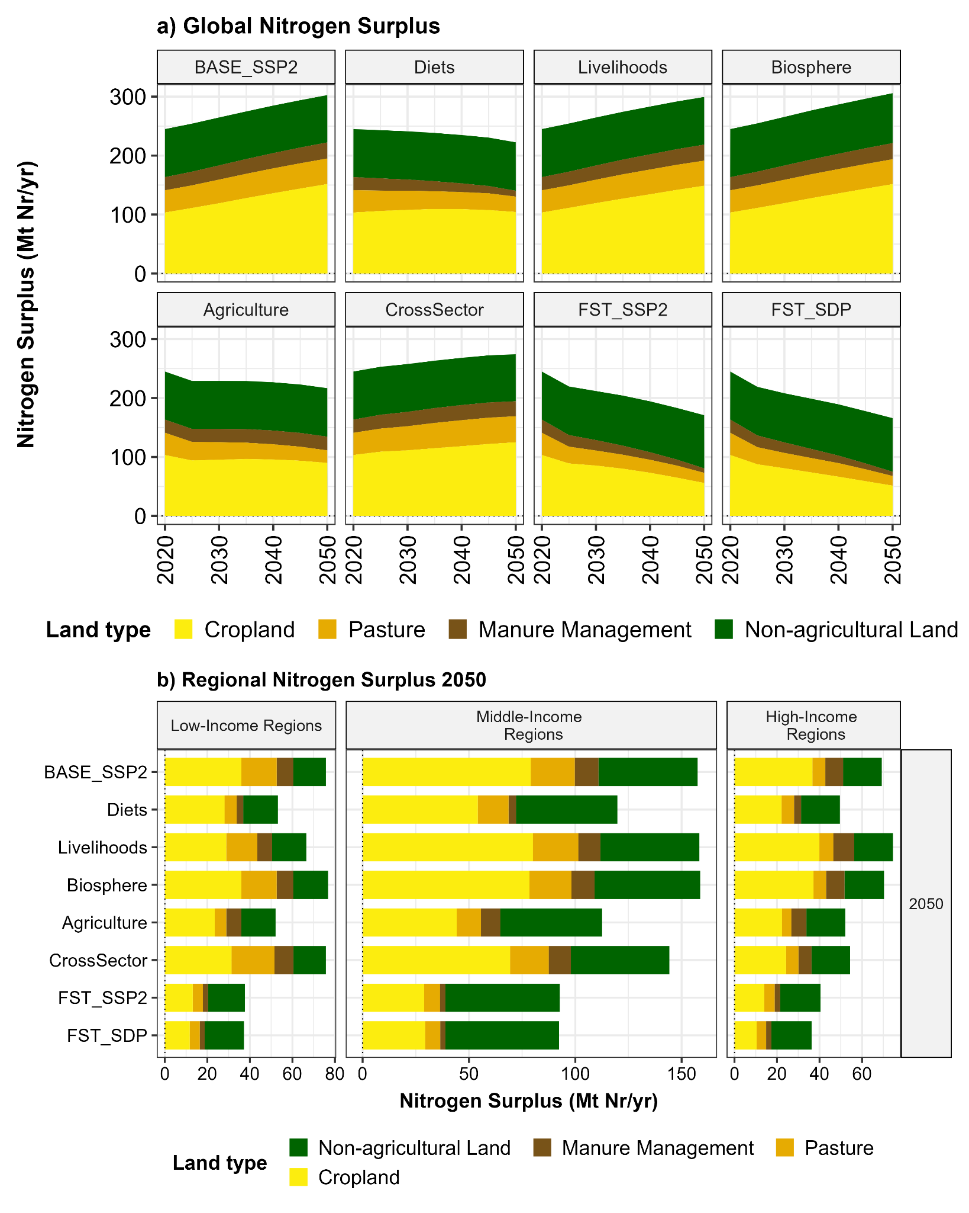

Supplementary Figure 9: Nitrogen surpluses in million tons of reactive nitrogen (Nr) per year by source for various scenarios. (a) Global over time; (b) For current low-, middle- and high-income regions (see S1.1.1) in the year 2050.

S2.2.6 Water
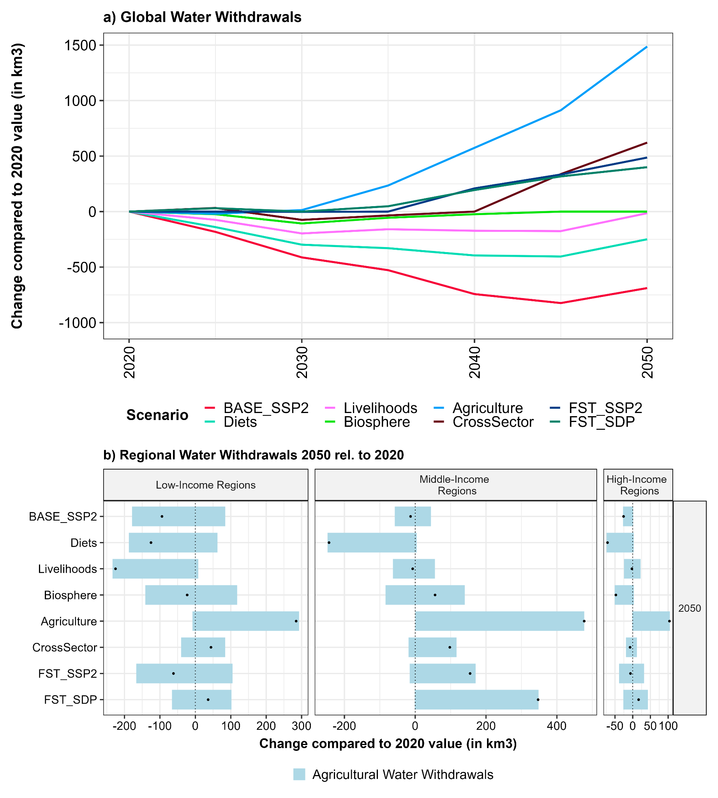

Supplementary Figure 10: Agricultural water withdrawals in km³ per year for various scenarios over time (a) and in 2020 and 2050 for current low-income, middle-income, and high-income regions (see S1.1.1).

S2.2.7 Climate Change
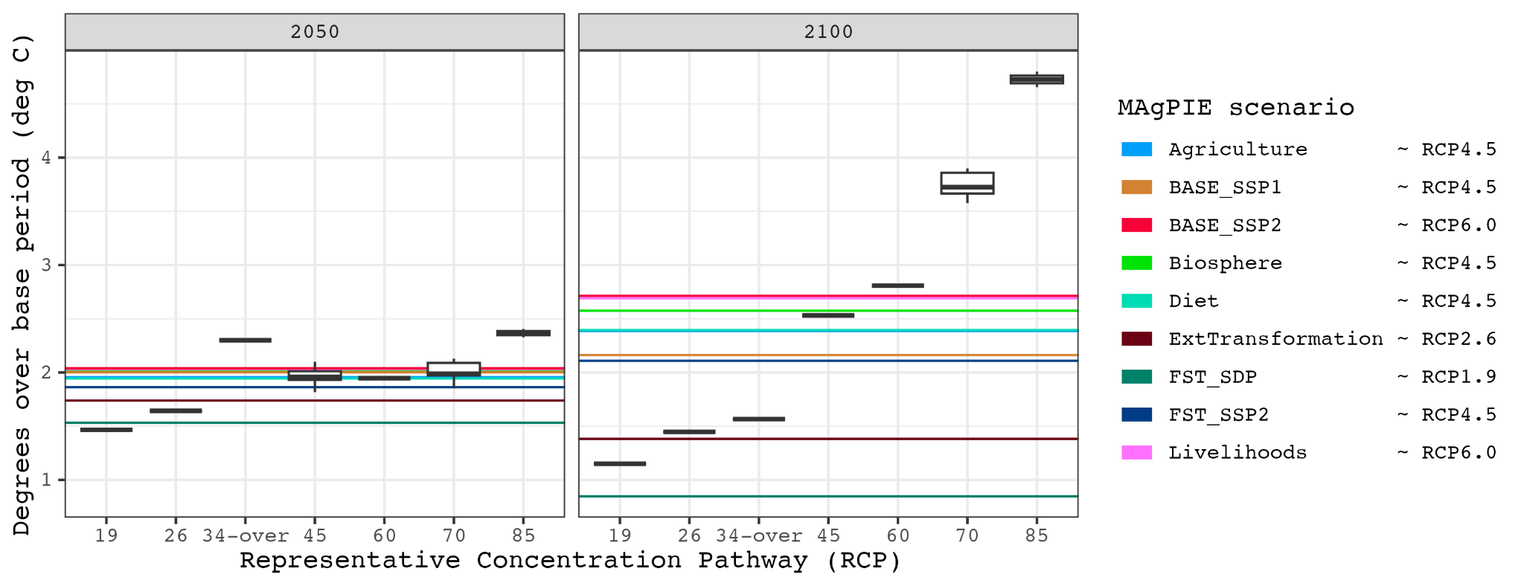

Supplementary Figure 11: Global Surface Temperature warming relative to reference period (1850-1900). Boxplots are estimates by the MRI-ESM2 climate model for the Representative Concentration Pathways (RCPs). Some scenarios have only a single climate model run, others have an ensemble based on multiple random seeds for the model. Colored lines are estimates by the MAGICC climate emulator for the greenhouse gas emission trajectories of the scenarios simulated for this analysis. In the legend, our scenarios are mapped to the respective RCP with the lowest sum of temperature divergences in 2050 and 2100.
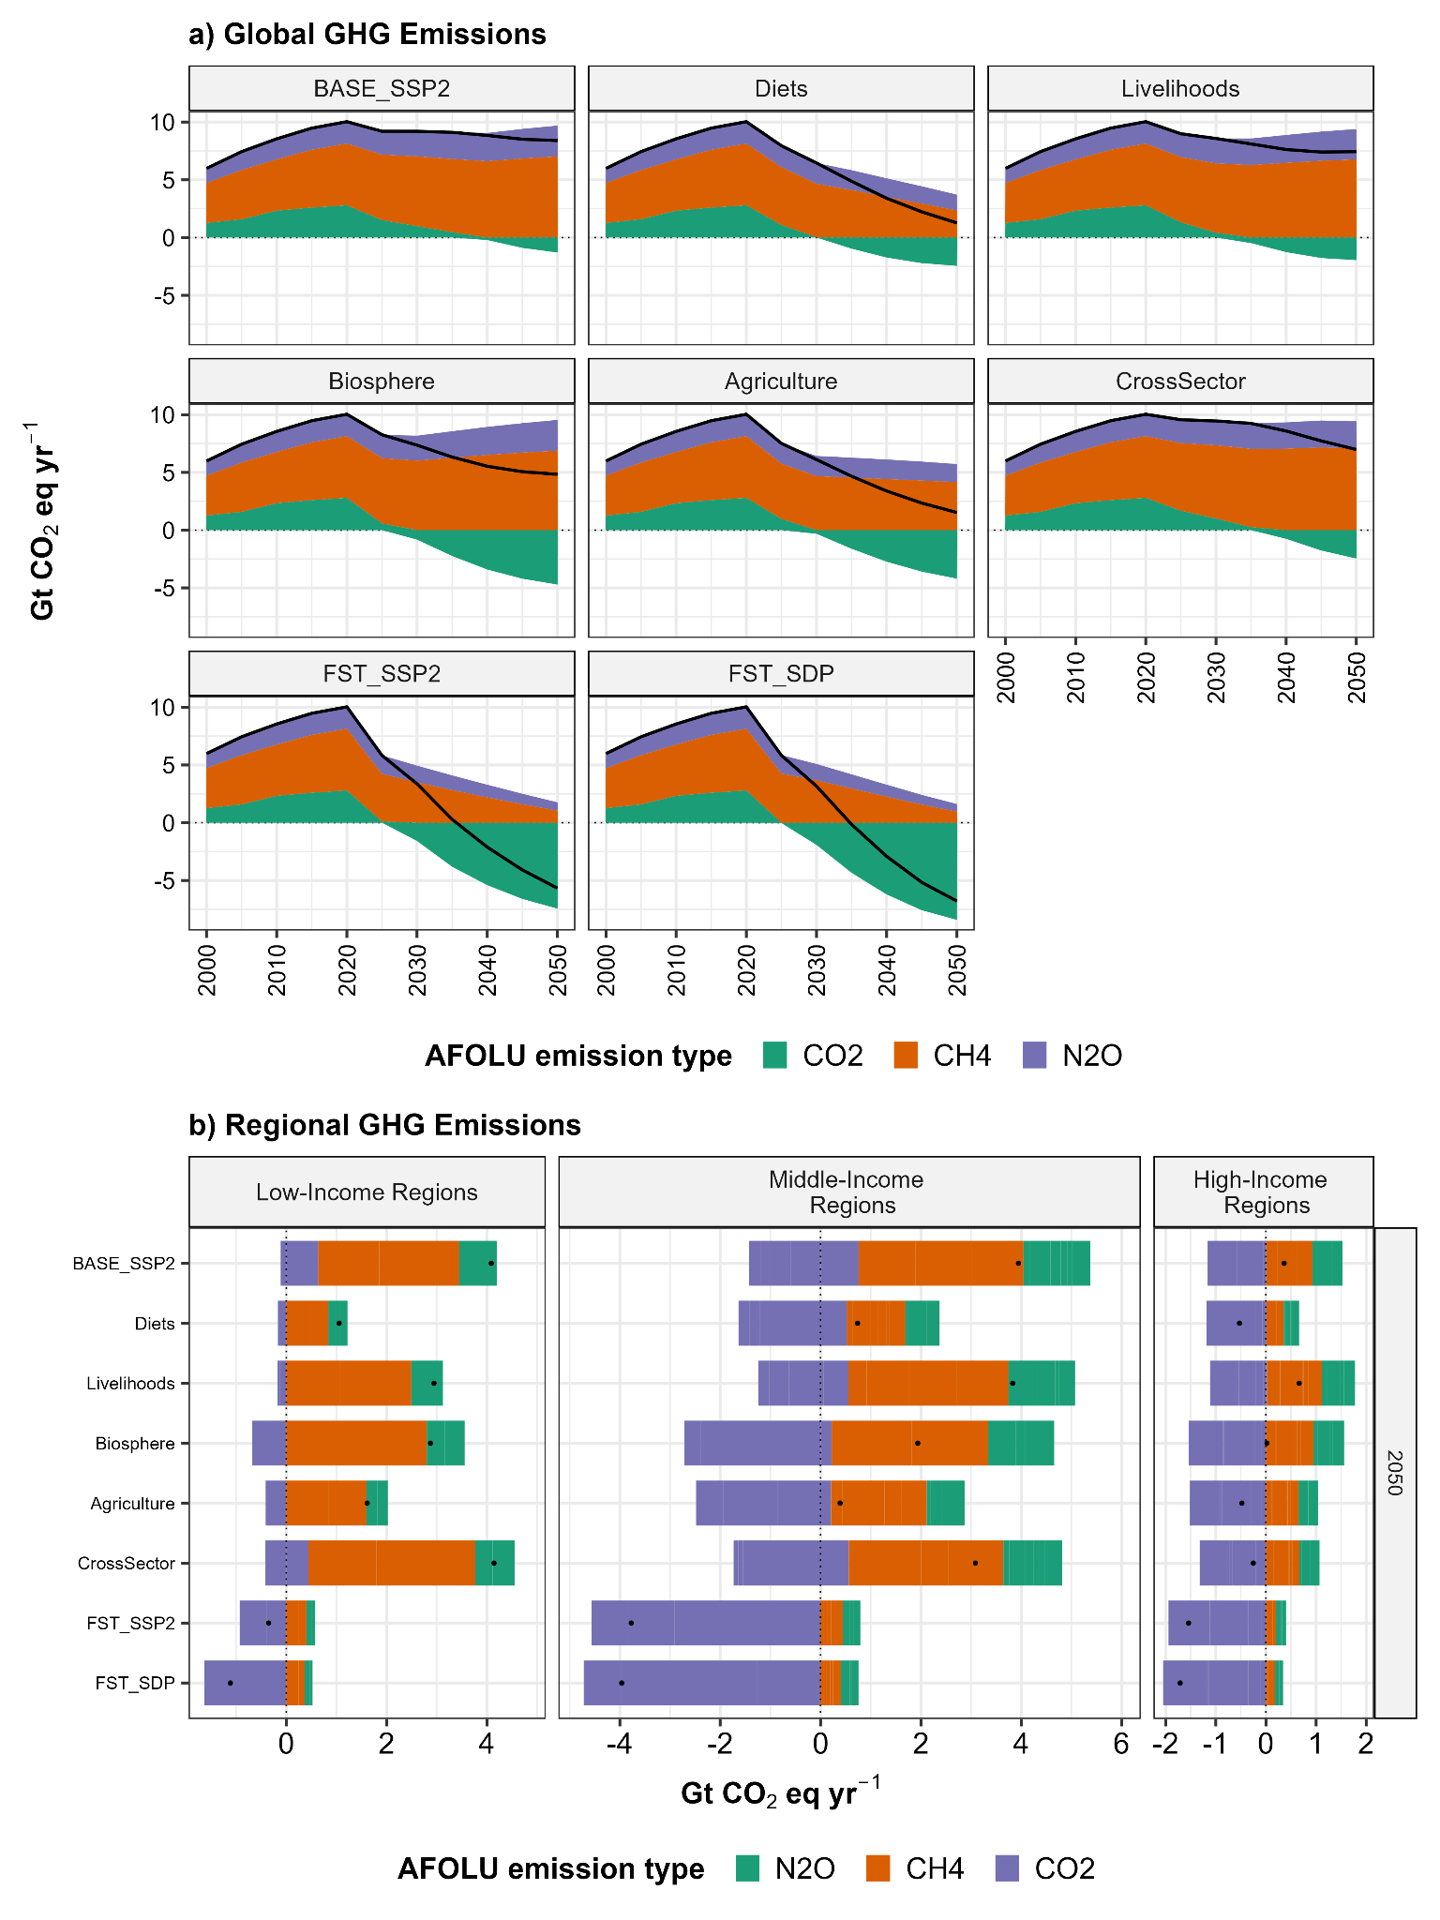Supplementary Figure 12: Greenhouse gas emissions of N₂O, CH₄ and CO₂ in CO₂-equivalents over time (a) and cumulated for the period 2020-2050 for current low-, middle-and high-income world regions (see S1.1.1) (b). Dots indicate net value.

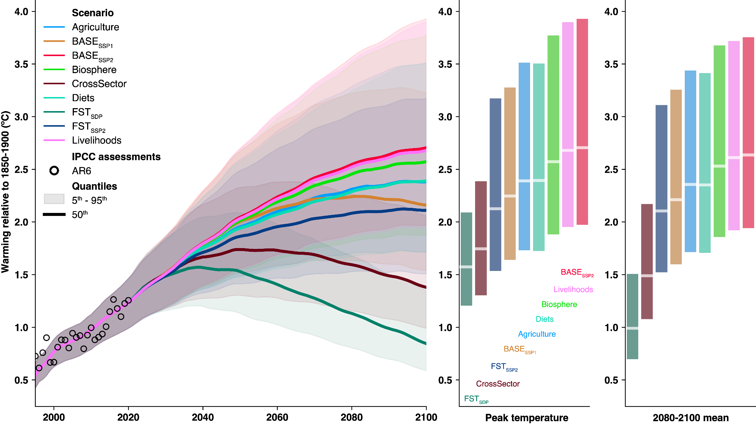Supplementary Figure 13: Global warming relative to 1850-1900 from MAGICC7.5.3 for key scenarios until 2100 (left panel); peak temperature during this period (middle panel); mean temperature in the later fifth of the 21st century (right panel). Lines represent median value across 600 runs of the MAGICC reduced-complexity climate model. Ribbons represent 5th-95th percentiles.

S2.2.8 Poverty

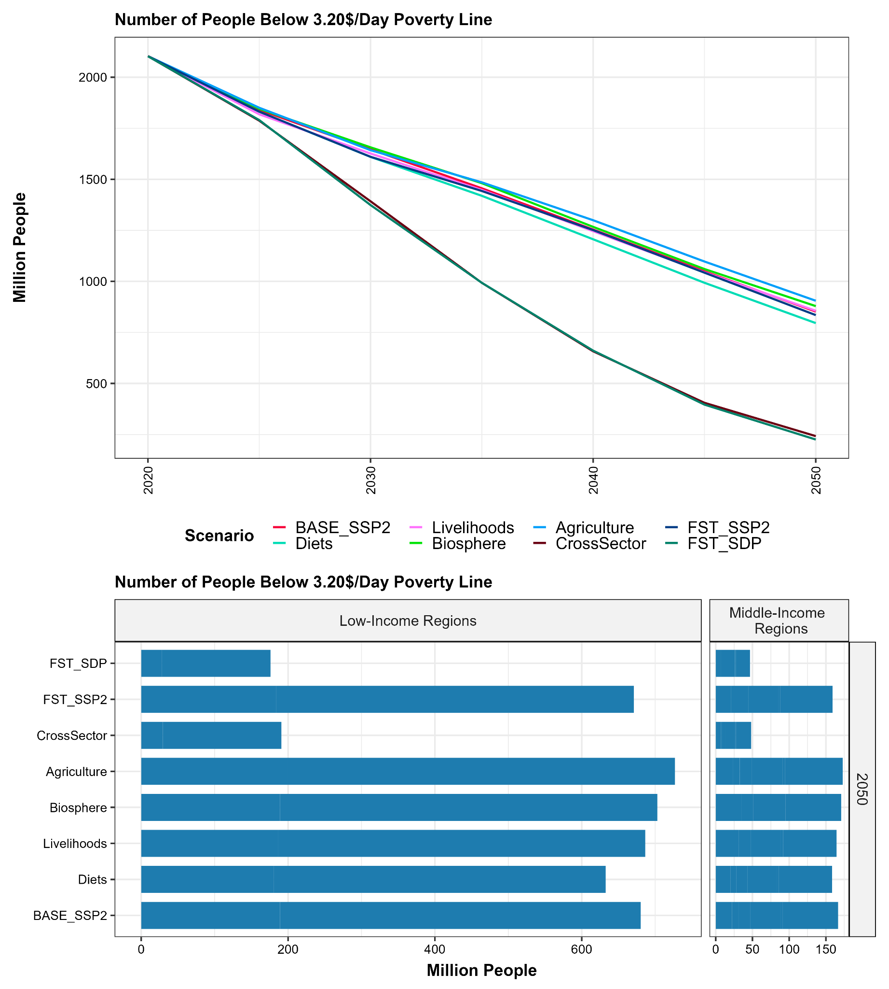Supplementary Figure 14: Number of people living with less than 3.20 USD_{2011PPP} as global total over time (a) and for current low- and middle-income regions (see S1.1.1) in the year 2050.

S2.2.9 Employment and Wages
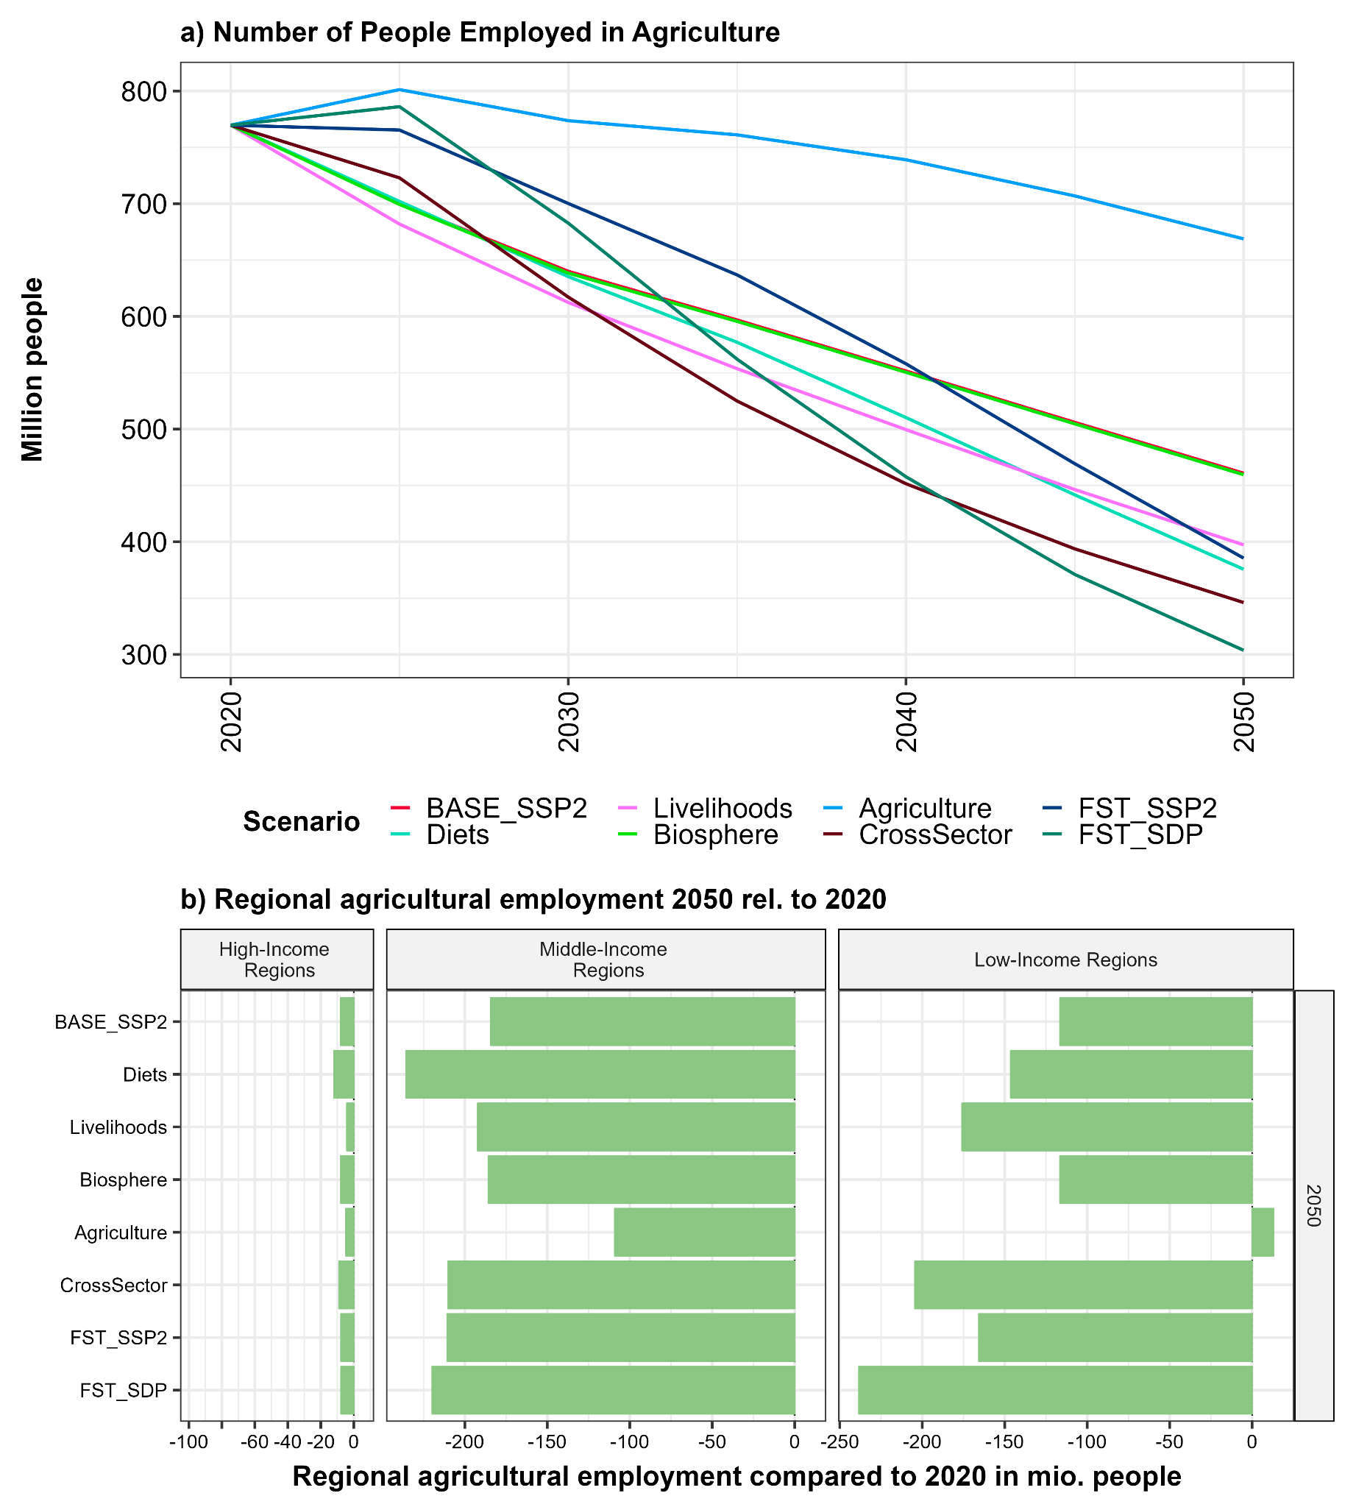

Supplementary Figure 15: Agricultural employment in million people for various scenarios, (a) over time and (b) in 2050 as change relative to 2020 in current low-, middle- and high-income world regions (see S1.1.1).

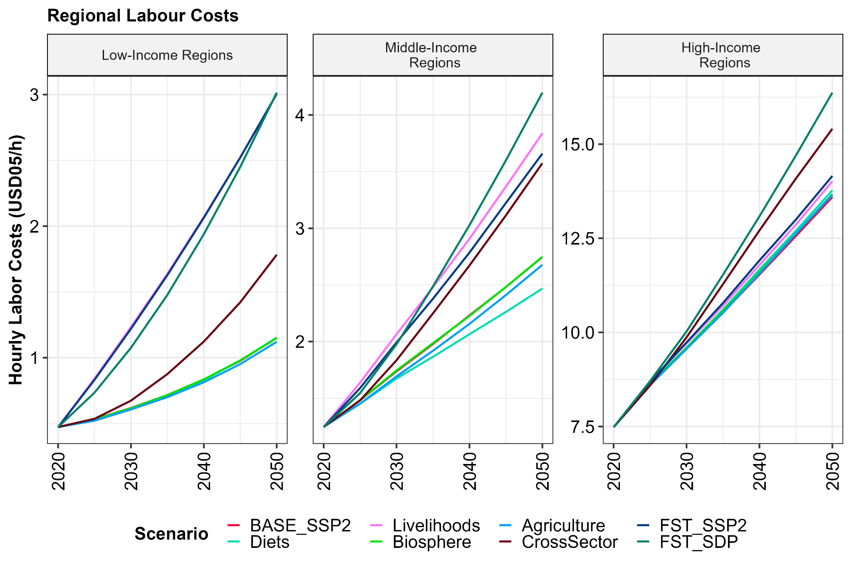

Supplementary Figure 16: Hourly labor costs in USD_{2005MER} in current low-, middle- and high-income regions (see S1.1.1) over time for various scenarios.

S2.3 Potential Intermediate Milestones

Milestone | Indicator | 2020 | 2030 | 2040 | 2050
Livestock product consumption per capita in current HIRs | Index | 1 | 0.61 | 0.42 | 0.27
Livestock product consumption per capita in current MIRs | Index | 1 | 0.91 | 0.65 | 0.38
Production of livestock products, global | Index | 1 | 0.94 | 0.75 | 0.47
Production of fruits, vegetables and nuts, global | Index | 1 | 1.27 | 1.52 | 1.67
Food waste per capita in current HIRs | Index | 1 | 0.73 | 0.65 | 0.57
Food waste per capita in current MIRs | Index | 1 | 0.93 | 0.82 | 0.72
Inorganic fertilizer, global | Mt N/yr | 118 | 103 | 99 | 97
Soil Nitrogen Uptake Efficiency (SNUpE), global | Percent | 57 | 64 | 69 | 74
Manure recycling quota, excluding field losses, global | Percent | 62 | 67 | 71 | 74
Rewetted formerly drained peatlands, global | Mha | 0.13 | 0.20 | 16.00 | 19.90
Anthropogenic LUC emissions, global | Gt CO₂/yr | 2.79 | -1.92 | -6.21 | -8.41
AFOLU emissions, global | Gt CO₂eq/yr | 10.21 | 3.31 | -2.80 | -6.68
Afforestation compared to 2020, global | Mha | 0 | 157 | 256 | 405
Total forest area, global | Mha | 4005 | 4189 | 4336 | 4546
Total other semi-natural vegetation, global | Mha | 3910 | 3931 | 4026 | 4065
Timber plantations, global | Mha | 149 | 183 | 227 | 278
Alternative livelihoods needed for people formerly working in agriculture, starting in 2020, global | Mio people | 0 | 87 | 312 | 466
Gini, global | Index | 0.42 | 0.42 | 0.4 | 0.38
Labor productivity in current LIRs | USD_{05MER}/worker | 1765 | 2531 | 4702 | 8596
Labor productivity in current MIRs | USD_{05MER}/worker | 5525 | 7255 | 10404 | 13339
Labor productivity in current HIRs | USD_{05MER}/worker | 53401 | 62455 | 70934 | 72558
Mortality from dietary and metabolic risks compared to 2020, global | Index | 1 | 0.67 | 0.48 | 0.37

References Supplementary Information

112. Dietrich, J. P., Popp, A. & Lotze-Campen, H. Reducing the loss of information and gaining accuracy with clustering methods in a global land-use model. Ecol. Model. 263, 233–243 (2013).
113. FAOSTAT. Database collection of the Food and Agriculture Organization of the United Nations. www.fao.org/faostat (2016).
114. IEA. World Energy Balances 2022. https://www.iea.org/data-and-statistics/data-product/world-energy-balances (2022).
115. Institute for Bioplastics and Biocomposites. Biopolymers-Facts-Statistics-einseitig-2021.pdf. https://www.ifbb-hannover.de/files/IfBB/downloads/faltblaetter_broschueren/f+s/Biopolymers-Facts-Statistics-einseitig-2021.pdf (2021).
116. Skoczinski, P. et al. Bio-Based Building Blocks and Polymers – Global Capacities, Production and Trends 2020 – 2025 (Short Version). (2021).
117. Sannigrahi, P., Ragauskas, A. J. & Tuskan, G. A. Poplar as a Feedstock for Biofuels: A Review of Compositional Characteristics. Biofuels Bioprod. Biorefining 4, 209–226 (2010).
118. Amarasekara, A. S. Handbook of Cellulosic Ethanol. (John Wiley & Sons, 2013).
119. Ribeiro, R. A., Colodette, J. L. & Júnior, S. V. Effect of residual effective alkali on eucalyptus kraft pulp yield and chemistry. CERNE 24, 408–419 (2018).
120. OECD. Global Plastics Outlook: Policy Scenarios to 2060. (Organisation for Economic Co-operation and Development, 2022).
121. Wirsenius, S. Human Use of Land and Organic Materials. (Chalmers University of Technology and Gäteborg University, 2000).
122. Global Trade, Assistance, and Production: The GTAP 7 Data Base. (2008).
123. Fuglie, K. Accounting for growth in global agriculture. Bio-Based Appl. Econ. Vol 4 No 3, 201-234 Pages (2015).
124. USDA. International Agricultural Productivity -- Machine-Readable and Long Format File of TFP Indices and Components for Countries, Regions, Countries Grouped by Income Level, and the World, 1961–2016. https://www.ers.usda.gov/data-products/international-agricultural-productivity/ (2021).
125. International Labour Organization. ILOSTAT. ILOSTAT https://ilostat.ilo.org/data/ (2021).
126. Rockström, J. et al. A safe operating space for humanity. Nature 461, 472--475 (2009).
127. de Vries, W., Kros, J., Kroeze, C. & Seitzinger, S. P. Assessing planetary and regional nitrogen boundaries related to food security and adverse environmental impacts. Curr. Opin. Environ. Sustain. 5, 392–402 (2013).
128. Klasen, S. et al. Economic and ecological trade-offs of agricultural specialization at different spatial scales. Ecol. Econ. 122, 111–120 (2016).
129. Seifert, C. A., Roberts, M. J. & Lobell, D. B. Continuous Corn and Soybean Yield Penalties across Hundreds of Thousands of Fields. Agron. J. 109, 541–548 (2017).
130. Landwirtschaftskammer NRW. Maximale Anbaukonzentration von Feldfruchtarten bzw. -gruppen, nach Zielen der nachhaltigen Pflanzenproduktion in %. (nach Baeumer 1990). (2015).
131. Schönhart, M., Schmid, E. & Schneider, U. A. CropRota – A crop rotation model to support integrated land use assessments. Eur. J. Agron. 34, 263–277 (2011).
132. Alfredo B. Escasinas and Rodolfo G. Escalada. Crop Rotation of Sweet Potato, Cassava, and Gabi with Legumes as a Cultural Management System. Ann. Trop. Res. 6, (1984).
133. IPCC. 2019 Refinement to the 2006 IPCC Guidelines for National Greenhouse Gas Inventories. https://www.ipcc.ch/report/2019-refinement-to-the-2006-ipcc-guidelines-for-national-greenhouse-gas-inventories/ (2019).
134. Scholes, R. J. & Biggs, R. A biodiversity intactness index. Nature 434, 45–49 (2005).
135. Purvis, A. et al. Chapter Five - Modelling and Projecting the Response of Local Terrestrial Biodiversity Worldwide to Land Use and Related Pressures: The PREDICTS Project. in Advances in Ecological Research (eds. Bohan, D. A., Dumbrell, A. J., Woodward, G. & Jackson, M.) vol. 58 201–241 (Academic Press, 2018).
136. Jeetze, P. von et al. Landscape-scale repercussions of global action for climate and biodiversity protection. https://www.researchsquare.com/article/rs-1478082/v1 (2022) doi:10.21203/rs.3.rs-1478082/v1.
137. Garibaldi, L. A. et al. Working landscapes need at least 20% native habitat. Conserv. Lett. 14, e12773 (2021).
138. Olson, D. M. et al. Terrestrial Ecoregions of the World: A New Map of Life on Earth: A new global map of terrestrial ecoregions provides an innovative tool for conserving biodiversity. BioScience 51, 933–938 (2001).
139. McDuffie, E. E. et al. A global anthropogenic emission inventory of atmospheric pollutants from sector- and fuel-specific sources (1970–2017): An application of the Community Emissions Data System (CEDS). https://essd.copernicus.org/preprints/essd-2020-103/essd-2020-103.pdf (2020) doi:10.5194/essd-2020-103.
140. Günther, A. et al. Prompt rewetting of drained peatlands reduces climate warming despite methane emissions. Nat. Commun. 11, 1644 (2020).
141. IPCC. 2006 IPCC Guidelines for National Greenhouse Gas Inventories, Prepared by the National Greenhouse Gas Inventories Programme. (2006).
142. Strefler, J. et al. Alternative carbon price trajectories can avoid excessive carbon removal. Nat. Commun. 12, 2264 (2021).
143. Strefler, J. et al. Carbon dioxide removal technologies are not born equal. Environ. Res. Lett. 16, 074021 (2021).
144. van Vuuren, D. P. et al. Energy, land-use and greenhouse gas emissions trajectories under a green growth paradigm. Glob. Environ. Change 42, 237–250 (2017).
145. Rafaj, P. et al. Air quality and health implications of 1.5 °C–2 °C climate pathways under considerations of ageing population: a multi-model scenario analysis. Environ. Res. Lett. 16, 045005 (2021).
146. Rauner, S., Hilaire, J., Klein, D., Strefler, J. & Luderer, G. Air quality co-benefits of ratcheting up the NDCs. Clim. Change 163, 1481–1500 (2020).
147. Fujino, J., Nair, R., Kainuma, M., Masui, T. & Matsuoka, Y. Multi-gas Mitigation Analysis on Stabilization Scenarios Using Aim Global Model. Energy J. 27, 343–353 (2006).
148. Lucas, P. L., Van Vuuren, D. P., Olivier, J. G. J. & Den Elzen, M. Long-term reduction potential of non-CO2 greenhouse gases. Environ. Sci. Policy 10, 85–103 (2007).
149. IPCC. Mitigation Pathways Compatible with 1.5°C in the Context of Sustainable Development. in Global Warming of 1.5°C: IPCC Special Report on Impacts of Global Warming of 1.5°C above Pre-industrial Levels in Context of Strengthening Response to Climate Change, Sustainable Development, and Efforts to Eradicate Poverty (Cambridge University Press, 2018). doi:10.1017/9781009157940.
150. O’Neill, B. C. et al. The roads ahead: Narratives for shared socioeconomic pathways describing world futures in the 21st century. Glob. Environ. Change (2015) doi:10.1016/j.gloenvcha.2015.01.004.
151. Koch, J. & Leimbach, M. SSP economic growth projections: Major changes of key drivers in integrated assessment modelling. Ecol. Econ. 206, 107751 (2023).
152. Worldbank. Poverty headcount ratio at $3.20 a day (2011 PPP). https://data.worldbank.org/indicator/SI.POV.LMIC.GC (2023).
153. Phillips, H. et al. The Biodiversity Intactness Index - country, region and global-level summaries for the year 1970 to 2050 under various scenarios. (2021) doi:10.5519/he1eqmg1.
154. Tubiello, F. N. et al. Greenhouse gas emissions from food systems: building the evidence base. Environ. Res. Lett. 16, 065007 (2021).

