Supplemental Information
Table S1 Gradient Flow Method for LCMS
Time (min) | Flow (mL/min) | %A (0.1% Formic Acid) | %B (Acetonitrile)
0 | 0.35 | 70 | 30
2 | 0.35 | 70 | 30
3 | 0.35 | 70 | 30
4 | 0.35 | 50 | 50
5 | 0.35 | 50 | 50
7 | 0.35 | 30 | 70
9 | 0.35 | 30 | 70
10 | 0.35 | 50 | 50
11 | 0.35 | 70 | 30
12 | 0.35 | 70 | 30

Table S2 Experimental parameters of ESI⁻ tandem mass spectrometry. Other operating parameters include a 500°C desolvation temperature, a desolvation gas flow of 800L/hr and a 0.07 MPa collision gas pressure
Compound | Parent Ion | Daughter Ion | Cone (V) | Collision (V)
MeP | 151 | 92 | 10 | 22
MeP | 151 | 136 | 10 | 20
EtP | 165 | 92 | 10 | 22
EtP | 165 | 137 | 8 | 18
PrP | 179 | 92 | 10 | 22
PrP | 179 | 137 | 10 | 20
BuP | 193 | 92 | 10 | 22
BuP | 193 | 137 | 8 | 20
BzP | 227 | 92 | 10 | 22
BzP | 227 | 136 | 10 | 25
MePOH | 167 | 108 | 10 | 25
MePOH | 167 | 152 | 10 | 25
EtPOH | 181 | 108 | 12 | 25
EtPOH | 181 | 153 | 10 | 30
PHBA | 137 | 65 | 12 | 25
PHBA | 137 | 92 | 12 | 25
DHBA | 153 | 109 | 12 | 25
ClMeP | 185 | 126 | 15 | 30
ClMeP | 185 | 170 | 10 | 25
ClEtP | 199 | 127 | 15 | 30
ClEtP | 199 | 170 | 15 | 30
Cl₂MeP | 219 | 132 | 20 | 35
Cl₂MeP | 219 | 160 | 15 | 29
Cl₂EtP | 233 | 161 | 20 | 35
Cl₂EtP | 233 | 205 | 15 | 30

Table S3 Recovery rates, LODs and LOQs for compounds of interest
Compound | Percent Recovery (%) ± SD | LOD (ng/L) | LOQ (ng/L)
MeP | 100 ± 9.0 | 0.072 | 0.167
EtP | 97 ± 9.6 | 0.047 | 0.115
PrP | 97 ± 8.6 | 0.020 | 0.051
BuP | 98 ± 8.2 | 0.004 | 0.011
BzP | 92 ± 7.8 | 0.005 | 0.012
PHBA | 98 ± 9.0 | 0.345 | 0.843
DHBA | 97 ± 7.0 | 0.308 | 0.755
MePOH | 94 ± 8.3 | 0.005 | 0.010
EtPOH | 99 ± 8.2 | 0.015 | 0.035
ClMeP | 95 ± 9.3 | 0.050 | 0.121
ClEtP | 95 ± 9.8 | 0.012 | 0.030
Cl₂MeP | 92 ± 9.7 | 0.009 | 0.022
Cl₂EtP | 89 ± 9.6 | 0.017 | 0.040

Table S4 Conversion factor from ng/L to pM
Compound | Molar Mass (g/mol) | Conversion Factor (pmol/ng)
MeP | 152.2 | 6.572
EtP | 166.2 | 6.018
PrP | 180.2 | 5.549
BuP | 194.2 | 5.149
BzP | 228.2 | 4.381
PHBA | 138.1 | 7.240
DHBA | 154.1 | 6.488
MePOH | 168.2 | 5.947
EtPOH | 182.2 | 5.489
ClMeP | 186.6 | 5.359
ClEtP | 200.6 | 4.985
Cl₂MeP | 221.0 | 4.524
Cl₂EtP | 235.1 | 4.254

Fig S1 Analyte concentrations during spring by site along the Brazos River

Fig S2 Analyte concentrations during summer by site along the Brazos River

Fig S3 Analyte concentrations during fall by site along the Brazos River

Fig S4 Analyte concentrations during winter by site along the Brazos River

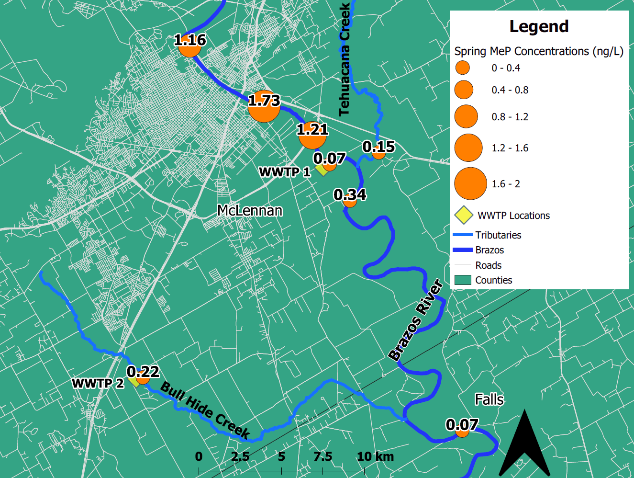
a
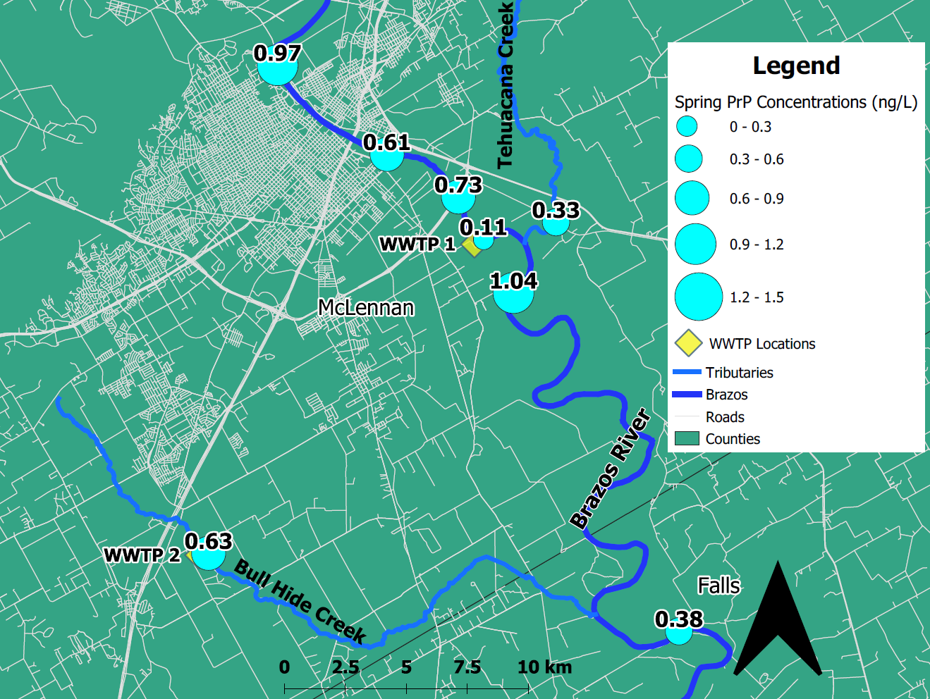
b
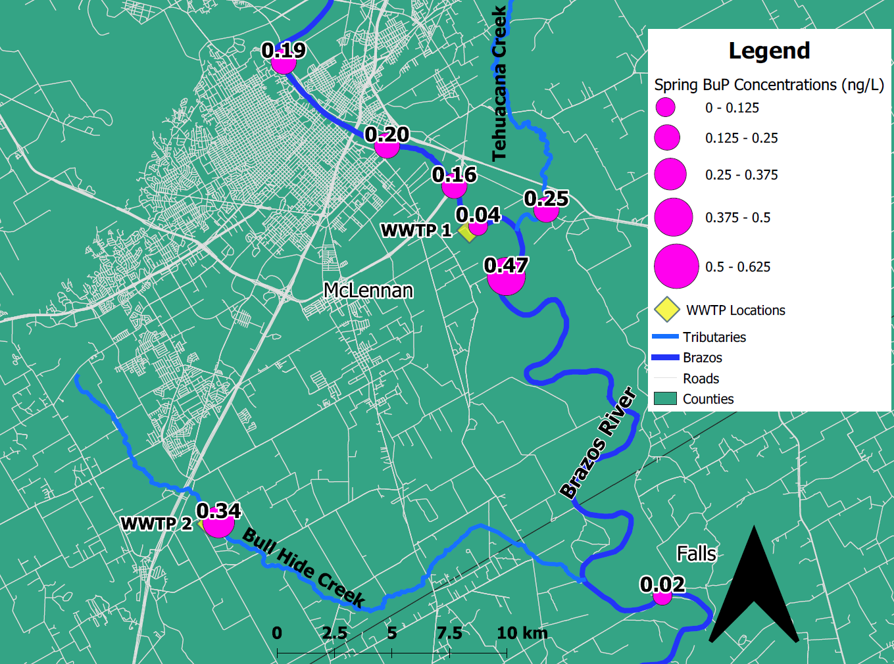
c
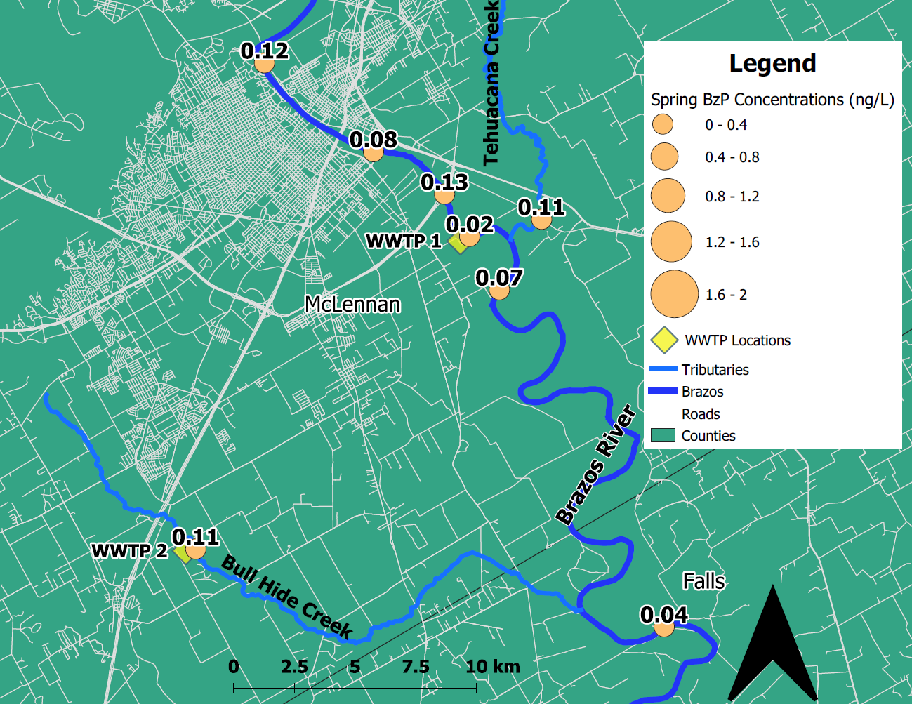
d
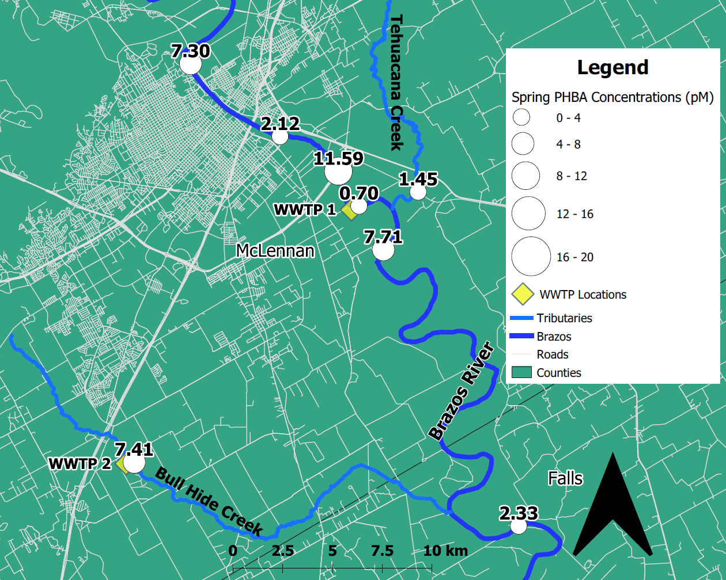
e
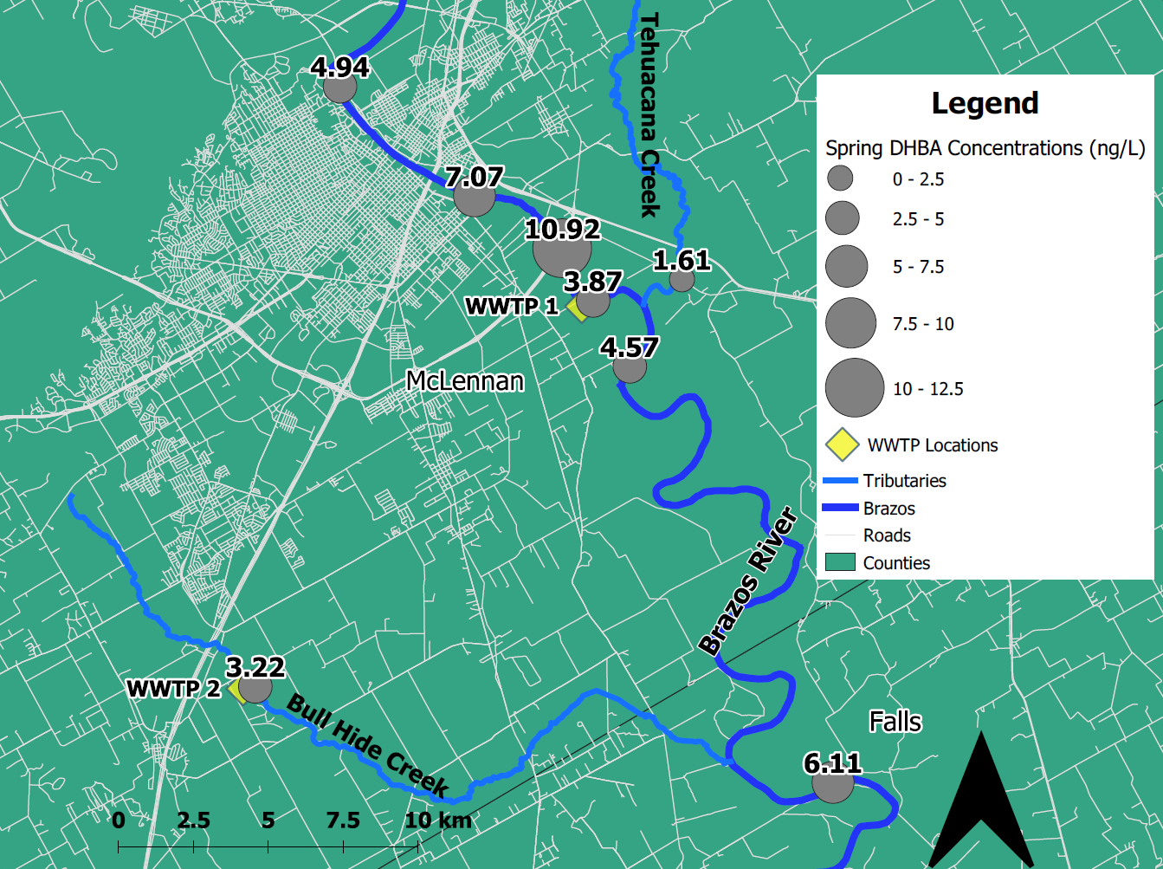
f
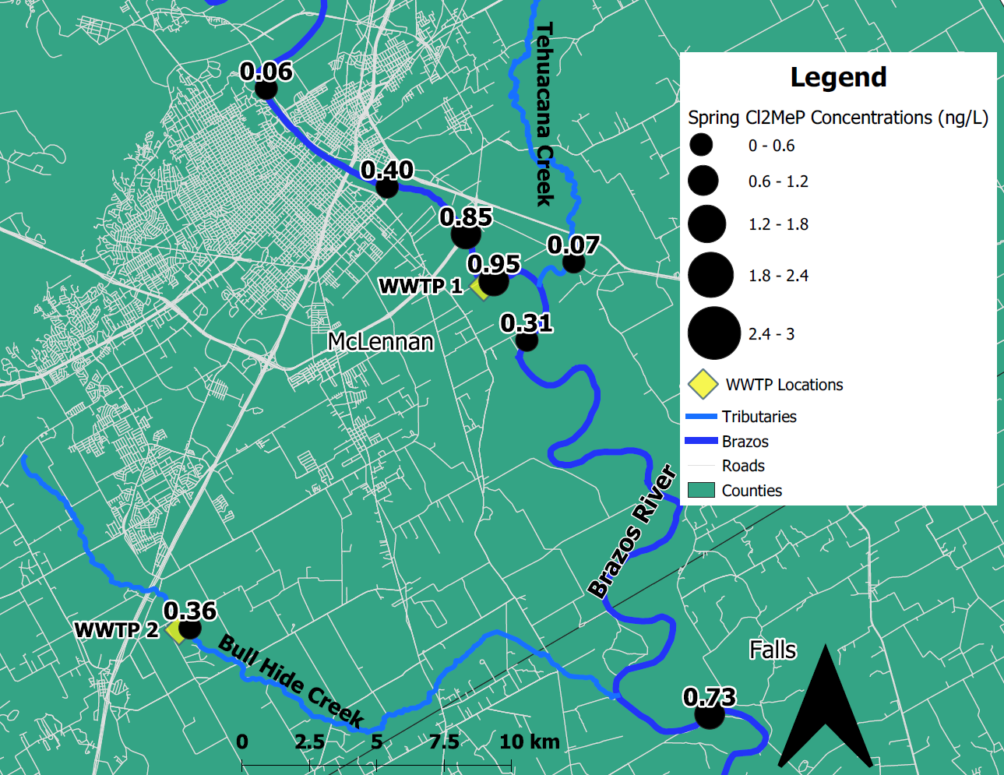
g
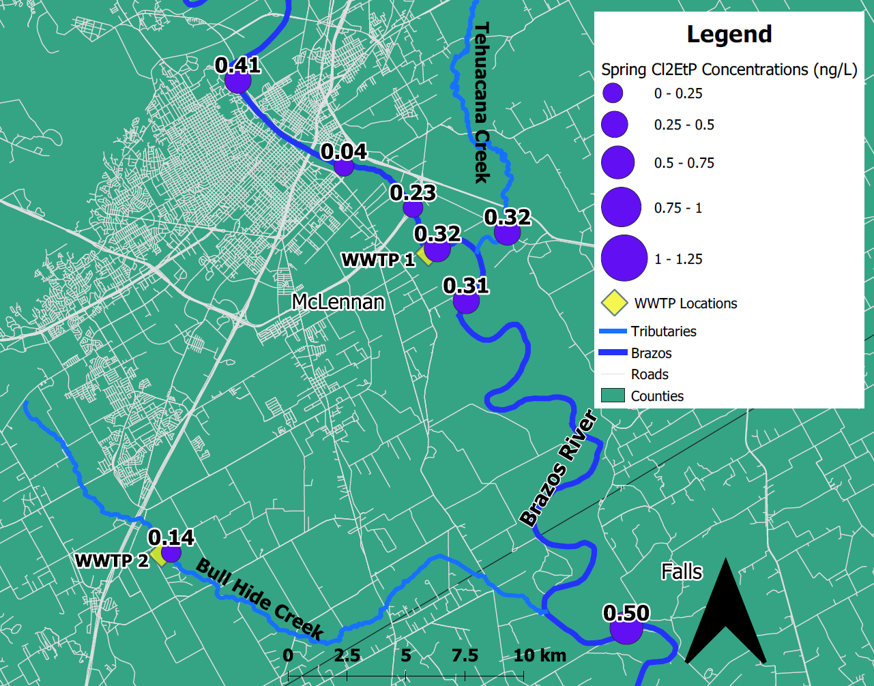
h
Fig S5 Analyte concentrations mapped by site along the Brazos River during spring. a. MeP. b. PrP. c.BuP. d. BzP. e. PHBA. f. DHBA. g. Cl₂MeP. h. Cl₂EtP
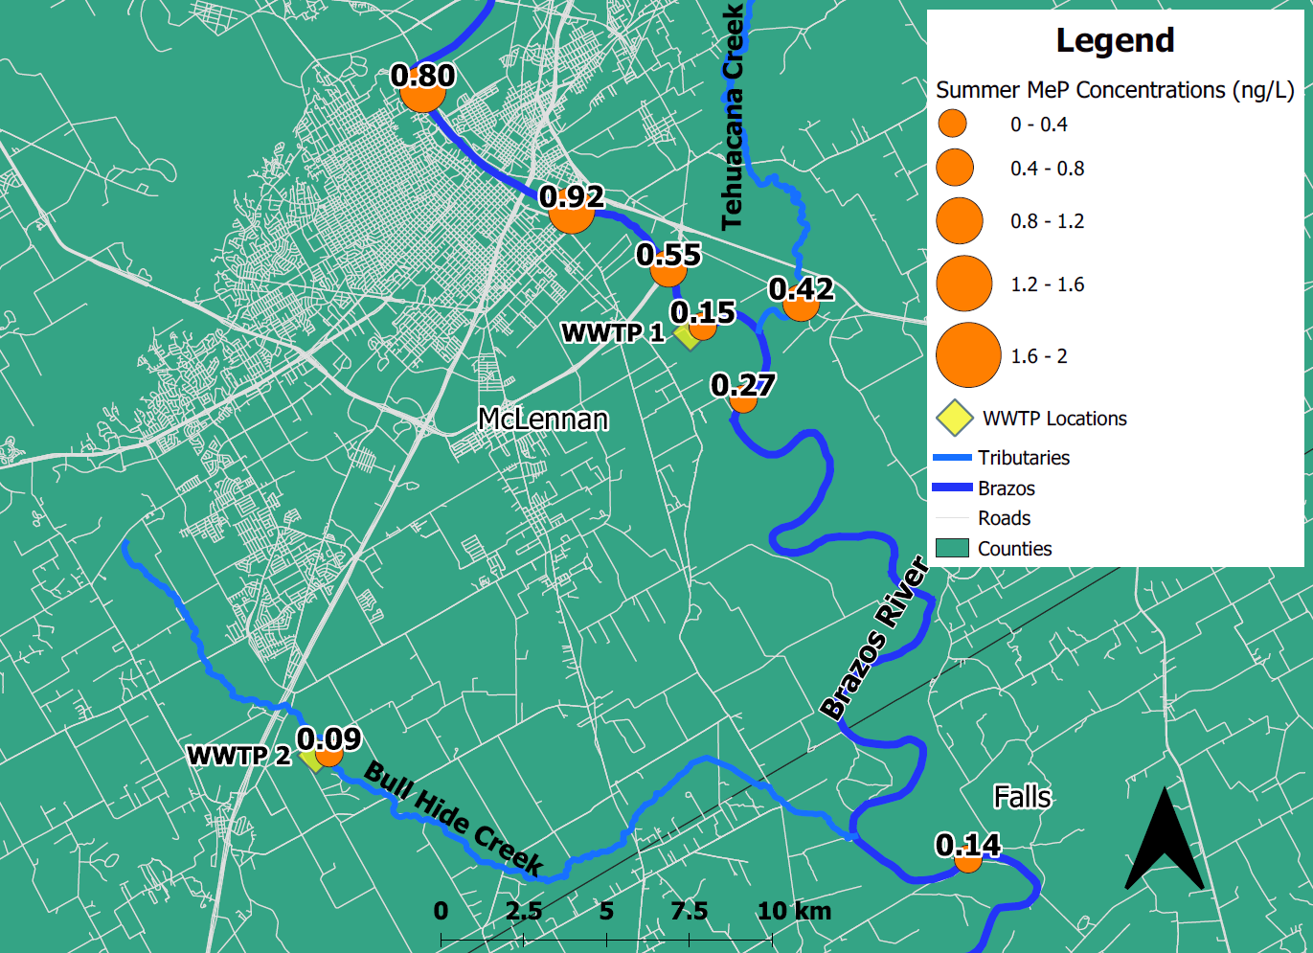
aa
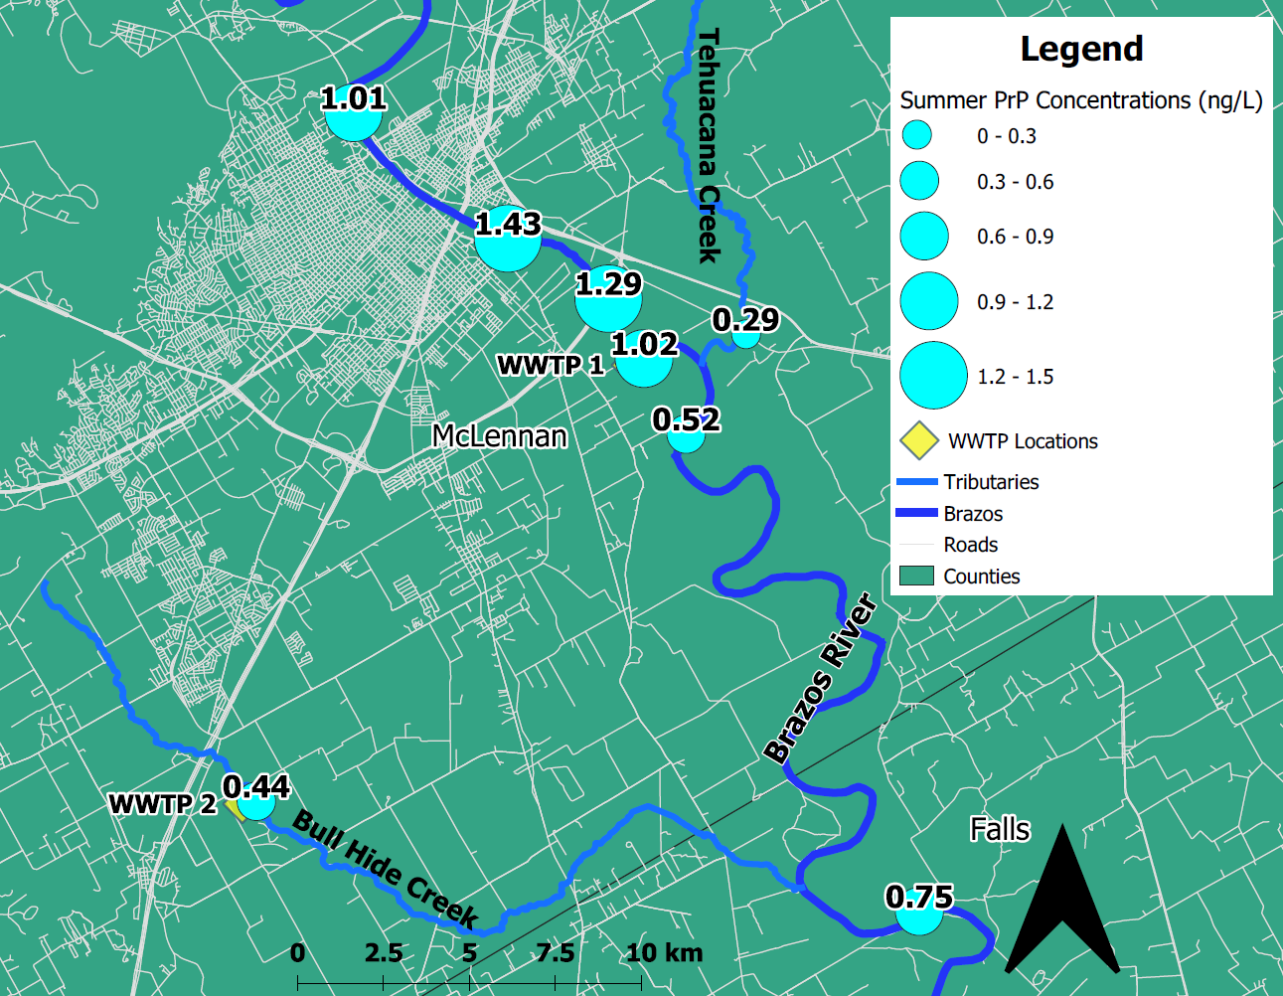
b
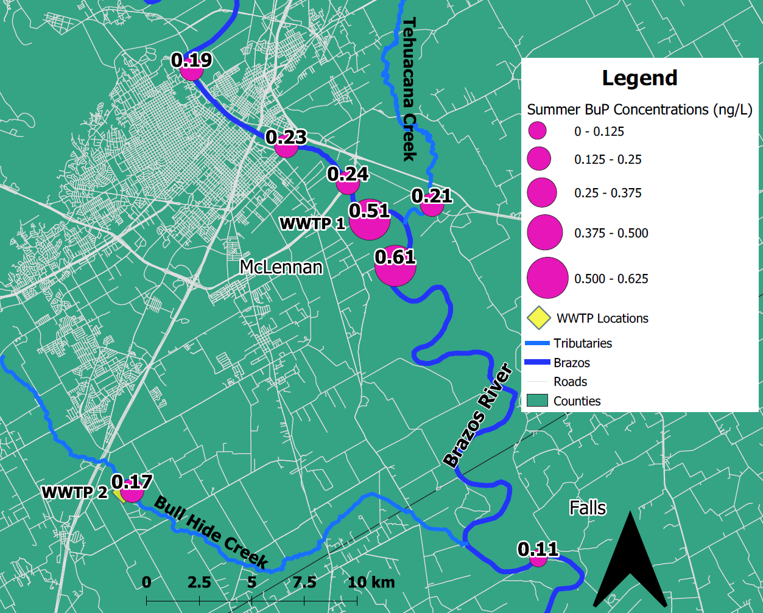
c

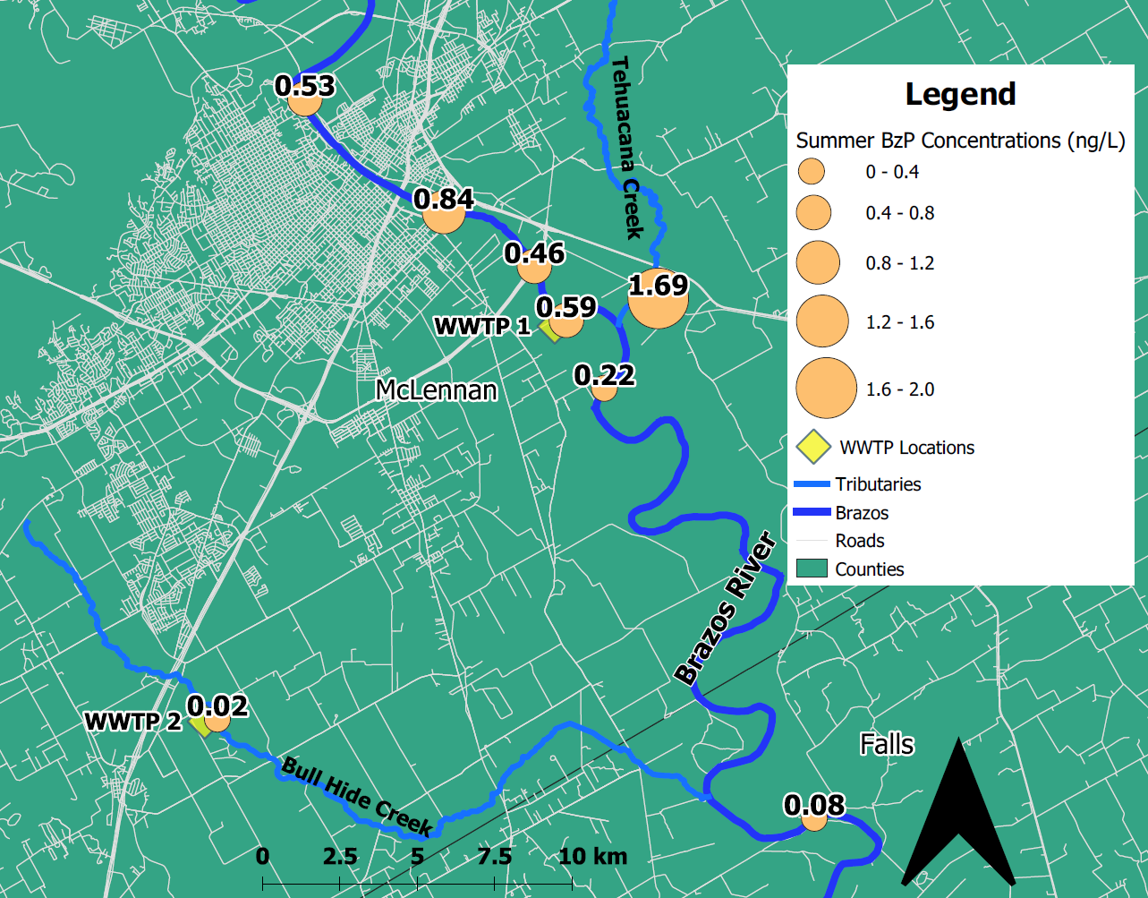
d
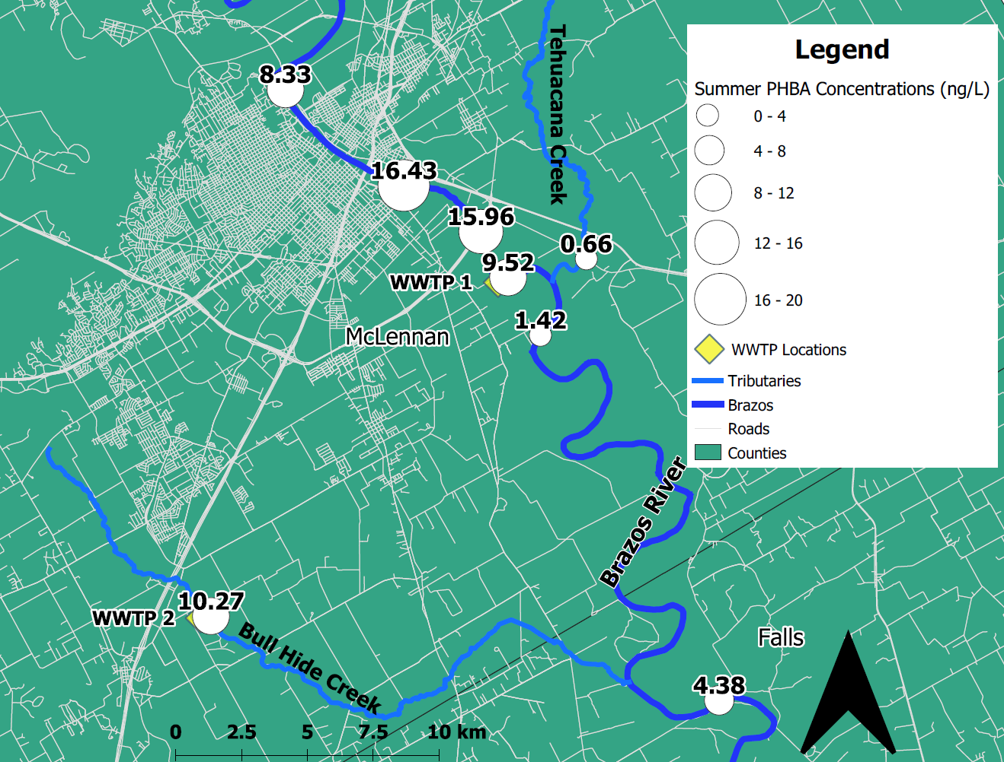
e
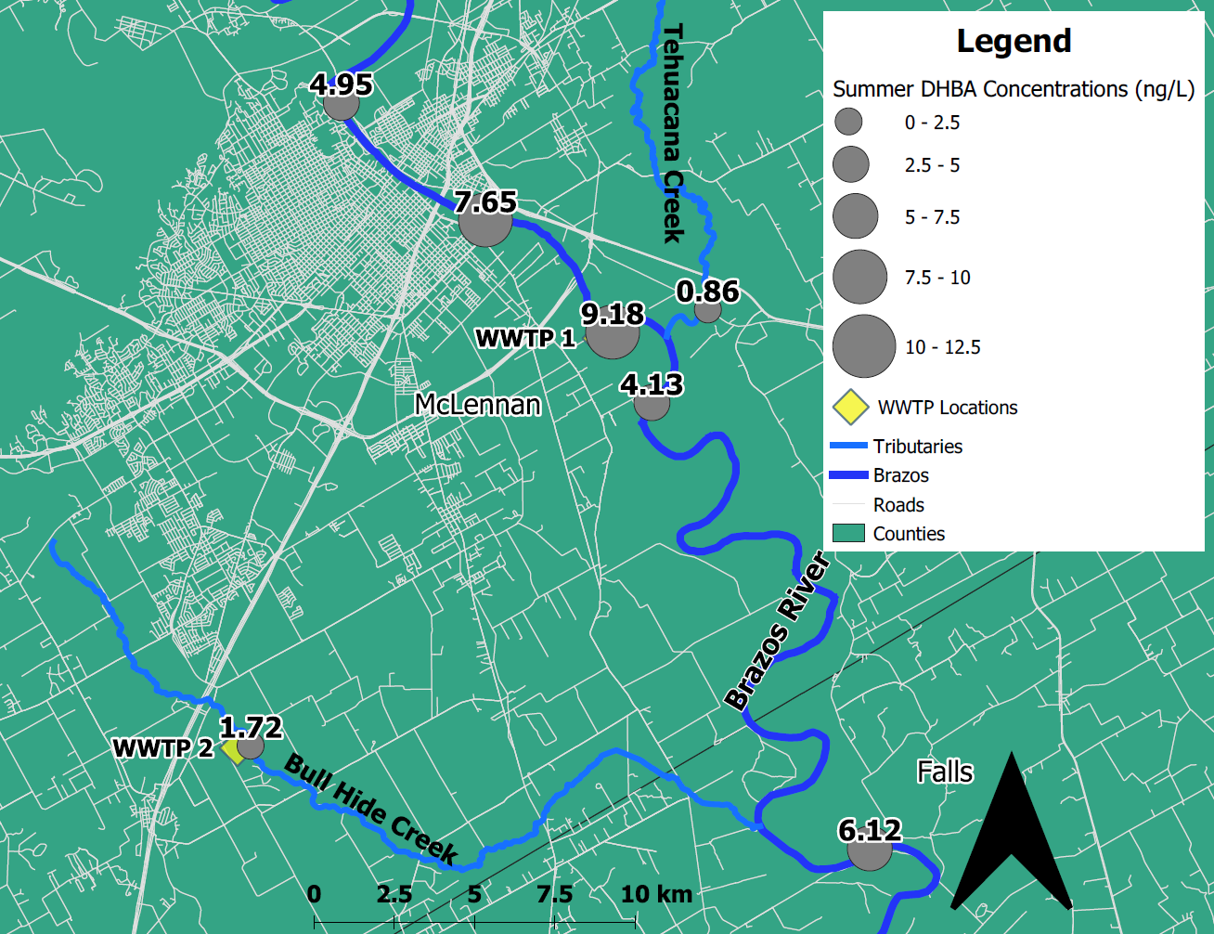
f
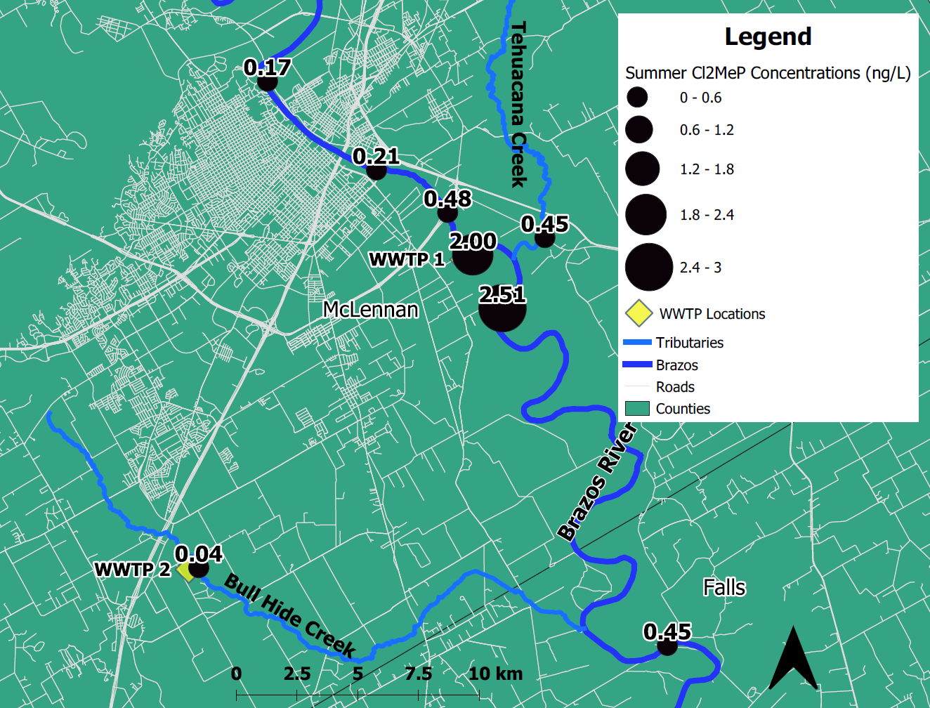
g
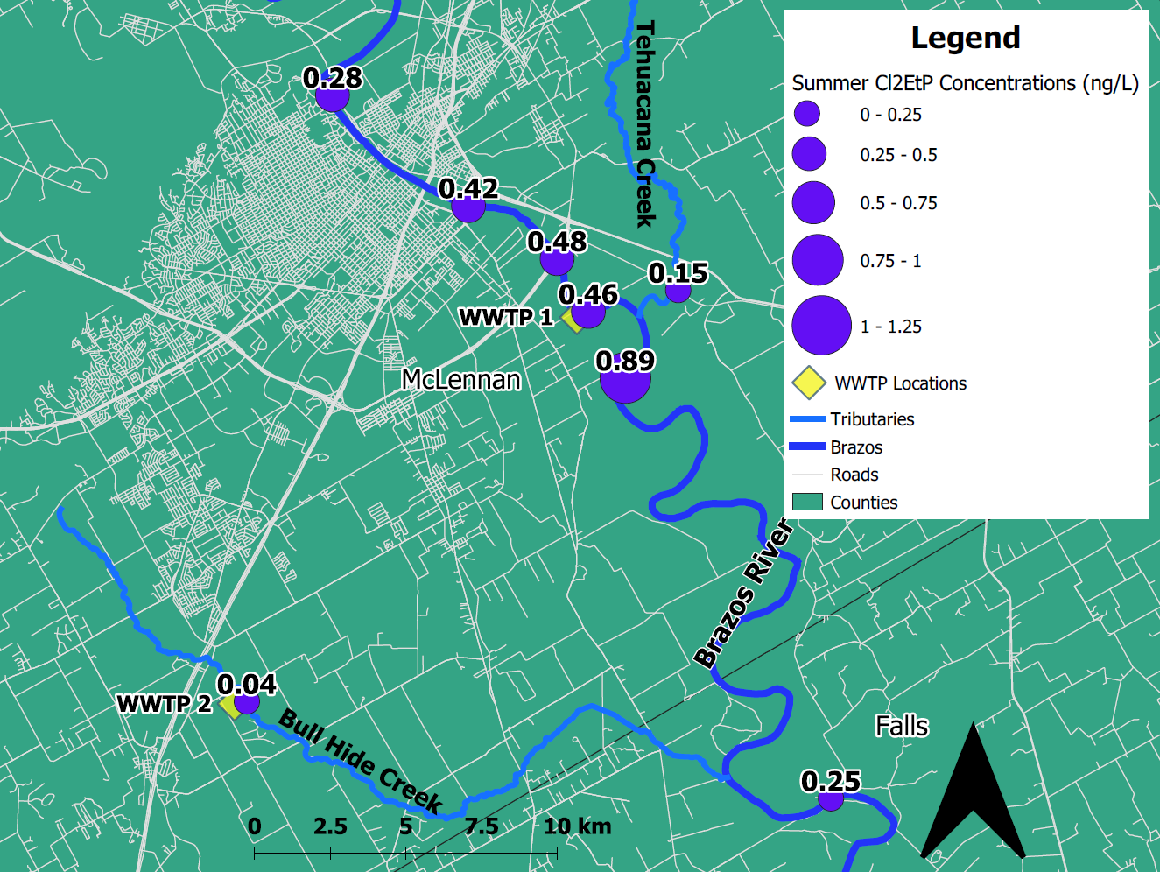
h
Fig S6 Analyte concentrations mapped by site along the Brazos River during summer. a. MeP. b. PrP. c.BuP. d. BzP. e. PHBA. f. DHBA. g. Cl₂MeP. h. Cl₂EtP

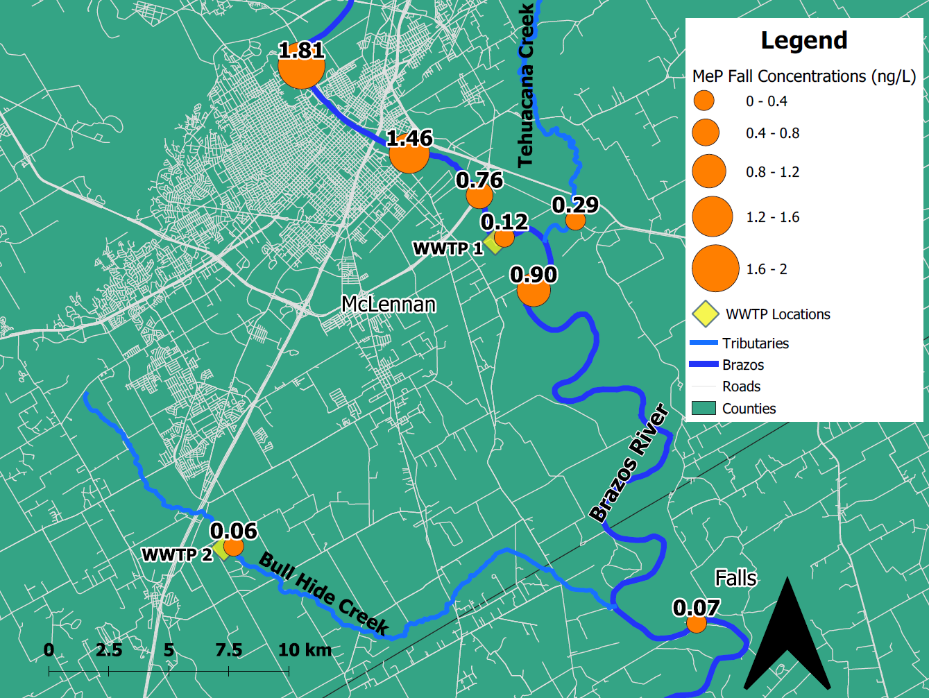
a
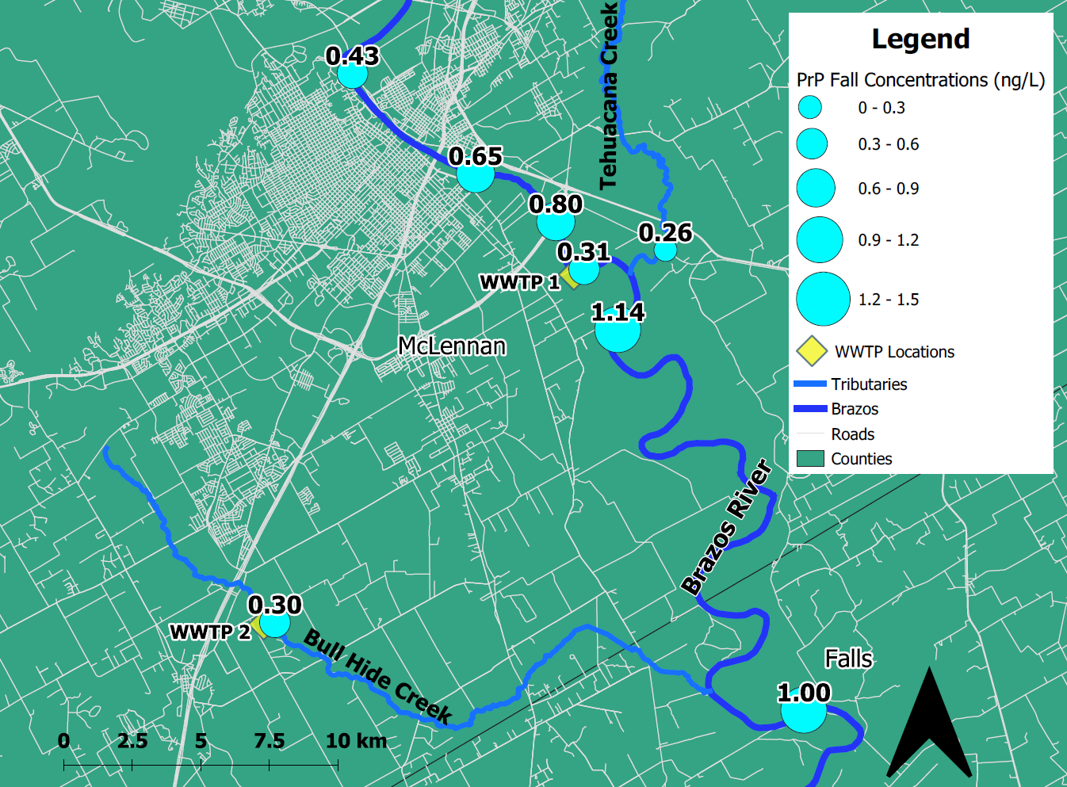
b
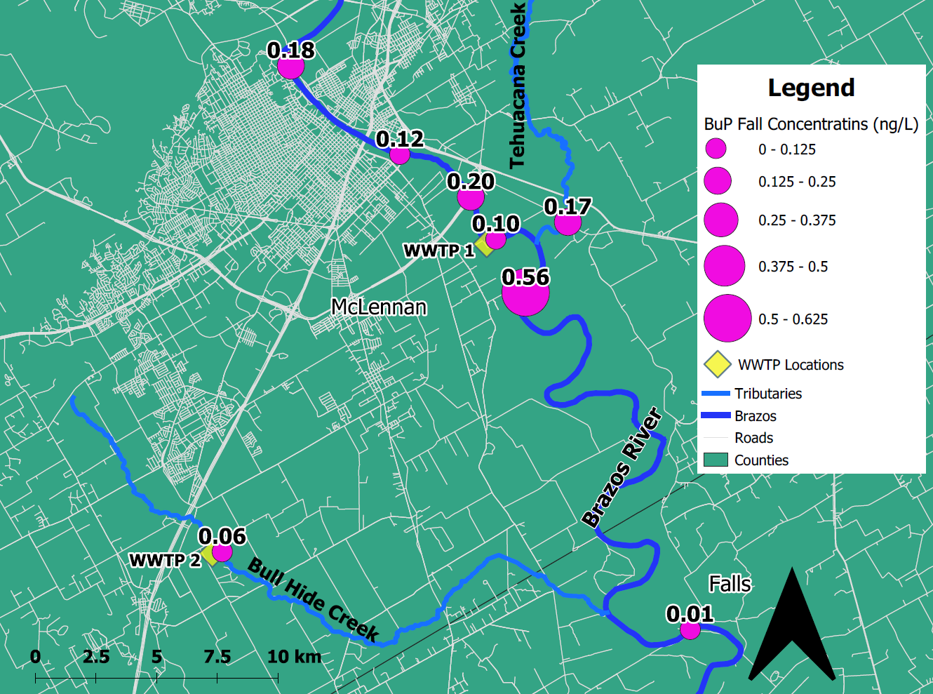
c
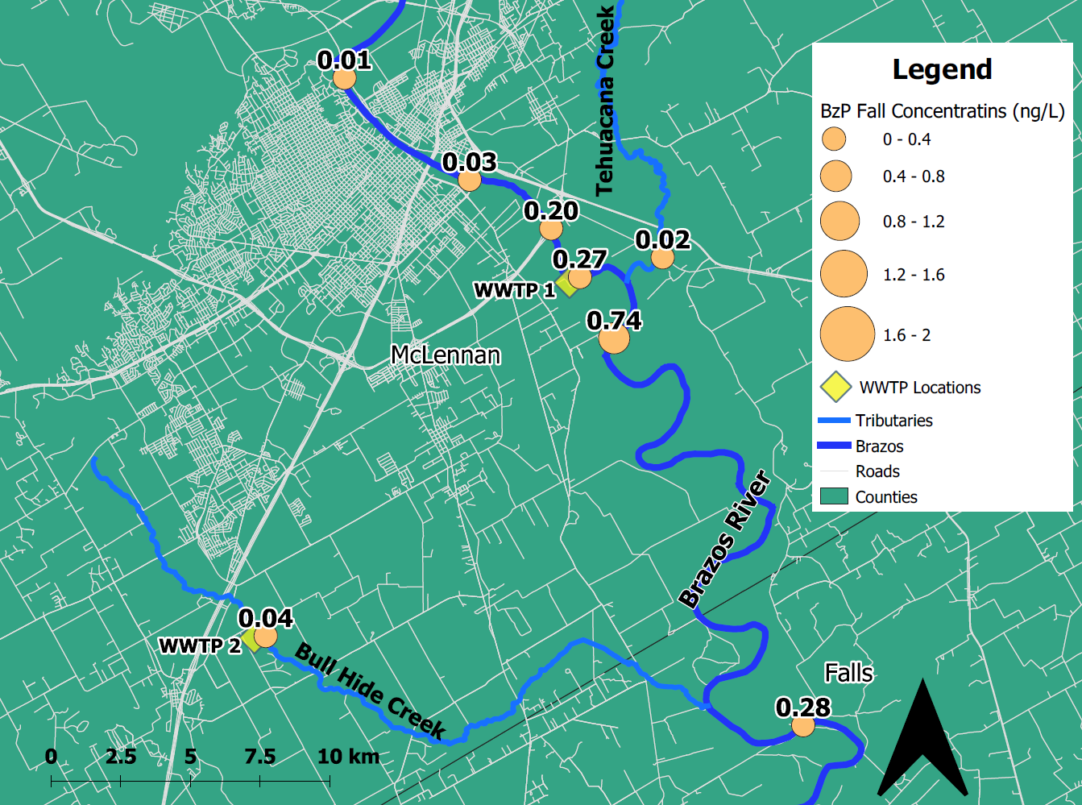
d
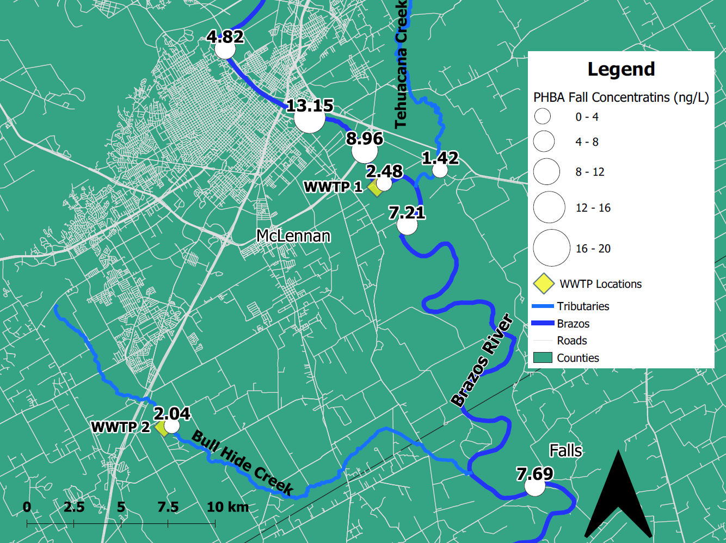
e
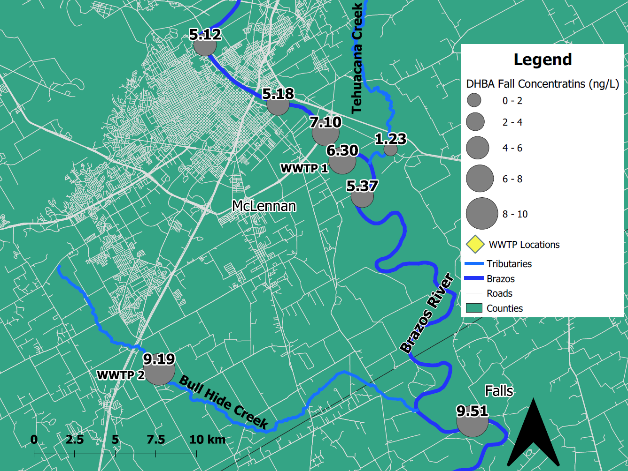
f
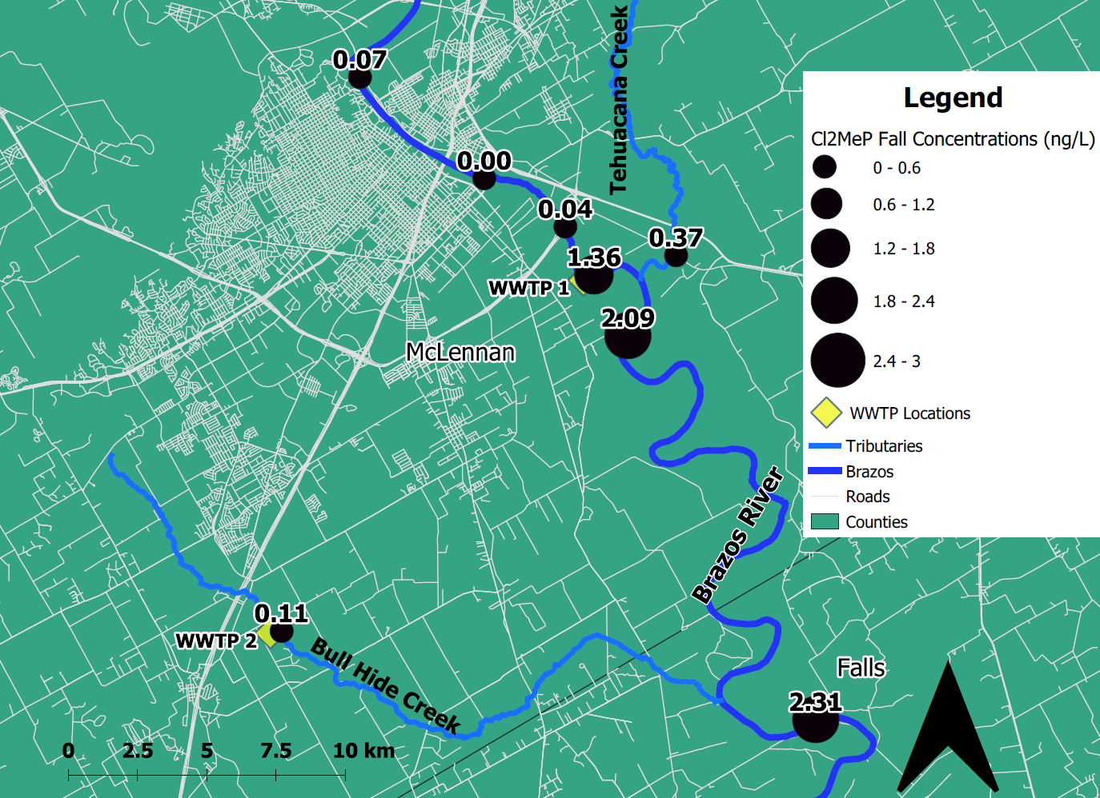
g
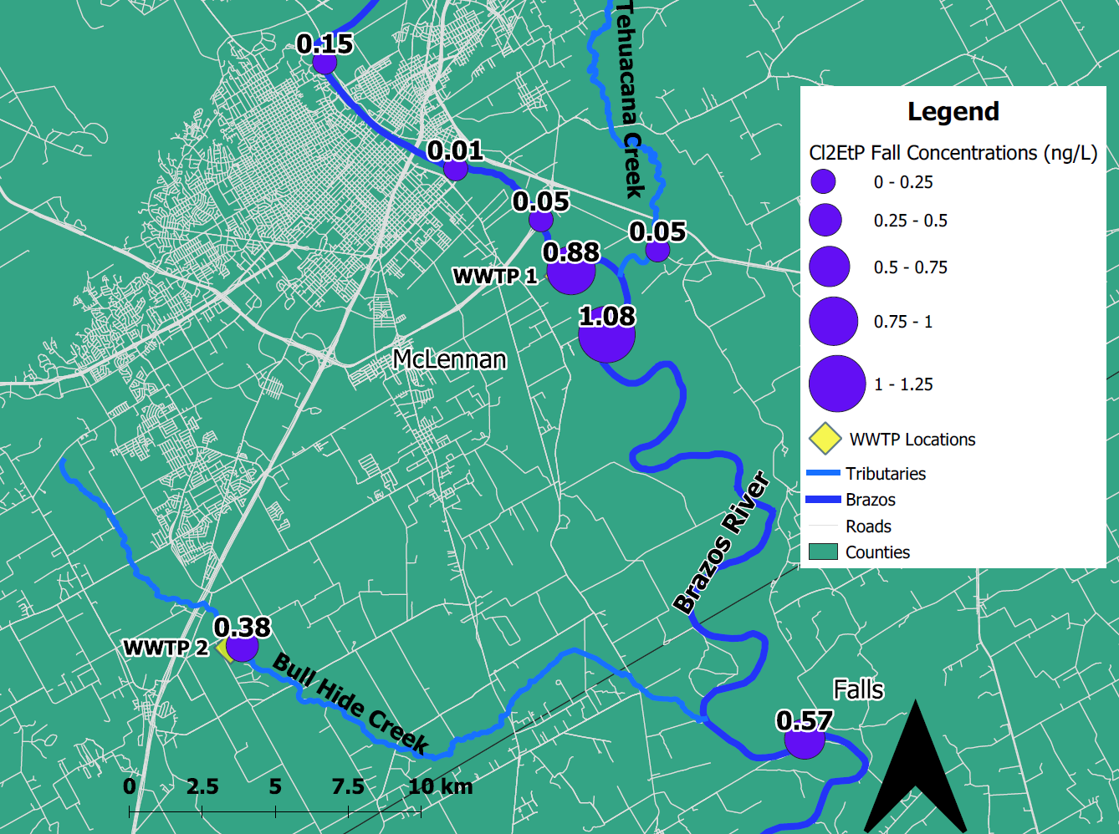
h
Fig S7 Analyte concentrations mapped by site along the Brazos River during fall. a. MeP. b. PrP. c. BuP. d. BzP. e. PHBA. f. DHBA. g. Cl₂MeP. h. Cl₂EtP
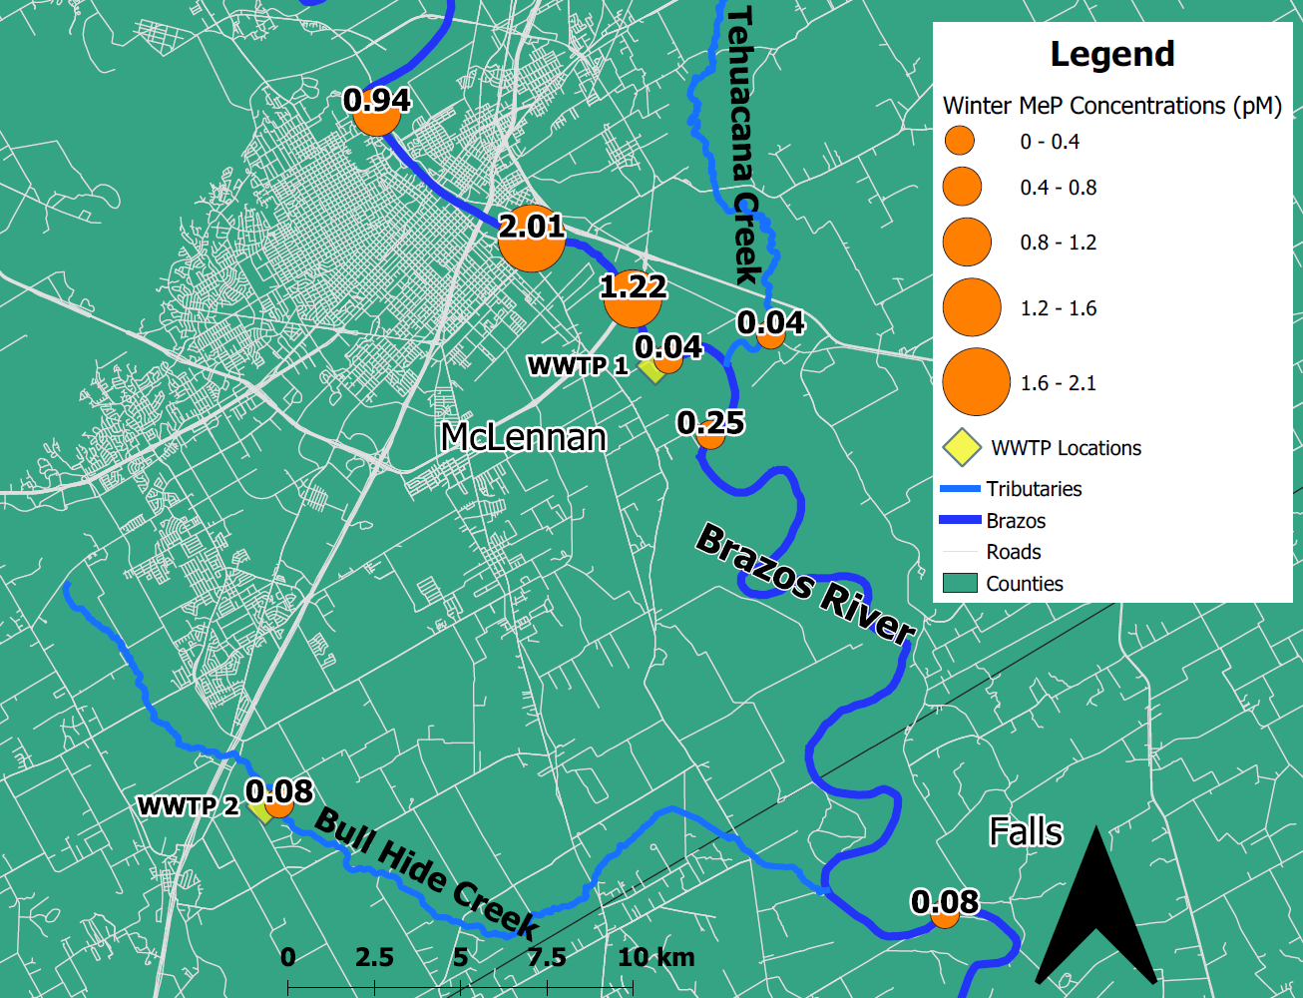
a
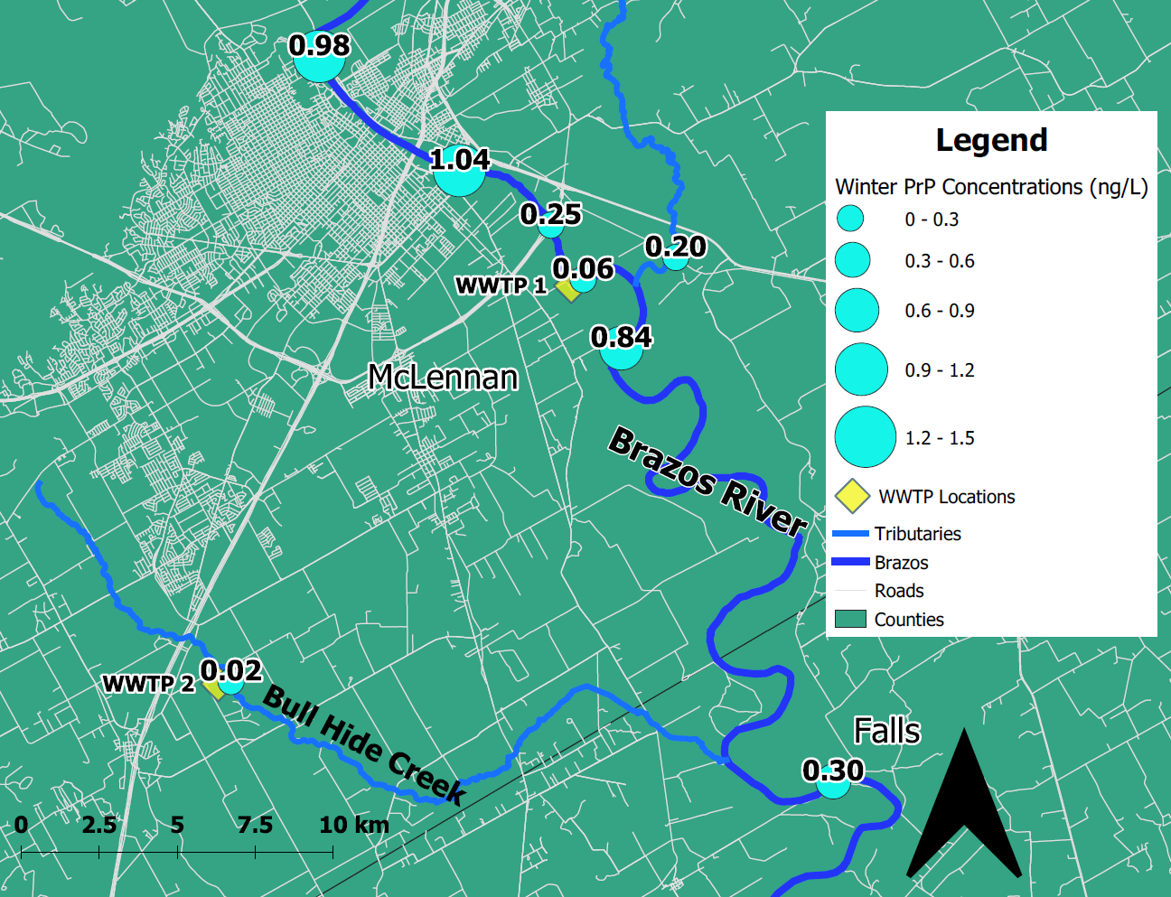
b
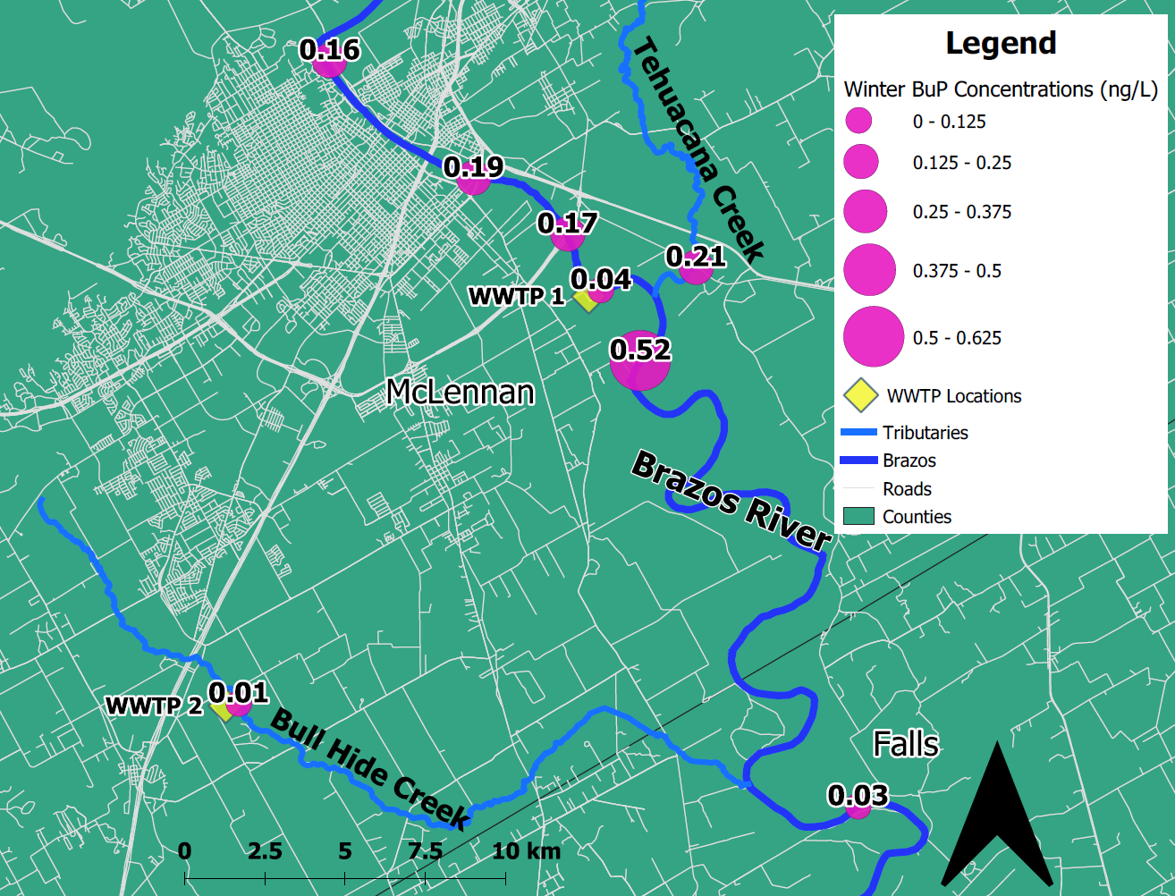
c

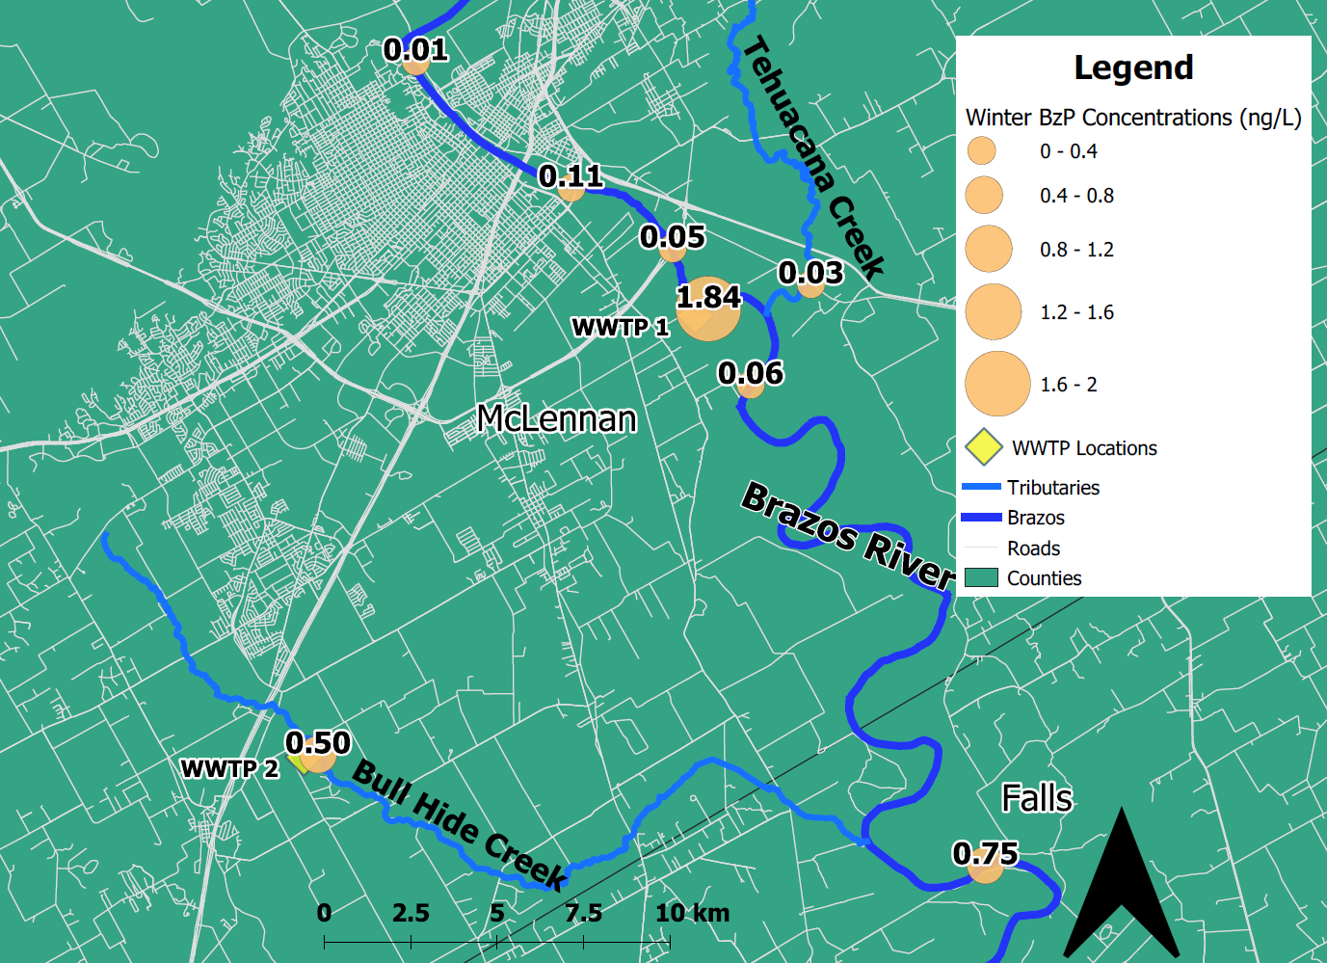
d
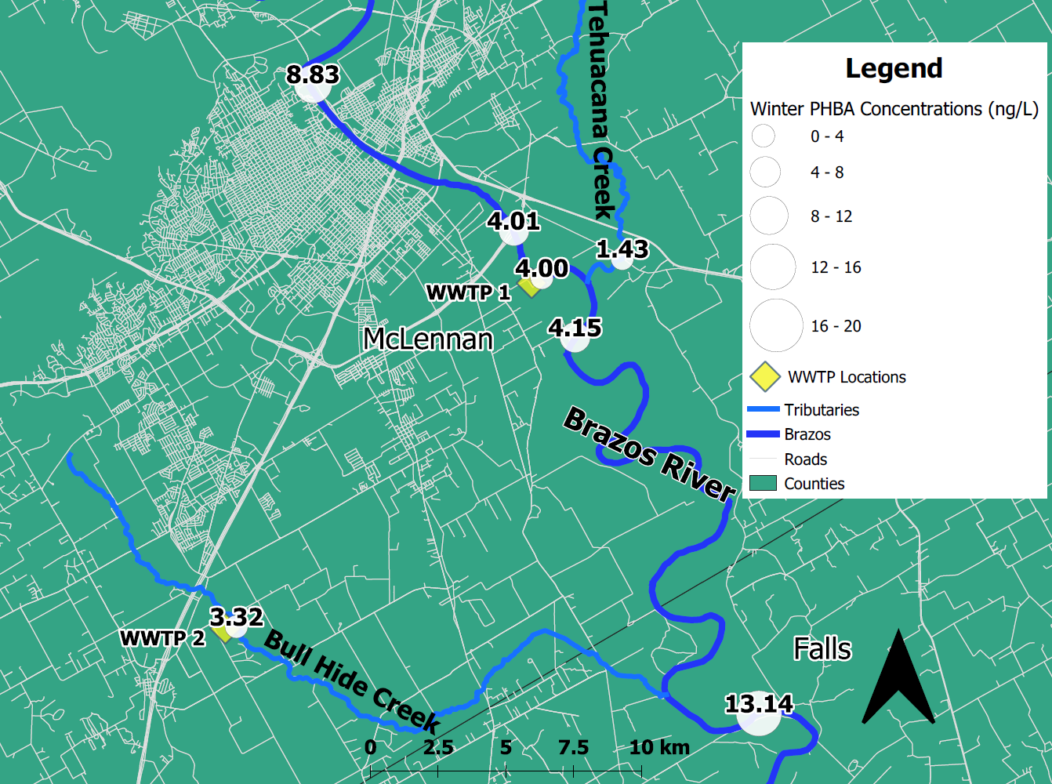
e
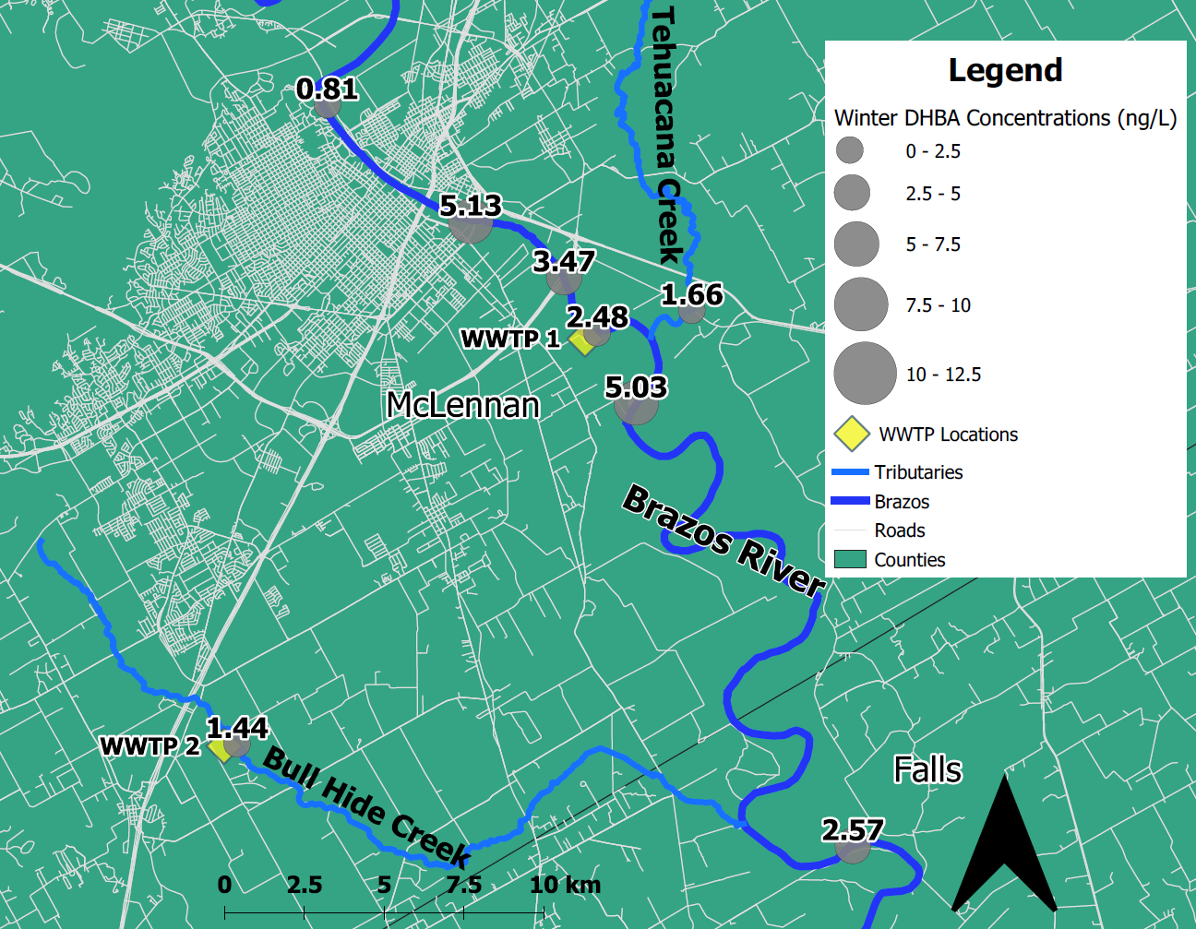
f
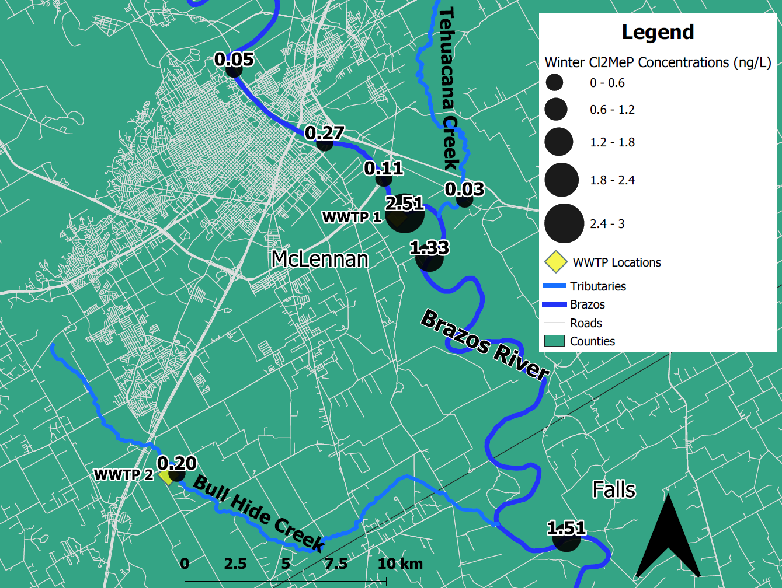
g
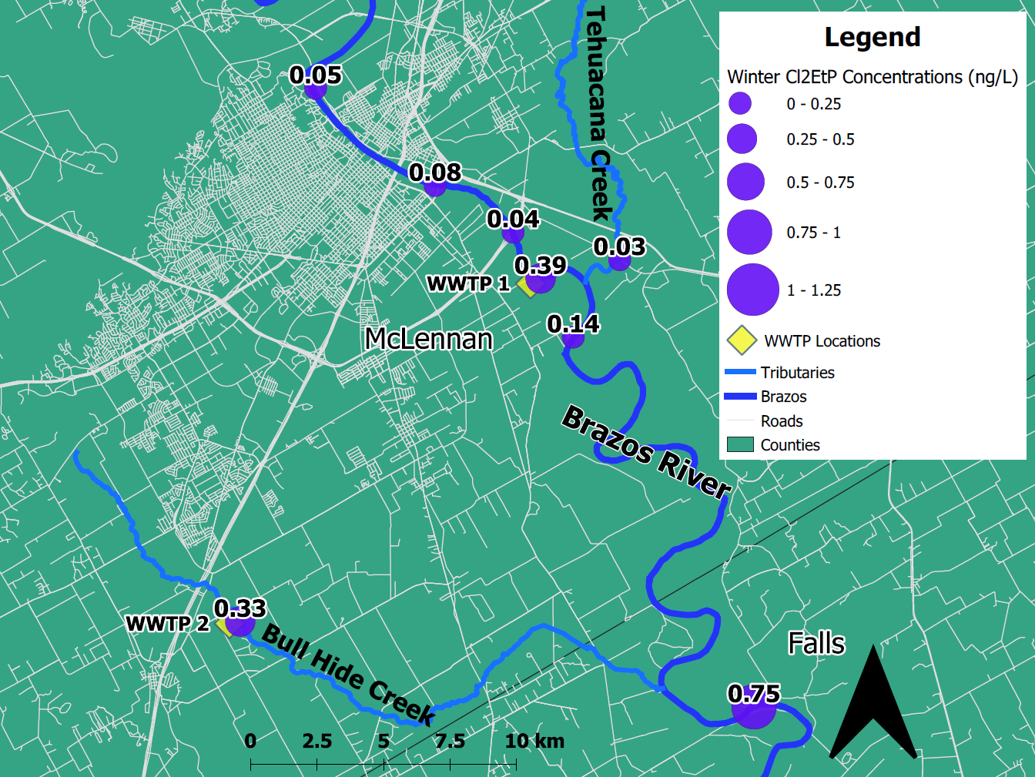
h
Fig S8 Analyte concentrations mapped by site along the Brazos River during Winter. a. MeP. b. PrP. c. BuP. d. BzP. e. PHBA. f. DHBA. g. Cl₂MeP. h. Cl₂EtP
Table S5 P-Values between yearly analyte concentrations between individual sites
Sites | MeP | EtP | PrP | BuP | BzP | PHBA | DHBA | MePOH | EtPOH | ClMeP | Cl₂MeP | ClEtP | Cl₂EtP
1 and 2 | 1.00 | 1.00 | 1.00 | 1.00 | 1.00 | 1.00 | 1.00 | 1.00 | 1.00 | 1.00 | 1.00 | 1.00 | 1.00
1 and 3 | 1.00 | 1.00 | 1.00 | 1.00 | 1.00 | 1.00 | 0.721 | 1.00 | 1.00 | 0.004 | 1.00 | 1.00 | 1.00
1 and 4 | <0.001 | 1.00 | 1.00 | 0.382 | 0.446 | 0.351 | 1.00 | 1.00 | 1.00 | 1.00 | 0.004 | 1.00 | 1.00
1 and 5 | 0.017 | 0.020 | 0.005 | 1.00 | 1.00 | <0.001 | 0.060 | 1.00 | 0.022 | <0.001 | 1.00 | <0.001 | 1.00
1 and 6 | 0.053 | 0.0554 | 1.00 | <0.001 | 1.00 | 1.00 | 1.00 | 1.00 | 1.00 | 0.089 | <0.001 | 1.00 | 0.269
1 and 7 | <0.001 | 1.00 | 0.053 | 1.00 | 1.00 | 1.00 | 1.00 | 1.00 | 0.297 | 1.00 | 1.00 | 1.00 | 1.00
1 and 8 | <0.001 | 1.00 | 1.00 | 1.00 | 0.962 | 1.00 | 1.00 | 1.00 | 1.00 | 1.00 | 0.006 | 1.00 | 0.732
2 and 3 | 1.00 | 1.00 | 1.00 | 1.00 | 1.00 | 1.00 | 1.00 | 1.00 | 1.00 | 0.759 | 1.00 | 1.00 | 1.00
2 and 4 | <0.001 | 1.00 | 1.00 | 1.00 | 1.00 | 0.018 | 1.00 | 1.00 | 1.00 | 1.00 | <0.001 | 1.00 | 0.0395
2 and 5 | <0.001 | 0.297 | 0.001 | 1.00 | 1.00 | <0.001 | <0.001 | 1.0 | 1.00 | <0.001 | 1.00 | <0.001 | 1.00
2 and 6 | 0.021 | 0.659 | 1.00 | <0.001 | 1.00 | 0.881 | 1.00 | 1.00 | 1.00 | 1.00 | <0.001 | 1.00 | 0.005
2 and 7 | <0.001 | 1.00 | 0.016 | 1.00 | 1.00 | 0.490 | 0.025 | 1.00 | 1.00 | 1.00 | 1.00 | 1.00 | 1.00
2 and 8 | <0.001 | 1.00 | 1.00 | 1.00 | 1.00 | 1.00 | 1.00 | 1.00 | 1.00 | 1.00 | 0.001 | 1.00 | 0.022
3 and 4 | <0.001 | 1.00 | 0.030 | 0.855 | 1.00 | 0.031 | 1.00 | 1.00 | 1.00 | 0.052 | 0.032 | 1.00 | 0.036
3 and 5 | 0.008 | 1.00 | 0.006 | 1.00 | 1.00 | <0.001 | <0.001 | 1.0 | 1.00 | 0.784 | 1.00 | 0.058 | 1.00
3 and 6 | 0.3645 | 1.00 | 1.00 | <0.001 | 1.00 | 1.00 | 0.463 | 1.00 | 1.00 | 1.00 | 0.009 | 1.00 | 0.0711
3 and 7 | <0.001 | 1.00 | 0.066 | 1.00 | 1.00 | 0.738 | 0.121 | 1.00 | 1.00 | 1.00 | 1.00 | 1.00 | 1.00
3 and 8 | <0.001 | 1.00 | 1.00 | 1.00 | 1.00 | 1.00 | 1.00 | 1.00 | 1.00 | 0.002 | 0.047 | 1.00 | 0.223
4 and 5 | 1.00 | 0.0554 | 1.00 | 1.00 | 0.104 | 1.00 | 0.003 | 1.00 | 1.00 | <0.001 | 0.007 | <0.001 | 0.030
4 and 6 | 0.041 | 0.142 | 0.015 | <0.001 | 1.00 | 1.00 | 1.00 | 1.00 | 1.00 | 0.627 | 1.00 | 1.00 | 1.00
4 and 7 | 1.00 | 1.00 | 1.00 | 1.00 | 0.223 | 1.00 | 1.00 | 1.00 | 1.00 | 1.00 | 0.002 | 1.00 | 0.323
4 and 8 | 1.00 | 1.00 | 0.137 | 1.00 | 1.00 | 1.00 | 1.00 | 1.00 | 1.00 | 1.00 | 1.00 | 1.00 | 1.00
5 and 6 | 1.00 | 1.00 | <0.001 | <0.001 | 1.00 | 0.025 | 0.104 | 1.00 | 0.012 | 0.070 | 0.001 | 0.073 | 0.004
5 and 7 | 1.00 | 0.303 | 1.00 | 1.00 | 1.00 | 0.055 | 0.405 | 1.00 | 1.00 | 0.002 | 1.00 | 0.076 | 1.00
5 and 8 | 1.00 | 1.00 | <0.001 | 1.00 | 0.256 | 0.013 | <0.001 | 0.587 | 0.649 | <0.001 | 0.011 | <0.001 | 0.016
6 and 7 | 0.722 | 0.672 | <0.001 | <0.001 | 1.00 | 1.000 | 1.00 | 1.00 | 0.182 | 1.000 | <0.001 | 1.00 | 0.062
6 and 8 | 0.045 | 0.013 | 1.000 | <0.001 | 1.00 | 1.00 | 1.00 | 0.506 | 1.00 | 0.046 | 1.00 | 1.00 | 1.000
7 and 8 | 1.00 | 1.00 | 0.002 | 1.00 | 0.512 | 1.00 | 0.535 | 1.00 | 1.00 | 0.722 | 0.004 | 1.00 | 0.197

Table S6 P-values between individual seasons
 | P-Value
Seasons | MeP | EtP | PrP | BuP | BzP | PHBA | DHBA | MePOH | EtPOH | ClMeP | Cl₂MeP | ClEtP | Cl₂EtP
Spring-Summer | 1.00 | 1.00 | 0.551 | 0.546 | 0.019 | 0.317 | 1.00 | 0.395 | 1.00 | 1.00 | 1.00 | 0.136 | 1.00
Spring-Fall | 1.00 | 1.00 | 1.00 | 1.00 | 1.00 | 0.353 | 1.00 | 1.00 | 1.00 | 1.00 | 1.00 | 1.00 | 1.00
Spring-Winter | 1.00 | 1.00 | 0.914 | 1.00 | 1.00 | 0.544 | 0.115 | 0.379 | 0.519 | 1.00 | 1.00 | 0.044 | 1.00
Summer-Fall | 1.00 | 1.00 | 1.00 | 0.116 | 0.064 | 0.872 | 1.00 | 1.00 | 1.000 | 1.00 | 0.965 | 1.00 | 1.00
Summer-Winter | 1.00 | 1.00 | 0.016 | 0.151 | 0.592 | 0.721 | 0.323 | 1.00 | 0.083 | 1.00 | 1.00 | 1.00 | 0.513
Fall-Winter | 1.00 | 1.00 | 0.178 | 1.000 | 1.000 | 0.817 | 0.023 | 1.00 | 0.155 | 1.00 | 1.00 | 0.452 | 1.00

Table S7 P-values between sites during the spring
 | P-Values
Sites | MeP | EtP | PrP | BuP | BzP | PHBA | DHBA | MePOH | EtPOH | ClMeP | Cl₂MeP | ClEtP | Cl₂EtP
1 and 2 | 1.00 | 1.00 | 1.00 | 1.00 | 1.00 | 1.00 | 1.00 | 1.00 | 1.00 | 1.00 | 1.00 | 1.00 | 1.00
1 and 3 | 1.00 | 1.00 | 1.00 | 1.00 | 1.00 | 1.00 | 1.00 | 1.00 | 1.00 | 1.00 | 1.00 | 1.00 | 1.00
1 and 4 | 0.009 | 1.00 | 0.926 | 0.178 | 1.00 | 1.00 | 1.00 | 1.0 | 1.00 | 1.00 | 0.296 | 1.00 | 0.130
1 and 5 | 0.310 | 1.00 | 0.975 | 1.00 | 1.00 | 0.223 | 1.00 | 1.00 | 1.00 | 1.00 | 1.00 | 1.00 | 1.00
1 and 6 | 1.00 | 1.00 | 0.526 | 0.002 | 1.00 | 1.00 | 1.00 | 1.00 | 1.00 | 1.00 | 0.146 | 1.00 | 1.00
1 and 7 | 0.978 | 1.00 | 1.00 | 1.00 | 1.00 | 1.00 | 1.00 | 1.00 | 1.00 | 1.00 | 0.573 | 1.00 | 1.00
1 and 8 | 1.00 | 1.00 | 0.447 | 0.080 | 1.00 | 1.00 | 1.00 | 1.00 | 0.905 | 1.00 | 0.206 | 1.00 | 1.00
2 and 3 | 1.00 | 1.00 | 1.00 | 1.00 | 1.00 | 1.00 | 1.00 | 1.00 | 1.00 | 1.00 | 1.00 | 1.00 | 1.00
2 and 4 | 0.011 | 1.00 | 0.803 | 0.439 | 1.00 | 1.00 | 1.00 | 1.00 | 1.00 | 1.00 | 0.331 | 1.00 | 0.023
2 and 5 | 0.415 | 1.00 | 1.00 | 1.00 | 1.00 | 0.694 | 0.034 | 1.00 | 1.00 | 1.00 | 0.136 | 1.00 | 0.391
2 and 6 | 0.141 | 1.00 | 1.00 | 0.010 | 1.00 | 1.00 | 1.00 | 1.00 | 1.00 | 1.00 | 0.057 | 1.00 | 0.036
2 and 7 | 1.00 | 1.00 | 1.00 | 1.00 | 1.00 | 1.00 | 1.00 | 1.00 | 1.00 | 1.00 | 0.520 | 1.00 | 1.00
2 and 8 | 1.00 | 1.00 | 1.00 | 0.212 | 1.00 | 1.00 | 1.00 | 1.00 | 0.155 | 1.00 | 0.020 | 1.00 | 0.541
3 and 4 | 0.006 | 1.00 | 0.754 | 0.116 | 1.00 | 1.00 | 1.00 | 1.00 | 1.00 | 1.00 | 0.601 | 1.00 | 0.034
3 and 5 | 0.174 | 1.00 | 0.116 | 1.00 | 1.00 | 1.00 | 0.003 | 1.00 | 1.00 | 1.00 | 0.037 | 1.00 | 0.407
3 and 6 | 0.096 | 1.00 | 0.242 | 0.001 | 1.00 | 1.00 | 1.00 | 1.00 | 1.00 | 1.00 | 0.192 | 1.00 | 0.386
3 and 7 | 0.652 | 1.00 | 1.00 | 1.00 | 1.00 | 1.00 | 1.00 | 1.00 | 1.00 | 1.00 | 0.260 | 1.00 | 1.00
3 and 8 | 0.906 | 1.00 | 0.243 | 0.050 | 1.00 | 1.00 | 1.00 | 1.00 | 1.000 | 0.779 | 0.458 | 1.00 | 0.159
4 and 5 | 1.00 | 1.00 | 1.00 | 1.00 | 1.00 | 1.00 | 1.00 | 1.00 | 1.00 | 1.00 | 0.360 | 1.00 | 0.135
4 and 6 | 0.130 | 1.00 | 0.568 | 1.00 | 1.00 | 1.00 | 1.00 | 1.00 | 1.00 | 1.00 | 0.643 | 1.00 | 0.142
4 and 7 | 1.00 | 1.00 | 1.00 | 1.00 | 1.00 | 1.00 | 1.00 | 1.00 | 1.00 | 1.00 | 1.00 | 1.00 | 0.081
4 and 8 | 0.595 | 1.00 | 0.475 | 1.00 | 1.00 | 1.00 | 1.00 | 1.00 | 1.00 | 1.00 | 1.00 | 1.00 | 0.550
5 and 6 | 1.00 | 1.00 | 0.170 | 0.085 | 1.00 | 1.00 | 1.00 | 1.00 | 1.00 | 1.00 | 0.020 | 1.00 | 1.00
5 and 7 | 1.00 | 1.00 | 1.00 | 1.00 | 1.00 | 1.00 | 1.00 | 1.00 | 1.00 | 1.00 | 1.00 | 1.00 | 0.420
5 and 8 | 1.00 | 1.00 | 0.517 | 0.744 | 1.00 | 1.00 | 0.055 | 1.00 | 0.679 | 1.00 | 0.575 | 1.00 | 0.436
6 and 7 | 1.00 | 1.00 | 0.365 | 0.880 | 1.00 | 1.00 | 1.00 | 1.00 | 1.00 | 1.00 | 0.793 | 1.00 | 0.391
6 and 8 | 0.379 | 1.00 | 1.00 | 1.00 | 0.780 | 1.00 | 1.00 | 1.00 | 1.00 | 1.00 | 1.00 | 1.00 | 0.452
7 and 8 | 1.00 | 1.00 | 1.00 | 1.00 | 1.00 | 1.00 | 1.00 | 1.00 | 1.00 | 1.00 | 1.00 | 1.00 | 0.529

Table S8 P-values between sites during the summer
 | P-Values
Sites | MeP | EtP | PrP | BuP | BzP | PHBA | DHBA | MePOH | EtPOH | ClMeP | Cl₂MeP | ClEtP | Cl₂EtP
1 and 2 | 1.00 | 1.00 | 1.00 | 1.00 | 1.00 | 1.00 | 1.00 | 1.00 | 1.00 | 1.00 | 1.00 | 1.00 | 1.00
1 and 3 | 1.00 | 1.00 | 1.00 | 1.00 | 1.00 | 1.00 | 1.00 | 0.422 | 1.00 | 0.074 | 1.00 | 1.00 | 1.00
1 and 4 | 0.222 | 0.202 | 0.112 | 0.034 | 1.00 | 1.00 | 1.00 | 1.00 | 1.00 | 0.039 | 0.488 | 0.134 | 1.00
1 and 5 | 0.248 | 0.692 | 0.080 | 1.00 | 1.00 | 1.00 | 0.177 | 1.00 | 1.00 | 1.00 | 0.339 | 1.00 | 1.00
1 and 6 | 0.302 | 0.123 | 1.00 | <0.001 | 1.00 | 1.00 | 1.00 | 1.00 | 1.00 | 1.00 | 0.307 | 1.00 | 1.00
1 and 7 | 0.375 | 0.445 | 0.912 | 1.00 | 0.036 | 1.00 | 1.00 | 1.00 | 0.898 | 0.280 | 0.409 | 0.188 | 0.224
1 and 8 | 0.243 | 0.455 | 0.071 | 1.00 | 1.00 | 1.00 | 1.00 | 1.00 | 1.00 | 0.177 | 0.623 | 0.200 | 1.00
2 and 3 | 1.00 | 0.542 | 1.00 | 1.00 | 1.00 | 1.00 | 1.00 | 1.00 | 1.00 | 0.253 | 1.00 | 1.00 | 1.00
2 and 4 | 0.245 | 0.078 | 0.080 | 0.075 | 1.00 | 1.00 | 1.00 | 1.00 | 1.00 | 0.107 | 0.306 | 0.037 | 1.00
2 and 5 | 0.881 | 0.088 | 0.009 | 1.00 | 1.00 | 1.00 | 0.102 | 1.00 | 1.00 | 1.00 | 0.880 | 1.00 | 1.00
2 and 6 | 0.339 | 0.052 | 0.590 | 0.001 | 1.00 | 1.00 | 1.00 | 1.00 | 1.00 | 1.00 | 0.101 | 1.00 | 1.00
2 and 7 | 0.440 | 0.578 | 0.159 | 1.00 | 0.136 | 1.00 | 1.00 | 1.00 | 1.00 | 0.645 | 1.00 | 0.054 | 1.00
2 and 8 | 0.267 | 0.058 | 0.495 | 1.00 | 1.00 | 1.00 | 1.00 | 1.00 | 1.00 | 0.426 | 0.727 | 0.058 | 1.00
3 and 4 | 0.196 | 0.231 | 0.109 | 0.133 | 0.975 | 1.00 | 1.00 | 1.00 | 1.00 | 1.00 | 0.104 | 0.171 | 1.00
3 and 5 | 0.812 | 1.00 | 0.046 | 1.00 | 1.00 | 1.00 | 0.027 | 1.00 | 1.00 | 1.00 | 1.00 | 1.00 | 0.201
3 and 6 | 0.260 | 1.00 | 1.00 | 0.001 | 1.00 | 1.00 | 0.361 | 1.00 | 1.00 | 1.00 | 0.871 | 1.00 | 1.00
3 and 7 | 0.306 | 1.00 | 0.245 | 1.00 | 0.670 | 1.00 | 1.00 | 0.532 | 1.00 | 1.00 | 1.00 | 0.239 | 0.010
3 and 8 | 0.215 | 1.00 | 0.069 | 1.00 | 1.00 | 1.0 | 1.00 | 1.00 | 1.00 | 1.00 | 0.782 | 0.254 | 1.00
4 and 5 | 1.00 | 0.092 | 1.00 | 0.198 | 1.00 | 1.00 | 0.072 | 1.00 | 1.00 | 0.866 | 1.00 | 1.00 | 1.00
4 and 6 | 0.668 | 1.00 | 1.00 | 1.00 | 1.00 | 1.00 | 0.470 | 1.00 | 1.00 | 0.388 | 1.00 | 0.361 | 1.00
4 and 7 | 0.292 | 1.00 | 1.00 | 1.00 | 1.00 | 1.00 | 0.956 | 1.00 | 0.083 | 1.00 | 0.522 | 1.00 | 0.068
4 and 8 | 1.00 | 1.00 | 1.00 | 1.00 | 1.00 | 1.00 | 1.00 | 1.00 | 1.00 | 1.00 | 1.00 | 1.00 | 1.00
5 and 6 | 1.00 | 1.00 | 0.145 | 0.003 | 1.00 | 1.00 | 1.00 | 1.00 | 1.00 | 1.00 | 1.00 | 1.00 | 0.135
5 and 7 | 0.112 | 1.00 | 1.00 | 1.00 | 0.288 | 1.00 | 1.00 | 1.00 | 0.907 | 1.00 | 1.00 | 1.00 | 1.00
5 and 8 | 0.777 | 1.00 | 1.00 | 1.00 | 1.00 | 1.00 | 0.132 | 1.00 | 1.00 | 1.00 | 1.00 | 1.00 | 1.00
6 and 7 | 0.093 | 0.409 | 0.522 | 0.337 | 0.623 | 1.00 | 1.00 | 1.00 | 0.117 | 1.00 | 0.365 | 0.491 | 0.020
6 and 8 | 0.707 | 1.00 | 0.521 | 1.00 | 1.000 | 1.00 | 0.775 | 1.00 | 1.00 | 1.00 | 1.00 | 0.519 | 0.787
7 and 8 | 0.272 | 1.00 | 1.00 | 1.00 | 0.675 | 1.00 | 1.00 | 1.00 | 1.00 | 1.00 | 1.00 | 1.00 | 1.00

Table S9 P-values between sites during the fall
 | P-Values
Sites | MeP | EtP | PrP | BuP | BzP | PHBA | DHBA | MePOH | EtPOH | ClMeP | Cl₂MeP | ClEtP | Cl₂EtP
1 and 2 | 1.00 | 1.00 | 1.00 | 1.00 | 1.00 | 1.00 | 1.00 | 1.00 | 1.00 | 1.00 | 1.00 | 1.00 | 1.00
1 and 3 | 1.00 | 0.786 | 1.00 | 1.00 | 0.816 | 1.00 | 1.00 | 1.00 | 1.00 | 1.00 | 1.00 | 1.00 | 1.00
1 and 4 | 0.028 | 1.00 | 1.00 | 1.00 | 0.035 | 1.00 | 1.00 | 1.00 | 1.00 | 0.111 | 0.041 | 0.621 | 1.00
1 and 5 | 0.412 | 1.00 | 1.00 | 1.00 | 1.00 | 0.140 | 1.00 | 1.00 | 1.00 | 1.00 | 1.00 | 1.00 | 1.00
1 and 6 | 1.00 | 1.00 | 0.219 | <0.001 | 0.067 | 1.00 | 1.00 | 1.00 | 1.00 | 1.00 | 0.004 | 1.00 | 0.193
1 and 7 | 0.048 | 0.344 | 1.00 | 1.00 | 1.00 | 1.00 | 1.00 | 1.00 | 1.00 | 1.00 | 1.00 | 1.00 | 1.00
1 and 8 | 1.00 | 1.00 | 1.00 | 0.962 | 1.00 | 1.00 | 1.00 | 1.00 | 1.00 | 1.00 | 0.309 | 0.856 | 1.00
2 and 3 | 1.00 | 1.00 | 1.00 | 1.00 | 1.00 | 1.00 | 1.00 | 1.00 | 1.00 | 1.00 | 1.00 | 1.00 | 1.00
2 and 4 | 0.009 | 1.00 | 1.00 | 1.00 | 0.869 | 1.00 | 1.00 | 1.00 | 1.00 | 0.598 | <0.001 | 1.00 | 1.00
2 and 5 | 0.161 | 1.00 | 0.155 | 1.00 | 1.00 | 0.001 | 0.377 | 1.00 | 1.00 | 1.00 | 1.00 | 1.00 | 1.00
2 and 6 | 1.00 | 0.137 | 1.00 | <0.001 | 1.00 | 1.00 | 1.00 | 1.00 | 1.00 | 1.00 | <0.001 | 1.00 | 0.034
2 and 7 | 0.020 | 1.00 | 1.00 | 1.00 | 1.00 | 1.00 | 1.00 | 1.00 | 1.00 | 1.00 | 1.00 | 1.00 | 1.00
2 and 8 | 1.00 | 1.00 | 1.00 | 0.992 | 1.00 | 1.00 | 1.00 | 1.00 | 1.00 | 1.00 | 0.008 | 1.00 | 1.00
3 and 4 | 0.018 | 1.00 | 1.00 | 1.00 | 1.00 | 1.00 | 1.00 | 1.00 | 1.00 | 0.143 | 0.045 | 1.00 | 1.00
3 and 5 | 0.334 | 1.00 | 0.026 | 1.00 | 0.216 | 0.464 | 1.00 | 1.00 | 1.00 | 1.00 | 1.00 | 1.00 | 1.00
3 and 6 | 0.112 | 0.082 | 1.00 | 0.001 | 1.00 | 1.00 | 1.00 | 1.00 | 1.00 | 1.00 | 0.052 | 1.00 | 0.213
3 and 7 | 0.039 | 1.00 | 1.00 | 1.00 | 1.00 | 1.00 | 1.00 | 1.00 | 1.00 | 1.00 | 1.00 | 1.00 | 1.00
3 and 8 | 0.169 | 1.00 | 1.00 | 1.00 | 1.00 | 1.00 | 1.00 | 1.00 | 1.00 | 1.00 | 1.00 | 1.00 | 1.00
4 and 5 | 1.00 | 1.00 | 0.386 | 1.00 | 0.009 | 1.00 | 1.00 | 1.00 | 1.00 | 0.076 | 1.00 | 0.634 | 1.00
4 and 6 | 1.00 | 1.00 | 1.00 | 0.984 | 1.00 | 1.00 | 1.00 | 1.00 | 1.00 | 0.438 | 1.00 | 1.00 | 1.00
4 and 7 | 1.00 | 1.00 | 1.00 | 1.00 | 0.359 | 1.00 | 1.00 | 1.00 | 1.00 | 1.00 | 1.00 | 1.00 | 1.00
4 and 8 | 1.00 | 1.00 | 1.00 | 1.00 | 1.00 | 1.00 | 1.00 | 1.00 | 1.00 | 1.00 | 1.00 | 1.00 | 1.00
5 and 6 | 1.00 | 1.00 | <0.001 | <0.001 | 0.012 | 0.039 | 0.413 | 1.00 | 1.00 | 1.00 | 0.239 | 1.00 | 0.013
5 and 7 | 1.00 | 1.00 | 1.00 | 1.00 | 1.00 | 1.00 | 1.00 | 1.00 | 1.00 | 1.00 | 1.00 | 1.00 | 1.00
5 and 8 | 1.00 | 1.00 | 0.682 | 0.728 | 0.941 | 1.00 | 1.00 | 1.00 | 1.00 | 1.00 | 1.00 | 0.872 | 1.00
6 and 7 | 1.00 | 0.050 | 0.054 | 1.00 | 1.00 | 1.00 | 1.00 | 1.00 | 1.00 | 1.00 | 1.00 | 1.00 | 1.00
6 and 8 | 1.00 | 1.00 | 1.00 | 1.00 | 1.00 | 1.00 | 1.00 | 1.00 | 1.00 | 1.00 | 1.00 | 1.00 | 1.00
7 and 8 | 1.00 | 1.00 | 1.00 | 1.00 | 1.00 | 1.00 | 1.00 | 1.00 | 1.00 | 1.00 | 1.00 | 1.00 | 1.00

Table S10 P-values between sites during the winter
 | P-Values
Sites | MeP | EtP | PrP | BuP | BzP | PHBA | DHBA | MePOH | EtPOH | ClMeP | Cl₂MeP | ClEtP | Cl₂EtP
1 and 2 | 1.00 | 0.538 | 1.00 | 1.00 | 1.00 | 1.00 | 1.00 | 1.00 | 1.00 | 0.050 | 1.00 | 1.00 | 1.00
1 and 3 | 1.00 | 1.00 | 1.00 | 1.00 | 1.00 | 1.00 | 1.00 | 0.706 | 1.00 | 0.465 | 1.00 | 1.00 | 1.00
1 and 4 | 0.022 | 0.255 | 0.049 | 1.00 | 0.230 | 1.00 | 1.00 | 1.00 | 1.00 | 0.656 | 0.051 | 1.00 | 0.159
1 and 5 | 0.137 | 1.00 | 0.629 | 1.00 | 1.00 | 0.118 | 1.00 | 0.960 | 1.00 | 0.465 | 1.00 | 1.00 | 0.442
1 and 6 | 0.152 | 1.00 | 1.00 | 0.012 | 0.457 | 1.00 | 1.00 | 1.00 | 1.00 | 0.460 | 0.029 | 1.00 | 0.086
1 and 7 | 1.00 | 0.010 | 0.069 | 1.00 | 1.00 | 1.00 | 1.00 | 1.00 | 1.00 | 0.042 | 1.00 | 1.00 | 0.130
1 and 8 | 0.406 | 0.010 | 1.00 | 1.00 | 0.452 | 1.00 | 1.00 | 1.00 | 1.00 | 0.043 | 0.028 | 1.00 | 0.403
2 and 3 | 1.00 | 1.00 | 1.00 | 1.00 | 1.00 | 1.00 | 1.00 | 1.00 | 1.00 | 1.00 | 1.00 | 1.00 | 0.540
2 and 4 | 0.038 | 1.00 | 1.00 | 1.00 | 1.00 | 0.289 | 1.00 | 1.00 | 1.00 | 1.00 | 0.150 | 1.00 | 0.024
2 and 5 | 0.067 | 1.00 | 1.00 | 1.00 | 0.978 | 0.045 | 1.00 | 1.00 | 1.00 | 1.00 | 1.00 | 1.00 | 1.00
2 and 6 | 0.030 | 1.00 | 1.00 | 0.228 | 1.00 | 1.00 | 1.00 | 1.00 | 1.00 | 1.00 | 0.114 | 1.00 | 0.153
2 and 7 | 0.593 | 1.00 | 0.225 | 1.00 | 1.00 | 1.00 | 1.00 | 1.00 | 1.00 | 1.00 | 1.00 | 0.542 | 0.204
2 and 8 | 0.071 | 1.00 | 1.00 | 1.00 | 1.00 | 1.00 | 1.00 | 1.00 | 1.00 | 1.00 | 0.092 | 0.543 | 0.070
3 and 4 | 0.018 | 1.00 | 1.00 | 0.499 | 0.700 | 1.00 | 1.00 | 1.00 | 1.00 | 1.00 | 0.024 | 0.273 | 0.015
3 and 5 | 0.102 | 1.00 | 1.00 | 1.00 | 1.00 | 1.00 | 1.00 | 1.00 | 1.00 | 1.00 | 1.00 | 0.617 | 0.383
3 and 6 | 0.042 | 1.00 | 0.422 | 0.019 | 1.00 | 1.00 | 1.00 | 1.00 | 1.00 | 1.00 | 0.024 | 1.00 | 0.022
3 and 7 | 0.075 | 0.178 | 1.00 | 1.00 | 1.00 | 1.00 | 1.00 | 1.00 | 1.00 | 1.00 | 1.00 | 0.075 | 0.105
3 and 8 | 0.090 | 0.187 | 1.00 | 1.00 | 1.00 | 1.00 | 1.00 | 1.00 | 1.00 | 1.00 | 0.044 | 0.075 | 0.016
4 and 5 | 1.00 | 0.555 | 1.00 | 0.956 | 0.036 | 1.00 | 1.00 | 1.00 | 1.00 | 1.00 | 1.00 | 1.00 | 0.395
4 and 6 | 0.041 | 1.00 | 0.059 | 1.00 | 1.00 | 1.00 | 1.00 | 1.00 | 1.00 | 1.00 | 1.00 | 0.991 | 1.00
4 and 7 | 1.00 | 1.00 | 0.495 | 0.814 | 1.00 | 1.00 | 1.00 | 1.00 | 1.00 | 1.00 | 1.00 | 1.00 | 1.00
4 and 8 | 0.555 | 1.00 | 1.00 | 1.00 | 1.00 | 1.00 | 1.00 | 1.00 | 1.00 | 1.00 | 1.00 | 1.00 | 1.00
5 and 6 | 1.00 | 0.415 | 0.210 | 0.053 | 0.058 | 0.547 | 1.00 | 1.00 | 1.00 | 1.00 | 0.796 | 1.00 | 0.362
5 and 7 | 1.00 | 0.029 | 1.00 | 1.00 | 0.512 | 1.00 | 1.00 | 1.00 | 1.00 | 1.00 | 0.286 | 1.00 | 0.856
5 and 8 | 0.846 | 0.034 | 1.00 | 1.00 | 0.081 | 1.00 | 1.00 | 1.00 | 1.00 | 1.00 | 0.780 | 1.00 | 0.193
6 and 7 | 1.00 | 1.00 | 0.022 | 0.081 | 1.00 | 1.00 | 1.00 | 1.00 | 1.00 | 1.00 | 1.00 | 0.327 | 1.00
6 and 8 | 1.00 | 1.00 | 1.00 | 0.031 | 1.00 | 1.00 | 1.00 | 1.00 | 1.00 | 1.00 | 1.00 | 0.327 | 1.00
7 and 8 | 1.00 | 1.00 | 1.00 | 1.00 | 1.00 | 1.00 | 1.00 | 1.00 | 1.00 | 1.00 | 1.00 | 1.00 | 1.00

