Supplementary Fig. 1
Supplementary Figure 1. (a-b) TEM images of AC and ACCT. (c) Zeta potential of AC, ACT, ACC and ACCT, respectively. (d-e) DLS measurement showing the particle size of AC and ACCT. (f) FTIR spectra of TPP-SH, Ce6-SH, AC and ACCT, respectively.
Supplementary Fig. 2

Supplementary Figure 2 Schematic illustration of the preparation of TPP-SH and Ce6-SH.

Supplementary Fig. 3
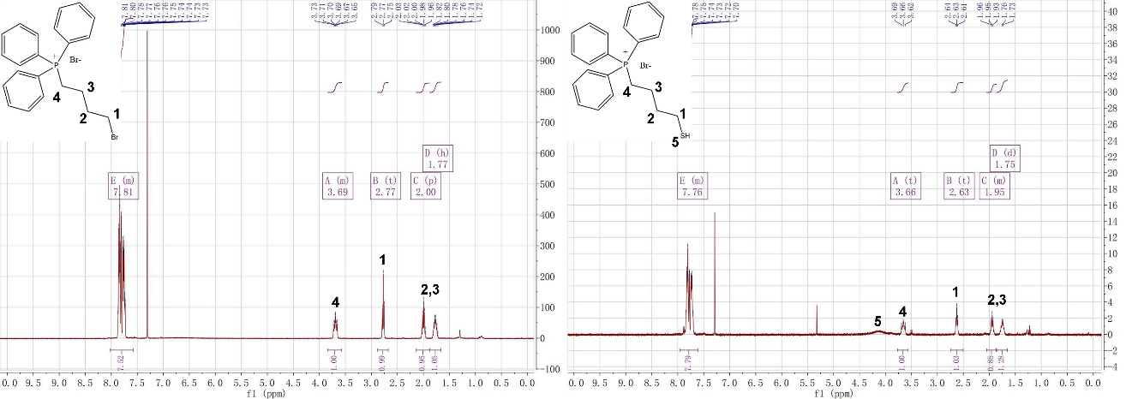
Supplementary Figure 3 ¹H NMR spectra of TPP-Br and TPP-SH. One of more than five repetitions with similar results is shown.

Supplementary Fig. 4
Supplementary Figure 4 ¹H NMR spectra of cysteamine, Ce6 and Ce6-SH, respectively. One of more than five repetitions with similar results is shown.

Supplementary Fig. 5
Supplementary Figure 5 Photoluminescence spectroscopy of (a) supernatant of 1mM ACCT with different addition of Ce6-SH. (b) Loading efficiency of Ce6. The load efficiency decreases as Ce6 increases.

Supplementary Fig. 6
Supplementary Figure 6 ACCT with different load rate of Ce6 and Ce6 (The amount of Ce6 is the same as the ACCT load).

Supplementary Fig. 7

Supplementary Figure 7 Photoluminescence spectroscopy of SOSG.

Supplementary Fig. 8
Supplementary Figure 8 Cellular uptake amounts of ACCT nanoparticles in 4T1 cells at different incubation times. The Au concentrations were determined by ICP–MS. N=3 biologically independent samples for each group. Center values and error bars denote the mean and SD, respectively.

Supplementary Fig. 9
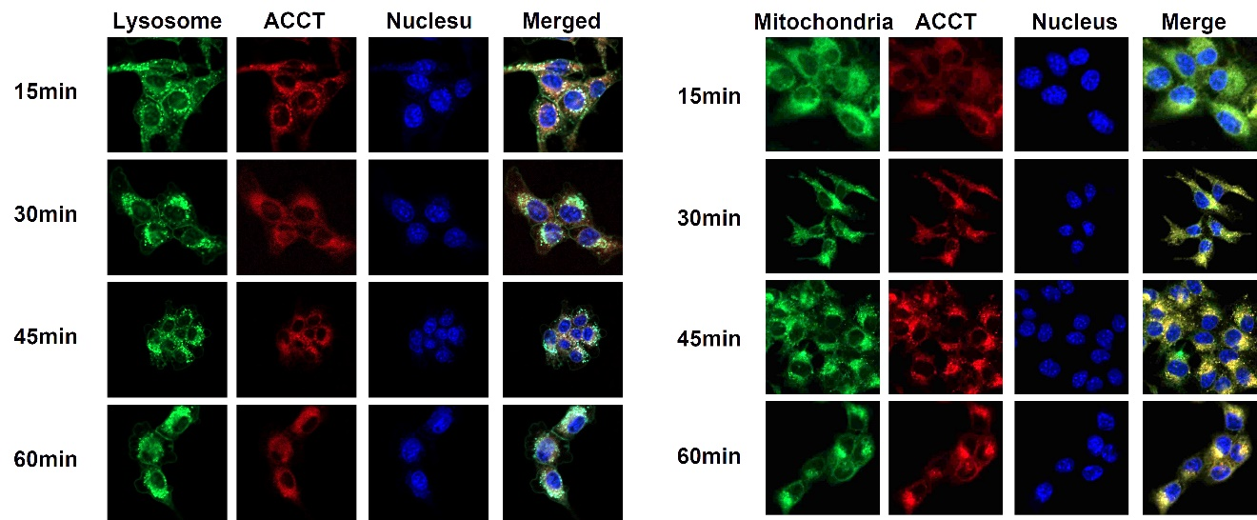
Supplementary Figure 9 Lysosome and mitochondria colocalization. (a) Representative fluorescent images of lysosomal colocalization of ACCT. Scale bars, 20 μm (b) Representative fluorescent images of mitochondria colocalization of ACCT. Scale bars, 20 μm.
Supplementary Fig. 10
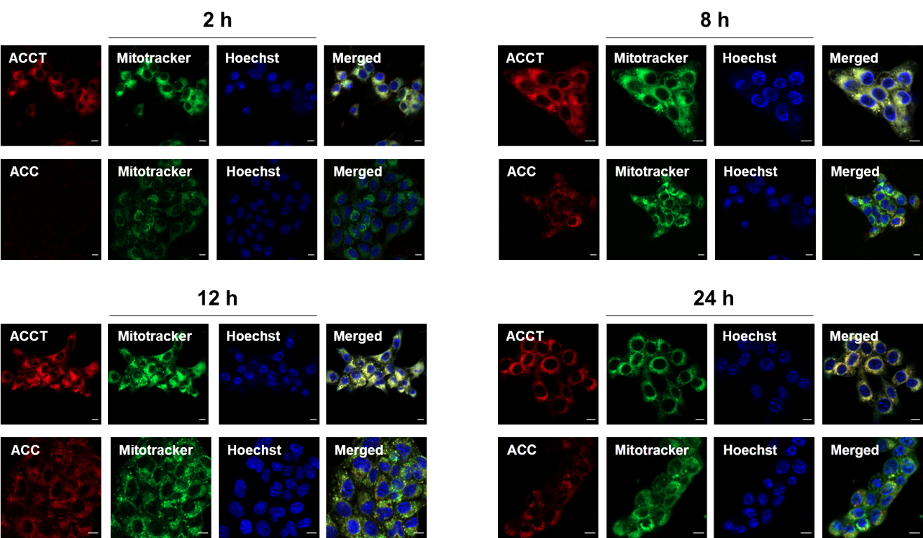

Supplementary Figure 10 Representative fluorescence images of ACCT and mitochondria colocalization in 4T1 cells at 2, 8, 12, 24 h. Scale bars, 20 μm.

Supplementary Fig. 11

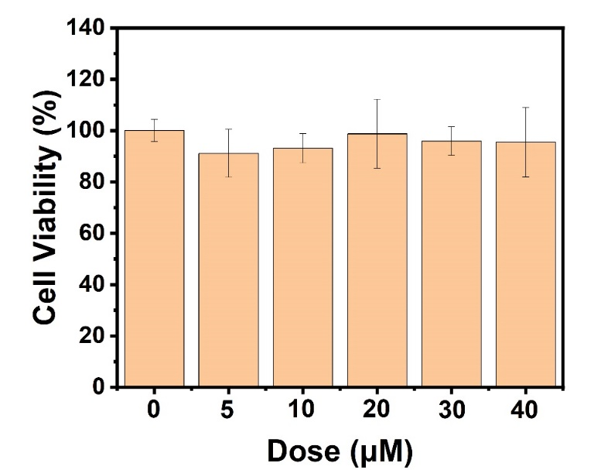
Supplementary Figure 11 The cell viability treated with different concentrations of ACCT on 4T1 cells without PDT. Data are presented as the mean values ± SD (n=5).

Supplementary Fig. 12
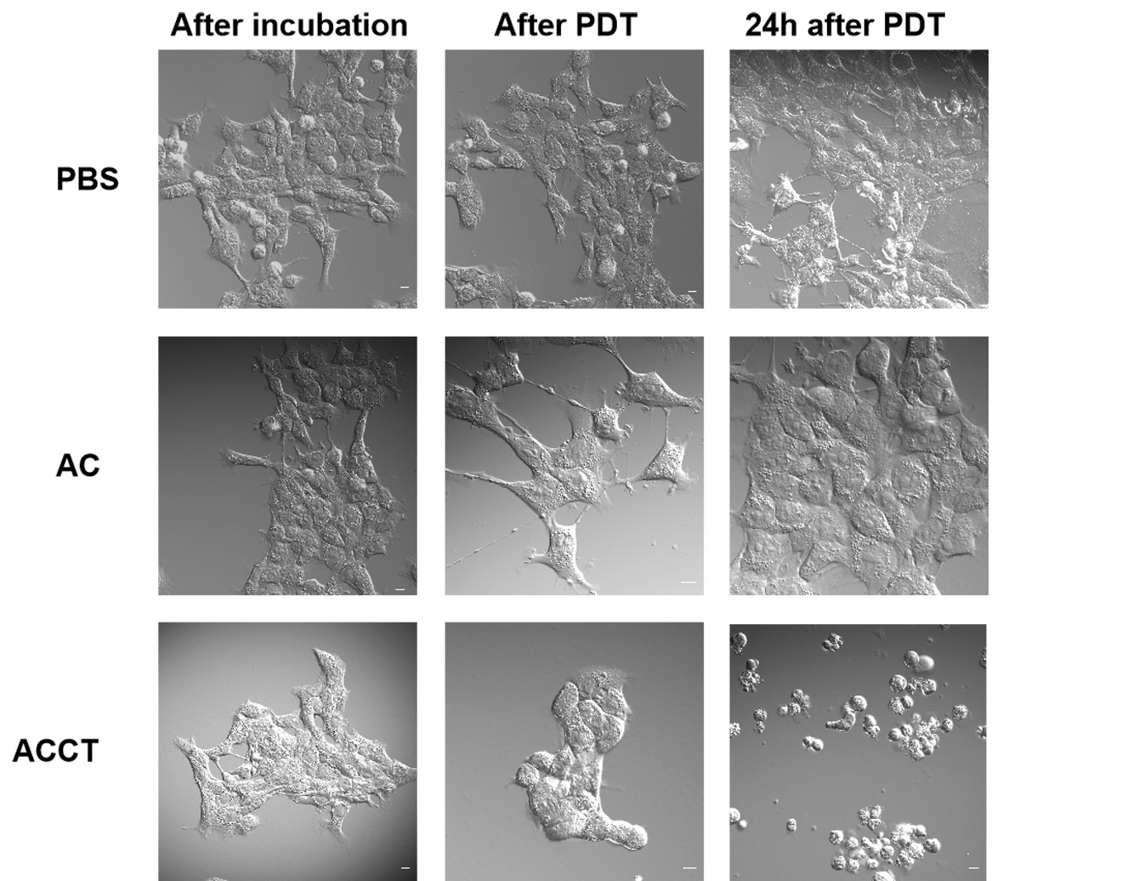

Supplementary Figure 12 Morphological change of 4T1 cells with laser treatment after 5 min and 24 h. Scale bars, 10 μm.

Supplementary Fig. 13
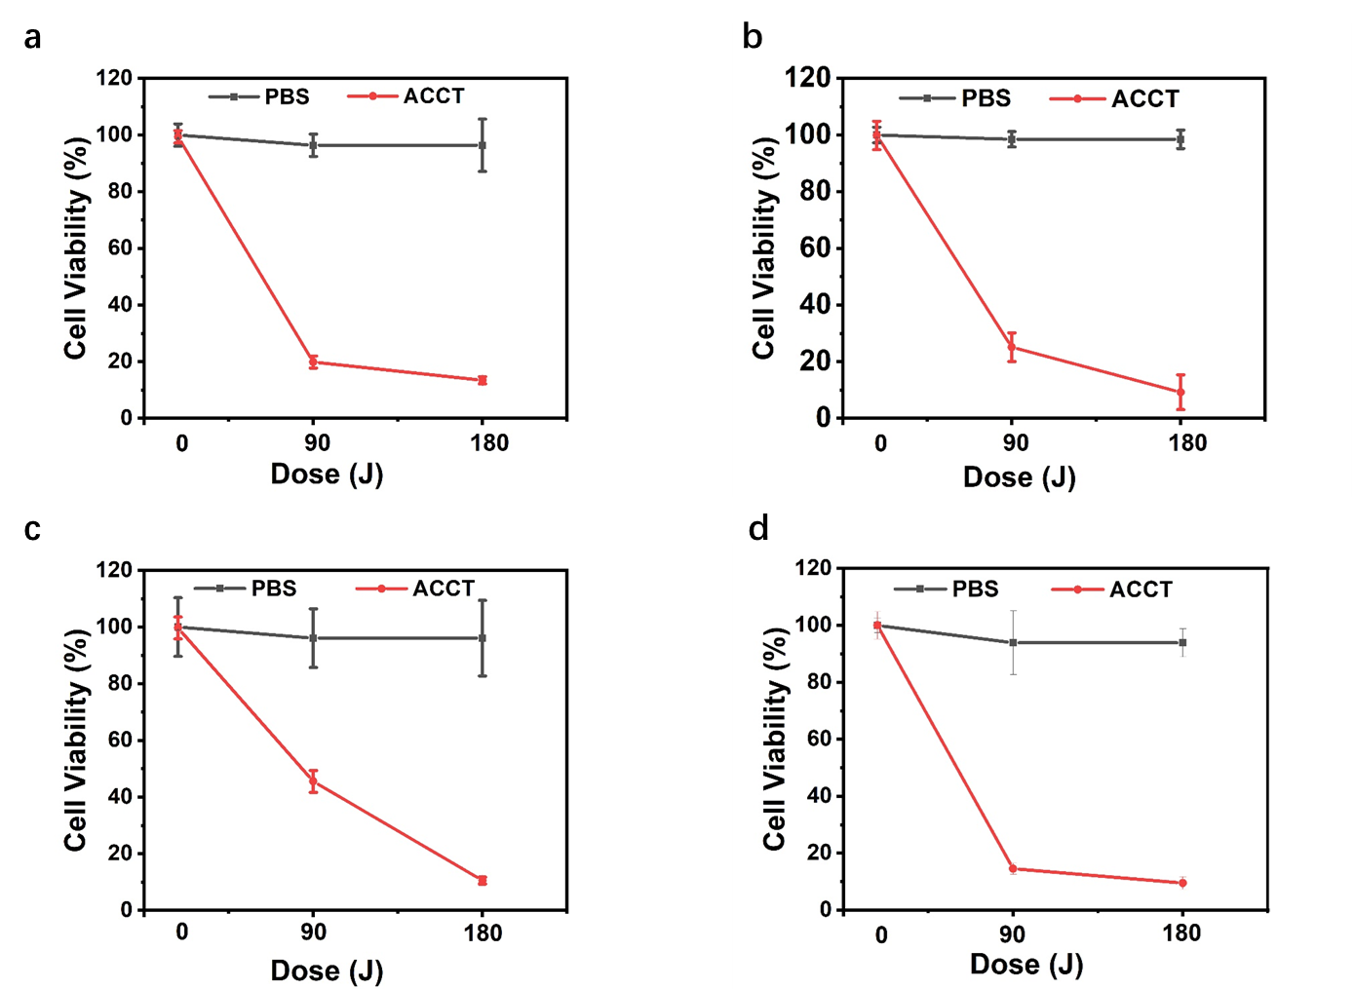
Supplementary Figure 13 Cytotoxicity of ACCT against (a) Cal-27, (b) ACC-M, (c) Hep-3b, (d) HN6 cells. The ACCT were incubated with the cells at a dose of 40 µM for 4 h followed by 180J/cm² light irradiation. The cell viability was evaluated by CCK-8 assay after 24 h. N=5 biologically independent samples for each group. Center values and error bars denote mean and SD, respectively.

Supplementary Fig. 14
Supplementary Figure 14 Uncropped scans of western blots and quantification of HIF-1α proteins normalized by β-actin.

Supplementary Fig. 15
Supplementary Figure 15 Uncropped scans of western blots and quantification of cleaved caspase-3, total caspase-3 and Bcl-2 proteins normalized by β-actin, respectively.

Supplementary Table 1
Table S1. Elemental composition of AC and ACCT determined by ICP-OES.
Supplementary Table 2
Table S2. The blood routine examination of mice after 24 days intravenous injection of PBS or ACCT (10 mg/kg). N=6 mice in each group.
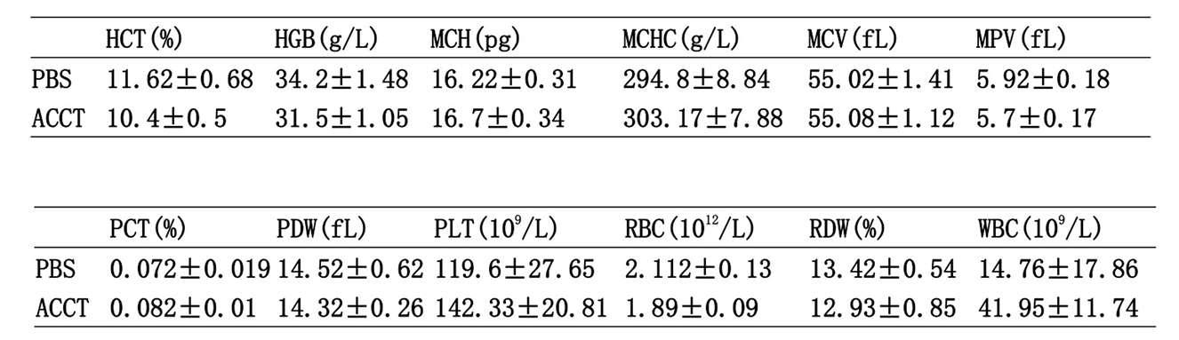
Supplementary Table 3
Table S3. The blood biochemistry of mice after 24 days intravenous injection of PBS or ACCT (10 mg/kg). N=6 mice in each group.
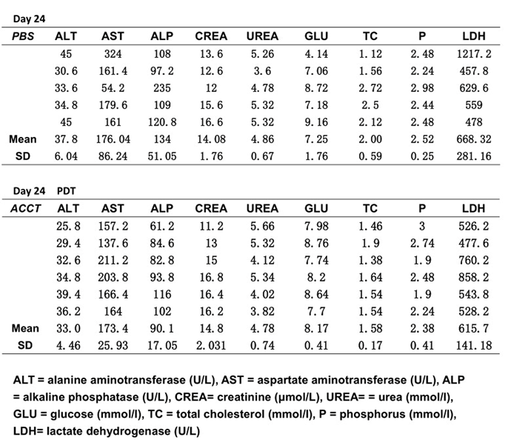

Description of Additional Supplementary Files
Synthesis of Ce6-SH
Ce6-SH was synthesized according to previous report, 22 mg (0.037mmol) Ce6, 41 mg (0.36 mmol) NHS, 56 mg (0.36 mmol) EDC mixed in 2mL of THF/H₂O (2:1) under magnetic stirring at room temperature for 1h before (45mg，0.37mmol) β-cysteamine was added into. The solution was stirred for 3 h at room temperature. After that, the solution was evaporated under reduced pressure to remove THF and washed with water for three times to remove EDC, NHS and excess of β-cysteamine.
Synthesis of TPP-SH
TPP-SH was synthesized according to previous report,¹ IRA-400 (chloride form) (5 g, 19 mmol) was added to a solution of NaSH.H₂O (850 mg, 15 mmol) in MeOH (50 mL) and the mixture was stirred for 2h. The IRA-400 was filtered off and washed with distilled water to remove NaCl and excess of NaSH. Then, the IRA-400 was washed for three times with methanol and diethyl ether, respectively. After that, the resin was dried under vacuum. The IRA-400, ammonium chloride (111 mg, 2.10 mmol) and 4-bromobutyltriphenylphosphonium bromide (1.0 g, 2.10 mmol) were added in 25 ml of MeOH, and stirred for 18h at room temperature. Then the IRA-400 was filtered off and washed with MeOH. The extract was evaporated under reduced pressure and then was extracted by saturated aqueous NaBr solution and CH₂Cl₂. The organic extract was dried over Na₂SO₄ and concentrated in vacuo to dryness to get TPP-SH (815 mg, 90%) as a white powder. TLC (CH₂Cl₂/MeOH 9:1) Rf 0.36.
Cellular uptake
We first evaluated the cellular uptake of ACCT in 4T1 cells. Cells were seeded on 6-well plates at 1×10⁶/well and further cultured for 12 h. ACCT was added to the cells at a Hu concentration of 40 µM. After incubation for 1, 2, 4 and 8 hours, the cells were collected, and the cell numbers were counted by a Bio–Rad TC20 automated cell counter. Cells were washed with PBS at least three times and then digested with concentrated hydrochloric acid and concentrated nitric acid (1:1) in a microwave reactor, and the Au concentrations were determined by ICP–MS. The results were expressed as the amount of Au (ng) per 10⁶ cells.
Intracellular GSH and H₂O₂ detection
4T1 cells in the logarithmic growth phase were plated in 6-well cell culture plates at initial densities of 1×10⁶/well and incubated for 24 h. Fresh medium containing 40 μM AC, ACT, ACC or ACCT was added to the cells and incubated for 4 h. After that, the cells were trypsinized and rinsed with PB, the cell numbers were counted by a Bio–Rad TC20 automated cell counter, and 5×10⁶ cells were collected. GSH and H2O2 extraction was performed from each group using the Reduced Glutathione (GSH) Content Assay Kit (Solarbio, China) and the Hydrogen Peroxide (H₂O₂) Content Assay Kit (Solarbio, China) according to the manufacturer's instructions, respectively.
Morphological Change Observation
4T1 cells were cultured in 35 mm confocal dishes (cover glass bottom dishes) overnight, incubated with ACCT, ACT and PBS for 4 h, and then irradiated with laser treatment (650 nm, 100 mW/cm²) for 15 min (total light dose 90J/cm²). The slides were then observed under CLSM.
Intracellular ¹O₂ detection
¹O₂ generation in live cells was detected by Singlet Oxygen Sensor Green (SOSG, Meilunbio, CN). 4T1 cells were seeded in a 3.5-cm petri dish and cultured under 1% or 21% O₂ for 24 h. The culture medium was then replaced with fresh medium containing 1 μM SOSG to preload the cells with SOSG. After incubating for 30 min, the cells were washed with PBS three times to remove excess SOSG.² The cells were incubated with PBS, 40 µM ACT or 40 µM ACCT for 4 h and then washed with PBS three times to remove excess drugs. Laser irradiation was applied to cells at a dose of 90 J/cm². CLSM was used to visualize the ¹O₂ generated in live cells by detecting the green fluorescence inside the cells.
JC-1 and TdT-mediated dUTP nick end labeling (TUNEL) staining
4T1 cells were cultured in 35 mm tissue culture dishes overnight and then treated with PBS, ACT, ACC or ACCT at an equivalent dose of 40 µM for 4 h followed by irradiation with 0, 90 J/cm² or 180 J/cm². Four hours later, the samples were stained with JC-1 (Biyuntian, CN) or TUNEL (Biyuntian, CN) at a concentration of 10 µM at 37°C for 30 min in the dark. For CLSM, slides were washed with PBS and observed directly.²
Cytochrome C release
4T1 cells were cultured in 35 mm tissue culture dishes overnight and then treated with PBS, ACT, ACC or ACCT at an equivalent dose of 40 µM for 4 h followed by irradiation with 0, 90 J/cm² or 180 J/cm². Cells were then stained with MitoTracker Red (KeyGEN, CN) at a concentration of 100 nM at 37°C for 30 min, fixed and permeabilized 8 h after irradiation. After staining with Cytochrome C Monoclonal Antibody (6H2), FITC, (Thermo Fisher, USA) at a concentration of 10 µM at 37°C for 1 h and DAPI, slides were observed under CLSM. The deco-localization of green and red fluorescence indicates the release of cytochrome c from mitochondria.
HIF-1α staining
4T1 cells were cultured in 35 mm tissue culture dishes overnight and then treated with PBS or ACCT at an equivalent dose of 40 µM for 4 h. Samples were stained with HIF-1α (ab216842, Abcam, USA, 1:200) at 37°C for 30 min in the dark. For CLSM, slides were washed with PBS and observed directly.
Western blotting
4T1 or Cal27 cells were cultured in 35 mm tissue culture dishes overnight and then treated with PBS, ACT, ACC or ACCT at an equivalent dose of 40 µM for 4 h followed by irradiation with 0, 90 J/cm2 or 180 J/cm2. For HIF-1α, 4T1 cells were treated with ACCT at various concentrations (Au: 5, 10, 20, 30 or 40 μM) without irradiation. After 4 h, cells were lysed and separated by SDS/polyacrylamide gel electrophoresis. After membrane transfer, anti-cleaved caspase-3 (ab214430, USA, 1: 5000), anti-caspase-3 (ab32351, Abcam, USA, 1: 1000), anti-Bcl-2 (ab182858, Abcam, USA, 1: 2000), HIF-1α (ab216842, Abcam, USA, 1: 1000), beta actin (Proteintech, USA, 1:10000), goat anti-mouse IgG secondary antibody HRP (Signalway Antibody, USA, 1:20000) and goat anti-rabbit IgG H&L (HRP) (ab97051, Abcam, USA, 1: 10000) were separately incubated with the cropped membranes for blotting.³
The serum biochemical and blood hematological data
For routine blood tests, the blood of healthy mice and the tumor-bearing mice after PDT treatment were collected, and then routine blood tests were conducted on an automatic hematology analyzer (BS-350E, Shenzhen Mindray Bio-Medical Electronics Co., Ltd, China).

References
1 Mehiri, M. et al. A "Ready-To-Use" fluorescent-labelled-cysteine-TBTP (4-thiobutyltriphenylphosphonium) synthon to investigate the delivery of non-permeable PNA (peptide nucleic acids)-based compounds to cells. 35, 313-326 (2007).
2 Lu, K., He, C., Guo, N., Chan, C. & Lin, W. J. N. B. E. Low-dose X-ray radiotherapy–radiodynamic therapy via nanoscale metal–organic frameworks enhances checkpoint blockade immunotherapy. 2, 1-11 (2018).

