Supplementary Material

Supplementary material 1 Three parts to the centrifuge container: a bottom receptacle, a circular disc and a top tube.

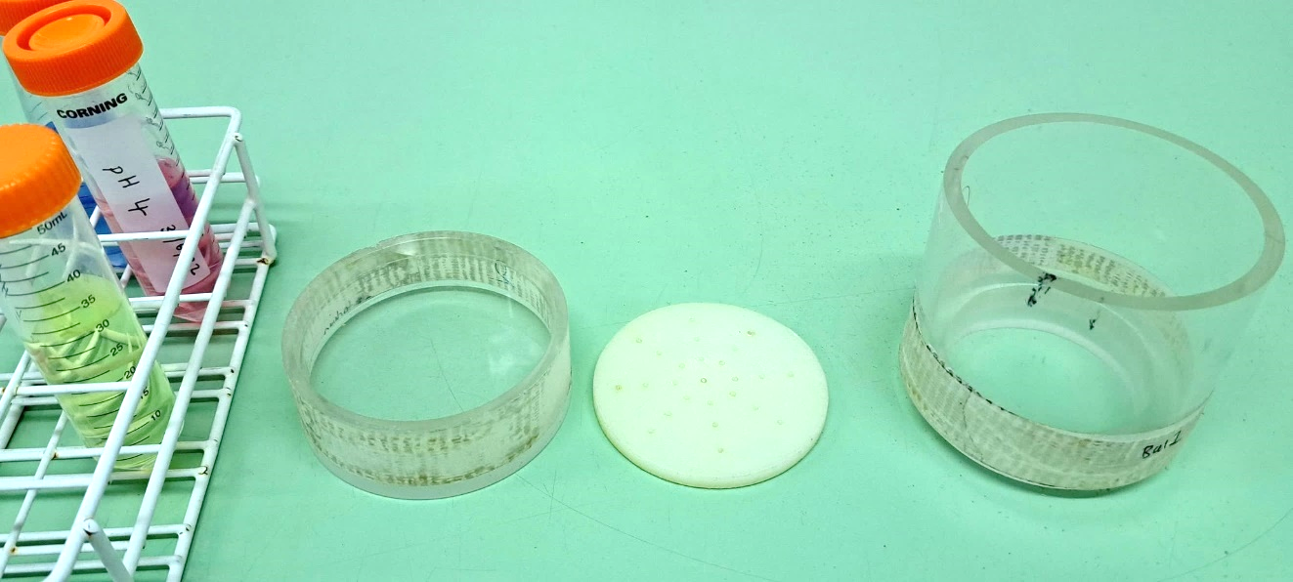

Supplementary material 2 (a) Centrifuge container with leachate contained in the plastic bag, (b) the soil disc flipped and transferred to a new filter paper, the remaining soil on the previous filter paper was scraped off and returned to the soil disc.
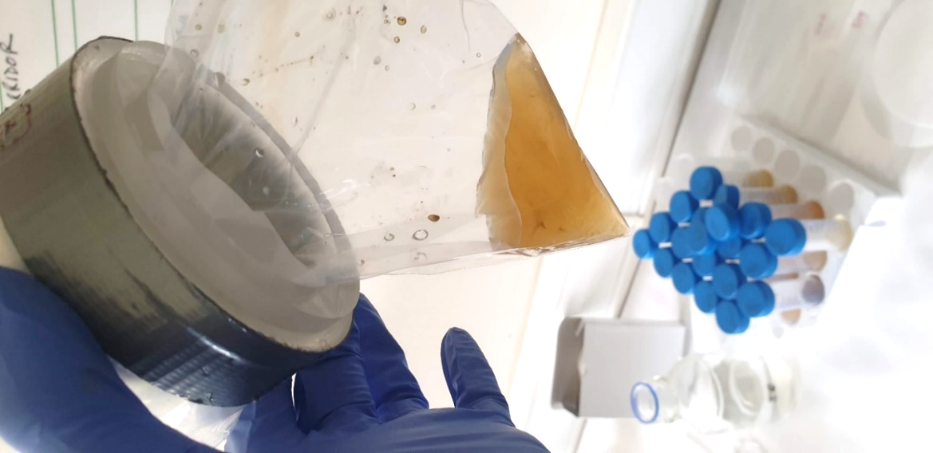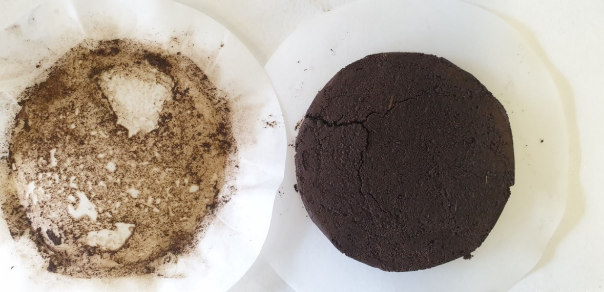
b
a
b
a
c
d
f
e

Supplementary material 3 Solution pH value measured along sequential centrifugal extractions for (a) Huntly, (b) Lyon 1, (c) Paterson, (d) Strathdon, (e) Craibstone and (f) Balmedie. Error bars represent standard error of the mean.

Supplementary material 4 Olsen extractable-P measured before and after centrifugation in the soils, with the percent change in measured extractable P after centrifugation. Analysis of variance and Tukey pairwise testing of significant values between four variables of before and after centrifuging, and control and limed soils.

Soil Name | Before, after  centrifugation | Control P mg/100g | Lime P mg/100g
Huntly | Before | 5.8 +0.2 A | 6.2 +2.2 B
(Loam) | After | 6.4 +0.5 A | 5.9 +0.2 A
 | % difference | -10.3 | 4.8
Tomintoul (34) | Before | 2.4 +0.2 A B | 2.3 +0.9 B
(Sandy loam) | After | 2.5 +0.2 A | 2.2 +0.2 A B
 | % difference | -4.2 | 4.3
Blairgowrie | Before | 3.2 +0.3 B C | 2.9 +0.4 C
(Silt loam) | After | 3.9 +0.2 A | 3.5 +0.1 A B
 | % difference | -21.9 | -20.7
Lyon 1 | Before | 7.8 +0.3 A B | 7.5 +0.4 B
(Loam) | After | 9.4 +0.3 A | 9.2 +0.2 A
 | % difference | -20.5 | -22.7
Tyndrum | Before | 2.9 +0.3 B | 3.1 +0.5 A B
(Sandy loam) | After | 3.9 A | 3.4 +0.1 A B
 | % difference | -34.5 | -9.7
Paterson | Before | 4.6 +0.4 B | 3.2 +1.7 C
(Loam) | After | 6.2 +0.1 A | 5.9 +0.3 A
 | % difference | -34.8 | -84.4
Lyon 2 | Before | 8.3 +0.8 B | 6.9 +1.2 B
(Loam) | After | 12.9 +0.3 A | 12.3 +1.5 A
 | % difference | -55.4 | -78.3
Strathdon | Before | 0.5 +0.3 B | 0.6 +0.8 B
(Silt loam) | After | 1.1 A | 0.3 +0.1 A
 | % difference | -120.0 | 50.0
Craibstone | Before | 15.9 +1.6 A | 13.2 +0.3 B
(Sandy loam) | After | 17.7 +0.5 A | 15.9 +0.6 A
 | % difference | -11.3 | -20.6
Balmedie | Before | 7.3 +0.8 A | 7.1 +0.2 A
(Sand) | After | 7.2 +0.3 A | 5.6 +0.4 B
 | % difference | 1.4 | 21.1

Supplementary material 5 Control and treatment cumulative Mg, K or Na for leachate, filter and combined leachate and filter (L & F). Statistics reflect significance from ANOVA with four replicates of cumulative yield. (P ≤ 0.05 = *, p ≤ 0.01 = **, p ≤ 0.001 = ***, the column including a star indicates whether the control vs lime was significantly higher.

Soil | Leach/Filter | Control K mg/100g soil | Lime K mg/100g soil | Control Mg mg/100g soil | Lime Mg mg/100g soil | Control Na mg/100g soil | Lime Na mg/100g soil
Huntly | Leachate | 1.5 +0.2 | 2.1 +0.6 | 0.6 +0.1 | 0.9 +0.3 | 2.8 +0.1 | 3.7 +0.5 *
(Loam) | Filter | 0.8 +0.1 * | 0.1 +0.1 | 1.3 +0.1 | 1.5 +0.1 * | 0.7 +0.1 | 0.9 +0.2
 | L & F | 2.4 +0.2 | 3.1 +0.6 | 1.9 +0.1 | 2.4 +0.2 * | 3.5 +0.2 | 4.6 +0.4 *
Tomintoul (9x) | Leachate | 1.0 +0.3 | 1.6 +0.3 | 0.7 +0.2 | 0.9 +0.1 | 3.3 +1.7 | 4.6 +0.7
(Sandy loam) | Filter | 2.6 +0.8 | 3.0 +0.6 | 2.0 +0.2 | 1.8 +0.1 | 7.3 +1.7 | 11.4 +3.0
 | L & F | 3.5 +1.1 | 4.6 +0.7 | 2.6 +0.4 | 2.6 +0.2 | 10.6 +3.3 | 15.9 +02.6
Tomintoul (34x) | Leachate | 2.2 +0.3 | 2.7 +0.3 | 1.2 +0.2 | 1.4 +0.1 | 6.8 +1.8 | 8.2 +0.6
 | Filter | 5.9 +1.3 | 5.9 +0.8 | 6.5 +0.5 | 6.2 +0.6 | 9.1 +1.8 | 13.2 +3.2
 | L & F | 8.1 +1.6 | 8.6 +1.0 | 7.6 +0.8 | 7.6 +0.7 | 15.9 +3.5 | 21.3 +2.9
Blairgowrie | Leachate | 1.0 +0.1 | 1.4 +0.3 | 1.1 +0.2 | 1.6 +0.5 | 2.4 +0.2 | 2.9 +0.4
(Silt loam) | Filter | 0.3 | 0.3 | 1.4 +0.1 | 1.5 +0.1 | 0.5 +0.1 | 0.5
 | L & F | 1.3 +0.1 | 1.7 +0.3 | 2.5 +0.8 | 3.1 +0.5 | 2.9 +0.2 | 3.4 +0.3
Lyon 1 | Leachate | 0.8 | 1.6 +0.1 *** | 0.4 | 2.5 +0.2 *** | 2.1 +0.1 | 2.9 +0.2 ***
(Loam) | Filter | 0.8 | 0.8 +0.1 | 2.6 +0.2 | 2.7 +0.1 | 1.3 +0.2 | 1.1 +0.1
 | L & F | 1.6 | 2.4 +0.1 *** | 2.9 +0.1 | 5.2 +0.3 *** | 3.4 +0.4 | 4.1 +0.2 *
Tyndrum | Leachate | 3.2 +1.2 | 3.1 +1.2 | 1.1 +0.3 | 0.9 +0.2 | 2.6 +1.2 | 3.0 +1.7
(Sandy loam) | Filter | 7.9 +2.4 | 7.1 +3.0 | 3.2 +0.9 | 2.7 +0.9 | 5.5 +1.4 | 5.4 +2.3
 | L & F | 11.1 +2.1 | 10.2 +3.4 | 4.2 +0.7 | 3.5 +0.8 | 8.1 +1.1 | 8.4 +1.8
Paterson | Leachate | 0.5 +0.1 | 0.8 +0.1 ** | 0.5 | 3.2 +0.3 *** | 3.3 +0.5 | 5.1 +0.5 **
(Loam) | Filter | 7.8 +2.3 *** | 0.4 +0.1 | 3.1 +0.9 * | 1.8 +0.1 | 5.5 +1.4 ** | 1.9 +0.3
 | L & F | 8.3 +2.3 ** | 1.1 +0.1 | 3.6 +0.9 | 4.4 +0.7 | 8.7 +1.5 | 6.3 +1.3
Lyon 2 | Leachate | 0.7 +0.4 * | 0.5 +0.2 | 1.3 +0.4 | 1.6 +0.3 * | 2.7 +1.5 | 2.9 +1.7
(Loam) | Filter | 1.4 +0.3 | 1.6 +0.3 | 3.5 +0.6 | 3.7 +1.0 | 8.8 +1.8 | 7.6 +2.9
 | L & F | 1.7 +0.3 | 2.0 +0.3 | 4.6 +0.8 | 4.8 +0.7 | 11.2 | 10.4 +3.8
Strathdon | Leachate | 0.5 | 0.6 * | 0.2 | 0.3 *** | 2.6 +0.2 | 2.7 +0.3
(Silt loam) | Filter | 0.5 ** | 0.4 | 1.3 +0.1 | 1.2 +0.1 | 1.0 +0.1 | 0.9 +0.1
 | L & F | 0.8 | 0.9 +0.1 | 1.4 +0.1 | 1.3 +0.1 | 3.4 +0.1 | 3.3 +0.5
Craibstone | Leachate | 0.7 | 0.7 +0.2 | 0.2 | 0.3 +0.1 | 1.3 | 1.2 +0.4
(Sandy loam) | Filter | 0.8 | 0.8 +0.3 | 1.3 +0.1 | 1.4 +0.5 | 0.4 | 0.4 +0.1
 | L & F | 1.3 | 1.4 +0.5 | 1.4 | 1.6 +0.6 | 1.6 +0.1 | 1.5 +0.4
Balmedie | Leachate | 0.8 ** | 0.7 | 0.3 | 0.3 | 1.6 +0.1 *** | 1.3 +0.1
(Sand) | Filter | 0.9 | 0.9 +0.1 | 1.5 | 1.5 +0.1 | 0.5 ** | 0.4
 | L & F | 1. +0.1 | 1.5 +0.1 | 1.7 +0.1 | 1.7 +0.1 | 1.9 +0.2 | 1.5 +0.1

Supplementary material 6 Eigenvector values of PC1, 2 and 3 in order of highest positive contribution to highest negative contribution.
Variable | PC1 |  | Variable | PC2 |  | Variable | PC3
E-CEC (meq/100g) | 0.314 |  | C-% BS | 0.448 |  | % Ca Diff L&F | 0.406
% C | 0.301 |  | soil pH CaCl₂ | 0.371 |  | % Ca Diff Leachate | 0.386
OM (C * 1.724) | 0.301 |  | E-% BS | 0.37 |  | % Clay | 0.265
% Clay | 0.289 |  | Initial pH Control | 0.327 |  | E-% BS | 0.161
Total % N | 0.285 |  | Final pH Control | 0.293 |  | % Silt | 0.083
C-CEC (meq/100g) | 0.278 |  | % Diff Control P mg/100g | 0.206 |  | C-% BS | 0.078
LBC 72-96h | 0.261 |  | Total % N | 0.197 |  | % Diff Lime P mg/100g | 0.053
% LOI | 0.207 |  | % LOI | 0.177 |  | Initial pH Control | 0.021
% Silt | 0.168 |  | LBC 72-96h | 0.17 |  | soil pH CaCl₂ | 0.019
% Ca Diff Leachate | 0.162 |  | % C | 0.131 |  | % Sand | 0.011
LR 72-96h | 0.146 |  | OM (C * 1.724) | 0.131 |  | % Diff Control P mg/100g | -0.082
soil pH CaCl₂ | 0.108 |  | % Ca Diff L&F | 0.116 |  | Total % N | -0.09
% Ca Diff L&F | 0.051 |  | Final pH Limed | 0.057 |  | E-CEC (meq/100g) | -0.108
C-% BS | -0.02 |  | % Ca Diff Leachate | 0.022 |  | LBC 72-96h | -0.124
% Diff Control P mg/100g | -0.118 |  | E-CEC (meq/100g) | 0.01 |  | Final pH Control | -0.156
Initial pH Control | -0.134 |  | % Sand | -0.02 |  | C-CEC (meq/100g) | -0.156
E-% BS | -0.139 |  | % Silt | -0.081 |  | LR 72-96h | -0.176
Final pH Control | -0.187 |  | Initial pH Limed | -0.082 |  | % C | -0.178
% Diff Lime P mg/100g | -0.209 |  | % Clay | -0.093 |  | OM (C * 1.724) | -0.178
Final pH Limed | -0.21 |  | % Diff Lime P mg/100g | -0.098 |  | % LOI | -0.325
Initial pH Limed | -0.219 |  | C-CEC (meq/100g) | -0.112 |  | Initial pH Limed | -0.364
% Sand | -0.233 |  | LR 72-96h | -0.308 |  | Final pH Limed | -0.389

Supplementary material 7 The percent clay contents regressed against the percent difference in limed cumulative leached Ca as compared to control. The percent difference values are those in Table 3. Legend symbols: X = sandy loam, ▲ = loam, + = silt loam, ● = sand, regression line r² = 0.49. Dashed line represents 1:1 line.

