Supplementary information
Heteropolyacid supported on on ionic liquid decorated hierarchical faujasite zeolite as an efficient catalyst for glycerol acetalization to solketal
Samahe Sadjadi^{a1}, Sara Tarighi*¹, Motahareh Delangiz^{a1}, Majid Heravi*²

Materials
To synthesize HR/Y-F127-IL-HPMo catalyst, the following reagents and solvents were utilized: phosphomolybdic acid (H₃[PMo₁₂O₄₀], HPMo), silicotungstic acid (H₄[W₁₂SiO₄₀], HW), phosphotungstic acid (H₃[PW₁₂O₄₀], HPW), triethanolamine (TEA), (3chloropropyl)triethoxysilane (CPTES), sodium hydroxide (NaOH), sodium aluminate (NaAlO₂), acetic acid, ammonium hydroxide (NH₄OH), ammonium nitrate (NH₄NO₃), Pluronic®F-127, ludox AS-30 colloidal silica, toluene, ethanol (EtOH), all was provided from Sigma-Aldrich. The used glycerol for the acetalization was purchased from Merck Co., while acetone was provided from Sigma-Aldrich.
Instruments
Characterization of HR/Y-F127-IL-HPMo catalyst was fulfilled via Fourier transform infrared (FT-IR) spectroscopy using KBr pellet (PERKIN-ELMER‐Spectrum 65 with scan time of 1 s and spectral resolution of 2 cm⁻¹), X-ray powder diffraction (XRD) analysis (Inel, EQUINOX 1000 X-ray diffractometer), Scanning electron microscopy (SEM) and elemental mapping analyses (VEGAII TESCAN scanning electron microscope, equipped with QX2, RONTEC energy dispersive X-ray analyzer), thermo gravimetric (TG) analysis (METTLER TOLEDO device, under O₂ atmosphere within the range of 25-800 ºC and heating rate of 10 °C/min). The acidity of the as-prepared samples was evaluated by the temperature programmed desorption of ammonia (NH₃-TPD(, Chemisorption Analyzer, NanoSORD (made by Sensiran Co., Iran), the heating ramp rate was 20 °C/min, in the temperature range of 25-800 °C). To measure the specific surface area (S_{BET}) and total pore volume (V_{P}) of the catalyst, Brunauer-Emmett-Teller (BET) method (BELSORP MINI II, BEL apparatus) was applied. The catalyst pre-heating step was done at 150 °C for 3 h. Average pore diameter (D_{P}), micropore volume (V_{micro}) and mesopore volume (V_{meso}) were obtained via BJH and t-plot methods.
To identify the reaction products and calculate their yields, GC analysis (Shimadzu GC 17A apparatus, equipped with flame ionization detector (FID) and fitted with a Carbowax capillary column) was employed. In this analysis, the temperature of detector and injector were fixed on 280 and 250 ºC, respectively.

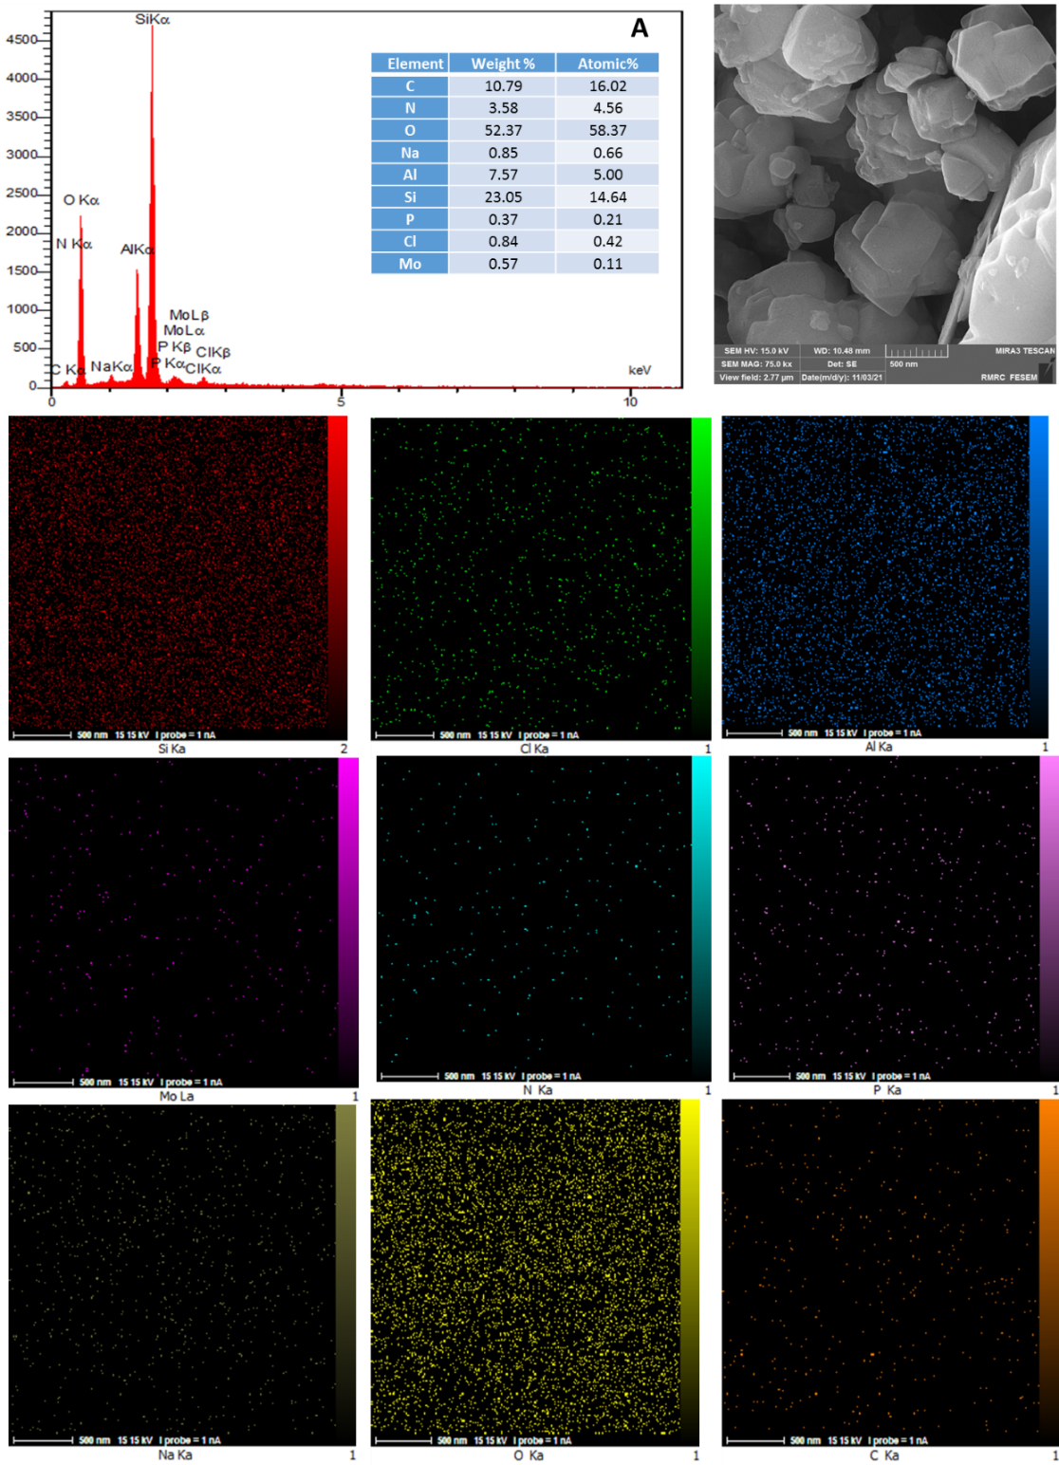
B
Figure S1. A: EDS and B: elemental mapping analyses of the catalyst.

Figure S2. NH₃-TPD profiles of HR/Y-F127 and HR/Y-F127-IL-HPMo

Figure S3. N₂-adsorption-desorption isotherms of HR/Y-F127 and HR/Y-F127-IL-HPMo

Figure S4. The results of recyclability of HR/Y-F127-IL-HPMo for the acetalization of glycerol under optimum condition.

Figure S5. The proposed mechanism for glycerol acetalization to DDM.

Table S1. Comparison of the activity of HR/Y-F127-IL-HPMo with other catalysts
No. | Catalyst | G: A* | Temp. (ºC) | Time (h) | Conv. (%) | DDM  selectivity (%) | DDM  yield (%) | Ref.
1 | HR/Y-F127-IL-HPMo | 1:20 | 55 | 2 | 100 | 98 | 98 | -  workwork
2 | HPW | 1:20 | r.t. | 2 | 83 | 98 | 81.3 | ¹
3 | NaY zeolite | 1:20 | 50 | 2 | 44.5 | 22.5 | 10.0 | ²
4 | HR/Y | 1:20 | 50 | 2 | 92.7 | 77.9 | 72.3 | ²
5 | Y-W₂₀ª | 1:20 | 50 | 2 | 75.9 | 68.8 | 52.2 | ²
6 | HR/Y-W₂₀^{b} | 1:20 | 50 | 2 | 98.1 | 96.4 | 94.6 | ²
7 | Nb₁₅-HUSY^{c} | 1:2 | 70 | 3 | 58 | 98 | 57 | ³
*Molar ration of glycerol to acetone
a: Faujasite zeolite-supported HPW (20 wt.%)
b: Hierarchical faujasite zeolite-supported HPW
c: H-form of Ultrastable Y zeolite-supported niobium pentoxide

References

1 da Silva, M. J., Julio, A. A. & Dorigetto, F. C. S. Solvent-free heteropolyacid-catalyzed glycerol ketalization at room temperature. RSC Adv. 5, 44499-44506, doi:10.1039/C4RA17090C (2015).
2 Talebian-Kiakalaieh, A. & Tarighi, S. Hierarchical faujasite zeolite-supported heteropoly acid catalyst for acetalization of crude-glycerol to fuel additives. J. Ind. Eng. Chem. 79, 452-464, doi:https://doi.org/10.1016/j.jiec.2019.07.021 (2019).
3 Ferreira, C. et al. Y zeolite-supported niobium pentoxide catalysts for the glycerol acetalization reaction. Microporous Mesoporous Mater. 271, 243-251, doi:https://doi.org/10.1016/j.micromeso.2018.06.010 (2018).

