Supplementary Table 1. Preliminary draft of the Focus program intervention plan
Timepoint | F | O | C |  | U | S
Meet and communicate with the caregivers, explain the purpose and process of this study, and get the consent of the caregivers and sign the informed consent
The first week | Family involvement therapy includes three themes: memory, present, and future, where patients express gratitude to their caregivers, recall past shared difficulties, current family strengths, future plans, and completion of the first day of the project | Carry out hand work production activities | Exercise items such as walking, brisk walking, etc. 3 times a week, each time at least 15 minutes, through the telephone, Internet, WeChat exercise supervisor | Distribution of the book "The Power of Grief" |  | Distribute health handbook and explain
In the second week of |  | Carergivers make their own handmade items | Movement on its own | "The Road to Cancer" is published by researchers. |  | Push health information
The third week |  | Carergivers make their own handmade items | Movement on its own | Researchers post 'Talk About Life and Death' |  | Push health information
The fourth week |  | Carergivers make their own handmade items | Movement on its own | Caregivers were encouraged to express their feelings and write them down |  | Push health information

Supplementary Table 2 Comparison of self-efficacy scores among 4 caregivers in the pre-test
Serial number | Before the intervention | After the intervention | differences
1 | 20 | 26 | 6
2 | 17 | 22 | 5
3 | 19 | 26 | 7
4 | 18 | 24 | 6

Supplementary Table 3 Comparison of care burden scores among 4 caregivers in the pre-test
Serial number | Before the intervention | After the intervention | differences
1 | 40 | 37 | 3
2 | 42 | 40 | 2
3 | 43 | 38 | 5
4 | 46 | 36 | 10

Supplementary Table 4 Comparison of coping style scores of 4 caregivers in the pre-test
Serial number | Before the intervention | After the intervention | differences
1 | 27 | 36 | 9
2 | 24 | 30 | 6
3 | 26 | 38 | 12
4 | 25 | 34 | 9

Supplementary Table 5 Comparison of mood state scores of 4 caregivers in the pre-test
Serial number | Before the intervention | After the intervention | differences
1 | 120 | 110 | 10
2 | 126 | 118 | 8
3 | 118 | 106 | 12
4 | 134 | 116 | 18

Supplementary Table 6 Focus program intervention plan
steps | content
F (family involvement in therapy) | Patients express gratitude to their caregivers. According to the needs of family caregivers within 4 weeks, answers and answer records are designated on a certain day and recorded on the specific implementation record sheet, lasting 15 ~ 20 min.
O (optimism) | Carry out hand work production activities, encourage recording and sharing, once a week, a total of 4 times, each time 15 ~ 20 min.
C (response effectiveness) | Exercise activities such as walking and brisk walking should occur 3 times a week for 4 weeks, with at least 15 min each time. Weekly telephone and network supervision
U (reduce uncertainty) | The QR code, the road to cancer and the audio about life and death videos or the power of grief are pushed every week, and the caregivers are required to watch the video or audio by themselves. The video or audio is 40-60 min a week for 4 weeks, and the expression is encouraged and recorded by researchers (face-to-face or WeChat group).
S (Symptom Management) | Issue symptom management cards and push QR code of symptom management; health care personnel regularly communicate with caregivers (face-to-face or online) on any day of the week for 4 weeks, with health instruction time of 10 min/time.

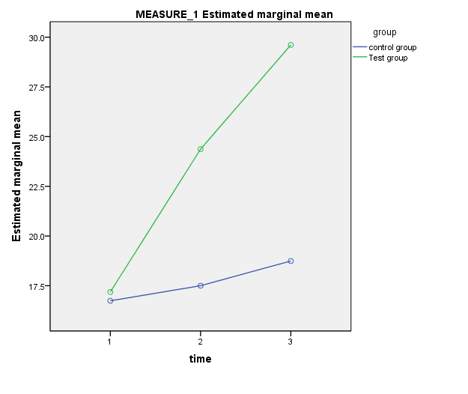

Supplementary Figure. 1 Variation in general self-efficacy scores of caregivers in the two groups over time

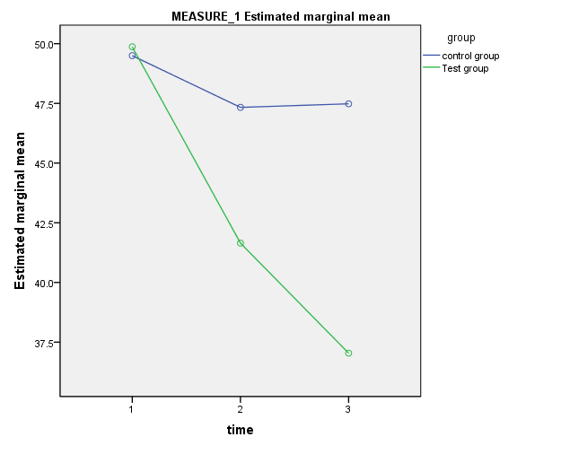

Supplementary Figure. 2 Variation in the caregiver burden scores of the two groups of caregivers over time

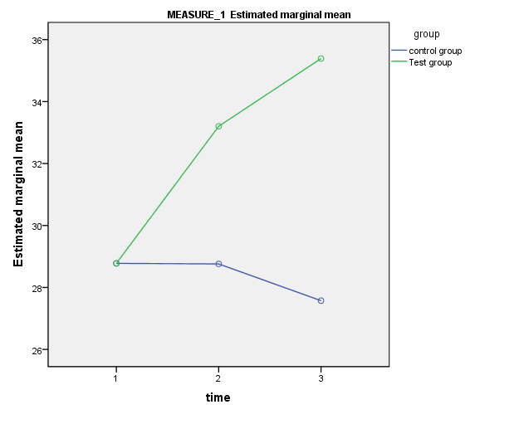

Supplementary Figure. 3 Variation in the coping style scores of caregivers in the two groups over time

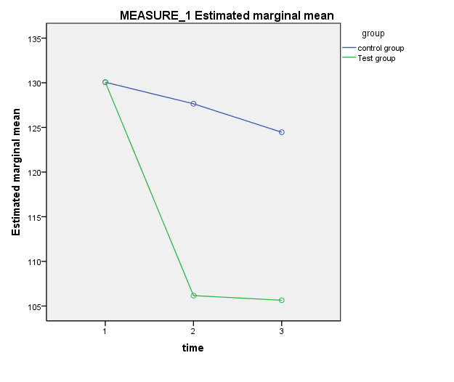

Supplementary Figure. 4 Variation in mood state scores of caregivers in the two groups over time

