Supporting Information

Microfluidic investigation of the impacts of flow fluctuations on the development of Pseudomonas putida biofilms

Guanju Wei ^{a, b}, Judy Q. Yang ^{a, b*}

ª Saint Anthony Falls Laboratory, University of Minnesota, Minneapolis MN 55414, USA
^{b} Department of Civil, Environmental, and Geo-Engineering, University of Minnesota, Minneapolis MN 55455, USA

Corresponding Author
*Judy Q. Yang (judyyang@umn.edu)
Table of Contents

Texts
Text S1. Derivation of the delay/adjust time T₀

Figures
Figure S1. Image analysis
Figure S2. Time sequence images of biofilm growth under steady flow and fluctuating flow conditions
Figure S3. Fast Fourier Transform (FFT) analysis
Figure S4. Constant grow rate u₀
Text S1. Derivation of the delay/adjust time T₀
The proposed modified biofilm growth model assumed that the biofilms do not grow during intervals of high shear and grow at a constant rate u₀ after a delay/adjust time T₀ during low shear stress intervals (Figure 3-(a)). The delay/adjust time T₀ is an important parameter considered here and we used the data from the high-frequency experiments to calculate it:
${\text{L}}_{\text{B}\text{avg-HF} }\text{=} \sum_{\text{phase-2}}{\text{n}\text{(}{\text{T}}_{\text{HF}} \text{-}{ \text{T}}_{\text{0}}\text{)}{\text{u}}_{\text{0}}}$ (S1)
where L_{Bavg-HF} = 6.4 μm is the average biofilm thickness during the fluctuation phase (Figure 2-(a), here we used the mean value calculated from three replicates). T_{HF} = 5.6 minutes is the time duration of each low shear stress interval of the high-frequency fluctuating flow. T₀ is the delay/adjust time for bacteria to adjust to the flow and form biofilms. u₀ = 3.2 μm/hour is the growth rate of the biofilm thickness obtained by linearly fitting of biofilm thickness versus growth time during the low shear stress interval of the low-frequency fluctuation flow (18 to 24 hours) (Figure S4). n = 48 is the number of low-high shear stress cycles during the exponential growth period.
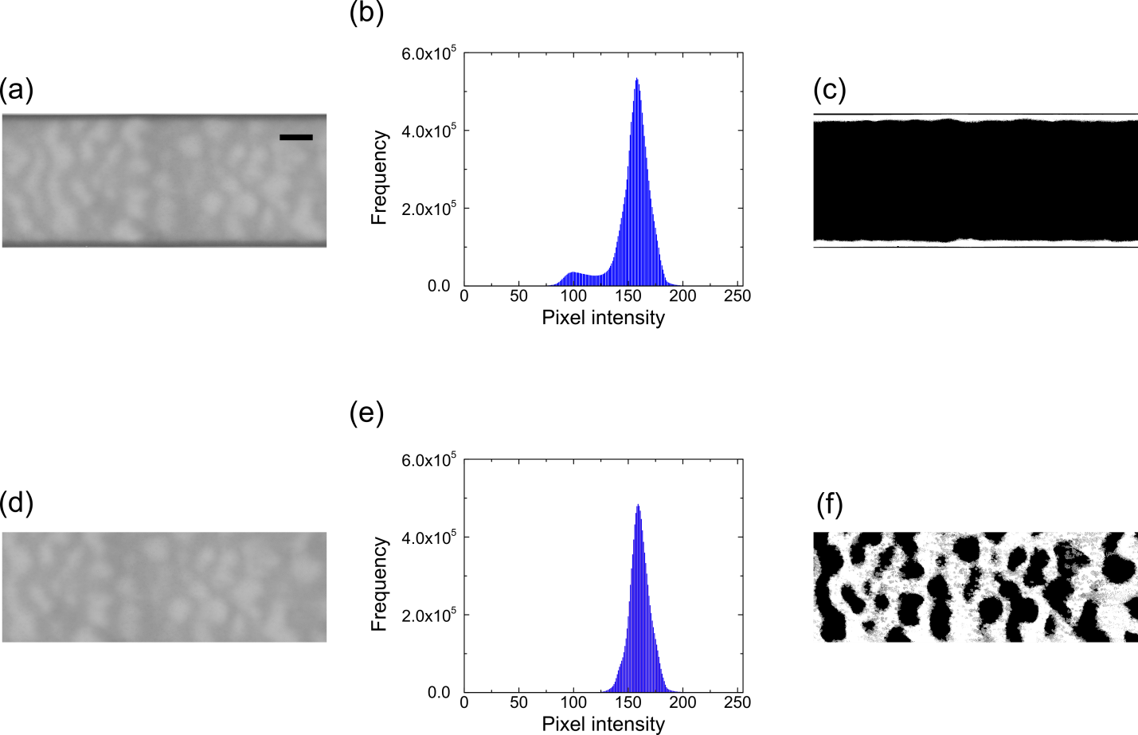
Figure S1. (a) The raw images obtained from Nikon confocal microscope. The images show both the membrane-like sidewall biofilms and ripple-like biofilms on the top PDMS surfaces. The scale bar is 100 μm for all panels. (b) The two-peak pixel intensity value distribution of the images shown in panel (a). (c) The binary image using Otsu’s method¹. (d) The raw images obtained from Nikon confocal microscope show the ripple-like biofilms. (e) The one-peak pixel intensity value distribution of the images shown in panel (d). (f) The binary image was obtained by a manually determined threshold method, which was based on comparing the pixel intensity between the light intensity of the ripple-like biofilms and the background using Image-J.
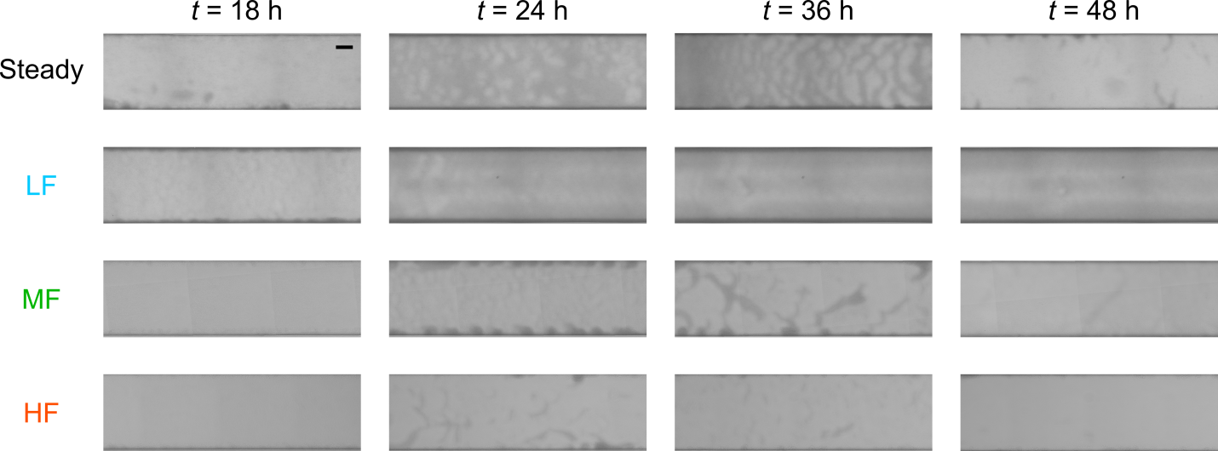
Figure S2. Time sequence images of biofilm growth under steady flow and fluctuating flow conditions: steady-flow (frequency f = 0 Hz), low-frequency fluctuating flow (LF, f = 2×10⁻⁵ Hz,), medium-frequency fluctuating flow (MF, f = 2×10⁻⁴ Hz), and high-frequency fluctuating flow (HF, f = 1×10⁻³ Hz). The scale bar on the top left image is 100 μm and all insets have the same scale bar.
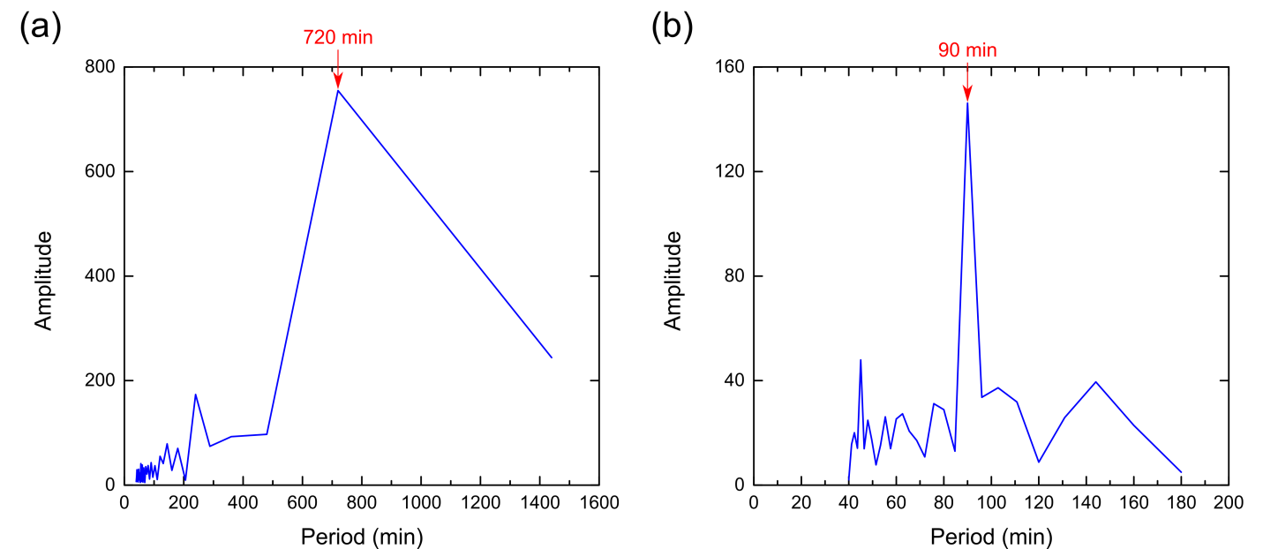
Figure S3. Fast Fourier Transform (FFT) analysis to determine the dominant frequency/time period for (a) low-frequency (12-hour time period) and (b) medium-frequency experiments (90-minute time period).
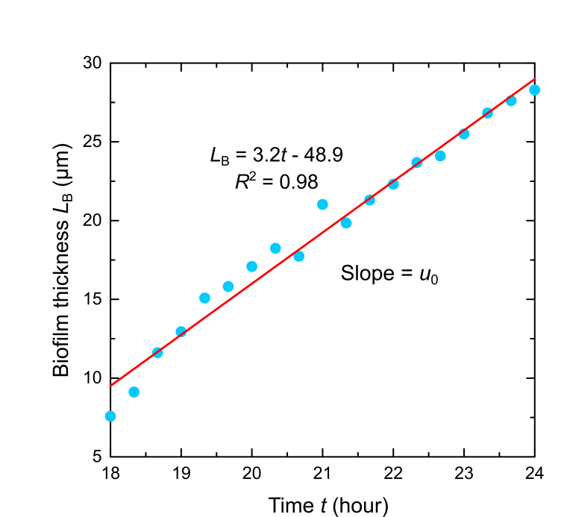
Figure S4. Linearly fitting of biofilm thickness versus growth time during the low shear stress interval of the low-frequency fluctuation flow (18 to 24 hours) (Figure 2-(a)). The slope of the fit represented the constant grow rate u₀ used in the theoretical model. Here we used the mean value from three replicates.

References

1. Otsu, N. A threshold selection method from gray-level histograms. IEEE transactions on systems, man, and cybernetics. 9: 62-66 (1979).

