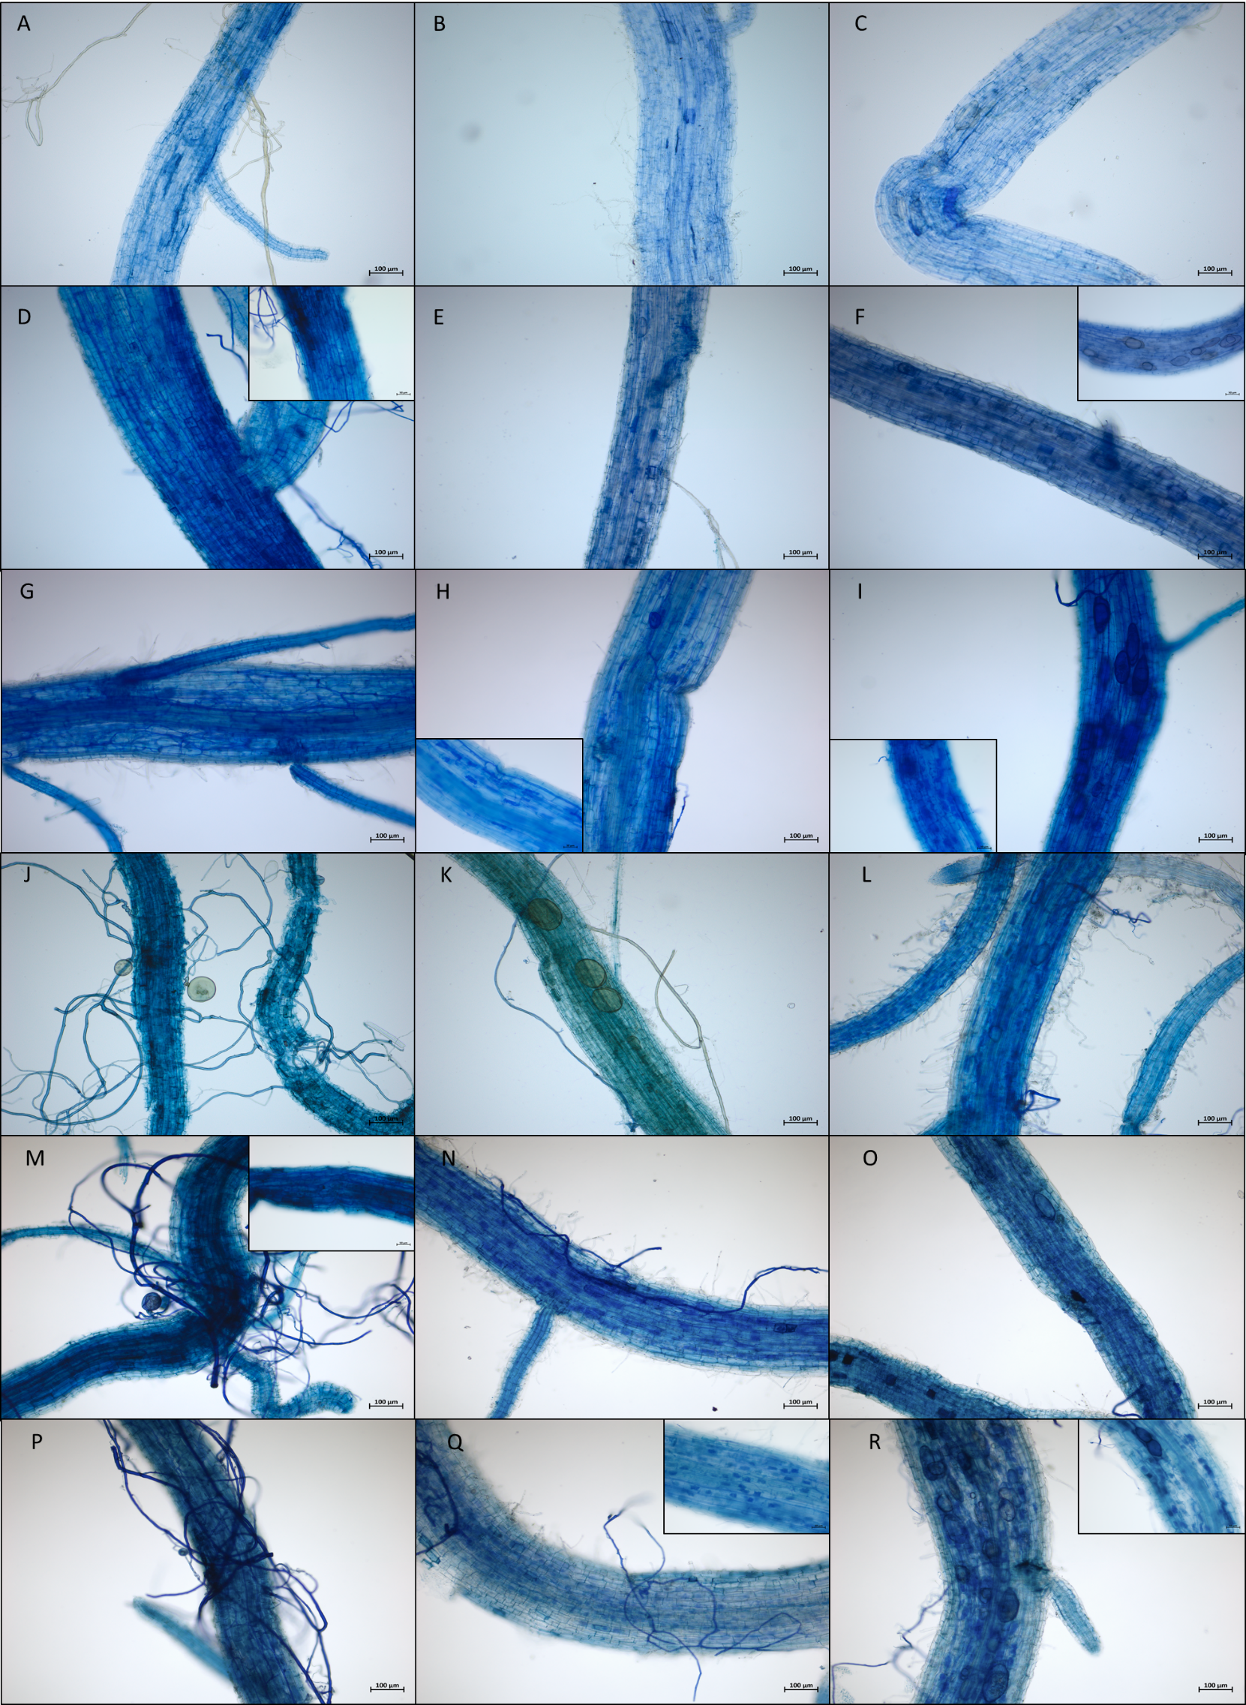
Additional file 3: Fig. S1. Colonisation of each rice genotype root with each AMF species. A, D, G, J, M, P = Roots colonised with Funneliformis mosseae FR140. B, E, H, K, N, Q = Roots colonised with Rhizophagus intraradices FR121. C, F, I, L, O, R = Roots colonised with Rhizophagus irregularis DAOM197198. A, B, C = IR64 roots. D, E, F = Phka Rumduol roots. G, H, I = Azucena roots. J, K, L = Kitaake roots. M, N, O = Nipponbare roots. P, Q, R = Zhonghua 11 roots.

