Supplementary material
Protein expression by immunohistochemistry
Immunohistochemistry procedures were carried out on an automated stainer (Benchmark Ultra from Roche/Ventana Medical Systems, Tucson, AZ, USA). A list of all utilized antibodies, their dilutions and incubation conditions, the antigen retrieval procedures, and applied cut-off scores are listed in the table below (Suppl. Table 1).
Table 1: Antibodies. Provider, clone and way of visualisation are stated. CC1 is ULTRA Cell Conditioning Solution (Ventana Medical Systems, Inc.); RTU – ready to use.
Antigen | Provider | Clone | Visualisation | Antigen retrieval | Dilution | Incubation (mins.) | Cut-off score
BCL2 | Ventana 790-4604 | SP66 | optiView | CC1 48 | RTU | 12 | ≥70 %
BCL6 | Ventana 760-4241 | G/191E/A8 | optiView | CC1 64 | RTU | 12 | ≥30 %
CD10 | Ventana 790-4506 | SP67 | optiView | CC1 40 | RTU | 4 | ≥30 %
CD20 | Ventana 760-2531 | L26 | optiView | CC1 32 | RTU | 8 | 0-49%, 50-95%, ≥96 %
MYC | Ventana 790-4628 | Y69 | optiView | CC1 48 | RTU | 32 | ≥40 %
MUM1 | Ventana 760-4529 | MRQ-43 | optiView | CC1 48 | RTU | 12 | ≥30 %

Fluorescence in situ hybridization (FISH)
FISH was performed with a locus-specific identifier dual-colour, break-apart probes for BCL2 (ZytoLight SPEC BCL2 Z-2192 from Zytomed Systems, Berlin, Germany), BCL6 (01N23-020 from Abbott/Vysis, Green Oaks, IL, USA) and MYC (ZytoLight SPEC MYC Z-2090-200 from Zytomed Systems). Cases were considered for evaluation if $≥$200 tumour cell nuclei displayed positive FISH signals. Abnormal FISH signals were recorded as a percentage of the total tumour cells showing an abnormality. The cut-off scores to consider a case rearranged were $>$4.95 % for BCL2 breaks/rearrangements, $>$5.15 % for BCL6 breaks, and $>$4.94 % for MYC breaks, as determined by the ISO15189 accredited standard diagnostic operating procedures of our institute. High-level amplifications were defined as the presence of either $≥$6 gene signals or tight clusters of $≥$5 gene signals per cell, but were not observable in our collective. To assess reproducibility, a comparison between the known results of routine diagnostic testing for the respective probes of 12 cases was executed (in 9 cases for MYC, in 5 partially non-overlapping cases for BCL2 and in 3 for BCL6); the agreement was perfect for breaks (κ=1).

Custom lymphoma panel validation:
Twenty-two FFPE lymphoma samples, 10 FFPE control samples (with no pathogenic mutations) and 1 peripheral blood mononuclear cells sample (used as high quality DNA control), along with 6 DLBCL cell lines: OCI-LY3, RIVA, SU-DHL-4, SU-DHL-10, SU-DHL-16 and HBL-1 were sequenced with the new custom lymphoma panel IonAmpliSeq™ (Thermo Fisher Scientific, Waltham, MA, USA). Additionally, by diluting RIVA with SU-DHL-4, we created samples with 20 %, 5 % and 2.5 % allelic frequency (AF) to test the panel sensitivity for detection of low AF mutations. The panel consists of 172 genes, 131 of which are full coding sequences and 41 hotspots only. It comprises 2 pools: I with 2359 amplicons and II with 2357 amplicons, with size range 125 – 175 bp. DNA was extracted by using the InvitrogenTM RecoverAll™ Multi-Sample RNA/DNA Workflow (#A26069 Thermo Fisher Scientific, Waltham, MA, USA) from 10 μm thick untreated embedded (FFPE) tissue samples according to the manufacturer’s protocol. Only cases with a TCC >20% were considered eligible for HTS. The DNA input was 10 ng/pool, 20 ng in total, and library preparation guidelines for 2x 2-primer pool panel were followed. Libraries were quantified by qPCR and the Ion Chef™ system was used for template preparation and chip loading. A maximum of 9 samples were included in the Ion 550™ chip in a single run that is expected to achieve an output of 12 million reads per sample. Chips were sequenced on the Ion Torrent™ Ion GeneStudio™ S5 Prime System (ThermoFisher Scientific).
Variants were annotated by the Lymphoma_V3 workflow v5.18, which incorporates a variant caller plugin Oncomine Variant Annotator v3.2 in the Ion Reporter software (Life Technologies). An in-house filterchain was used to call only non-synonymous variants within exonic regions, and intronic mutations at the splice site and promoter regions in the analysis. Germline polymorphisms were filtered out using the 5000Exomes population database (Global MAF >0.002) and variants with coverage <100 were excluded. Quality control parameters keep out variants with a Phred-quality score <50 and/ or variant allele frequency (VAF) <5%. Positions of the remaining variants were manually inspected on the integrative genomics viewer (IGV) using generated BAM files to exclude sequencing artifacts.
For variant classification, the total number of entries of a particular amino acid change at a position in COSMIC was considered, along with their significance in silico prediction tools and their deleteriousness in functional studies, and description in at least one genomic database (ClinVar, OncoKb, VarSome).
We achieved mapped reads >15 million, with on-target being >98 %, mean depth of >3800 and uniformity >93 %.
The filtered variants across all samples were compared to the variants output from sequencing with the previous in use lymphoma panel of 68 genes (most of which are hotspots only). We have observed more pathogenic and likely pathogenic variants with the new panel, with AF detection down to 2.5 %. Additionally, panel-specific artifacts were flagged and excluded from the variant annotation pipeline.

Sequencing run metrics, data parsing and data deliverables
Metrics for the sequencing run were executed as shown in the supplementary material (Table 2). The data on mRNA expression of target genes was returned from the sequencer in the form of demultiplexed FASTQ files. The HTG EdgeSeq Parser automated pipeline was used to align the FASTQ files to the probe list to collate the data. Data deliverables were provided as data tables of raw, QC raw, log₂ CPM (counts per million), and median normalised data. The HTG EdgeSeq Reveal Application was utilised to quality-check and normalise data.
Post-sequencing quality control (QC)
Quality control was performed by HTG and provided to the investigators.
Post-sequencing QC metrics (QC0, QC1, QC2, and QC3) detect four different sample failure modes as shown in the supplementary material provided (Table 3). QC0 detects degraded RNA or poor quality/quantity samples, by assessing the percentage of overall reads being allocated to the positive process control probe for each sample. QC1 detects samples with insufficient read depth; this is evaluated by setting the cut-off at the minimum number of reads that can be allocated to each sample for the data set to be replicable. QC2 detects samples with minimal expression variability, which is determined by the median log₂ CPM for negative control probes. QC3 detects samples with elevated genomic DNA (gDNA) background, which is caused by incomplete digestion of gDNA by the DNase enzyme. One study sample (UPN15) did not pass QC0 and one sample (UPN7) failed QC2.

Table 2: Executed sequencing metrics
Metric | Acceptance Criteria | Run
% Q30 | $≥$87.0 | 93.6
Total Yield (Gb) | $≥$16.0 | 31.0
Total Pass Filter Reads (Millions) | $≥$271.00 | 524.99
% Pass Filter | NA | 80.79
Cluster Density (k/mm²) | NA | 251

Table 3: HTG transcriptome panel QC metrics
QC label | QC failure mode | Cut-off
QC0 | Insufficient RNA | POS% >4% as failure
QC1 | Insufficient read depth | Read depth < 7 m as failure
QC2 | Insufficient expression variability | Median log₂(CPM) negative control probes > 2 as failure
QC3 | Incomplete digestion of gDNA by DNase | Median adjusted log₂(CPM) of gDNA probes > 1 as failure

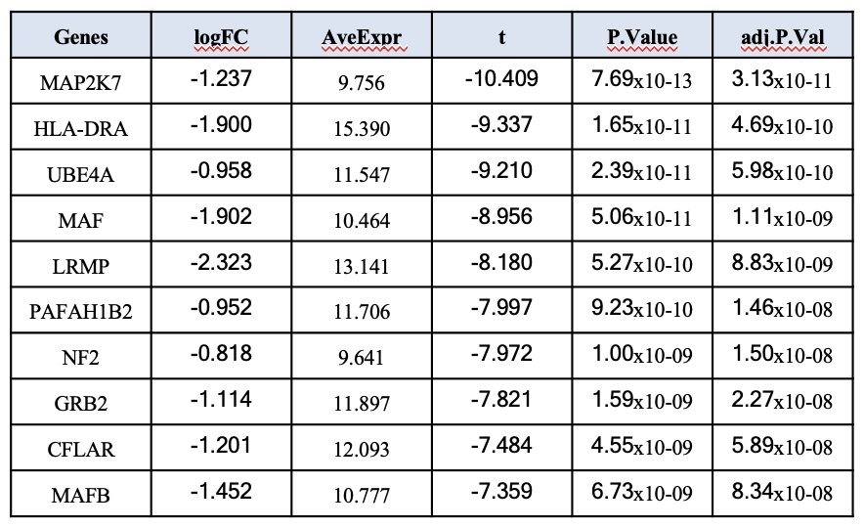
Table 4: The top 10 up-regulated genes in PB-DLBCL compared to nodal GCB-DLBCL.

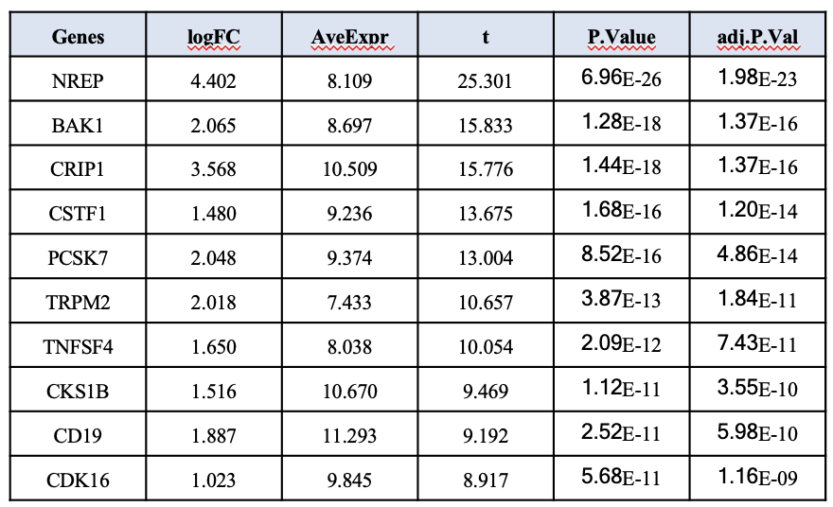
Table 5: The top 10 down-regulated genes in PB-DLBCL compared to nodal GCB-DLBCL.
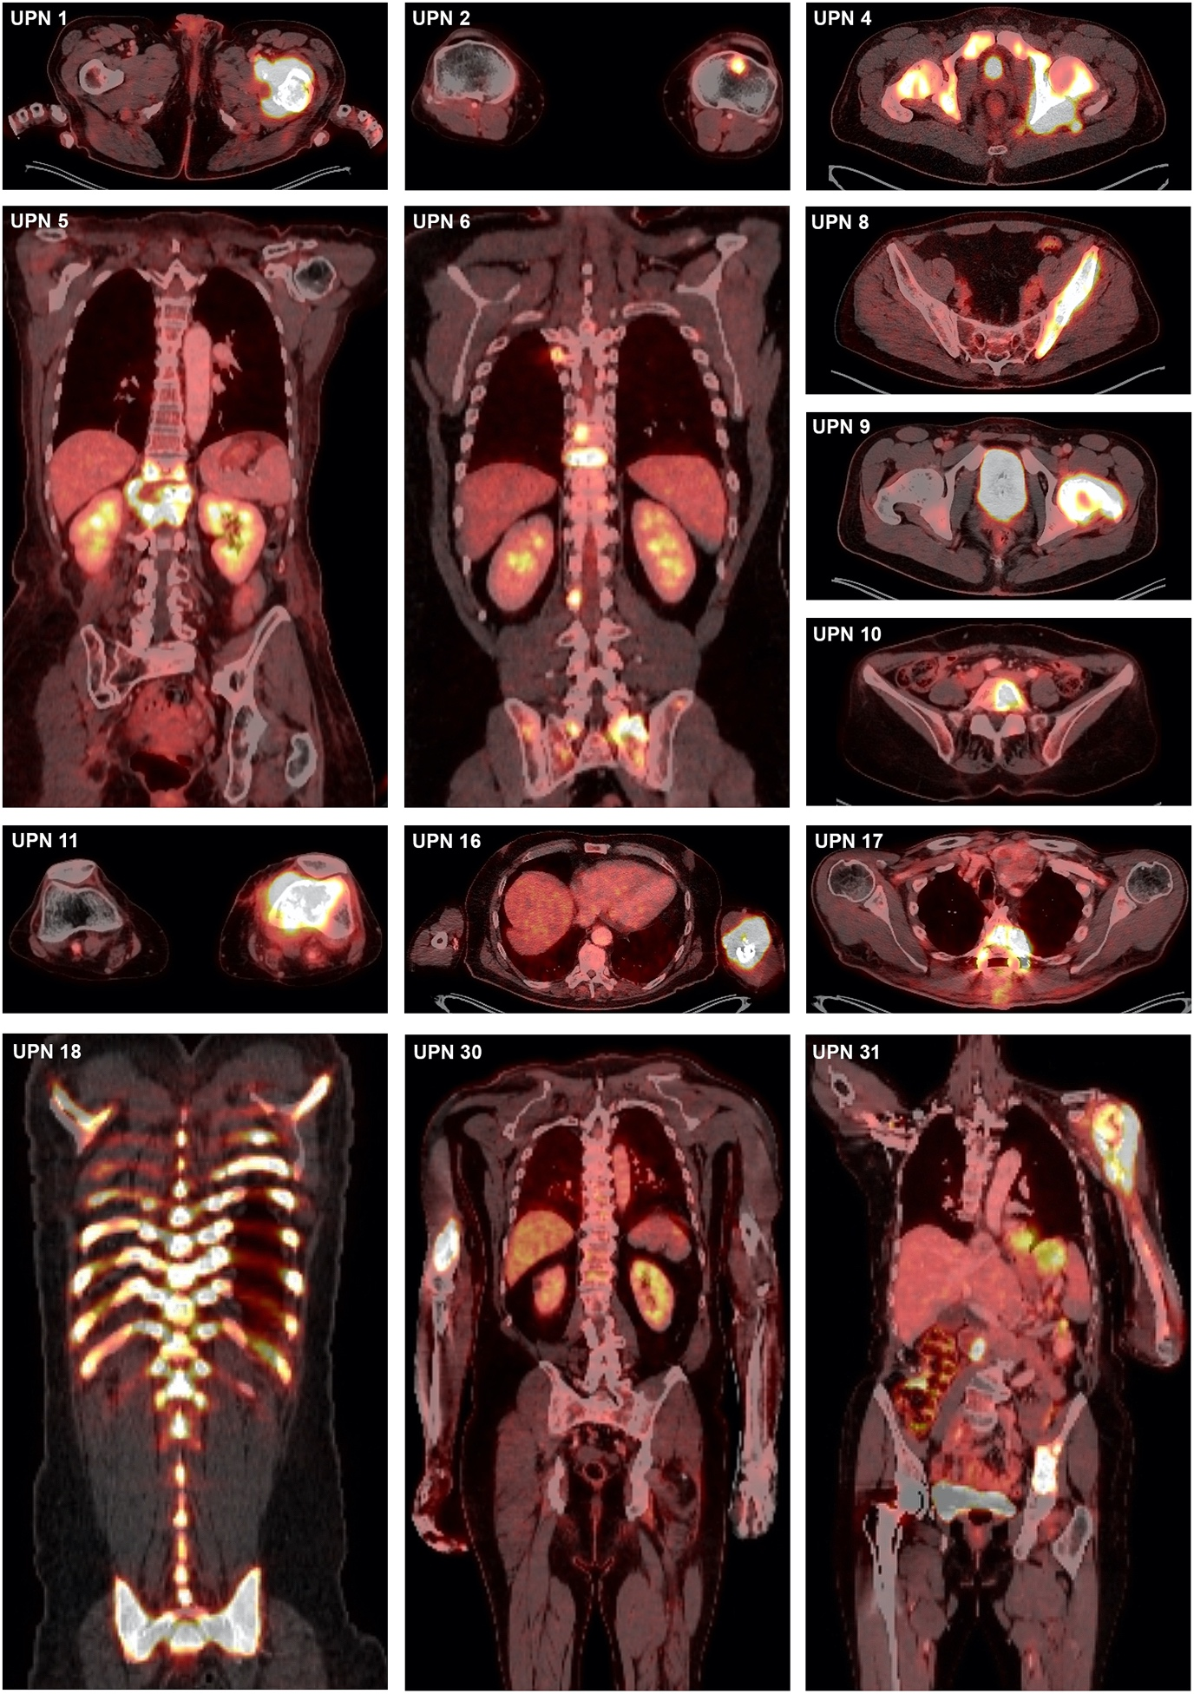
Figure 1: PET-CT imaging presentation of selected PB-DLBCL patients presenting as either monostotic (UPN 1, 2, 8, 9, 10, 11, 16, 17, 30), or polyostotic disease up to diffuse skeletal involvement (UPN 18).

