Supplementary Table 1 The highest OD₆₀₀ and lag phase of strains in media with ammonium salts
Strains |  | AS medium |  |  | AN medium |  |  | ACl medium
Strains |  | Highest OD | Lag phase (h) |  | Highest OD | Lag phase (h) |  | Highest OD | Lag phase (h)
168 |  | 0.48 ± 0.00 | 17.59 ± 0.44 |  | 0.53 ± 0.00 | 18.75 ± 0.14 |  | 0.50 ± 0.00 | 21.75 ± 0.30
PY79 |  | 0.45 ± 0.04 | 6.21 ± 0.28 |  | 0.68 ± 0.08 | 7.18 ± 0.23 |  | 0.50 ± 0.01 | 7.24 ± 0.03
DSM1092 |  | 0.10 ± 0.00 | 6.80 ± 0.37 |  | 0.10 ± 0.00 | 7.31 ± 0.05 |  | 0.10 ± 0.00 | 7.40 ± 0.23
WB800 |  | 0.46 ± 0.00 | 8.47 ± 0.45 |  | 0.55 ± 0.00 | 10.52 ± 0.06 |  | 0.47 ± 0.00 | 11.29 ± 0.15
3NA |  | 0.51 ± 0.00 | 6.69 ± 0.06 |  | 0.66 ± 0.02 | 7.29 ± 0.19 |  | 0.52 ± 0.01 | 7.50 ± 0.18
PS832 |  | 0.43 ± 0.00 | 7.86 ± 0.12 |  | 0.53 ± 0.00 | 9.02 ± 0.07 |  | 0.45 ± 0.01 | 8.83 ± 0.06
NCIB3610 |  | 0.46 ± 0.00 | 3.86 ± 0.11 |  | 0.64 ± 0.01 | 4.35 ± 0.04 |  | 0.44 ± 0.00 | 9.22 ± 0.06
168S |  | 0.44 ± 0.00 | 21.45 ± 0.20 |  | 0.36 ± 0.06 | 38.06 ±17.63 |  | 0.45 ± 0.00 | 24.38 ± 0.80
PY79S |  | 0.49 ± 0.00 | 5.63 ± 0.02 |  | 0.59 ± 0.00 | 5.91 ± 0.05 |  | 0.52 ± 0.00 | 6.49 ± 0.12
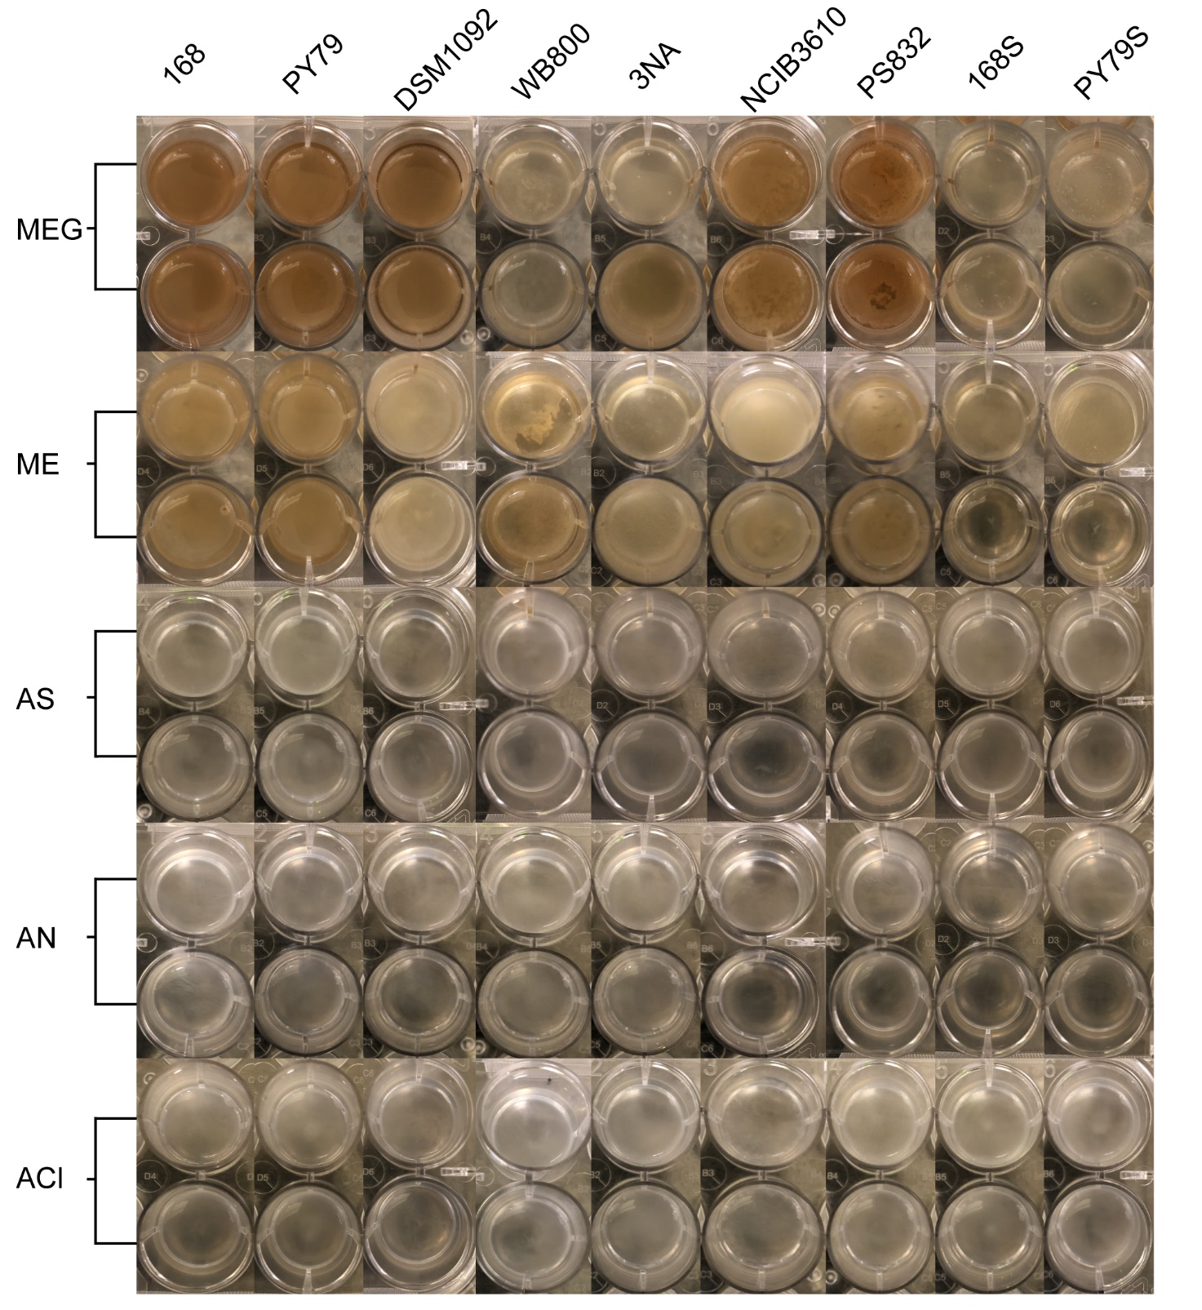
Supplementary Figure 1 | 1-day static incubation images of strains at 37°C in 24-well plates.

Supplementary Figure 2 | Metabolic distribution of nine B. subtilis strains in medium with casein hydrate (CA), peptone (PE), casein hydrate with glucose (CAG) and peptone with glucose (PEG) under high DO, optimal DO and oxygen-deprived conditions.
Supplementary Figure 3 | A~D: Growth curves of strains in flasks in medium with peptone and glucose (PEG), peptone (PE), casein hydrolysate and glucose (CAG) and casein hydrolysate (CA) under high DO, optimal DO and oxygen-deprived conditions. The shallow surrounding growth curve represents the standard deviations of replicates.

