Supplementary data

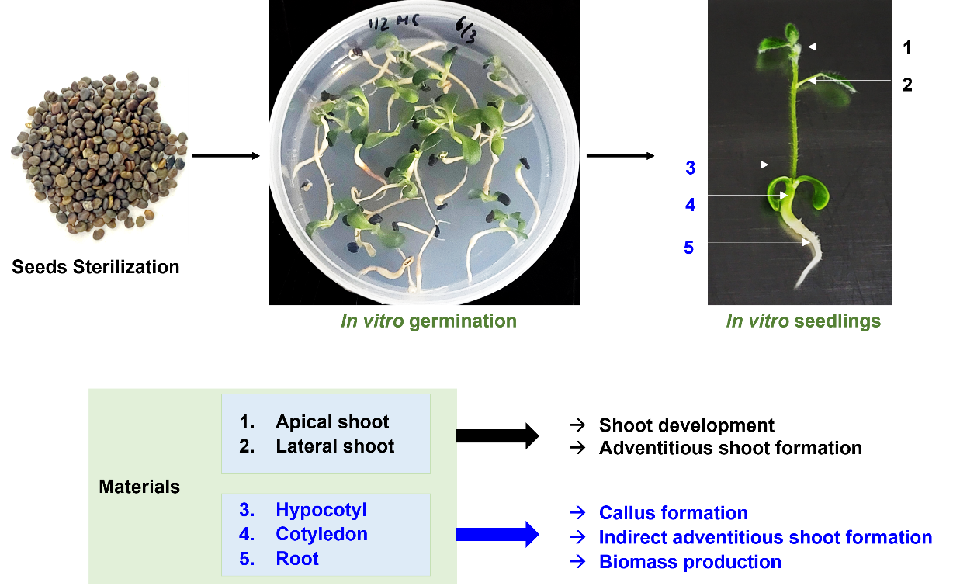

Fig. S1. Plant materials preparation.

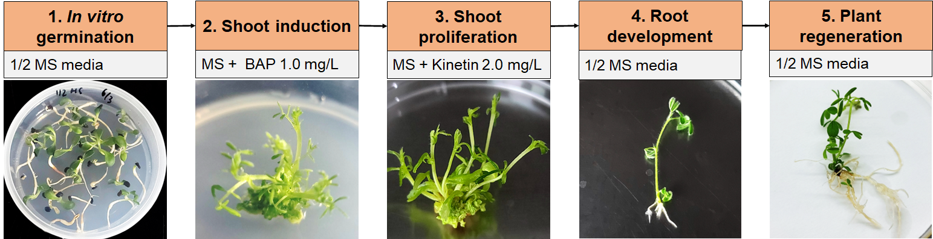

Fig. S2. The process of direct organogenesis

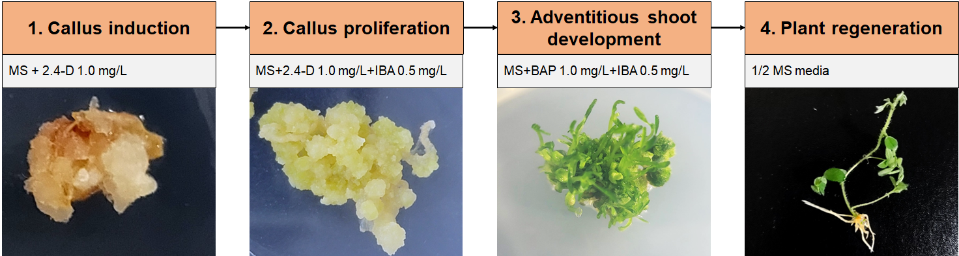
Fig. S3. The process of indirect organogenesis

