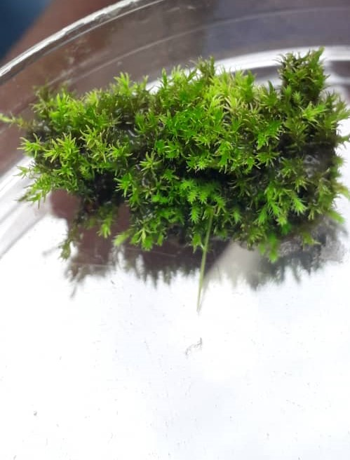
Plate 1: The Moss plant (Mnium hornum)

