Caffeic acid, a dietary polyphenol pre-sensitizes PDAC to chemotherapeutic drug.
Journal- Cellular Oncology
Authors: Shruti Gupta¹, Harshita Tak², Khushhal Rathore¹, Hemanth Naick Banavath², Kiran Kumar Tejavath^{1 *}
- Department of Biochemistry, School of Life Sciences, Central University of Rajasthan, NH-8, Bandarsindri, Ajmer 305817, Rajasthan, India.
- Department of Sports Bio-Sciences, School of Sports Science MYAS-CURAJ, Central University of Rajasthan, NH-8, Bandarsindri, Ajmer 305817, Rajasthan, India.

SUPPLEMENTARY FIGURES

Orcid IDs:
Shruti Gupta - 0000-0002-4934-4061
Harshita Tak- 0009-0008-7997-0072
Khushhal Rathore- 0009-0007-7063-4075
Hemanth Naick Banavath- 0000-0002-6972-5670
Kiran Kumar Tejavath – 0000-0001-7876-421X

*Corresponding Author:
Kiran Kumar Tejavath
Department of Biochemistry,
Central University of Rajasthan,
NH-8, Bandarsindri, Ajmer 305817,
Rajasthan, India.
e-mail: kirankumar@curaj.ac.in, kirankumartejavath@gmail.com.
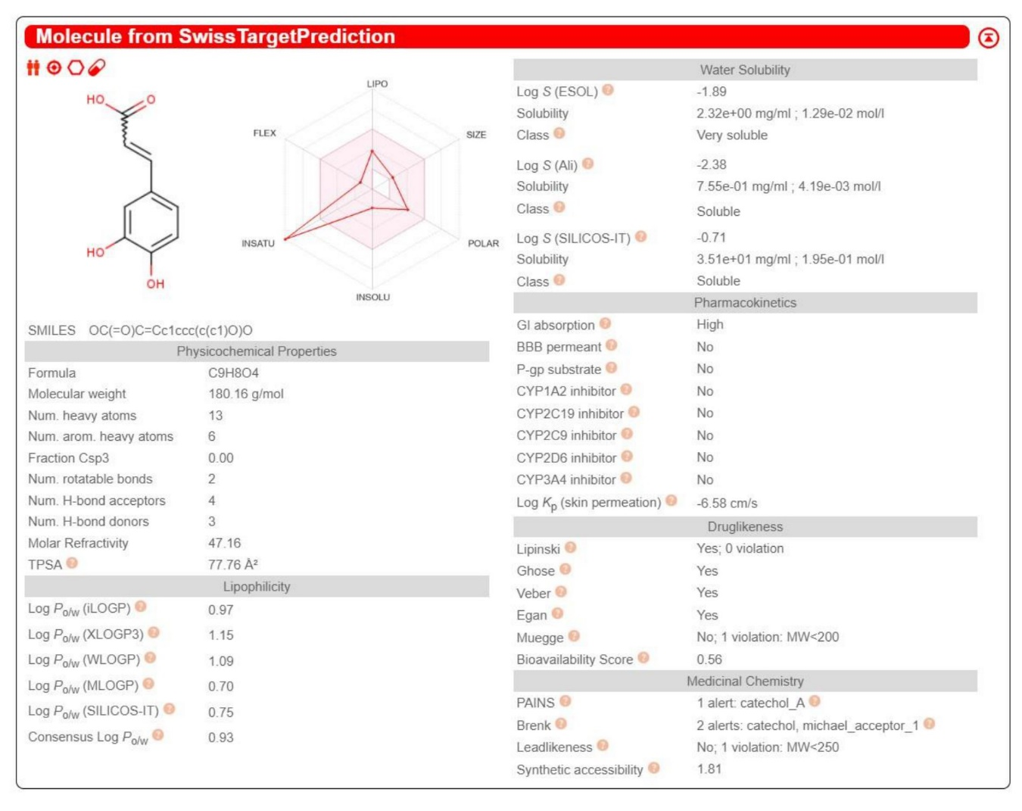

Fig. S1

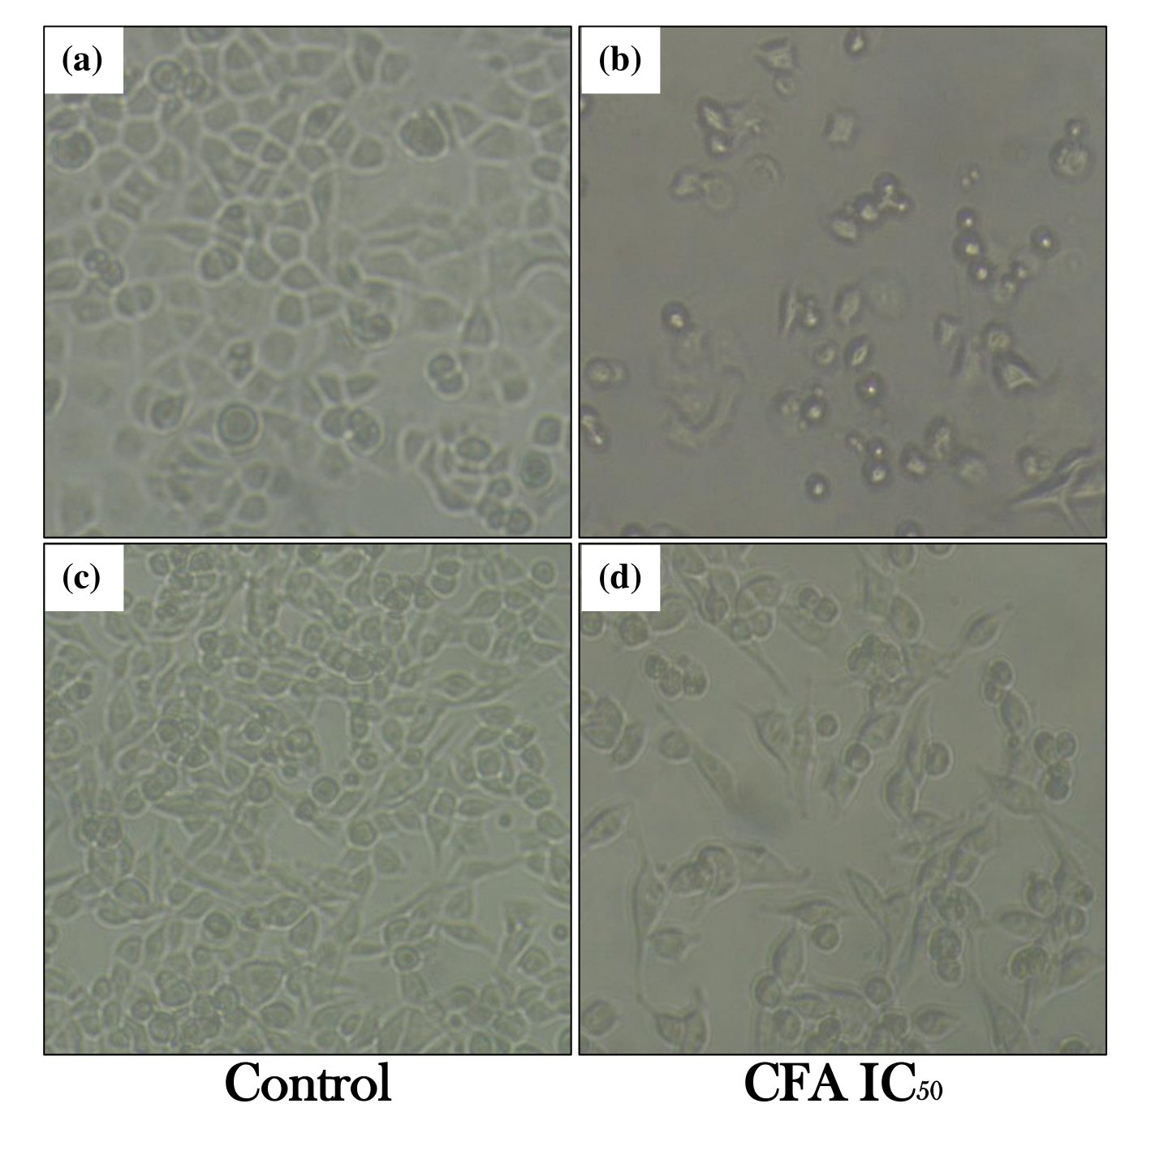
Fig. S2

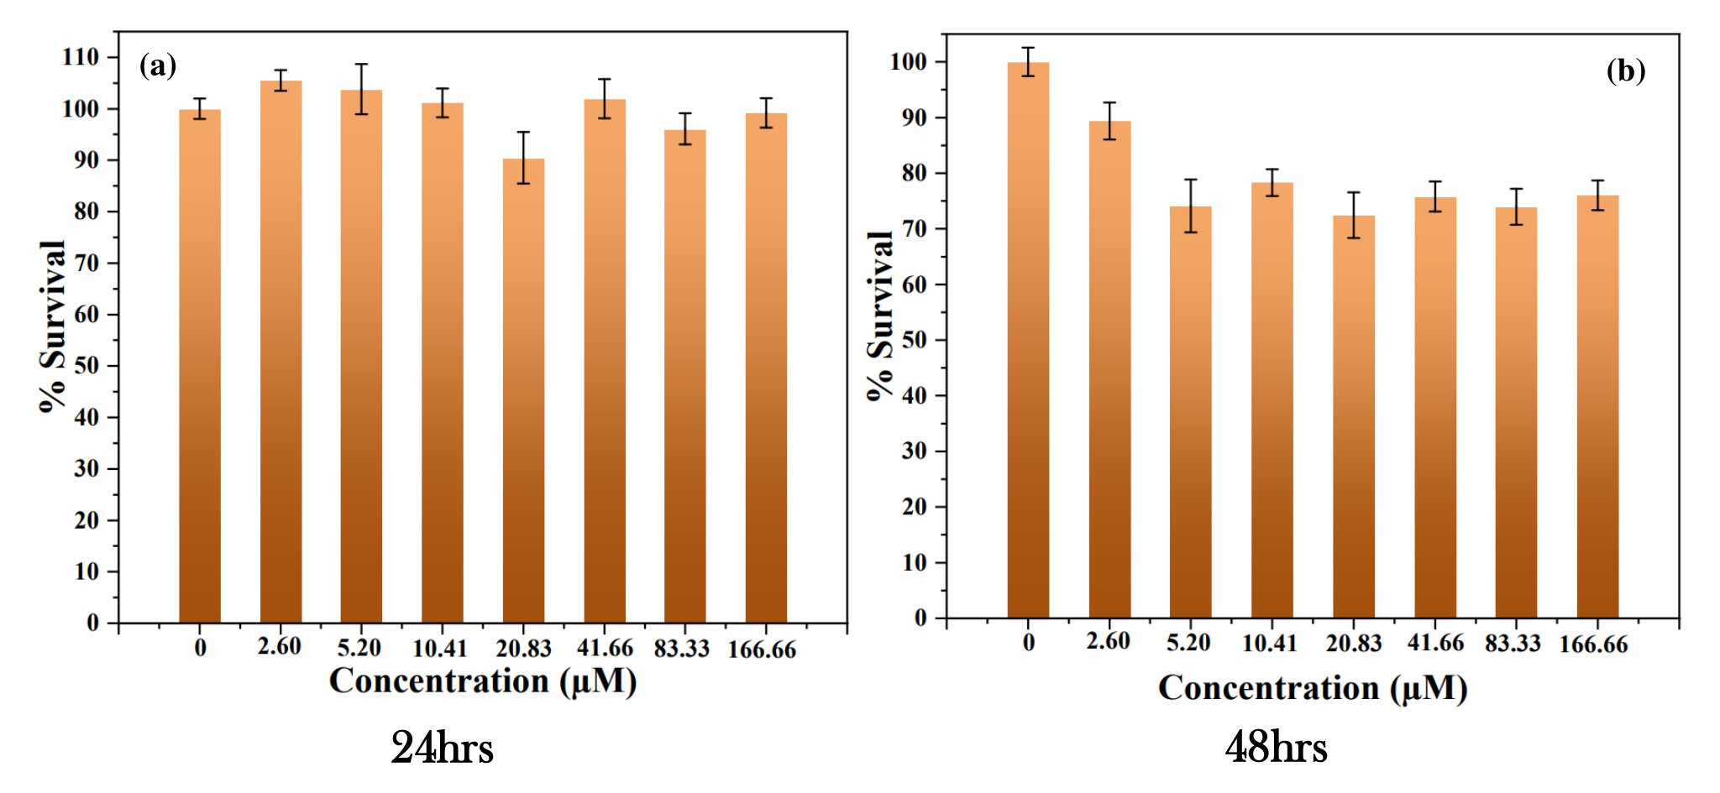
Fig. S3

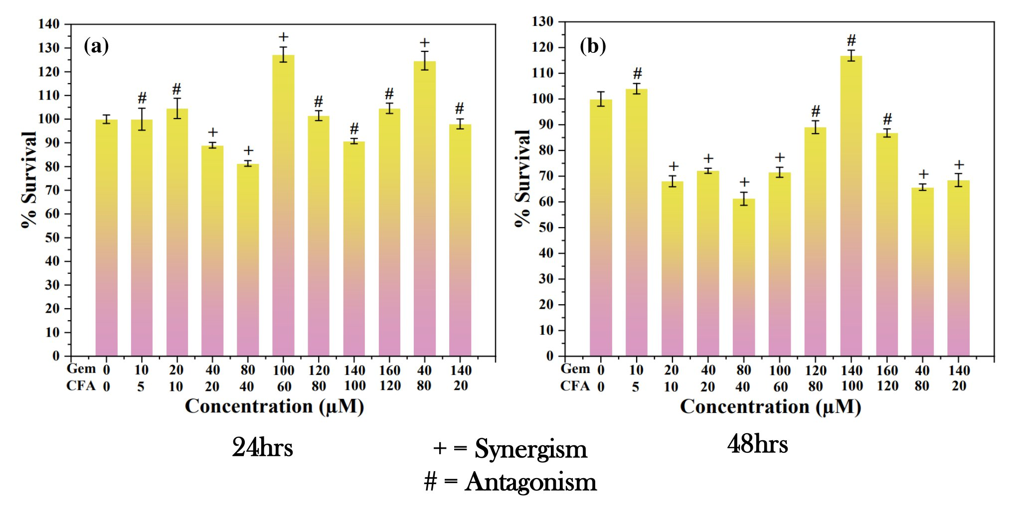
Fig. S4

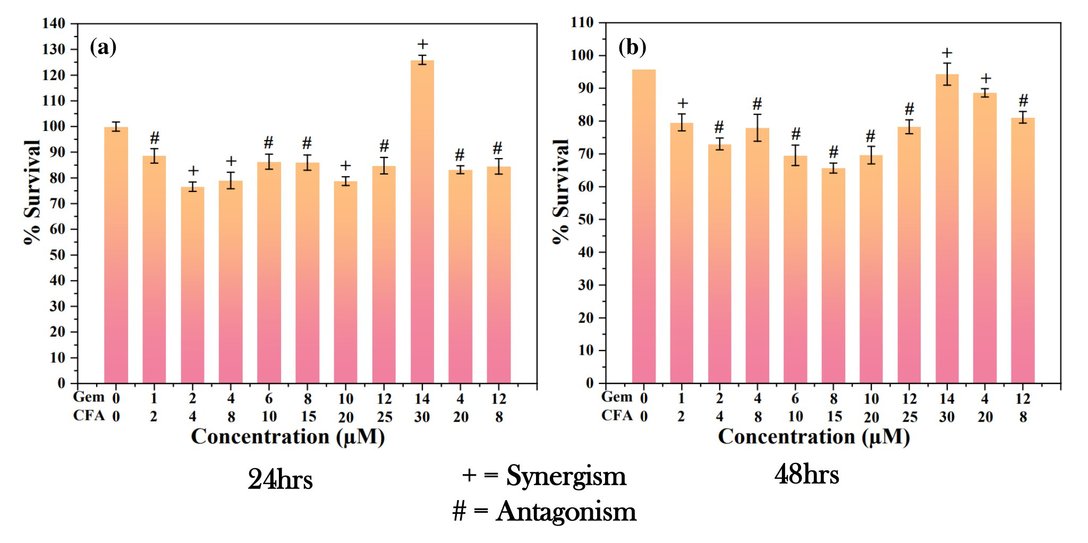
Fig. S5

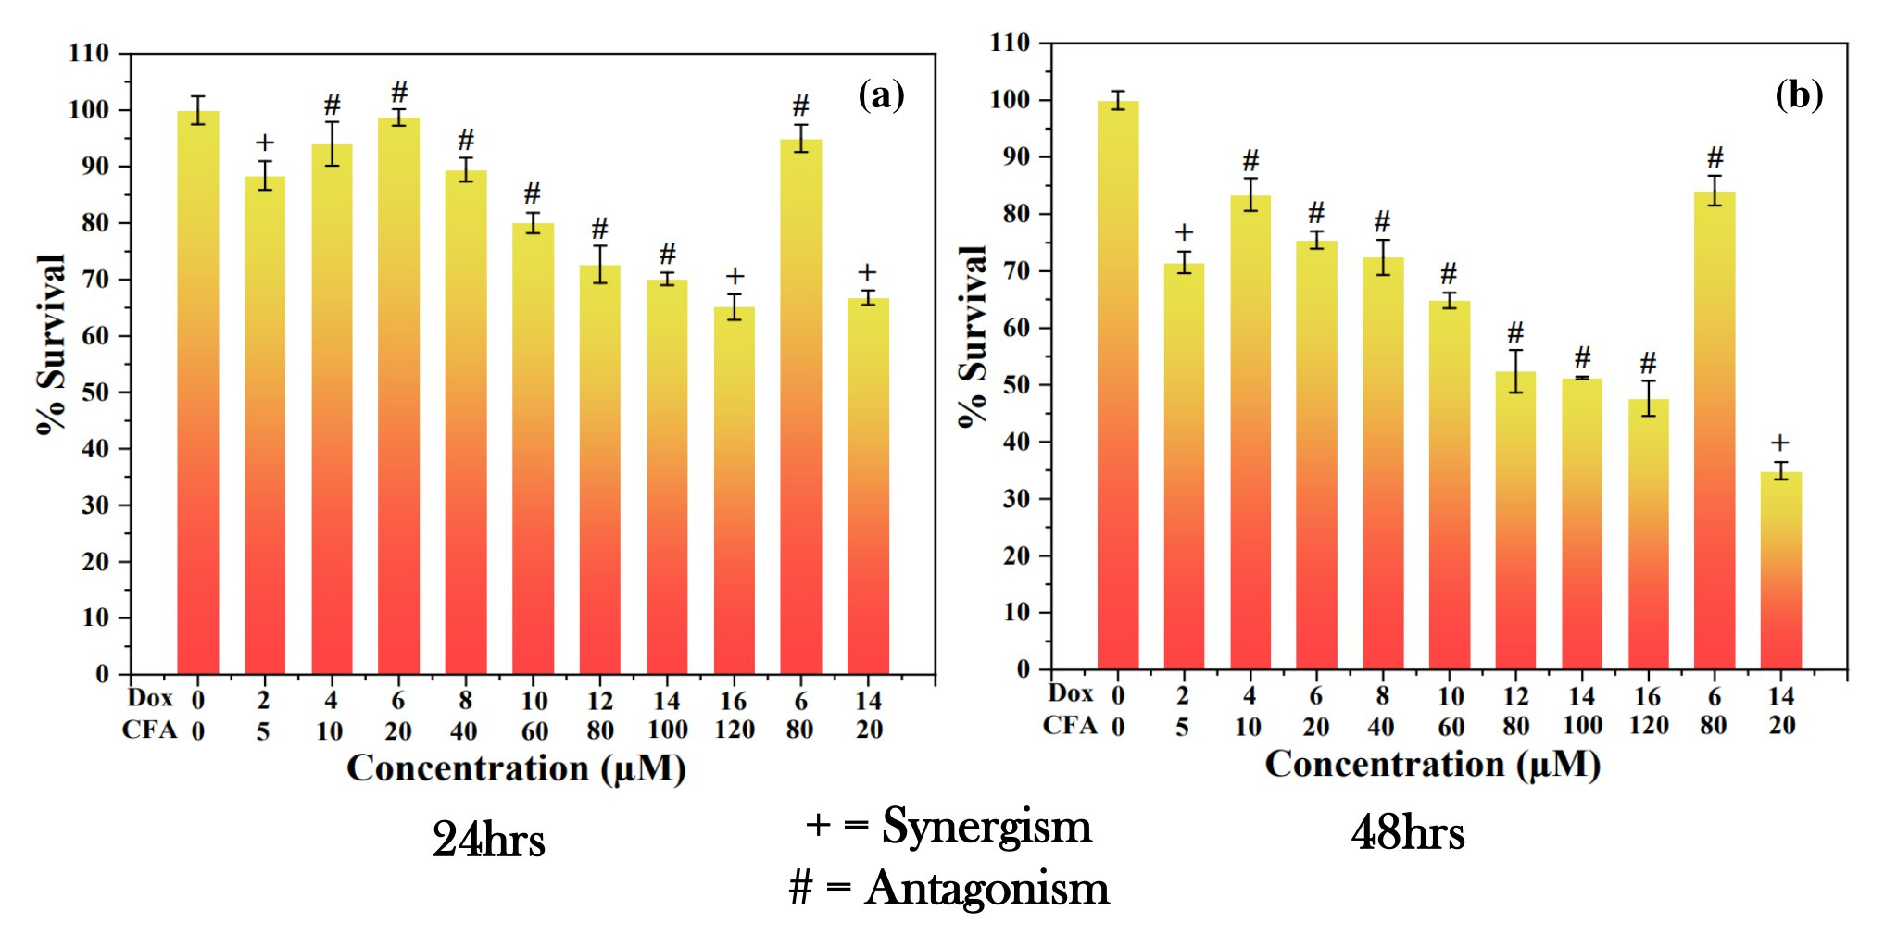
Fig. S6
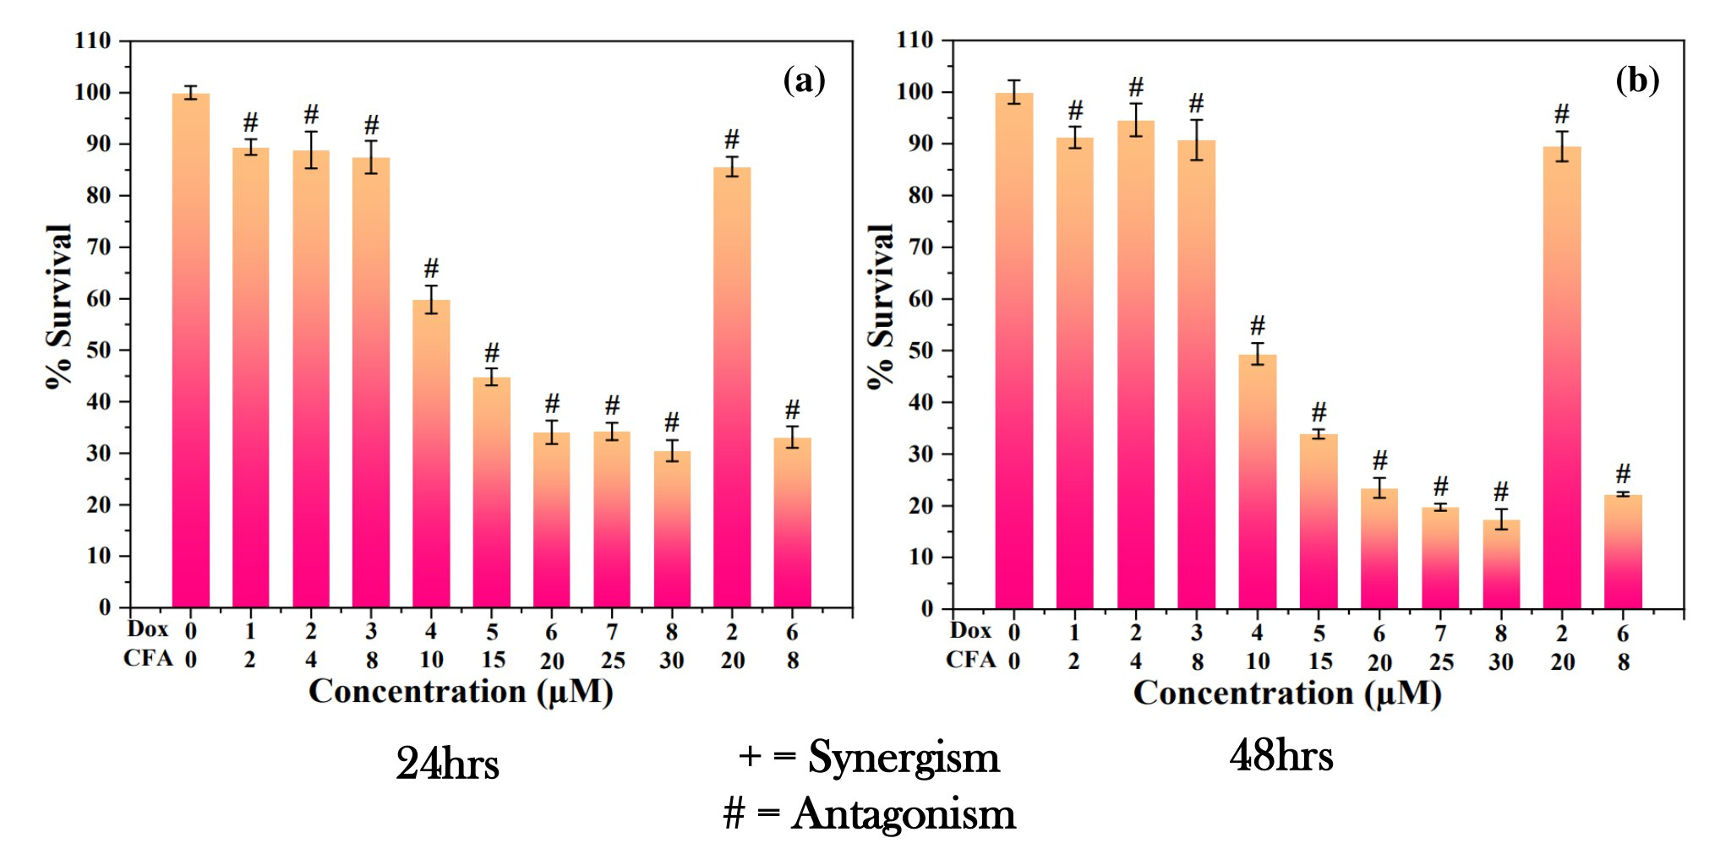
Fig. S7

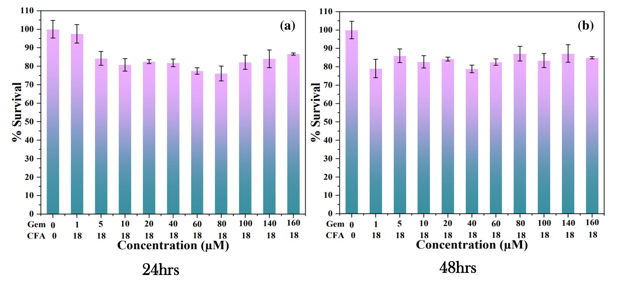
Fig. S8
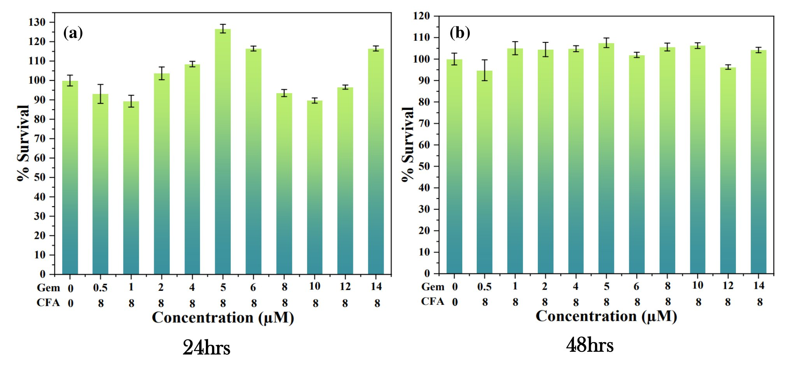

Fig. S9

