Supplementary Material
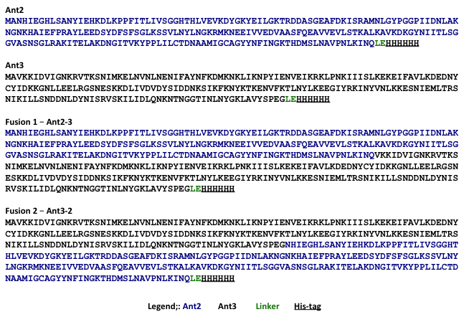
Figure A1: Amino acid sequences for all antigens: The amino acid sequence for single antigens, Ant2 (blue), Ant3 (black), fusion 1 (Ant2-3) and fusion 2 (Ant3-2) are shown. The position of a linker (green) and C-terminal 6×His tag (underlined) is also indicated.

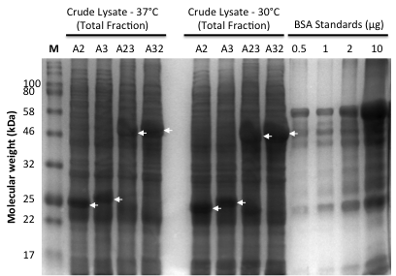
Figure A2: Analysis of protein production in bacterial cultures grown at higher temperatures (37°C and 30°C): Bacterial cultures for each antigen were harvested post-IPTG induction (20 h at 37°C or 30°C). The cell pellet was lysed via sonication and a sample of the crude lysate (total fraction) analysed by SDS-PAGE. Bovine serum albumin (BSA) was used as a protein standard. The band position for each protein is indicated with an arrow. Data is representative of at least four biological replicates.

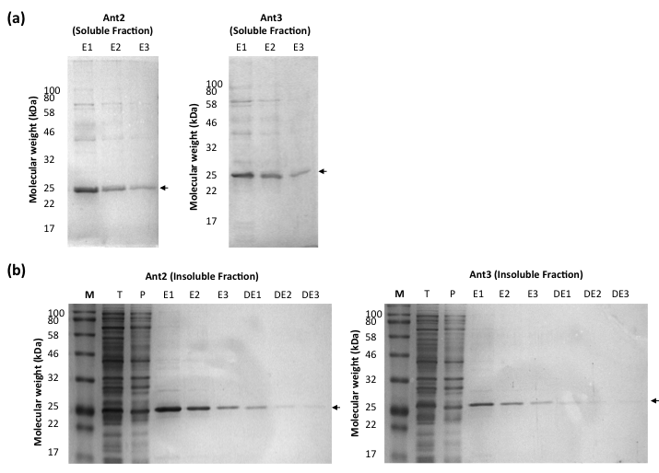
Figure A3: Purification of the single antigens from the soluble and insoluble fraction using immobilised metal affinity chromatography (IMAC). Ant2 and Ant3 were purified using the 6×His tag via IMAC from the soluble (a) and insoluble (b) fraction. For the insoluble fraction, proteins were re-solubilised in urea buffer prior to His-tag purification. Proteins were eluted with imidazole in 3 x 1ml stages (E1-E3). For the insoluble fraction, after elution with imidazole (E1-E3), insoluble proteins (after the re-solubilisation stage) were eluted with in 3 x 1ml stages with a denaturing elution buffer (DE1-DE3).

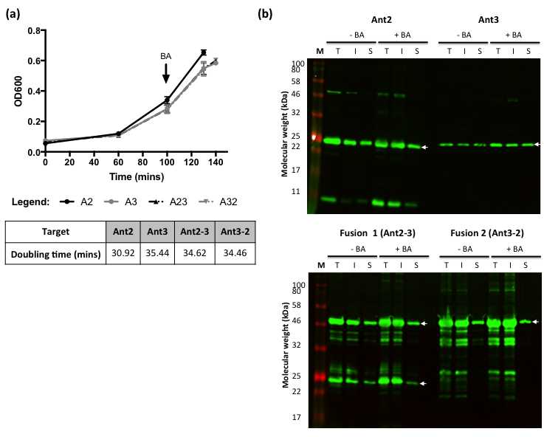
Figure A4: Addition of benzyl alcohol to bacterial cultures. This figure shows the OD600 plotted against the time (mins) for bacterial cultures transformed with Ant2, Ant3, fusion 1 (Ant2-3) and fusion 2 (Ant3-2) (a). Benzyl alcohol (BA, 10mM final concentration) was added to cultures 30 min prior to IPTG induction. The table summarises the estimated doubling time (mins) of each culture analysed using the exponential growth equation in GraphPad Prism. Error bars shown are the mean value ± SEM of three biological replicates (n=3). Untreated cultures were used as a control (data not shown). Cultures were induced with IPTG and incubated for 20 h at 18°C. After incubation, cultures ± BA were harvested and the total fraction (T), insoluble fraction (I) and soluble fraction (S) isolated for western blot analysis (b). Data is representative of three biological replicates.
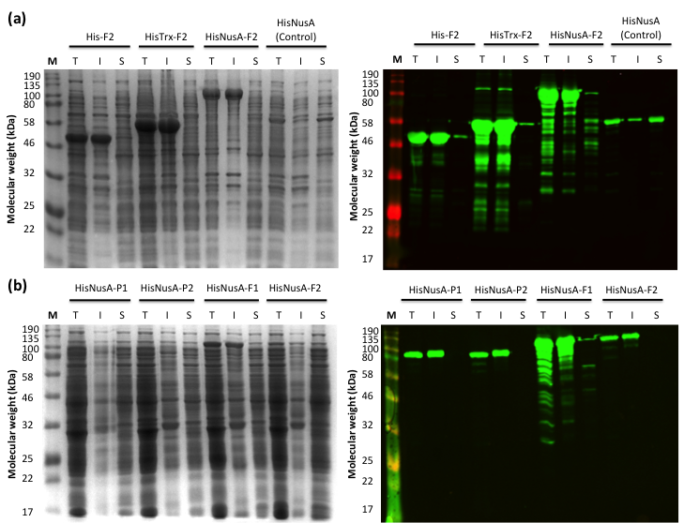
Figure A5: Repeat analysis of N-terminal solubility-tagged Fusion 2 (Ant3-2) constructs and addition of the N-terminal NusA solubility tag to the single antigens (Ant2 and Ant3) and fusion 1 (Ant2-3). This figure shows repeat SDS-PAGE and western blot analysis of the different N-terminally tagged Ant3-2 constructs expressed in the BL21-CodonPlus (DE3) E.coli strain with the expression of pHisNusA alone as a control (a). Ant2, (P1) Ant3 (P2) and Fusion 1 (F1, Ant2-3) were cloned with a N-terminal pHisNusA tag. The different N-terminally tagged constructs were expressed in BL21-CodonPlus (DE3) E.coli strain and the protein production and solubility assessed via SDS-PAGE and western blot (b).

Table AI: Protein concentration of purified protein samples.
Sample |  | Protein concentration (mg/ml)
Ant2 | E1 | 1.52
Ant2 | E2 | 1.80
Ant2 | E3 | 1.99
Ant2 | E4 | 1.94
Ant2 | E5 | 1.71
Ant3 | E1 | 1.09
Ant3 | E2 | 1.16
Ant3 | E3 | 1.20
Ant3 | E4 | 1.13
Ant3 | E5 | 1.12
This table summarises the estimated protein concentration for Ant2 and Ant3 after 6×His tag purification and re-folding from the insoluble fraction (1L total volume bacterial culture).

