Supplemental: Structure-Dynamics Correlation in Metallic Glass Revealed by 5-Dimensional Scanning Transmission Electron Microscopy
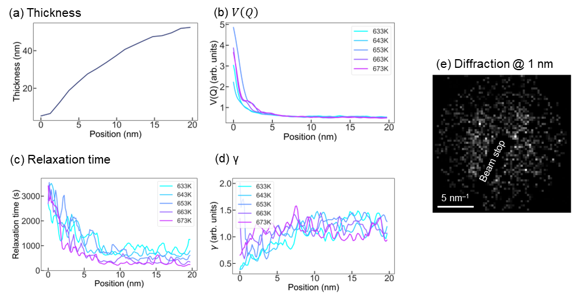
Fig. S1 (a) Thickness, (b) $V\left(Q\right)$, (c) relaxation time, and (d) $γ$, measured along the spatial x-axis and averaged along the y-axis. As shown fig. S1(e), diffraction patterns acquired within 1 nm from the left edge of the sample exhibit no speckles and are dominated by noise around 4 nm⁻¹ because of the small thickness. The values of $V\left(Q\right)$, relaxation time, and $γ$ measured in this area are not reliable. Strong thickness dependences of $V\left(Q\right)$, relaxation time, and $γ$ are observed at positions from 1 nm to 10 nm. As the thickness increases, relaxation time and $γ$ increase and $V\left(Q\right)$ decreases in this sample area. Thickness dependences saturate at positions > 10 nm. Only the area which positions > 10 nm was used for measuring the average relaxation time, $γ$, $V\left(Q\right)$ and correlation between heterogeneities to reduce the thickness dependence.

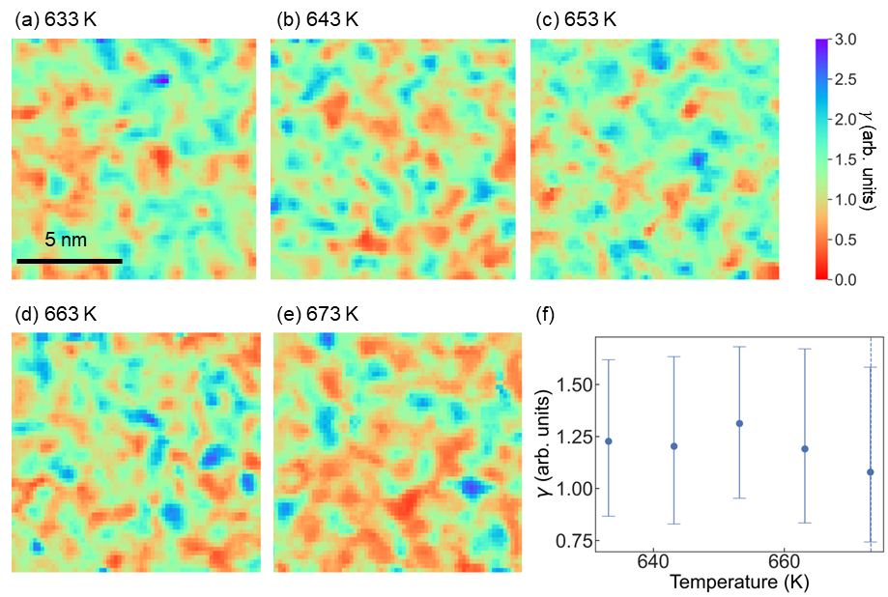
Fig. S2 Maps of $γ$ at (a) 633 K, (b) 643 K, (c) 653 K, (d) 663 K, and (e) 673 K. (f) Temperature dependence of the average value of $γ$.
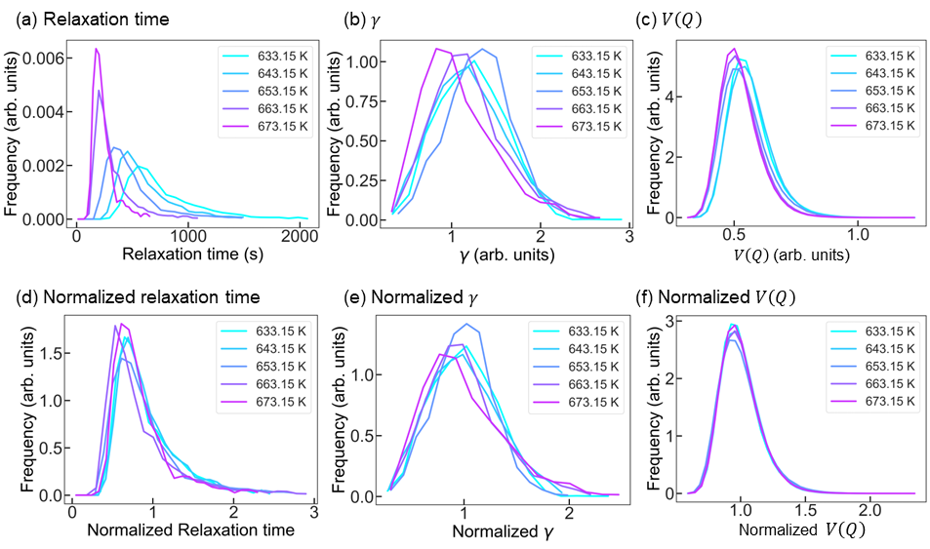

Fig. S3 Distributions of (a) relaxation time, (b)$γ$ and (c)$V\left(Q\right)$. Panels (d), (e), and (f) show the distributions of normalized relaxation time, $γ$, and $V\left(Q\right)$. Normalizations are conducted by divisions by their average values.
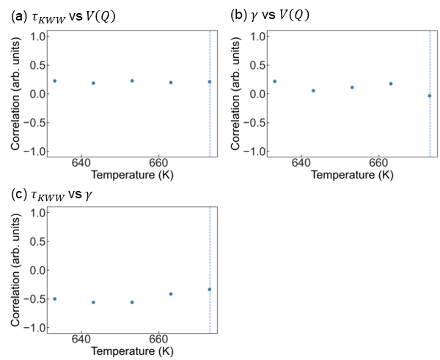
Fig. S4. Temperature dependences of pairwise correlations of (a)$τ_{KWW}$ vs $V\left(Q\right)$, (b)$γ$ vs $V\left(Q\right)$, and (c)$τ_{KWW}$ vs $γ$.

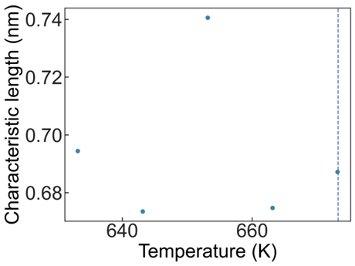
Fig. S5. Temperature dependence of the characteristic length of dynamical heterogeneity.

Measurement of relaxation time.
In calculating the correlation $G\left(Q, t_{1}, t_{2}\right)$, diffraction patterns were binned by 2 along the time direction to reduce noise. After binning, the number of temporal diffraction images became 53. Gaussian blur with a variance of 0.21 nm⁻¹ was applied to diffraction patterns. Then $G\left(Q, t_{1}, t_{2}\right)$ was calculated from pixels whose $\left|Q\right|$ ranged from 4.2 to 4.6 nm⁻¹. $g\left(Q, t\right)$ was calculated from $G\left(Q, t_{1}, t_{2}\right)$ and the relaxation time was measured by fitting the KWW function. To reduce noise, $g\left(Q, 0\right)$ and $g\left(Q, t>t_{half}\right)$ was excluded from fitting. $t_{half}$ indicates half of the observation time. We set the range of relaxation time from 0 to 5,000 s and the range of γ from 0 to 3, and performed fitting.

Thickness measurement
Thickness was measured by EELS using the log-ratio method and a convergence semiangle of 20 mrad. We calculated the absolute thickness taking 110 nm as the mean free path of Zr₅₀Cu₄₀Al₁₀. This value is the average of mean free path values for each element weighted by its composition¹. The thickness variation across the sample and thickness dependences of $τ$, $γ$ and $V\left(Q\right)$ are shown in fig. S1; $τ$, $γ$ and $V\left(Q\right)$ were averaged values over a region of the same thickness. The sample is thicker at the right side than at the left side. The values of $τ$ and $V\left(Q\right)$ at the left edge are excessively high because of the weak signals originating from a thin sample area. In the right half of the sample, $τ$ and $V\left(Q\right)$ increase with thickness. Thickness dependences of $V\left(Q\right)$, relaxation time, and $γ$ saturate at positions larger than10 nm from the left edge, indicating a small thickness dependence in the range 35 to 50 nm. To reduce the effect of thickness, only the right half of the sample was used for measuring the average relaxation time, $γ$, $V\left(Q\right)$, characteristic length and correlation between heterogeneities.

Mapping of $γ$
Spatial distributions of $γ$ are shown in Figs. S2. They are heterogeneous at all temperatures. The temperature dependence of average value of $γ$ is shown in Fig. S2(f). Note that $γ$ represents the nonlinearity and is expected to be smaller than 1 according to the heterogeneous dynamic scenario. However, at low temperatures, the average of $γ$ is around 1.2. As temperature approaches T_{g}, average $γ$ approaches 1.0 indicating the decrease of linearity. Thus, in this experiment, the decay of correlation function takes compressed shape. Compressed relaxation functions below T_{g} is also observed by X-ray photon correlation spectroscopy in the Mg₆₅Cu₂₅Y₁₀ glass².

Histograms of $τ$, $γ$ and $V\left(Q\right)$
Figures S3 show the histograms of $τ$, $γ$ and $V\left(Q\right)$. The frequency means the number of counts for each value. The bottom row shows the histograms normalized by their average values. As temperature increases, the frequency of small values of $τ$, $γ$ and $V\left(Q\right)$increases and the histograms become narrower. Normalization eliminated the temperature dependence for relaxation time, $V\left(Q\right)$, and possibly for $γ$ (considering the large uncertainty in its value). Thus, these values can be scaled by temperature.

Correlation among $τ$, $γ$ and $V\left(Q\right)$
We also measured the positional correlation among $τ$, $γ$ and $V\left(Q\right)$. The results are shown in Figs. S4. The correlation between $τ$ and $V\left(Q\right)$ at arbitrary $γ$ ranges from 0.15 to 0.27 indicating a weaker positive correlation than correlation between $τ$ and $V\left(Q\right)$ measured at $γ$ = 1. The correlation between $γ$ and $V\left(Q\right)$ also ranges from 0.17 to 0.0. The correlation between $τ$ and $V\left(Q\right)$ ranges from -0.74 to -0.56 indicating a strong negative correlation between them. Thus, a long relaxation time relates to a small $γ$. The small $γ$ ($γ<1$) stretches the decay function and effectively lengthen relaxation time and vice versa. The correlation between $τ$ and $V\left(Q\right)$ is weaker at arbitrary $γ$ than at $γ=1$ because small γ and high $τ$ correspond to large $V\left(Q\right)$.

Characteristic length
To estimate the size of the dynamic heterogeneous region, we also measured the characteristic length of structural heterogeneity $ξ$ by calculating a four-point correlation. We used the following equation:
$$G_{4}\left(Q, Δr, Δt\right)=\frac{{\left\langle I\left(Q, r, t\right)I\left(Q, r+Δr, t\right)I\left(Q, r, t+Δt\right)I\left(Q, r+Δr, t+Δt\right)\right\rangle }_{k, r, t}}{{\left\langle I\left(Q, r, t\right)\right\rangle }_{k}{\left\langle I\left(Q, r+Δr, t\right)\right\rangle }_{k}{\left\langle I\left(Q,r, t+Δt\right)\right\rangle }_{k}{\left\langle I\left(Q,r+Δr, t+Δt\right)\right\rangle }_{k}}$$
The correlation was measured from the part of diffraction patterns whose spatial frequency ranged from 4.2. to 4.6 nm⁻¹. We measured $ξ$ by fitting the following equation
$$G_{4}\left(Q, r, t\right)-1=β\exp\left(-2{\left(\frac{t}{τ}\right)}^{γ_{t}} \right)\exp\left(-2{\left(\frac{r}{ξ}\right)}^{γ_{r}} \right),$$
where $r$ is the position in real space and $γ_{t}$ and $γ_{r}$ are stretch factors. This fitting yields the length and time to lose the correlation between diffraction patterns. The characteristic length at 633 K was 0.69 nm, which is close to the diameter of the electron probe (0.78 nm). The temperature dependence of characteristic length is shown in Fig. S5. At all temperatures, the characteristic length was smaller than the diameter of the electron probe. Thus, no drastic change in the size of the dynamic heterogeneous region near T_{g} could be detected.

Movie S1. Temporal change of diffraction patterns with low relaxation time at 633 K. (1,000 s compressed to 10 s)
Movie S2. Temporal change of diffraction patterns with high relaxation time at 633 K. (1,000 s compressed to 10 s)

1. Iakoubovskii, K., Mitsuishi, K., Nakayama, Y. & Furuya, K. Mean free path of inelastic electron scattering in elemental solids and oxides using transmission electron microscopy: Atomic number dependent oscillatory behavior. Phys. Rev. B 77, 1–7 (2008).
2. Ruta, B. et al. Atomic-scale relaxation dynamics and aging in a metallic glass probed by X-ray photon correlation spectroscopy. Phys. Rev. Lett. 109, 1–5 (2012).

