Supplementary
Table S1 Correlations between gauge-based rainfall observations and reanalysis rainfall. Gauge-based rainfall datasets include CPC UNI, CMAP, CHIRPS, and GPCC. Reanalysis products include MERRA-2, ERA-5, JRA-55, and NCEP Reanalysis I. See Methods for references.
 | CPC UNI | CMAP | GPCC | CHIRPS
CPC UNI | 1
CMAP | 0.92 | 1
GPCC | 0.81 | 0.94 | 1
CHIRPS | 0.87 | 0.85 | 0.86 | 1
MERRA-2 | 0.94 | 0.91 | 0.84 | 0.89
JRA-55 | 0.79 | 0.73 | 0.69 | 0.88
NCEP-I | 0.53 | 0.57 | 0.49 | 0.53
ERA-5 | 0.66 | 0.76 | 0.93 | 0.73

Table S2 List of ﻿CMIP6 models and the ensemble sizes for historical all-forcing, historical GHG-only, SSP2-4.5, and SSP5-8.5 experiments.

Model name | hist all-forcing | hist GHG-only | SSP2-4.5 | SSP5-8.5
ACCESS-CM2 | 10 | 3 | 5 | 5
ACCESS-ESM1-5 | 40 | 3 | 40 | 40
AWI-CM-1-1-LR | 1
AWI-CM-1-1-MR | 5 |  | 1 | 1
CAMS-CSM1-0 | 3 |  | 2 | 2
CanESM5 | 50 | 50 | 50 | 50
CanESM5-CanOE | 3 |  | 3 | 3
CAS-ESM2-0 | 4 |  | 2 | 2
CESM2 | 11 | 3 | 3 | 3
CESM2-FV2 | 4
CESM2-WACCM | 3 |  | 5 | 5
CESM2-WACCM-FV2 | 3
CMCC-CM2-HR4 | 1
CMCC-CM2-SR5 | 6 |  | 1 | 1
CMCC-ESM2 | 1 |  | 1 | 1
CNRM-CM6-1 | 30 | 10 | 6 | 6
CNRM-CM6-1-HR | 1 |  | 1 | 1
CNRM-ESM2-1 | 11 |  | 10 | 5
E3SM-1-0 | 5 | 3 |  | 5
E3SM-1-1 | 1 |  |  | 1
E3SM-1-1-ECA | 1
E3SM-2-0 | 5 | 5
EC-Earth3 | 10 |  | 10 | 10
EC-Earth3-CC | 6 |  | 1 | 1
EC-Earth3-Veg | 6 |  | 6 | 5
EC-Earth3-Veg-LR | 3 |  | 3 | 3
FGOALS-f3-L | 3 |  | 1 | 1
FGOALS-g3 | 4 | 3 | 4 | 4
GFDL-ESM4 | 3 | 1 | 3 | 1
GISS-E2-1-G | 44 | 10 |  | 11
GISS-E2-1-H | 25 |  | 9 | 6
GISS-E2-2-G | 11 |  | 5 | 5
GISS-E2-2-H | 5
HadGEM3-GC31-LL | 5 | 5 | 5 | 4
HadGEM3-GC31-MM | 4 |  |  | 4
IITM-ESM | 1 |  | 1 | 1
INM-CM4-8 | 1 |  | 1 | 1
INM-CM5-0 | 10 |  | 1 | 1
IPSL-CM5A2-INCA | 1
IPSL-CM6A-LR | 33 | 10 | 11 | 7
IPSL-CM6A-LR-INCA | 1
MIROC-ES2H | 3
MIROC-ES2L | 31 |  | 30 | 10
MIROC6 | 50 | 50 | 50 | 50
MPI-ESM-1-2-HAM | 3
MPI-ESM1-2-HR | 10 |  | 2 | 2
MPI-ESM1-2-LR | 31 |  | 30 | 30
MRI-ESM2-0 | 12 | 5 | 10 | 6
NESM3 | 5 |  | 2 | 2
NorCPM1 | 30
NorESM2-LM | 3 | 3 | 13 | 1
NorESM2-MM | 3 |  | 2 | 1
UKESM1-0-LL | 19 |  | 5 | 5

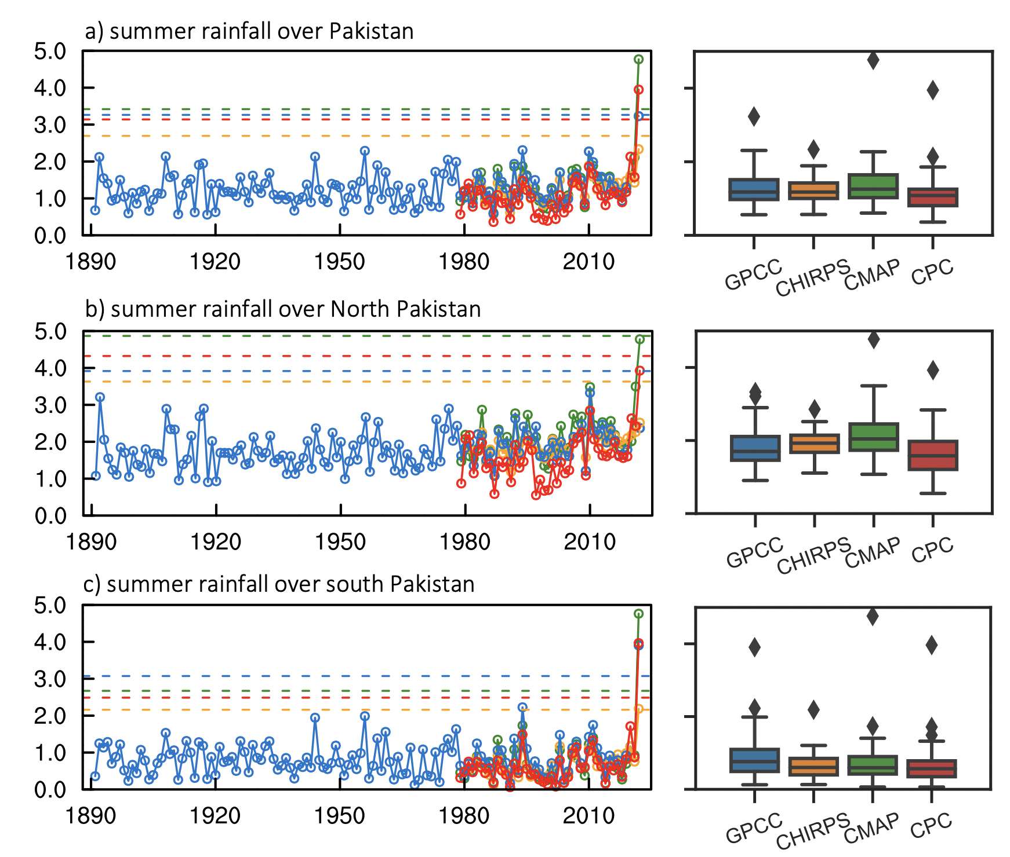
Supplementary Figure S1 Time series and boxplot of the summer rainfall averaged over (a) Pakistan, (b) northern Pakistan (to the north of 30°N), and (c) southern Pakistan (to the south of 30°N) during period 1890-2022. Blue, gray, green, and red colors represent GPCC, CHIRPS, CMAP, and CPC UNI rainfall datasets. The dashed lines in (c,e,g) denote 5 standard deviations (σ).

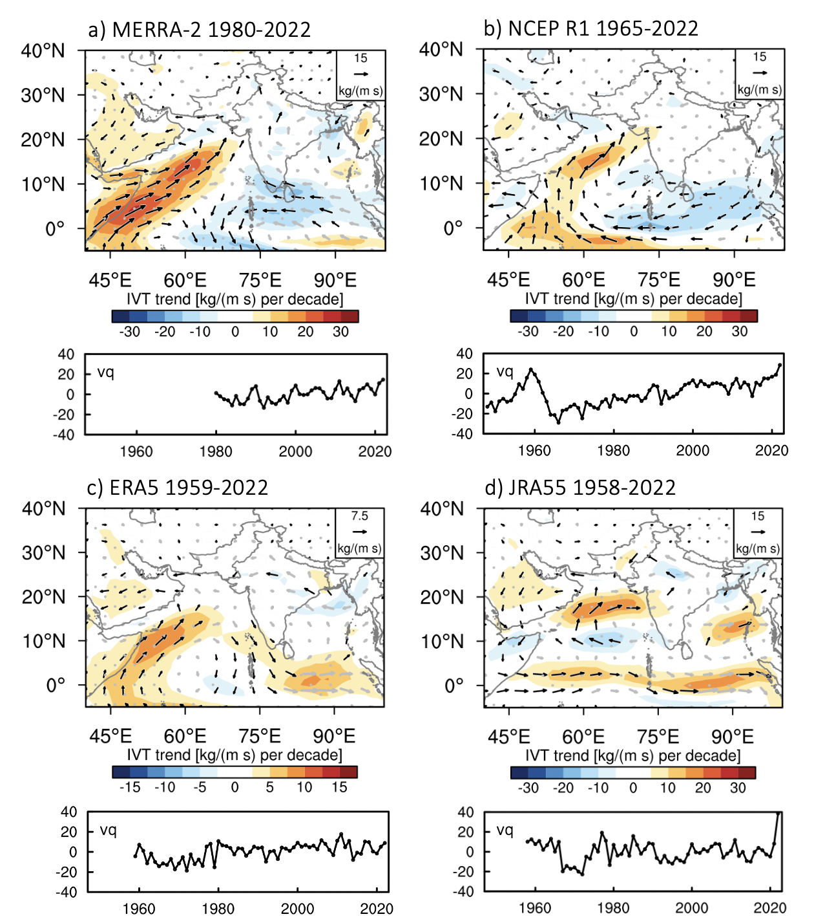
Supplementary Figure S2 (top) Linear trend of moisture fluxes (vector) and its magnitude (shading) and (bottom) meridional moisture flux averaged over 0°-20°N, 40°E-65°E in (a) MERRA-2 (1980-2022), (b) NCEP Reanalysis I (1965-2022), (c) ERA-5 (1959-2022), and (d) JRA-55 (1958-2022). Stippling indicates statistical significance at 90% confidence level.

Supplementary Text S1: Bash script to obtain LPS trajectories using TempestExtremes
# File containing geopotential (m²/s²)
topofile="MERRA2_orography.nc"

# File containing 850hPa vorticity (vo; s⁻¹)
vorfile=vor.nc

# File containing sea level pressure (slp; unit: hPa)
pslfile="slp.nc"

# File containing wind field at 850 hPa (ua, va ;m/s)
ufile="u850.nc"
vfile="v850. nc"

# Candidate file
candidatefile="LPS_candidates.txt"

# Output file
outfile="LPS_output.txt"

# Detect candidates
$PATH_TEMPEST_BIN/DetectNodes
--in_data "$vorfile;$ufile;$vfile;$pslfile;$topofile" --out $candidatefile
--searchbymax "vo" --mergedist 3.0
--thresholdcmd "vo,>=,4.e-5,0;zs,<=,10000,0"
--closedcontourcmd "slp,0.2,5.0,3.0"
--outputcmd "vo,max,0;slp,min,5;_VECMAG(ua,va),max,5;zs,max,0"
--minlat 0 --maxlat 45 --minlon 40 --maxlon 110

# Stitch candidates
$PATH_TEMPEST_BIN/StitchNodes
--in $candidatefile --out $outfile
--format "i,j,lon,lat,vo,slp,wind,alt"
--range 5.0 --maxgap 2 --min_path_dist 5
--minlength 8 --min_endpoint_dist 5
--threshold "lat,>=,10,1;lat,<=,35,1;lon,>=,60,1;lon,<=,95,1;slp,<=,-2.0,4"

