Extended Data
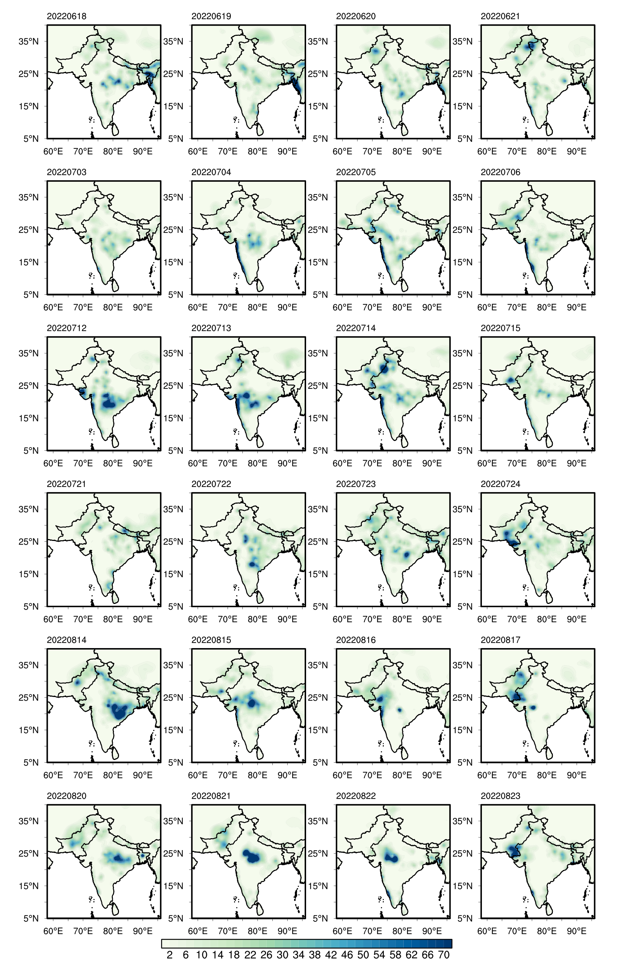
Extended Data Fig. 1 | Evolution of daily rainfall during the six rain pluses that influenced Pakistan during summer 2022. Each row is for a different rain pulse, followed for four days (left to right) as indicated by the panel titles. Unit: mm/day.

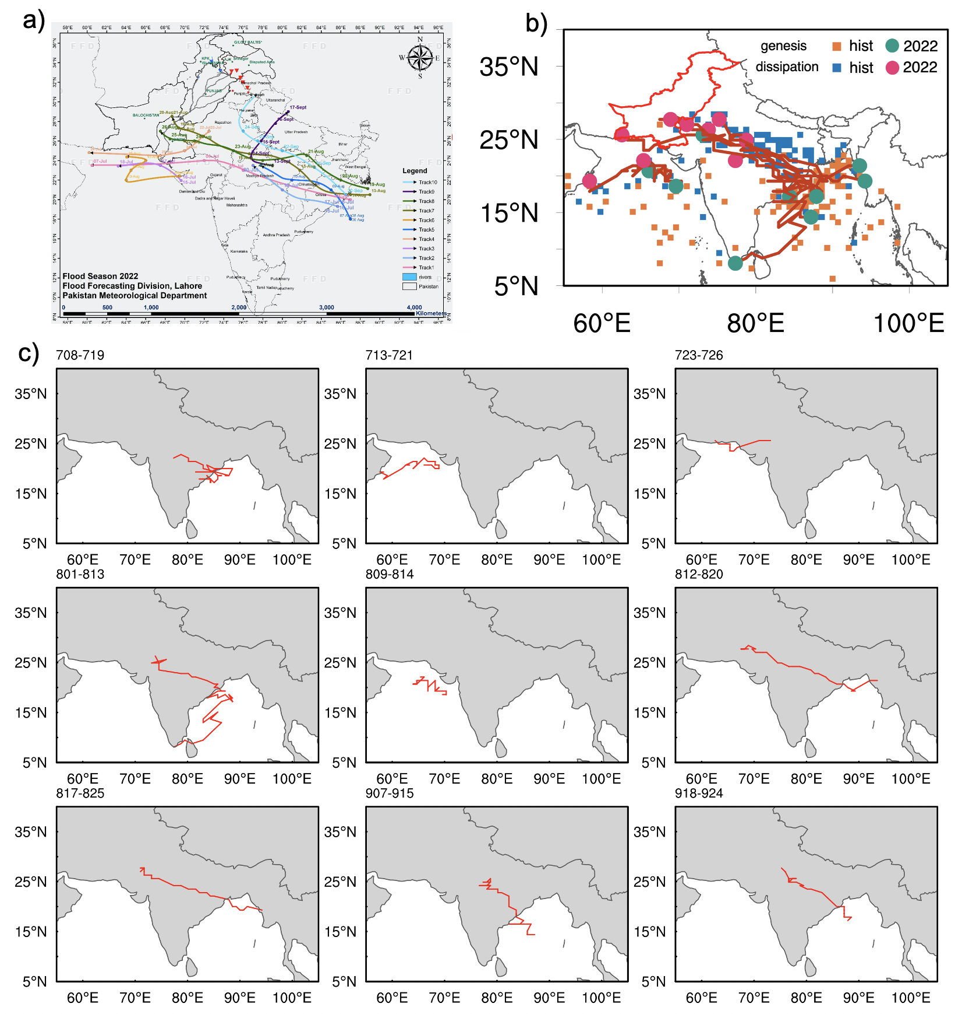
Extended Data Fig. 2 | Manual and objective tracking of 2022 LPS. 2022 LPS trajectories obtained by a, Pakistan Meteorological Department (from https://www.pmd.gov.pk/cdpc/Monsoon_2022_update/MonsoonTracks.jpg) and b, the objective feature tracking algorithm. The orange and blue squares (green and pink circles) denote the trajectories, genesis locations, and dissipation locations for the LPS in random 10 summers during 1980-2010 (the LPS in summer 2022), respectively. c, Trajectories and timing of the nine individual 2022 LPS obtained by objective tracking.
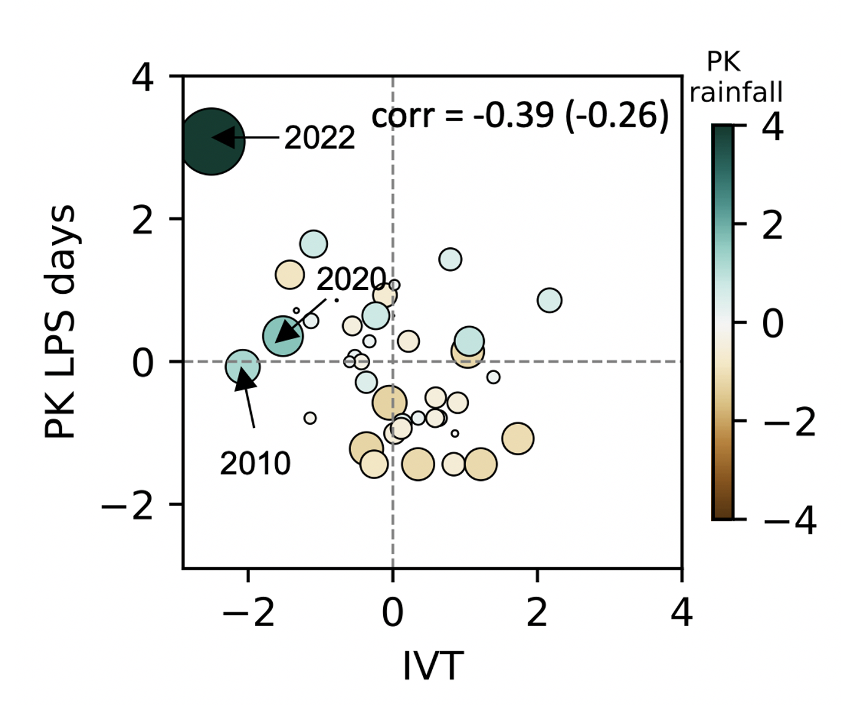
Extended Data Fig. 3 | Contribution of water vapor transport over the eastern Bay of Bengal to LPS activity over Pakistan. Scatter plot of the normalized summer mean water vapor transport over the eastern Bay of Bengal (10°-30°N, 75°-95°E; x axis) and the normalized number of days on which the LPS were present inside the Pakistan box (y axis). The size and color of the markers indicates the normalized summertime rainfall averaged over Pakistan (see color bar). Correlations outside and inside the parentheses are calculated with and without 2022 values, respectively.

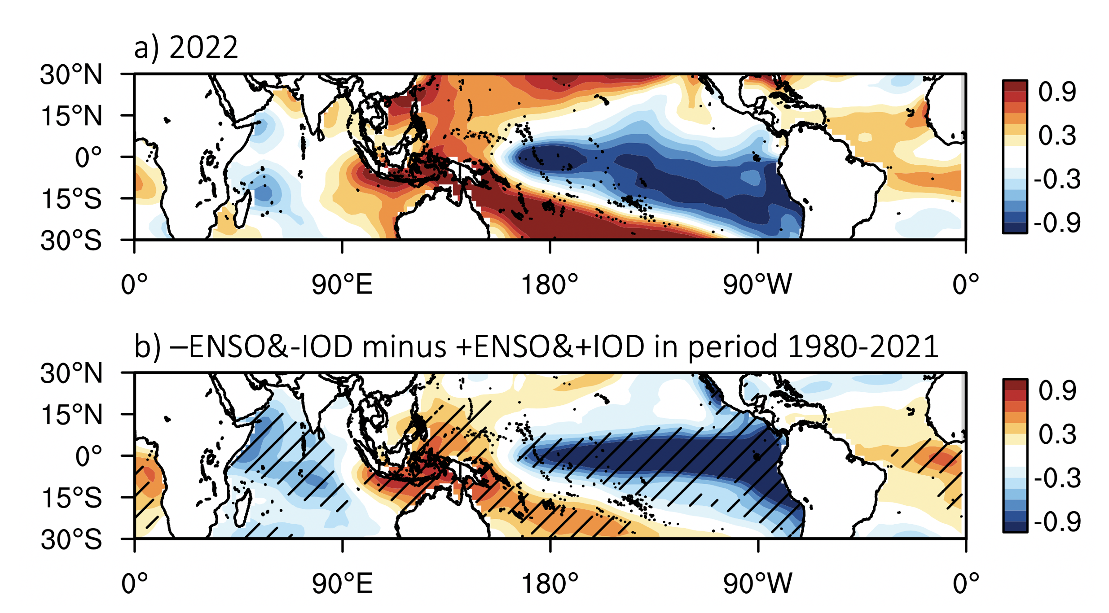
Extended Data Fig. 4 | Sea surface temperature (SST) anomalies. a, SST anomalies during summer 2022. b, Difference of SST anomalies between summers with negative phases of ENSO and IOD and summers with positive phases. Hatching in (b) represents statistical significance at 95% confidence level as determined by a student t-test. Unit: K.

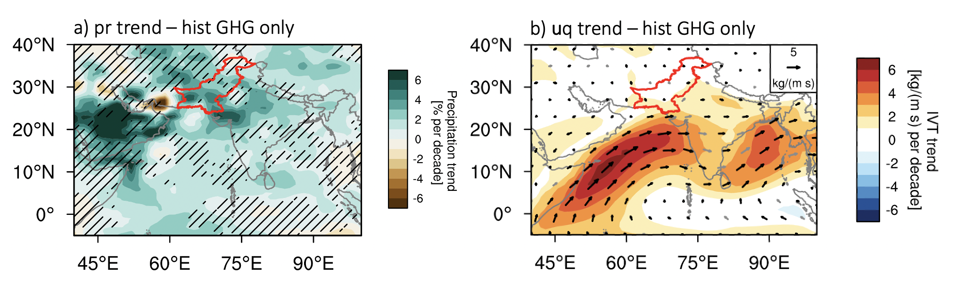
Extended Data Fig. 5 | Modelled trends in Pakistan rainfall and large-scale monsoon circulation forced by anthropogenic emissions of greenhouse gases (GHG). a, Multi-model mean of the linear trend of summer rainfall (% per decade; shading) and b, moisture fluxes and their magnitude (kg m⁻¹ s⁻¹ per decade) during the period 1980-2014 in the CMIP6 historical GHG-only simulation. Shading in (a) represent areas where less than 75% of the models agree on the sign of the trend.

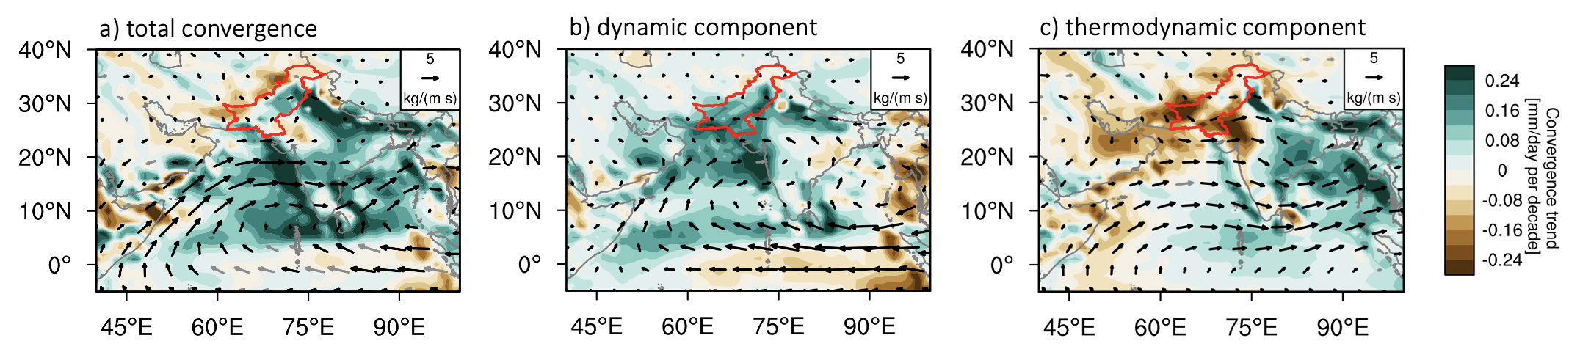
Extended Data Fig. 6 | Dynamic and thermodynamic contributions to Pakistan rainfall trend during 1980-2014. Multi-model mean trend of (a) total moisture convergence and its (b) dynamic and (c) thermodynamic component (mm/day per decade; shading) in the CMIP6 historical simulations. The associated zonal and meridional components of moisture fluxes are shown in vectors (kg m⁻¹ s⁻¹ per decade).

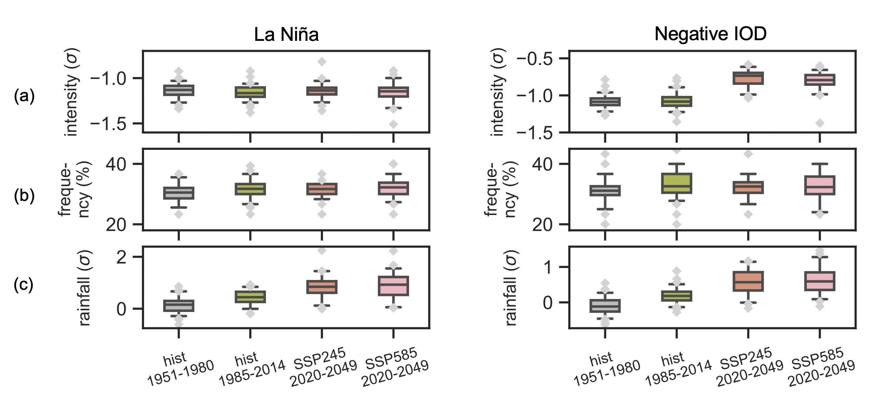
Extended Data Fig. 7 | Historical and future changes in oceanic natural modes of variability and in Pakistan rainfall conditioned upon La Niña and negative IOD. (a) magnitude and (b) frequency of (left) La Niña and (right) negative IOD events, and (c) their associated normalized intensity of Pakistan rainfall during 1985-2014 for CMIP6 historical all-forcing experiment, and during the period 2020-2049 for CMIP6 SSP2-4.5 and SSP5-8.5 experiments. La Niña and negative IOD events are defined based on detrended SST field. Pakistan rainfall is normalized based on each model’s mean and standard deviation of rainfall during the reference period 1951-1980.

