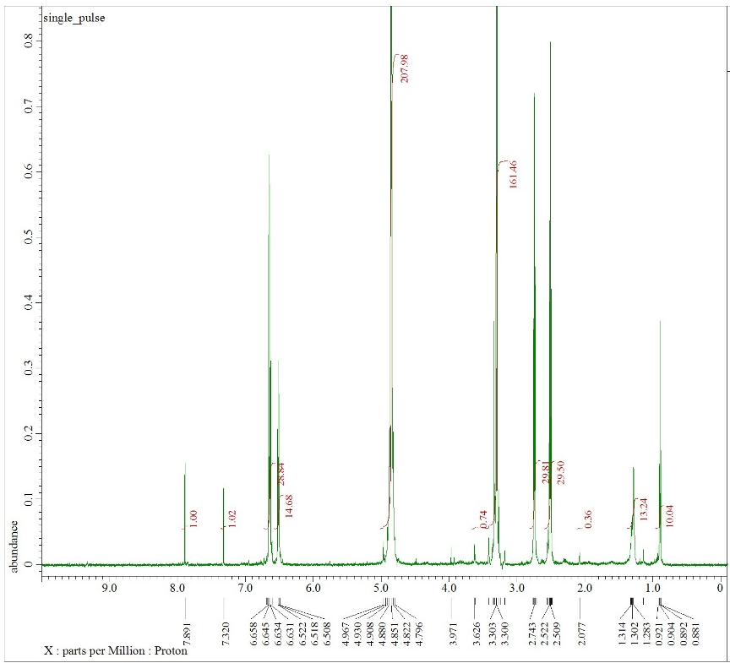
S1 (b)
S1 (a)

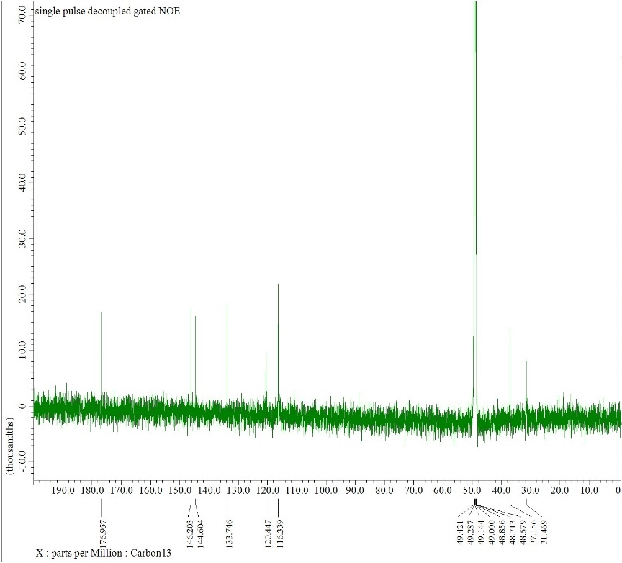
Figure S1 (a) ¹H-NMR spectra and (b) ¹³C-NMR spectra of Dihydrocaffeic acid, purified from fMA-SN13T

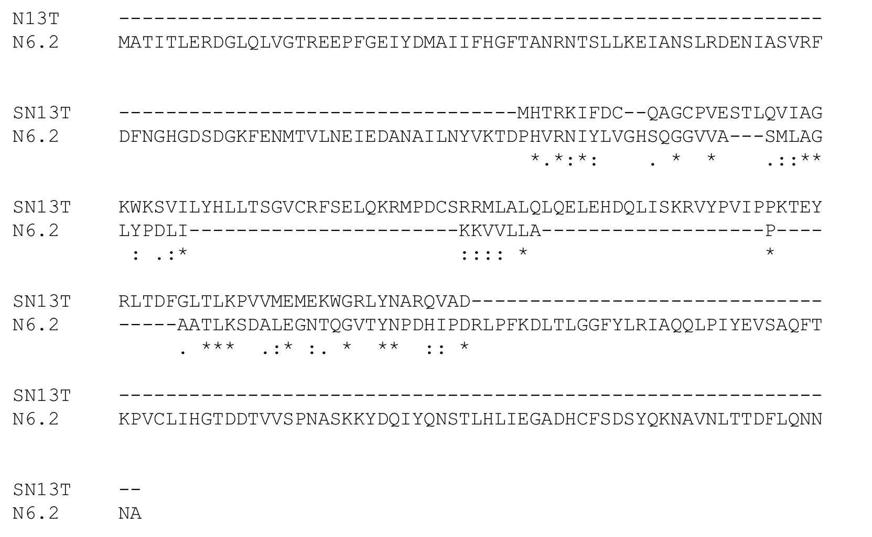
S2 (b)
S2 (a)

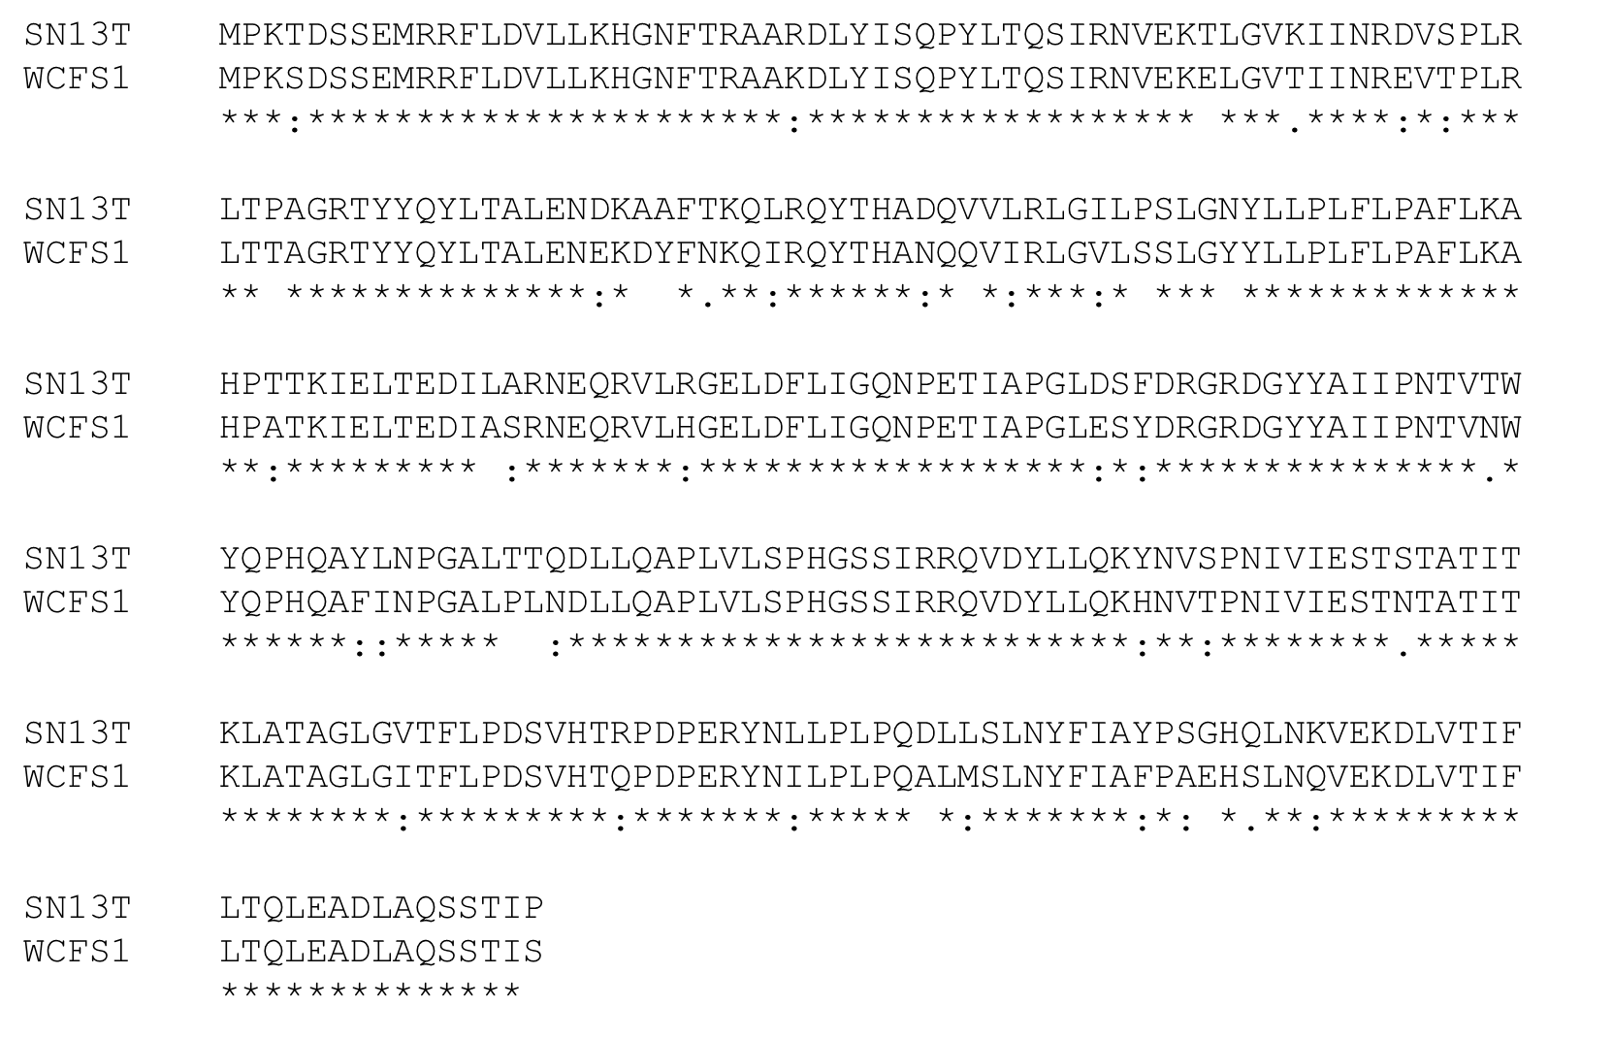

S2 (c)
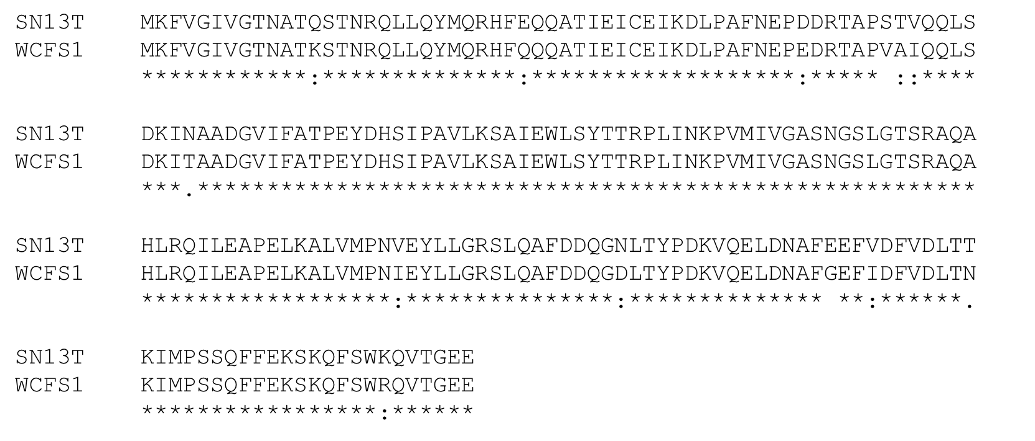
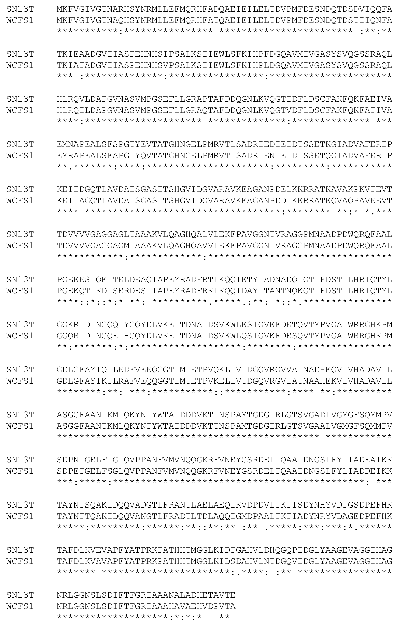
S2 (d)
S2 (e)

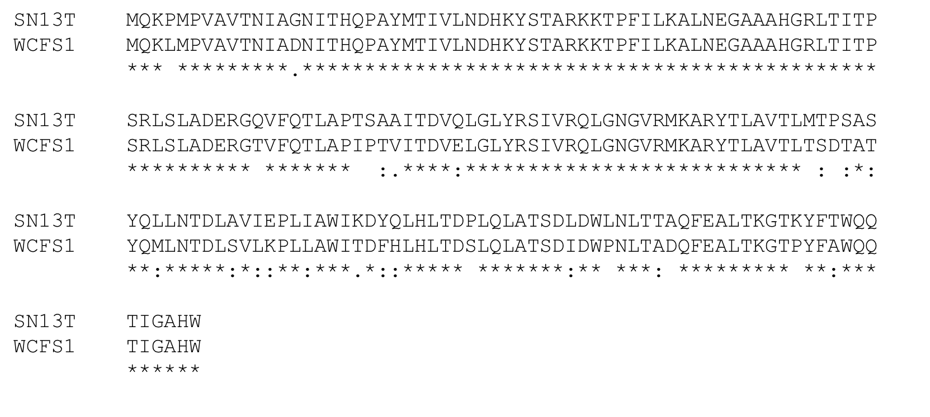
Figure S2 Comparison of amino acid sequences of putative (a) ceh (b) hcrR, (c) hcrA, (d) hcrB and (e) hcrC. Multiple alignments were done using the program ClustalOmega after retrieval of sequences from BLAST homology searches. Residues that are identical (*), conserved (:) or semiconserved (.) in all sequences are indicated. Dashes indicated gaps introduced to maximize similarities.

