Supplementary Information for:

Citizen data for global mapping of atmospheric urban heat islands
Jesus Lizana^{a,b,}*– jesus.lizana@eng.ox.ac.uk – ORCID: 0000-0002-1802-5017
Miguel Núñez-Peiró^{c} - miguel.nunez@upm.es – ORCID: 0000-0002-3895-6791
Radhika Khosla^{a,d} – radhika.khosla@smithschool.ox.ac.uk – ORCID: 0000-0002-7730-8041
Malcolm McCulloch^{a,b} - malcolm.mcculloch@eng.ox.ac.uk – ORCID: 0000-0001-5378-1128

ª Future of Cooling Programme, Oxford Martin School, University of Oxford, Oxford OX1 3BD, United Kingdom
^{b} Energy and Power Group, Department of Engineering Science, University of Oxford, Parks Road, Oxford OX1 3PJ, United Kingdom
^{c} School of Architecture, Universidad Politécnica de Madrid, Avda. Juan de Herrera 4, 28040 Madrid, Spain
^{d} Smith School of Enterprise and the Environment, School of Geography and the Environment, University of Oxford, Oxford, UK
* Corresponding author. E-mail address: jesus.lizana@eng.ox.ac.uk

Supplementary Information
This document provides additional information about the methods used and the results obtained from the analysis. The content is divided into seven supplementary notes (SN) as follows:
SN1. Network of official weather stations globally
SN2. Summary of previous studies using crowdsourced data from citizen weather stations
SN3. Geospatial availability of citizen weather stations globally.
SN4. Detailed definition of data pre-processing methods (cleaning and quality control)
SN5. Detailed results of data pre-processing steps for the city of London.
SN6. Detailed results of diagnostic analytics for the city of London.
SN7. Additional visualisation of results.

Supplementary Note 1. Network of official weather stations globally
Supplementary Fig. 1 illustrates the distribution of official weather stations globally. This set comprises the database of about 45,000 worldwide weather stations published by Weather Graphics¹. This dataset consists of a Master Location Identifier Database (MLID), which harmonises their identification and location from different primary sources such as WMO, ICAO or FAA, among others. Today, around 14,000 active observations from these weather stations can be accessed through the US NOAA's Integrated Surface Database (ISD)^{2,3}.
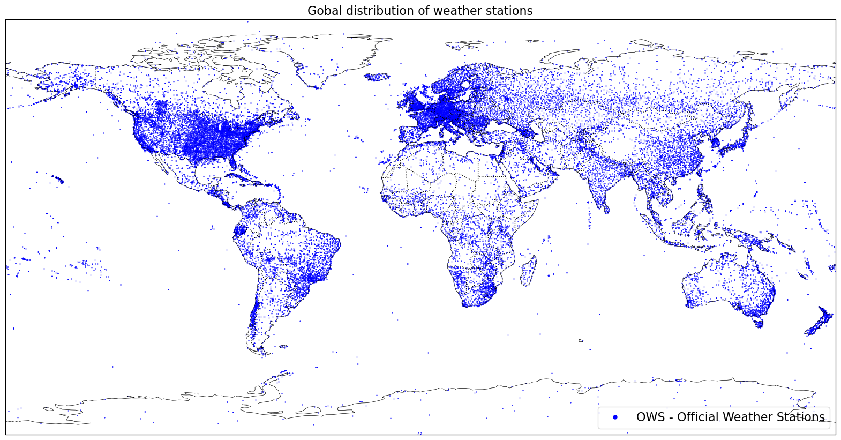
Supplementary Figure 1.1. Map showing the global network of ground-based weather stations collected from Weather Graphics database¹.

Supplementary Note 2. Summary of available data sources and previous studies using crowdsourced data from citizen weather stations
This supplementary note summarises available data sources and previous studies and contributions using crowdsourced data from citizen weather stations.
Supplementary Table 2.1. Summary of available data sources of citizen weather data.
Platforms | Area | CWS number | Studies | Variables ª | Reference
Wunderground | Global | 253253 | 6 | All | www.wunderground.com
Netatmo | Global | 304952 | 28 | Partially  (mainly T, RH, BP) | weathermap.netatmo.com
WOW-NL | Netherlands | - | 2 | All | https://wow.knmi.nl/
UK Met Office Weather Observation Website  (WOW-UK) | Global | - | 1 | All | http://wow.metoffice.gov.uk/
Het Weer Actueel (HWA) | the Netherlands | - | 1 | All | http://www.hetweeractueel.nl/
Citizen Weather Observer Program (CWOP) | North America | ≈10000 |  | All | http://wxqa.com/
WOW-BE | Belgium |  |  |  | https://wow.meteo.be
European Weather Network (EWN) | Europe | - |  | All | http://euweather.eu/
Davis WeatherLink (DWL) | Global | - |  | All | http://www.weatherlink.com/
mPING | North America |  |  | All | https://mping.nssl.noaa.gov/
FieldSense | Denmark | >1000 | 2 | All | https://fieldsense.dk/en/
ª Variables: Temperature (T), relative humidity (RH), wind speed/direction (WS/D), precipitation (P), dew point (DP), Barometric pressure (BP)

Supplementary Table 2.2. Previous studies with citizen weather stations.
Authors | Year | Title | Journal | Crowdsourced data | Region | Pre-processingª
Research articles
Bell et al. ⁴ | 2013 | The state of automated amateur weather observations | Weather | Temperature, humidity and pressure (WOW-UK and Wunderground) | UK | No
Muller et al. ⁵ | 2015 | Crowdsourcing for climate and atmospheric sciences: Current status and future potential | International Journal of Climatology
Meier et al. ⁶ | 2015 | Challenges and benefits from crowdsourced atmospheric data for urban climate research using Berlin, Germany, as testbed | Conference. ICUC9 | Temperature (Netatmo) |  | Yes (approach 1-v1)
Bell et al. ⁷ | 2015 | How good are citizen weather stations? Addressing a biased opinion | Weather | Testing common models of CWS | UK
Chapman et al. ⁸ | 2017 | Can the crowdsourcing data paradigm take atmospheric science to a new level? | International Journal of Climatology | Temperature (Netatmo) | London (UK) | Yes (approach 2-v1)
Meier et al. ⁹ | 2017 | Crowdsourcing air temperature from citizen weather stations for urban climate research | Urban Climate | Temperature (Netatmo) | Berlin (Germany) | Yes (approach 1-v2)
Fenner et al. ¹⁰ | 2017 | Intra and inter 'local climate zone' variability of air temperature as observed by crowdsourced citizen weather stations in Berlin, Germany | Meteorologische Zeitschrift | Temperature (Netatmo) | Berlin (Germany) | Yes (approach 1-v2)
De Vos et al. ¹¹ | 2017 | The potential of urban rainfall monitoring with crowdsourced automatic weather stations in Amsterdam | Hydrology and Earth System Sciences | Precipitation (Wunderground and Netatmo) | Netherlands | No
Chen et al. ¹² | 2018 | Trust me, my neighbors say it's raining outside | 5th Conference on Systems for Built Environments | Precipitation (Wunderground) | Norfolk (Virginia) | Yes (approach 3-v1)
Bruns et al. ¹³ | 2018 | Automated quality assessment of (citizen) weather stations | GI_Forum | Temperature (Wunderground) | South-west Germany | Yes (approach 4-v1)
Hammerberg et al. ¹⁴ | 2018 | Implications of employing detailed urban canopy parameters for mesoscale climate modelling: a comparison between WUDAPT and GIS databases over Vienna, Austria | International Journal of Climatology | Temperature (Wunderground) | Vienna (Austria) | Yes (approach 1-v3)
Napoly et al. ¹⁵ | 2018 | Development and Application of a Statistically-Based Quality Control for Crowdsourced Air Temperature Data | Frontiers in Earth Science | Temperature (Netatmo) | Berlin (Germany)  Toulouse (France) | Yes (approach 1-v4: CrowdQC)
Rahimpour Golroudbary et al. ¹⁶ | 2018 | Urban impacts on air temperature and precipitation over the netherlands | Climate Research | Temperature and precipitation  (Netatmo and hetweeractueel) | The Netherlands | Yes (approach 5-v1)
Clark et al. ¹⁷ | 2018 | Fine-scale analysis of a severe hailstorm using crowdsourced and conventional observations | Meteorological Applications | Temperature, wind and pressure (Wunderground) | UK | Yes (approach 6-v1)
Uteuov et al. ¹⁸ | 2019 | The cities weather forecasting by crowdsourced atmospheric data | Procedia Computer Science | Temperature (Netatmo) | Moscow and Saint Petersburg (Russia) | Yes (approach 1-v4: CrowdQC)
Fenner et al. ¹⁹ | 2019 | Contrasting changes of urban heat island intensity during hot weather episodes | Environmental Research Letters | Temperature (Netatmo) | Berlin (Germany) | Yes (approach 1-v4: CrowdQC)
de Vos et al. ²⁰ | 2019 | Quality Control for Crowdsourced Personal Weather Stations to Enable Operational Rainfall Monitoring | Geophysical Research Letters | Precipitation (Netatmo) | Amsterdam (Netherlands) | Yes (approach 7-v1)
Nipen et al. ²¹ | 2020 | Adopting citizen observations in operational weather prediction | Bulletin of the American Meteorological Society | Temperature (Netatmo) | Southern Norway | Yes (approach 8-v1: TITAN)
Varentsov et al. ²² | 2020 | Citizen weather stations data for monitoring applications and urban climate research: An example of Moscow megacity | IOP Conference Series: Earth and Environmental Science | Temperature (Netatmo) | Moscow (Russia) | Yes (approach 1-v4: CrowdQC)
Varentsov et al. ²³ | 2020 | Urban heat island of the Moscow megacity: The long-term trends and new approaches for monitoring and research based on crowdsourcing data | IOP Conference Series: Earth and Environmental Science | Temperature (Netatmo) | Moscow (Russia) | Yes (approach 1-v4: CrowdQC)
Vulova et al. ²⁴ | 2020 | Summer Nights in Berlin, Germany: Modeling Air Temperature Spatially with Remote Sensing, Crowdsourced Weather Data, and Machine Learning | IEEE Journal of Selected Topics in Applied Earth Observations and Remote Sensing | Air temperature (Netatmo) | Berlin (Germany) | Yes (approach 1-v4: CrowdQC)
Droste et al. ²⁵ | 2020 | Assessing the potential and application of crowdsourced urban wind data | Quarterly Journal of the Royal Meteorological Society | Wind data  (Netatmo) | Amsterdam (Netherlands) | Yes (approach 9-v1)
Venter et al. ²⁶ | 2020 | Hyperlocal mapping of urban air temperature using remote sensing and crowdsourced weather data | Remote Sensing of Environment | Temperature (Netatmo) | Oslo (Norway) | Yes (approach 1-v4: CrowdQC)
Feichtinger et al. ²⁷ | 2020 | Case-study of neighborhood-scale summertime urban air temperature for the City of Vienna using crowdsourced data | Urban Climate | Temperature (Netatmo) | Vienna (Austria) | Yes (approach 1-v4: CrowdQC)
Båserud et al. ²⁸ | 2020 | TITAN automatic spatial quality control of meteorological in-situ observations | Advances in Science and Research | Temperature and precipitation  (Netatmo) | Oslo and Lillehammer (Norway) | Yes (approach 8-v1: TITAN)
Mandement and Caumont ²⁹ | 2020 | Contribution of personal weather stations to the observation of deep-convection features near the ground | Natural Hazards and Earth System Sciences | Temperature, humidity and pressure (Netatmo) | France | Yes (approach 10-v1)
de Vos et al. ³⁰ | 2020 | Hydrometeorological monitoring using opportunistic sensing networks in the Amsterdam metropolitan area | Bulletin of the American Meteorological Society | Temperature, humidity, precipitation, wind and pressure (Netatmo) | Amsterdam (Netherlands) | Yes (approach 7-v2)
Cornes et al. ³¹ | 2020 | Correcting citizen-science air temperature measurements across the Netherlands for short wave radiation bias | Meteorological Applications | Temperature (WOW-NL) | Netherlands | Yes (approach 11-v1)
Zumwald et al. ³² | 2021 | Mapping urban temperature using crowd-sensing data and machine learning | Urban Climate | Temperature (Netatmo) | Zurich (Switzerland) | Yes (approach 1-v4: CrowdQC)
Venter et al. ³³ | 2021 | Crowdsourced air temperatures contrast satellite measures of the urban heat island and its mechanisms | Science Advances | Temperature (Netatmo) | Europe | Yes (approach 1-v4: CrowdQC)
Fenner et al. ³⁴ | 2021 | CrowdQC+—A Quality-Control for Crowdsourced Air-Temperature Observations Enabling World-Wide Urban Climate Applications | Frontiers in Environmental Science | Temperature (Netatmo) | Amsterdam (Netherlands)  Toulouse (France) | Yes (approach 1-v5: CrowdQC+)
Graf et al. ³⁵ | 2021 | Combined rainfall estimates from personal weather station and commercial microwave link data in Germany | EGU General Assembly | Precipitation  (Netatmo) | Germany | No
Chen et al. ³⁶ | 2021 | Quality control and bias adjustment of crowdsourced wind speed observations | Quarterly Journal of the Royal Meteorological Society | Wind  (WOW-NL) | Utrecht (Netherlands) | Yes (approach 12-v1)
Meyer et al. ³⁷ | 2022 | Intercomparison and combination of low-cost urban air temperature measurement approaches | Meteorologische Zeitschrift | Temperature (Netatmo) | Bern (Switzerland) | Yes (approach 1-v4: CrowdQC)
Brousse et al. ³⁸ | 2022 | Evidence of horizontal urban heat advection in London using six years of data from a citizen weather station network | Environmental Research Letters | Temperature (Netatmo) | London (England) | Yes (approach 1-v4: CrowdQC)
Sgoff et al. ³⁹ | 2022 | Assimilation of crowdsourced surface observations over Germany in a regional weather prediction system | Quarterly Journal of the Royal Meteorological Society | Temperature and humidity (Netatmo) | Germany | Yes (approach 13-v1)
Alerskans et al. | 2022 | A transformer neural network for predicting near-surface temperature | Meteorological Applications | Temperature (FieldSense) | Denmark | Yes (approach v14-v1)
Alerskans et al. | 2022 | Optimizing Spatial Quality Control for a Dense Network of Meteorological Stations. | Journal of Atmospheric and Oceanic Technology | Temperature (Netatmo and FieldSense) | Denmark | Yes (approach 8-v2: TITAN)
Reviews
Gharesifard et al. ⁴⁰ | 2017 | Towards benchmarking citizen observatories: Features and functioning of online amateur weather networks | Journal of Environmental Management
Middel et al. ⁴¹ | 2022 | Urban Climate Informatics: An Emerging Research Field | Frontiers in Environmental Science
Hahn et al. ⁴² | 2022 | Observations from Personal Weather Stations—EUMETNET Interests and Experience | Climate
ªPre-processing refers to the quality control algorithm procedures used in each study to filter out unreliable measurements from crowdsourced data.

Supplementary Table 2.3. Data extraction tools of citizen weather stations
Extraction tool | Year | Platform | Link to repository | Reference articles
patatmo | 2019 | Netatmo | https://pypi.org/project/patatmo/ | Varentsov et al. ²²
LoadNetatmoData | 2020 | Netatmo | https://github.com/pavelkargashin/LoadNetatmoData | Varentsov et al. ²²
the-weather-scraper | 2022 | Wunderground | https://github.com/Karlheinzniebuhr/the-weather-scraper | -
UHA_CWS_ERL202 | 2022 | Netatmo | https://github.com/oscarbrousse/UHA_CWS_ERL2022 | Brousse et al. ³⁸

Supplementary Table 2.4. Pre-processing tools for citizen weather stations
Quality control tool | Year | Variable | Link to repository | Reference articles
CrowdQC | 2018 | Temperature | https://depositonce.tu-berlin.de/handle/11303/7520.3 | Napoly et al. ¹⁵
NetAtmoQC | 2020 | Temperature | https://source.coderefinery.org/iOBS/wp2/task-2- 3/netatmoqc
TitanLib | 2020 | Temperature | https://github.com/metno/TITAN | Nipen et al. ²¹
CrowdQC+ | 2021 | Temperature | https://github.com/dafenner/CrowdQCplus | Fenner et al. ³⁴
UHA_CWS_ERL202 | 2022 | Temperature | https://github.com/oscarbrousse/UHA_CWS_ERL2022 | Brousse et al. ³⁸
PWSQC | 2022 | Precipitation | https://github.com/LottedeVos/PWSQC | de Vos et al. ²⁰

Supplementary Note 3. Geospatial availability of citizen weather stations globally.
Supplementary Figure 1. Data availability of citizen weather stations per platform

This supplementary note provides additional information on the data distribution of citizen weather stations globally.

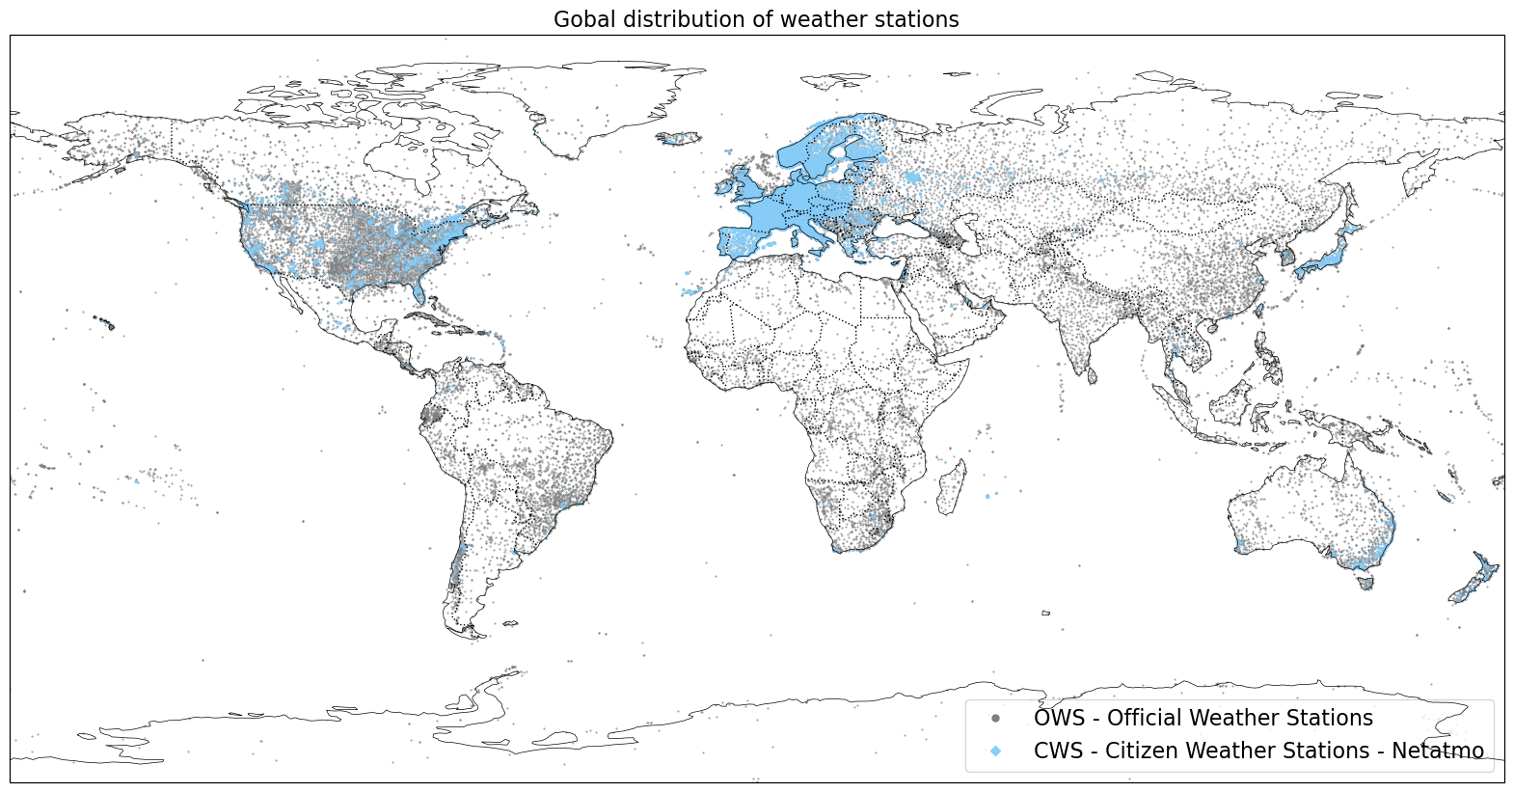
Supplementary Figure 3.1. Map showing the global network of Netatmo weather stations.

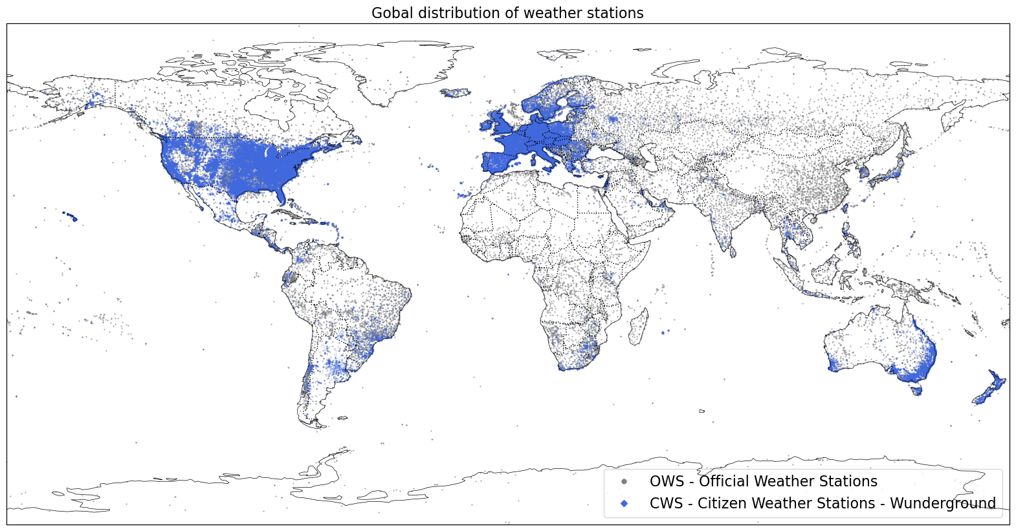
Supplementary Figure 3.2. Map showing the global network of Wunderground weather stations.

Supplementary Table 3.1. Ranking of cities with higher citizen weather data availability globally.
Citiesª | Total CWS | Netatmo | Wunderground | Country
Paris | 10350 | 10055 | 295 | France
Oslo | 4270 | 4210 | 60 | Norway
Düsseldorf | 4132 | 3555 | 577 | Germany
Berlin | 3657 | 3205 | 452 | Germany
Versailles | 3378 | 3263 | 115 | France
Milan | 2862 | 2460 | 402 | Italy
Copenhagen | 2722 | 2550 | 172 | Denmark
Vienna | 2626 | 2251 | 375 | Austria
Los Angeles | 2473 | 329 | 2144 | United States of America
Brussels | 2331 | 1919 | 412 | Belgium
Frankfurt | 2301 | 2100 | 201 | Germany
Munich | 2158 | 1960 | 198 | Germany
London | 2079 | 1236 | 843 | United Kingdom
Koln | 2070 | 1786 | 284 | Germany
Stockholm | 2055 | 1940 | 115 | Sweden
Zürich | 2047 | 1987 | 60 | Switzerland
San Francisco | 2022 | 421 | 1601 | United States of America
Hamburg | 1907 | 1697 | 210 | Germany
Barcelona | 1875 | 1307 | 568 | Spain
Stuttgart | 1855 | 1593 | 262 | Germany
Lyon | 1768 | 1689 | 79 | France
The Hague | 1716 | 1251 | 465 | Netherlands
Seattle | 1714 | 255 | 1459 | United States of America
Dortmund | 1561 | 1313 | 248 | Germany
Prague | 1527 | 1244 | 283 | Czechia
Madrid | 1434 | 1231 | 203 | Spain
Essen | 1362 | 1183 | 179 | Germany
Melbourne | 1294 | 349 | 945 | Australia
New York | 1288 | 340 | 948 | United States of America
Chicago | 1257 | 169 | 1088 | United States of America
Nice | 1194 | 1121 | 73 | France
Rotterdam | 1168 | 813 | 355 | Netherlands
Sydney | 1161 | 337 | 824 | Australia
Denver | 1157 | 149 | 1008 | United States of America
San Diego | 1127 | 138 | 989 | United States of America
Rome | 1116 | 897 | 219 | Italy
Mannheim | 1106 | 954 | 152 | Germany
Phoenix | 1066 | 96 | 970 | United States of America
Houston | 1039 | 116 | 923 | United States of America
Portland | 1034 | 108 | 926 | United States of America
Toulouse | 984 | 907 | 77 | France
Tokyo | 974 | 888 | 86 | Japan
Duisburg | 954 | 793 | 161 | Germany
Helsinki | 943 | 900 | 43 | Finland
San Jose | 934 | 197 | 737 | United States of America
Dresden | 889 | 685 | 204 | Germany
Lille | 876 | 786 | 90 | France
Bonn | 876 | 764 | 112 | Germany
Bordeaux | 865 | 819 | 46 | France
Warsaw | 820 | 723 | 97 | Poland
Moscow | 780 | 750 | 30 | Russia
Nurnberg | 756 | 665 | 91 | Germany
Minneapolis | 754 | 99 | 655 | United States of America
Wuppertal | 733 | 607 | 126 | Germany
Wiesbaden | 730 | 645 | 85 | Germany
Atlanta | 707 | 86 | 621 | United States of America
Budapest | 700 | 512 | 188 | Hungary
Boston | 683 | 188 | 495 | United States of America
Perth | 680 | 117 | 563 | Australia
Miami | 665 | 91 | 574 | United States of America
Irvine | 659 | 82 | 577 | United States of America
Washington, D.C. | 650 | 234 | 416 | United States of America
Tampa | 650 | 39 | 611 | United States of America
Adelaide | 642 | 83 | 559 | Australia
Antwerpen | 639 | 497 | 142 | Belgium
Como | 632 | 501 | 131 | Italy
Goteborg | 606 | 566 | 40 | Sweden
Brisbane | 602 | 174 | 428 | Australia
Bremen | 600 | 501 | 99 | Germany
Detroit | 597 | 58 | 539 | United States of America
Saarbrucken | 593 | 479 | 114 | Germany
Pasadena | 586 | 78 | 508 | United States of America
Dallas | 568 | 141 | 427 | United States of America
Salt Lake City | 546 | 55 | 491 | United States of America
Austin | 493 | 86 | 407 | United States of America
Philadelphia | 486 | 96 | 390 | United States of America
Cleveland | 480 | 38 | 442 | United States of America
Newark | 463 | 107 | 356 | United States of America
Oakland | 463 | 72 | 391 | United States of America
Amsterdam | 449 | 321 | 128 | Netherlands
Heidelberg | 440 | 381 | 59 | Germany
Sacramento | 439 | 55 | 384 | United States of America
San Mateo | 414 | 118 | 296 | United States of America
Tucson | 414 | 28 | 386 | United States of America
Aurora | 410 | 31 | 379 | United States of America
Leipzig | 401 | 261 | 140 | Germany
Mesa | 400 | 31 | 369 | United States of America
Hannover | 390 | 310 | 80 | Germany
Reading | 389 | 214 | 175 | United Kingdom
Albuquerque | 373 | 19 | 354 | United States of America
Athens | 371 | 205 | 166 | Greece
Toronto | 369 | 198 | 171 | Canada
Pittsburgh | 368 | 34 | 334 | United States of America
Marseille | 367 | 323 | 44 | France
Utrecht | 367 | 252 | 115 | Netherlands
Orlando | 366 | 30 | 336 | United States of America
Kansas City | 366 | 29 | 337 | United States of America
Bergamo | 360 | 291 | 69 | Italy
Everett | 359 | 58 | 301 | United States of America
Canberra | 351 | 85 | 266 | Australia
Colorado Springs | 337 | 22 | 315 | United States of America
Long Beach | 333 | 49 | 284 | United States of America
Oceanside | 324 | 39 | 285 | United States of America
Basel | 318 | 261 | 57 | Switzerland
Drammen | 317 | 302 | 15 | Norway
Metz | 312 | 287 | 25 | France
Nantes | 311 | 272 | 39 | France
Charlotte | 311 | 31 | 280 | United States of America
Manchester | 310 | 145 | 165 | United Kingdom
Fort Lauderdale | 309 | 37 | 272 | United States of America
Montreal | 307 | 244 | 63 | Canada
Vatican City | 307 | 243 | 64 | Italy
Newcastle | 303 | 85 | 218 | United Kingdom
Turin | 301 | 255 | 46 | Italy
Columbus | 298 | 27 | 271 | United States of America
San Bernardino | 298 | 18 | 280 | United States of America
Naples | 296 | 202 | 94 | Italy
Potsdam | 291 | 255 | 36 | Germany
Pontiac | 289 | 34 | 255 | United States of America
Liege | 287 | 245 | 42 | Belgium
St. Petersburg | 287 | 13 | 274 | United States of America
Malmo | 283 | 268 | 15 | Sweden
Cincinnati | 280 | 20 | 260 | United States of America
Furth | 274 | 231 | 43 | Germany
Indianapolis | 272 | 35 | 237 | United States of America
Glendale | 272 | 14 | 258 | United States of America
Melun | 269 | 253 | 16 | France
Las Vegas | 269 | 32 | 237 | United States of America
Linz | 268 | 194 | 74 | Austria
Milwaukee | 266 | 25 | 241 | United States of America
Karlsruhe | 263 | 194 | 69 | Germany
Eindhoven | 262 | 167 | 95 | Netherlands
Bergen | 260 | 235 | 25 | Norway
Graz | 259 | 166 | 93 | Austria
Geneva | 256 | 234 | 22 | Switzerland
Koblenz | 252 | 192 | 60 | Germany
National City | 252 | 22 | 230 | United States of America
Florence | 251 | 185 | 66 | Italy
Alexandria | 250 | 118 | 132 | United States of America
Vancouver | 249 | 22 | 227 | United States of America
Waukegan | 248 | 35 | 213 | United States of America
Valencia | 247 | 142 | 105 | Spain
Portsmouth | 247 | 94 | 153 | United Kingdom
Vancouver | 244 | 118 | 126 | Canada
Brno | 243 | 148 | 95 | Czechia
Tacoma | 243 | 13 | 230 | United States of America
Gent | 242 | 170 | 72 | Belgium
Evanston | 242 | 55 | 187 | United States of America
Riverside | 240 | 12 | 228 | United States of America
Trondheim | 237 | 218 | 19 | Norway
Birmingham | 237 | 104 | 133 | United Kingdom
St. Paul | 234 | 25 | 209 | United States of America
Aarhus | 230 | 203 | 27 | Denmark
Haarlem | 227 | 161 | 66 | Netherlands
Fort Collins | 227 | 14 | 213 | United States of America
Strasbourg | 224 | 203 | 21 | France
Grenoble | 224 | 194 | 30 | France
St. Louis | 223 | 40 | 183 | United States of America
Chemnitz | 220 | 152 | 68 | Germany
San Antonio | 218 | 15 | 203 | United States of America
Toulon | 214 | 177 | 37 | France
Bucharest | 214 | 171 | 43 | Romania
Jacksonville | 214 | 10 | 204 | United States of America
Aurora | 213 | 29 | 184 | United States of America
West Palm Beach | 212 | 25 | 187 | United States of America
Genoa | 209 | 121 | 88 | Italy
Auckland | 209 | 70 | 139 | New Zealand
Pasadena | 209 | 16 | 193 | United States of America
Osaka | 206 | 192 | 14 | Japan
Luzern | 206 | 189 | 17 | Switzerland
Calgary | 204 | 94 | 110 | Canada
Sheffield | 203 | 88 | 115 | United Kingdom
Yokohama | 202 | 181 | 21 | Japan
Lisbon | 200 | 157 | 43 | Portugal
Cranbourne | 197 | 33 | 164 | Australia
Lugano | 196 | 185 | 11 | Switzerland
Paterson | 195 | 51 | 144 | United States of America
Ostrava | 192 | 125 | 67 | Czechia
Kiel | 191 | 147 | 44 | Germany
Gdansk | 190 | 153 | 37 | Poland
Berkeley | 190 | 29 | 161 | United States of America
Augsburg | 189 | 150 | 39 | Germany
Bielefeld | 188 | 145 | 43 | Germany
Braunschweig | 187 | 145 | 42 | Germany
Baltimore | 186 | 32 | 154 | United States of America
Tours | 183 | 169 | 14 | France
Katowice | 183 | 142 | 41 | Poland
Omaha | 181 | 10 | 171 | United States of America
Ft. Worth | 180 | 35 | 145 | United States of America
Tampere | 178 | 175 | 3 | Finland
Montpellier | 178 | 159 | 19 | France
Kassel | 178 | 131 | 47 | Germany
Bratislava | 178 | 111 | 67 | Slovakia
Monterey | 178 | 24 | 154 | United States of America
Coral Springs | 177 | 23 | 154 | United States of America
Nancy | 173 | 155 | 18 | France
Kawasaki | 172 | 158 | 14 | Japan
Odense | 172 | 148 | 24 | Denmark
Santa Barbara | 172 | 22 | 150 | United States of America
Krakow | 170 | 133 | 37 | Poland
Wroclaw | 169 | 145 | 24 | Poland
Porto | 169 | 119 | 50 | Portugal
Marietta | 167 | 20 | 147 | United States of America
Poznan | 165 | 125 | 40 | Poland
Magdeburg | 165 | 118 | 47 | Germany
Bournemouth | 164 | 70 | 94 | United Kingdom
Sarasota | 162 | 20 | 142 | United States of America
Bologna | 158 | 123 | 35 | Italy
Osnabrück | 158 | 120 | 38 | Germany
Orleans | 157 | 136 | 21 | France
St. Petersburg | 156 | 148 | 8 | Russia
Münster | 156 | 124 | 32 | Germany
Kansas City | 156 | 12 | 144 | United States of America
Dayton | 156 | 5 | 151 | United States of America
Rouen | 155 | 145 | 10 | France
Tallinn | 155 | 135 | 20 | Estonia
Melbourne | 155 | 4 | 151 | United States of America
Santa Rosa | 154 | 17 | 137 | United States of America
Oldenburg | 153 | 116 | 37 | Germany
Regensburg | 153 | 115 | 38 | Germany
Brighton | 153 | 76 | 77 | United Kingdom
Nottingham | 153 | 64 | 89 | United Kingdom
Ljubljana | 152 | 117 | 35 | Slovenia
Lubeck | 149 | 112 | 37 | Germany
Ingolstadt | 149 | 109 | 40 | Germany
New Haven | 149 | 20 | 129 | United States of America
Clermont-Ferrand | 145 | 126 | 19 | France
Bilbao | 145 | 106 | 39 | Spain
Hachioji | 143 | 127 | 16 | Japan
Nagoya | 141 | 131 | 10 | Japan
Verona | 141 | 102 | 39 | Italy
Boise | 141 | 18 | 123 | United States of America
Saint-Etienne | 139 | 126 | 13 | France
Monaco | 137 | 133 | 4 | Monaco
Raleigh | 137 | 44 | 93 | United States of America
Reno | 137 | 14 | 123 | United States of America
Quebec | 136 | 107 | 29 | Canada
Sofia | 135 | 93 | 42 | Bulgaria
Southend | 135 | 46 | 89 | United Kingdom
Christchurch | 135 | 34 | 101 | New Zealand
Riga | 133 | 126 | 7 | Latvia
Aalborg | 133 | 112 | 21 | Denmark
Mulhouse | 132 | 120 | 12 | France
Windsor | 132 | 13 | 119 | United States of America
Mataro | 131 | 84 | 47 | Spain
Charleston | 131 | 7 | 124 | United States of America
Bern | 130 | 110 | 20 | Switzerland
Knoxville | 130 | 14 | 116 | United States of America
Madison | 130 | 12 | 118 | United States of America
Freiburg | 128 | 85 | 43 | Germany
Liverpool | 128 | 59 | 69 | United Kingdom
Skien | 127 | 119 | 8 | Norway
Innsbruck | 127 | 87 | 40 | Austria
Buenos Aires | 127 | 45 | 82 | Argentina
Angers | 125 | 116 | 9 | France
Santiago | 125 | 97 | 28 | Chile
Greenville | 125 | 15 | 110 | United States of America
Caen | 124 | 116 | 8 | France
Lausanne | 124 | 116 | 8 | Switzerland
Palma | 124 | 74 | 50 | Spain
Hong Kong | 124 | 35 | 89 | China
Charleroi | 123 | 103 | 20 | Belgium
Rostock | 121 | 89 | 32 | Germany
Ulm | 121 | 87 | 34 | Germany
Stavanger | 120 | 108 | 12 | Norway
Wurzburg | 120 | 90 | 30 | Germany
Ottawa | 120 | 76 | 44 | Canada
Wichita | 120 | 7 | 113 | United States of America
Dublin | 119 | 105 | 14 | Ireland
Louisville | 119 | 13 | 106 | United States of America
Bristol | 118 | 57 | 61 | United Kingdom
Boulder | 118 | 19 | 99 | United States of America
Joliet | 118 | 11 | 107 | United States of America
Turku | 117 | 105 | 12 | Finland
Lowell | 117 | 28 | 89 | United States of America
Mexico City | 116 | 96 | 20 | Mexico
Sanford | 116 | 9 | 107 | United States of America
Townsville | 116 | 7 | 109 | Australia
Limoges | 115 | 101 | 14 | France
Norfolk | 115 | 16 | 99 | United States of America
Lodz | 112 | 89 | 23 | Poland
Southampton | 112 | 46 | 66 | United Kingdom
Zagreb | 111 | 74 | 37 | Croatia
Wellington | 111 | 34 | 77 | New Zealand
Grand Rapids | 111 | 11 | 100 | United States of America
Anchorage | 111 | 7 | 104 | United States of America
Hamilton | 110 | 46 | 64 | Canada
Richmond | 110 | 22 | 88 | United States of America
Biarritz | 109 | 98 | 11 | France
Uppsala | 108 | 103 | 5 | Sweden
Seville | 108 | 81 | 27 | Spain
Leeds | 108 | 54 | 54 | United Kingdom
Bradford | 108 | 53 | 55 | United Kingdom
Waukesha | 108 | 7 | 101 | United States of America
New Orleans | 108 | 6 | 102 | United States of America
Ogden | 108 | 5 | 103 | United States of America
Salzburg | 107 | 77 | 30 | Austria
Edinburgh | 107 | 63 | 44 | United Kingdom
Palm Springs | 107 | 23 | 84 | United States of America
Baton Rouge | 107 | 6 | 101 | United States of America
Dijon | 106 | 90 | 16 | France
Johannesburg | 105 | 38 | 67 | South Africa
Wilmington | 105 | 17 | 88 | United States of America
Lakeville | 105 | 7 | 98 | United States of America
Roskilde | 104 | 94 | 10 | Denmark
Victoria | 104 | 37 | 67 | Canada
Provo | 104 | 13 | 91 | United States of America
Glasgow | 103 | 55 | 48 | United Kingdom
Eugene | 103 | 10 | 93 | United States of America
Columbia | 103 | 6 | 97 | United States of America
Luxembourg | 101 | 84 | 17 | Luxembourg
Erfurt | 101 | 73 | 28 | Germany
Spokane | 101 | 12 | 89 | United States of America
Kawagoe | 100 | 90 | 10 | Japan
ª In this ranking, “cities” refers to urban areas, including several adjacent municipalities. Only cities with more than 100 CWS are listed.

Supplementary note 4. Detailed definition of data pre-processing methods (cleaning and quality control)
The Python pre-processing approach for data cleaning and quality control of hourly air temperature is divided into 12 steps and grouped into two categories: individual QC methods and group QC methods. They are summarised in Supplementary Table 4.1.
Supplementary Table 4.1. Pre-processing steps for data cleaning, quality control and filtering of hourly CWS data.
QC methods | Step definition | Control process | Criteria for QC step
Individual QC methods
QC_I1 | Contaminated data | Data type
QC_I2 | Manual visual check | Flawed data based on a visual inspection
QC_I3 | Outliers a | Gross-error limit test | Threshold: -40ºC and 60ºC
QC_I4 | Inconsistent data | Temporal consistency: slope test | Threshold: 20ºC/h
QC_I5 | Inconsistent data | Temporal consistency: persistence test | Timeframe: 6h
Group QC methods
QC_G1 | Manual visual check | Flawed data based on a visual inspection
QC_G2 | Structural time errors | Revision and visual check of datetime | UTC winter time (UTC + 0:00h)
QC_G3 | Inconsistent data | Data units and CWS/OWS id
QC_G4 | Duplicate data | Duplicate CWS/OWS
QC_G5 | Group outliers a | Statistical analysis: data distribution | Modified Z-score analysis (Qn)
QC_G6 | Group outliers b | Statistical analysis: constant errors | Threshold: outliers > 25%
QC_G7 | Group outliers c | Statistical analysis: group temporal correlation | Threshold:  Pearson correlation coefficient <0.9
QC_G8 | Filling gap | Interpolation | Gap > 2 time steps

The Individual QC methods/steps refer to pre-processing functions applied individually to hourly time series data. They are based on basic quality control procedures commonly used to meteorological weather data^{34,43–46}. Five methods are proposed and defined as follows:
- QC_I1. Contaminated data (data type): checking that time series data are based on float/integer/numerical values.

function = qc.QC_I1_datatype(df) | Code (1)

- QC_I2. Manual visual check (flawed data): identification of flawed data patterns based on a visual inspection of time series.

- QC_I3. Outliers (gross-error limit test): values outside a defined temperature range are eliminated. The default range is defined between -40ºC and 60ºC.

function = qc.QC_I3_limittest(df) | Code (2)

- QC_I4. Inconsistent data (slope test): temperature gradients higher than a specific threshold are flagged as suspect and not considered. The default gradient threshold for hourly data is defined as 20ºC/h. This value should be adapted according to temporal resolution (e.g. 6ºC for 5-minute resolution; or 10ºC 15-minute resolution).

function = qc.QC_I4_slopetest(df) | Code (3)

- QC_I5. Inconsistent data (persistence test): values persisting for a certain period are flagged as suspect and not considered. With hourly data, the selected timeframe is 6 hours, but this value should be adapted according to the temporal resolution (e.g. 2h for 5-minute resolution; or 3h for 15-minute resolution)

function = qc.QC_I5_consistencytest(df) | Code (4)

The group QC methods/step consist of pre-processing functions applied to a cluster of hourly time series data located in the same urban context. They are based on previous CWS QC criteria introduced by previous studies in Supplementary Note 2. Eight methods/steps are proposed and defined as follows:
- QC_G1. Manual visual check (flawed data). This procedure involves a visual check of the time index in order to ensure that all time series are in UTC winter time.

- QC_G2. Structural time errors (UTC time). It ensures that time indices follow the same criteria for all data sources, for example, UTC winter time. Moreover, it should be verified that all hourly values are obtained following similar procedures, where the timestamps are returned by the same default offset.

- QC_G3. Inconsistent data (units and station id). This step performs a revision of inconsistent data into the datasets. Here, we ensure all data have the appropriate identification id, units and magnitude order inside the expected range.

- QC_G4. Duplicate data (id). This procedure eliminates data with duplicate values or missing values according to the station id, longitude and latitude.

function = qc.QC_G4_duplicate(CWS_coordinates_all) | Code (5)

- QC_G5. Group outliers a (statistical analysis: data distribution). This procedure implements three approaches for outlier detection to flag any suspicious data according to the data distribution profile and considered confidence interval per time step. Three data distribution analytical procedures can be used: z-score distribution, the modified z-score distribution using the median absolute deviation (MAD), and the modified z-score using the Qn robust estimator of scale.
The standard normal distribution (or Z-score distribution) indicates how much a given value differs from the standard deviation of the sample for a given time⁴⁷. If a Z-score is 0, the data point's score is identical to the mean score. It is calculated following Eq. (1):

$$Z= \frac{{Ta}_{i,j}-mean({Ta}_{i})}{σ({Ta}_{i})}$$ | Eq (1)
where:
${Ta}_{i,j}$: temperature data for the time i, and station j.
${mean(Ta}_{i})$: mean of the sample at the time i.
$σ({Ta}_{i})$: standard deviation of the sample at the time i.
$Z$: standard z-score.

The modified z-score using the median and MAD is calculated according to Eq. (2):
$$Z_{mod-mad}= \frac{{Ta}_{i,j}-median({Ta}_{i})}{MAD({Ta}_{i})}$$ | Eq. (2)
where:
${Ta}_{i,j}$: temperature data for the time i, and station j.
${median(Ta}_{i})$: median of the sample at the time i.
$MAD({Ta}_{i})$: median absolute deviation of the sample at the time i.
$Z$: modified z-score.

The modified z-score calculation using the Qn robust estimator of scale was proposed by Croux and Rousseeuw (1992)⁴⁸ as an alternative to the median absolute deviation (MAD), according to Eq. (3):

$$Z_{mod-Qn}= \frac{{Ta}_{i,j}-median({Ta}_{i})}{Q_{n}({Ta}_{i})}$$ | Eq. (3)
where:
${Ta}_{i,j}$: temperature data for the time i, and station j.
${median(Ta}_{i})$: median of the sample at the time i.
$Q_{n}({Ta}_{i})$: Qn robust estimator of scale of the sample at the time i.
$Z$: modified z-score.

By default, the outlier identification following this data distribution analysis is performed using the modified z-score based on the Qn estimator since previous studies have shown higher efficiency for outlier detection^{49–51}, and it has already been successfully tested with CWS by Napoli et al.¹⁵.
After the data distribution measurement, z-score data outside the range between -2.32 and 1.64 are flagged as wrong and eliminated. These thresholds are defined by considering a confidence interval from 1% (α = 0.01 at the lower tail) to 95% (α = 0.05 on the upper tail) of the normal distribution⁵². The approach also integrates the confidence interval definition following the student’s t distribution (instead of normal distribution). This approach is recommended for areas with only a small amount of CWS (n < 200)¹⁵.
It should be considered that this outlier detection procedure treats the upper tail of the confidence interval stricter. This stricter criterion is supported by previous studies, which have shown that most common outliers in CWS data are related to sensor overheating due to location in non-shaded areas or influenced by adjacent surface temperatures⁹.

function = qc.QC_G5_distribution(df,z_score= "mod_z_score_qn", t_distribution=False, 0.01, 0.95) | Code (6)

- QC_G6. Group outliers b (statistical analysis: constant errors). This procedure eliminates data from weather stations with constant errors. The approach is applied monthly and assumes that the station is too erroneous to be kept if too many values are removed. Thus, for every month, data from weather stations with more than 25% of outliers are flagged as suspicious and eliminated. The percentage threshold can be adapted as required.

function = qc.QC_G6_trust(df,df_outliers, 0.75,time="M") | Code (7)

- QC_G7. Group outliers c (statistical analysis: group temporal correlation). This control approach performs a temporal correlation of each weather station and the median of all weather stations on a monthly basis. The Pearson correlation coefficient (R) is used between each individual station and the median of CWS. If the correlation is lower than 0.9, that station's data in the considered month are set to NaN.
This temporal correlation helps identify data from indoor environments since it is assumed they are less correlated to outdoor temperature oscillation as their diurnal cycles are shifted in time or are otherwise non-representative of outdoor environments¹⁵. This approach only applies to datasets with similar climate conditions.

function = qc.QC_G7_tcorrelation(df, 0.9) | Code (8)

- QC_G8. Missing data. This procedure performs a temporal linear interpolation of missing data in the time series if the gap between valid values is shorter than two time steps. The aim is to increase data availability.

function = qc.QC_G8_interpolation(df, 2) | Code (9)

Supplementary note 5. Detailed results of data pre-processing steps for the city of London.
This supplementary note shows and discusses the complete results of the pre-processing protocol defined in the previous Supplementary Note 4, and implemented in the CWSs available in London.
Supplementary Table 5.1 summarises the data availability and outliers identified by every cleaning and quality control step.
Supplementary Table 5.1. Summary of pre-processing steps applied to CWS data. The table summarises the data availability, number of outliers identified, and accumulated outliers for every data cleaning and quality control step.
QC level | Size of DataFrame | Number of available data points | Available data (%) | Number of available CWS | Outliers identified (%) | Accumulated outliers (%)
Raw data | 15813605 | 13776904 | 87.12 | 1805 | 0.00 | 0.00
Individual QC methods
QC_I3. Outliers a | 15813605 | 13776904 | 87.12 | 1805 | 0.00 | 0.00
QC_I4. Inconsistent data | 15813605 | 13776856 | 87.12 | 1805 | 0.00 | 0.00
QC_I5. Inconsistent data | 15813605 | 13682187 | 86.52 | 1805 | -0.69 | -0.69
Group QC methods
QC_G4. Duplicate data | 15813605 | 13681726 | 86.52 | 1805 | 0.00 | -0.69
QC_G5. Group outliers a | 15813605 | 12394220 | 78.38 | 1805 | -9.41 | -10.04
QC_G6. Group outliers b | 14578304 | 11923913 | 81.79 | 1664 | -3.79 | -13.45
QC_G7. Group outliers c | 14578304 | 11822180 | 81.09 | 1664 | -0.85 | -14.19
QC_G8. Filling gap | 14578304 | 11963328 | 82.06 | 1664 | 1.19 | -13.16

The results show how after individual QC methods, 0.69% of data were flagged as suspicious and eliminated. The application of group QC methods identified most of the suspicious data in the dataset, achieving an accumulated outlier rate of 14.19%. The last step (GC_G8) retrieved back some missing data through temporal linear interpolation, only for those cases when the gap between valid values is shorter than two timesteps.
The following figures (Supplementary figures 5.1-5.6) illustrate the performance of different pre-processing techniques for data cleaning and quality control of air temperature data. The results are based on the air temperature data for London in 2021. The figures show the overlapping of temperature data by colours according to the data sources (CWS – Netatmo, CWS – Wunderground or OWS), with outliers highlighted in red. More details of the figures are introduced in the title.

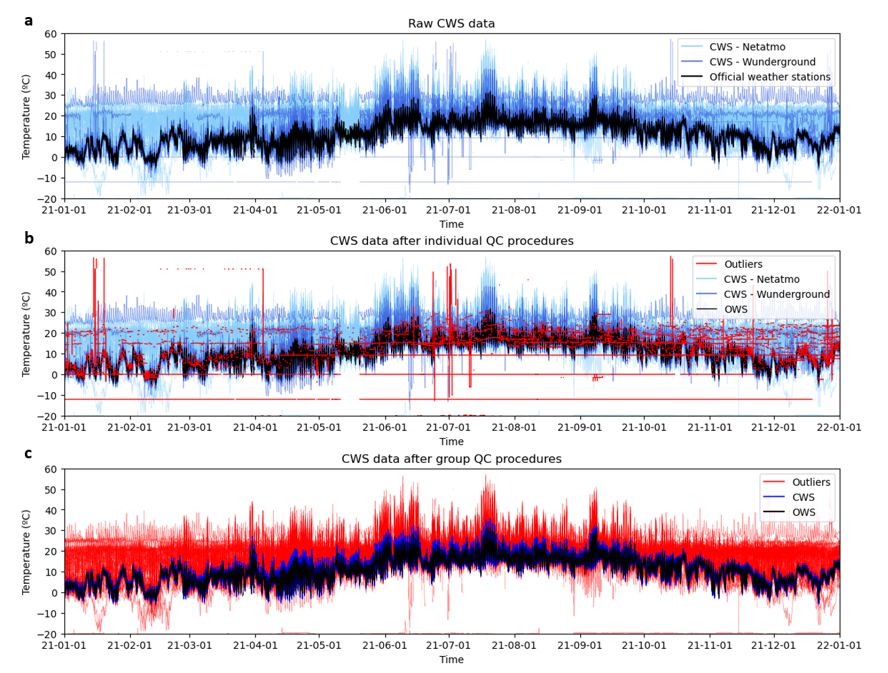
Supplementary Figure 5.1. Overlapping of air temperature time series from CWS and OWS before and after pre-processing. a, Raw data of air temperature from CWS. b, Air temperature data after individual QC procedures. c, Air temperature data after group QC procedures. The outliers identified during the pre-processing protocol are highlighted in red.

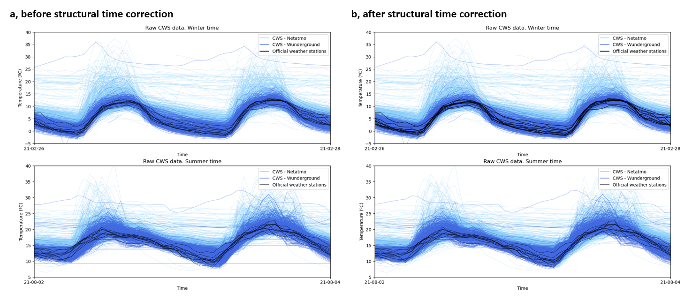
Supplementary Figure 5.2. Illustration of the QC step G2: Structural time errors (UTC time). a, Data overlapping for winter time and summer time before time correction. b, Data overlapping for winter time and summer time after time correction. This figure shows how the temporal structure of wunderground CWS data is corrected from local time to winter time along the year.

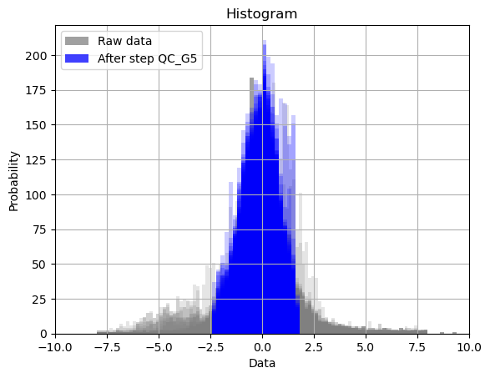
Supplementary Figure 5.3. Data histogram before and after the QC step G5. It shows the results of the modified z-score values obtained from the dataset (grey color – data before QC_G5); and how values outside the confidence interval, ranging from 1% (α = 0.01 at the lower tail) to 95% (α = 0.05 on the upper tail) of the normal distribution, are flagged as suspicious and eliminated (blue area – data after QC_G5).

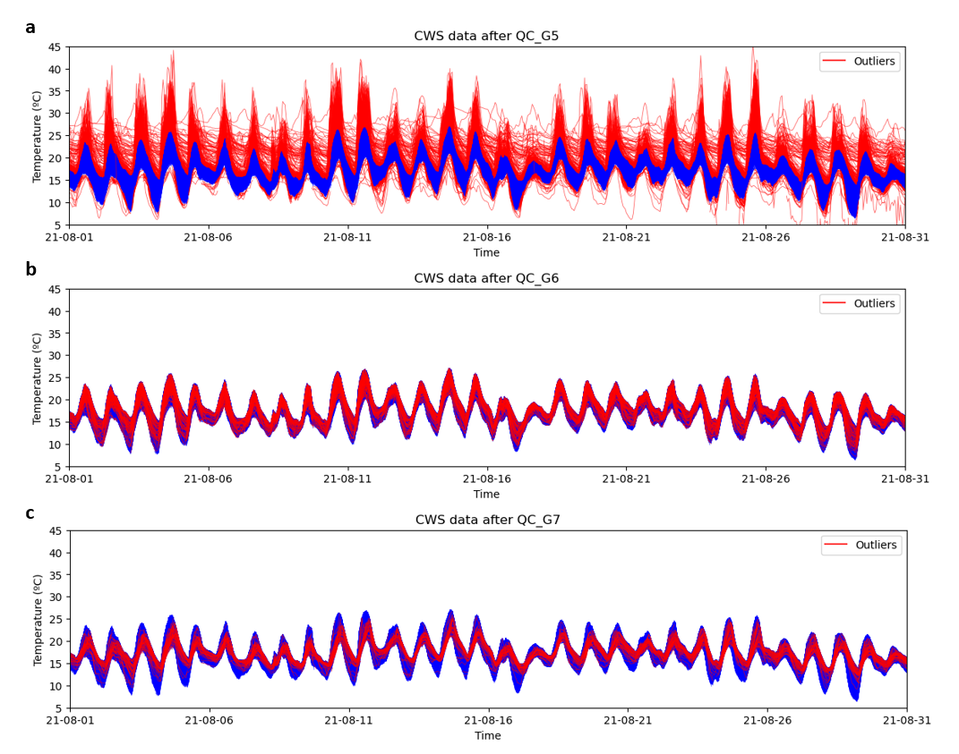
Supplementary Figure 5.4. Results after outlier identification by applying different group QC steps: G5, G6 and G7. a, Outliers after QC_G5 mainly related to sensor overheating or wrong sensor locations. b, Outliers after QC_G6 from CWS too erroneous to be kept, with more than 25% of data flagged as suspicious. c, Outliers after QC_G7 related to data from indoor environments or other specific microenvironments less correlated to outdoor temperature oscillation.

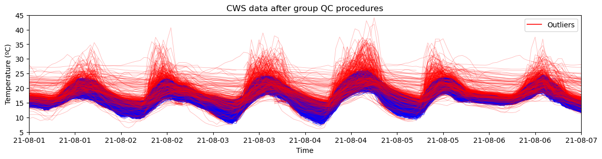
Supplementary Figure 5.5. Overlapping of air temperature data after outlier identification by applying all group QC techniques. Data from August 2021 in London. Air temperature profiles in blue involve all CWSs available from Netatmo and Wunderground.

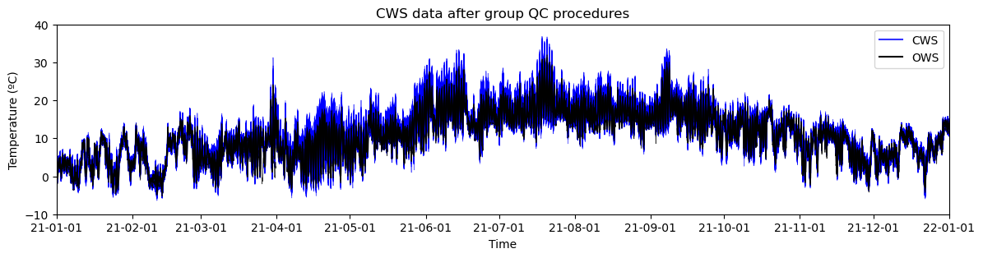
Supplementary Figure 5.6. Final dataset after pre-processing techniques of London climate data in 2021. The black line illustrates the temperature data from official weather stations (OWS), and the blue lines the temperature data from citizen weather stations (CWS)

Supplementary note 6. Detailed results of diagnostic analytics for the city of London.
In this section, some of the techniques used for data analytics in this study are further detailed. Supplementary Figure 6.1b illustrates the location of CWSs clustered as rural locations. These stations are below the 5th percentile of the annual average of daily minimum temperatures, whose hourly mean temperature profile is illustrated in Supplementary Figure 6.1c (red line).
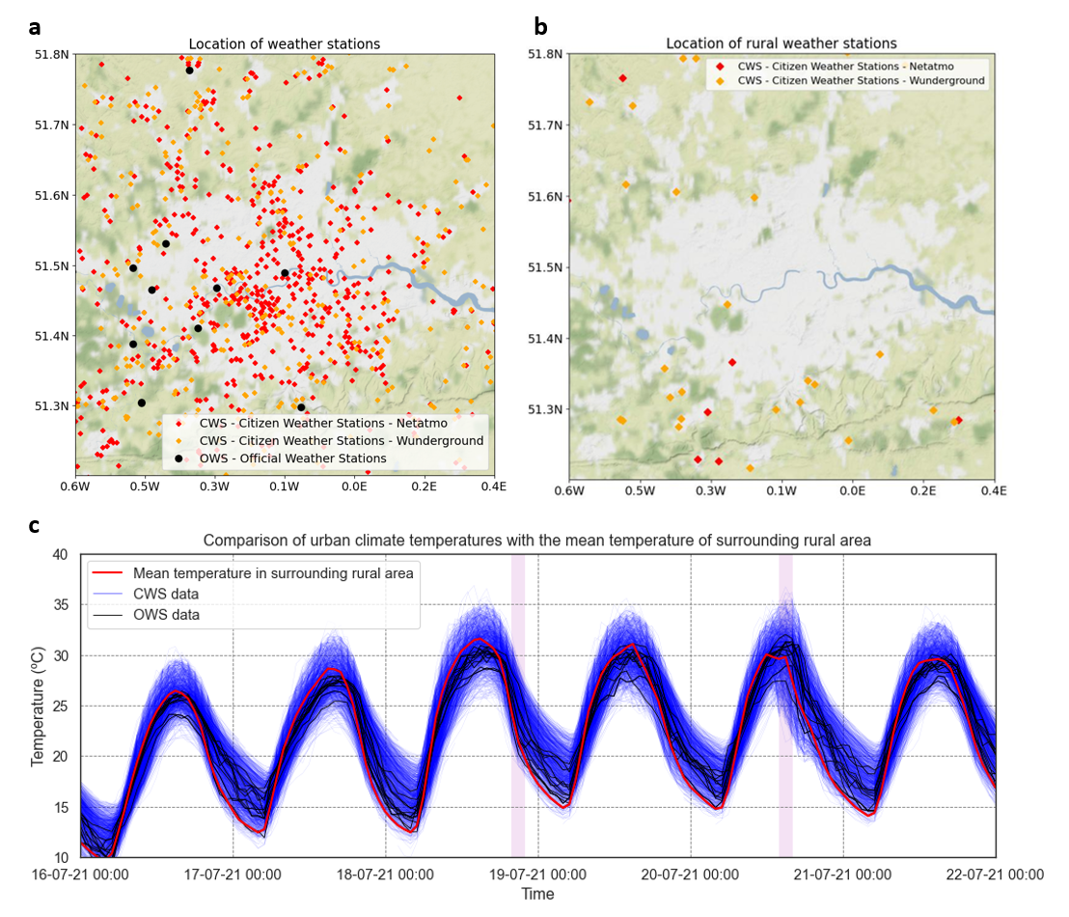
Supplementary Figure 6.1. Example of diagnostic analytics for the CWS data of London in 2021. a, Location of all weather stations used in this study: CWS from Netatmo, CWS from Wunderground and OWS from Met Office MIDAS database in the UK. b, Location of the cluster of weather stations characterised as rural following the approach defined in data analytics. c, Overlaping of air temperature profiles from all CWS (blue), all OWS (black), and hourly mean air temperature obtained from CWSs identified as rural (red line). Vertical purple lines identify the hours with higher UHI intensity at night and daytime, respectively. It is noted how the average air temperature profile calculated from rural CWS reaches a minimum temperature value every day close to the daily minimum across the sample.

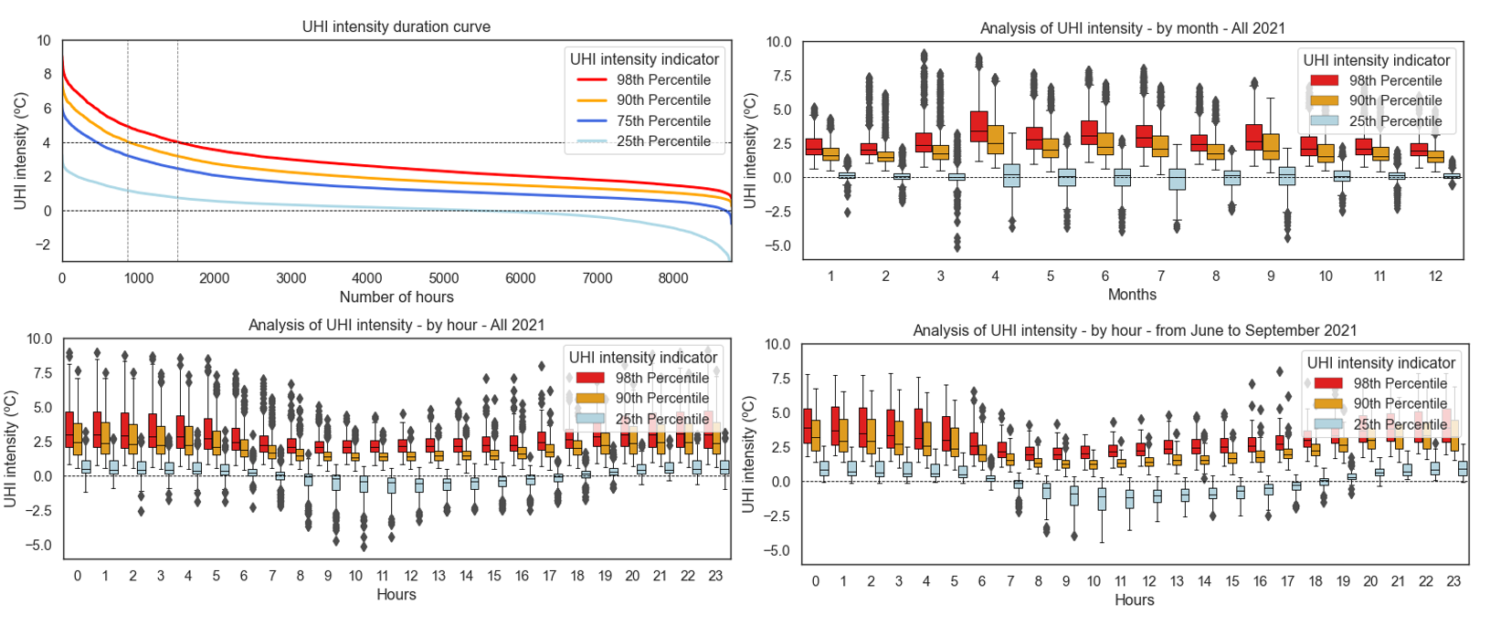
Supplementary Figure 6.2. Analysis of UHI intensity in London 2021. a, Duration curve of UHI intensity throughout the year. b, Boxplot analysis of UHI intensity by month in 2021. c, Boxplot analysis of UHI intensity hourly in 2021. d, Boxplot analysis of UHI intensity hourly from June to September 2021.

Supplementary note 7. CWS analysis per local climate zone (LCZ).
This supplementary note provides additional statistics of the CWSs per Local Climate Zone (LCZ).
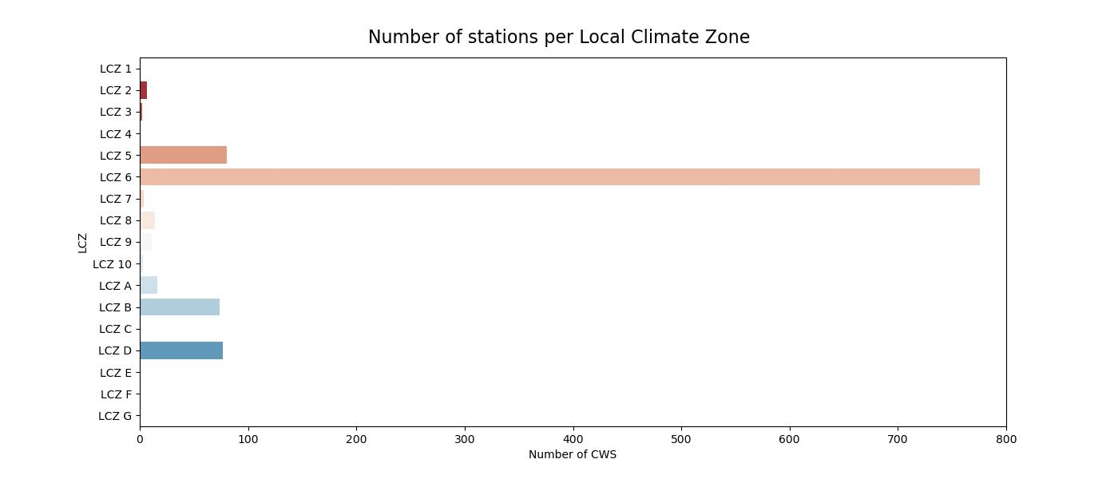
Supplementary Figure 7.1. Number of CWSs per Local Climate Zone.

Supplementary note 8. Additional visualisation of results
This supplementary note illustrates during 24 hours the hourly evolution of the UHI intensity at high spatio-temporal resolution for the days with the highest UHI intensity at night and daytime in London.
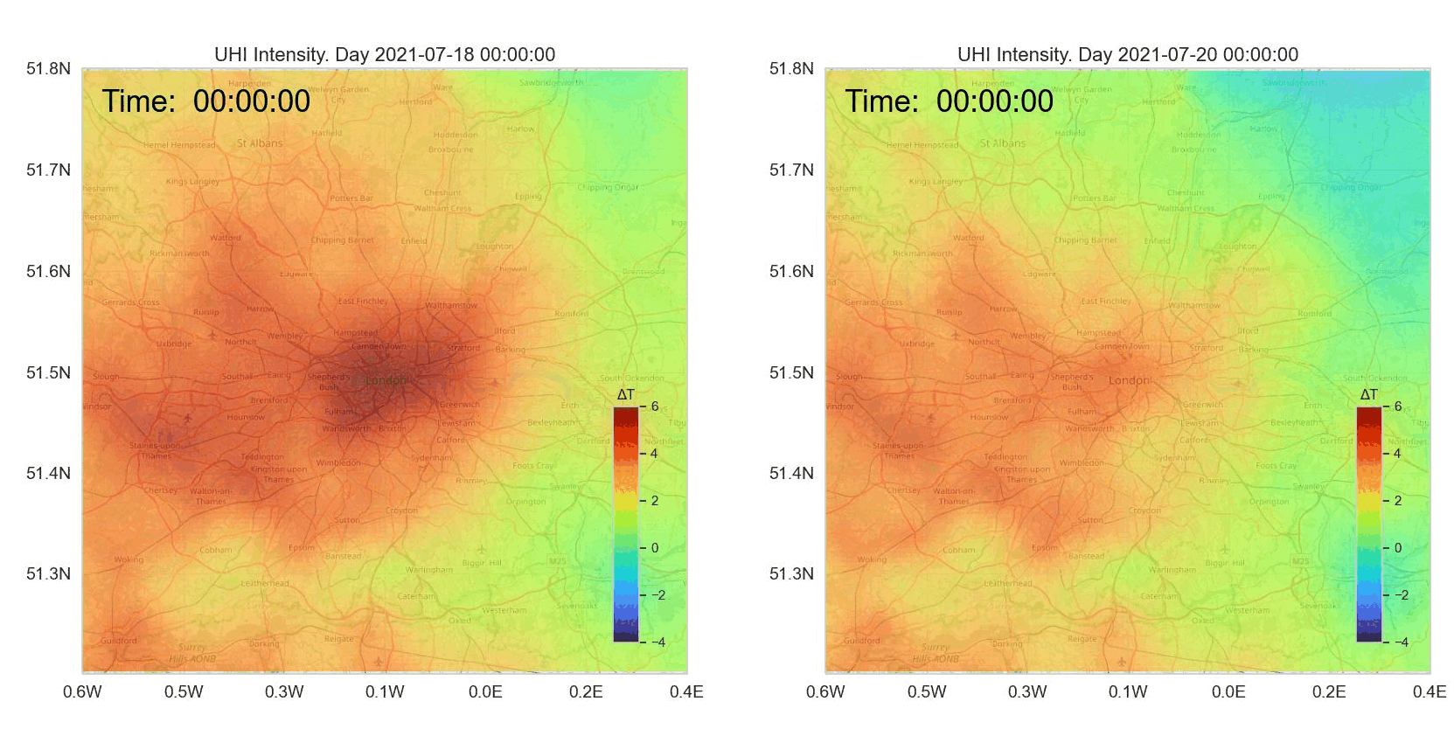
Supplementary Figure 8.1. Gifs showing the hourly evolution of UHI intensity at high spatio-temporal resolution for the days with highest UHI intensity at night (18/07/2021) and daytime (20/07/2021). The left map shows an intense nighttime UHI intensity under stable atmospheric conditions. The right map shows a day with a varying UHI intensity under unstable atmospheric conditions, mainly related to local precipitation.

Supplementary References
1. Weather Graphics. Weather Station Identifiers. http://www.weathergraphics.com/identifiers/.
2. Smith, A., Lott, N. & Vose, R. The integrated surface database: Recent developments and partnerships. Bulletin of the American Meteorological Society 92, 704–708 (2011).
3. National Centers for Environmental Information (NCEI). Global Hourly - Integrated Surface Database (ISD). https://www.ncei.noaa.gov/products/land-based-station/integrated-surface-database.
4. Bell, S., Cornford, D. & Bastin, L. The state of automated amateur weather observations. Weather 68, 36–41 (2013).
5. Muller, C. L. et al. Crowdsourcing for climate and atmospheric sciences: Current status and future potential. International Journal of Climatology 35, 3185–3203 (2015).
6. Meier, F. et al. Challenges and benefits from crowdsourced atmospheric data for urban climate research using Berlin, Germany, as testbed. in ICUC9 - 9th International Conference on Urban Climate jointly with 12th Symposium on the Urban Environment Challenges 6p. (2015).
7. Bell, S., Cornford, D. & Bastin, L. How good are citizen weather stations? Addressing a biased opinion. Weather 70, 75–84 (2015).
8. Chapman, L., Bell, C. & Bell, S. Can the crowdsourcing data paradigm take atmospheric science to a new level? A case study of the urban heat island of London quantified using Netatmo weather stations. International Journal of Climatology 37, 3597–3605 (2017).
9. Meier, F., Fenner, D., Grassmann, T., Otto, M. & Scherer, D. Crowdsourcing air temperature from citizen weather stations for urban climate research. Urban Climate 19, 170–191 (2017).
10. Fenner, D., Meier, F., Bechtel, B., Otto, M. & Scherer, D. Intra and inter ‘local climate zone’ variability of air temperature as observed by crowdsourced citizen weather stations in Berlin, Germany. Meteorologische Zeitschrift 26, 525–547 (2017).
11. De Vos, L., Leijnse, H., Overeem, A. & Uijlenhoet, R. The potential of urban rainfall monitoring with crowdsourced automatic weather stations in Amsterdam. Hydrology and Earth System Sciences 21, 765–777 (2017).
12. Chen, A. B., Behl, M. & Goodall, J. L. Trust me, my neighbors say it’s raining outside. in 5th Conference on Systems for Built Environments 25–28 (2018). doi:10.1145/3276774.3276792.
13. Bruns, J., Riesterer, J., Wang, B., Riedel, T. & Beigl, M. Automated quality assessment of (citizen) weather stations. GI_Forum 6, 65–81 (2018).
14. Hammerberg, K., Brousse, O., Martilli, A. & Mahdavi, A. Implications of employing detailed urban canopy parameters for mesoscale climate modelling: a comparison between WUDAPT and GIS databases over Vienna, Austria. International Journal of Climatology 38, e1241–e1257 (2018).
15. Napoly, A., Grassmann, T., Meier, F. & Fenner, D. Development and Application of a Statistically-Based Quality Control for Crowdsourced Air Temperature Data. Frontiers in Earth Science 6, 1–16 (2018).
16. Golroudbary, V. R., Zeng, Y., Mannaerts, C. M. & Su, Z. Urban impacts on air temperature and precipitation over the netherlands. Climate Research 75, 95–109 (2018).
17. Clark, M. R., Webb, J. D. C. & Kirk, P. J. Fine-scale analysis of a severe hailstorm using crowd-sourced and conventional observations. Meteorological Applications 25, 472–492 (2018).
18. Uteuov, A., Kalyuzhnaya, A. & Boukhanovsky, A. The cities weather forecasting by crowdsourced atmospheric data. Procedia Computer Science 156, 347–356 (2019).
19. Fenner, D., Holtmann, A., Meier, F., Langer, I. & Scherer, D. Contrasting changes of urban heat island intensity during hot weather episodes. Environmental Research Letters 14, (2019).
20. de Vos, L. W., Leijnse, H., Overeem, A. & Uijlenhoet, R. Quality Control for Crowdsourced Personal Weather Stations to Enable Operational Rainfall Monitoring. Geophysical Research Letters 46, 8820–8829 (2019).
21. Nipen, T. N., Seierstad, I. A., Lussana, C., Kristiansen, J. & Hov, Ø. Adopting citizen observations in operational weather prediction. Bulletin of the American Meteorological Society 101, E43–E57 (2020).
22. Varentsov, M. I. et al. Citizen weather stations data for monitoring applications and urban climate research: An example of Moscow megacity. IOP Conference Series: Earth and Environmental Science 611, (2020).
23. Varentsov, M. I. et al. Urban heat island of the Moscow megacity: The long-term trends and new approaches for monitoring and research based on crowdsourcing data. IOP Conference Series: Earth and Environmental Science 606, (2020).
24. Vulova, S., Meier, F., Fenner, D., Nouri, H. & Kleinschmit, B. Summer Nights in Berlin, Germany: Modeling Air Temperature Spatially with Remote Sensing, Crowdsourced Weather Data, and Machine Learning. IEEE Journal of Selected Topics in Applied Earth Observations and Remote Sensing 13, 5074–5087 (2020).
25. Droste, A. M., Heusinkveld, B. G., Fenner, D. & Steeneveld, G. J. Assessing the potential and application of crowdsourced urban wind data. Quarterly Journal of the Royal Meteorological Society 146, 2671–2688 (2020).
26. Venter, Z. S., Brousse, O., Esau, I. & Meier, F. Hyperlocal mapping of urban air temperature using remote sensing and crowdsourced weather data. Remote Sensing of Environment 242, 111791 (2020).
27. Feichtinger, M. et al. Case-study of neighborhood-scale summertime urban air temperature for the City of Vienna using crowd-sourced data. Urban Climate 32, 1–12 (2020).
28. Båserud, L. et al. TITAN automatic spatial quality control of meteorological in-situ observations. Advances in Science and Research 17, 153–163 (2020).
29. Mandement, M. & Caumont, O. Contribution of personal weather stations to the observation of deep-convection features near the ground. Natural Hazards and Earth System Sciences 20, 299–322 (2020).
30. de Vos, L. W. et al. Hydrometeorological monitoring using opportunistic sensing networks in the Amsterdam metropolitan area. Bulletin of the American Meteorological Society 101, E167–E185 (2020).
31. Cornes, R. C., Dirksen, M. & Sluiter, R. Correcting citizen-science air temperature measurements across the Netherlands for short wave radiation bias. Meteorological Applications 27, 1–16 (2020).
32. Zumwald, M., Knüsel, B., Bresch, D. N. & Knutti, R. Mapping urban temperature using crowd-sensing data and machine learning. Urban Climate 35, 100739 (2021).
33. Venter, Z. S., Chakraborty, T. & Lee, X. Crowdsourced air temperatures contrast satellite measures of the urban heat island and its mechanisms. Science Advances 7, 1–10 (2021).
34. Fenner, D., Bechtel, B., Demuzere, M., Kittner, J. & Meier, F. CrowdQC+—A Quality-Control for Crowdsourced Air-Temperature Observations Enabling World-Wide Urban Climate Applications. Frontiers in Environmental Science 9, 1–21 (2021).
35. Graf, M. et al. Combined rainfall estimates from personal weather station and commercial microwave link data in Germany. EGU General Assembly online, 19–30 Apr 2021, EGU21-12445 (2021).
36. Chen, J., Saunders, K. & Whan, K. Quality control and bias adjustment of crowdsourced wind speed observations. Quarterly Journal of the Royal Meteorological Society 147, 3647–3664 (2021).
37. Meyer, L., Gubler, M., Meier, F. & Brönnimann, S. Intercomparison and combination of low-cost urban air temperature measurement approaches. Meteorologische Zeitschrift 31, 131–148 (2022).
38. Brousse, O. et al. Evidence of horizontal urban heat advection in London using six years of data from a citizen weather station network. Environmental Research Letters 17, (2022).
39. Sgoff, C. et al. Assimilation of crowd-sourced surface observations over Germany in a regional weather prediction system. Quarterly Journal of the Royal Meteorological Society 148, 1752–1767 (2022).
40. Gharesifard, M., Wehn, U. & van der Zaag, P. Towards benchmarking citizen observatories: Features and functioning of online amateur weather networks. Journal of Environmental Management 193, 381–393 (2017).
41. Middel, A., Nazarian, N., Demuzere, M. & Bechtel, B. Urban Climate Informatics: An Emerging Research Field. Frontiers in Environmental Science 10, 1–15 (2022).
42. Hahn, C. et al. Observations from Personal Weather Stations—EUMETNET Interests and Experience. Climate 10, 192 (2022).
43. WMO. Guidelines on Surface Station Data Quality Control and Quality Assurance for Climate Applications 2021. (2021).
44. Fiebrich, C. A., Morgan, C. R., McCombs, A. G., Hall, P. K. & McPherson, R. A. Quality Assurance Procedures for Mesoscale Meteorological Data. Journal of Atmospheric and Oceanic Technology 27, 1565–1582 (2010).
45. Estévez, J., Gavilán, P. & Giráldez, J. V. Guidelines on validation procedures for meteorological data from automatic weather stations. Journal of Hydrology 402, 144–154 (2011).
46. Cerlini, P. B., Silvestri, L. & Saraceni, M. Quality control and gap‐filling methods applied to hourly temperature observations over central Italy. Meteorological Applications 27, (2020).
47. Thomopoulos, N. T. Statistical Distributions. Statistical Distributions. Applications and Parameter Estimates (2017). doi:10.1007/978-3-319-65112-5.
48. Rousseeuw, P. J. & Croux, C. Alternatives to the median absolute deviation. Journal of the American Statistical Association 88, 1273–1283 (1993).
49. Leys, C., Ley, C., Klein, O., Bernard, P. & Licata, L. Detecting outliers: Do not use standard deviation around the mean, use absolute deviation around the median. Journal of Experimental Social Psychology 49, 764–766 (2013).
50. Aggarwal, C. C. High-Dimensional Outlier Detection: The Subspace Method. in Outlier Analysis 135–167 (Springer New York, 2013). doi:10.1007/978-1-4614-6396-2_5.
51. Iglewicz, B. & Hoaglin, D. Volume 16: How to Detect and Handle Outliers. (ASQC Quality Press, 1993).
52. Ahsanullah, M., Kibria, B. M. G. & Shakil, M. Normal and Student’s t Distributions and Their Applications. (Atlantis Press, 2014). doi:10.2991/978-94-6239-061-4.

