Figure S1: Species specific vertical distribution of oothecae. Zero indicates the substrate surface, negative values represent buried othecae and positive values represent oothecae placed on blades of grasses.
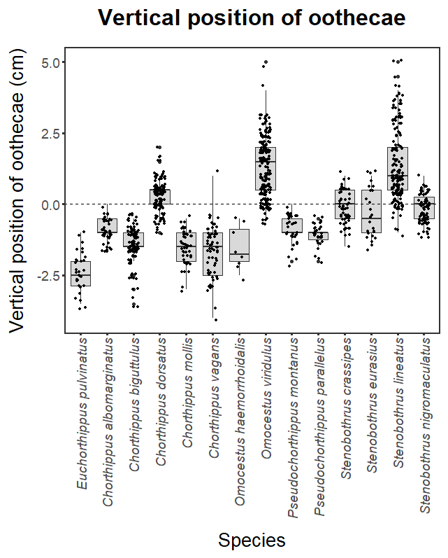

Figure S2: Effects of moisture on species specific vertical distribution of bare ground-laid oothecae. Full line represents the overall fit (across all species) based on the phyllogeneticaly corrected mixed-effect model. In general, increasing substrate moistures resulted in significantly shallower placement of oothecae.
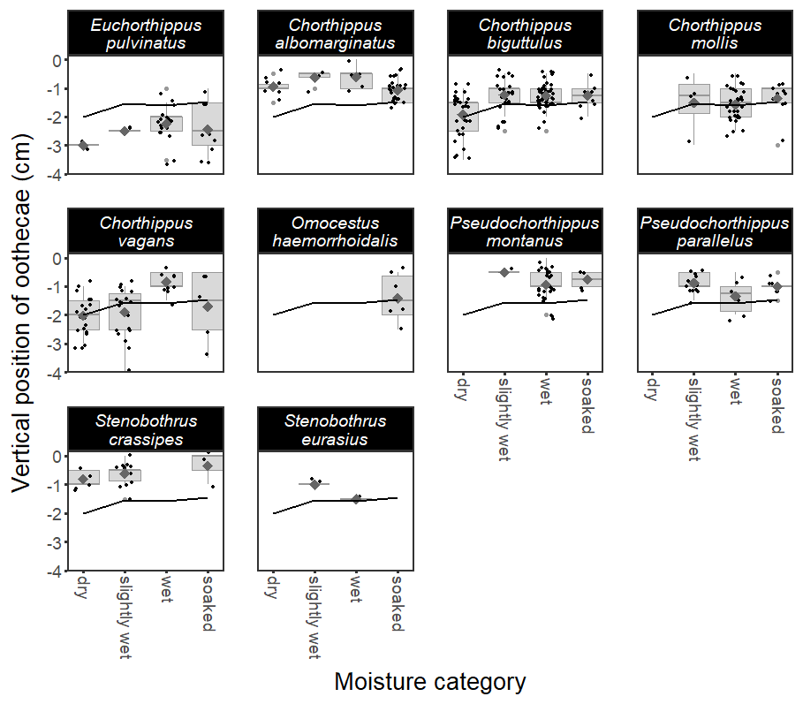

Figure S3: Effects of moisture on species specific vertical distribution of tussock-laid oothecae. Full line represents the overall fit (across species) based on the phyllogeneticaly corrected mixed-effect model. In general, vertical position of oothecae significantly increased with substrate moisture.
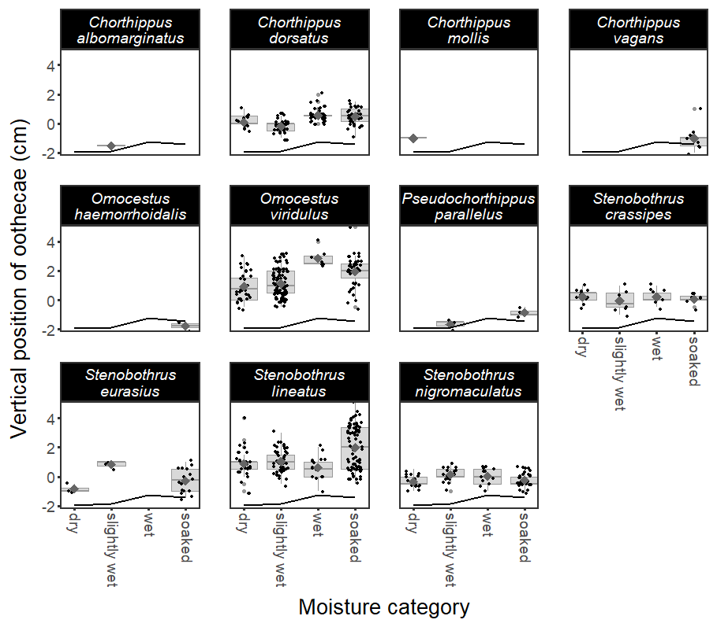

Figure S4: Phyllogenetic relationships of species studied.

