Supporting Information
Vertical textile Epifluidics for integrated real-time electrochemical sweat analysis.
Marina Galliani¹, Esma Ismailova^{1*}, Pooya Azizian^{2,3}, Anatolii Makhinia^{4,5}, Joan M. Cabot²,
¹ Mines Saint-Etienne, Centre CMP, Département BEL, F-13541 Gardanne, France ; marina.galliani@emse.fr ; ismailova@emse.fr
² Energy and Engineering Department, Leitat Technological Center, Terrassa (Barcelona) Spain.
³ Mechanical Engineering Department, Technical University of Catalonia, Terrassa (Barcelona) Spain.
⁴ RISE Research Institutes of Sweden, Digital Systems – Smart Hardware – Printed, Bio- and Organic Electronics, Norrköping 60233, Sweden.
⁵Laboratory of Organic Electronics, Department of Science and Technology, Linköping University, Norrköping 602 21, Sweden

Figure S1: Flexible photoresin appearance.

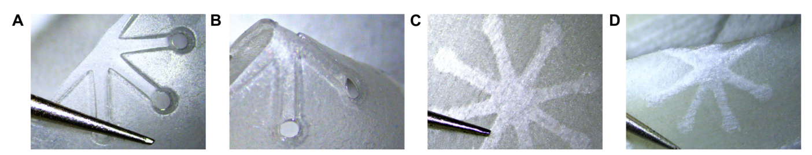
Figure S1: A) Resin made 3D-printed microfluidics module A showing the plain material’s appearance. B) Folded printed object to emphasize the resin’s flexibility. C) Frontal view of a printed A module in which flexible resin is embedded into the fabric. D) Folded module to show the preserved flexibility when integrated in textile.

Figure S2: Screen-printed, microfluidics-integrated, and K⁺-selective OECT fabrication steps.

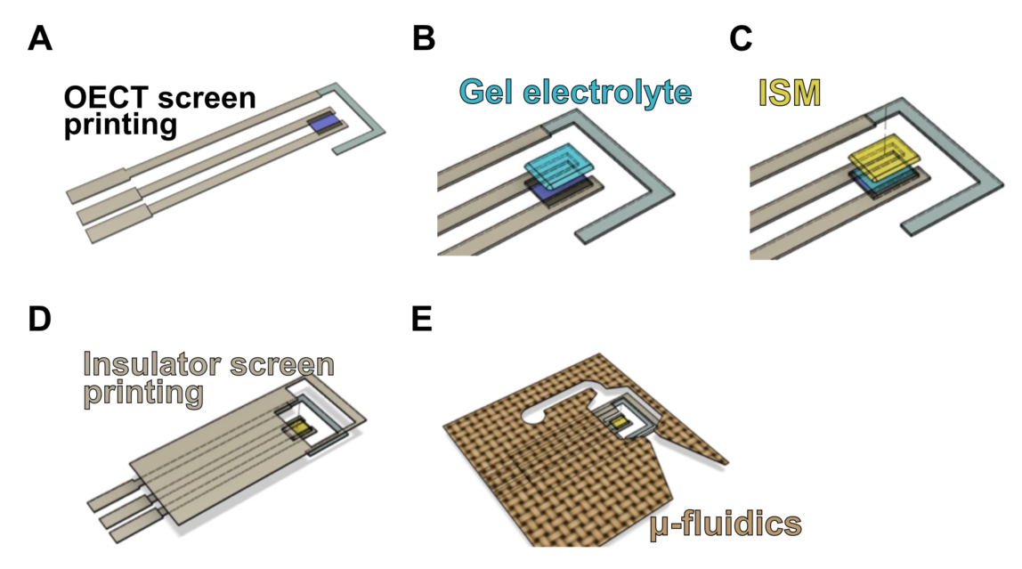

Figure S2: OECT fabrication by the screen-printing technique. A) Ag-based ink for the contact pads and connection track to the source and drain electrodes, PEDOT:PSS-based ink for the channel, carbon-based ink for the source and drain electrodes, Ag/AgCl-based ink for the gate electrode. B) Deposition by drop casting of the NaPSS based gel electrolyte. It is importnt to recall that the response of p-type depletion-mode OECTs relies on the electrolyte’s cations moving in and out from the conducting polymer.^{[1]} Ion-selective membrane deposited onto the channel is semi-hydrophobic barrier that reduces the ions mobility from the electrolyte into the PEDOT:PSS by 1000 times in respect to the aqueous environment. As reported elsewhere^{[2]} and as we observed in our devices (data not shown), a ISM-PEDOT:PSS OECT has a substantial loss of current modulation upon varying the gate voltage. Therefore , to solve this issue, we deposited a NaPSS polyelectrolyte layer prior to the ISM casting. C) Drop-casting of the ISM. The introduction of the ISM functionalization in the course of the OECT fabrication process represents a strategic approach to elude the need for an additional ISM securing step. D) Screen-printing of a UV-curable insulating and sealing ink. E) Sensor’s alignment and lamination onto the 3D textile microfluidics.

Capillary-driven flow analysis
Capillary Pressure
To analyze a capillary-driven flow, it is important to recall the gas-liquid interface properties, fluid intermolecular interactions, and their interaction with the solid porous media define the capillary wicking process. For a simplified estimation of the flow rate and of the imbibition length vs. time, in a specific porous and permeable medium, Darcy's law^{[3]} and the Lucas-Washburn equations can be respectively used. However, these equations have demonstrated to lack prediction ability for heterogeneous porous media,^{[4]} thus for a more accurate study, we take into account pore shapes and tortuosity to experimentally validate and describe the capillary pressures and viscous forces properties.
The capillary pressure generation functioning can be explained, while considering the represented forces in the conservation of momentum, by model capillarity as a force applied on a meniscus (σκ$δ_{s}$n) where σ, κ, $δ_{s}$, n are the surface tension, curvature, Dirac delta, and the normal vector to the interface, respectively.^{[5,6]} The Young-Laplace equation (Eq.1 main text) it is used to calculate the P_{C} considering that it describes the P_{C} across a liquid-air meniscus in a closed rectangular microchannel. The setup shown in Figure 4B, composed of a microchannel connected to a textile capillary pump of fixed dimensions, was used to experimentally calculate the P_{C} difference in 3 porous materials. In this system, θ_{bottom} is kept ≈ 90°, while θ_{top}, θ_{left}, θ_{right} are referred to θ and are tuned by exposing the microchannel with oxygen plasma surface treatment. For textile 1, when employing a microchannel with h equal to 150 μm and a θ ≈ 45°, the textile pump dragged all the fluid, meaning its P_{C} is higher than the one of the channel, which resulted equal to 713 Pa by means of Eq. 1. Whereas, by employing a channel with h equal to 100 μm and lowering the θ to 30° we reached the no-flow balanced-force static state. In these conditions, the calculated microchannel P_{C} is ≈ 873 Pa and we can associate it to the one of textile 1. With the same experimental approach, we found a 1496 ≥ PC > 873 Pa for material 2 using a microchannel with h equal to 100 and 50 μm and a θ of 30°. Differently, with textile 3 we could not reach the no-flow balanced-force static state since it was not possible to fabricate smaller 3D printed microchannels. We then concluded that the superhydrophilic textile 3 generates a P_{C} > 1624 Pa.

Viscous Forces
As described in section 2.2.1., the fluid transport is also influenced by the viscous force (R). In a dynamic system, R is opposed to the flow direction, and it is defined as the fluid resistance to flow under shear stress. For instance, the shear stress in the x-direction in the x-y plane is τxy=μ ((∂u)⁄(∂y)) where μ is the fluid viscosity. This force appears as the viscous term in the Navier-Stokes equation in 3D space (∇.(2μD), where D is the deformation tensor). In a microchannel, resistance (R) is the factor that regulates the flow rate (Q), and it can be estimated using the channel’s length, height, and width (L, h, w) respectively.^{[7]} Indeed, by taking into consideration D, there is an inverse proportionality between R and the channel’s dimensions. The R that we find in a filled channel with rectangular cross-sections can be calculated using the below equation $R=\frac{12μ L}{(1-0.63(\frac{h}{w})).(h^{3}.w)}$ (Eq 2) where μ stands for the fluid viscosity. To compare the viscous forces inside our microfluidic system, we monitored over time the traveling fluid distance within closed channels for the porous media 1, 2, 3 as reported in Figure 4C. These experiments inspect the Q values, in terms of fluid speed, which are inversely proportional to R. When the speed is not linear, the traveling distance in a porous material with the capillary radius of r might be described with the Lucas-Washburn (L-W) equation $X(t)=\sqrt{\frac{r σ cos θ }{2 μ} t }$ = K $\sqrt{ t }$ (Eq 3) in which the distance is proportional to the square root of the time by the capillary coefficient of K. However, this coefficient decreases for our textiles when the flow marches downstream due to the textiles’ tortuosity and resistance. So, the traveling distances diverge from the L-W equation (Eq.3). The changes in K for textile 1 is with a linear rate of approximately -0.01, and for textiles 2 and 3, it is approximately -0.03 based on the acquired data (Figure S3).
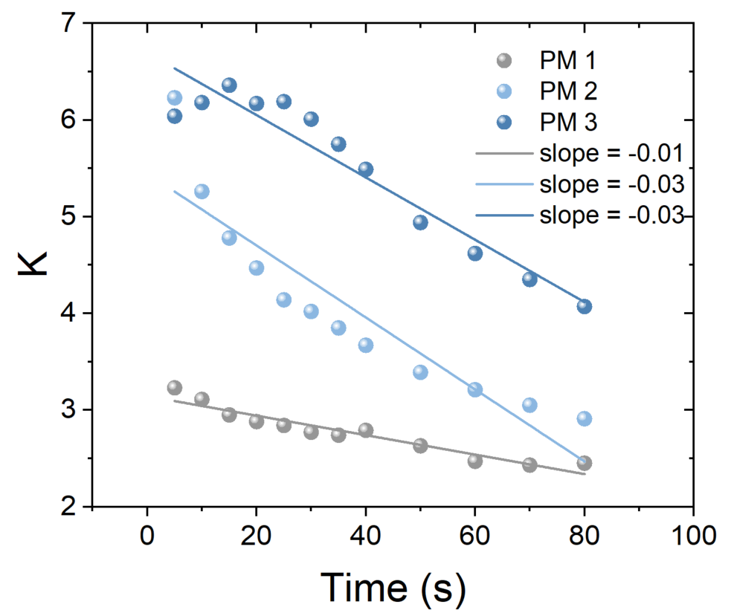
Figure S3: Capillary coefficients (K) of the three PM experimentally calculated (dots). The linear fittings estimate the relative rates.
Computational fluid dynamics
To characterize the tortuosity, in the computational fluid dynamics (CFD) numerical simulation the threads, forming the pores’ walls, were considered hydrophilic having 30° water contact angle, and the textile was confined from its top and bottom with a hydrophobic adhesive having 90° contact angle. Periodic boundary conditions were considered for the textile sides by connecting the left and the right boundaries of the domain, while the capillary action displaces water from the upstream into the downstream and not by an imposed pressure difference on its boundaries.

References
[1] J. Rivnay, S. Inal, A. Salleo, R.M. Owens, M. Berggren, G.G. Malliaras, Nature Reviews Materials 2018, 3, 17086.
[2] S. Han, S. Yamamoto, A.G. Polyravas, G.G. Malliaras, Advanced Materials 2020, 32, 2004790.
[3] M. Liu, S. Suo, J. Wu, Y. Gan, D. AH Hanaor, C.Q. Chen, Journal of Colloid and Interface Science 2019, 539, 379.
[4] J. Cai, T. Jin, J. Kou, S. Zou, J. Xiao, Q. Meng, Langmuir 2021, 37, 1623.
[5] P. Azizian, M. Azarmanesh, M. Dejam, M. Mohammadi, M. Shamsi, A. Sanati-Nezhad, A.A. Mohamad, Chemical Engineering Science 2019, 195, 201.
[6] M. Azarmanesh, M. Farhadi, P. Azizian, Physics of Fluids 2016, 28, 032005.
[7] A. Olanrewaju, M. Beaugrand, M. Yafia, D. Juncker, Lab Chip 2018, 18, 2323.

TOC
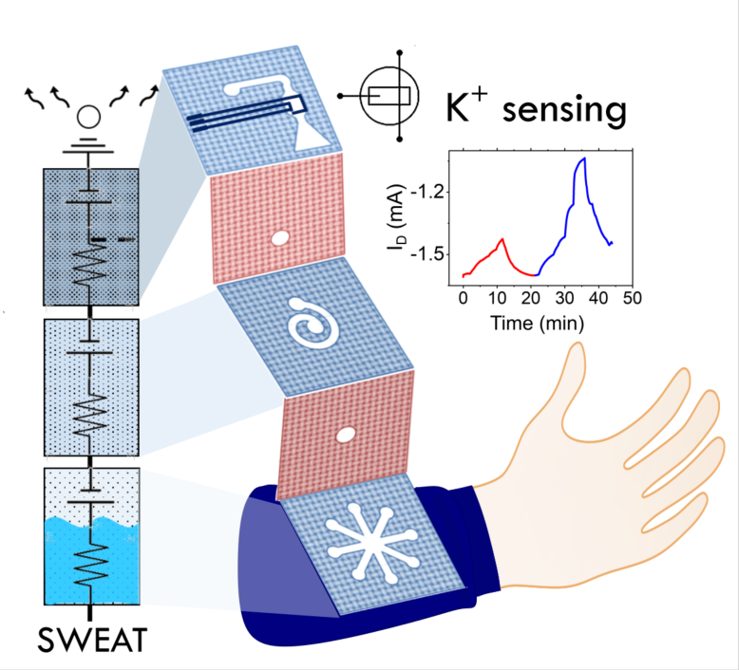

Selective 3D printing of a flexible photoresin within textiles enables monolithic wearable microfluidics integration. Generated capillary pressure gradients in the textile microfluidic modules provide controlled sweat collection, storage and transport capability. An integrated organic electronic transistor monitors the potassium levels in the collected quantity of sweat sample for an ergonomic in-situ and real-time analysis.

