Supporting Information
Interfacial self-healing polymer electrolytes for ultralong-life solid-state lithium-sulfur batteries
Fei Pei, Lin Wu, Yi Zhang, Yaqi Liao, Qi Kang, Yan Han, Huangwei Zhang, Yue Shen, Henghui Xu, Zhen Li* & Yunhui Huang*

State Key Laboratory of Materials Processing and Die & Mould Technology
School of Materials Science and Engineering
Huazhong University of Science and Technology
Wuhan 430074, China

*Corresponding authors

E-mail: li_zhen@hust.edu.cn; huangyh@hust.edu.cn

Methods
Materials. All reagents were commercially available and used as supplied without further purification. Dimethylacetamide (DMAc), dichloromethane, PEO, polytetrahydrofuran (PTMG, 2000 g mol⁻¹), hexamethylene diisocyanate (HDI) and 2-Hydroxyethyl disulfide (BHDS) and dibutyltin dilaurate (DBTDL) catalyst were purchased from Alfa Aesar. Lithium bis(fluorosulfonyl)imide (LiFSI) were purchased from Aldrich.
Material Characterization
The SEM analyze was carried out on FEI Nova NanoSEM450 microscope operated at 10 kV. FTIR spectra were measured using a Nicolet iS50 FT/IR Spectrometer (Thermo Fisher) with a diamond attenuated total reﬂectance attachment. Mechanical testing was carried out on an Instron 5565 testing stain using a strain rate of 5 cm min⁻¹. Powder X-ray diffraction (PXRD) analysis was characterized by X-ray powder diffraction (XRD, Cu Ka radiation, Rigaku Ultima IV) with a scanning rate of 2º min⁻¹. XPS tests were performed on ThermoFisher Thermo Scientific KAlpha+. ¹H NMR spectra was recorded on a Bruker 500 NMR MHz spectrometer at room temperature. Gel permeation chromatography (GPC) was carried out in DMF on two PolyPore columns (Agilent) connected in series with a DAWN multiangle laser light scattering (MALLS) detector.
Electrochemical Characterizations
The ionic conductivities of the solid composite electrolytes at different temperatures were measured by sandwiching the SPEs between two steel sheets in CR2032 cells and the frequency range was 0.1-10⁶ Hz. The ionic conductivity σ was calculated by the equation σ = L/(RS), where R was the total resistance of solid electrolyte, L was the sample thickness, and S was the area of solid electrolyte. The Li⁺ transference number (t_{Li}⁺) was obtained using a symmetric Li||Li cell by a chronoamperometry test with a DC voltage amplitude of 50 mV. The EIS tests were taken before and after DC polarization. The t_{Li}⁺ can be calculated according to t_{Li}⁺ = Is(ΔV−R₀I₀)/[I₀(ΔV−R_{s}I_{s})], where I₀ and I_{s} are the initial and steady-state DC current, respectively; R₀ and R_{s} are the initial and steady-state interfacial resistances, respectively. The electrochemical stability of the SPEs are evaluated a scan rate of 10 mV s⁻¹ from 0 to 6 V at room temperature.

DFT calculation
Density Functional Theory (DFT) calculations were carried out to better understand the electrolyte. This simulation calculation was carried out on Material studio software. All computations of electrolytes were calculated by using the DMol³ module. The exchange correlation functional was treated by the generalized-gradient-approximation (GGA) with the Perdew-Burke-Ernzerhof (PBE) functional¹. For the geometry optimization, convergence energy was set to 1.0 × 10⁻⁵ Ha for energy, 0.001 Ha/Å for force, and 0.005 Å for displacement.
The binding energy (Eb) was computed in the following equation²:
ΔE_{b} = E_{total} - E_{Li}⁺ - E_{Polymer}
where ΔE_{b} is the binding energy between the Li⁺ ion and polymer. E_{total} is the DFT total energy of the corresponding system with adsorbed Li⁺. E_{Li}⁺ and E_{s} represent the Gibbs energies of a Li⁺ ion and the corresponding polymer substrates, respectively.

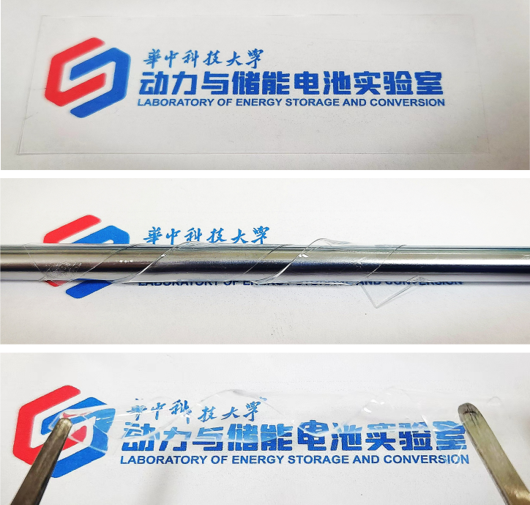
Supplementary Fig. 1 Digital photographs of the PTMG-HDI-BHDS films in various states.

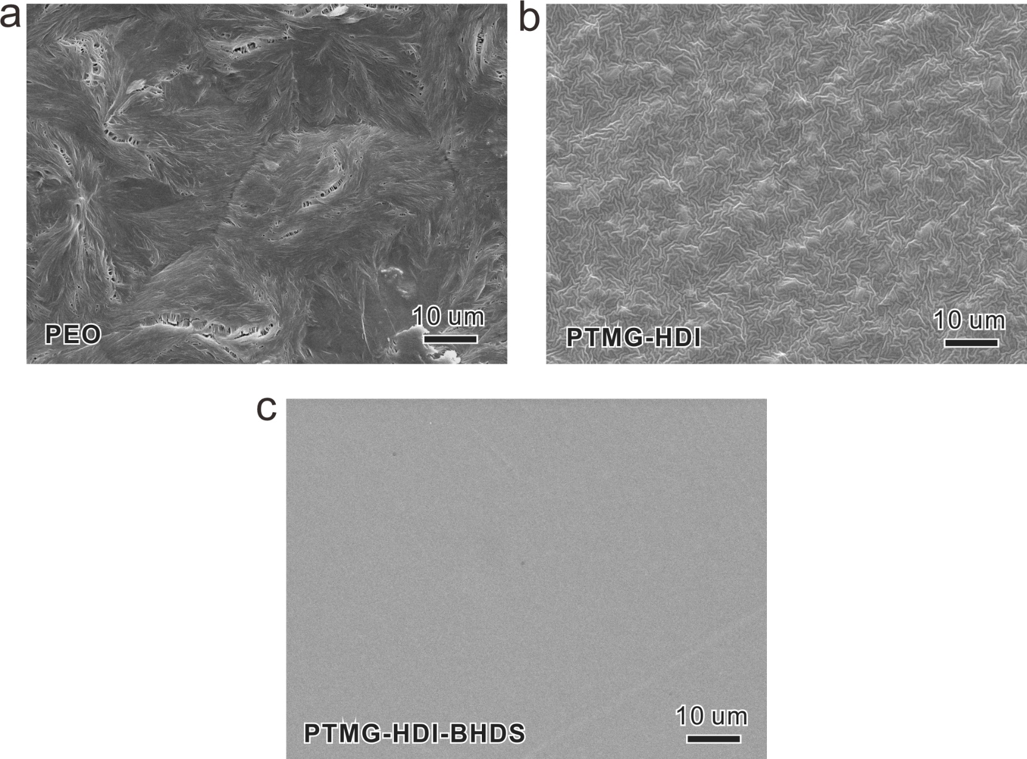
Supplementary Fig. 2 Top-view SEM images of PEO, PTMG-HDI and PTMG-HDI-BHDS films.
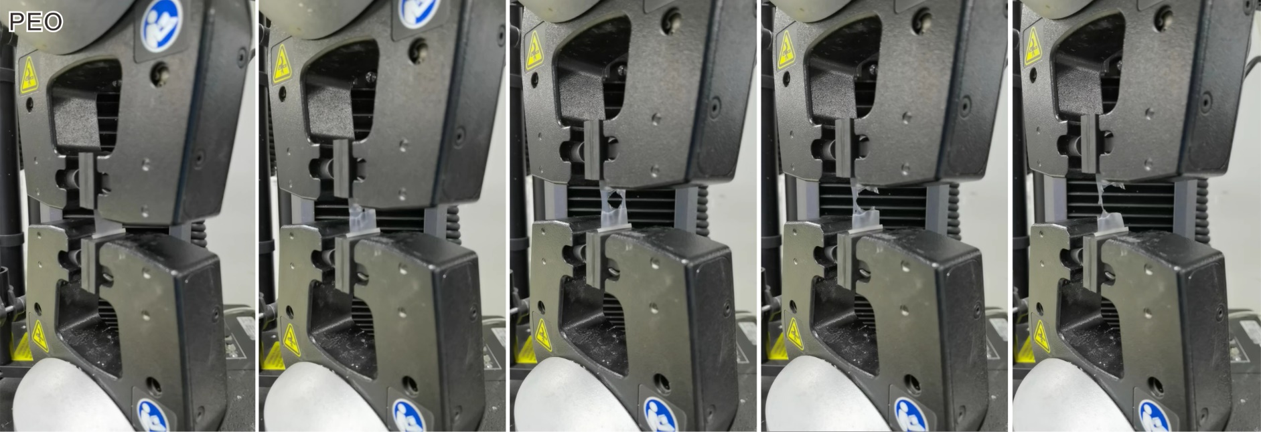
Supplementary Fig. 3 Photographs of the stress-strain measurement of PEO film.

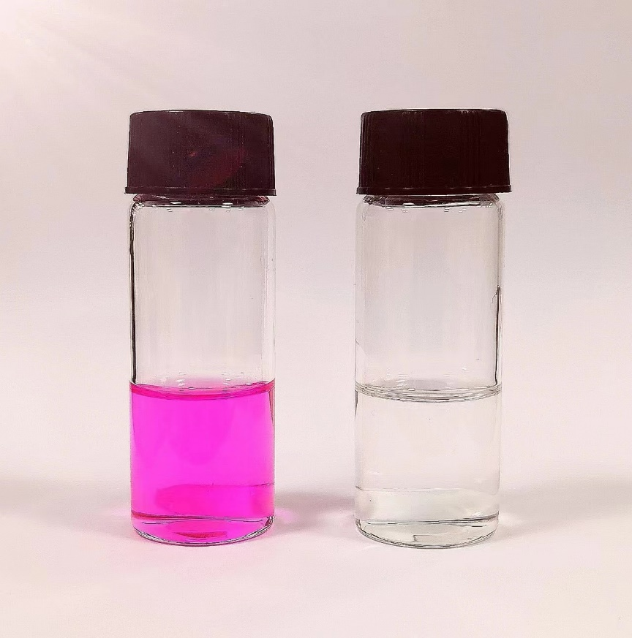
Supplementary Fig. 4 Photographs of before and after rhodamine B was added in the colorless PTMG-HDI-BHDS gel solution.

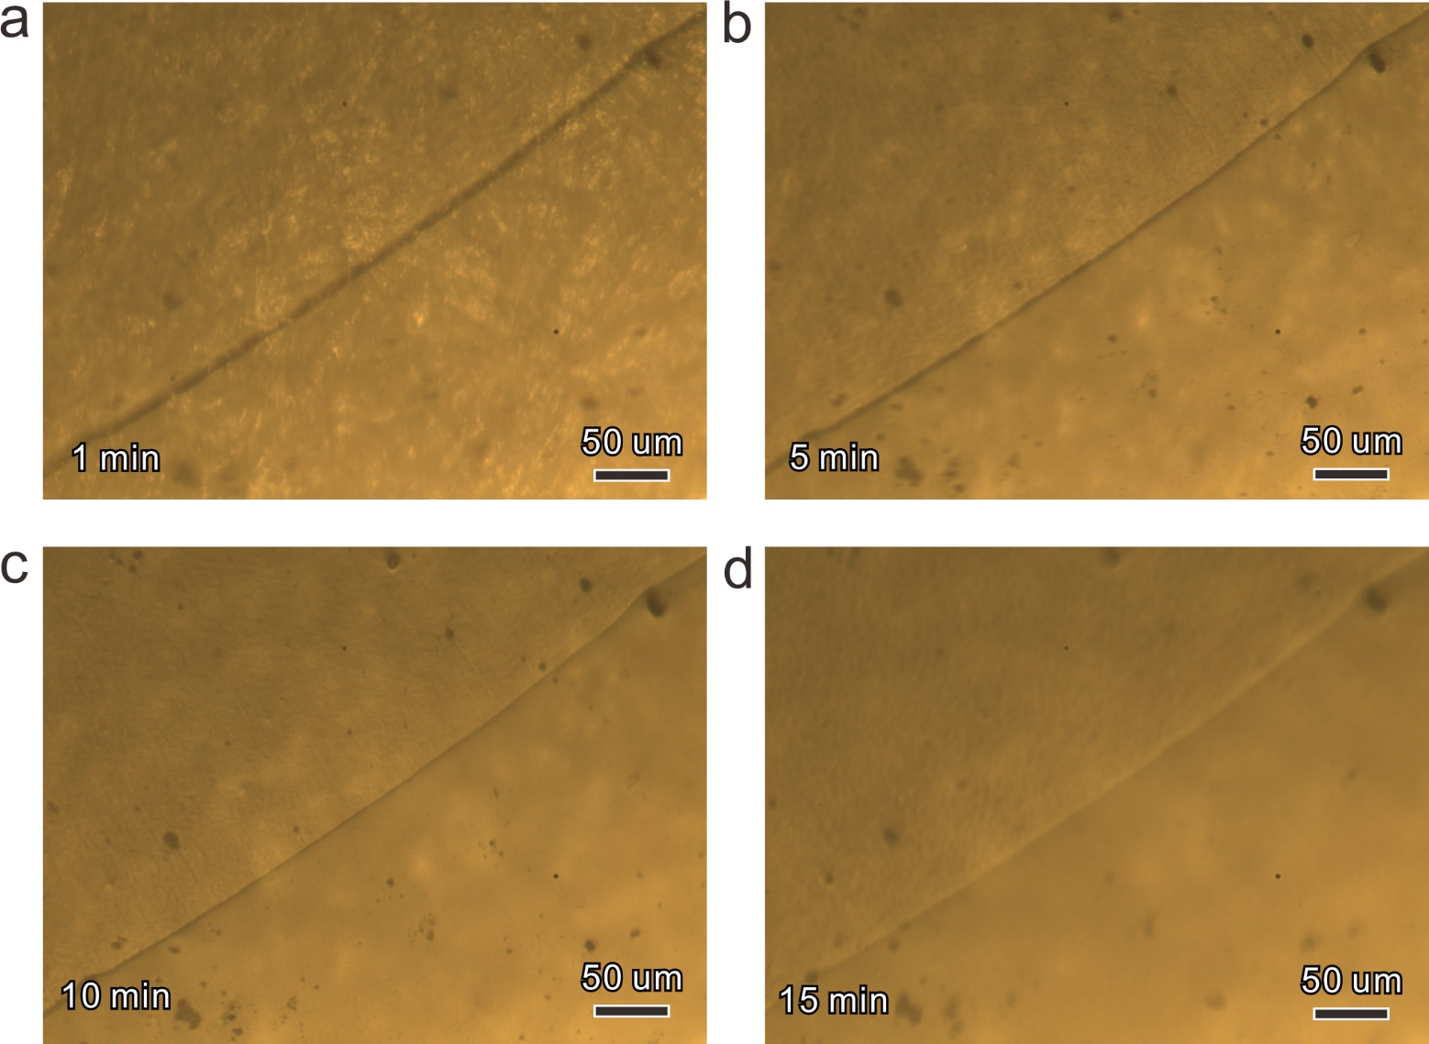
Supplementary Fig. 5 Optical microscopy images of the scratch on the PTMG-HDI-BHDS film before and after healing for 15 min at 30 ºC.

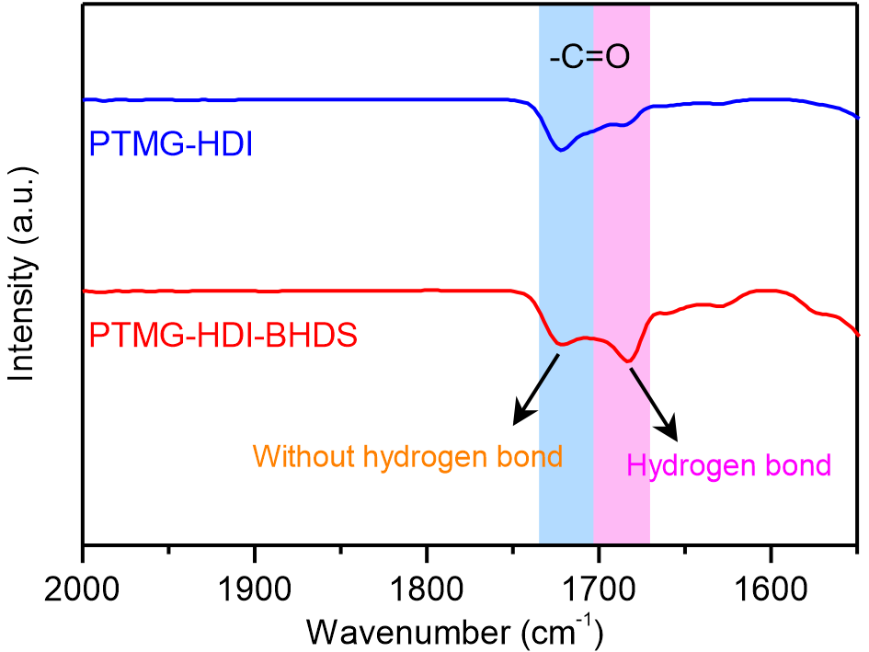
Supplementary Fig. 6 FTIR spectra of PTMG-HDI and PTMG-HDI-BHDS films.
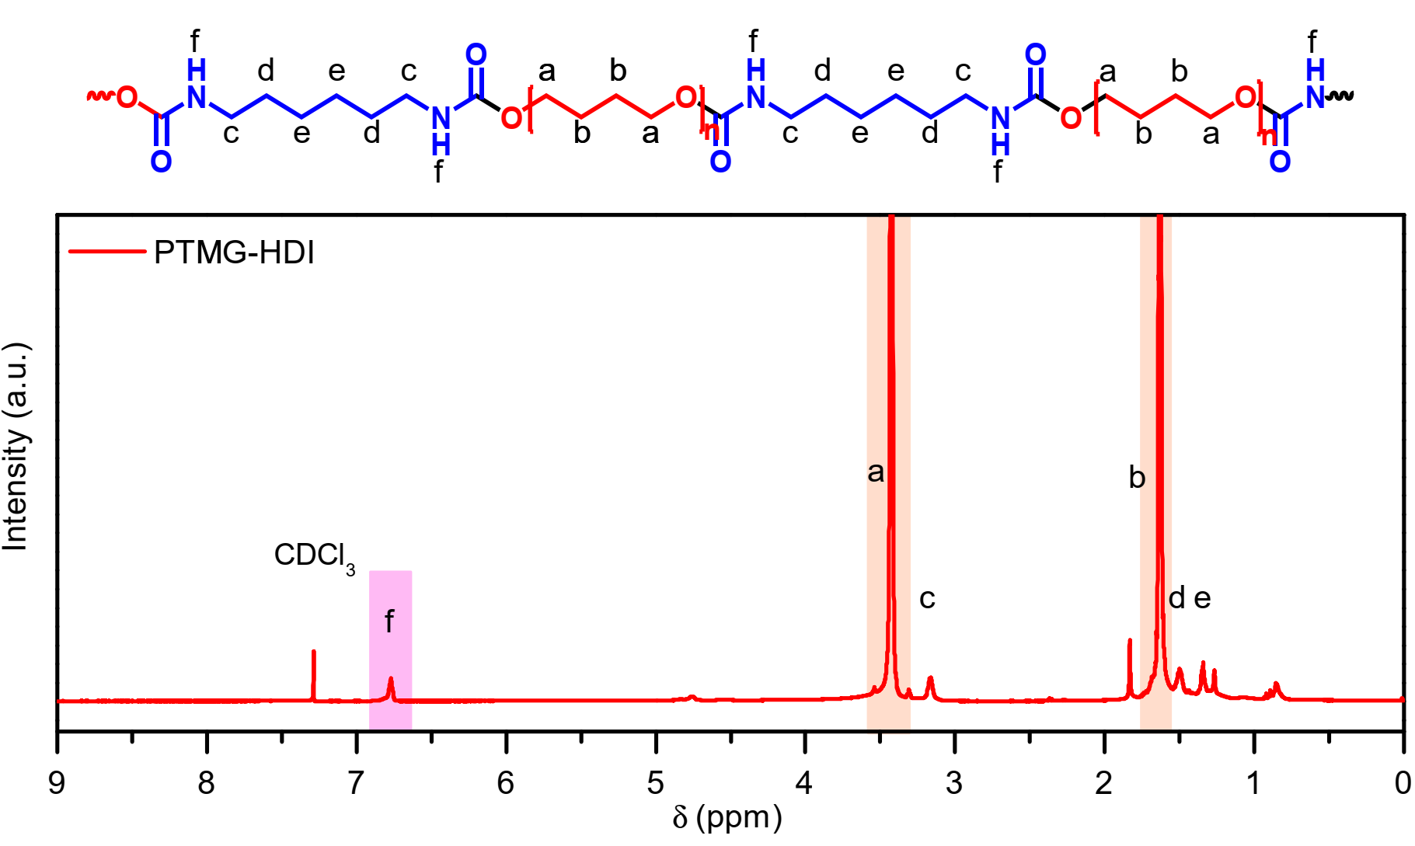
Supplementary Fig. 7 ¹H NMR spectrum of the synthesized PTMG-HDI in CDCl₃ (500 MHz).

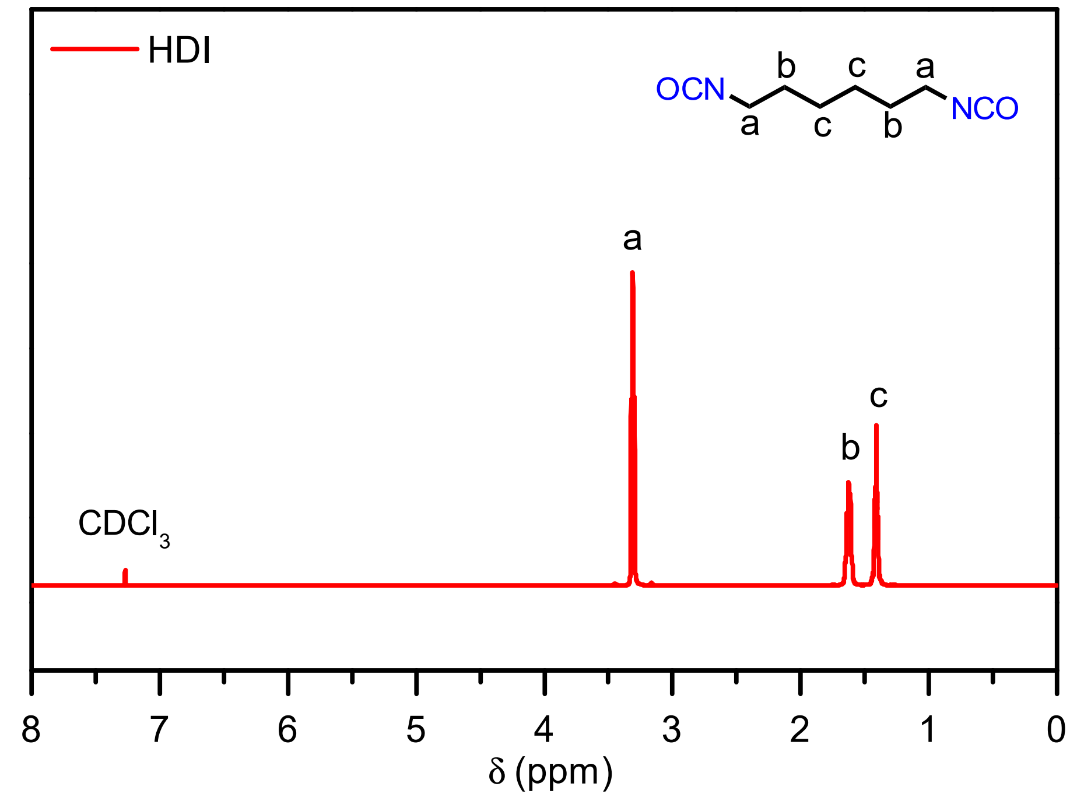
Supplementary Fig. 8 ¹H NMR spectrum of the HDI in CDCl₃ (500 MHz).

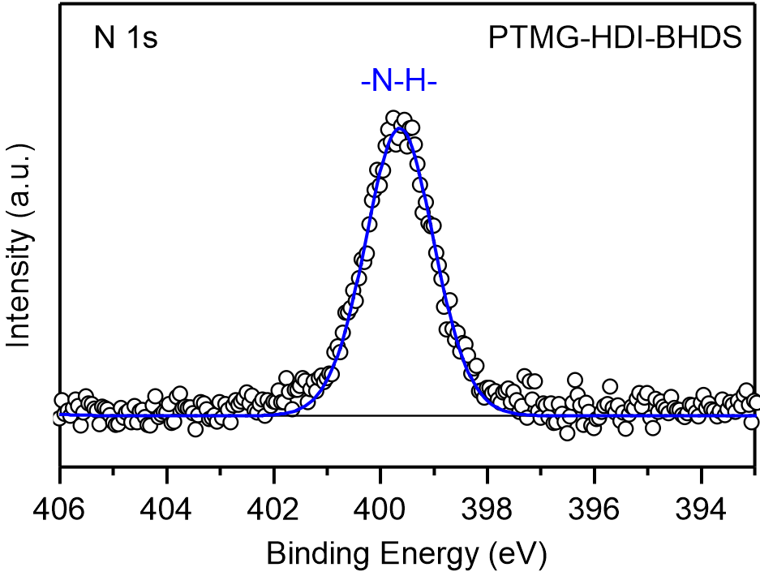
Supplementary Fig. 9 N 1s XPS spectrum of PTMG-HDI-BHDS film.

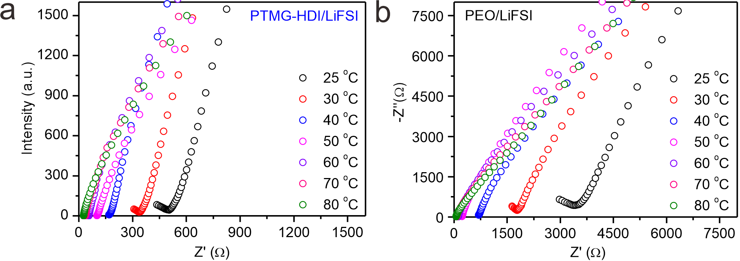
Supplementary Fig. 10 ElS measurements of the (a) PTMG-HDI/LiFSI and (b) PEO/LiFSI at different temperatures.

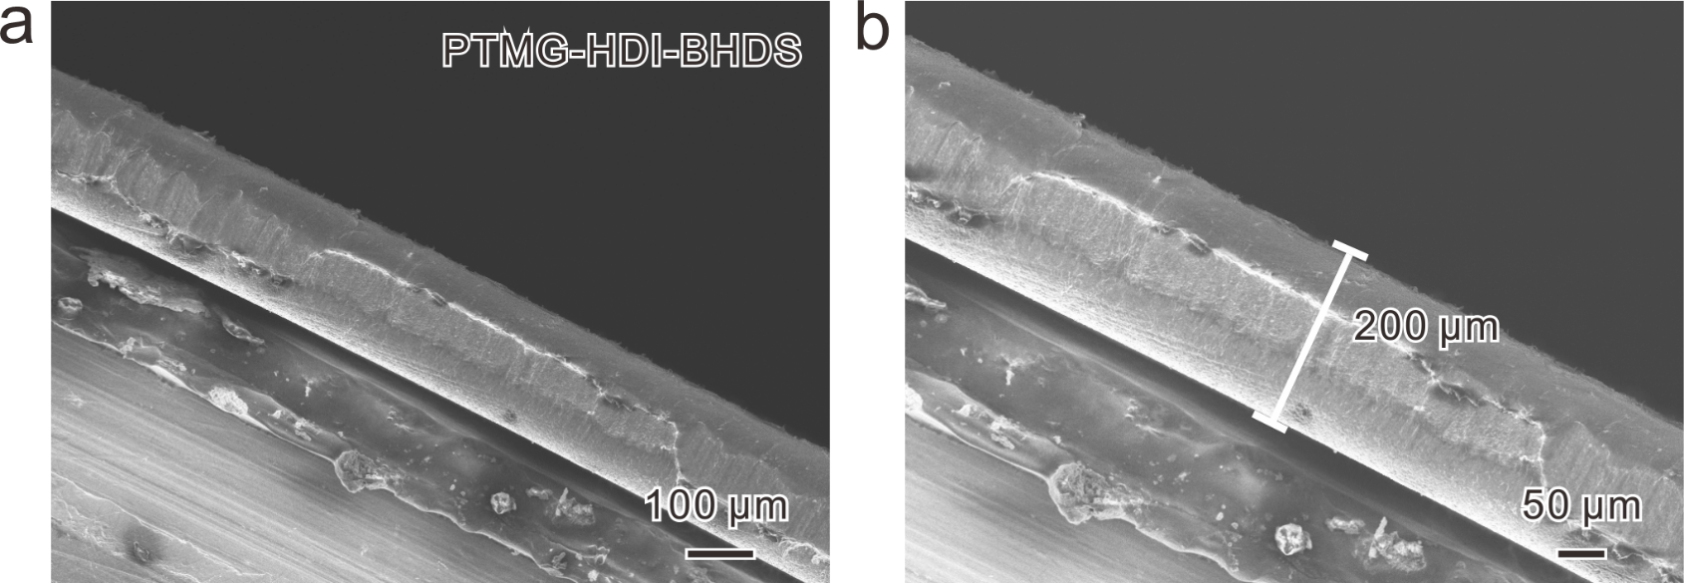
Supplementary Fig. 11 Cross-sectional SEM images of the PTMG-HDI-BHDS/LiFSI film teared off from SS|PTMG-HDI-BHDS|SS cell.

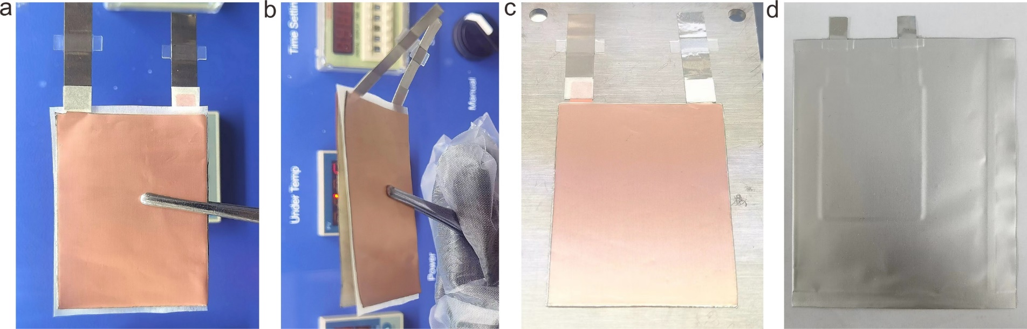
Supplementary Fig. 12 Digital photographs of the conventional (a, b) laminated Li|PEO|Li pouch cell and (c, d) integrated Li|PTMG-HDI-BHDS|Li pouch cell.

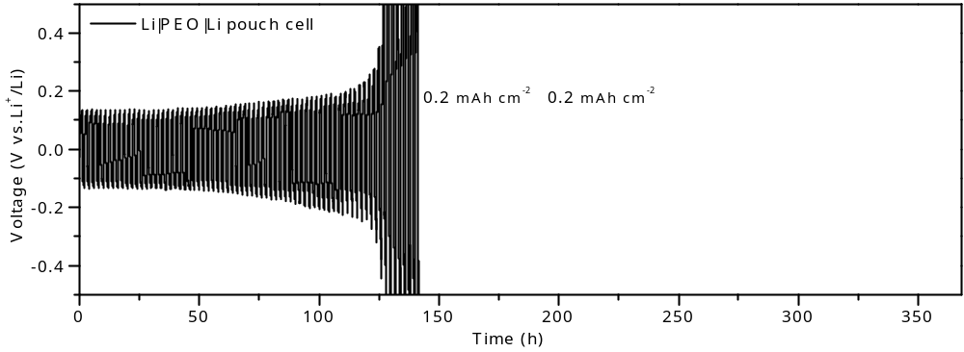
Supplementary Fig. 13 Galvanostatic cycling of Li|PEO|Li pouch cells at the current density of 0.2 mA cm⁻².

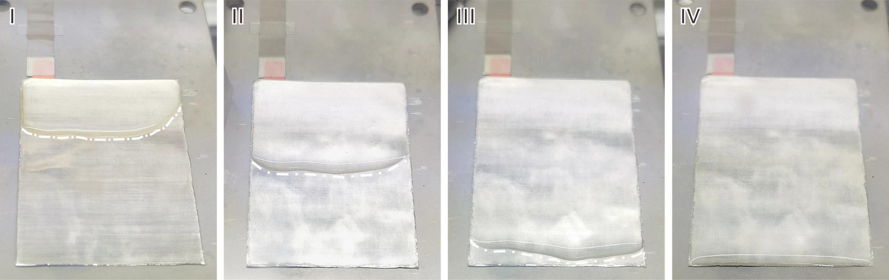
Supplementary Fig. 14 The SPEs solution were introduced on the Li anodes through casting infiltration, the integrated Li@SPE were formed by the subsequent solvent evaporation.

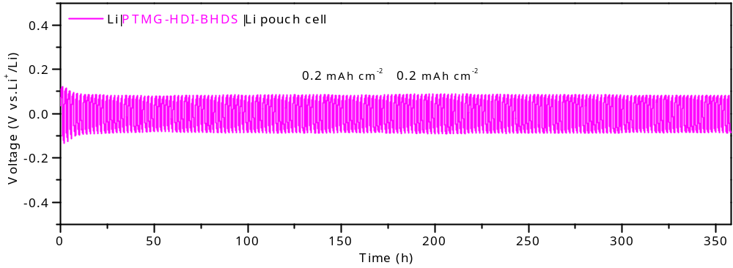
Supplementary Fig. 15 Galvanostatic cycling of Li|PTMG-HDI-BHDS|Li pouch cells at the current density of 0.2 mA cm⁻².

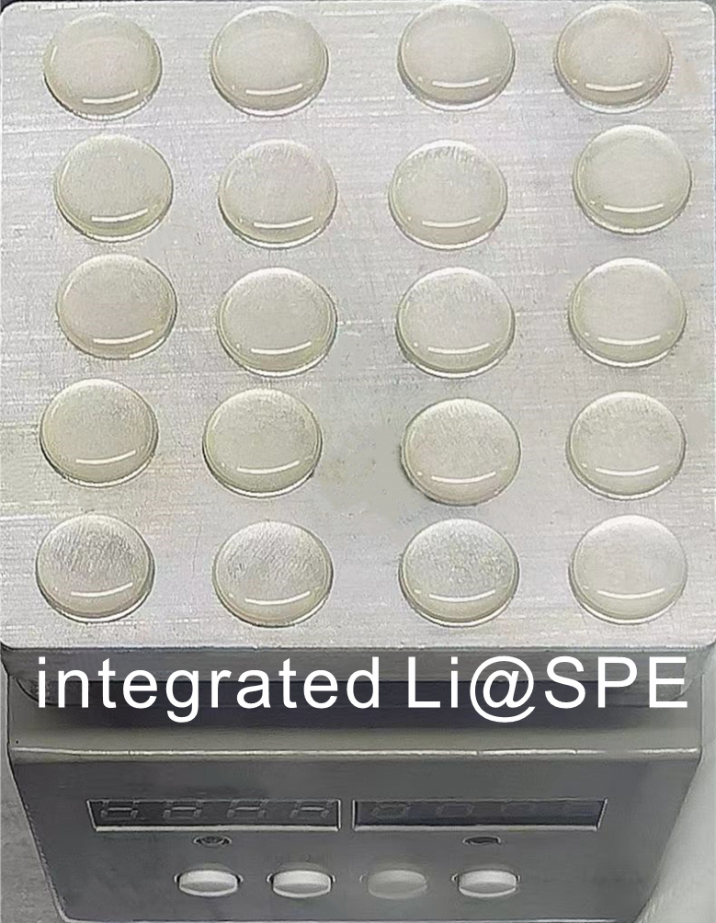
Supplementary Fig. 16 Digital photograph of the integrated Li@SPE before drying.

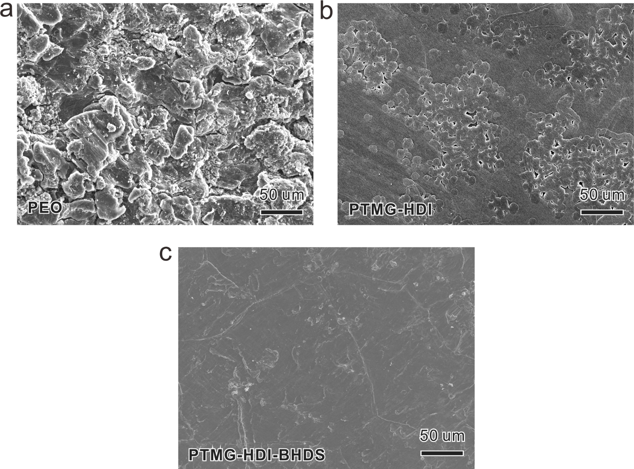
Supplementary Fig. 17 Top view SEM images of the cycled Li anodes detached from Li|PEO|Li (a), Li|PTMG-HDI|Li (b) and Li|PTMG-HDI-BHDS|Li cells (c).

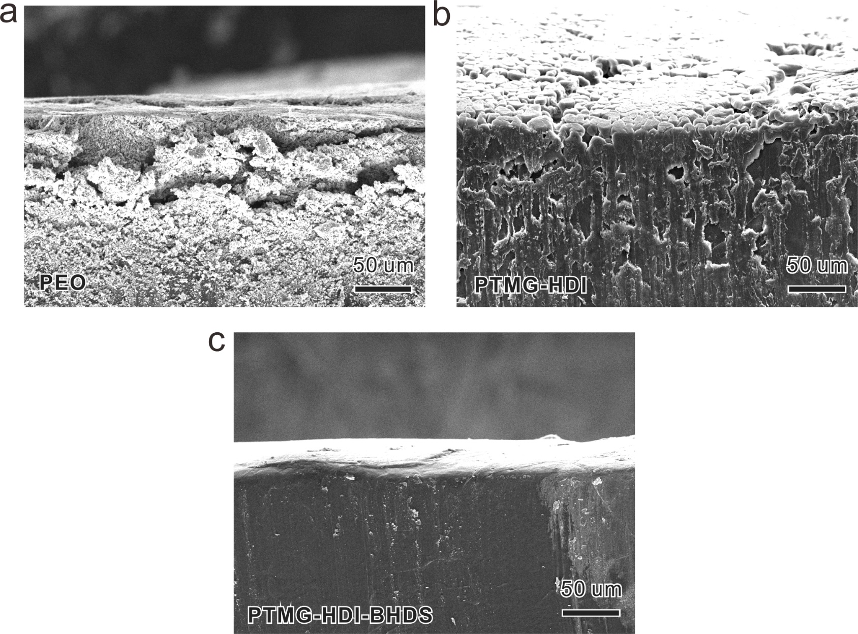
Supplementary Fig. 18 Cross-sectional SEM images of the cycled Li anodes detached from (a) Li|PEO|Li, (b) Li|PTMG-HDI|Li and (c) Li|PTMG-HDI-BHDS|Li cells.

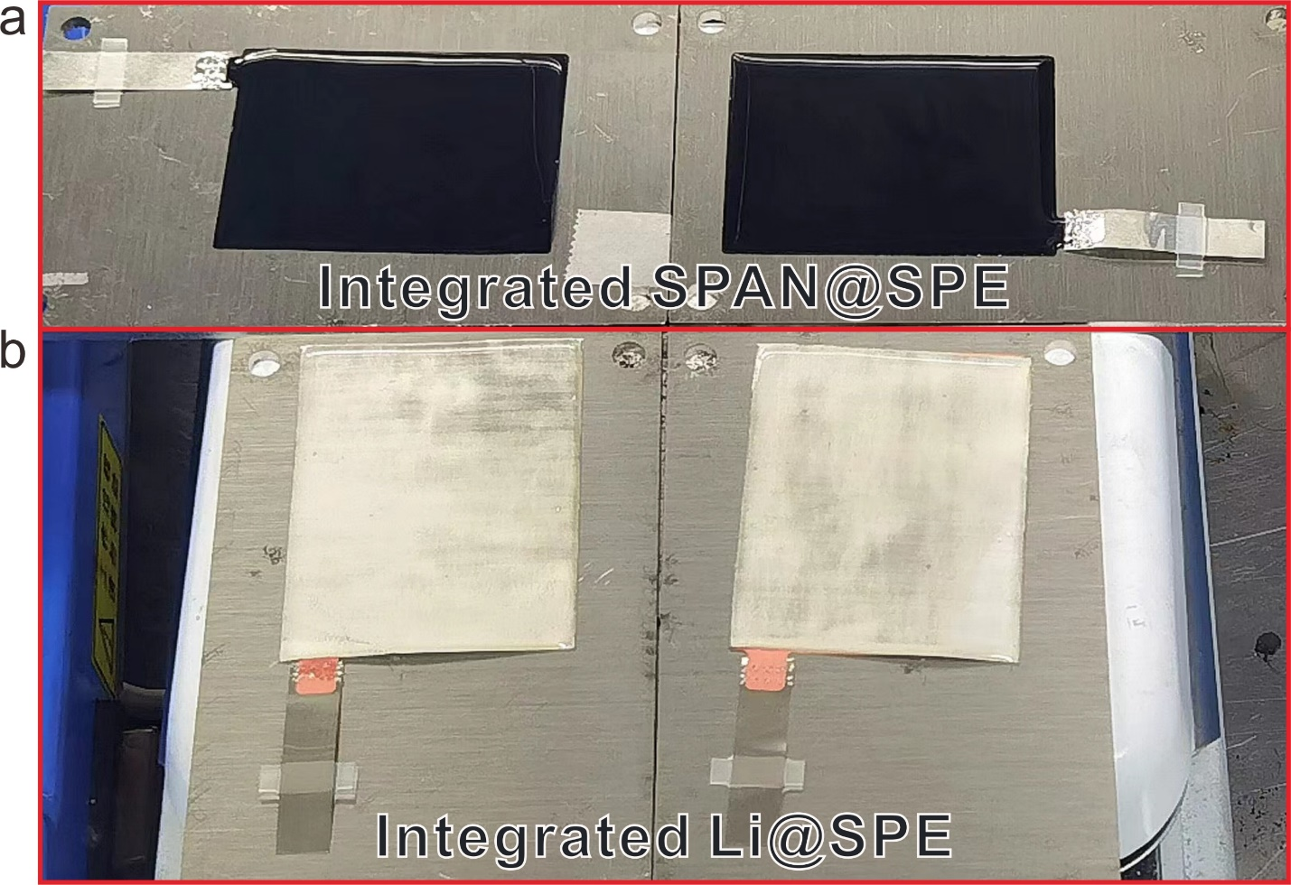
Supplementary Fig. 19 Digital photographs of the integrated (a) SPAN@SPE and (b) Li@SPE.

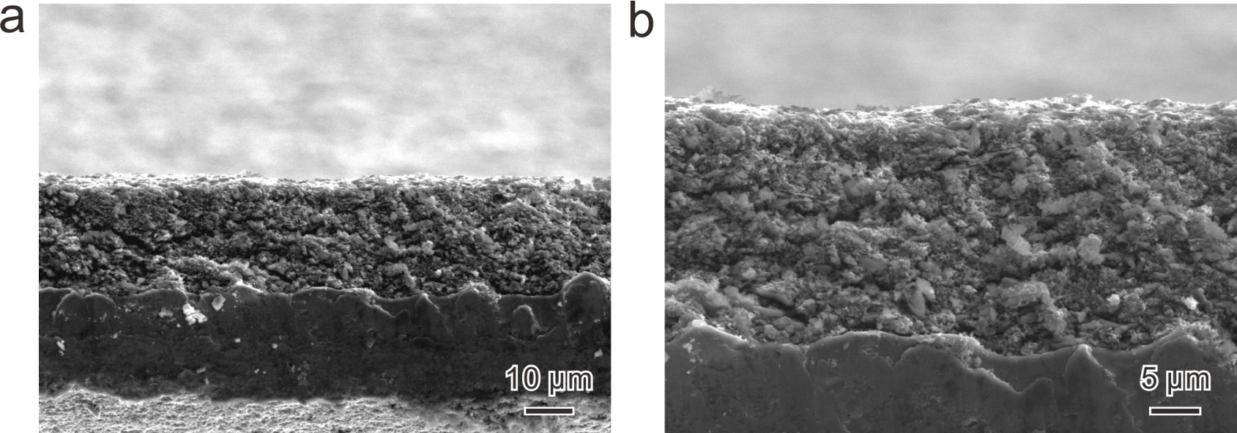
Supplementary Fig. 20 The cross-sectional SEM images of SPAN cathode.

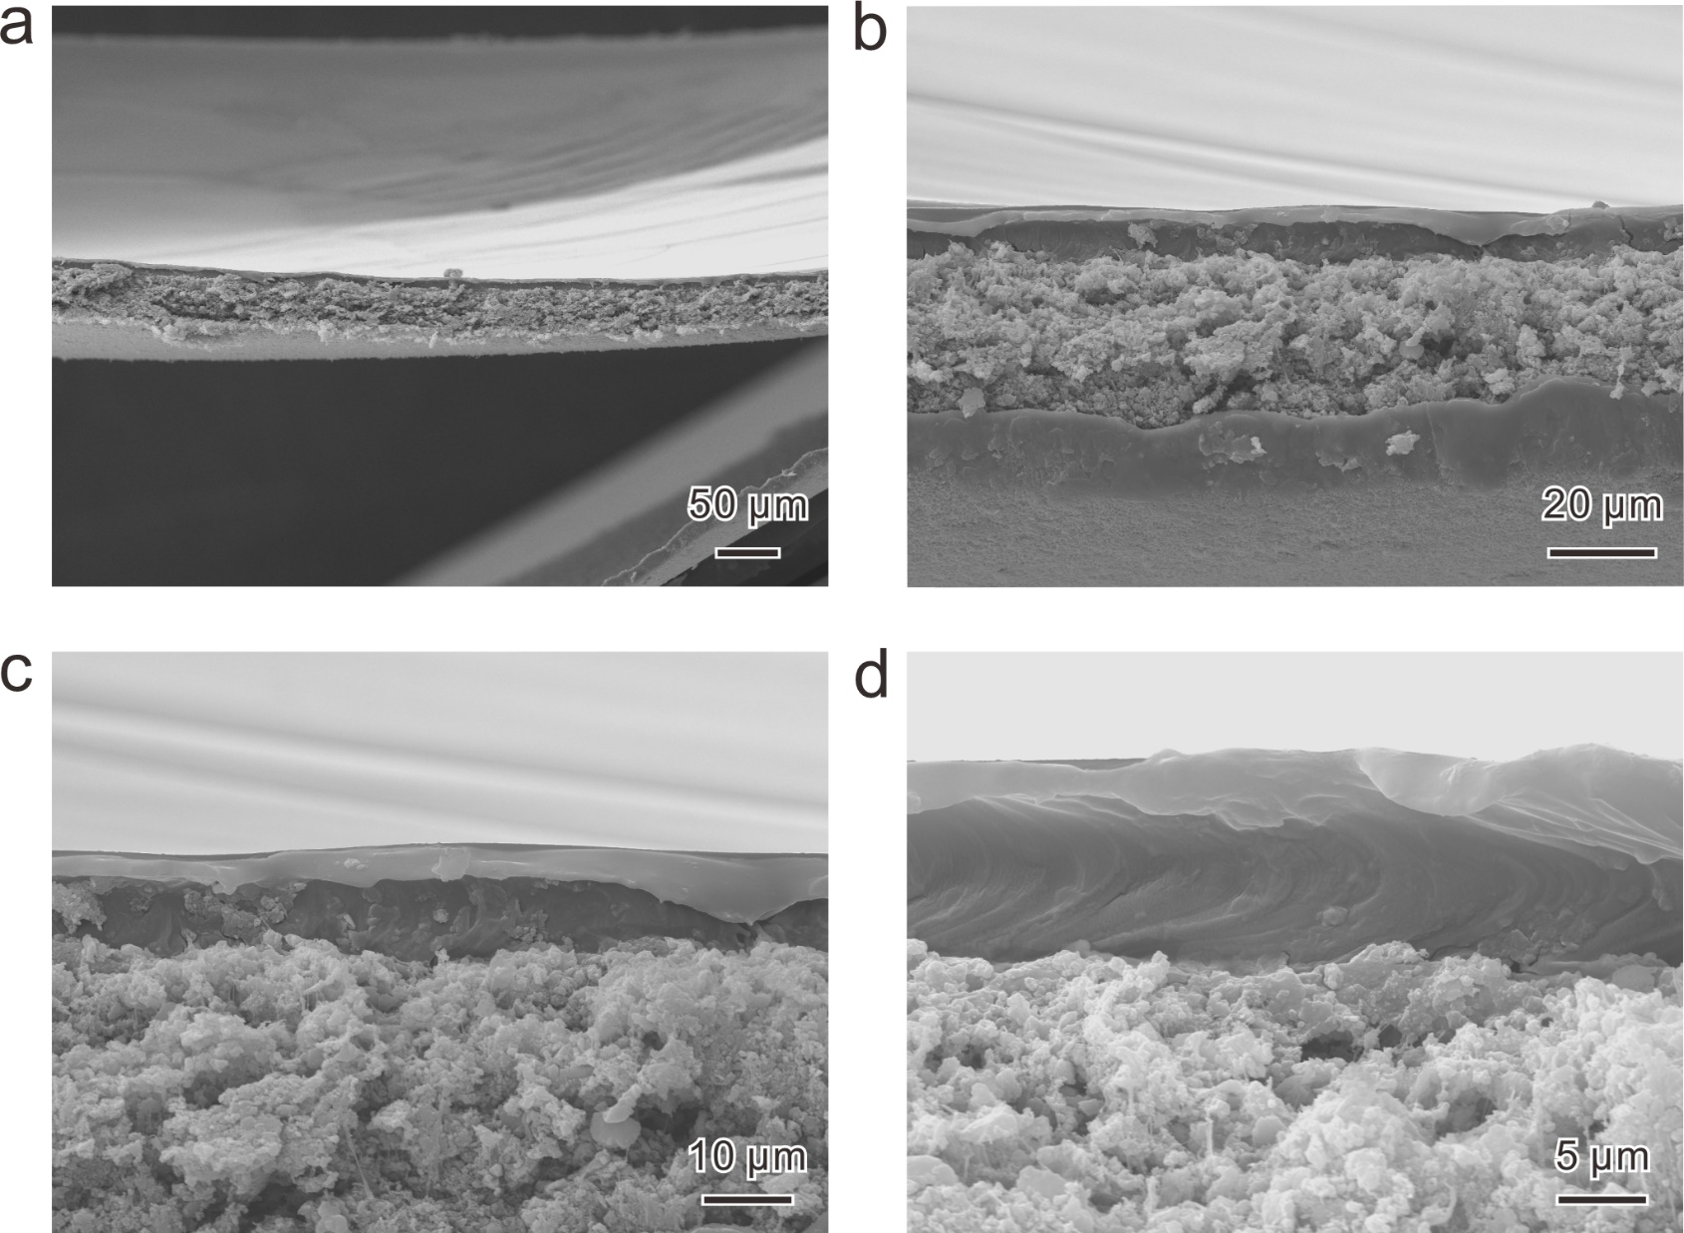
Supplementary Fig. 21 The cross-sectional SEM images of integrated SPAN@SPE cathode.

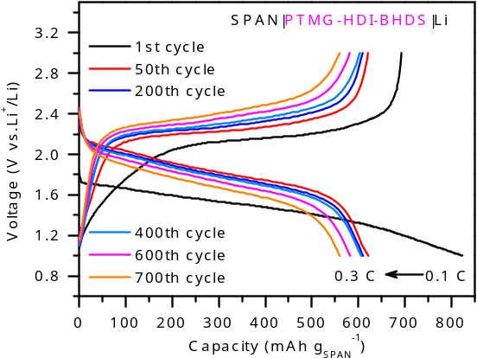
Supplementary Fig. 22 Charge/discharge curves of the SPAN|PTMG-HDI-BHDS|Li cell at 0.3 C.

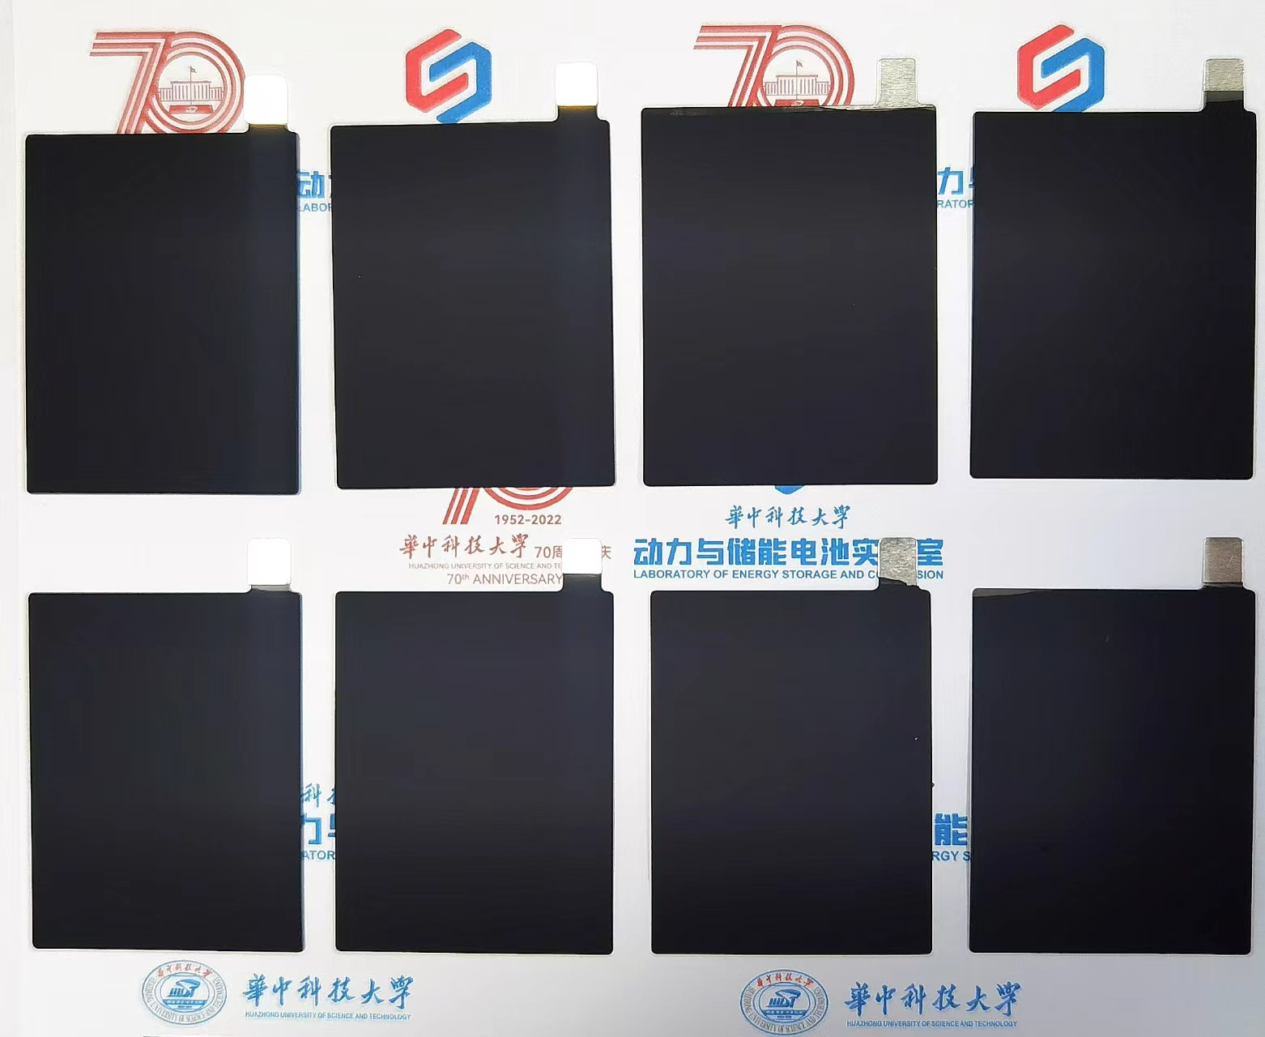
Supplementary Fig. 23 Digital photograph of the large-scale preparation of SPAN@SPE.

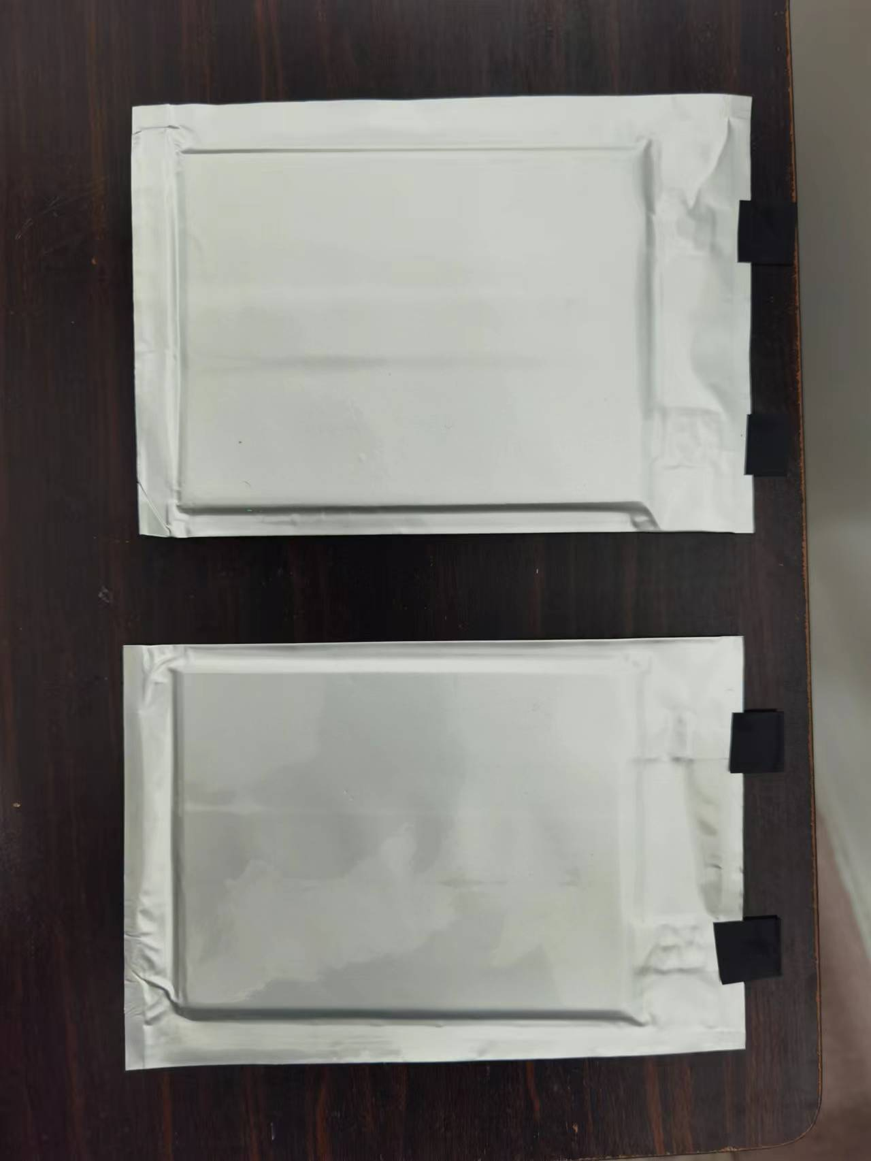
Supplementary Fig. 24 Digital photograph of the integrated SPAN|PTMG-HDI-BHDS|Li pouch cell.

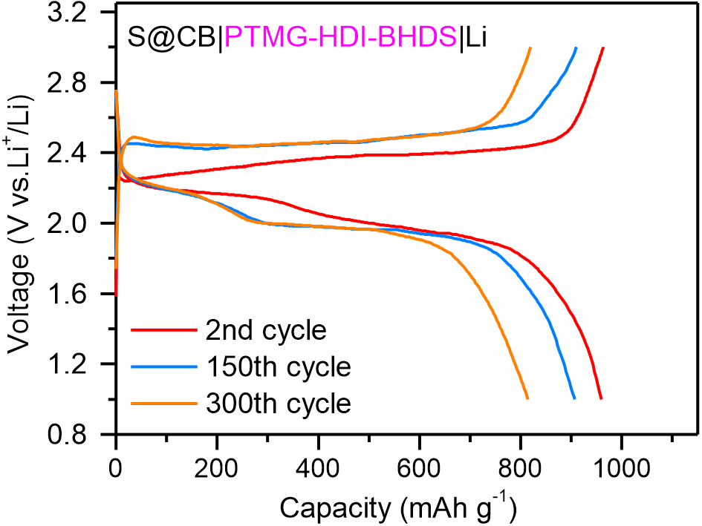
Supplementary Fig. 25 Charge/discharge curves of the S@CB|PTMG-HDI-BHDS|Li cell at 0.3 C.

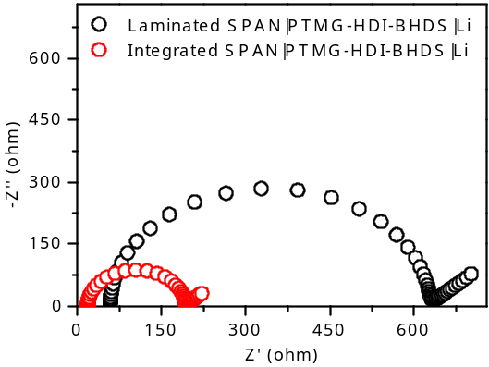
Supplementary Fig. 26 EIS plots of the Laminated SPAN|PTMG-HDI-BHDS|Li and Integrated SPAN|PTMG-HDI-BHDS|Li cells.

Supplementary Table 1. The cycling stabilities of the solid-state Li|SPEs|Li symmetric cells.
Electrolytes | Current density/capacity  (mA cm⁻²/mAh cm⁻²) | Cycling time  (h) | Rate capability  (mA cm⁻²) | References
PVFH-VEC-SN | 0.2/0.2 (26 ºC) | 1500 | 1 | Adv. Mater. 2022, 34, 2202143
PVDF-hfp/SiO₂ | 0.2/0.2 (25 ºC) | 3000 | 0.5 | Adv. Mater. 2022, 34, 2205575
PAN/Li_{1.4}Al_{0.4}Ti_{1.6}(PO₄)₃/PEO-LiTFSI | 0.2/0.2 (60 ºC) | 1000 | 0.2 | JACS 2019, 141, 9165-9169
PEO/LLZTO-LiTFSI | 0.2/0.1 (55 ºC) | 600 | 0.2 | Adv. Energy Mater. 2019, 9, 1804004
PEO-LiFTFSI | 0.1/0.2 (70 ºC) | 200 | 0.1 | JACS 2018, 140, 9921-9933.
PEGMEA-Li₇La₃Zr₂O₁₂  LiTFSI | 0.1/0.1 (55 ºC) | 3200 | 0.1 | JACS 2018, 140, 82-85
PEO/PMA | 0.1/0.1 (65 ºC) | 336 | 0.1 | Adv. Mater. 2019, 31, 1805574
PEO/Li_{3/8}Sr_{7/16}Ta_{3/4}Zr_{1/4}O₃-LiTFSI | 0.1/0.1 (45 ºC) | 700 | 0.6 | PNAS 2019, 116, 18815-18821.
PE/PEGMEA | 0.1/0.1 (60 ºC) | 1500 | 0.45 | Adv. Mater. 2021, 2100353
PI/DBDPE/PEO  -LiTFSI | 0.1/0.1 (60 ºC) | 300 | 0.1 | Nano Lett. 2020, 20, 1686-1692
PI/PEO-LiTFSI | 0.1/0.1 (60 ºC) | 1000 | 0.1 | Nat. Nanotechnol. 2019, 14, 705-711.
PEGDA-LiTFSI/LiBOB | 0.05/0.05 (30 ºC) | 1300 | 0.05 | Joule, 2018, 2, 1838-1856.
PE/PEO-LiTFSI | 0.1/0.1 (60 ºC) | 1500 | 0.1 | Adv. Energy Mater. 2019, 1902767
PTMG-HDI-BHDS | 0.2/0.2 (30 ºC) | 5500 | 1 | This  work

Supplementary Table 2. Comparison of cycling performance of solid-state Li-S batteries.
Electrolytes | S cathode | S  loading  (mg cm⁻²) | Capacity after the cycling test  (mAh g⁻¹) | Ref.
PE/PEO-LiTFSI | S | 1.0 (26 ºC) | ~625 mAh g_{S}⁻¹  (30th cycle at 0.1 C) | Adv. Energy Mater. 2019, 1902767
Poly(DOL)/PEG/SiO₂-LiTFSI | SPAN | 0.5 (60 ºC) | ~500 mAh g_{S}⁻¹  (100th cycle at 0.1 C) | Adv. Mater. 2022, 34, 2110333
PEO/PVDF-LiTFSI | S | ~1.0 (55 ºC) | ~650 mAh g_{S}⁻¹  (60th cycle at 0.1 C) | Adv. Funct. Mater. 2021, 31, 2001812
PEO/LGPS-LiTFSI | SPAN | ~1.0 (60 ºC) | ~588 mAh g_{S}⁻¹  (50th cycle at 0.1 C) | Adv. Funct. Mater. 2020, 30, 1910123
PEO/CNT/GO-LiTFSI | S | 0.5 (60 ºC) | 800 mAh g_{S}⁻¹  (50th cycle at 0.2 C) | Adv. Funct. Mater. 2021, 31, 2104863
PEO/LLZO-LiClO₄ | S | 0.6-0.9 (37 ºC) | ~800 mAh g_{S}⁻¹  (200th cycle at 0.08 C) | Nano Lett. 2017, 17, 2967-2972
PEO-PIM-LiTFSI | S | 1.0 (26 ºC) | ~720 mAh g_{S}⁻¹  (100th cycle at 0.5 C) | Adv. Funct. Mater. 2021, 31, 2104830
PEO-LiFTFSI | S | ~1.0 (70 ºC) | ~750 mAh g_{S}⁻¹  (60th cycle at 0.1 C) | JACS. 2018, 140, 9921−9933
PEO-PAN-LiTFSI | S | ~1.0 (70 ºC) | ~752 mAh g_{S}⁻¹  (75th cycle at 0.1 C) | Adv. Funct. Mater. 2022, 32, 2203272
PIN/SN-LiTFSI | S | ~1.0 (70 ºC) | ~420 mAh g_{S}⁻¹  (50th cycle at 1 C) | Nano Lett. 2019, 19, 2343-2349
LLZO/PEO-LiTFSI | S | 0.41 (45 ºC) | 820 mAh g_{S}⁻¹  (50th cycle at 0.073 C) | Energy Environ. Sci., 2019, 12, 2496-2506
PTMG-HDI-BHDS | SPAN  S | 2 (30 ºC)  2 (30 ºC) | 745 mAh g_{SPAN}⁻¹  (700th cycle at 0.3 C)  782 mAh g_{S}⁻¹  (350th cycle at 0.3 C) | This  work

References:
- Perdew, J. P., Burke, K. & Ernzerhof M. Generalized gradient approximation made simple. Phys. Rev. Lett. 77, 3865 (1996).
- Wang, H. et al. Electrolytes enriched by crown ethers for lithium metal batteries. Adv. Funct. Mater. 31, 2002578 (2021).

