Supplementary Appendix
Supplementary to: Machine learning on longitudinal multi-modal data enables the understanding and prognosis of Alzheimer’s disease progression
Table of contents
Supplemental Tables 2
Supplementary Table 1. Description of data used in the analysis. 2
Supplementary Table 2. Detailed demographics, clinical biomarkers, cognitive assessment scores, and neuroimaging features in the ADNI cohort. 3
Supplementary Table 3. Detailed demographics, clinical biomarkers, cognitive assessment scores, and neuroimaging features in the AIBL cohort. 4
Supplementary Table 4. List of 74 brain regions segmented using FreeSurfer. 5
Supplementary Table 5. Statistical analysis of the identified disease-related states and clinical indicators 7
Supplementary Table 6. Proportion of participants in subgroups in terms of Abeta status. 8
Supplementary Table 7. Proportion of participants in subgroups in terms of pTau status. 8
Supplementary Table 8. Proportion of participants in A/T/N subgroups. 8
Supplementary Table 9. Statistical analysis was performed on the states and clinical indicators in the AIBL dataset. 9
Supplementary Table 10. Transition matrix between the identified disease-related states in the AIBL dataset. 10
Supplementary Figures. 11
Supplementary Figure 1. Exclusion and Inclusion Criteria. 11
Supplementary Figure 2. Results of the cross-validation analysis to select the number of states. 11
Supplementary Figure 3. Corrected p-values for each of the pairwise state comparisons with respect to cognitive assessments. 12
Supplementary Figure 4. Corrected p-values for each of the pairwise state comparisons with respect to core brain regions. 14
Supplementary Figure 5. Visualization of brain region atrophy in the identified disease-related states of participants with Abeta-positive status in the ADNI dataset. 15
Supplementary Figure 6. Paired testing was performed between the identified disease-related states in the discovered progression patterns. 16
Supplementary Figure 7. Atrophy in representative brain regions for the identified disease stage states. 17
Supplementary Figure 8. Survival curves of ADNI participants converting from any state to the final C-IV state (a) or to AD dementia (b). 20
Supplementary Figure 9. Survival curves of AIBL participants converting from any state to the final state (a) or to AD dementia (b). 22

Supplemental Tables

Supplementary Table 1. Description of data used in the analysis. The abbreviations in parenthesis are used throughout the manuscript. The list of model variables results in a 24-dimensional vector for each patient visit.

Model variables | Description
Age | Age
Sex | Sex
APOE4 | Apolipoprotein E4 alleles
CDRSB | Clinical Dementia Rating Sum of Boxes
ADAS11 | Alzheimer’s Disease Assessment Scale cognitive subscale-11
ADAS13 | Alzheimer’s Disease Assessment Scale cognitive subscale-13
ADASQ4 | Alzheimer’s Disease Assessment Scale cognitive subscale-Q4
MMSE | Minimum Mental State Examination
RAVLT_immediate | Rey's Auditory Verbal Learning Test scores immediate
RAVLT_learning | Rey's Auditory Verbal Learning Test scores learning
RAVLT_forgetting | Rey's Auditory Verbal Learning Test scores forgetting
RAVLT_perc_forgetting | Rey's Auditory Verbal Learning Test scores perc-forgetting
LDELTOTAL | Logical Memory Test: total number of units recalled
TRABSCOR | Trail Making Test-B
FAQ | Functional Activities Questionnaire
Ventricles | Ventricles volume
Hippocampus | Hippocampus volume
WholeBrain | WholeBrain volume
Entorhinal | Entorhinal volume
Fusiform | Fusiform volume
MidTemp | Middle Temporal volume
ICV | Intracerebral Volume
mPACCdigit | Preclinical Alzheimer's Cognitive Composite (mPACCdigit)
mPACCtrailsB | Preclinical Alzheimer's Cognitive Composite (mPACCtrailsB)

Supplementary Table 2. Detailed demographics, clinical biomarkers, cognitive assessment scores, and neuroimaging features in the ADNI cohort.

ADNI dataset | Overall | CN | MCI | Dementia | p
Number of follow-up visits | 7667 | 2229 | 3709 | 1729
Male gender (vs female %) | 4331 (56.5) | 1124 (50.4) | 2218 (59.8) | 989 (57.2) | <0.001
AGE (mean (SD)), y | 75.07 (7.29) | 76.01 (6.24) | 74.14 (7.63) | 75.88 (7.53) | <0.001
PTEDUCAT (mean (SD)), y | 15.94 (2.82) | 16.30 (2.70) | 15.97 (2.82) | 15.42 (2.91) | <0.001
APOE4 (%) |  |  |  |  | <0.001
Non-carriers | 4099 (53.5) | 1615 (72.5) | 1943 (52.4) | 541 (31.3)
1 allele | 2807 (36.6) | 569 (25.5) | 1392 (37.5) | 846 (48.9)
2 alleles | 761 (9.9) | 45 (2.0) | 374 (10.1) | 342 (19.8)
CDRSB (mean (SD)) | 1.96 (2.42) | 0.14 (0.48) | 1.54 (1.16) | 5.20 (2.75) | <0.001
ADAS11 (mean (SD)) | 11.17 (8.18) | 5.71 (3.12) | 9.91 (5.15) | 20.90 (9.51) | <0.001
ADAS13 (mean (SD)) | 17.34 (11.37) | 8.87 (4.64) | 15.90 (7.59) | 31.34 (11.36) | <0.001
ADASQ4 (mean (SD)) | 5.25 (3.11) | 2.73 (1.87) | 5.22 (2.68) | 8.57 (1.90) | <0.001
MMSE (mean (SD)) | 26.73 (3.71) | 29.00 (1.27) | 27.50 (2.26) | 22.14 (4.36) | <0.001
RAVLT_immediate (mean (SD)) | 34.28 (13.46) | 44.44 (10.83) | 34.17 (11.33) | 21.44 (8.89) | <0.001
RAVLT_learning (mean (SD)) | 4.02 (2.82) | 5.72 (2.47) | 4.02 (2.66) | 1.81 (1.90) | <0.001
RAVLT_forgetting (mean (SD)) | 4.18 (2.53) | 3.49 (2.80) | 4.55 (2.50) | 4.28 (2.00) | <0.001
RAVLT_perc_forgetting (mean (SD)) | 59.86 (38.86) | 33.86 (32.95) | 61.19 (36.66) | 90.55 (24.43) | <0.001
TRABSCOR (mean (SD)) | 125.23 (82.77) | 82.40 (42.93) | 113.82 (67.45) | 204.94 (96.19) | <0.001
FAQ (mean (SD)) | 5.08 (7.34) | 0.35 (1.48) | 3.31 (4.51) | 14.98 (7.69) | <0.001
mPACCdigit (mean (SD)) | -6.11 (7.74) | 0.14 (3.20) | -5.33 (5.12) | -15.86 (7.05) | <0.001
mPACCtrailsB (mean (SD)) | -5.86 (7.42) | 0.04 (3.01) | -5.03 (4.90) | -15.24 (6.85) | <0.001
Ventricles/ICV (mean (SD)), % | 2.73 (1.36) | 2.33 (1.13) | 2.65 (1.35) | 3.40 (1.41) | <0.001
Hippocampus/ICV (mean (SD)), % | 0.43 (0.09) | 0.48 (0.07) | 0.44 (0.08) | 0.36 (0.07) | <0.001
WholeBrain/ICV (mean (SD)), % | 66.15 (5.67) | 67.35 (4.88) | 67.02 (5.74) | 62.76 (5.15) | <0.001
Entorhinal/ICV (mean (SD)), % | 0.22 (0.05) | 0.25 (0.04) | 0.23 (0.05) | 0.18 (0.05) | <0.001
Fusiform/ICV (mean (SD)), % | 1.11 (0.18) | 1.17 (0.15) | 1.14 (0.17) | 0.99 (0.16) | <0.001
MidTemp/ICV (mean (SD)), % | 1.25 (0.19) | 1.32 (0.15) | 1.27 (0.18) | 1.09 (0.18) | <0.001
Abbreviations: CN, Cognitive Normal; MCI, Mild Cognitive Impairment; APOE4, number of Apolipoprotein E4 alleles; CDRSB, Clinical Dementia Rating Scale Sum of Boxes; ADAS-cog, Alzheimer’s Disease Assessment Scale–Cognitive Subscale; MMSE, Mini-Mental State Examination; RAVLT, Rey's Auditory Verbal Learning Test; LDELTOTAL, logical memory delayed recall total; TRABSCOR, Trail Making Test-B, FAQ, Functional Activities Questionnaire; mPACCdigit, Preclinical Alzheimer's Cognitive Composite Scores; mPACCtrailsB, Preclinical Alzheimer's Cognitive Composite trails B, MidTemp, Middle Temporal Gyrus; ICV: Intracerebral Volume.

Supplementary Table 3. Detailed demographics, clinical biomarkers, cognitive assessment scores, and neuroimaging features in the AIBL cohort.

AIBL dataset | Overall | CN | MCI | Dementia | p
Number of follow-up visits | 857 | 651 | 113 | 93
Male gender (vs female %) | 427 (49.8) | 313 (48.1) | 69 (61.1) | 45 (48.4) | 0.037
AGE (mean (SD)), y | 73.68 (6.83) | 73.16 (6.58) | 76.17 (6.45) | 74.13 (8.25) | <0.001
PTEDUCAT (mean (SD)), y | 16.13 (2.88) | 16.37 (2.62) | 16.08 (3.24) | 14.47 (3.54) | <0.001
APOE4 (%) |  |  |  |  | <0.001
Non-carriers | 621 (72.5) | 510 (78.3) | 77 (68.1) | 34 (36.6)
1 allele | 194 (22.6) | 125 (19.2) | 28 (24.8) | 41 (44.1)
2 alleles | 42 (4.9) | 16 (2.5) | 8 (7.1) | 18 (19.4)
CDRSB (mean (SD)) | 0.18 (0.39) | 0.02 (0.09) | 0.47 (0.13) | 0.99 (0.60) | <0.001
ADAS11 (mean (SD)) | 7.82 (5.81) | 6.13 (3.52) | 9.15 (4.02) | 18.04 (8.86) | <0.001
ADAS13 (mean (SD)) | 12.15 (8.31) | 9.52 (5.37) | 15.02 (6.03) | 27.06 (10.54) | <0.001
ADASQ4 (mean (SD)) | 3.84 (2.69) | 2.99 (2.08) | 5.21 (2.35) | 8.09 (2.13) | <0.001
MMSE (mean (SD)) | 27.66 (3.67) | 28.85 (1.24) | 27.12 (1.99) | 19.98 (6.27) | <0.001
RAVLT_immediate (mean (SD)) | 40.13 (13.50) | 43.60 (12.22) | 34.58 (10.25) | 22.62 (8.89) | <0.001
RAVLT_learning (mean (SD)) | 4.98 (2.71) | 5.48 (2.52) | 4.27 (2.74) | 2.37 (2.24) | <0.001
RAVLT_forgetting (mean (SD)) | 3.78 (2.69) | 3.49 (2.76) | 4.88 (2.42) | 4.44 (1.93) | <0.001
RAVLT_perc_forgetting (mean (SD)) | 46.20 (36.12) | 36.99 (32.71) | 64.16 (33.09) | 88.88 (20.16) | <0.001
TRABSCOR (mean (SD)) | 98.89 (63.75) | 83.16 (43.86) | 111.35 (60.68) | 193.86 (93.19) | <0.001
FAQ (mean (SD)) | 1.01 (2.87) | 0.34 (1.40) | 1.46 (3.55) | 5.15 (5.16) | <0.001
mPACCdigit (mean (SD)) | -2.71 (6.07) | -0.58 (3.64) | -5.39 (4.63) | -14.33 (6.75) | <0.001
mPACCtrailsB (mean (SD)) | -2.75 (6.29) | -0.58 (3.38) | -5.06 (4.22) | -15.06 (8.51) | <0.001
Ventricles/ICV (mean (SD)), % | 2.95 (1.38) | 2.67 (1.19) | 3.45 (1.59) | 4.30 (1.44) | <0.001
Hippocampus/ICV (mean (SD)), % | 0.48 (0.06) | 0.50 (0.05) | 0.45 (0.07) | 0.40 (0.05) | <0.001
WholeBrain/ICV (mean (SD)), % | 68.65 (3.96) | 69.51 (3.61) | 66.76 (3.93) | 64.88 (3.25) | <0.001
Entorhinal/ICV (mean (SD)), % | 0.21 (0.04) | 0.22 (0.04) | 0.20 (0.04) | 0.17 (0.04) | <0.001
Fusiform/ICV (mean (SD)), % | 1.02 (0.12) | 1.04 (0.11) | 0.98 (0.10) | 0.90 (0.12) | <0.001
MidTemp/ICV (mean (SD)), % | 1.63 (0.18) | 1.67 (0.16) | 1.57 (0.16) | 1.41 (0.18) | <0.001
Abbreviations: CN, Cognitive Normal; MCI, Mild Cognitive Impairment; APOE4, number of Apolipoprotein E4 alleles; CDRSB, Clinical Dementia Rating Scale Sum of Boxes; ADAS-cog, Alzheimer’s Disease Assessment Scale–Cognitive Subscale; MMSE, Mini-Mental State Examination; RAVLT, Rey's Auditory Verbal Learning Test; LDELTOTAL, logical memory delayed recall total; TRABSCOR, Trail Making Test-B, FAQ, Functional Activities Questionnaire; mPACCdigit, Preclinical Alzheimer's Cognitive Composite Scores; mPACCtrailsB, Preclinical Alzheimer's Cognitive Composite trails B, MidTemp, Middle Temporal Gyrus; ICV: Intracerebral Volume.

Supplementary Table 4. List of 74 brain regions segmented using FreeSurfer.

Index | Short Name | Long Name
1 | G_and_S_frontomargin | Fronto-marginal gyrus (of Wernicke) and sulcus
2 | G_and_S_occipital_inf | Inferior occipital gyrus and sulcus
3 | G_and_S_paracentral | Paracentral lobule and sulcus
4 | G_and_S_subcentral | Subcentral gyrus (central operculum) and sulci
5 | G_and_S_transv_frontopol | Transverse frontopolar gyri and sulci
6 | G_and_S_cingul-Ant | Anterior part of the cingulate gyrus and sulcus
7 | G_and_S_cingul-Mid-Ant | Middle-anterior part of the cingulate gyrus and sulcus
8 | G_and_S_cingul-Mid-Post | Middle-posterior part of the cingulate gyrus and sulcus
9 | G_cingul-Post-dorsal | Posterior-dorsal part of the cingulate gyrus
10 | G_cingul-Post-ventral | Posterior-ventral part of the cingulate gyrus
11 | G_cuneus | Cuneus
12 | G_front_inf-Opercular | Opercular part of the inferior frontal gyrus
13 | G_front_inf-Orbital | Orbital part of the inferior frontal gyrus
14 | G_front_inf-Triangul | Triangular part of the inferior frontal gyrus
15 | G_front_middle | Middle frontal gyrus
16 | G_front_sup | Superior frontal gyrus
17 | G_Ins_lg_and_S_cent_ins | Long insular gyrus and central sulcus of the insula
18 | G_insular_short | Short insular gyri
19 | G_occipital_middle | Middle occipital gyrus
20 | G_occipital_sup | Superior occipital gyrus
21 | G_oc-temp_lat-fusifor | Lateral occipito-temporal gyrus
22 | G_oc-temp_med-Lingual | Lingual gyrus, ligual part of the medial occipito-temporal gyrus
23 | G_oc-temp_med-Parahip | Parahippocampal gyrus, parahippocampal part of the medial occipito-temporal gyrus
24 | G_orbital | Orbital gyri
25 | G_pariet_inf-Angular | Angular gyrus
26 | G_pariet_inf-Supramar | Supramarginal gyrus
27 | G_parietal_sup | Superior parietal lobule
28 | G_postcentral | Postcentral gyrus
29 | G_precentral | Precentral gyrus
30 | G_precuneus | Precuneus
31 | G_rectus | Straight gyrus, Gyrus rectus
32 | G_subcallosal | Subcallosal area, subcallosal gyrus
33 | G_temp_sup-G_T_transv | Anterior transverse temporal gyrus
34 | G_temp_sup-Lateral | Lateral aspect of the superior temporal gyrus
35 | G_temp_sup-Plan_polar | Planum polare of the superior temporal gyrus
36 | G_temp_sup-Plan_tempo | Planum temporale or temporal plane of the superior temporal gyrus
37 | G_temporal_inf | Inferior temporal gyrus
38 | G_temporal_middle | Middle temporal gyrus
39 | Lat_Fis-ant-Horizont | Horizontal ramus of the anterior segment of the lateral sulcus (or fissure)
40 | Lat_Fis-ant-Vertical | Vertical ramus of the anterior segment of the lateral sulcus (or fissure)
41 | Lat_Fis-post | Posterior ramus (or segment) of the lateral sulcus (or fissure)
42 | Pole_occipital | Occipital pole
43 | Pole_temporal | Temporal pole
44 | S_calcarine | Calcarine sulcus
45 | S_central | Central sulcus (Rolando’s fissure)
46 | S_cingul-Marginalis | Marginal branch (or part) of the cingulate sulcus
47 | S_circular_insula_ant | Anterior segment of the circular sulcus of the insula
48 | S_circular_insula_inf | Inferior segment of the circular sulcus of the insula
49 | S_circular_insula_sup | Superior segment of the circular sulcus of the insula
50 | S_collat_transv_ant | Anterior transverse collateral sulcus
51 | S_collat_transv_post | Posterior transverse collateral sulcus
52 | S_front_inf | Inferior frontal sulcus
53 | S_front_middle | Middle frontal sulcus
54 | S_front_sup | Superior frontal sulcus
55 | S_interm_prim-Jensen | Sulcus intermedius primus (of Jensen)
56 | S_intrapariet_and_P_trans | Intraparietal sulcus (interparietal sulcus) and transverse parietal sulci
57 | S_oc_middle_and_Lunatus | Middle occipital sulcus and lunatus sulcus
58 | S_oc_sup_and_transversal | Superior occipital sulcus and transverse occipital sulcus
59 | S_occipital_ant | Anterior occipital sulcus and preoccipital notch (temporo-occipital incisure)
60 | S_oc-temp_lat | Lateral occipito-temporal sulcus
61 | S_oc-temp_med_and_Lingual | Medial occipito-temporal sulcus (collateral sulcus) and lingual sulcus
62 | S_orbital_lateral | Lateral orbital sulcus
63 | S_orbital_med-olfact | Medial orbital sulcus (olfactory sulcus)
64 | S_orbital-H_Shaped | Orbital sulci (H-shaped sulci)
65 | S_parieto_occipital | Parieto-occipital sulcus (or fissure)
66 | S_pericallosal | Pericallosal sulcus (S of corpus callosum)
67 | S_postcentral | Postcentral sulcus
68 | S_precentral-inf-part | Inferior part of the precentral sulcus
69 | S_precentral-sup-part | Superior part of the precentral sulcus
70 | S_suborbital | Suborbital sulcus (sulcus rostrales, supraorbital sulcus)
71 | S_subparietal | Subparietal sulcus
72 | S_temporal_inf | Inferior temporal sulcus
73 | S_temporal_sup | Superior temporal sulcus (parallel sulcus)
74 | S_temporal_transverse | Transverse temporal sulcus

Supplementary Table 5. Statistical analysis of the identified disease-related states and clinical indicators
 | A-I | A-II | A-III | A-IV | B-I | B-II | C-I | C-II | C-III | C-IV | p
Number of follow-up visits | 335 | 661 | 647 | 609 | 609 | 692 | 907 | 439 | 752 | 173
Label (%) |  |  |  |  |  |  |  |  |  |  | <0.001
CN | 84 (25.1) | 85 (12.9) | 43 (6.6) | 4 (0.7) | 142 (23.3) | 28 (4.0) | 0 (0.0) | 0 (0.0) | 0 (0.0) | 0 (0.0)
MCI | 251 (74.9) | 575 (87.0) | 591 (91.3) | 521 (85.6) | 465 (76.4) | 600 (86.7) | 463 (51.0) | 175 (39.9) | 67 (8.9) | 1 (0.6)
Dementia | 0 (0.0) | 1 (0.2) | 13 (2.0) | 84 (13.8) | 2 (0.3) | 64 (9.2) | 444 (49.0) | 264 (60.1) | 685 (91.1) | 172 (99.4)
Male gender (vs female %) | 126 (37.6) | 335 (50.7) | 368 (56.9) | 374 (61.4) | 392 (64.4) | 519 (75.0) | 520 (57.3) | 279 (63.6) | 409 (54.4) | 95 (54.9) | <0.001
AGE | 68.25 (5.87) | 69.70 (6.25) | 71.57 (7.66) | 73.35 (7.02) | 77.96 (5.77) | 79.10 (5.97) | 76.32 (7.02) | 75.71 (7.66) | 76.54 (7.67) | 75.48 (7.15) | <0.001
PTEDUCAT | 17.25 (2.25) | 16.59 (2.37) | 15.41 (2.84) | 15.64 (2.89) | 16.47 (2.46) | 15.94 (2.79) | 15.70 (2.79) | 14.97 (3.23) | 15.18 (2.94) | 15.34 (3.33) | <0.001
APOE4 (%) |  |  |  |  |  |  |  |  |  |  | <0.001
Non-carriers | 197 (58.8) | 410 (62.0) | 340 (52.6) | 239 (39.2) | 410 (67.3) | 389 (56.2) | 282 (31.1) | 198 (45.1) | 201 (26.7) | 46 (26.6)
1 allele | 125 (37.3) | 210 (31.8) | 234 (36.2) | 250 (41.1) | 172 (28.2) | 242 (35.0) | 468 (51.6) | 189 (43.1) | 392 (52.1) | 99 (57.2)
1 alleles | 13 (3.9) | 41 (6.2) | 73 (11.3) | 120 (19.7) | 27 (4.4) | 61 (8.8) | 157 (17.3) | 52 (11.8) | 159 (21.1) | 28 (16.2)
CDRSB | 0.71 (0.73) | 0.73 (0.74) | 1.28 (0.96) | 1.89 (1.25) | 0.94 (0.95) | 1.85 (1.30) | 3.20 (1.58) | 3.57 (1.95) | 5.40 (2.28) | 9.76 (3.43) | <0.001
ADAS11 | 3.47 (1.93) | 6.19 (2.64) | 9.30 (3.43) | 11.78 (3.37) | 6.90 (2.92) | 10.10 (3.23) | 15.30 (4.17) | 16.86 (5.75) | 23.42 (5.69) | 39.51 (10.14) | <0.001
ADAS13 | 4.82 (2.40) | 9.76 (3.75) | 14.81 (4.28) | 19.60 (4.50) | 10.87 (4.01) | 16.68 (4.21) | 24.68 (5.02) | 26.25 (6.88) | 34.88 (6.71) | 52.99 (10.35) | <0.001
ADASQ4 | 1.09 (1.06) | 3.19 (1.57) | 4.97 (1.68) | 7.03 (1.85) | 3.35 (1.61) | 5.45 (1.69) | 8.29 (1.70) | 7.62 (1.94) | 9.40 (1.16) | 9.91 (0.31) | <0.001
MMSE | 29.60 (0.68) | 28.99 (1.20) | 27.78 (1.67) | 26.82 (1.78) | 28.87 (1.25) | 27.49 (1.72) | 25.12 (1.95) | 24.02 (2.63) | 21.04 (2.75) | 13.66 (4.50) | <0.001
RAVLT_immediate | 54.39 (9.17) | 41.56 (8.94) | 34.19 (7.98) | 28.79 (6.95) | 38.88 (8.97) | 31.63 (7.25) | 25.13 (6.74) | 23.99 (8.24) | 18.65 (6.12) | 9.32 (6.55) | <0.001
RAVLT_learning | 6.76 (2.28) | 5.47 (2.40) | 4.13 (2.21) | 2.74 (2.03) | 5.17 (2.56) | 3.82 (2.36) | 2.45 (2.24) | 1.93 (1.68) | 1.39 (1.54) | 0.84 (1.34) | <0.001
RAVLT_forgetting | 2.20 (2.22) | 4.10 (2.73) | 4.86 (2.40) | 5.45 (1.95) | 4.17 (2.86) | 4.73 (2.47) | 5.47 (1.38) | 5.71 (1.04) | 6.10 (1.89) | 6.97 (2.28) | <0.001
RAVLT_perc_forgetting | 16.86 (17.41) | 41.46 (28.67) | 59.32 (28.53) | 81.87 (21.08) | 43.18 (44.24) | 61.71 (35.13) | 86.20 (27.61) | 92.64 (40.79) | 98.16 (11.87) | 98.95 (8.35) | <0.001
LDELTOTAL | 14.72 (3.45) | 11.15 (3.54) | 7.97 (3.70) | 5.00 (3.73) | 10.76 (3.95) | 7.04 (3.90) | 3.14 (3.66) | 1.78 (2.76) | 0.55 (1.69) | 0.05 (0.22) | <0.001
TRABSCOR | 64.99 (22.40) | 76.41 (33.67) | 100.56 (51.64) | 106.63 (51.57) | 92.28 (38.31) | 140.16 (73.83) | 152.01 (77.20) | 204.56 (106.57) | 232.78 (81.96) | 287.65 (44.45) | <0.001
FAQ | 0.86 (1.79) | 0.49 (1.59) | 2.23 (3.28) | 4.84 (4.98) | 1.67 (2.65) | 4.62 (5.09) | 9.06 (6.56) | 10.41 (7.17) | 16.28 (7.23) | 24.08 (4.71) | <0.001
mPACCdigit | 2.41 (1.82) | -1.05 (2.44) | -5.02 (2.84) | -8.02 (3.23) | -1.37 (2.66) | -5.77 (2.76) | -11.65 (3.26) | -12.63 (4.17) | -18.09 (4.09) | -28.45 (7.67) | <0.001
mPACCtrailsB | 2.24 (1.66) | -0.74 (2.22) | -4.33 (2.77) | -7.26 (2.89) | -1.51 (2.49) | -5.85 (2.71) | -11.16 (2.96) | -12.11 (4.44) | -17.33 (3.84) | -27.97 (7.00) | <0.001
Ventricles/ICV (%) | 1.85 (0.94) | 1.77 (0.80) | 1.96 (0.84) | 2.33 (0.81) | 2.92 (1.13) | 3.92 (1.41) | 3.01 (1.26) | 3.45 (1.50) | 3.59 (1.38) | 4.10 (1.38) | <0.001
Hippocampus/ICV (%) | 0.52 (0.06) | 0.51 (0.05) | 0.50 (0.07) | 0.42 (0.06) | 0.43 (0.05) | 0.38 (0.06) | 0.37 (0.06) | 0.39 (0.08) | 0.35 (0.06) | 0.34 (0.07) | <0.001
WholeBrain/ICV (%) | 71.17 (4.31) | 71.72 (4.14) | 71.28 (4.84) | 67.24 (3.90) | 64.49 (3.39) | 62.09 (3.80) | 63.76 (4.46) | 63.43 (5.38) | 61.81 (4.39) | 59.09 (5.00) | <0.001
Entorhinal/ICV (%) | 0.26 (0.04) | 0.26 (0.04) | 0.26 (0.04) | 0.21 (0.04) | 0.23 (0.04) | 0.20 (0.05) | 0.19 (0.04) | 0.19 (0.05) | 0.17 (0.04) | 0.16 (0.04) | <0.001
Fusiform/ICV (%) | 1.24 (0.14) | 1.28 (0.14) | 1.26 (0.16) | 1.14 (0.12) | 1.09 (0.11) | 1.01 (0.12) | 1.04 (0.14) | 1.00 (0.17) | 0.96 (0.14) | 0.85 (0.14) | <0.001
MidTemp/ICV (%) | 1.42 (0.15) | 1.41 (0.14) | 1.39 (0.15) | 1.27 (0.14) | 1.24 (0.12) | 1.16 (0.13) | 1.15 (0.16) | 1.11 (0.20) | 1.05 (0.15) | 0.92 (0.17) | <0.001
Abbreviations: CN, Cognitive Normal; MCI, Mild Cognitive Impairment; APOE4, number of Apolipoprotein E4 alleles; CDRSB, Clinical Dementia Rating Scale Sum of Boxes; ADAS-cog, Alzheimer’s Disease Assessment Scale–Cognitive Subscale; MMSE, Mini-Mental State Examination; RAVLT, Rey's Auditory Verbal Learning Test; LDELTOTAL, logical memory delayed recall total; TRABSCOR, Trail Making Test-B, FAQ, Functional Activities Questionnaire; mPACCdigit, Preclinical Alzheimer's Cognitive Composite Scores; mPACCtrailsB, Preclinical Alzheimer's Cognitive Composite trails B, MidTemp, Middle Temporal Gyrus; ICV: Intracerebral Volume.

Supplementary Table 6. Proportion of participants in subgroups in terms of Abeta status.

 | A-/CN | A+/CN | A-/MCI | A+/MCI | A-/dementia | A+/dementia
A-I | 23.08% | 13.85% | 44.62% | 18.46% | 0.00% | 0.00%
A-II | 9.70% | 4.24% | 53.33% | 32.73% | 0.00% | 0.00%
A-III | 3.61% | 2.58% | 43.30% | 48.97% | 0.52% | 1.03%
A-IV | 0.00% | 0.00% | 19.67% | 68.31% | 3.28% | 8.74%
B-I | 12.00% | 14.00% | 34.67% | 39.33% | 0.00% | 0.00%
B-II | 1.05% | 3.68% | 27.89% | 61.58% | 1.58% | 4.21%
C-I | 0.00% | 0.00% | 4.26% | 44.57% | 4.65% | 46.51%
C-II | 0.00% | 0.00% | 3.23% | 32.26% | 7.26% | 57.26%
C-III | 0.00% | 0.00% | 0.58% | 5.78% | 1.73% | 91.91%
C-IV | 0.00% | 0.00% | 0.00% | 0.00% | 0.00% | 100.00%

Supplementary Table 7. Proportion of participants in subgroups in terms of pTau status.

 | T-/CN | T+/CN | T-/MCI | T+/MCI | T-/dementia | T+/dementia
A-I | 21.54% | 15.38% | 56.92% | 6.15% | 0.00% | 0.00%
A-II | 10.30% | 3.64% | 64.24% | 21.82% | 0.00% | 0.00%
A-III | 3.09% | 3.09% | 48.97% | 43.30% | 1.03% | 0.52%
A-IV | 0.00% | 0.00% | 24.04% | 63.93% | 1.64% | 10.38%
B-I | 11.33% | 14.67% | 41.33% | 32.67% | 0.00% | 0.00%
B-II | 3.16% | 1.58% | 50.53% | 38.95% | 3.16% | 2.63%
C-I | 0.00% | 0.00% | 10.85% | 37.98% | 8.53% | 42.64%
C-II | 0.00% | 0.00% | 9.68% | 25.81% | 20.97% | 43.55%
C-III | 0.00% | 0.00% | 2.31% | 4.05% | 13.87% | 79.77%
C-IV | 0.00% | 0.00% | 0.00% | 0.00% | 12.90% | 87.10%

Supplementary Table 8. Proportion of participants in A/T/N subgroups.

 | A-/T- | A+/T- | A-/T+ | A+/T+
A-I | 56.92% | 21.54% | 10.77% | 10.77%
A-II | 51.52% | 23.03% | 11.52% | 13.94%
A-III | 31.44% | 21.65% | 15.98% | 30.93%
A-IV | 13.66% | 12.02% | 9.29% | 65.03%
B-I | 27.33% | 25.33% | 19.33% | 28.00%
B-II | 20.00% | 36.84% | 10.53% | 32.63%
C-I | 4.26% | 15.12% | 4.65% | 75.97%
C-II | 4.84% | 25.81% | 5.65% | 63.71%
C-III | 1.16% | 15.03% | 1.16% | 82.66%
C-IV | 0.00% | 12.90% | 0.00% | 87.10%

Supplementary Table 9. Statistical analysis was performed on the states and clinical indicators in the AIBL dataset. We verified the disease-related states using the AIBL cohort. Each state is primarily differentiated by the demographics (age, gender, education), genetics (APOE4), cognitive function scores (MMSE, CDRSB, ADAS, etc.) and brain regions (hippocampus, fusiform, entorhinal, etc.)
 | AI | AII | AIII | AIV | BI | BII | CI | CII | p
Number of follow-up visits | 275 | 49 | 214 | 66 | 76 | 87 | 57 | 33
Label (%) |  |  |  |  |  |  |  |  | <0.001
CN | 272 (98.9) | 35 (71.4) | 213 (99.5) | 46 (69.7) | 56 (73.7) | 24 (27.6) | 5 (8.8) | 0 (0.0)
MCI | 3 (1.1) | 13 (26.5) | 1 (0.5) | 20 (30.3) | 19 (25.0) | 43 (49.4) | 14 (24.6) | 0 (0.0)
Dementia | 0 (0.0) | 1 (2.0) | 0 (0.0) | 0 (0.0) | 1 (1.3) | 20 (23.0) | 38 (66.7) | 33 (100.0)
Male gender (vs female %) | 118 (42.9) | 28 (57.1) | 98 (45.8) | 30 (45.5) | 51 (67.1) | 58 (66.7) | 25 (43.9) | 19 (57.6) | <0.001
AGE (mean (SD)), y | 70.56 (5.47) | 71.69 (5.41) | 72.73 (9.85) | 73.85 (6.17) | 77.71 (5.69) | 78.06 (6.14) | 75.44 (7.43) | 74.57 (6.79) | <0.001
PTEDUCAT (mean (SD)), y | 16.94 (2.26) | 16.82 (3.00) | 15.72 (2.73) | 15.27 (3.19) | 17.09 (2.37) | 15.56 (2.99) | 14.72 (3.46) | 14.39 (4.16) | <0.001
APOE4 (%) |  |  |  |  |  |  |  |  | <0.001
Non-carriers | 227 (82.5) | 38 (77.6) | 165 (77.1) | 40 (60.6) | 67 (88.2) | 54 (62.1) | 19 (33.3) | 11 (33.3)
1 allele | 46 (16.7) | 9 (18.4) | 41 (19.2) | 23 (34.8) | 7 (9.2) | 30 (34.5) | 24 (42.1) | 14 (42.4)
1 alleles | 2 (0.7) | 2 (4.1) | 8 (3.7) | 3 (4.5) | 2 (2.6) | 3 (3.4) | 14 (24.6) | 8 (24.2)
CDRSB (mean (SD)) | 0.00 (0.00) | 0.18 (0.24) | 0.00 (0.00) | 0.19 (0.24) | 0.16 (0.24) | 0.44 (0.26) | 0.67 (0.35) | 1.45 (0.73) | <0.001
ADAS11 (mean (SD)) | 3.96 (1.88) | 5.23 (1.87) | 7.14 (2.95) | 10.37 (3.35) | 6.49 (2.95) | 10.45 (3.56) | 15.48 (3.50) | 26.01 (9.26) | <0.001
ADAS13 (mean (SD)) | 5.95 (2.63) | 7.82 (3.26) | 10.95 (3.80) | 17.54 (4.72) | 10.03 (3.52) | 17.28 (4.31) | 24.92 (4.92) | 36.59 (9.63) | <0.001
ADASQ4 (mean (SD)) | 1.71 (1.24) | 2.51 (1.72) | 3.59 (1.63) | 5.98 (1.94) | 3.11 (1.42) | 5.87 (1.70) | 8.30 (1.74) | 9.45 (1.12) | <0.001
MMSE (mean (SD)) | 29.54 (0.67) | 28.88 (1.03) | 28.61 (1.05) | 27.00 (1.49) | 28.76 (0.95) | 26.62 (1.65) | 22.82 (2.65) | 13.94 (6.28) | <0.001
RAVLT_immediate (mean (SD)) | 51.09 (9.87) | 46.63 (12.48) | 39.29 (9.49) | 31.47 (8.22) | 40.30 (10.62) | 29.53 (6.88) | 23.88 (5.42) | 17.64 (8.39) | <0.001
RAVLT_learning (mean (SD)) | 6.53 (2.25) | 6.12 (2.11) | 4.98 (2.23) | 3.52 (2.28) | 5.59 (2.44) | 3.20 (2.48) | 2.19 (1.61) | 1.42 (1.92) | <0.001
RAVLT_forgetting (mean (SD)) | 2.45 (2.60) | 2.22 (1.96) | 4.31 (2.66) | 5.39 (2.00) | 4.03 (2.66) | 5.30 (2.33) | 5.04 (1.52) | 3.73 (1.97) | <0.001
RAVLT_perc_forgetting (mean (SD)) | 19.08 (22.20) | 24.31 (21.36) | 45.63 (30.87) | 77.15 (25.10) | 43.93 (30.51) | 74.14 (27.38) | 92.33 (13.46) | 98.48 (8.70) | <0.001
TRABSCOR (mean (SD)) | 62.28 (17.43) | 76.94 (31.12) | 93.25 (41.07) | 114.70 (61.52) | 83.51 (37.39) | 128.89 (67.21) | 171.98 (80.32) | 271.67 (52.52) | <0.001
FAQ (mean (SD)) | 0.00 (0.00) | 1.04 (1.00) | 0.00 (0.00) | 1.61 (2.62) | 0.00 (0.00) | 1.74 (3.10) | 5.25 (4.87) | 7.82 (6.09) | <0.001
mPACCdigit (mean (SD)) | 2.14 (1.68) | -0.11 (2.55) | -1.84 (1.87) | -6.73 (3.13) | -0.65 (2.45) | -6.48 (2.74) | -13.48 (2.86) | -20.70 (4.48) | <0.001
mPACCtrailsB (mean (SD)) | 2.01 (1.56) | -0.07 (2.01) | -1.92 (1.73) | -6.10 (2.86) | -0.59 (2.23) | -6.28 (2.29) | -12.91 (3.36) | -23.05 (7.86) | <0.001
Ventricles/ICV (mean (SD)), % | 2.21 (0.72) | 2.28 (0.97) | 2.53 (0.76) | 2.37 (0.68) | 4.61 (1.37) | 4.56 (1.53) | 3.93 (1.58) | 4.30 (1.06) | <0.001
Hippocampus/ICV (mean (SD)), % | 0.51 (0.05) | 0.51 (0.06) | 0.50 (0.04) | 0.51 (0.05) | 0.43 (0.05) | 0.41 (0.06) | 0.41 (0.05) | 0.40 (0.05) | <0.001
WholeBrain/ICV (mean (SD)), % | 70.71 (2.93) | 70.59 (3.25) | 69.53 (2.92) | 70.79 (3.43) | 64.25 (2.87) | 64.60 (2.74) | 66.30 (2.96) | 63.48 (2.95) | <0.001
Entorhinal/ICV (mean (SD)), % | 0.23 (0.04) | 0.23 (0.03) | 0.22 (0.03) | 0.23 (0.03) | 0.19 (0.03) | 0.18 (0.04) | 0.17 (0.03) | 0.16 (0.05) | <0.001
Fusiform/ICV (mean (SD)), % | 1.07 (0.11) | 1.05 (0.10) | 1.05 (0.10) | 1.04 (0.10) | 0.97 (0.08) | 0.95 (0.09) | 0.94 (0.09) | 0.81 (0.11) | <0.001
MidTemp/ICV (mean (SD)), % | 1.71 (0.15) | 1.69 (0.14) | 1.66 (0.13) | 1.71 (0.18) | 1.53 (0.14) | 1.47 (0.16) | 1.50 (0.16) | 1.34 (0.20) | <0.001
Abbreviations: CN, Cognitive Normal; MCI, Mild Cognitive Impairment; APOE4, number of Apolipoprotein E4 alleles; CDRSB, Clinical Dementia Rating Scale Sum of Boxes; ADAS-cog, Alzheimer’s Disease Assessment Scale–Cognitive Subscale; MMSE, Mini-Mental State Examination; RAVLT, Rey's Auditory Verbal Learning Test; LDELTOTAL, logical memory delayed recall total; TRABSCOR, Trail Making Test-B, FAQ, Functional Activities Questionnaire; mPACCdigit, Preclinical Alzheimer's Cognitive Composite Scores; mPACCtrailsB, Preclinical Alzheimer's Cognitive Composite trails B, MidTemp, Middle Temporal Gyrus; ICV: Intracerebral Volume.

Supplementary Table 10. Transition matrix between the identified disease-related states in the AIBL dataset.
 | A-I | A-II | A-III | A-IV | B-I | B-II | C-I | C-II
A-I | 0.505 | 0.069 | 0.312 | 0.069 | 0.025 | 0.015 | 0.005 | 0.000
A-II | 0.321 | 0.250 | 0.143 | 0.143 | 0.000 | 0.071 | 0.071 | 0.000
A-III | 0.348 | 0.065 | 0.432 | 0.077 | 0.032 | 0.019 | 0.026 | 0.000
A-IV | 0.236 | 0.109 | 0.200 | 0.236 | 0.000 | 0.091 | 0.127 | 0.000
B-I | 0.000 | 0.000 | 0.000 | 0.000 | 0.547 | 0.377 | 0.057 | 0.019
B-II | 0.000 | 0.000 | 0.000 | 0.000 | 0.228 | 0.491 | 0.175 | 0.105
C-I | 0.000 | 0.000 | 0.034 | 0.000 | 0.034 | 0.207 | 0.379 | 0.345
C-II | 0.000 | 0.000 | 0.000 | 0.000 | 0.000 | 0.000 | 0.083 | 0.917
The values larger than 0.1 are marked with bold font.

Supplementary Figures.

Supplementary Figure 1. Exclusion and Inclusion Criteria.

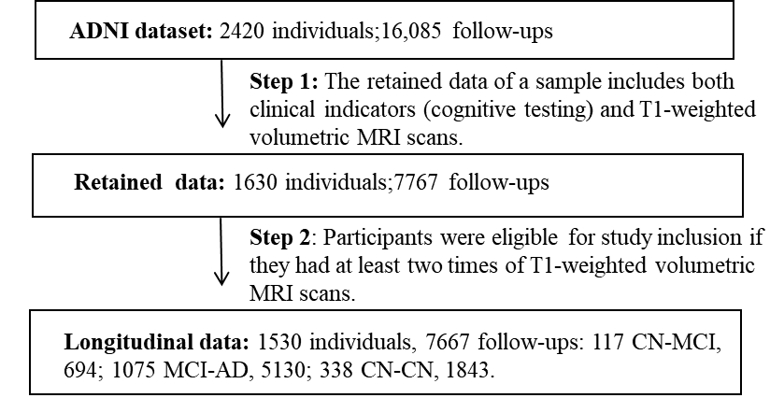

Supplementary Figure 2. Results of the cross-validation analysis to select the number of states. When the K value is above 10, the loss of model learning eventually becomes stable in both training and validation data. Therefore, we set the number of states to 10 in our study.

Supplementary Figure 3. Corrected p-values for each of the pairwise state comparisons with respect to cognitive assessments.
Corrected p-values for each of the pairwise state comparisons for the cognitive assessments of AD. These results are intended to support the interpretation of the distinguishing features of the states (e.g. Figure 1). Analysis was performed using post-hoc Nemenyi test after all groups were found to be statistically significant using Kruskal-Wallis test, and the Benjamini-Hochberg false discovery rate correction was used to account for multiple testing.

Supplementary Figure 4. Corrected p-values for each of the pairwise state comparisons with respect to core brain regions.
Corrected p-values for each of the pairwise state comparisons for the core brain regions of AD. These results are intended to support the interpretation of the distinguishing features of the states (e.g. Figure 1). Analysis was performed using post-hoc Nemenyi test after all groups were found to be statistically significant using Kruskal-Wallis test, and the Benjamini-Hochberg false discovery rate correction was used to account for multiple testing.

Supplementary Figure 5. Visualization of brain region atrophy in the identified disease-related states of participants with Abeta-positive status in the ADNI dataset.
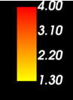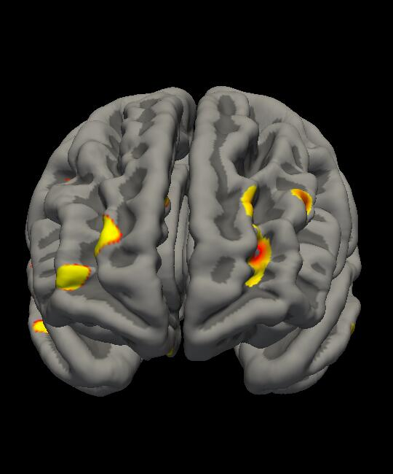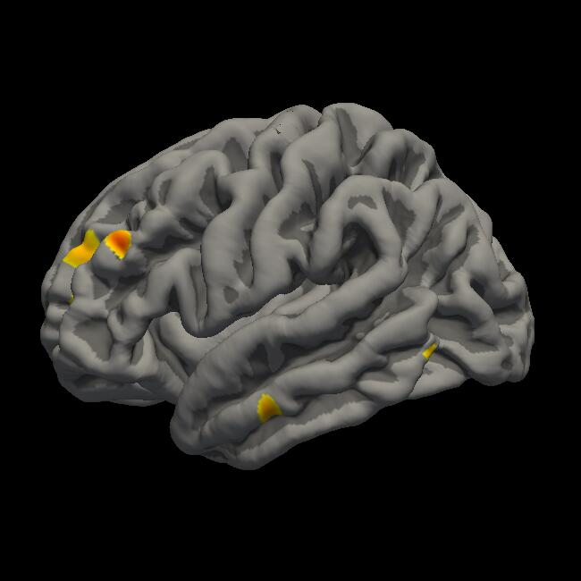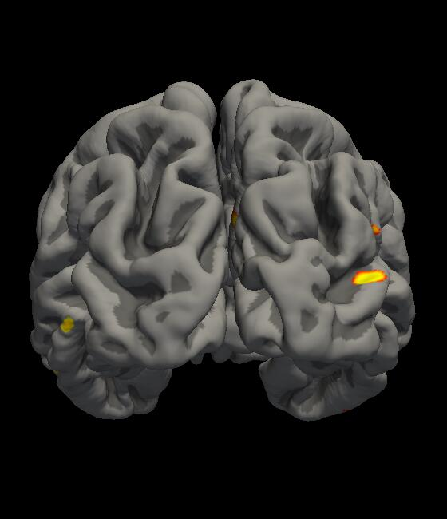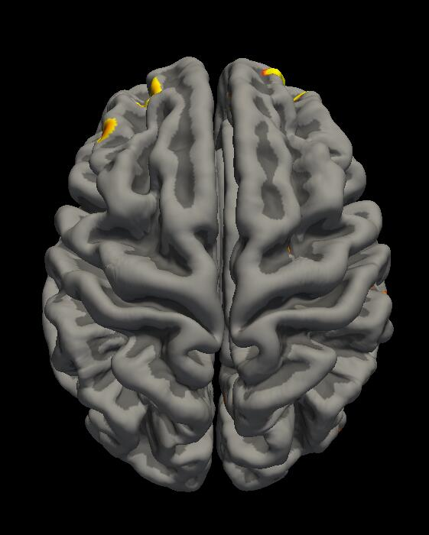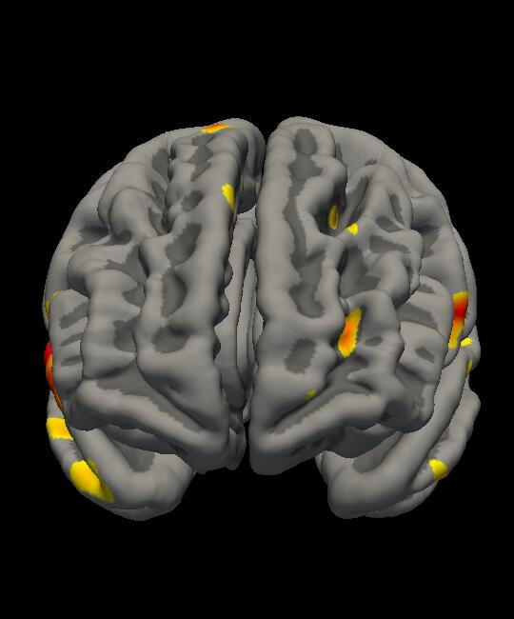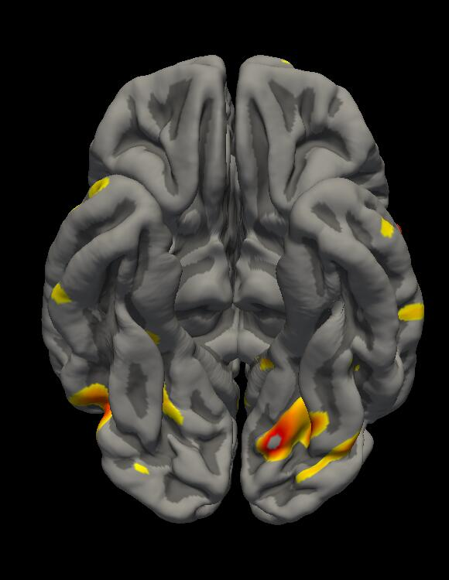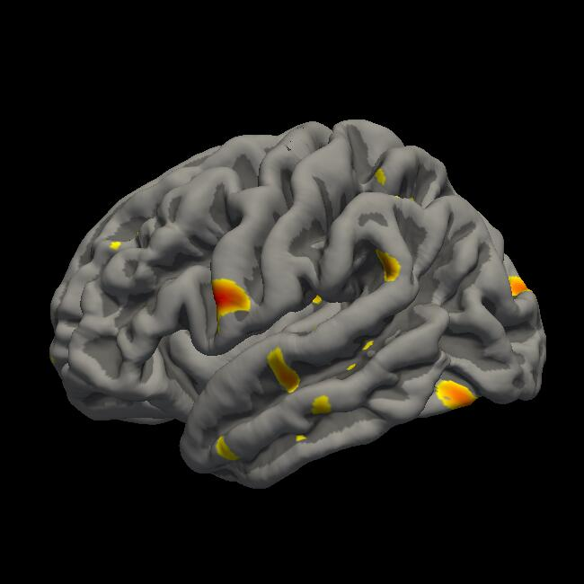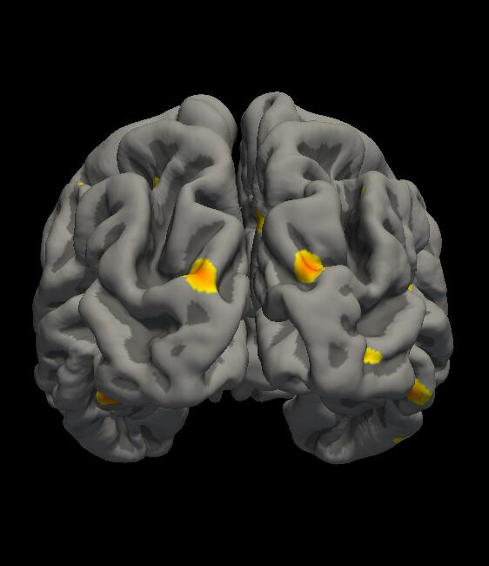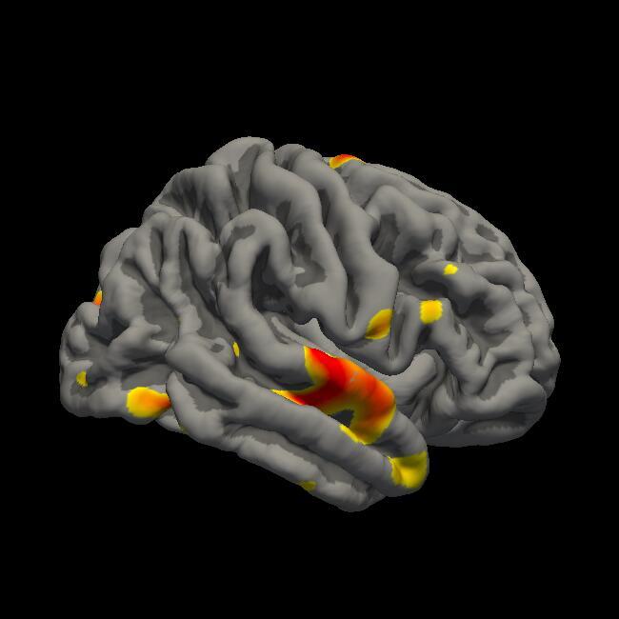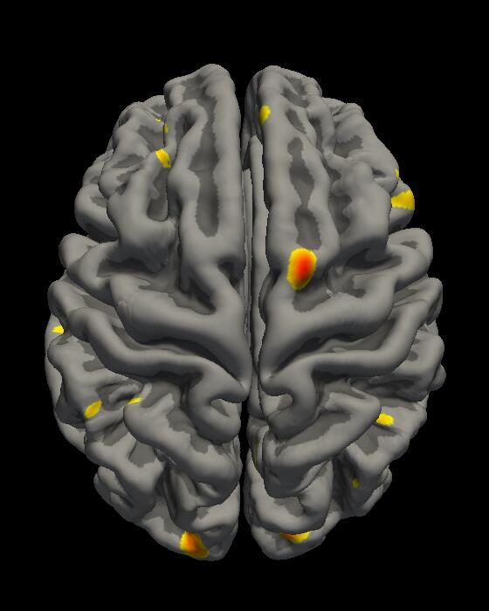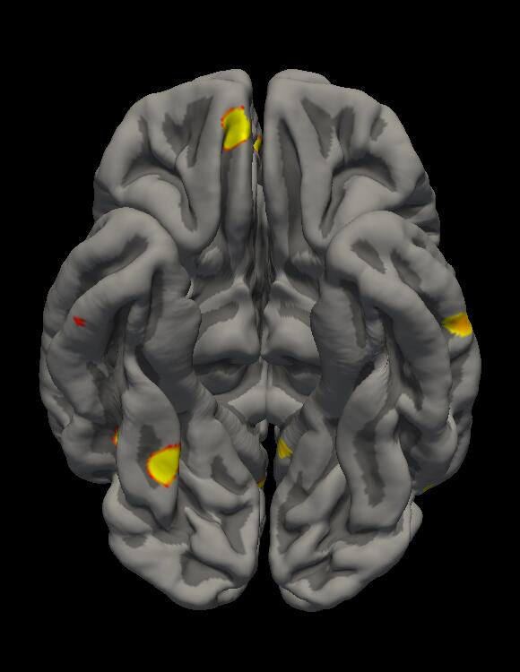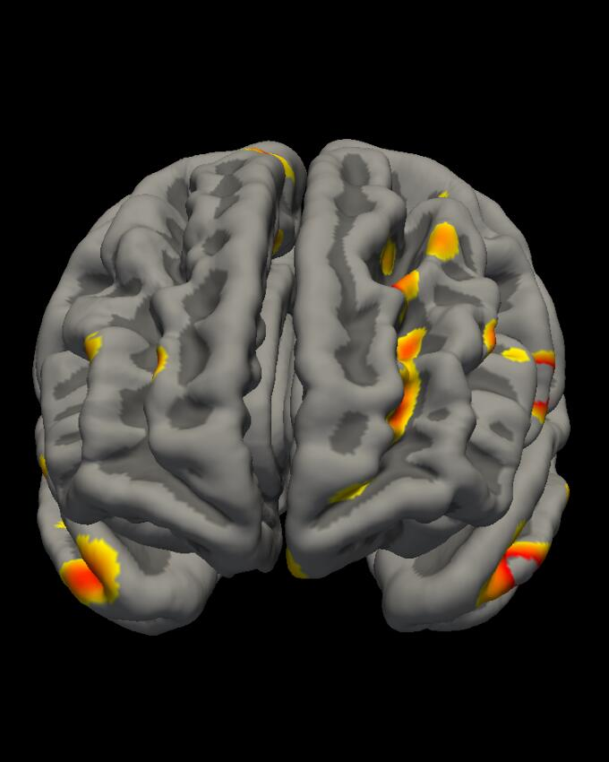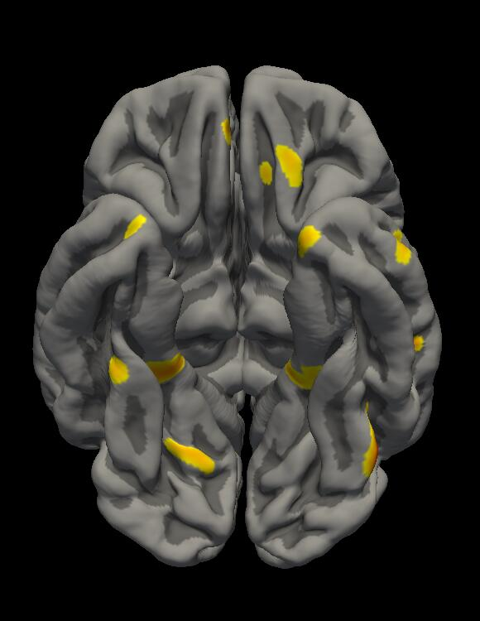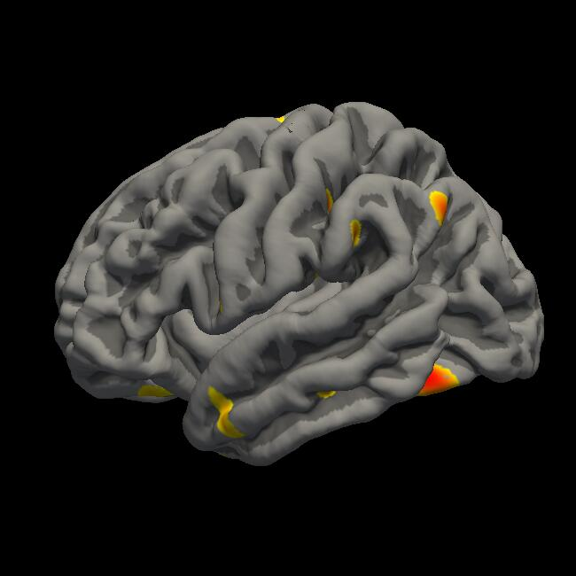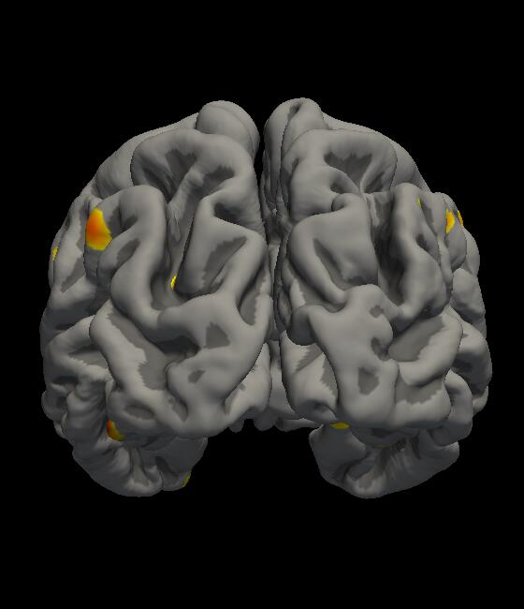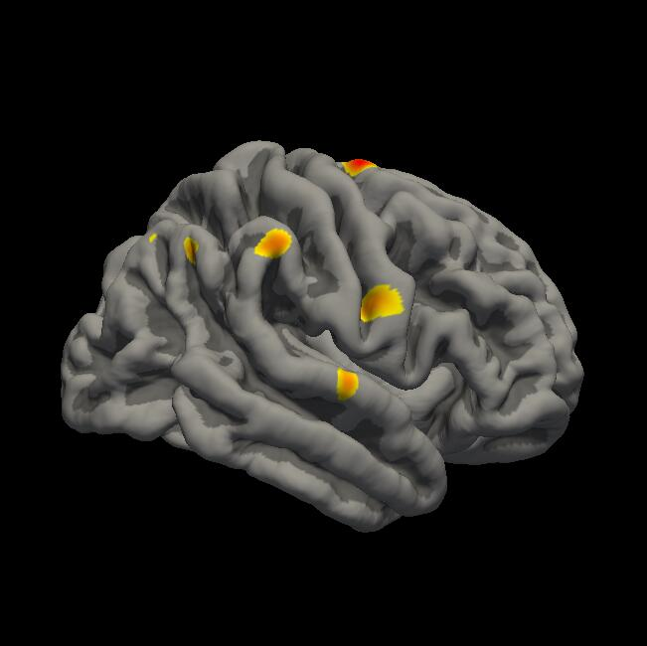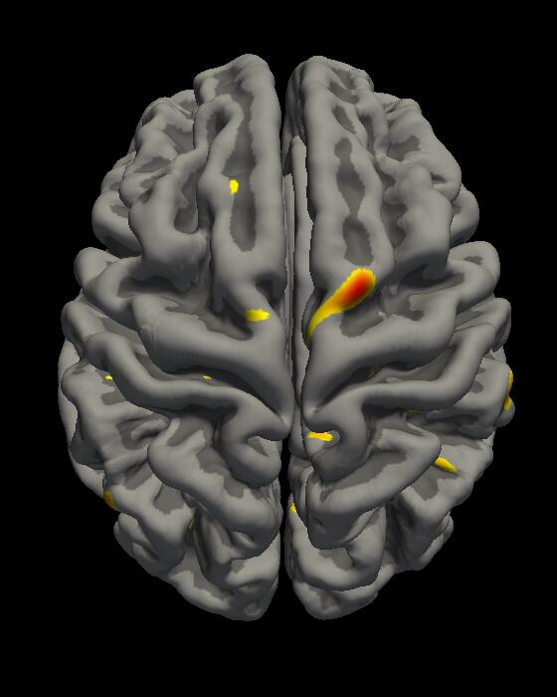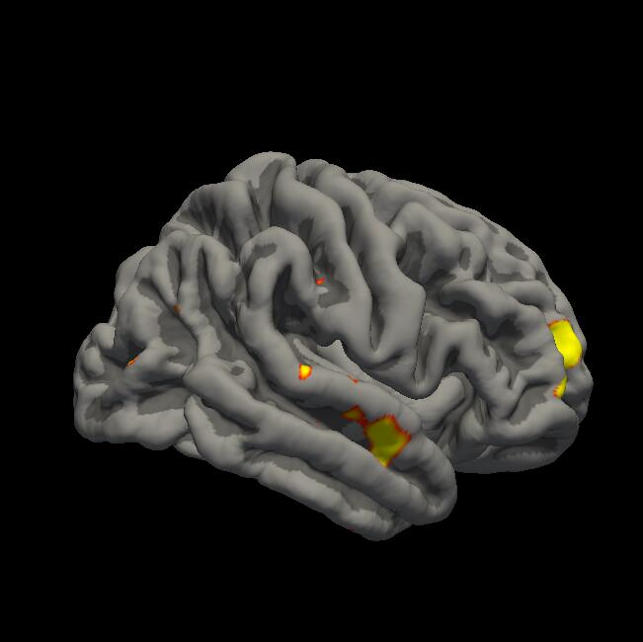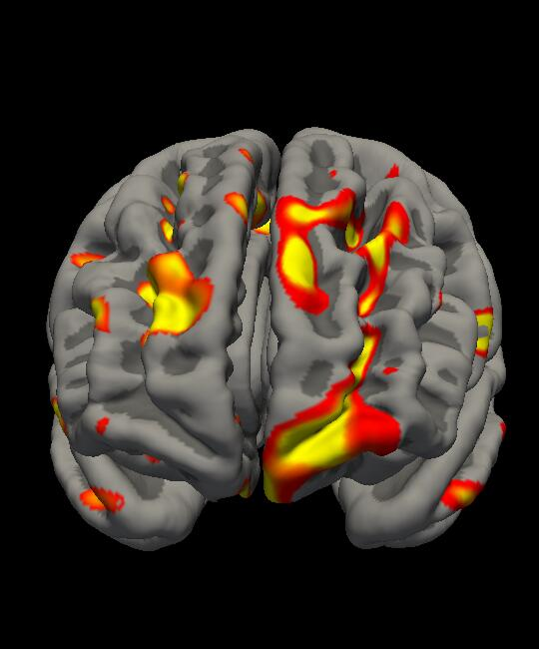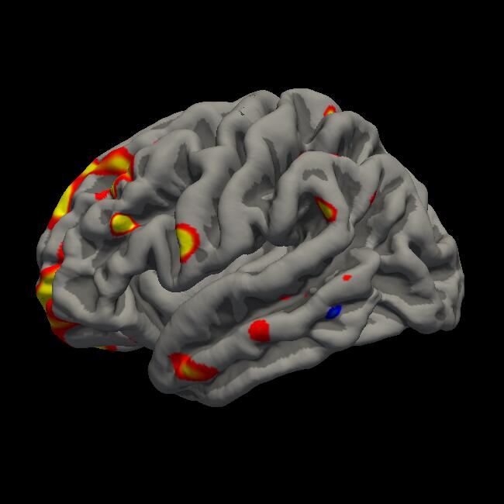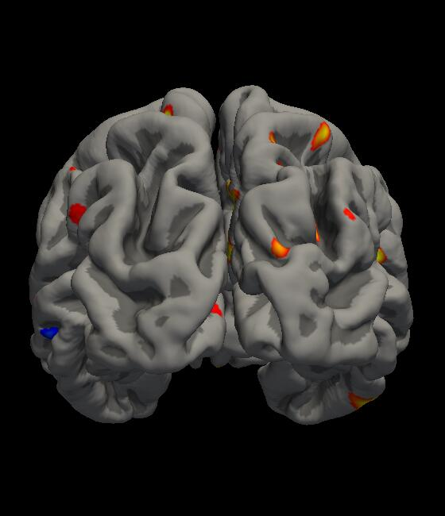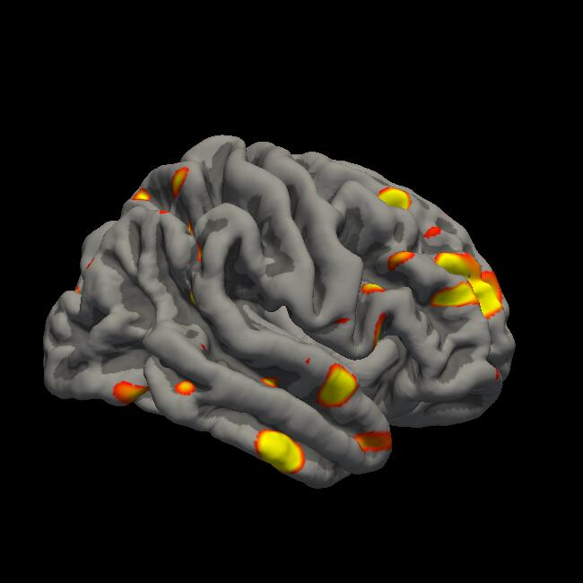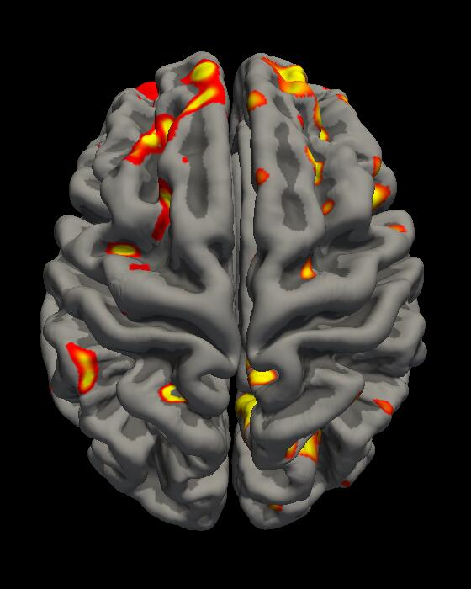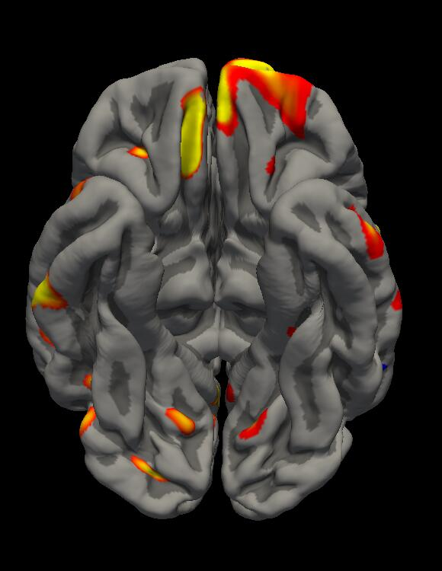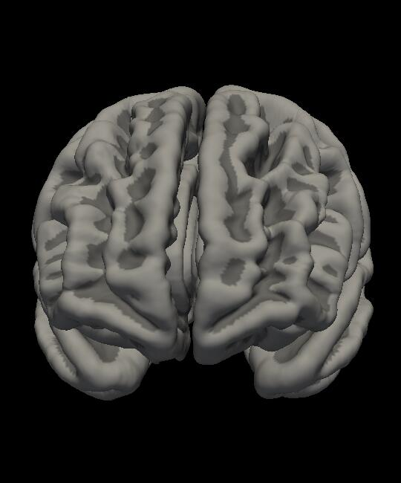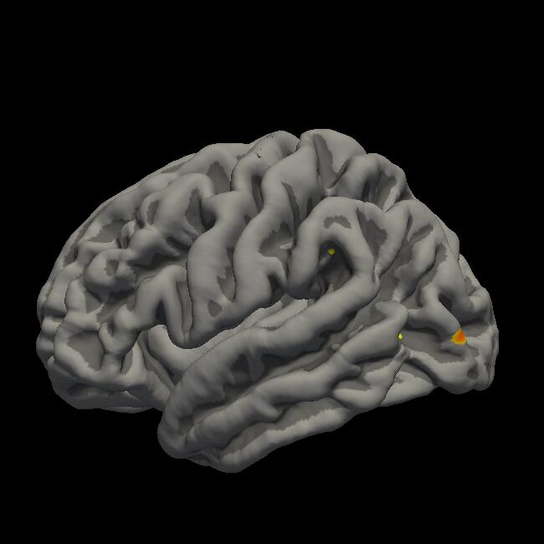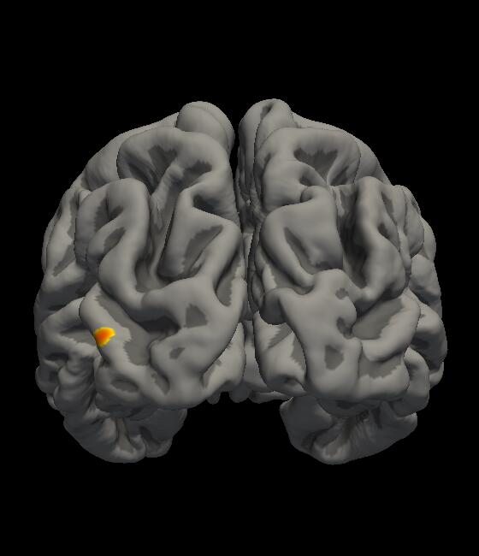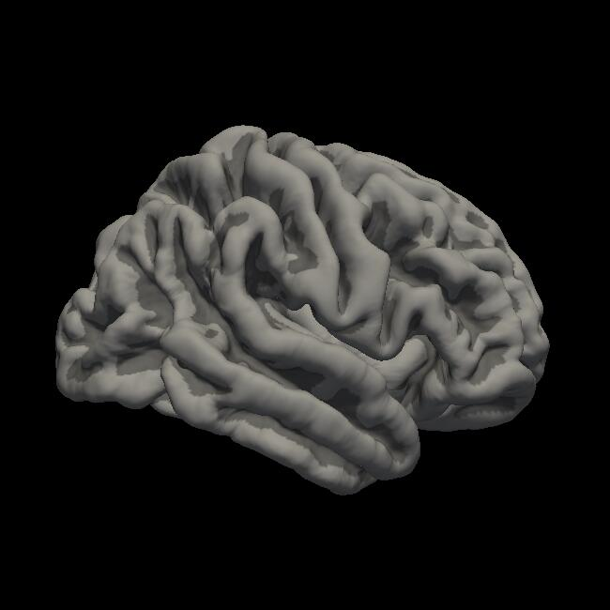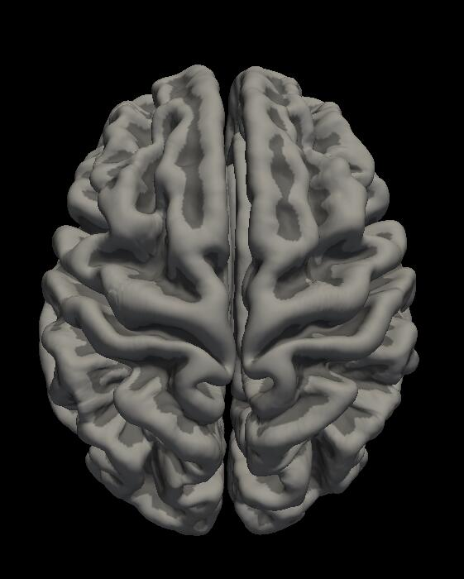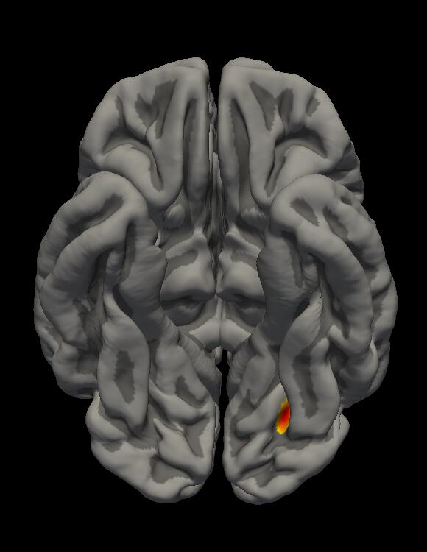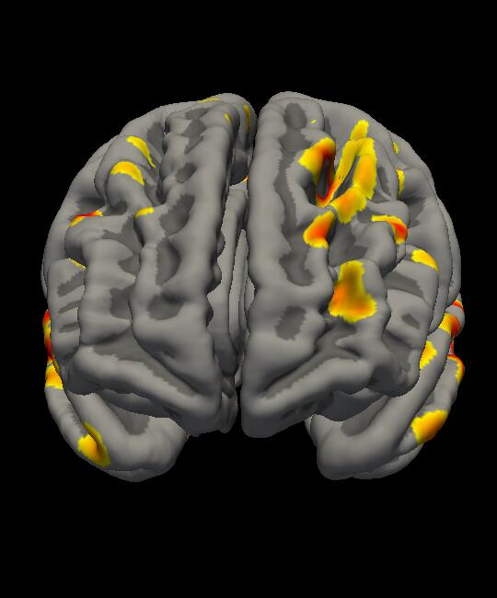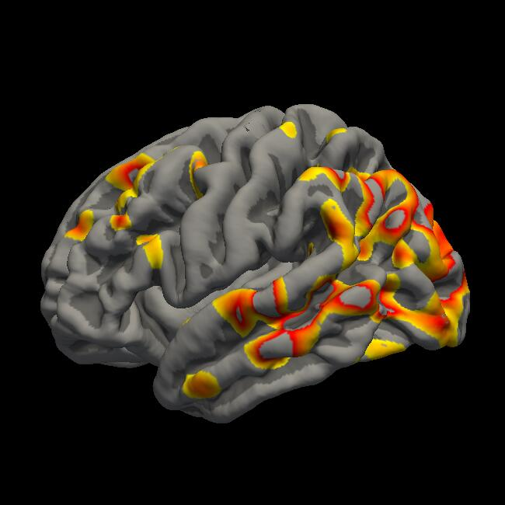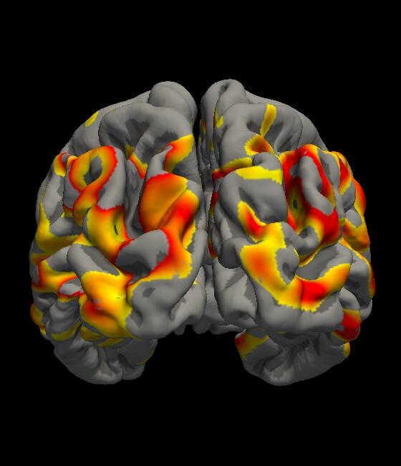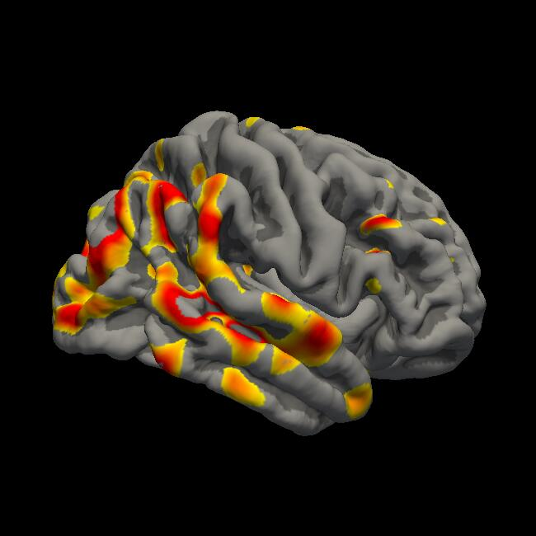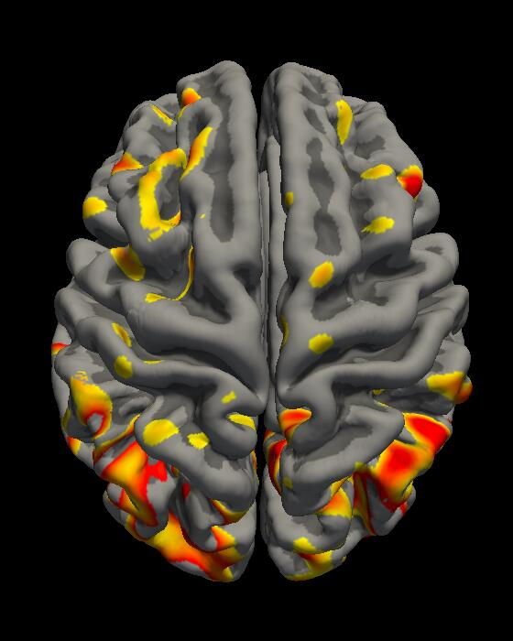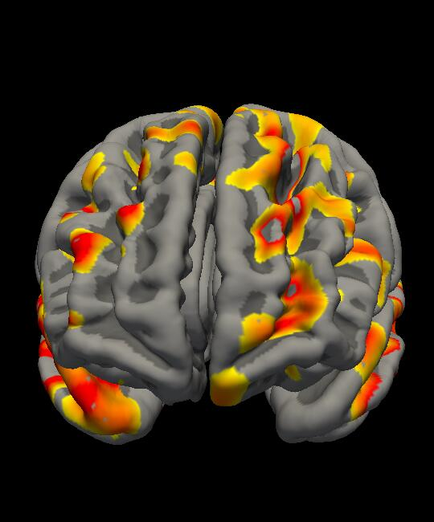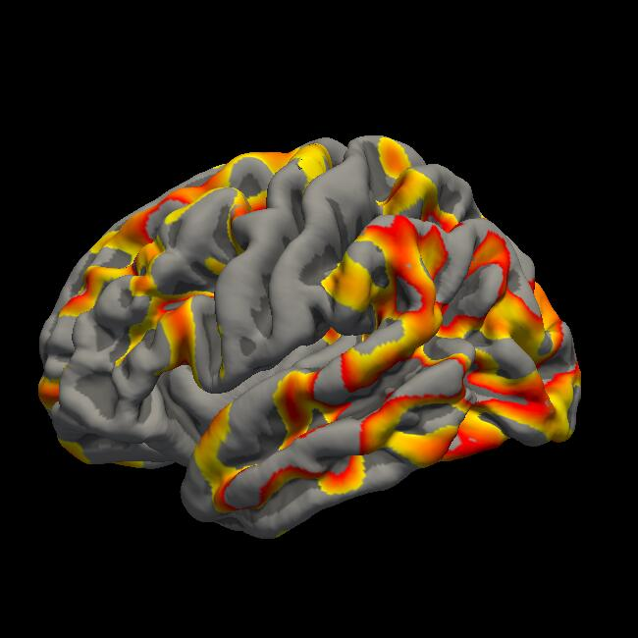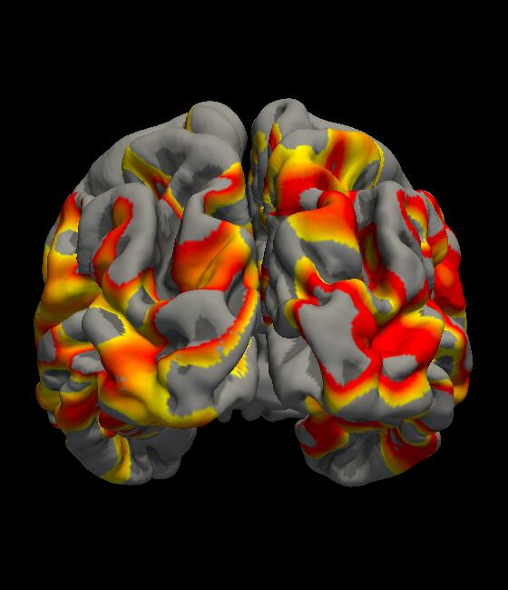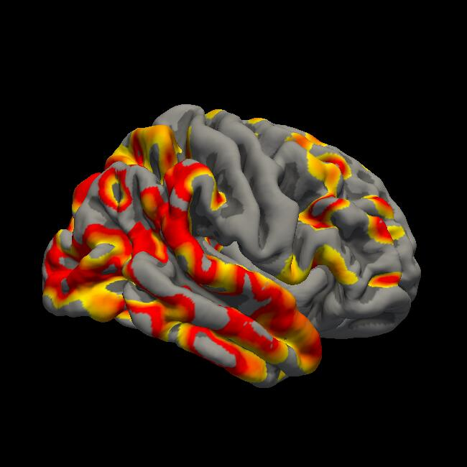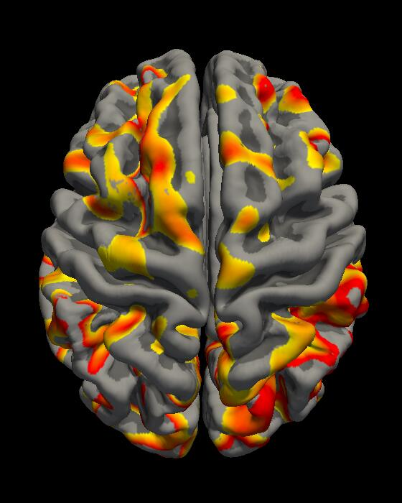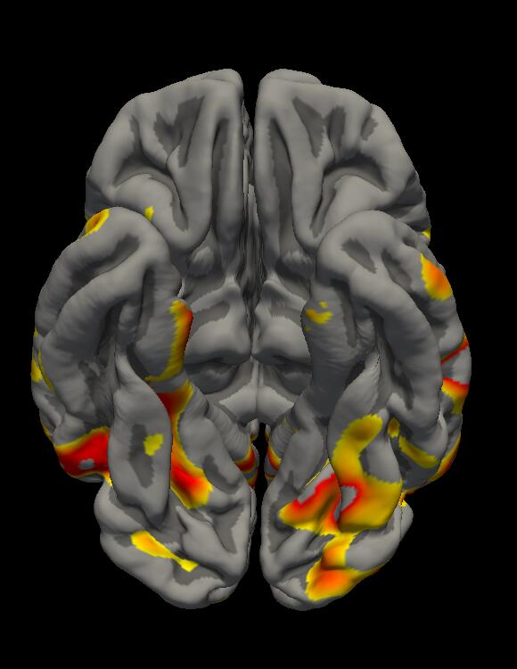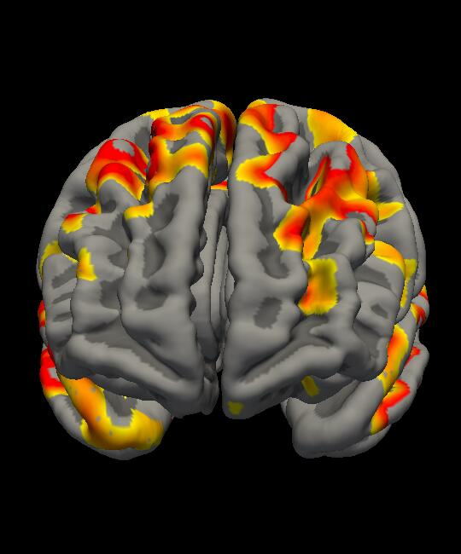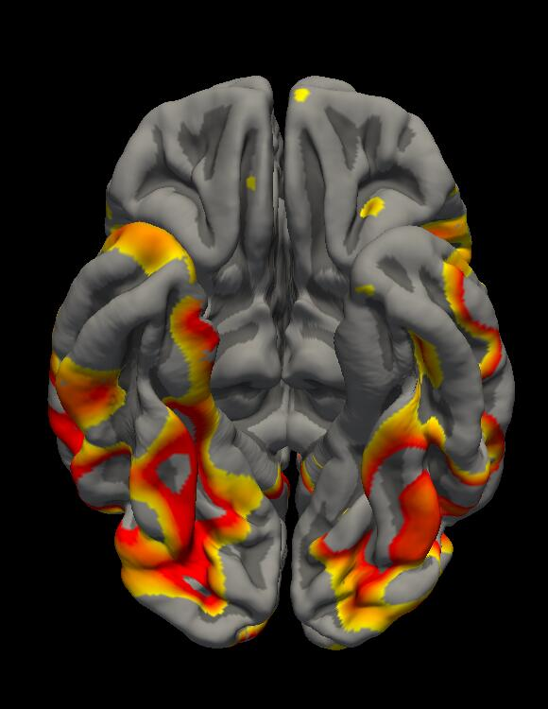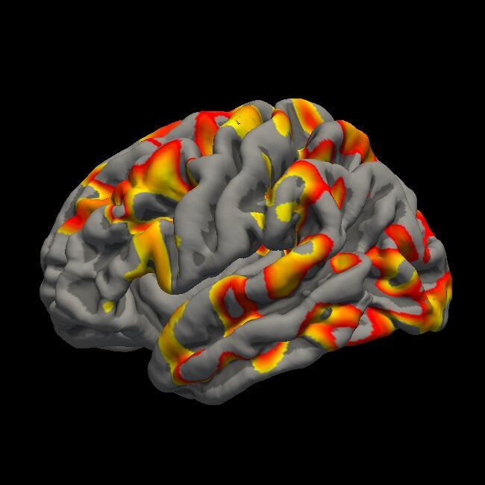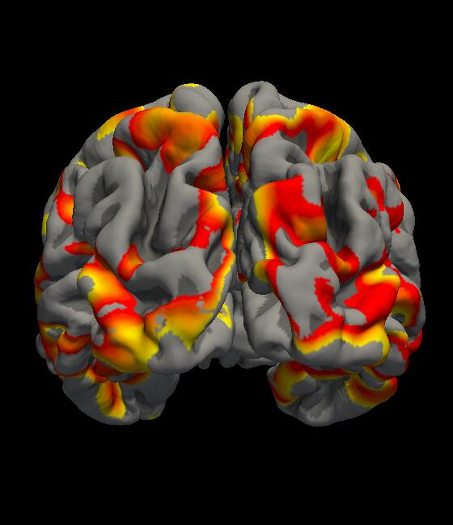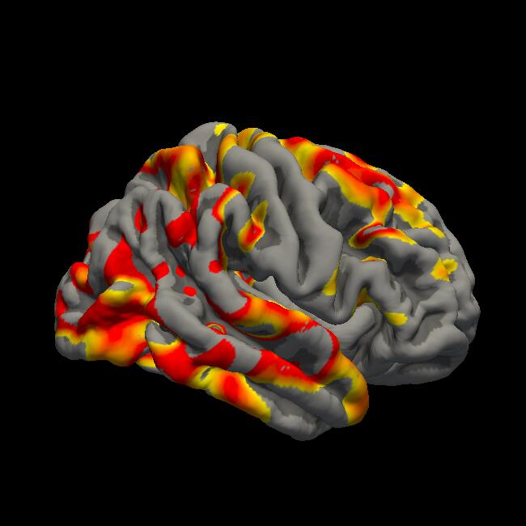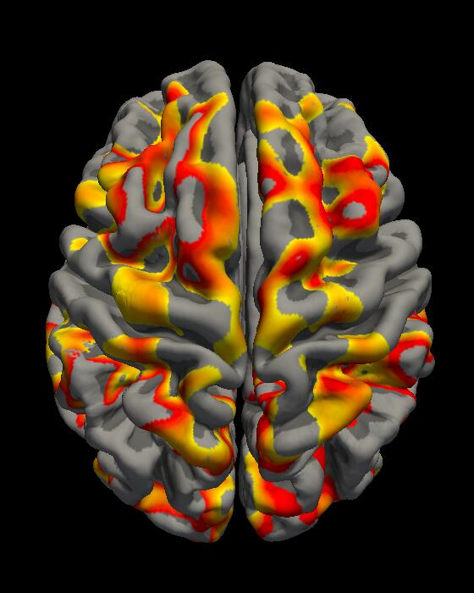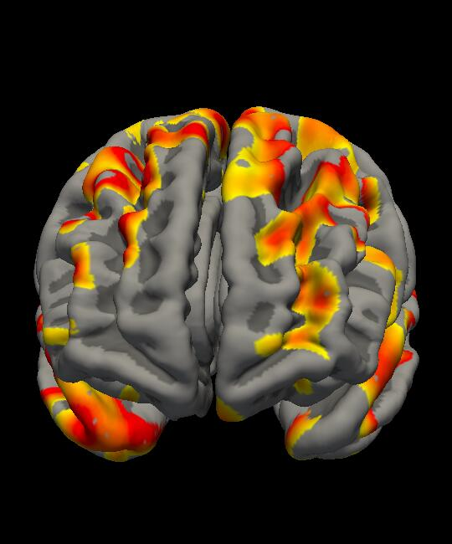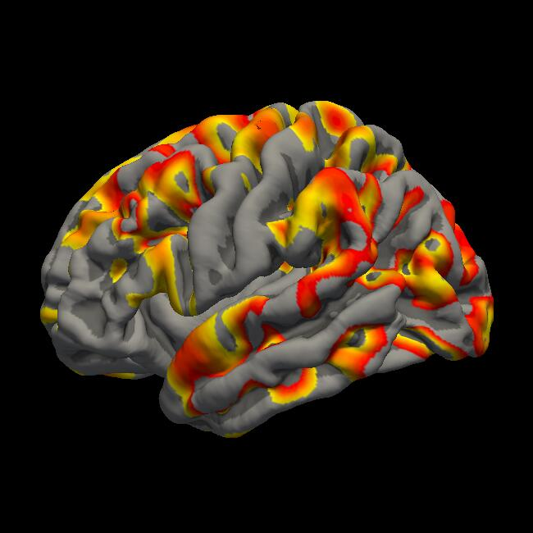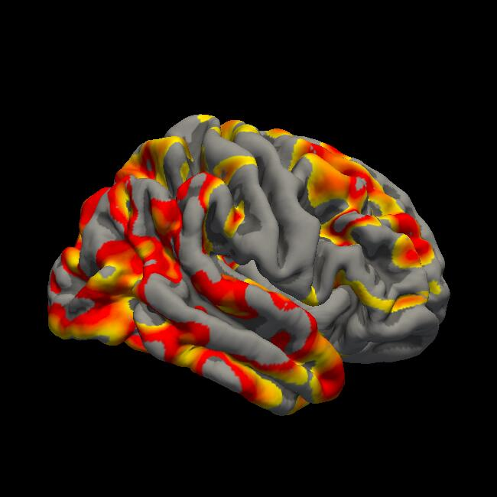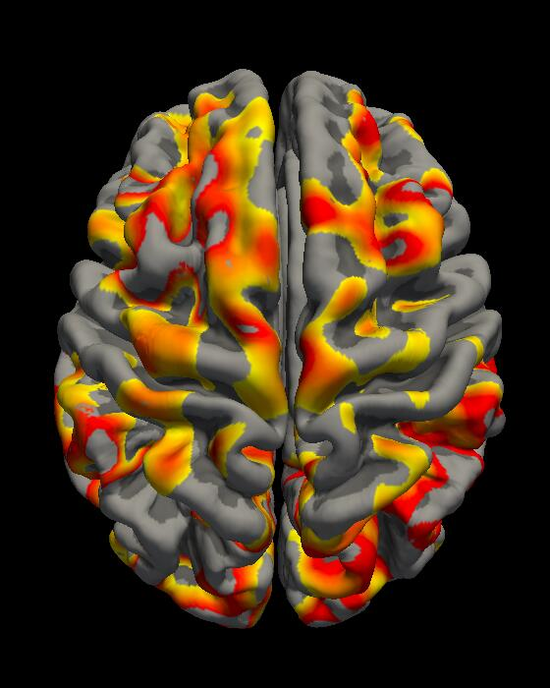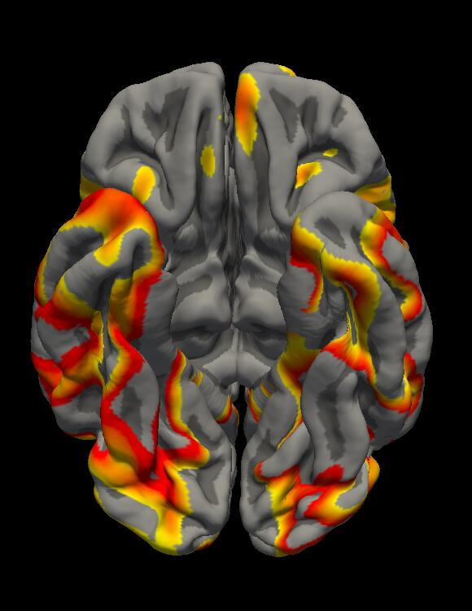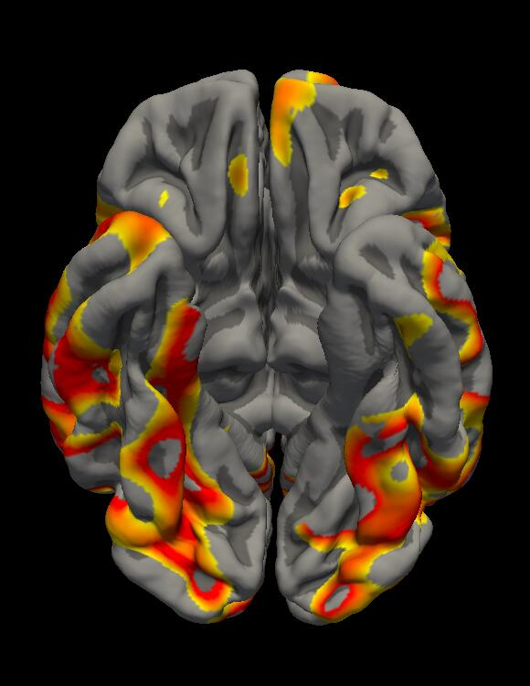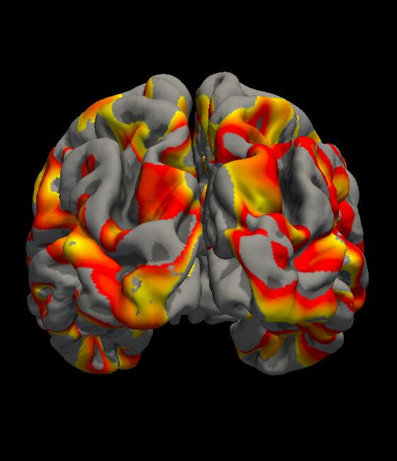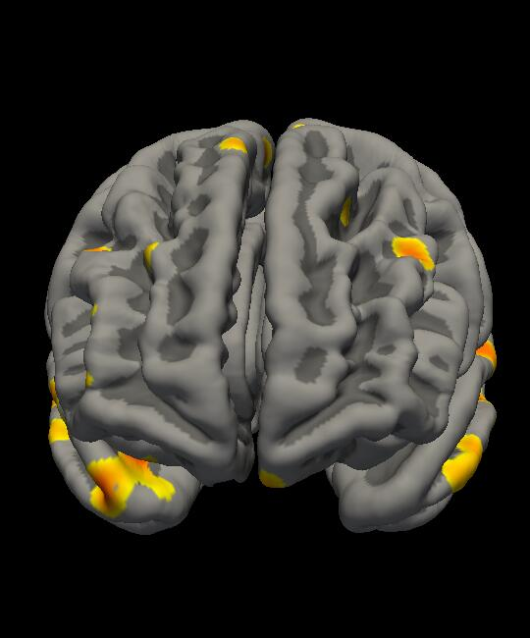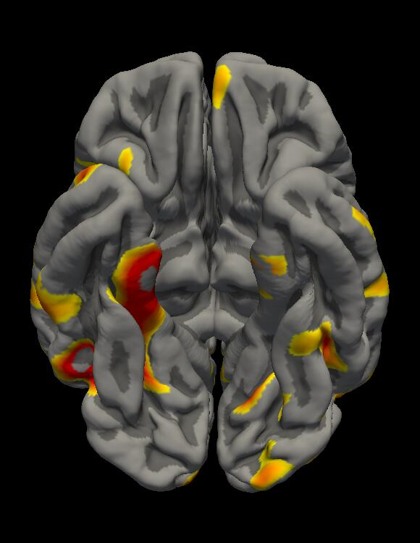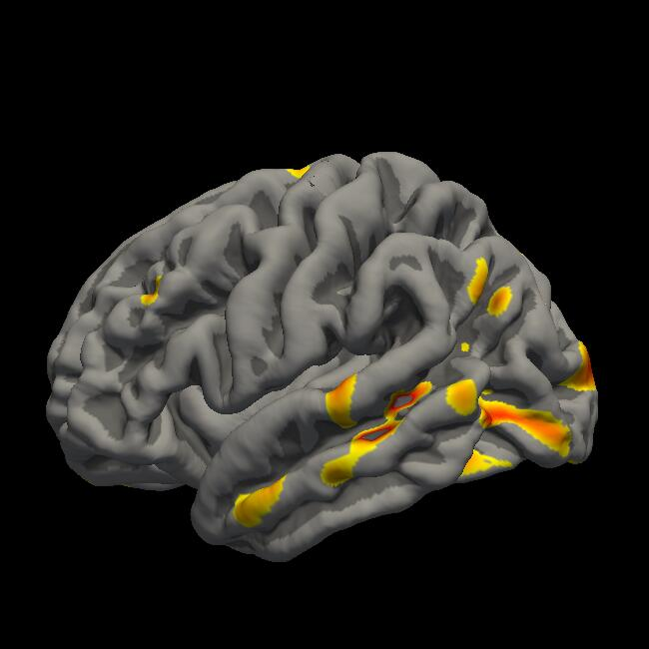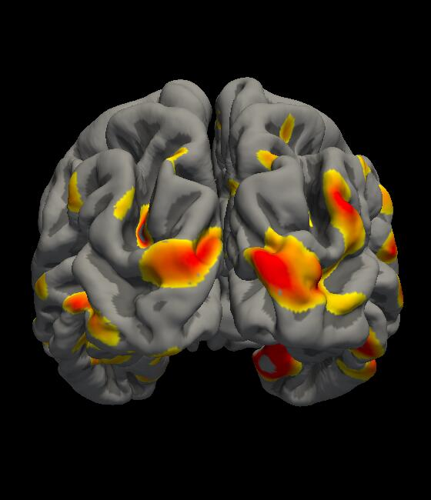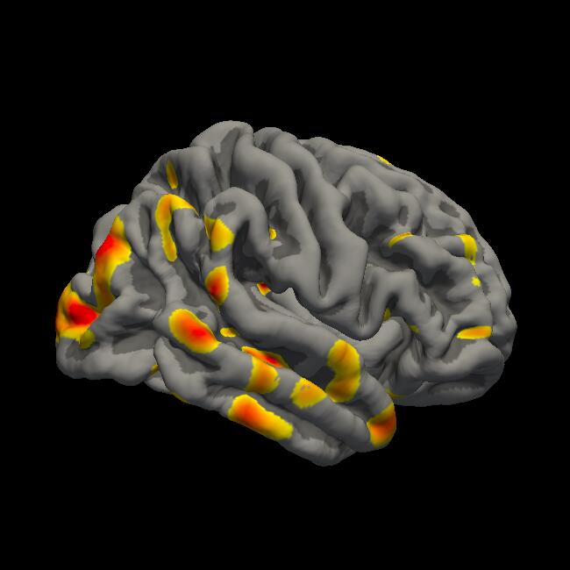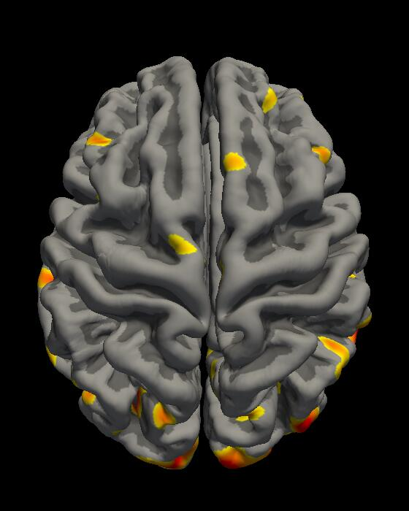The visualization of atrophy of brain regions is drawn by comparing with healthy controls.
A-I
A-II
A-IV
A-III
B-I
C-I
C-II
C-III
C-IV
B-II

Supplementary Figure 6. Paired testing was performed between the identified disease-related states in the discovered progression patterns.
Abbreviations: CDRSB, Clinical Dementia Rating Scale Sum of Boxes; ADAS-cog, Alzheimer’s Disease Assessment Scale–Cognitive Subscale; MMSE, Mini-Mental State Examination; LDELTOTAL, logical memory delayed recall total; mPACCdigit, Preclinical Alzheimer's Cognitive Composite Scores; mPACCtrailsB, Preclinical Alzheimer's Cognitive Composite trails B, MidTemp, Middle Temporal Gyrus; ICV: Intracerebral Volume.
*** indicates a value less than 0.001, ** indicates a value between 0.001 and 0.01 and * indicates a value between 0.01 and 0.05.

Supplementary Figure 7. Atrophy in representative brain regions for the identified disease stage states.
(a) Atrophies in representative brain regions for the identified states of stage A.
(b) Atrophies in representative brain regions for the identified states of stage B.
(c) Atrophies in representative brain regions for the identified states of stage C.

Supplementary Figure 8. Survival curves of ADNI participants converting from any state to the final C-IV state (a) or to AD dementia (b).
(a) Survival curves of ADNI participants converting from any state to the final C-IV state. Survival tables below the survival curves show the number of patients currently at risk, censored, or having an event (event representing progression from any state to C-IV) at each time point corresponding to the x-axis.
(b) Survival curves of ADNI participants converting from any state to AD dementia. Survival tables below the survival curves show the number of patients currently at risk, censored, or having an event (event representing progression from any state to AD dementia) at each time point corresponding to the x-axis.

Supplementary Figure 9. Survival curves of AIBL participants converting from any state to the final state (a) or to AD dementia (b).
(a) Survival curves of AIBL participants converting from any state to the final state. Survival tables below the survival curves show the number of patients currently at risk, censored, or having an event (event representing progression from any state to the final state) at each time point corresponding to the x-axis.

(b) Survival curves of AIBL participants converting from any state to AD dementia. Survival tables below the survival curves show the number of patients currently at risk, censored, or having an event (event representing progression from any state to AD dementia) at each time point corresponding to the x-axis.

