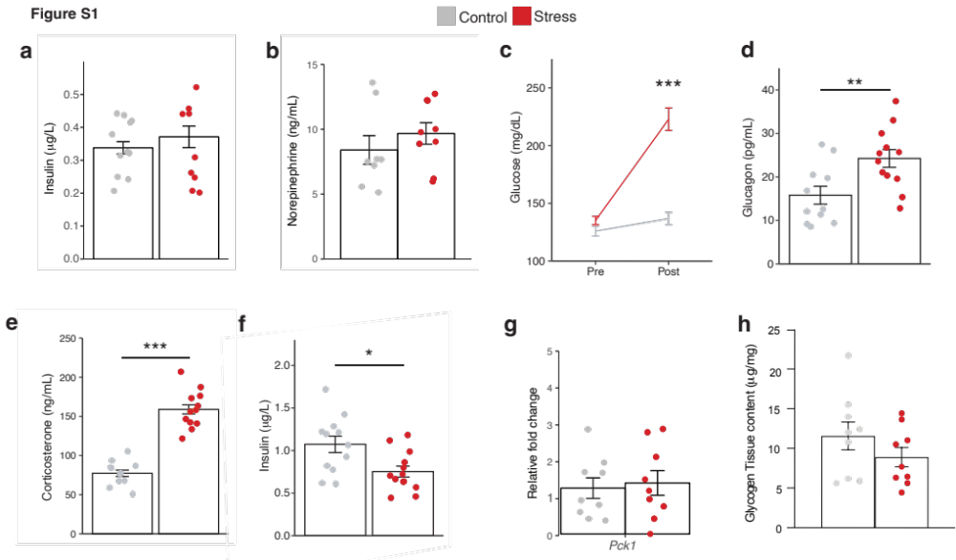Fig S1| Metabolic effects of acute stressors
a-b, Mean plasma insulin (a) and plasma norepinephrine (b) with (red) and without (grey) 30 minutes restraint stress in 6 hour fasted mice (n = 11 control/9 stress, n = 8 control/8 stress respectively).
c, Mean liver glycogen content with (n = 9) and without 30 minutes restraint stress (n = 9) in 6 hour fasted mice.
d, Mean blood glucose pre and post no stress (grey, n = 12) or 30 minutes restraint stress (red, n = 12) in fed mice. *** P < 0.001, control vs. stress. Linear mixed model with post-hoc Tukey’s test.
e-g, Mean plasma corticosterone (e), plasma insulin (f) and plasma glucagon (g), with and without 30 minutes restraint stress in fed animals. * P < 0.05, ** P < 0.01, control vs. stress *** P < 0.001, two-tailed t-test, control vs. stress (n = 12/12, 11/12, n = 9/7 respectively).
H, Relative fold change in liver phosphoenolpyruvate carboxykinase expression with (n = 9) and without 30 minutes restraint stress (n = 9) in fed animals.

All data represented as mean± SEM. Individual data points represent individual mice.
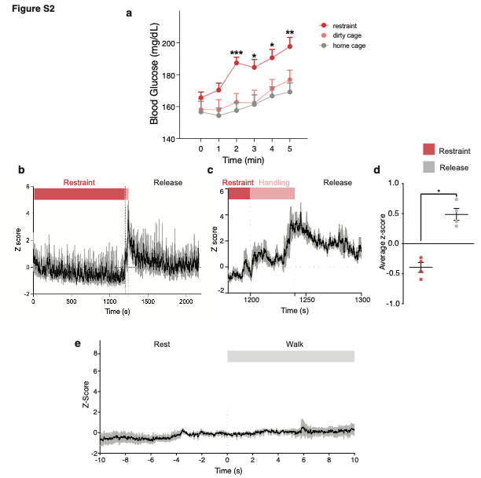
Fig S2|Activation of medial amygdala neurons by acute stressors
a, Mean blood glucose over first 5 minutes s in control (grey, n = 10), restraint stress (red, n = 13) and territorialized cage exposure (pink, n = 7). *** P < 0.001, ** P < 0.01, * P < 0.05 control vs. restraint stress. Two way ANOVA with post-hoc Tukey’s test.
b, MeA GCaMP6m z-score during restraint in a decapicone, handling to release (cutting the cone) and release. Color-coded shade bars indicate periods when the animal was restrained (restraint, red), handled (pink) and released, n = 4.
c, Plot of z-score aligned to end of restraint period, n = 4.
d, Mean z-score for restraint and release periods. * P < 0.05, baseline vs. capture, two-sided paired t-test, n = 4.
e, MeA GCaMP6m z-score in clean cage in the transition from resting to walking, n = 4.
All data represented as mean± SEM. Individual data points represent individual mice.
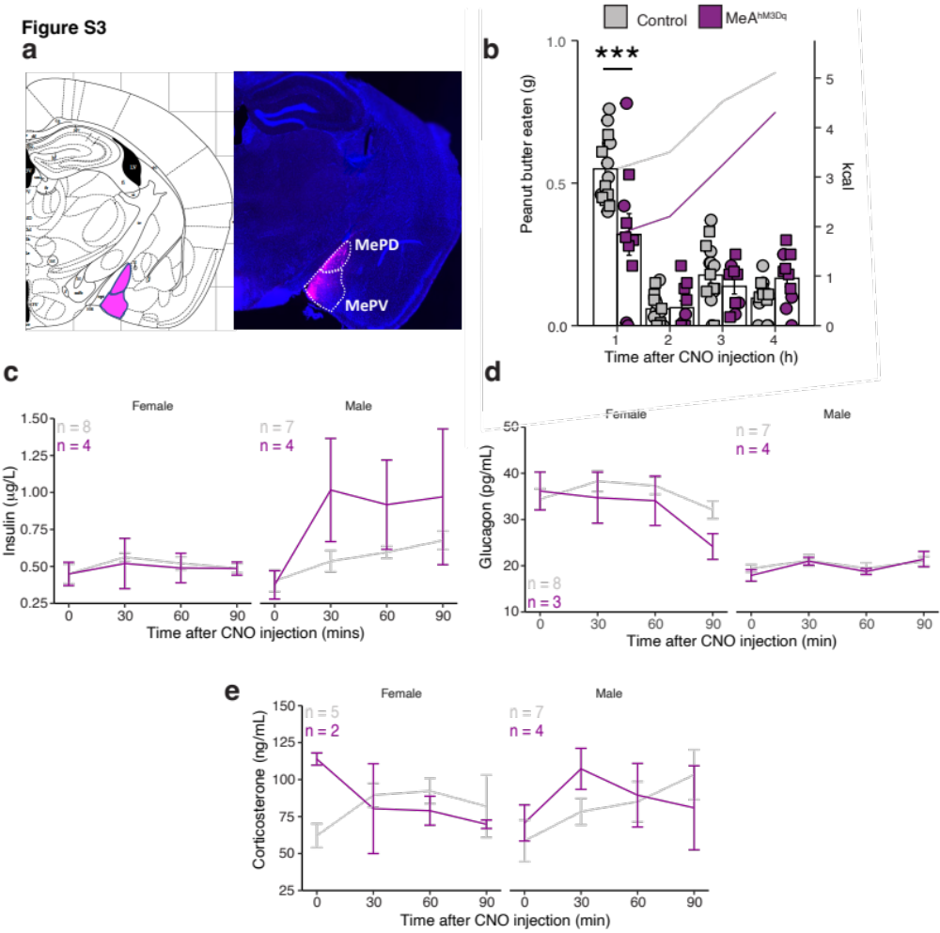
Fig S3|Activation of medial amygdala does not alter pancreatic hormones
a, MeA neurons expressing hSyn-hM3DGq-mCherry.
b, Effect of CNO injection on peanut butter intake in overnight-fasted mice expressing hSyn-hM3Dq (n = 9) compared to those expressing hSyn-mCherry (n = 14).
c-e, Effect of CNO injection on plasma insulin (c), plasma glucagon (d) or plasma corticosterone (e) in male or female mice expressing hSyn-hM3DGq compared to those expressing hSyn-mCherry, (n = 8 mCherry/4 hM3DGq female, 7 mCherry/4 hM3DGq male for insulin, n = 8 mCherry/3 hM3DGq female, 7 mCherry/4 hM3DGq male for glucagon, n = 5 mCherry/2 hM3DGq female, 7 mCherry/4 hM3DGq male for corticosterone.)
Data analyzed by linear mixed model with post-hoc Tukey’s test. All data represented as mean± SEM. Individual data points represent individual mice.
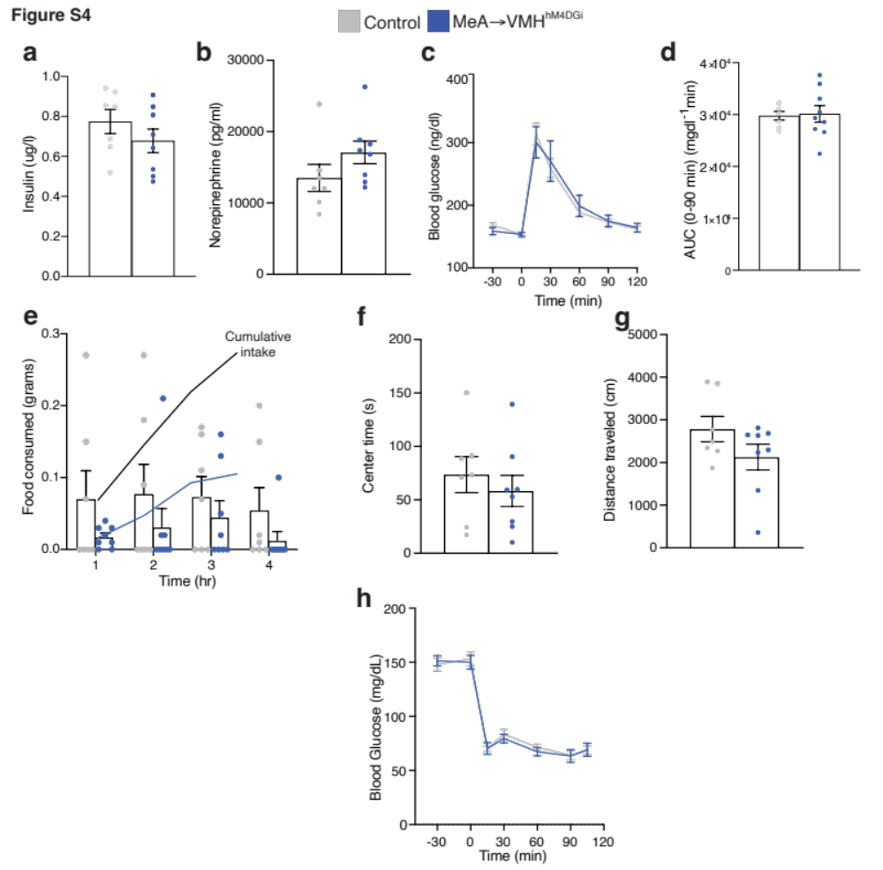
Fig. S4| Inhibition of MeA neurons projecting to VMH does not alter anxiety-like behavior or food intake.
a, b, Effects of CNO injection on plasma insulin (a) and plasma norepinephrine (b) in restrained mice expressing Flex-hM4DGi (n = 8) compared to those expressing Flex-mCherry (n = 7).
c,d, Effects of CNO injection on blood glucose (a) and cumulative change in blood glucose (b) during glucose tolerance testing (ipGTT) in unstressed mice expressing Flex-hM4DGi (n = 8) compared to those expressing Flex-mCherry (n = 7).
e, Effect of CNO injection on food intake in unstressed mice expressing Flex-hM4DGi (n = 8) compared to those expressing Flex-mCherry (n = 7).
f,g, Effect of CNO injection on distance travelled (f) or center time (g) in open field test in unstressed mice expressing Flex-hM4DGi (n = 8) compared to those expressing Flex-mCherry (n = 7).
h, Effect of CNO injection on blood glucose during insulin tolerance testing (ITT) in unstressed mice expressing Flex-hM4DGi (n = 8) compared to those expressing Flex-mCherry (n = 7).
Data were analyzed by two-way ANOVA with post-hoc Sidak’s test (a, d, h), two-sided t-test (b, c, e, g) and Mann-Whitney test. All data represented as mean± SEM. Individual data points represent individual mice.
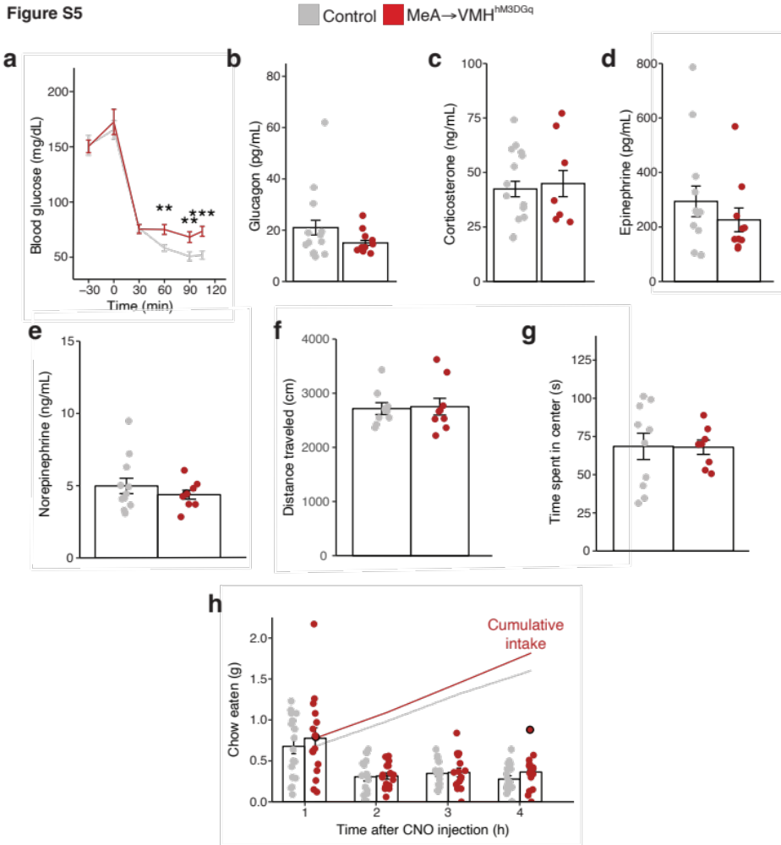
Fig. S5| Activation of MeA neurons projecting to VMH does not alter anxiety-like behavior or food intake.
a, Effect of CNO injection on blood glucose during insulin tolerance testing (ITT) in unstressed mice expressing Flex-hM3GDGq (n = 11) compared to those expressing Flex-mCherry (n = 13), * P < 0.05, ** P < 0.01, *** P < 0.001 control vs. hM3DGq, linear mixed model with post-hoc Tukey’s test.
b-e, Effect of CNO injection on plasma glucagon (b), plasma corticosterone (c), plasma epinephrine (d) or plasma norepinephrine (e) in unstressed mice expressing Flex-hM3DGq (n = 10, 7, 10 for b, c and d) compared to those expressing Flex-mCherry (n = 13, 13, 11 for b, c and d).
f,g, Effect of CNO injection on distance travelled (f) and center time (g) in open field test in unstressed mice expressing Flex-hM3DGq (n = 8) compared to those expressing Flex-mCherry (n = 10).
h, Effect of CNO injection on food intake in unstressed mice expressing Flex-hM3Dq (n = 14) compared to those expressing Flex-mCherry (n = 15).
Data were analyzed by Mann-Whitney test (b-g) and linear mixed model with post-hoc Tukey’s test (a and h). All data represented as mean± SEM. Individual data points represent individual mice.
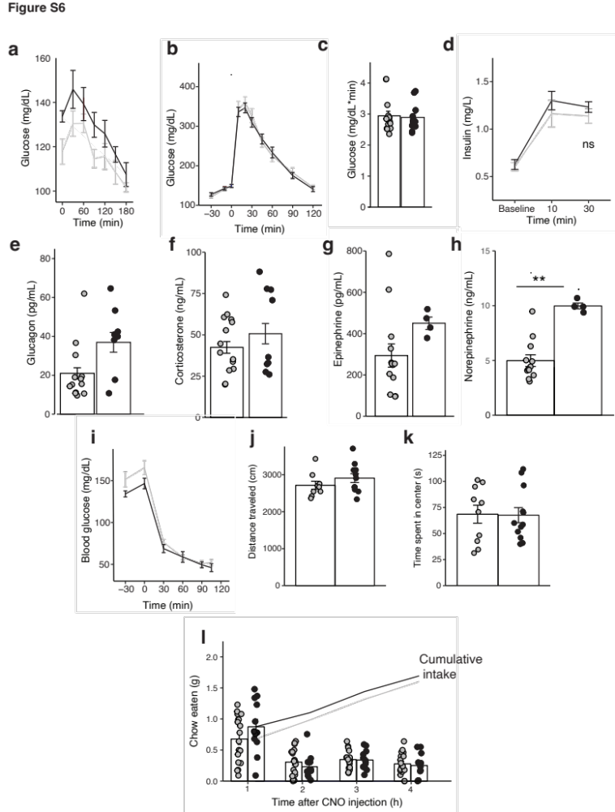
Fig. S6| Activation of MeA neurons projecting to BNST does not alter blood glucose, anxiety-like behavior or food intake.
a, Effect of CNO injection on blood glucose in unstressed mice expressing Flex-hM3DGq (n = 8) in MeA-BNST neurons compared to those expressing Flex-mCherry (n = 9).
b-d, Effect of CNO injection on blood glucose (b), cumulative change in blood glucose (c) and plasma insulin (d) during glucose tolerance testing (ipGTT) in unstressed mice expressing Flex-hM3DGq (n = 12) in MeA-BNST neurons compared to those expressing Flex-mCherry (n = 15).
e-h, Effect of CNO injection on plasma glucagon (e), plasma corticosterone (f) or plasma epinephrine (g) and plasma norepinephrine (h) in unstressed mice expressing Flex-hM3DGq (n = 8, 9, 4, 4 for e, f, g, and h) in MeA-BNST neurons compared to those expressing Flex-mCherry (n = 13, 14, 12, 12 for e, f, g and h), ** P < 0.01, Mann-Whitney test.
i, Effect of CNO injection on blood glucose during insulin tolerance testing in unstressed mice expressing Flex-hM3DGq (n = 7) in MeA-BNST neurons compared to those expressing Flex-mCherry (n = 13).
j,k, Effect of CNO injection on distance travelled (j) and center time (k) in open field test in unstressed mice expressing Flex-hM3Dq (n = 12) in MeA-BNST neurons compared to those expressing Flex-mCherry (n = 10).
l, Effect of CNO injection on food intake in unstressed mice expressing Flex-hM3Dq (n = 11) in MeA-BNST neurons compared to those expressing Flex-mCherry (n = 17).
Data were analyzed by Mann-Whitney test (c, e-h), two-tailed t-test (j, k) and linear mixed model with post-hoc Tukey’s test (a, b, d, i, and l). All data represented as mean± SEM. Individual data points represent individual mice.

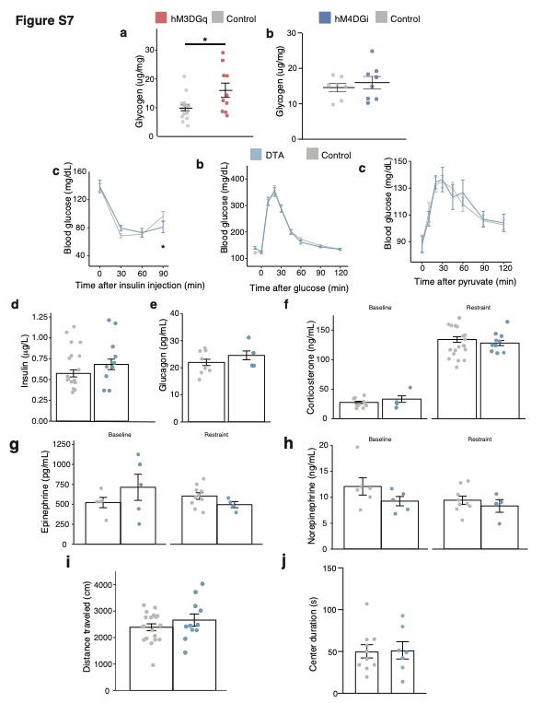
Fig S7| Chronic MeA-VMH neural silencing does not alter stress-induced hormone release
a, Effect of CNO treatment on liver glycogen content in unstressed mice expressing Flex-hM3Dq (n = 10) in MeA-VMH neurons compared to those expressing Flex-mCherry (n = 8) *P< 0.05, Mann-Whitney U test.
b, Effect of CNO treatment on liver glycogen content in stressed mice expressing Flex-hM4DGi (n = 8) in MeA-VMH compared to those expressing Flex-mCherry (n = 7).
c-e, Effect of chronic silencing of MeA-VMH neurons with DTA (n = 10) compared to control mice (n = 13) on blood glucose during insulin tolerance testing (c), glucose tolerance testing (d) and pyruvate tolerance testing (e).
f-j, Effect of chronic silencing of MeA-VMH neurons with DTA compared to control mice on plasma insulin (f, n = 13 control, 10 DTA) or plasma glucagon (g, n = 8 control, 4 DTA) in restrained mice or plasma corticosterone (h, n = 10 baseline, 18 restraint control, n = 4 baseline, 10 restraint DTA), plasma epinephrine (i, n = 5 baseline, 10 restraint control, n = 5 baseline, 4 restraint DTA) or plasma norepinephrine (j, n = 6 baseline, 9 restraint control, n = 5 baseline, 4 restraint DTA)) in unstressed or restrained mice.
k,l, Effect of chronic silencing of MeA-VMH neurons with DTA compared to control mice on distance traveled (k, n = 19 control, 11 DTA) and center time (l, n = 10 control, 7 DTA) in an open field test in unstressed mice.
Data were analyzed by linear mixed model with post-hoc Tukey’s test (c-e) and Mann-Whitney U test (a, b, f-l). All data represented as mean± SEM. Individual data points represent individual mice.

