Supplemental Information for:
Carbon emissions from urban takeaway delivery in China
Tables, Figures and Notes

Supplementary Table 1 Features selection of annual takeout order volume(ATOV) prediction model 3

Supplementary Table 2 Features selection of delivery distance per order(DDOP) prediction model 4

Supplementary Table 3 The fitting results of Chinese take-out order growth model 4

Supplementary Table 4 Estimate and projection of carbon emissions from takeout deliveries in China from 2014 to 2035 5

Supplementary Table 5 Transportation-related GHG emissions outputs of multi-scenario mitigation strategies compared with BAU(kt) 6

Supplementary Table 6 . Data sources related to urban takeaway deliveries 7

Supplementary Table 7 . Parameters of uncertainty analysis for FDCE model based on Monte Carlo simulation 7

Supplementary Table 8 . Parameters of uncertainty analysis for ML-FDCE model based on Monte Carlo simulation 8

Supplementary Table 9 Performance comparison of DDOP prediction models 9

Supplementary Fig1. MAPE performance of DDOP prediction model for each city 10

Supplementary Fig2. MAE performance of machine learning model for average delivery distance of each city 10

Supplementary Fig3. SHAP value for XGBoostReg model parameter 11

Supplementary Fig4. MAPE of base models for predicting ATOV 11

Supplementary Fig5. R-squared of base models for predicting ATOV 12

Supplementary Fig6. MAE of base models for predicting ATOV 12

Supplementary Fig7. MAPE of model1 for predicting ATOV 13

Supplementary Fig8. R-squared of model1 for predicting ATOV 13

Supplementary Fig9. MAE of model1 for predicting ATOV 14

Supplementary Fig10. MAPE of model2 for predicting ATOV 14

Supplementary Fig11. R-squared of model2 for predicting ATOV 15

Supplementary Fig12. MAE of model2 for predicting ATOV 15

Supplementary Fig13. MAE of model3 for predicting ATOV 16

Supplementary Fig14. MAE of models for predicting DDOP 16

Supplementary Fig15. MAPE of models for predicting DDOP 17

Supplementary Fig16. SHAP value of DDOP prediction model (XGBoost) 17

Supplementary Fig17. Predicted ATOV map in 270 cities in 2019 18

Supplementary Fig18. Predicted DDPO map in 270 cities in 2019 19

Supplementary Fig19. Predicted GHG emissions map in 270 cities in 2019 20

Supplementary Fig20. The fitting curving of takeout order volume 20

Supplementary Fig21. City-level ban-motorcycle search volume and BMSI 21

Supplementary Fig22. City-level the usage of electric vehicles and motorcycles 22

Supplementary Fig23. Fuel consumption per 100km for multiple motorcycles 23

Supplementary Fig24. The maximum speed of various vehicles 23

Supplementary Fig25. GHG emission per 100km for various vehicles 24

Supplementary Fig26. Average delivery time ranking by 56 Chinese cities 25

Supplementary Fig27. Delivery distance per order ranking by 56 Chinese cities 25

Supplementary Fig28. Total GHG emissions from takwaway delivery 26

Supplementary Fig29. Total takeaway consumption price ranking by 56 Chinese cities(Hundred million Yuan) 27

Supplementary Fig30. Carbon emission intensity of takeout delivery ranking by 56 Chinese cities(Kg/Yuan) 28

Supplementary Fig31. Total takeout order volume ranking by 56 Chinese cities(Million pieces) 28

Supplementary Note.1. EDT 29

Supplementary Note.2. Estimate of delivery distance per order 30

Contents
- Features selection of annual takeout order volume(ATOV) prediction model
Feature |  | Spearman | Pearson | Kendall | MIC | Selected
E | GRP | 0.83***(0.000) | 0.92***(0.000) | 0.65***(0.000) | 0.63 | Y
E | GRP per capita | 0.50***(0.000) | 0.48***(0.000) | 0.34***(0.000) | 0.30 | Y
P | Urbanization rate | 0.39**(0.002) | 0.25(0.058) | 0.30***(0.000) | 0.30 | Y
P | Permanent population | 0.74***(0.000) | 0.71(0.000) | 0.57***(0.000) | 0.57 | Y
T | Road network density | -0.23(0.076) | -0.12(0.347) | -0.16(0.080) | 0.28 | N
T | Road area | 0.39**(0.002) | 0.81***(0.000) | 0.30*(0.001) | 0.46 | Y
C | Precipitation | 0.25(0.054) | -0.00(0.967) | 0.18*(0.039) | 0.35 | Y
C | Temperature | 0.17(0.209) | 0.13(0.331) | 0.11(0.193) | 0.25 | N
C | PM2.5 | 0.06(0.611) | 0.13(0.331) | 0.03(0.671) | 0.25 | N
CI | Catering area | 0.25(0.059) | 0.25(0.063) | 0.20*(0.032) | 0.28 | Y
CI | Number of restaurants | 0.12(0.361) | 0.10(0.447) | 0.09(0.349) | 0.20 | N
CI | Restaurant income | 0.17(0.187) | 0.13(0.336) | 0.11(0.212) | 0.25 | N
CI | Meal digits | 0.28*(0.034) | 0.26*(0.049) | 0.21*(0.020) | 0.31 | Y
CI | Employees | 0.27*(0.043) | 0.31(0.018) | 0.20*(0.028) | 0.31 | Y
CI | Legal entity | 0.24(0.063) | 0.26*(0.044) | 0.19*(0.034) | 0.31 | Y
TSV | takeout search volume | 0.88***(0.000) | 0.89***(0.000) | 0.71***(0.000) | 0.70 | Y
CF | mobile phones | 0.87***(0.000) | 0.92***(0.000) | 0.70***(0.000) | 0.73 | Y
A | built-up area | 0.74***(0.000) | 0.42***(0.000) | 0.58***(0.000) | 0.60 | Y
Note: 1).EI is Economic indicator, P is Population indicators, T is Traffic road indicators，C is Climate indicators，CI is Catering industry operation，TSV is takeout search volume，CF is Communication Facility， A is Area indicators. 2). The p values of the correlation test are in parentheses.*: * p<0.05, ** p<0.01, *** p<0.001. 3). Factors with p values less than 0.1 in correlation statistical test were selected as features of the machine learning model.

- Features selection of delivery distance per order(DDOP) prediction model
Feature |  | Spearman | Pearson | Kendall | Selected
E | GRP | -0.14 (0.272) | -0.07 (0.601) | -0.11 (0.198) | N
E | GRP per capita | -0.06(0.628) | -0.12 (0.345) | -0.04 (0.610) | N
P | Urbanization rate | 0.16(0.236) | 0.02 (0.872) | 0.10 (0.237) | N
P | Permanent population | -0.27* (0.037) | -0.02 (0.880) | 0.198*(0.027) | Y
T | Road network density | 0.01 (0.924) | -0.09 (0.500) | 0.00 (0.949) | N
T | Road area | -0.38**(0.003) | 0.81***(0.000) | -0.27** (0.002) | Y
C | Precipitation | 0.25(0.056) | 0.25(0.053) | 0.17(0.058) | N
C | Temperature | 0.34**(0.009) | 0.34**(0.008) | 0.25**(0.004) | Y
C | PM2.5 | -0.24(0.072) | -0.20 (0.13) | -0.15(0.089) | N
CI | Catering area | 0.14 (0.287) | -0.37**(0.004) | 0.09 (0.307) | Y
CI | Number of restaurants | 0.19 (0.159) | 0.28*(0.030) | 0.13 (0.159) | Y
CI | Restaurant income | 0.10 (0.422) | 0.14 (0.294) | 0.07(0.402) | N
CI | Meal digits | 0.23(0.077) | 0.32*(0.015) | 0.165*(0.076) | Y
CI | Employees | 0.21 (0.118) | 0.37**(0.004) | 0.142 (0.129) | Y
CI | Legal entity | 0.16 (0.234) | 0.21 (0.108) | 0.108 (0.244) | N
TSV | takeout search volume | -0.22(0.091) | -0.21 (0.111) | -0.16(0.071) | N
CF | mobile phones | -0.20 (0.132) | 0.00 (0.970) | -0.16(0.076) | N
A | built-up area | -0.16(0.214) | -0.01 (0.917) | -0.12 (0.177) | N

Note: 1).EI is Economic indicator, P is Population indicators, T is Traffic road indicators，C is Climate indicators，CI is Catering industry operation，TSV is takeout search volume，CF is Communication Facility， A is Area indicators. 2). The p values of the correlation test are in parentheses. * p<0.05, ** p<0.01, *** p<0.001. 3). Factors with p values less than 0.05 in correlation statistical test were selected as features of the machine learning model.

- The fitting results of Chinese take-out order growth model
Model formula | $$y=\frac{K}{1+ae^{-rt}}$$
Model parameters | $$K= 4678850.87$$  $$a= 26.95$$  $$r=0.39$$
R-square | 0.961
(Note: K is the maximum environmental capacity, t denotes the time variable, y denote order volume corresponding to the time point t, a is a limiting factor which has a certain inhibitory effect on its growth, also known as logistic coefficient, and r denotes the coder volume growth rate.)
- Estimate and projection of carbon emissions from takeout deliveries in China from 2014 to 2035
Data acquisition | Year |  | Order volume(millions) | Transportation GHG (kt) | Package emissions  (kt) | GHG emissions(kt)
Historical  estimate | 2014 |  | 2433.42 | 1387.05 | 172.52 | 1559.58
Historical  estimate | 2015 |  | 3510.54 | 2001.00 | 248.89 | 2249.90
Historical  estimate | 2016 |  | 5010.56 | 2856.02 | 355.24 | 3211.27
Historical  estimate | 2017 |  | 7047.17 | 4016.89 | 499.64 | 4516.53
Historical  estimate | 2018 |  | 9719.02 | 5539.84 | 689.07 | 6228.92
Historical  estimate | 2019 | 13070.68 |  | 7450.29 | 926.71 | 8377.00
Historical  estimate | 2020 | 17046.67 |  | 9716.60 | 1208.60 | 10925.21
Historical  estimate | 2021 | 21462.26 |  | 12233.49 | 1521.67 | 13755.16
Predictive  result | 2022 |  | 26020.95 | 14831.94 | 1844.88 | 16676.82
Predictive  result | 2023 |  | 30386.18 | 17320.12 | 2154.38 | 19474.50
Predictive  result | 2024 |  | 34275.11 | 19536.81 | 2430.10 | 21966.91
Predictive  result | 2025 |  | 37523.14 | 21388.19 | 2660.39 | 24048.58
Predictive  result | 2026 |  | 40092.79 | 22852.89 | 2842.57 | 25695.47
Predictive  result | 2027 |  | 42039.97 | 23962.78 | 2980.63 | 26943.41
Predictive  result | 2028 |  | 43467.79 | 24776.64 | 3081.86 | 27858.50
Predictive  result | 2029 |  | 44489.75 | 25359.16 | 3154.32 | 28513.48
Predictive  result | 2030 |  | 45208.64 | 25768.92 | 3205.29 | 28974.21
Predictive  result | 2031 |  | 45708.17 | 26053.65 | 3240.70 | 29294.36
Predictive  result | 2032 |  | 46052.32 | 26249.82 | 3265.10 | 29514.93
Predictive  result | 2033 |  | 46288.04 | 26384.18 | 3281.82 | 29666.01
Predictive  result | 2034 |  | 46448.85 | 26475.84 | 3293.22 | 29769.06
Predictive  result | 2035 |  | 46558.24 | 26538.19 | 3300.97 | 29839.17
Future Cumulative  (2023-2035) |  |  | 548539.04 | 312667.25 | 38891.41 | 351558.67

- Transportation-related GHG emissions outputs of multi-scenario mitigation strategies compared with BAU(kt)
 | BAU | S1 | S2 | S3 | S4 | S5
2023 | 17320.12 | 13673.78 | 13289.39 | 13287.46 | 14889.22 | 11242.88
2024 | 19536.81 | 15423.80 | 14990.22 | 14988.03 | 16794.80 | 12681.79
2025 | 21388.19 | 16885.41 | 16410.74 | 16408.35 | 18386.34 | 13883.56
2026 | 22852.89 | 18041.75 | 17534.58 | 17532.03 | 19645.47 | 14834.33
2027 | 23962.78 | 18917.98 | 18386.18 | 18383.50 | 20599.58 | 15554.78
2028 | 24776.64 | 19560.50 | 19010.64 | 19007.87 | 21299.21 | 16083.08
2029 | 25359.16 | 20020.39 | 19457.59 | 19454.76 | 21799.98 | 16461.21
2030 | 25768.92 | 20343.88 | 19772.00 | 19769.12 | 22152.23 | 16727.19
2031 | 26053.65 | 20568.67 | 19990.47 | 19987.55 | 22397.00 | 16912.02
2032 | 26249.82 | 20723.54 | 20140.98 | 20138.05 | 22565.64 | 17039.36
2033 | 26384.18 | 20829.62 | 20244.08 | 20241.13 | 22681.14 | 17126.57
2034 | 26475.84 | 20901.98 | 20314.40 | 20311.44 | 22759.93 | 17186.07
2035 | 26538.19 | 20951.20 | 20362.24 | 20359.28 | 22813.53 | 17226.54
Cumulative  GHG | 312667.25 | 246842.56 | 239903.57 | 239868.63 | 268784.13 | 202959.44
Reduced GHG |  | 65824k.69 | 72763.68 | 72798.62 | 43883.11 | 109707.81

- . Data sources related to urban takeaway deliveries
Important parameters | Formula | Unit | Major Sources
Estimated delivery time(EDT) |  | min | Meituan App
Delivery time |  | min | Meituan App
Order volume |  | piece | Meituan App
Motorcycle ban search volume |  |  | Baidu platform
Sales of different types of vehicles |  | piece | China Automobile Industry Statistical Yearbook
Number of electric bicycles per 100 households in cities of each province |  | piece | China statistical Yearbook
Number of motorcycles per 100 households in cities of each province |  | piece | China statistical Yearbook
Maximum speed of multiple vehicles |  | km/h | Jingdong platform
Fuel motorcycle capacity |  |  | Jingdong platform
Electric vehicle power consumption per unit distance |  | KWh/km | Jingdong platform
Average carbon dioxide emission factor of provincial power grid |  | kgCO2/kWh | National Center for Climate Change Strategy and International Cooperation (NCSC)
Fuel consumption per hundred kilometers for different displacement of fuel motorcycle |  | L/100km | 《The limits and measurement methods of fuel consumption for motorcycles and mopeds》 GB15744-2019
Meituan Daily order volume |  | piece | Wind Database
The annual market share of Meituan Takeaway |  |  | Study newspapers and news

- . Parameters of uncertainty analysis for FDCE model based on Monte Carlo simulation
 | Index | Range of variation
Important parameters value range | Delivery time(EDT) | $$±5\%$$
Important parameters value range | Deliveryman waiting time | from 6.68 to 14.52 min
Important parameters value range | Average driving speed of the vehicle | 65 to 75 percent of maximum speed
Important parameters value range | usage of EB in 56 cities | $$±1\%$$
Important parameters value range | usage of EM in 56 cities | $$±1\%$$
Important parameters value range | usage of FM1 in 56 cities | $$±1\%$$
Important parameters value range | usage of FM2 in 56 cities | $$±1\%$$
Important parameters value range | usage of FM3 in 56 cities | $$±1\%$$
Important parameters value range | usage of FM4 in 56 cities | $$±1\%$$
Important parameters value range | usage of FM5 in 56 cities | $$±1\%$$
Important parameters value range | Average delivery distance in 56 cities | $$±0.75 km$$
GHG estimation average deviation | GHG emissions in 56 cities | 13.19%

- . Parameters of uncertainty analysis for ML-FDCE model based on Monte Carlo simulation
 | Index | Range of variation
Important parameters value range | Order volume | $$±27\%$$
Important parameters value range | Delivery time (EDT) | $$±5\%$$
Important parameters value range | Deliveryman waiting time | from 6.68 to 14.52 min
Important parameters value range | Average driving speed of the vehicle | 65 to 75 percent of maximum speed
Important parameters value range | Usage of EB in 270 cities | $$±1\%$$
Important parameters value range | Usage of EM in 270 cities | $$±1\%$$
Important parameters value range | Usage of FM1 in 270 cities | $$±1\%$$
Important parameters value range | Usage of FM2 in 270 cities | $$±1\%$$
Important parameters value range | Usage of FM3 in 270 cities | $$±1\%$$
Important parameters value range | Usage of FM4 in 270 cities | $$±1\%$$
Important parameters value range | Usage of FM5 in 270 cities | $$±1\%$$
Important parameters value range | Average delivery distance in 270 cities | $$(1±0.06e)±0.75 km$$
GHG estimation average deviation | GHG emissions in 56 cities | 13.80%
Note: e is baseline value of average delivery distance. $(1±0.06e)±0.75 km$ : random disturbance of 6% followed by disturbance within 0.75km.

- Performance comparison of DDOP prediction models

Models | MAPE | MAE | Std(MAPE)
RidgeReg | 0.09 | 0.34 | 0.03
LassoReg | 0.08 | 0.31 | 0.02
ElasticNet | 0.08 | 0.31 | 0.02
MLP | 0.09 | 0.32 | 0.04
DecisionTree | 0.09 | 0.39 | 0.05
XGBoostReg | 0.09 | 0.35 | 0.04
SVR | 0.08 | 0.31 | 0.03
KNeighborsReg | 0.06 | 0.25 | 0.02
where E is the economic index, P is population index, C is Climate, T is Transport road, CF is Communication Facility, CI is Catering industry operation, and SI is the takeout search volume from the Baidu search engine

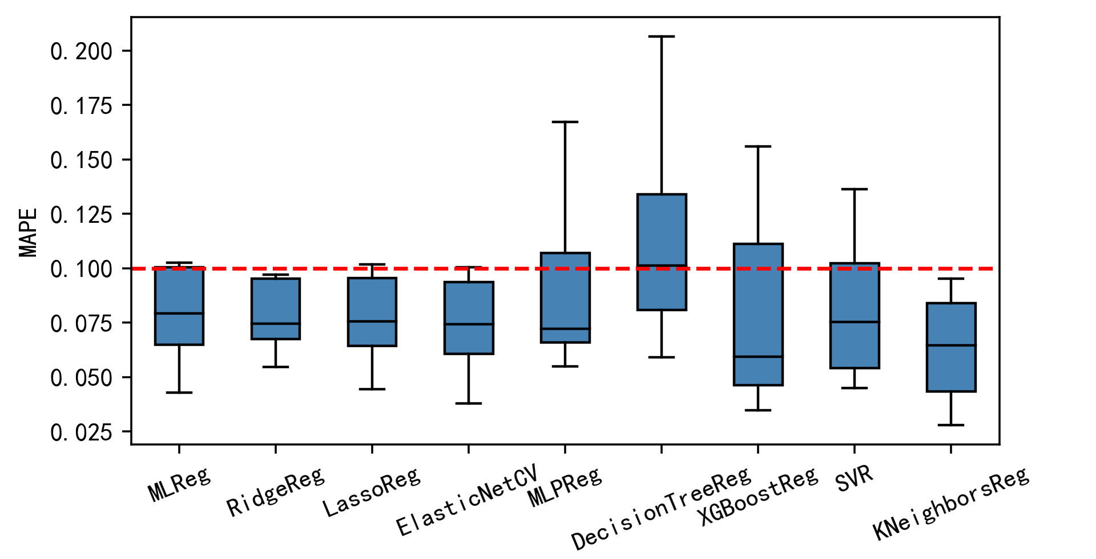

MAPE performance of DDOP prediction model for each city
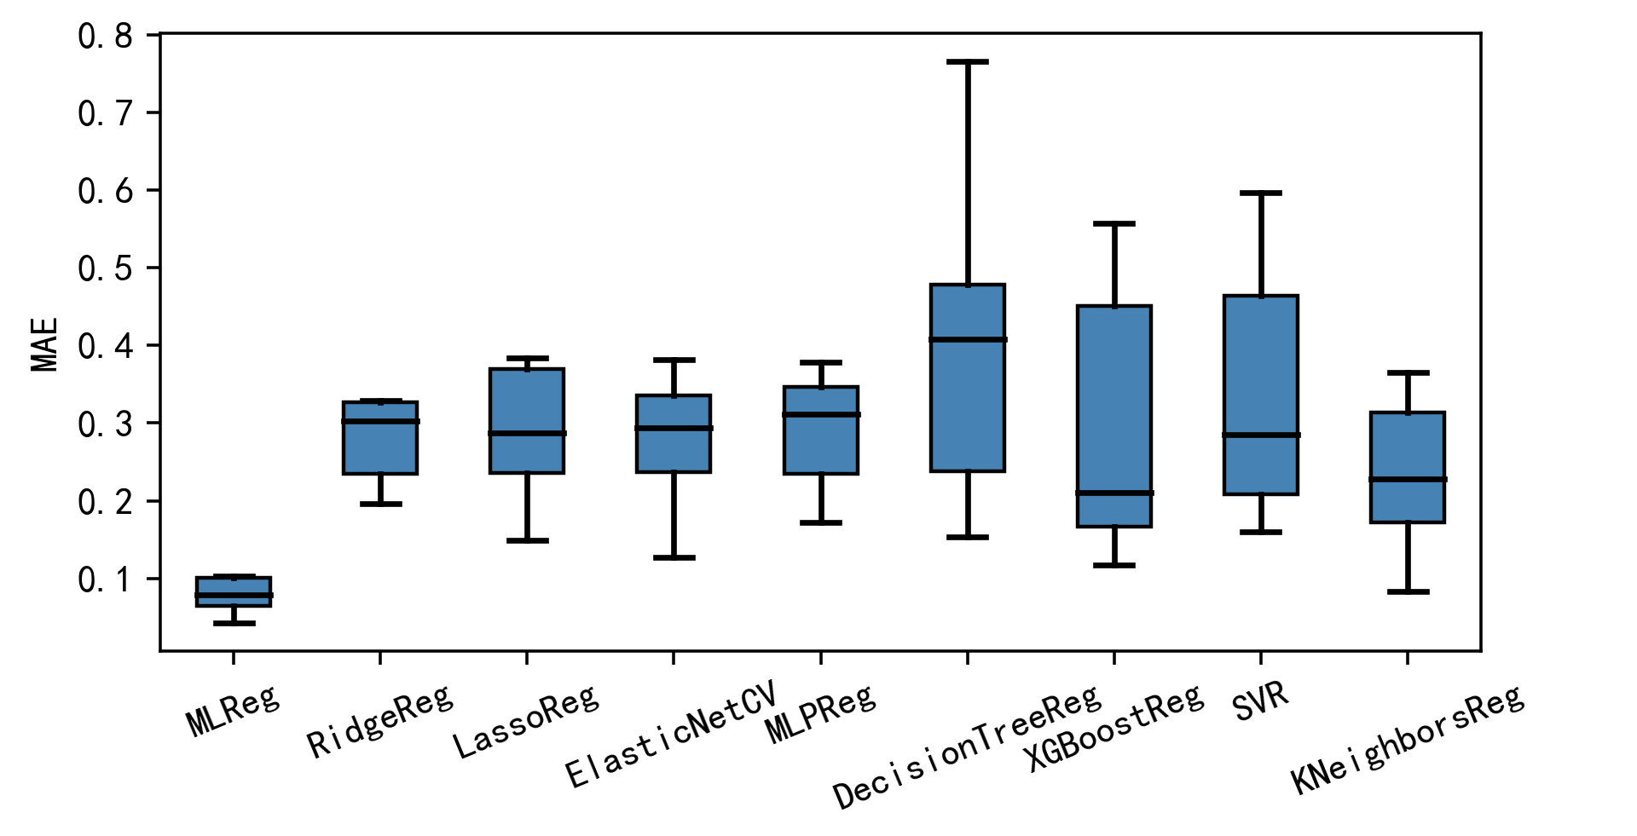

MAE performance of machine learning model for average delivery distance of each city

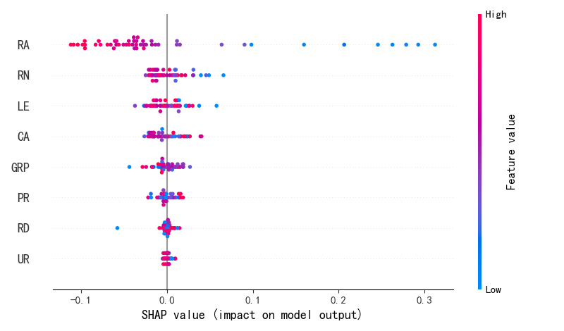

SHAP value for XGBoostReg model parameter
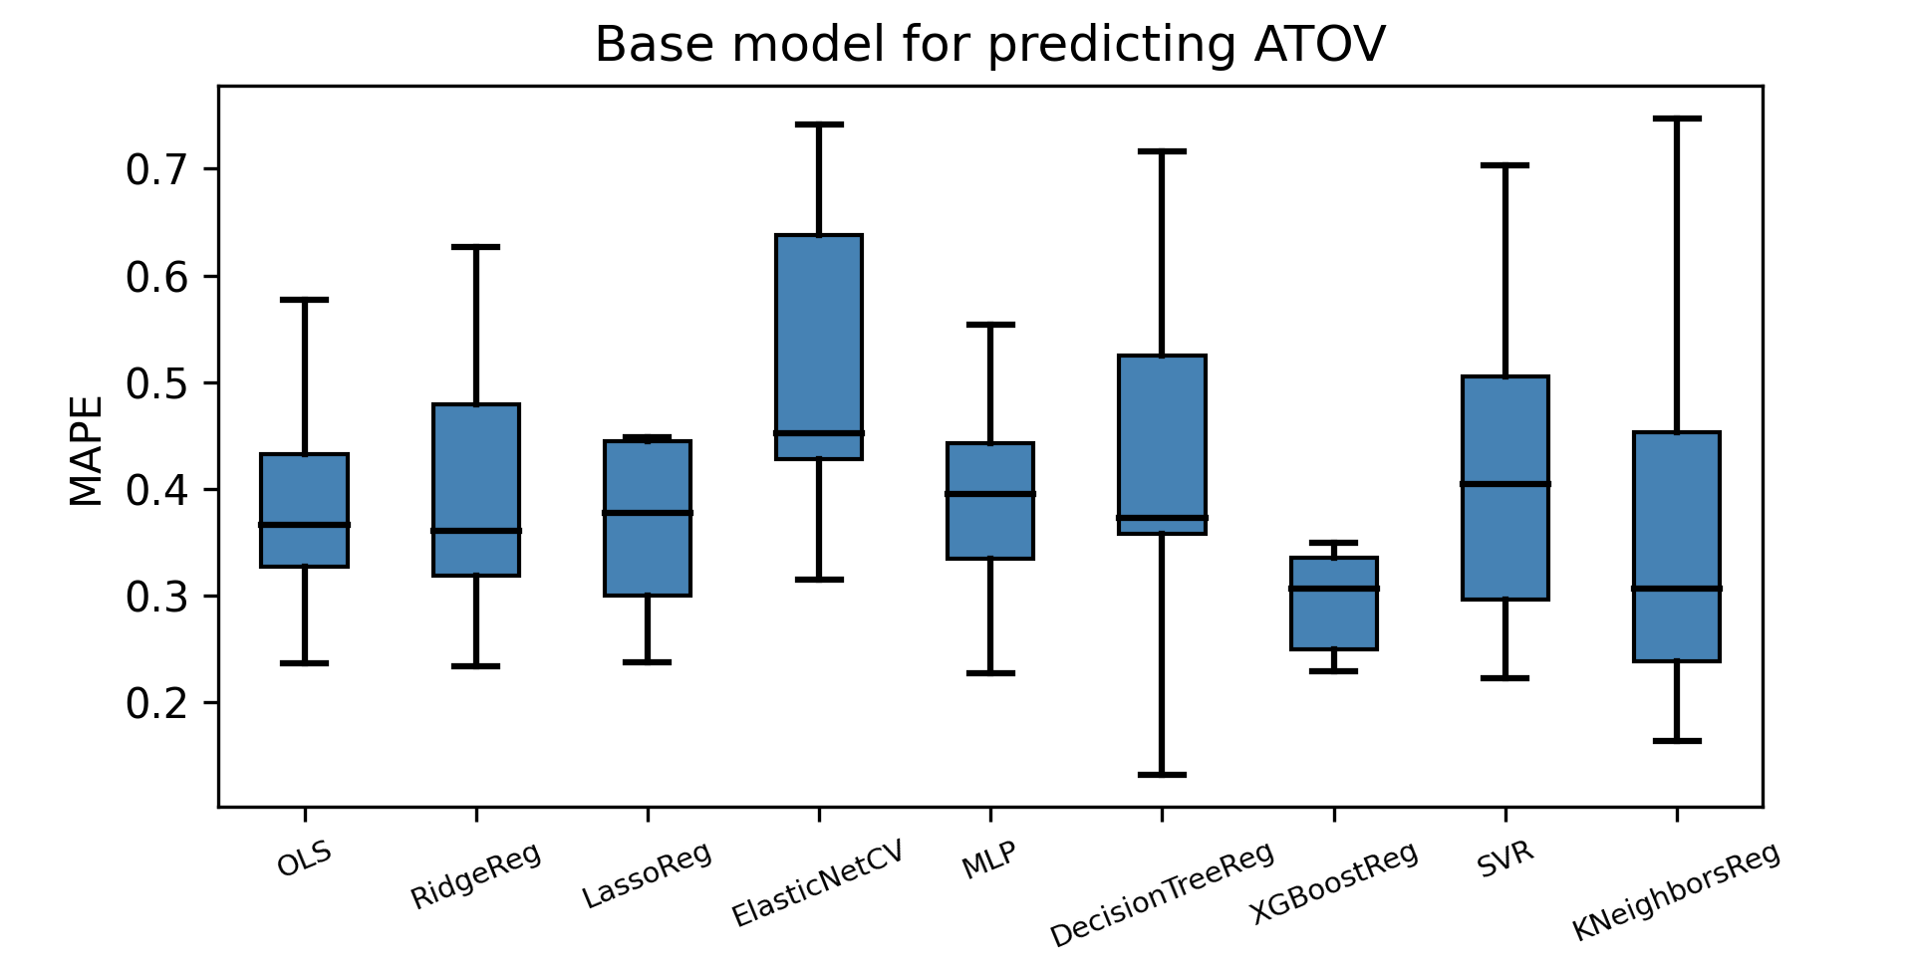

MAPE of base models for predicting ATOV

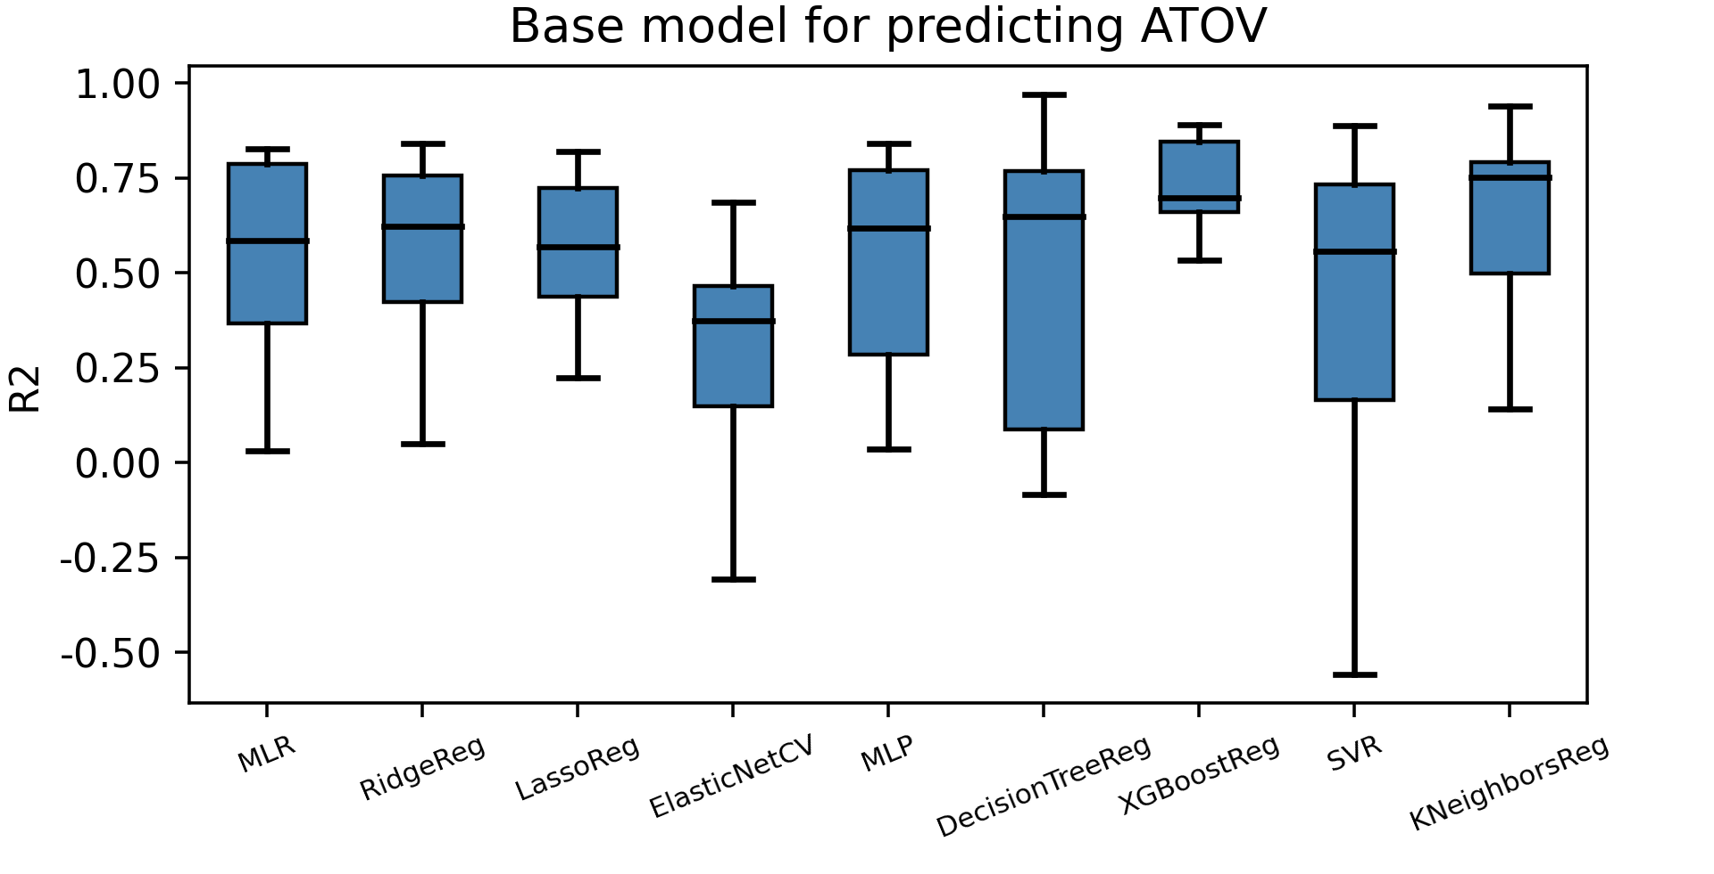

R-squared of base models for predicting ATOV
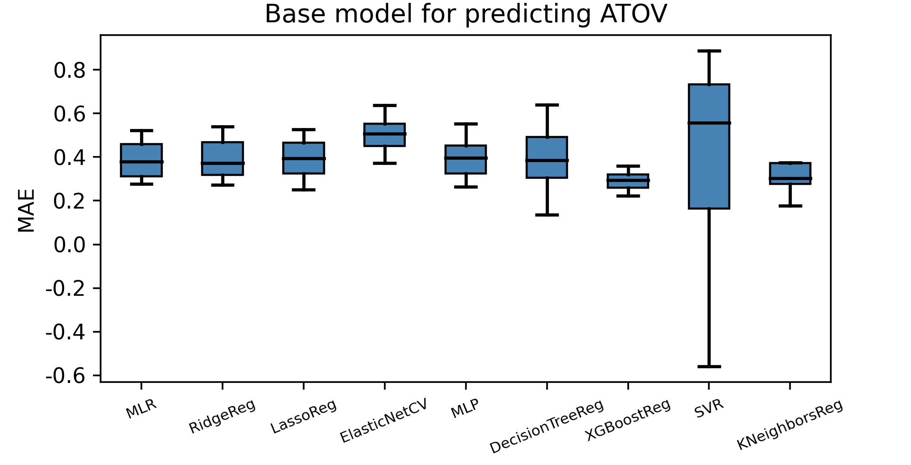

MAE of base models for predicting ATOV

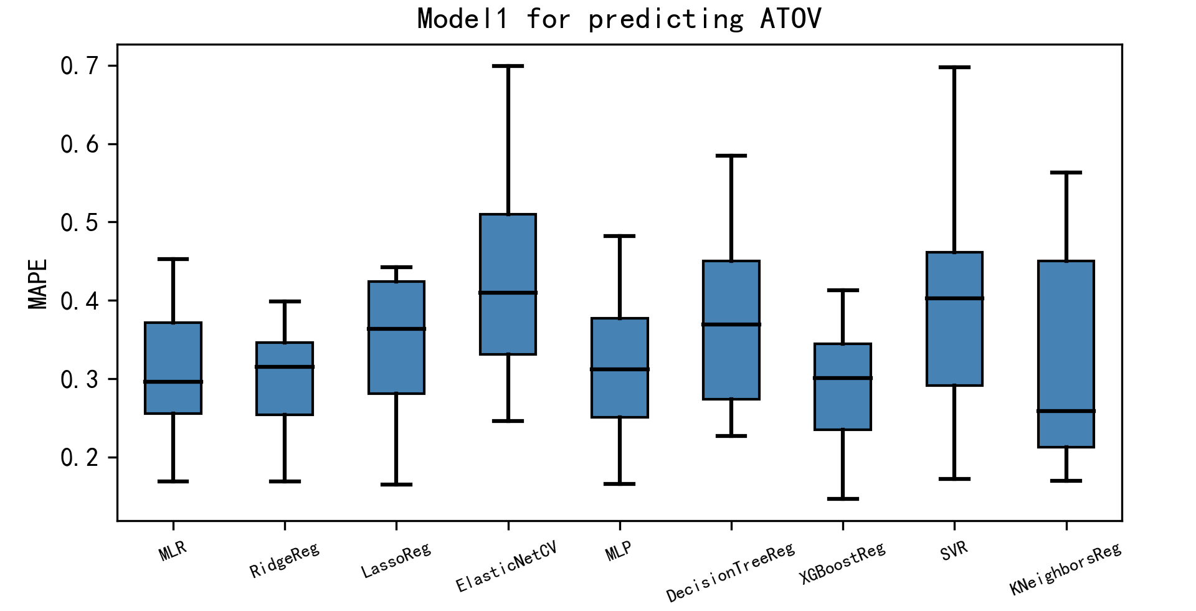

MAPE of model1 for predicting ATOV

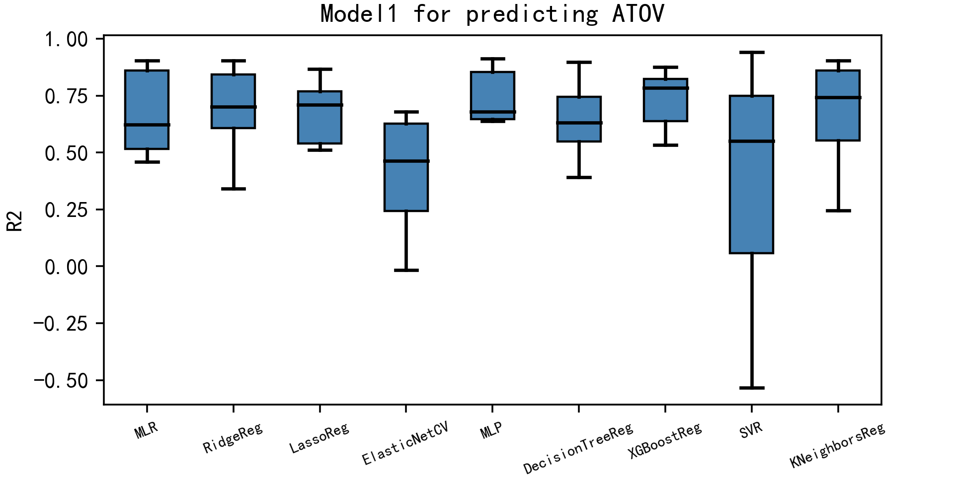

R-squared of model1 for predicting ATOV

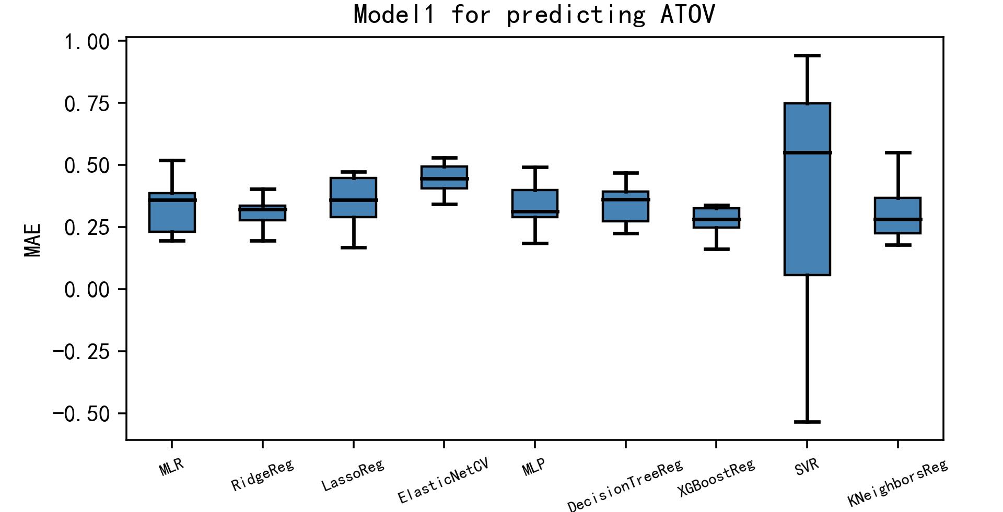

MAE of model1 for predicting ATOV
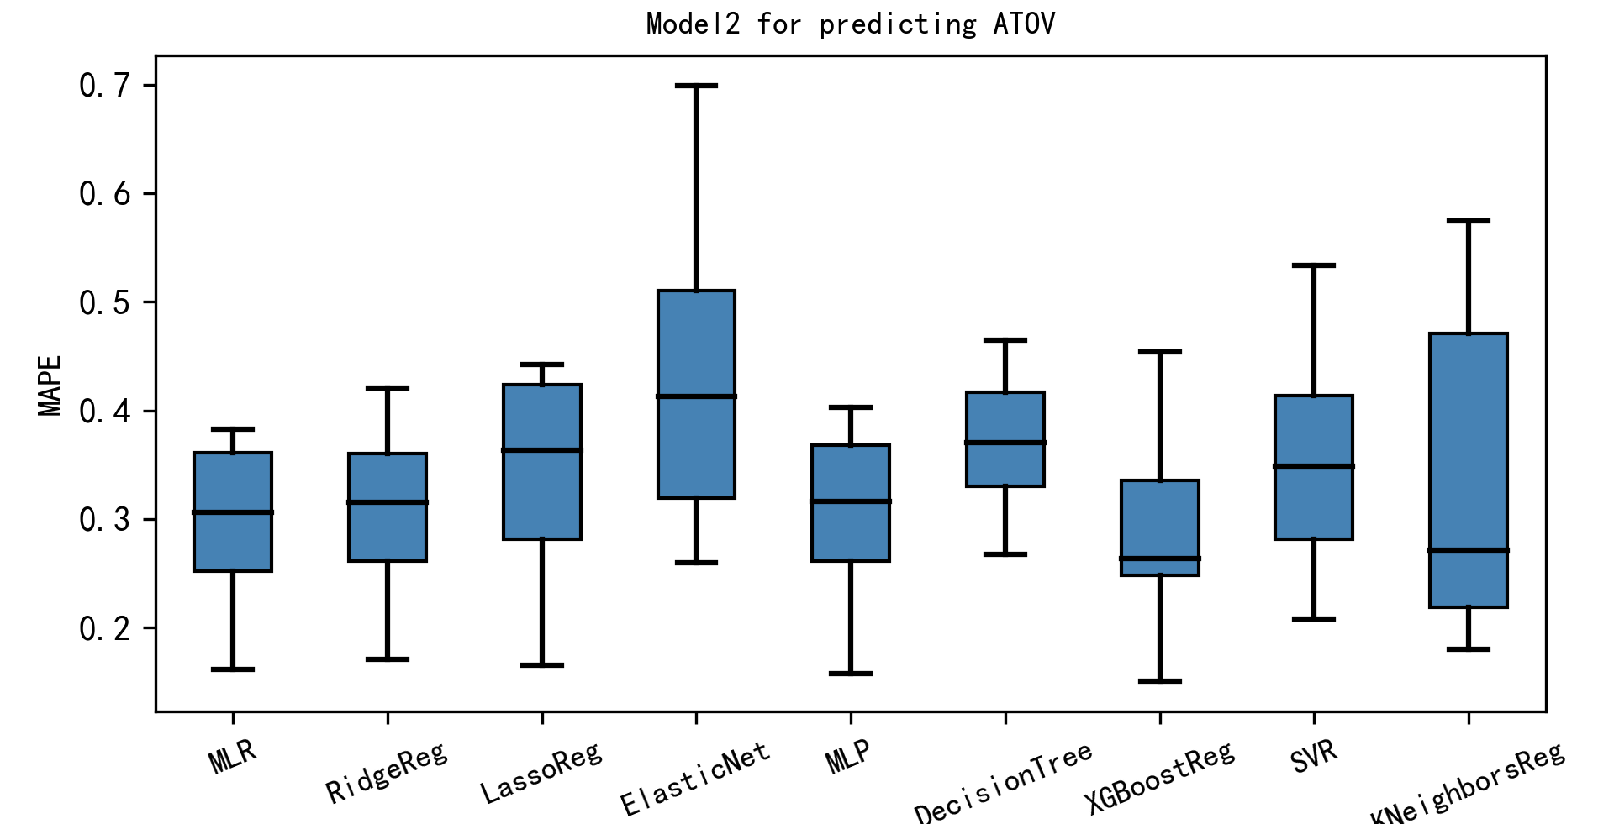

MAPE of model2 for predicting ATOV

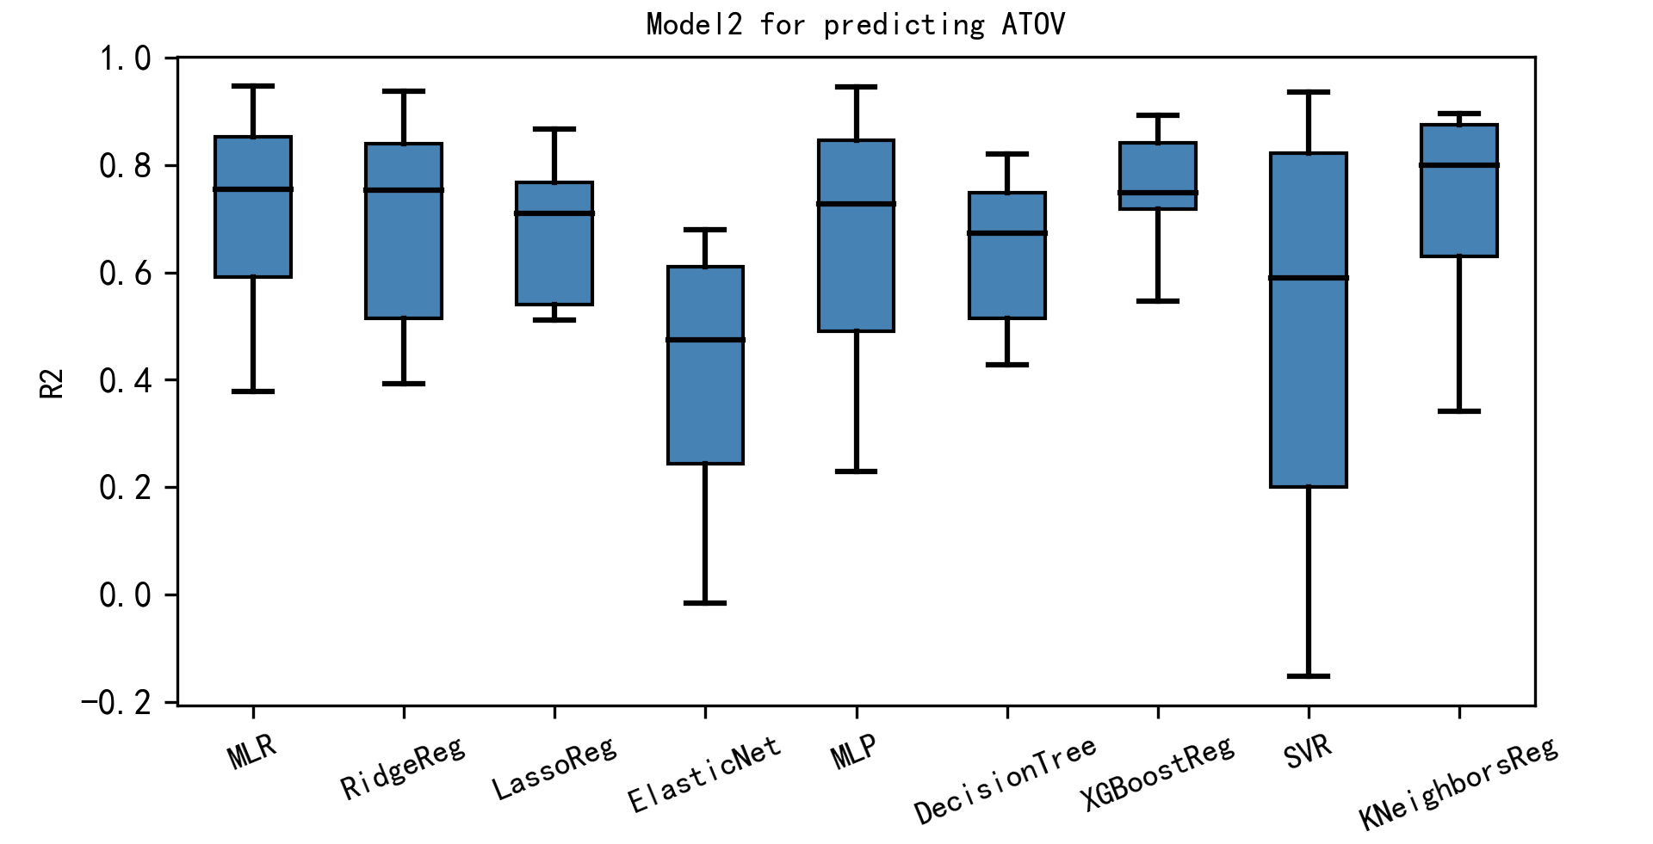

R-squared of model2 for predicting ATOV
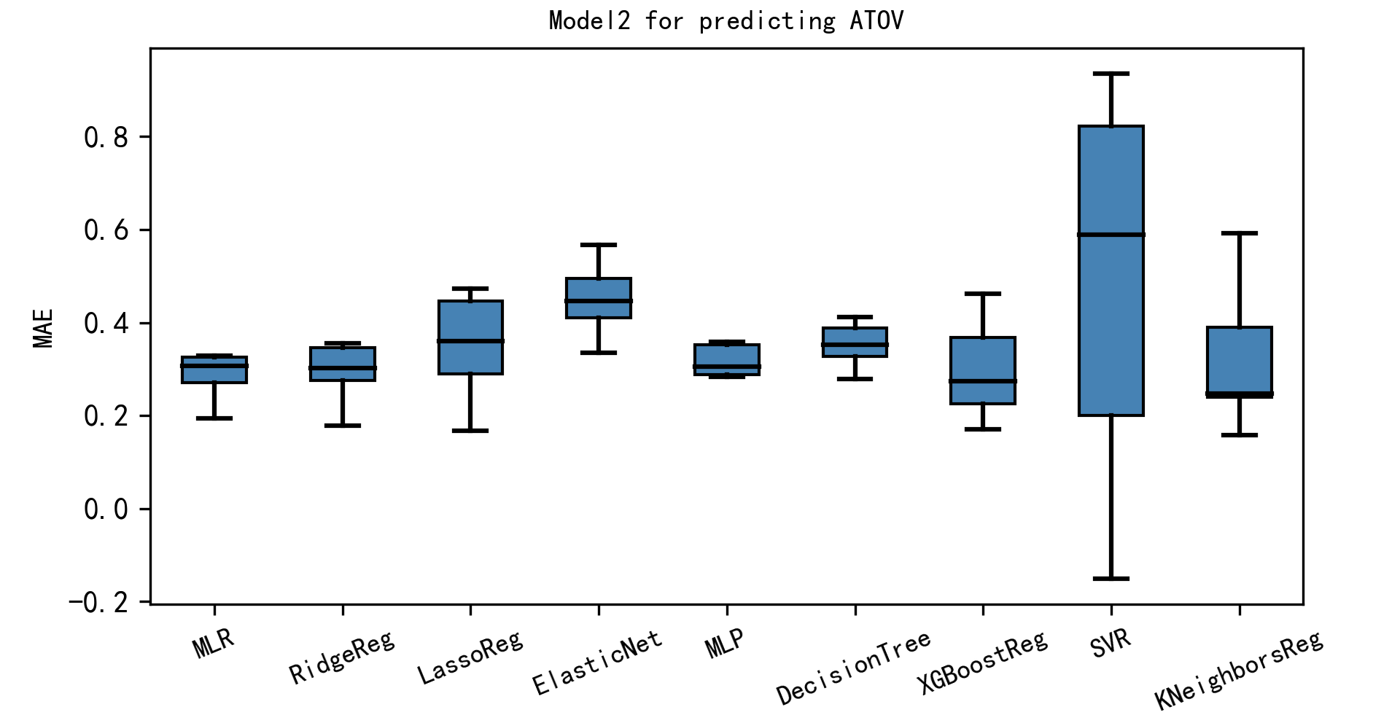

MAE of model2 for predicting ATOV

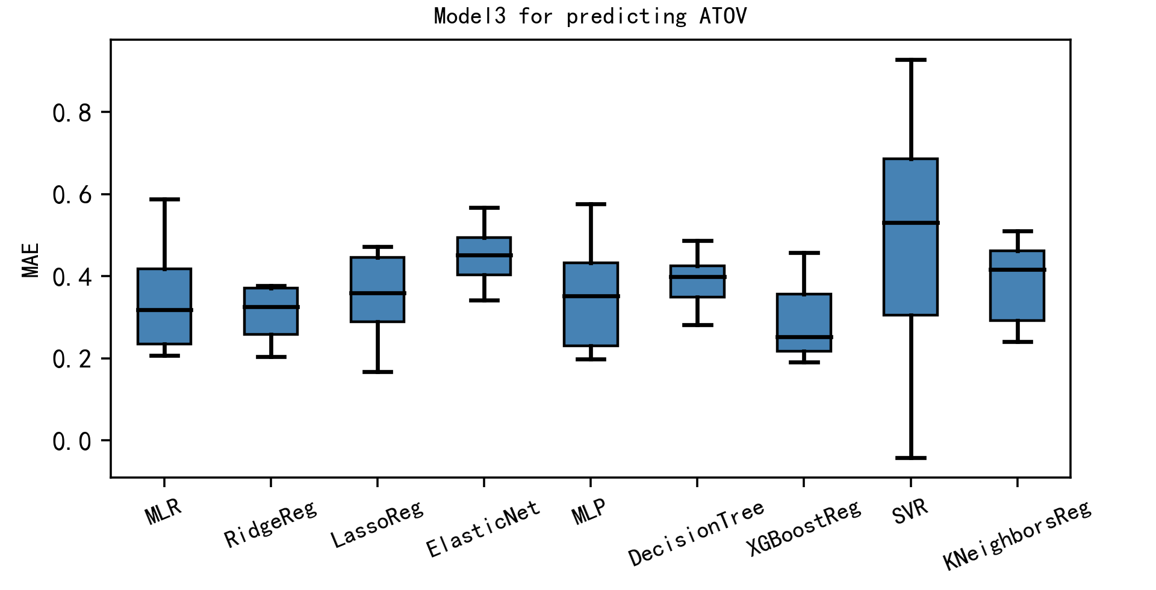

MAE of model3 for predicting ATOV
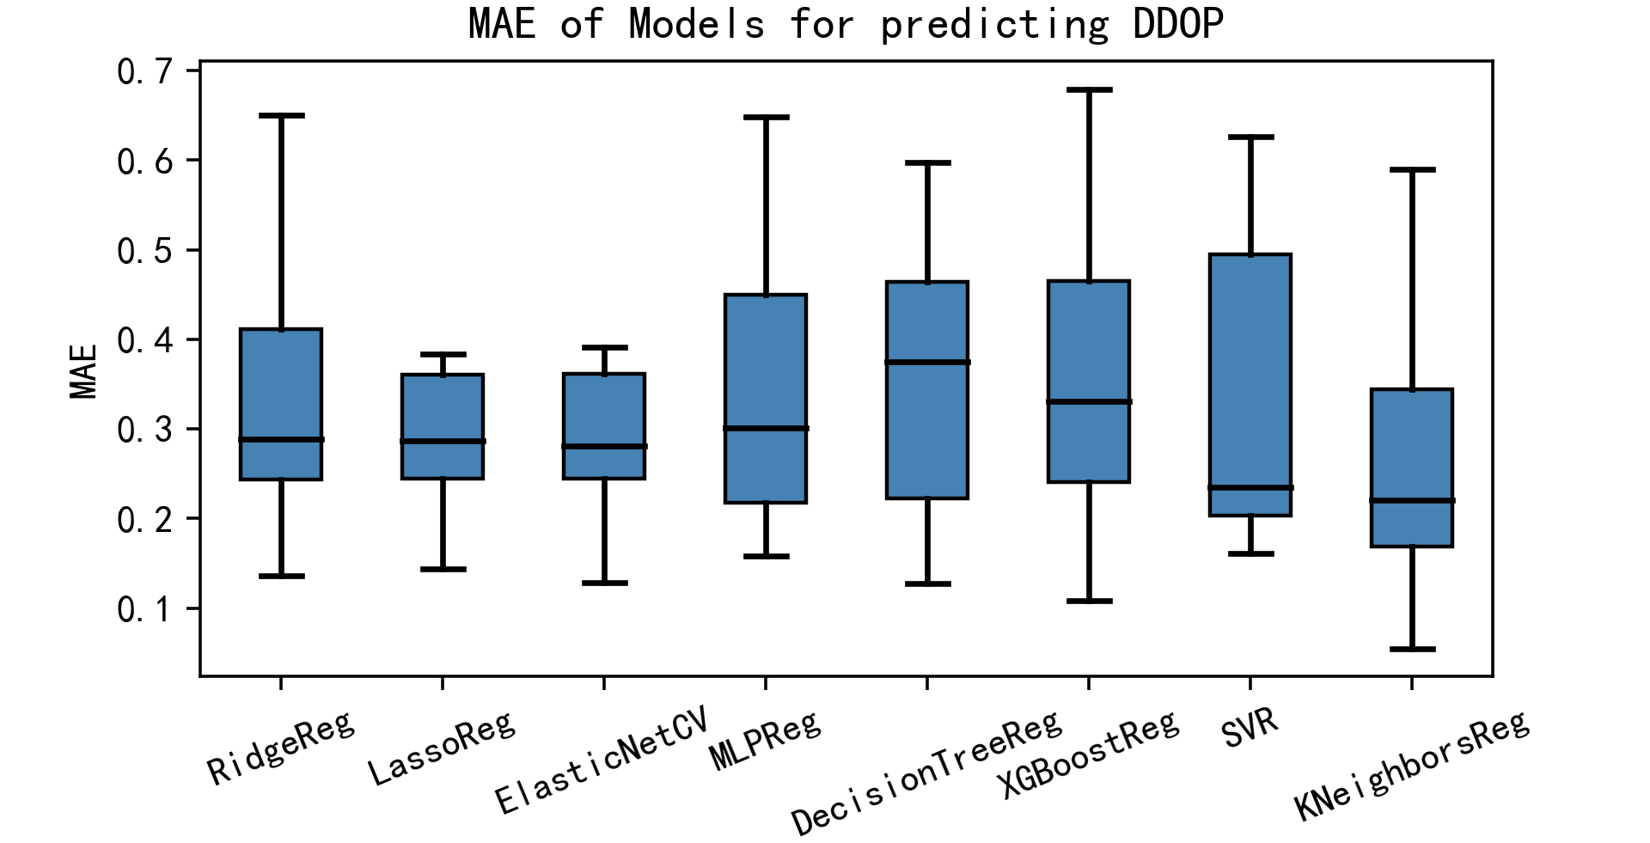

MAE of models for predicting DDOP

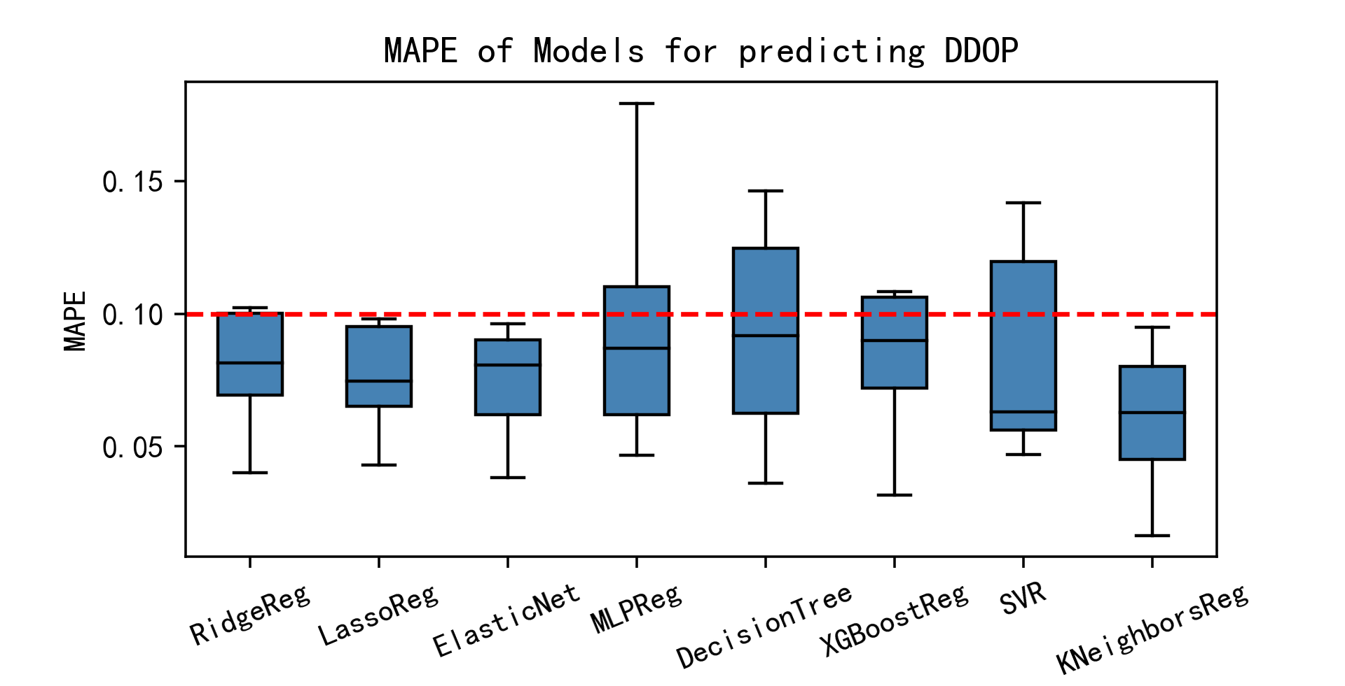

MAPE of models for predicting DDOP

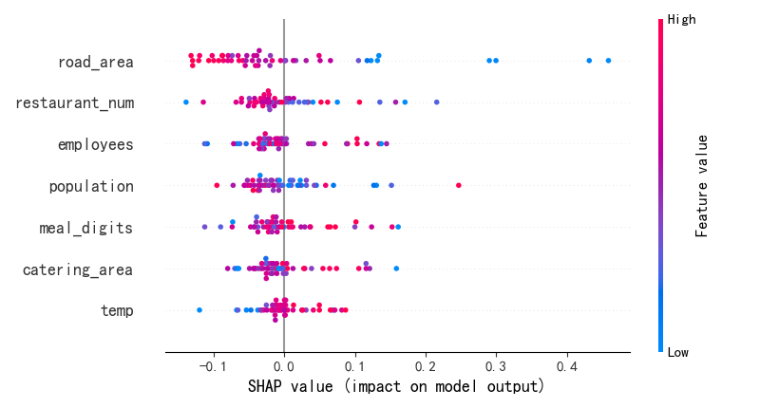

SHAP value of DDOP prediction model (XGBoost)

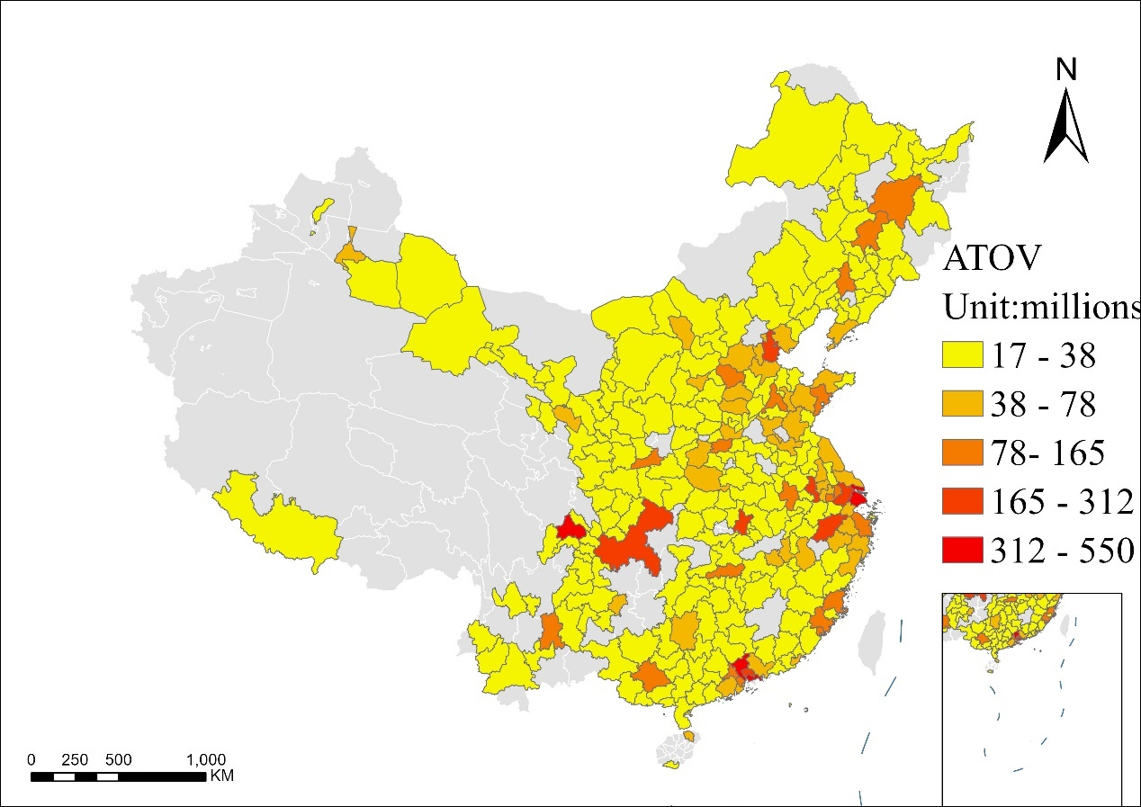

Predicted ATOV map in 270 cities in 2019

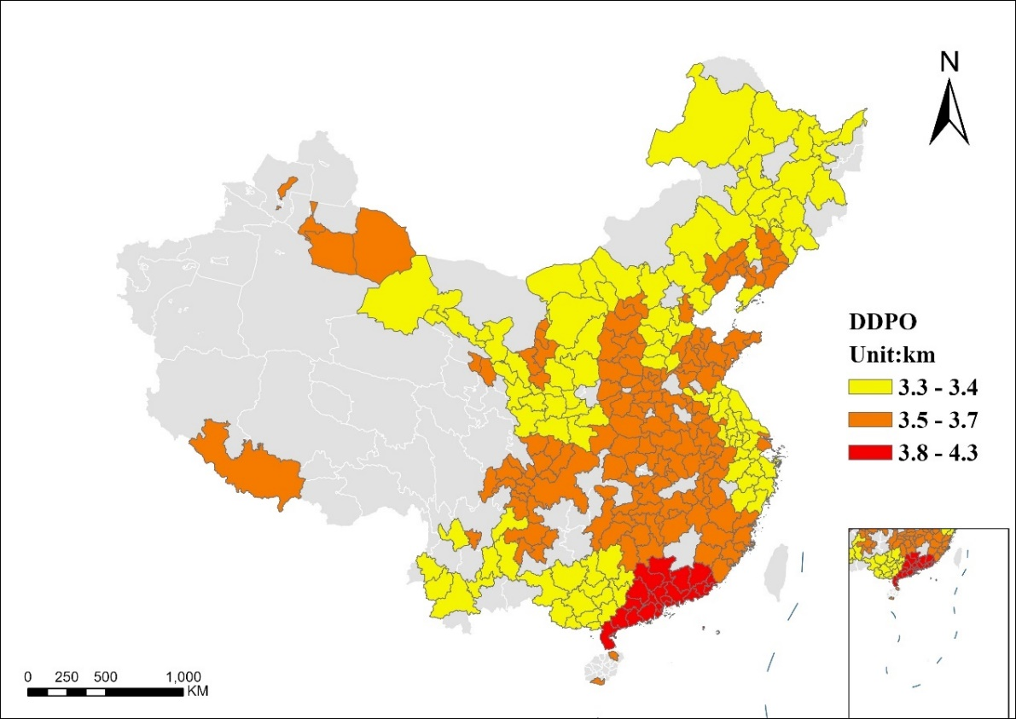

Predicted DDPO map in 270 cities in 2019
Note: The calculated DDPO value is mainly between 3.3-4.3km. Taking into account the non-linear coefficient of public transport lines should not be greater than 1.4¹, the line delivery distance is mainly in the range of 2.2 to 2.8 when converted into linear distance.

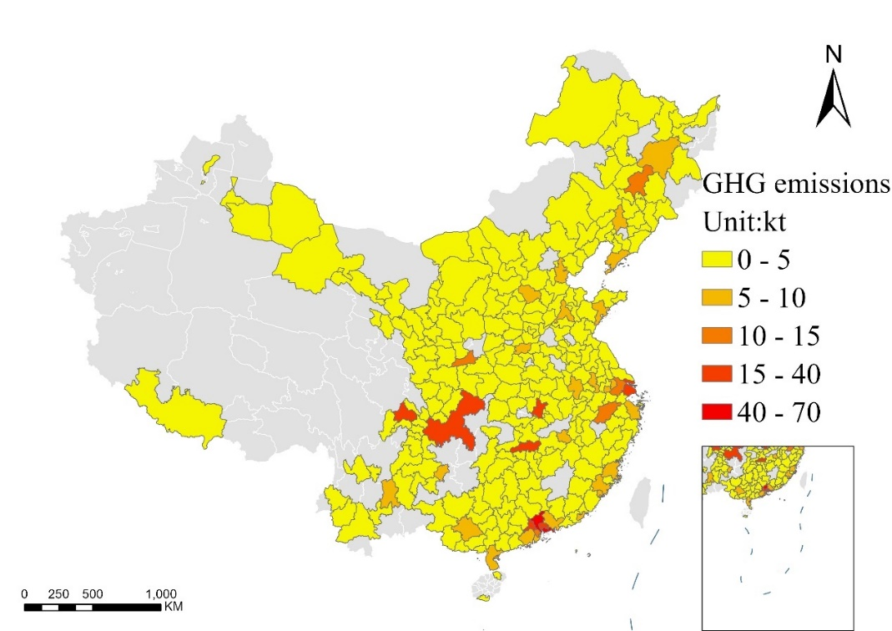

Predicted GHG emissions map in 270 cities in 2019
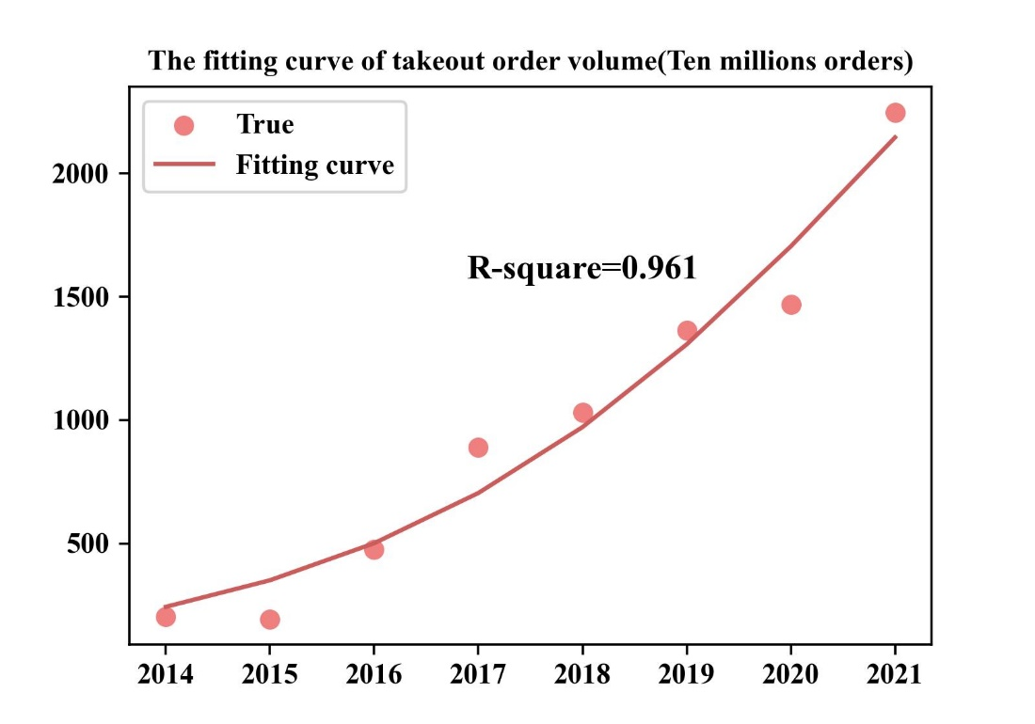

The fitting curving of takeout order volume

a b
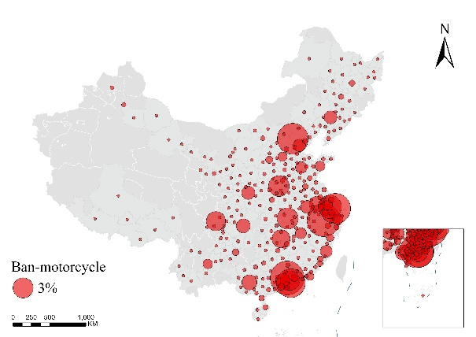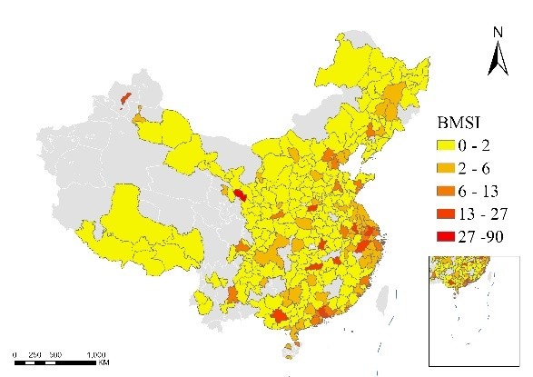

City-level ban-motorcycle search volume and BMSI

a b
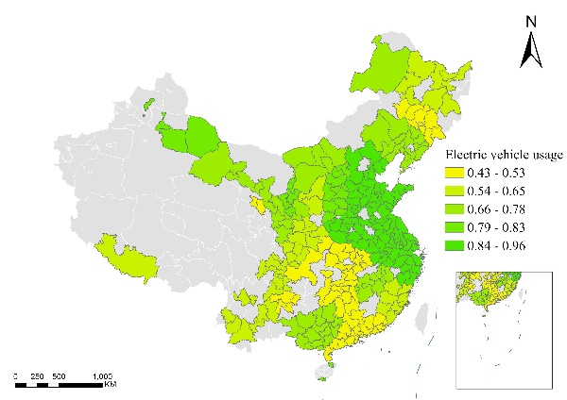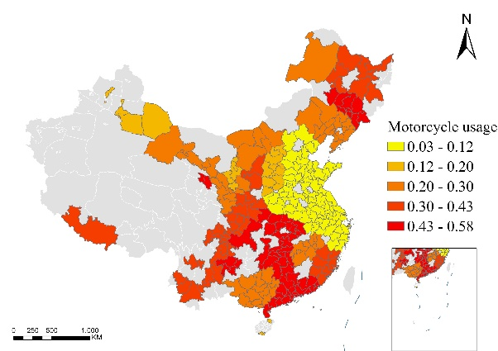
c
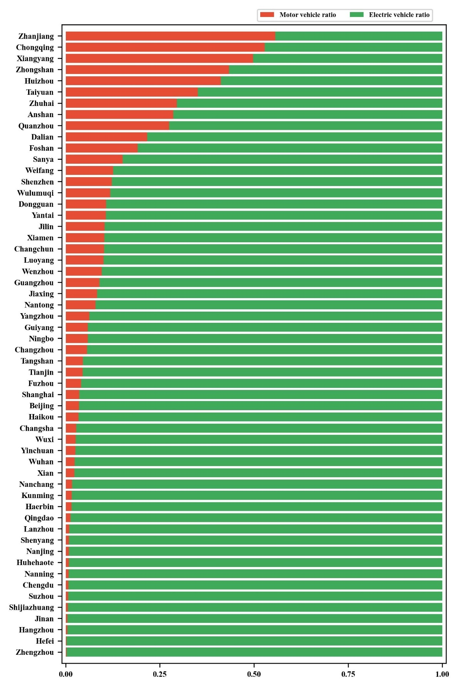

City-level the usage of electric vehicles and motorcycles

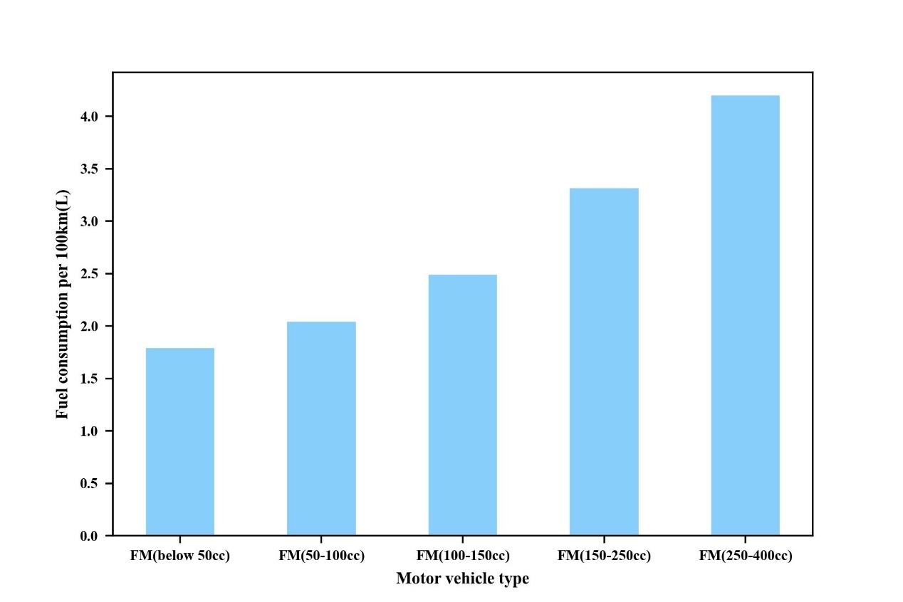

Fuel consumption per 100km for multiple motorcycles
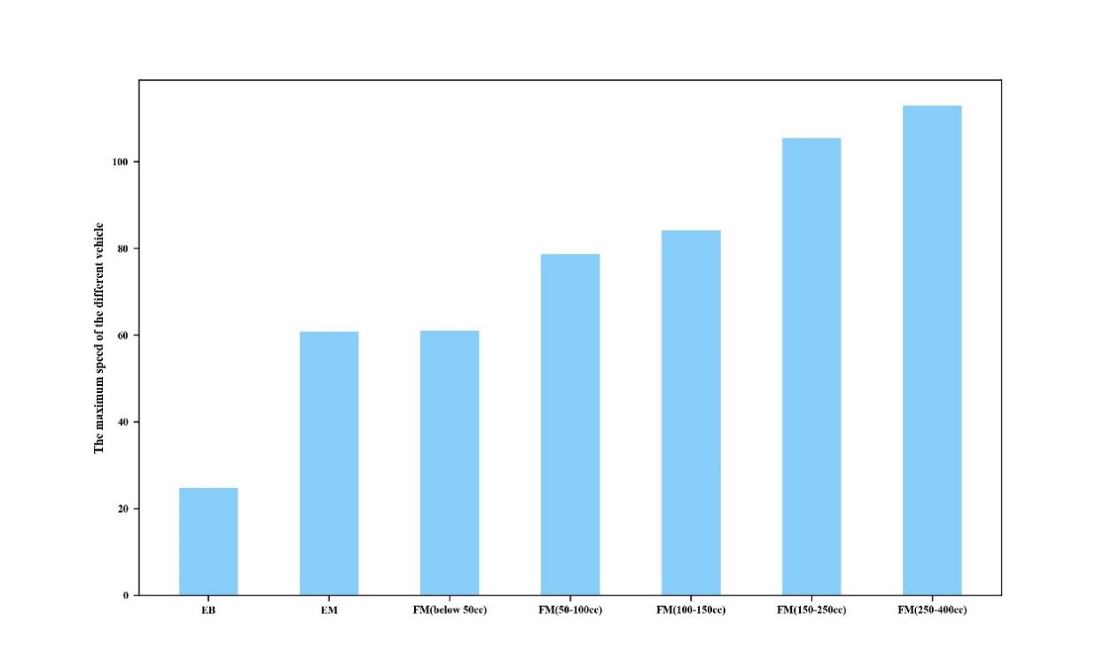

The maximum speed of various vehicles

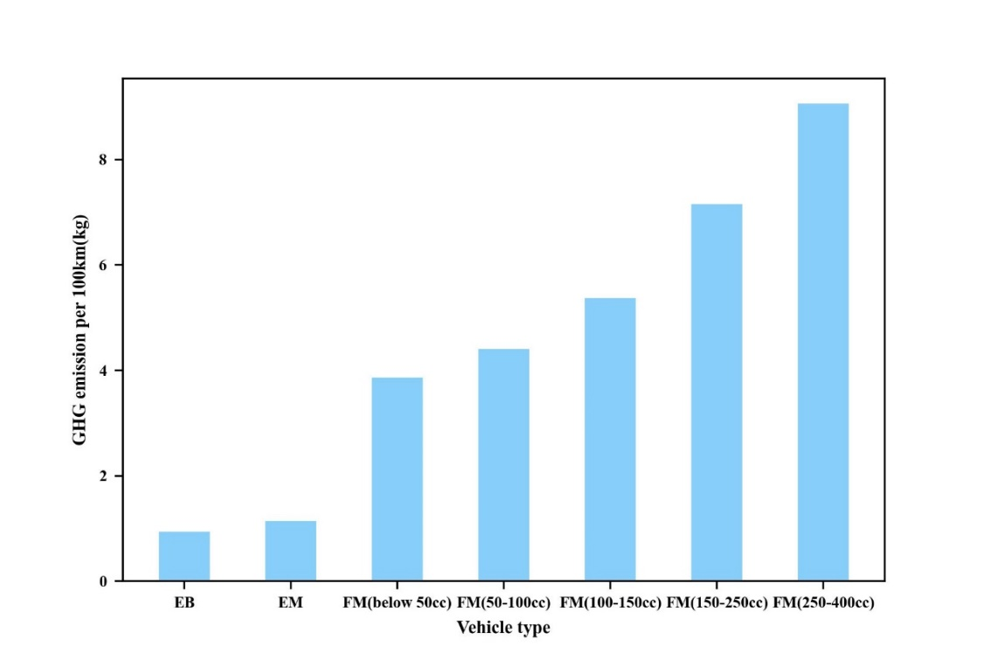

GHG emission per 100km for various vehicles
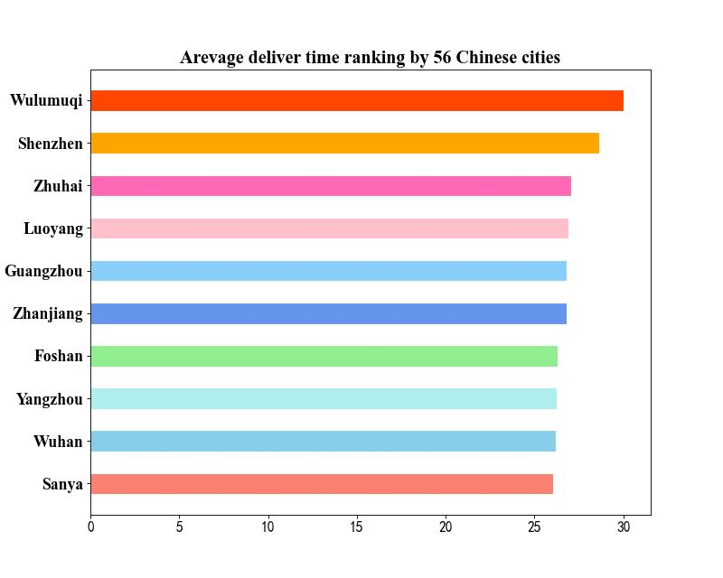

Average delivery time ranking by 56 Chinese cities

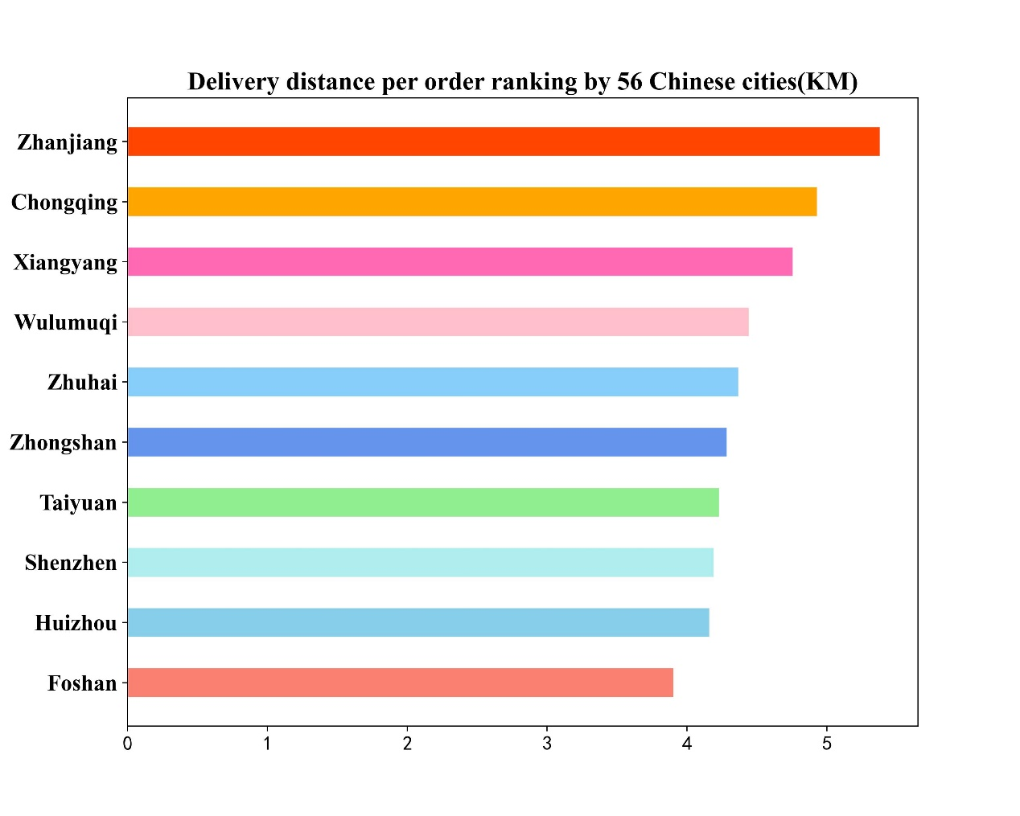

Delivery distance per order ranking by 56 Chinese cities

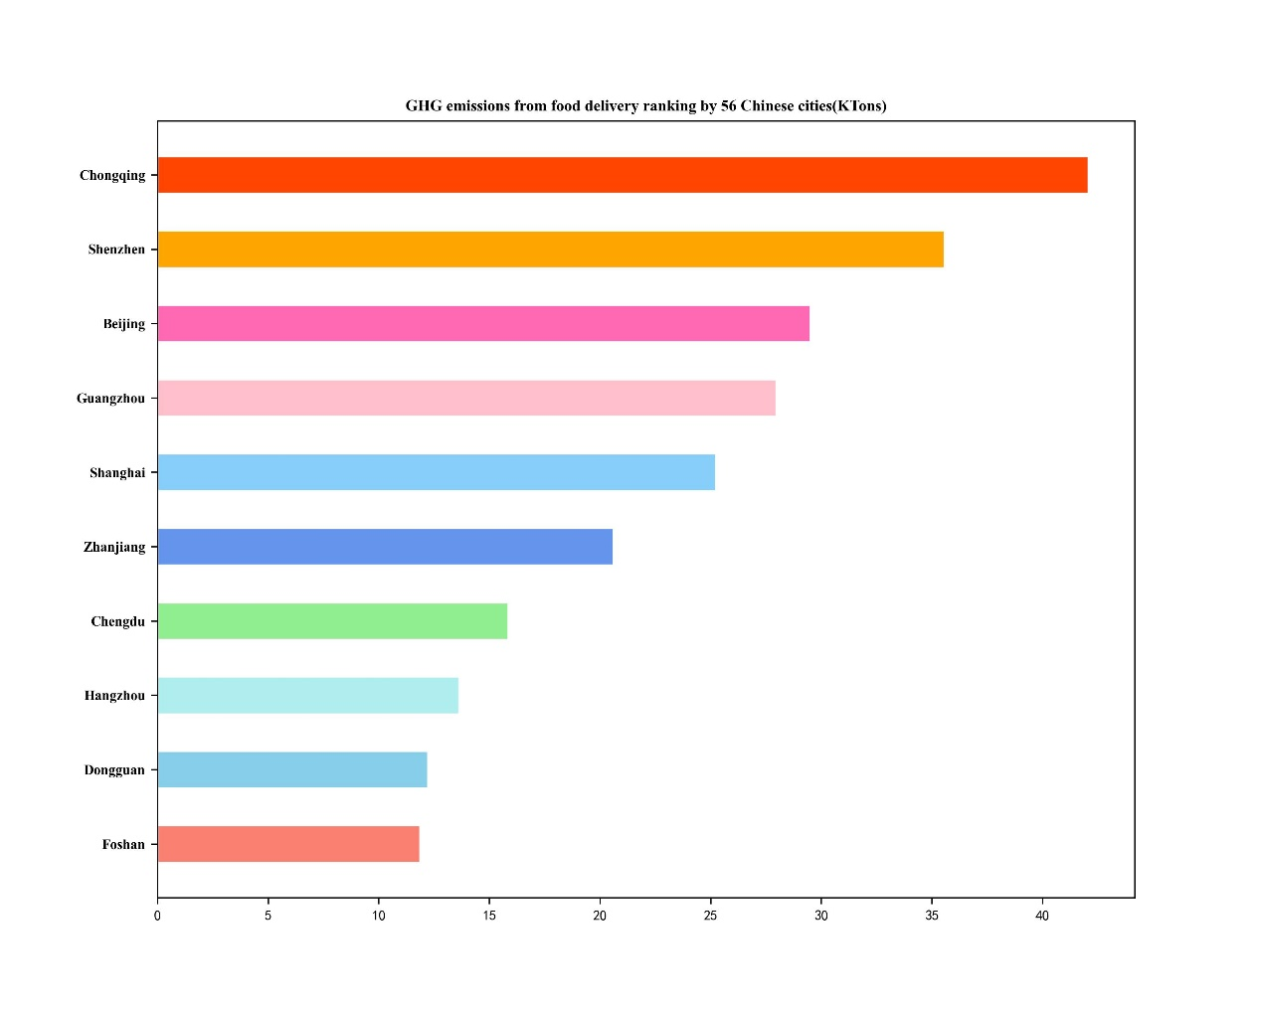

Total GHG emissions from takwaway delivery

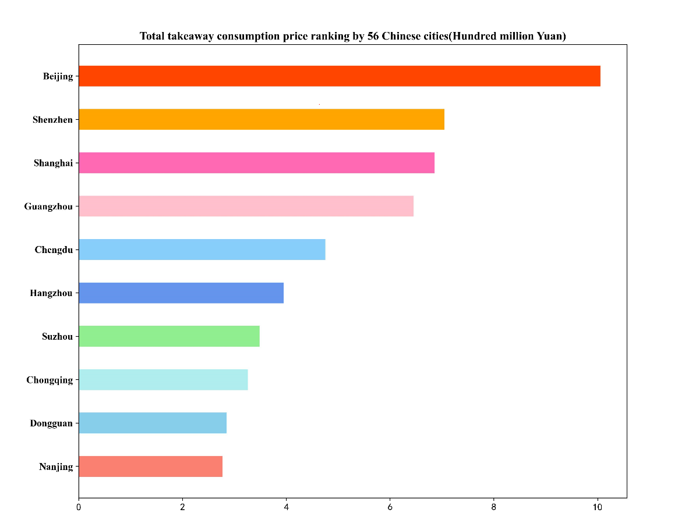

Total takeaway consumption price ranking by 56 Chinese cities(Hundred million Yuan)

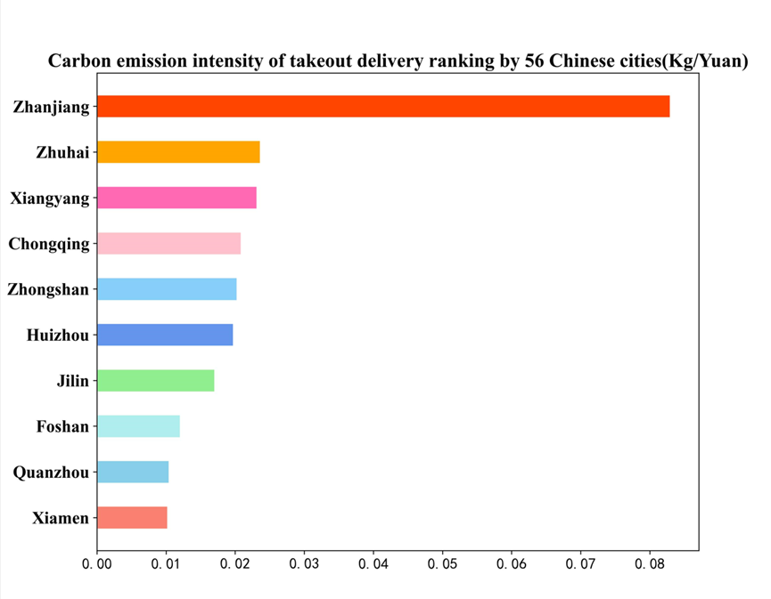

Carbon emission intensity of takeout delivery ranking by 56 Chinese cities(Kg/Yuan)
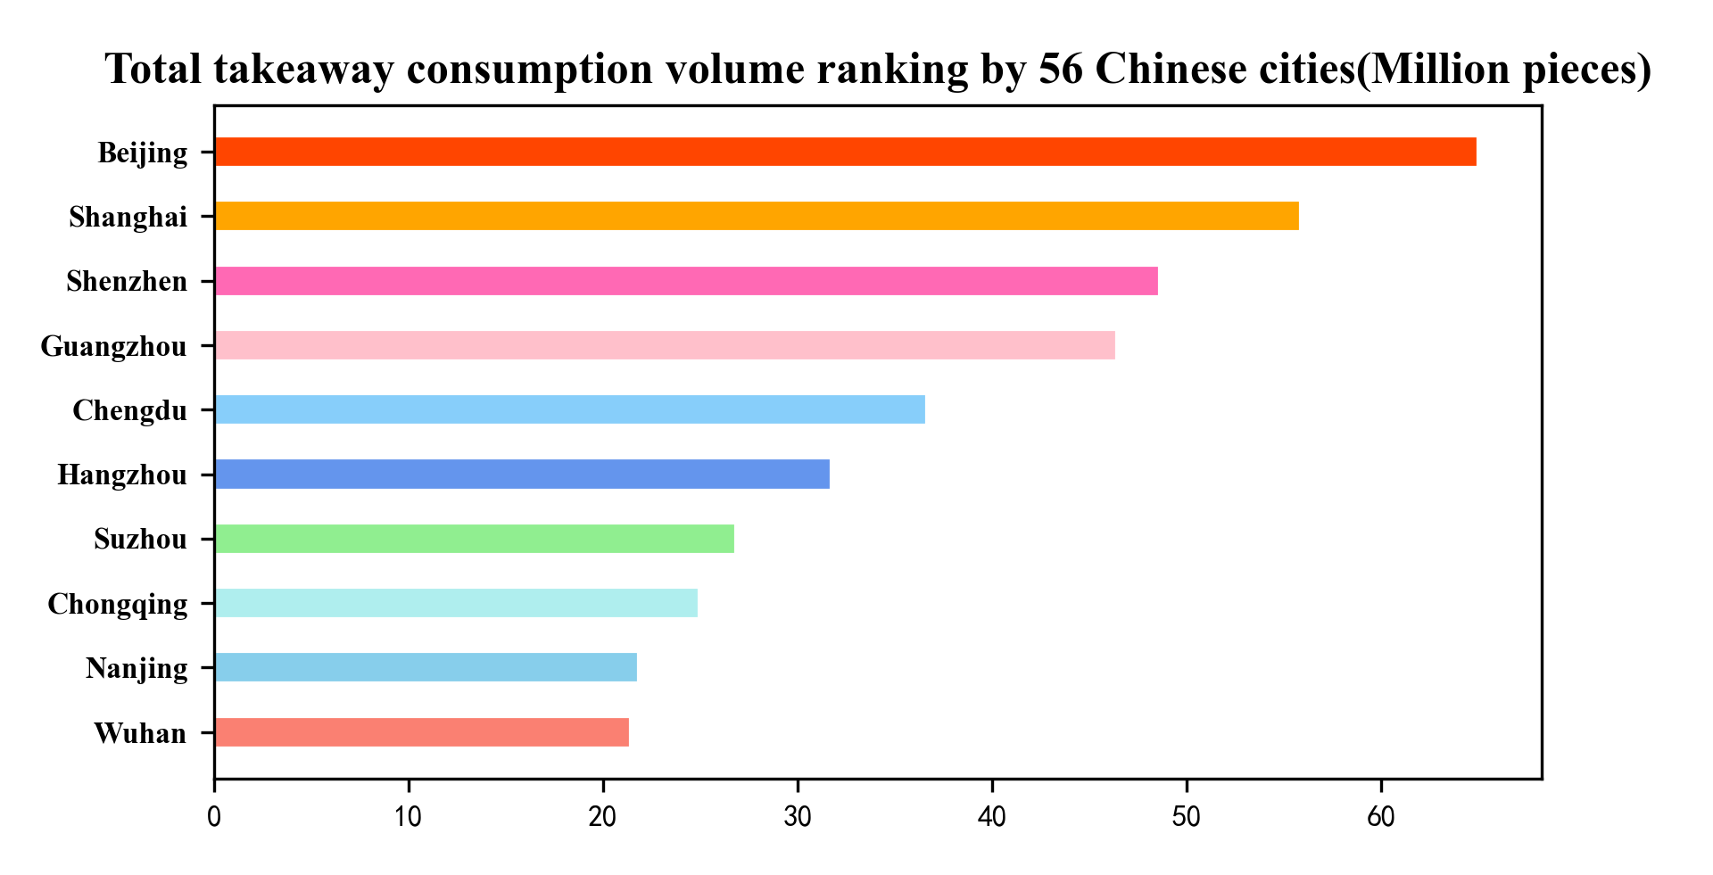

Total takeout order volume ranking by 56 Chinese cities(Million pieces)

- EDT
EDT (Estimated delivery time) is developed by Meituan, which is available on the Meituan App Client. Meituan app uses the positioning information of our location and the information of stores in the surrounding area to infer the delivery time to our location point through machine learning. In the figure below, EDT is circled in red.
The method of data acquisition is to continuously set up a virtual mobile phone location in 56 cities to obtain the EDT of food stores around the location. The virtual mobile phone location points are set up every 3 kilometers.
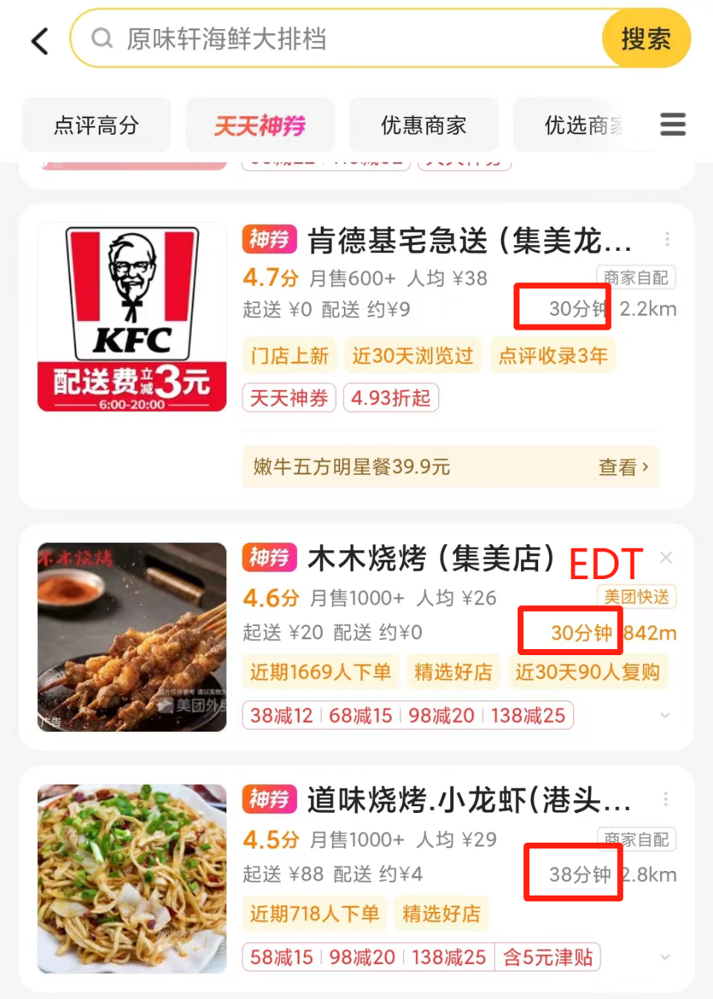
- Estimate of delivery distance per order
In this study, for each food store, EDT per 3KM grid range sampling were used to estimate a month's delivery distance for the restaurant.
To facilitate the estimation of the range of distribution distances, simplified settings are adopted, including the following two points:
- Assume that the spatial distribution of store locations(S) are uniform distribution throughout 3km grid range.
- Assume that the spatial distribution of customer real location for all orders, are uniform distribution throughout 3km grid range.
In the figure below, C is the real location of the consumer, S is Food store or restaurant. Due to the uniform distribution of store locations, S1, S2, S3, S4 can be found, and they form a square with a geometric center that coincides with the center of the circle. L is virtual mobile location.
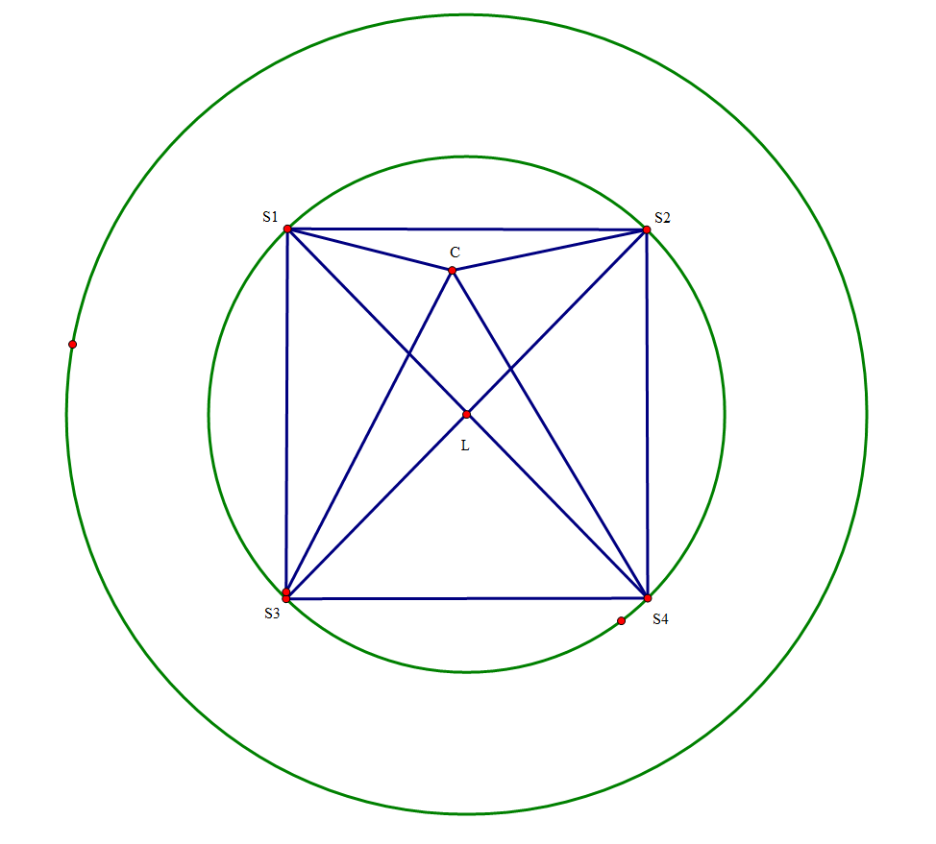
Since the sum of the two sides of the triangle is greater than the third side, we get the following equation:
$$CS_{4}+CS_{1}≥LS_{1}+LS_{4}$$
$$CS_{3}+CS_{2}≥LS_{3}+LS_{2}$$
Addition of two formulas:
$$CS_{3}+CS_{2}+CS_{4}+CS_{1}≥LS_{1}+LS_{4}+LS_{3}+LS_{2}$$
$$\sum_{i}^{4}{LS_{i}}≤\sum_{i}^{4}{CS_{i}}≤\sum_{i}^{4}{LS_{i}}+\sum_{i}^{4}{LC}$$
Take the mathematical expectation of above formula:
$$E\left(\sum_{i}^{4}{LS_{i}}\right)≤E\left(\sum_{i}^{4}{CS_{i}}\right)≤E\left(\sum_{i}^{4}{LS_{i}}\right)+E\left(\sum_{i}^{4}{LC}\right)$$
where $LS_{i}$ is estimated by EDT (i.e. d mentioned in the article), The average of all the $CS_{i}$is average actual delivery straight-line distance (i.e. $\tilde{d}$ mentioned in the article). As follows:
$$4d≤4\tilde{d}≤4d+4E(r)$$
$$r\sim U\left(0,R\right)$$
Since most orders are delivered within 3km^{2, 3} as the straight line, 3km is set to radius R of the circle. Deforming above formula:
$$E\left(r\right)=\frac{0+R}{2}$$
$$d≤\tilde{d}≤d+\frac{R}{2}$$
The median of this interval is used as an estimate of $\tilde{d}$
$$\tilde{d}=d+\frac{R}{4}=d+0.75$$

References
1. Ministry of Construction of the People's Republic of China. Urban road traffic planning and design specifications(in Chinese). https://www.soujianzhu.cn/NormAndRules/NormContent.aspx?id=20. (1995).

2. Xie J, Xu Y, Li H. Environmental impact of express food delivery in China: the role of personal consumption choice. Environ Dev Sustain 23, 8234-8251 (2021).

3. Topsperity Securities.Meituan Research report: Optimization logic and spatial calculation of take-out UE(in Chinese).https://www.vzkoo.com/document/20220611bdc76d128cc14c2375a48cc1.html?keyword=%E5%A4%96%E5%8D%96UE%E7%9A%84%E4%BC%98%E5%8C%96%E9%80%BB%E8%BE%91%E5%8F%8A%E7%A9%BA%E9%97%B4%E6%B5%8B%E7%AE%97., (2022).

