Supplementary Information

“Urban form influences travel distances, car ownership, and mode choice: Evidence from 19 European cities”
Peter Berrill^{1,2}, Aneeque Javaid^{2.3}, Nikola Milojevic-Dupont^{1,2}, Florian Nachtigall^{1,2}, Felix Wagner^{1,2}, Felix Creutzig^{1,2}
¹Sustainability Economics of Human Settlements, Technische Universität Berlin, Berlin, Germany
²Land Use, Infrastructure and Transport Working Group, Mercator Research Institute on Global Commons and Climate Change, Berlin, Germany
³International Institute for Applied Systems Analysis, Laxenburg, Austria

Summary literature review
Table S1 summarizes relevant literature which use Gradient Boosting Decision Tree (GBDT) models to investigate influences of urban form on urban mobility indicators. Machine learning (ML) models are a recent addition to the suite of tools used to predict and understand urban mobility patterns and emissions. There are wide variations in how they are designed and applied, hindering the comparability of different studies. In a comprehensive review of ML models of mode choice, Hillel et al (2021) identify current limitations and generate recommendations for future models, on topics including sampling methods, model validation and measures of performance, and reducing model bias. GBDTs are perhaps the most widely ML model in studies relating urban form and urban mobility. They have been used (occasionally alongside other model types) to investigate urban forms influence on car ownership in Beijing (Zhang et al., 2020), mode choice in the Netherlands (Hagenauer & Helbich, 2017), Delaware valley (Wang & Ross, 2018), Xiamen (Liu et al., 2021), Seoul (Kim, 2021), and Beijing (Ding et al., 2022), driving distance in Olso (Ding et al., 2018), Berlin (Wagner et al., 2022), and Stavanger (Tao & Næss, 2022), transit ridership in the Washington DC metro area (Ding et al., 2019), and mobility related CO₂ emissions in Minneapolis-St. Paul (Wu et al., 2019). Common findings among these models include a high importance of distance to center for travel distance, mode choice, and mobility emissions, various other measures of accessibility across all target variables, and travel distance for mode choice.
Table S1, Summary of literature using GBDT models to investigate influence of urban form on urban mobility and emissions
Authors | Location | Model(s) | Target variable | Important predictors
Hagenauer & Helbich (2017) | Netherlands | MNL, NB, GBDT, SVM, RF, Bagging | Trip mode choice | Density, mainly for transit trips. Trip distance is by far the most important variable
Ding et al (2018) | Oslo | GBDT | Non-work driving distance | Distance to center, population density, distance to sub-centers
Wang Ross (2018) | Delaware Valley | MNL, GBDT | Trip mode choice | Car ownership, bus stop density. Travel time and distance are the most important variables
Wu et al (2019) | Minneapolis St. Paul | GBDT | Average daily co2/cap from mobility | Land-use mix, job density, distance to center, population density, distance to transit
Ding et al (2019) | Washington metro | GBDT | Passengers/day per metrorail station | Car ownership, bus stop density, employment and population density, land-use mix
Zhang (2020) | Beijing | GBDT | Car ownership (continuous), number of cars per household | Local accessibility measured by retail/service/job density. Otherwise, household income and size, and householder age are very important.
Liu (2021) | Xiamen | GBDT | Trip mode choice is active (dummy) | House area, bus stop density, population density, distance to center, land-use mix. Trip distance is the most important variable
Kim (2021) | Seoul | GBDT, RF, ANN | Tour mode choice | Land-use at destination, job and population density. Age is the most important variable overall. Travel time and activity duration are very important. Education is important for renters but not for owners.
Ding et al (2022) | Beijing | GBDT | Trip mode choice = transit (dummy) | Street intersection density, bus stop density, employment density, and distance to center
Wagner et al (2022) | Berlin | GBDT | average commuting (trip) distance by car | Distance to center, distance to sub-centers, land-use at origin and destination
Tao Naess (2022) | Stavanger | GBDT | Weekly driving distance per person | Distance to city center. Distance to sub-centers and job and population densities have smaller importance. Income, gender, and age are other important variables.
GBDT: Gradient Boosting Decision Tree, MNL: Multinomial logistic regression, NB: Naïve Bayesian, SVM: Support Vector Machine, RF: Random Forest, ANN: Artificial Neural Network

Spatial boundaries of cities
Spatial extents for German cities are restricted to official administrative city boundaries, as only households within those city boundaries were surveyed. The source data for Wien is a mobility survey for all of Austria (Tomschy, R. et al., 2016). We defined the spatial extent of Wien as the federal state of Wien plus several municipalities from the federal state of Lower Austria which are within 12.5 km of Wien city center. Surveys in French cities and Madrid covered the wider metropolitan areas, and so decisions were required in each case on where to draw the boundaries of analysis.
For Clermont, we limit the boundaries to the urban public transport perimeter (Périmètre des Transports Urbains, Syndicat Mixte des Transports en Commun) (SMTC de l’agglomération clermontoise, 2013), equivalent to the 21 communes of Clermont Communauté which existed until 2018. For Dijon, we restrict to the Ville de Dijon and Grand Dijon hypercentre. For Lille, we restrict to the ‘Métropole Européenne de Lille’, which covers the French part of the Eurometropole, and includes also the satellite cities of Tourcoing and Roubaix (Métropole Européenne de Lille, 2017). For Lyon, we restrict to the two survey districts including and closely surrounding the center of Lyon: Lyon – Villeurbanne, and Grand Lyon Hors Centre. For Montpellier, we restrict to the 'Montpellier Agglomération', which was in 2015 replaced by the Montpellier Méditerranée Métropole. For Nantes, we restrict to Nantes Metropole. For Nimes, we restrict to the commune boundary. Nimes is thus the smallest city in our study both by area and population. Extending to the ‘Communauté d'agglomération Nîmes Métropole’ would have been possible, but this would have resulted in including very sparsely populated areas surrounding the city. For Toulouse, we restrict to the city of Toulouse and the near periphery, the two central districts shown in the survey documentation (Tisséo-SMTC, 2013). We define the boundary of Paris as the ‘Métropole du Grand Paris’, which consists of the city of Paris, the entire surrounding departments of Hauts-de-Seine, Seine-Saint-Denis, and Vale-de-Marne, plus seven further communes in the departments of Essonne and Val-d'Oise.
For Madrid, we consider the municipality of Madrid, and the following surrounding municipalities which include high density agglomerations: Alcorcón, Leganés, Getafe, Móstoles, Fuenlabrada, Coslada, Alcobendas, Pozuelo de Alarcón, San Fernando de Henares, Torrejon de Ardoz,Parla, Alcala de Henares,Las Rozas de Madrid,San Sebastian de los Reyes,Rivas, Majadahonda.
Table S2 provides summary descriptions (count, mean, and standard deviation of the area) of the spatial units used for each city. The administrative unit used for calculating urban form features, and locating the residence of the households, trip origin and trip destination varies by the spatial specifications of each survey. For Germany, the 5-digit postcodes were used. For Vienna, the 5-digit municipality IDs were used. For Paris, 5-digit INSEE codes were used. For other French cities, mixed resolution custom units are defined for each survey, based on the procedure described in the Data section of the main text (all lower resolution spatial units larger than 10km² were disaggregated into their constituent smaller units, if available). Figure S1 demonstrates the custom spatial unit definition for Madrid and Dijon.

Table S2, Number of low- and high-resolution administrative units and the mean and standard deviation of their area
City | Low-res units |  | High-res units |  | Mixed-res units
 | N | km² μ(σ) | N | km² μ(σ) | N | km² μ(σ)
Berlin | 191 | 5.2 (7)
Dresden | 29 | 11.3 (12.6)
Düsseldorf | 37 | 5.8 (6.8)
Frankfurt | 45 | 5.6 (6.0)
Kassel | 11 | 9.8 (5.5)
Leipzig | 34 | 8.8 (8.5)
Magdeburg | 14 | 14.4 (15.4)
Potsdam | 8 | 23.5 (26.0)
Clermont | 19 | 16.4 (21.1) | 128 | 2.4 (6.1) | 67 | 4.6 (8.1)
Dijon | 24 | 10 (16.3) | 147 | 1.6 (2.5) | 49 | 4.9 (3.7)
Lille | 57 | 10.8 (13.6) | 1,033 | 0.6 (1.3) | 208 | 3.0 (2.8)
Lyon | 96 | 5.7 (7.5) | 615 | 0.9 (1.7) | 176 | 3.1 (2.9)
Montpellier | 48 | 9.1 (12.3) | 469 | 0.9 (1.8) | 87 | 5.0 (5.5)
Nantes | 53 | 10.1 (15) | 418 | 1.3 (3) | 105 | 5.1 (5.6)
Nimes | 20 | 8.1 (16.5) | 157 | 1 (2.4) | 28 | 5.8 (13.0)
Paris | 150 | 5.4 (3.7)
Toulouse | 56 | 14.0 (14.6) | 1,362 | 0.6 (1) | 191 | 4.1 (3.8)
Madrid | 100 | 13.5 (22.5) | 972 | 1.4 (6.6) | 507 | 2.7 (9)
Vienna | 44 | 19.5 (23)

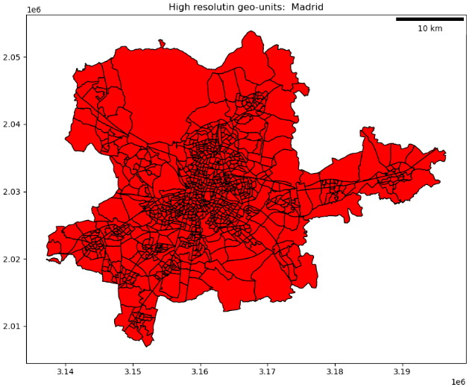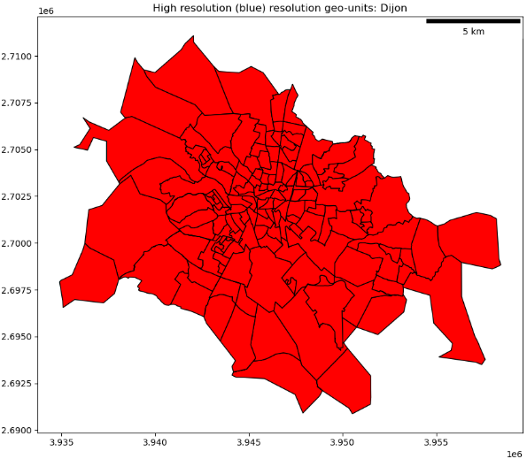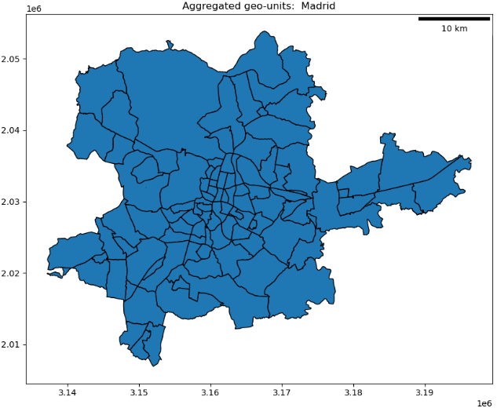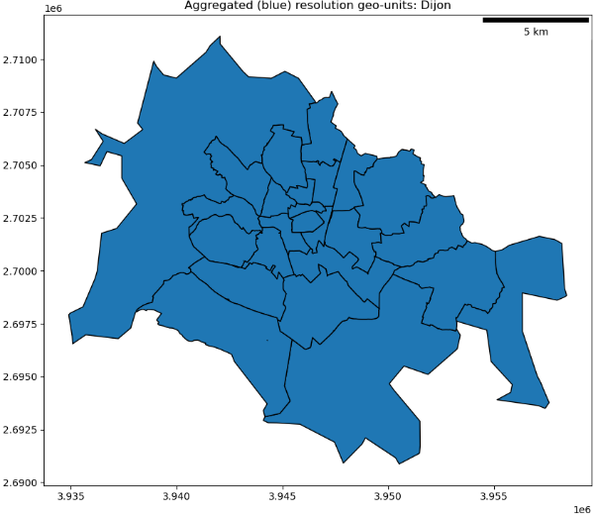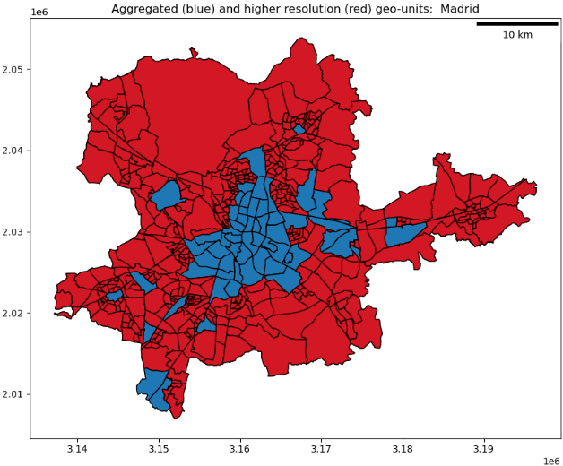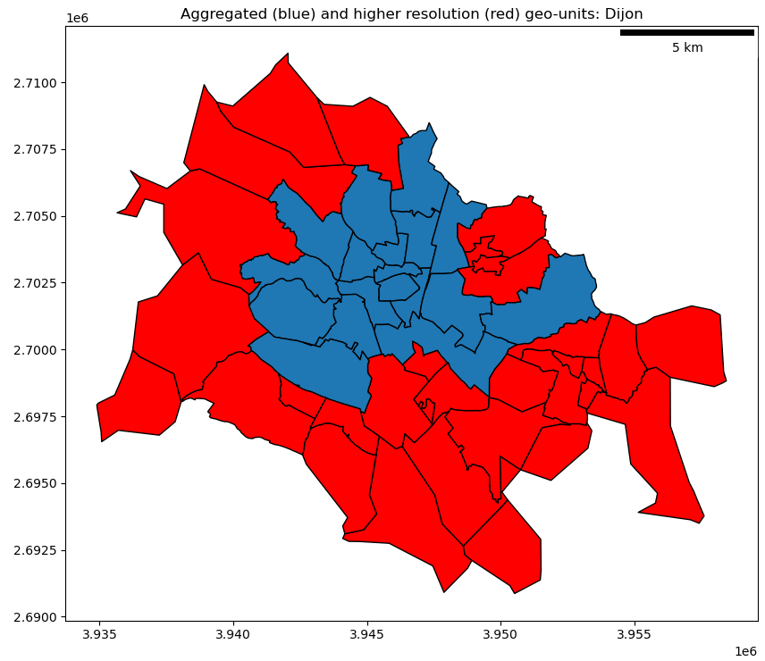
Figure S1 Demonstration of combining high and lor resolution to create mixed-resolution spatial units for Madrid and Dijon

Additional survey data
Table S3 shows characteristics of daily travel distances per person, by mode and for all modes combined, and average trip distances, for all cities. There are substantial differences in daily travel per person, mostly accounted for by differences in travel by car and by transit. Toulouse, Lille, and Nantes have the highest average daily car travel distances per capita. Car travel is the lowest in Paris, with just over 5 km/cap/day. Wien, followed by Berlin Paris, has the highest average daily transit travel distances per capita. Transit travel is lowest in Clermont and Nimes. Daily travel distances from all modes are highest in Wien, Toulouse, Nantes, and Lille, and lowest in Nimes, Paris, and Kassel. The cities which have low daily travel per capita are interesting because they lie on the opposite sides of the size and density spectra. Nimes, Kassel, and Magdeburg are all small cities with relatively low daily travel per capita, while Paris and Madrid are very large densely populated cities with relatively low daily travel per capita. These data provided suggestive evidence that overall travel distances can be kept low in different ways in different types of cities.
Table S4 shows mode shares, and summaries of the total size of the survey data, as well as aggregate population and size characteristics for each city. Bike mode shares are comparable in all Germany cities, ranging from 10-15% and seeming uncorrelated with total city size or population density. In contrast, all non-German cities have much smaller bike mode shares of 0-2%. Car mode shares range from 39-64% in German cities, 39%-84% in French cities, and are 54% and 47% in Madrid and Wien respectively. Transit mode shares range from 16-42% in German cities, 9-52% in French cities, and are 40% and 46% in Madrid and Wien respectively. Car and transit mode shares do appear correlated with overall city density and population (Fig. 1, Fig. S2). The absolute value of daily distances travelled by foot are quite consistent, ranging from 0.7-1.0 km/cap/day. Mode shares of distances travelled by foot vary more (3% - 8%) due to the differences in distances travelled by all modes. Daily distances traveled in 2-3 wheelers are low, ranging from 0 - 0.3 km/cap/day, or 0-3% of mode shares.
Table S3, Summary of average daily travel per person by individual and combined modes, and average trip distances by city
City | Average daily km/cap per mode |  |  |  |  |  | Average Trip Distance
 | Car | Bike | Foot | Transit | 2-3 Wheel | All modes | All modes
Berlin | 7.0 | 2.2 | 0.9 | 7.4 | 0.2 | 17.7 | 4.9
Dresden | 7.8 | 2.2 | 0.9 | 3.5 | 0.2 | 14.6 | 4.0
Düsseldorf | 9.1 | 1.7 | 0.9 | 4.3 | 0.1 | 16.1 | 4.6
Frankfurt | 8.5 | 2.0 | 0.9 | 4.2 | 0.2 | 15.9 | 4.6
Kassel | 8.1 | 1.4 | 1.1 | 3.0 | 0.1 | 13.7 | 3.7
Leipzig | 8.4 | 2.1 | 0.9 | 3.3 | 0.1 | 14.9 | 4.1
Magdeburg | 8.9 | 1.8 | 0.9 | 2.3 | 0.0 | 13.9 | 3.8
Potsdam | 7.9 | 2.2 | 0.7 | 5.5 | 0.0 | 16.4 | 5.1
Clermont | 13.6 | 0.1 | 0.9 | 1.5 | 0.2 | 16.2 | 4.6
Dijon | 10.6 | 0.2 | 1.0 | 2.4 | 0.1 | 14.3 | 3.7
Lille | 15.2 | 0.2 | 0.9 | 3.1 | 0.1 | 19.5 | 4.8
Lyon | 11.2 | 0.2 | 1.1 | 4.9 | 0.2 | 17.6 | 5.1
Montpellier | 12.8 | 0.3 | 0.9 | 2.6 | 0.3 | 16.8 | 4.8
Nantes | 14.7 | 0.3 | 0.9 | 3.9 | 0.2 | 20.0 | 4.7
Nimes | 9.6 | 0.1 | 0.9 | 1.2 | 0.1 | 12.0 | 4.0
Paris | 5.3 | 0.1 | 0.7 | 7.1 | 0.4 | 13.6 | 3.7
Toulouse | 15.9 | 0.3 | 0.7 | 4.1 | 0.3 | 21.3 | 6.0
Madrid | 7.9 | 0.0 | 0.7 | 5.8 | 0.2 | 14.6 | 5.4
Wien | 10.4 | 0.4 | 0.9 | 10.2 | 0.2 | 22.0 | 7.5

Table S4 Summary of distance-based mode share, number of trips in cleaned sample, population, area, and population density for each city
City | Year | Mode Share |  |  |  |  | N Trips | Pop. | Area | Pop. Density
 |  | Car | Bike | Foot | Trans | 2-3W |  | (1e⁶) | (km²) | (Per/ km²)
Berlin | 2018 | 39% | 12% | 5% | 42% | 1% | 114,273 | 3.399 | 896 | 3,687
Dresden | 2018 | 54% | 15% | 6% | 24% | 1% | 9,631 | 0.513 | 328 | 1,562
Düsseldorf | 2018 | 56% | 11% | 6% | 27% | 1% | 22,775 | 0.586 | 215 | 2,724
Frankfurt | 2018 | 54% | 13% | 6% | 27% | 1% | 5,742 | 0.704 | 253 | 2,785
Kassel | 2018 | 59% | 10% | 8% | 22% | 0% | 8,858 | 0.191 | 108 | 1,765
Leipzig | 2018 | 57% | 14% | 6% | 22% | 1% | 11,155 | 0.503 | 298 | 1,689
Magdeburg | 2018 | 64% | 13% | 7% | 16% | 0% | 9,118 | 0.228 | 202 | 1,131
Potsdam | 2018 | 49% | 14% | 4% | 33% | 0% | 5,323 | 0.156 | 188 | 828
Clermont | 2012 | 84% | 0% | 6% | 9% | 1% | 11,933 | 0.285 | 311 | 915
Dijon | 2016 | 74% | 2% | 7% | 17% | 0% | 13,636 | 0.254 | 241 | 1,052
Lille | 2016 | 78% | 1% | 5% | 16% | 0% | 33,593 | 1.140 | 613 | 1,859
Lyon | 2015 | 64% | 1% | 6% | 28% | 1% | 56,249 | 1.383 | 549 | 2,517
Montpellier | 2014 | 76% | 2% | 5% | 15% | 2% | 29,025 | .437 | 439 | 995
Nantes | 2015 | 73% | 2% | 4% | 19% | 1% | 33,773 | .646 | 535 | 1,208
Nimes | 2015 | 80% | 1% | 8% | 10% | 1% | 10,534 | .151 | 161 | 935
Paris | 2010 | 39% | 1% | 5% | 52% | 3% | 67,551 | 6.942 | 815 | 8,514
Toulouse | 2013 | 75% | 1% | 3% | 19% | 2% | 38,188 | 0.891 | 781 | 1,140
Madrid | 2018 | 54% | 0% | 5% | 40% | 1% | 168,195 | 5.279 | 1,353 | 3,902
Vienna | 2014 | 47% | 2% | 4% | 46% | 1% | 21,298 | 1.872 | 857 | 2,185
2-3W: 2-3 wheeler (motorbike, moped, etc.)
Table S5 shows summaries of model accuracy using GDBT ML regression (trip distance) and classification (car ownership and mode choice) models, compared against standard linear regression (trip distance) and logistic regression (car ownership and mode choice) models. R² is used to estimate the accuracy of regression models, and F1 scores are used to estimate the accuracy of classification models. In some individual German cities (Frankfurt, Kassel, Potsdam), the ML and LR models are unable to predict trip distances with any degree of accuracy. As single observations relate to postcodes for average trip distance models, this leads in some cases to excessively small sample sizes (most extremely in Kassel, Magdeburg and Potsdam), which can explain ineffective prediction models. Combining all German cities outside Berlin into a single model with 168 observations produces a more respectable accuracy of 0.38 with the GBDT model. Apart from the poorest performing trip distance model, where the LR accuracies are much worse than the ML models, accuracy scores are comparable between ML and LR models, with the LR regression overall tending to have slightly higher accuracies. The benefit of using ML in this case lies not so much in improved prediction measures, but greater explainability over feature values and spatially.
Car ownership F1 scores are quite high in all cities, and here ML models do have a prediction advantage over LR models. By individual mode, the car ownership models are much better at getting correct predictions in households that do own a car than in households that do not. In Berlin for example, 85% of households who do own a car were correctly predicted, while only 58% of households who do not own a car were correctly predicted. Car ownership models were not estimated for cities whose surveys lacked income data.
Mode choice accuracy scores from ML models are relatively high in all cities, and notably lower for LR models. Again, there are differences in performance for each class of the outcome variable. Mode choice is generally very well predicted for car and foot trips, moderately well predicted for transit trips and bike trips where bike mode share is not negligible, and poorly predicted for bike trips especially in cities with very low bike mode shares. In Berlin accuracy is 83% for foot trips, 78% for car trips, 61% for transit trips, and 47% for bike trips, leading to an overall weighted F1 score of 69%. In Paris, accuracy is 89% for foot trips, 70% for car trips, 78% for transit trips, and just 3% for bike trips, leading to an overall weighted F1 score of 79%.

Table S5 Summary of accuracy for each model type, accuracy is compared using r2 or F1 scores from GBDT machine learning (ML) models and traditional linear or logistic regression (LR) models. Number of observations in for each model is denoted N
City | Accuracy
 | Trip Distance |  |  | Car Ownership |  |  | Mode Choice
 | (r² ML) | (r² LR) | N | (F1 ML) | (F1 LR) | N | (F1 ML) | (F1 LR) | N
Berlin | 0.799 | 0.805 | 190 | 0.741 | 0.692 | 16021 | 0.689 | 0.495 | 41716
Dresden | 0.174 | -0.37 | 27 | 0.775 | 0.719 | 1186 | 0.711 | 0.451 | 3508
Düsseldorf | 0.438 | 0.489 | 37 | 0.743 | 0.728 | 3145 | 0.675 | 0.474 | 8714
Frankfurt | -0.30 | -0.80 | 37 | 0.737 | 0.399 | 755 | 0.667 | 0.436 | 2092
Kassel | -0.45 | -25 | 11 | 0.819 | 0.792 | 1150 | 0.706 | 0.509 | 3367
Leipzig | 0.657 | -0.05 | 34 | 0.738 | 0.687 | 1570 | 0.727 | 0.464 | 4272
Magdeburg | 0.244 | -6.7 | 14 | 0.791 | 0.733 | 1270 | 0.722 | 0.492 | 3304
Potsdam | -0.174 | -10.3 | 8 | 0.727 | 0.654 | 807 | 0.690 | 0.792 | 2170
Germany other | 0.381 | 0.317 | 168 | 0.766 | 0.717 | 9883 | 0.685 | 0.442 | 27427
Clermont | 0.269 | 0.242 | 63 | 0.834 | 0.816 | 1378 | 0.923 | 0.741 | 4013
Dijon | 0.686 | 0.757 | 45 |  |  |  | 0.889 | 0.665 | 6035
Lille | 0.222 | 0.271 | 194 |  |  |  | 0.918 | 0.708 | 14118
Lyon | 0.378 | 0.390 | 168 |  |  |  | 0.886 | 0.589 | 22789
Montpellier | 0.624 | 0.629 | 83 |  |  |  | 0.877 | 0.675 | 10795
Nantes | 0.673 | 0.708 | 100 |  |  |  | 0.868 | 0.645 | 14140
Nimes | 0.783 | 0.760 | 28 |  |  |  | 0.913 | 0.727 | 4055
Paris | 0.637 | 0.657 | 149 | 0.759 | 0.730 | 7631 | 0.792 | 0.543 | 27831
Toulouse | 0.449 | 0.525 | 183 | 0.850 | 0.844 | 4271 | 0.868 | 0.643 | 14047
France other | 0.496 | 0.466 | 670 | 0.853 | 0.835 | 5649 | 0.889 | 0.651 | 90082
Madrid | 0.673 | 0.674 | 325 |  |  |  | 0.719 | 0.566 | 73937
Vienna | 0.175 | 0.317 | 44 |  |  |  | 0.708 | 0.545 | 9335

Figure S2 shows variations of mode shares in cities ordered by total population. Transit mode shares have a correlation of 0.78 with aggregate population density, car mode shares have a correlation of -0.57 with population density.
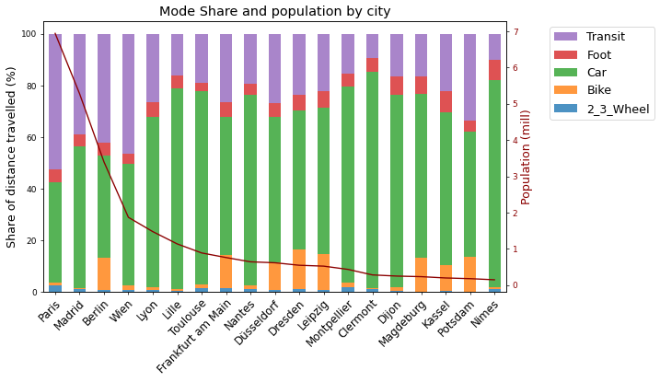
Figure S2 Summary of mode share by travel distance and population total in each city. Cities are ordered on the x-axis by total population
Correlations of daily car use and car mode share with density and distance to center vary between the cities (Fig. S3). Here we group German cities other than Berlin and French cities other than Paris together. Fig. S3 (a, b) show the variations of average daily car travel (p-km/cap) in the postcodes of each survey city. In the case of Madrid, the relationship between car travel and density looks roughly linear, but in most cases daily car travel tends to increase non-linearly, especially below densities of 5,000 per/km² (50 per/ha). Linear approximations make a good representation of correlations between daily car travel and distance to city center (Fig. S3b), and the slopes tend to below 1 (0.5-0.8), except for the other French cities where the slope is 1.2. In Paris for instance living 1 km additional distance from the center is associated with 0.5 km extra travel)
Daily car travel is higher in the small and medium-size cities (FR, Other and to a lesser extent DE, Other), some of which are quite small (Table S4). Car mode share appears to reduce non-linearly with increased density and increase linearly with distance to center. Trends in Madrid appear different to other cities, with a close-to-linear reduction of car mode share with density, and a smaller linear slope relating car mode share to distance to center. In Madrid living an additional 1km from the city center relates to a 1% increase in car mode share, while in all other cities an increase of approximately 2% is observed (or 2.5% in Wien). Before taking other explanatory variables into account, density and distance to center seem to have weaker effects on travel distance by car and car mode share in Madrid than in other cities. The relationship between density and distance to center is shown in Figure S4.
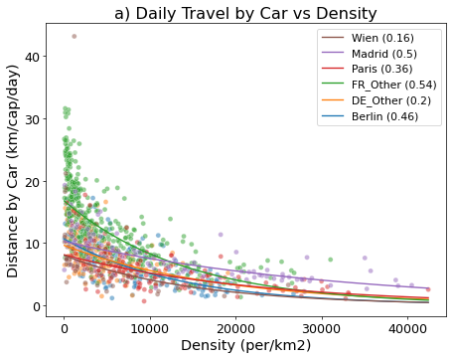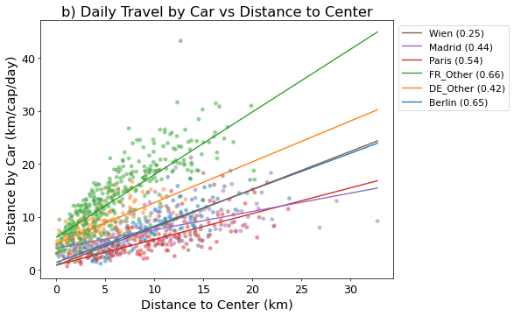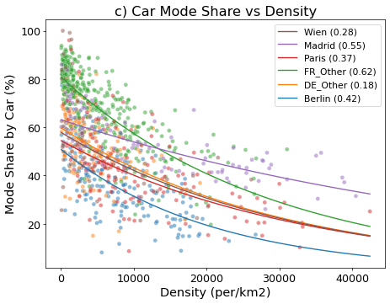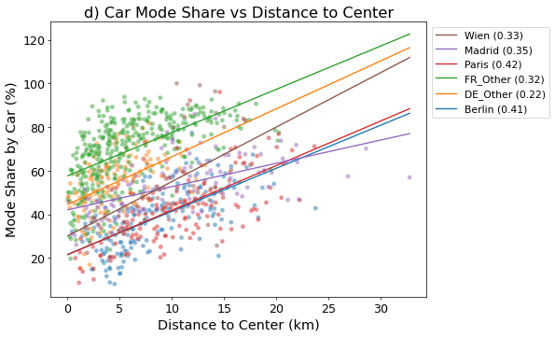
Figure S3 Average daily car travel per person vs a) population density and b) distance to city center, and average car mode share (on p-km basis) vs c) population density and d) distance to city center, for residential postcodes (or similar) in nineteen European cities. Trend lines are estimated as exponential functions of density, and linear functions of distance to center, R² measures of goodness-of-fit are indicated in parentheses for each region
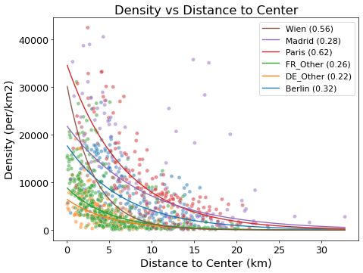
Figure S4 Population density vs distance to city center in nineteen European cities. Trend lines are estimated as exponential functions of density, and linear functions of distance to center, R² measures of goodness-of-fit are indicated in parentheses for each region
Trips by mode and distance are shown in Figure S5 for all cities, and trips by mode, distance, and purpose are shown in Figure S6 for the four capital cities. The share of very short trips (<1km) is by far the highest in Paris (48%) and is lowest in Wien (15%). This may correspond with the substantially higher density seen throughout the center of Paris, compared to other cities, lending itself to greater walkability, and higher likelihood of having desirable destinations within walking distance. Wien by contrast has the highest share of trips over 8km (32%). No other city in our sample has such a high share of long trips. Differences in sample selection and other aspects of survey design may account for some of the differences in trip distance distributions between cities and countries, which are not the main focus of this study. An intuitive trend is that as trips get longer, the likelihood of travelling by car or transit increases; this is consistent across all cities. Another notable trend visible in Fig. S5 is that bike trips do not have substantial mode shares in any non-German city. Cultural preferences and practices and preferences could help to explain the large differences in biking inside and outside of Germany.
Adding in the dimension of trip purpose in Figure S6, a number of patterns emerge. We see that longer (<8km) trips are most often work commutes, and are usually done by car or transit, apart from small bike shares in German cities. Short (<1km) trips are usually for shopping, leisure, or other (non-work, non-school) purposes, and are usually made by foot. Trips with companions (mostly parent and child trips (Leroutier & Quirion, 2022)) are usually shorter (<2km) and are achieved with a variety of modes, with the likelihood of travelling by car rising rapidly with trip distance. Overall, travel per person per day follows long-tailed exponential shaped distributions in all cities, with large majorities of respondents travelling less than 10km/day.

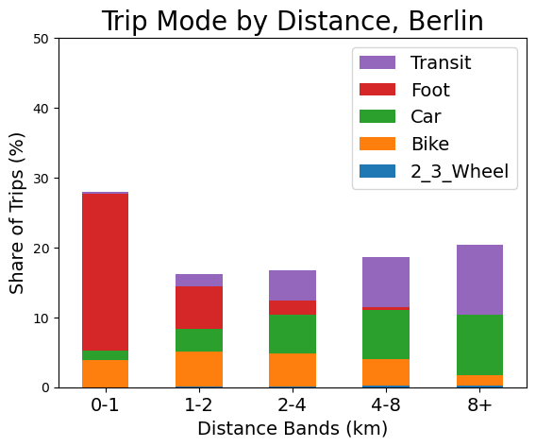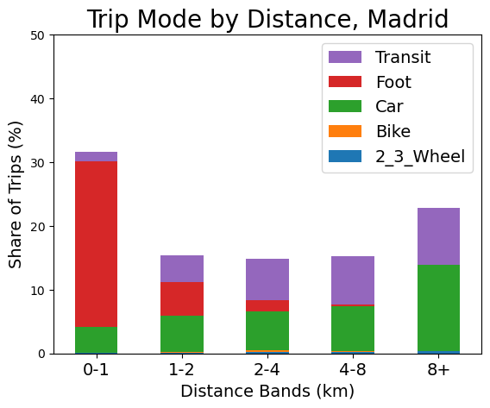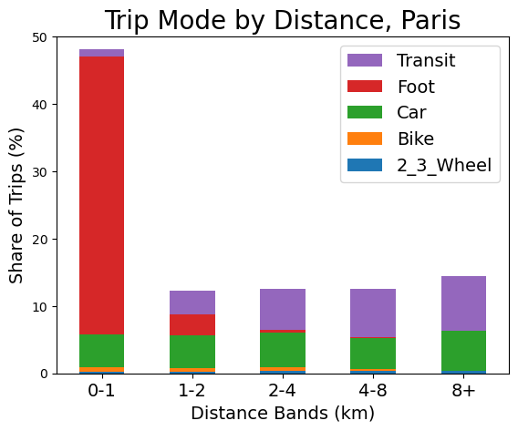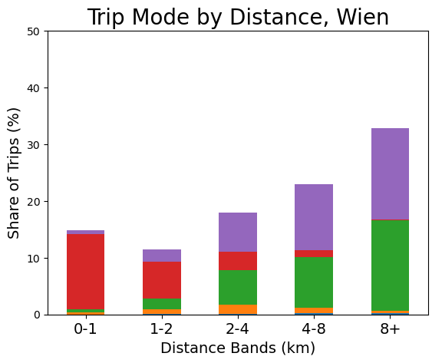
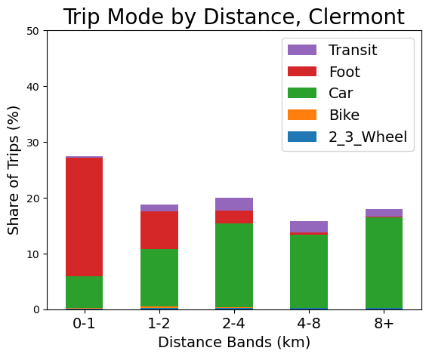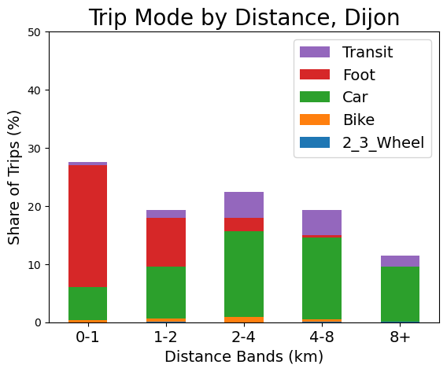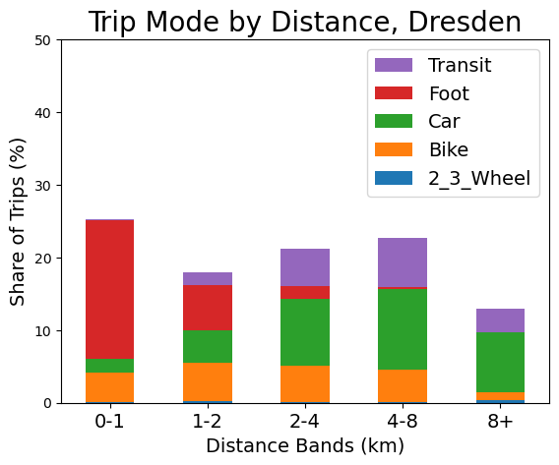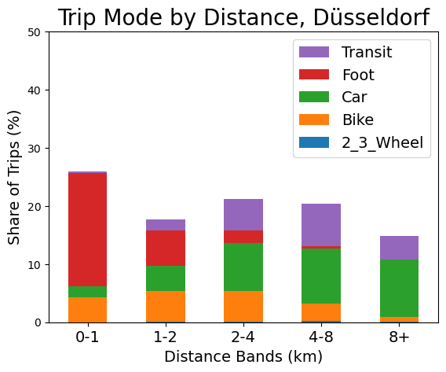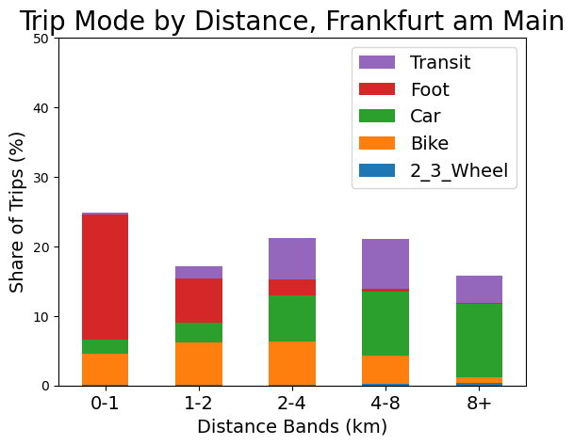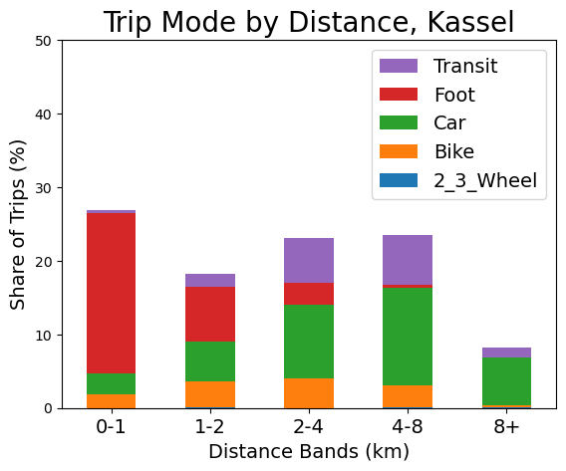
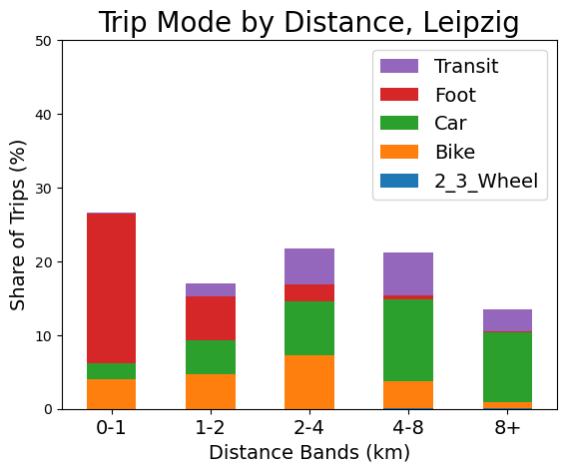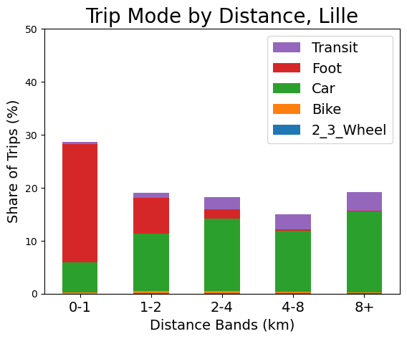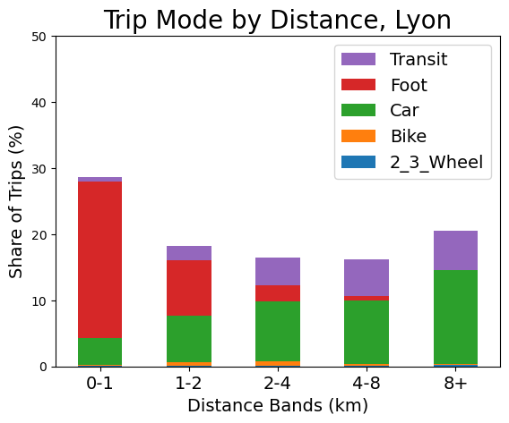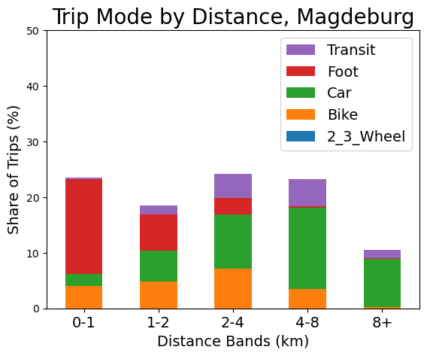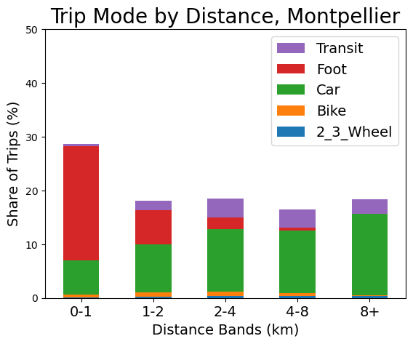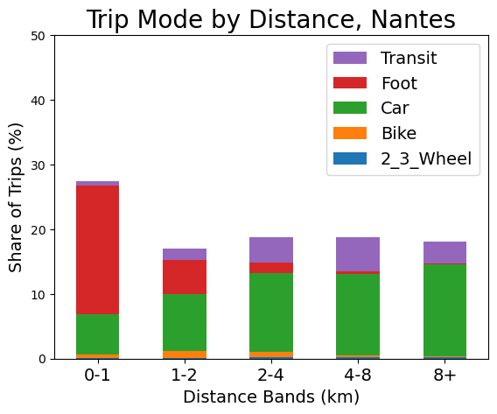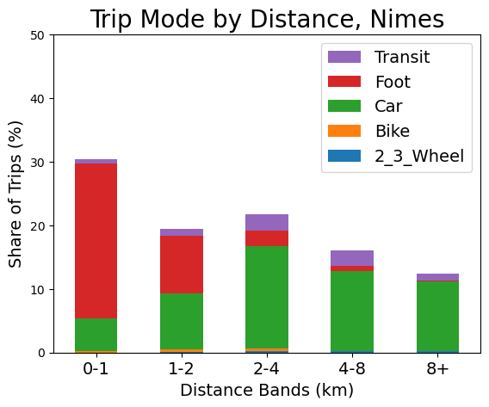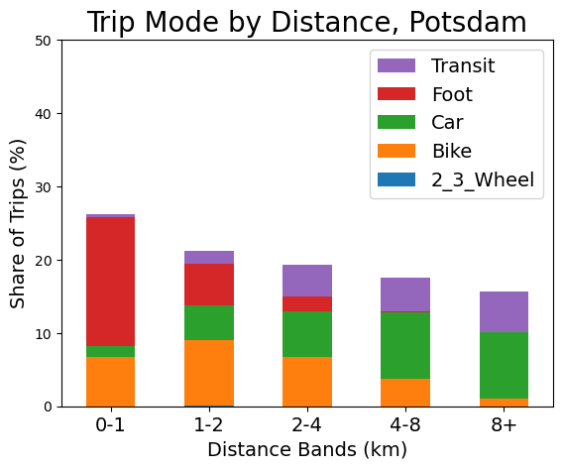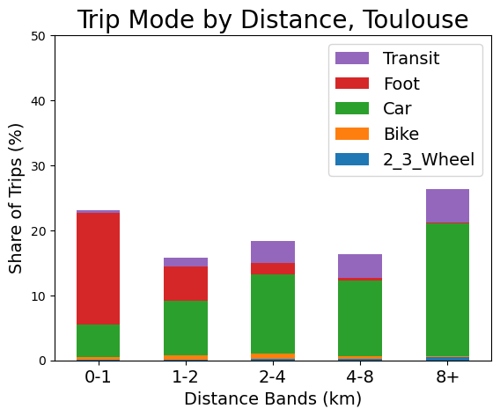
Figure S5 Variation of distribution of trip modes by distance in all non-capital cities.
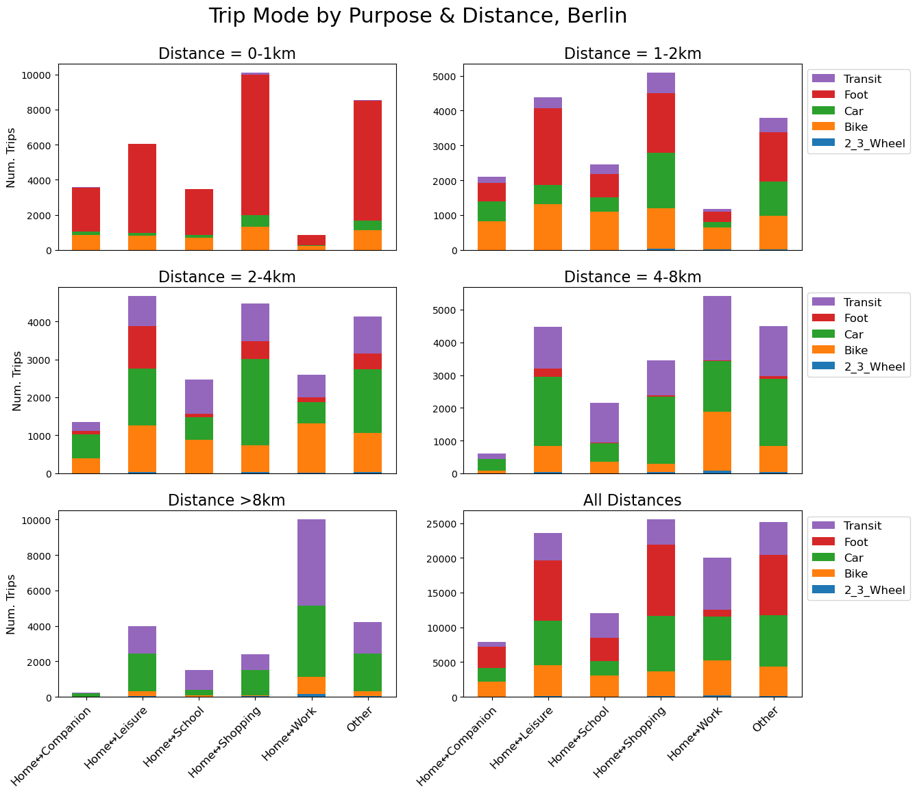
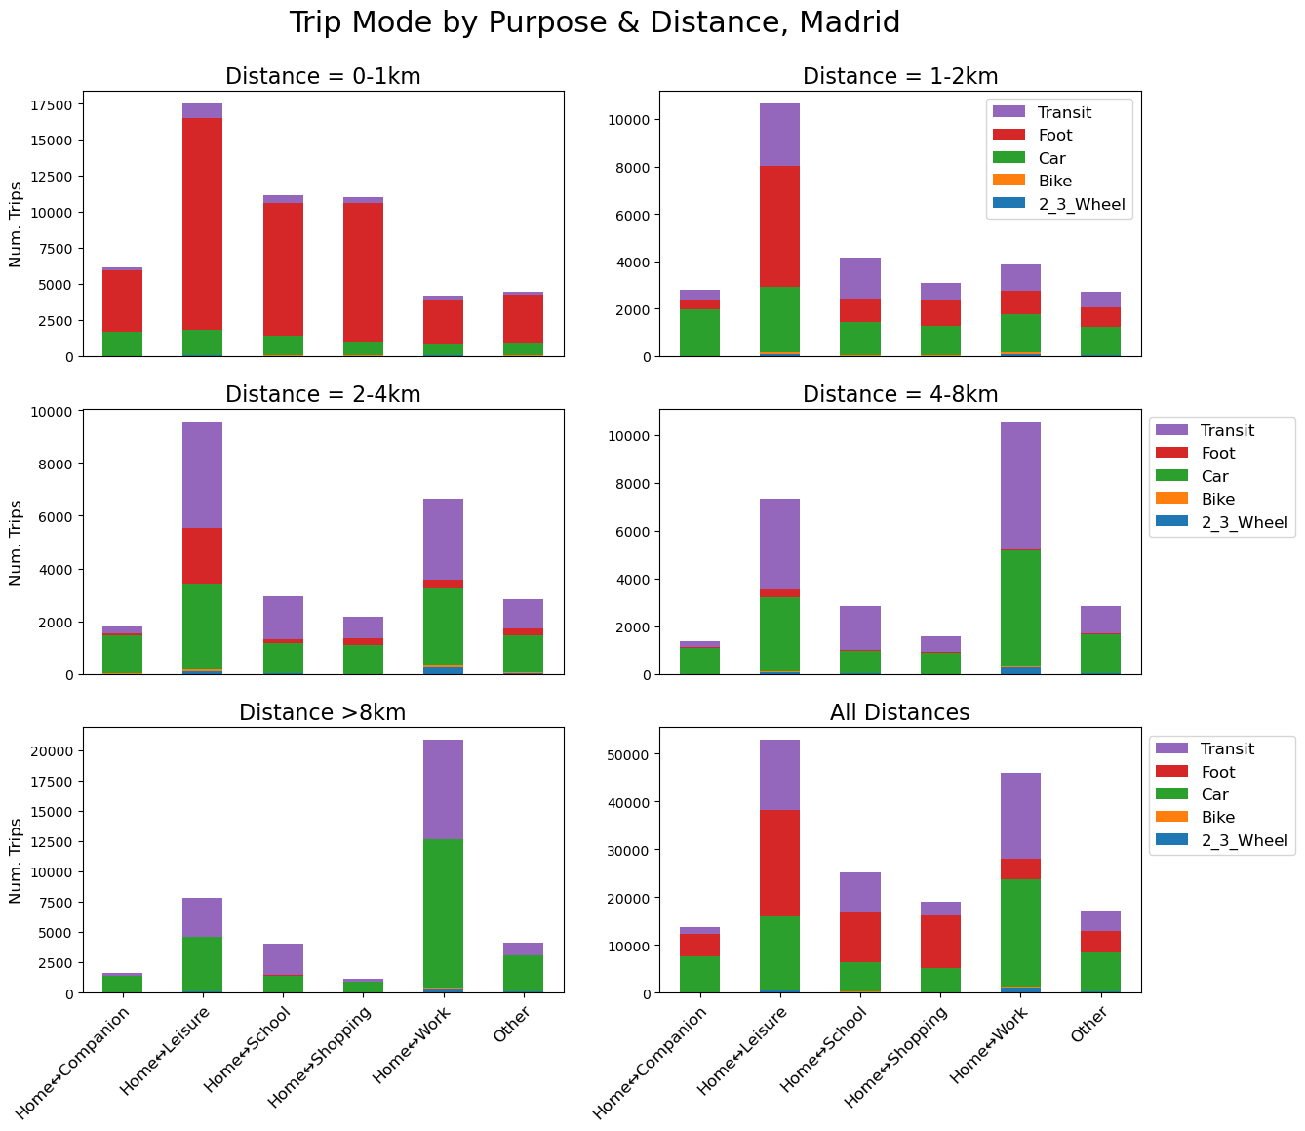
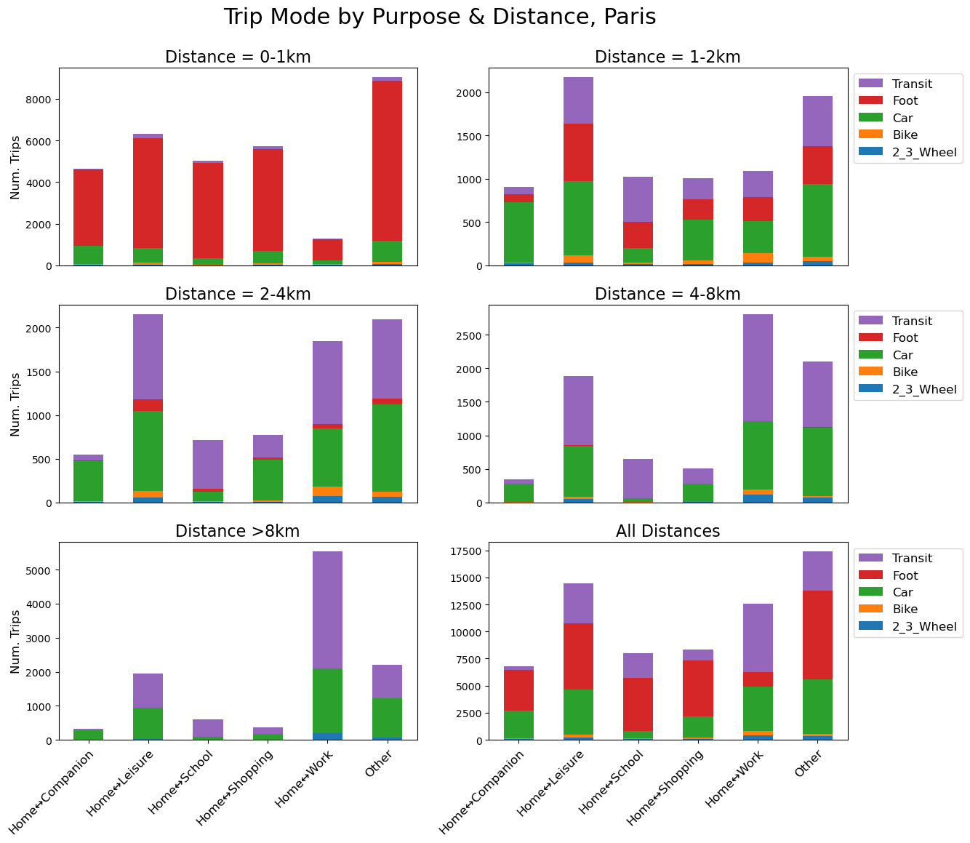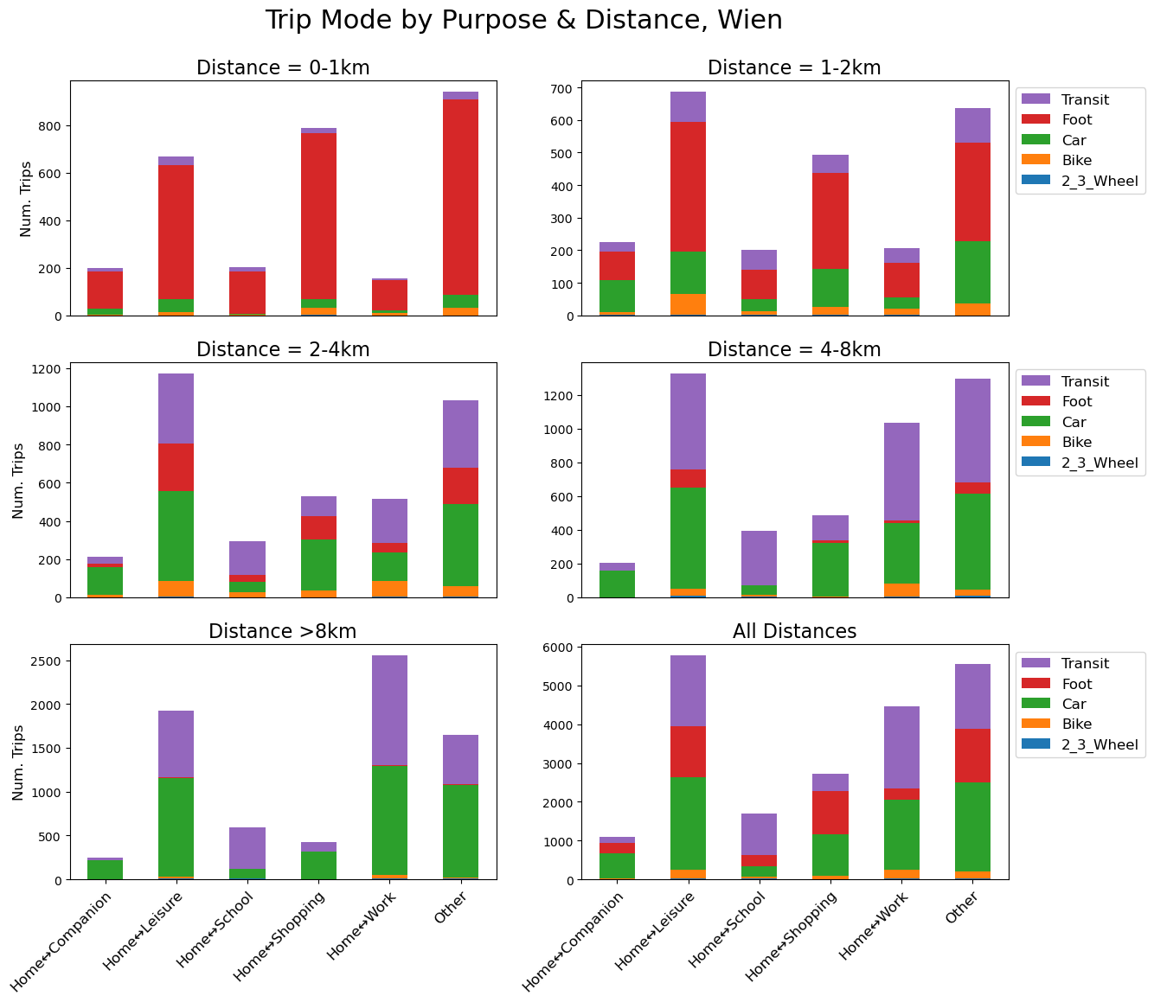
Figure S6 Variation of distribution of trips by mode, purpose, and distance in all capital cities
In Fig. S7-S9 we plot car mode share, car ownership, and population density for the Berlin, Paris, Madrid, and Wien. These figures give a visual representation of the influence of distance from the city center on several variables. In Berlin, daily travel needs, car mode share, and car ownership all tend to be highest on city perimeters, while values can be quite low closer to the center, particularly for car ownership and mode share. Population density on the other hand tends to be high closer to the city center, although this is not a simple monotonic relationship. Areas of low population density also exist close to the city center (sometimes due to large parks, or areas with predominantly commercial or governmental land-uses), while areas of relatively high population density exist outside of the inner-city ring (which we approximate with an 8 km buffer), signifying a polycentric urban form. Madrid is somewhat unique among these cities in that the dense urban core and small densely populated satellite suburbs are separated by vast areas of very low population density. This is also visible in Berlin, but to a lesser extreme. The polycentricity of Madrid may help to explain the lower influence of distance to center on car travel distances and mode share (Fig. S3). Madrid is the only of the cities/regions shown in Fig. 6 where distance to subcenter is one of the highest influences on mode choice.
To briefly summarize spatial relationship for all cities, including those not shown in Fig S7-S9, many French cities very quickly transition from low-moderate car mode share to high mode as distance to city center increases (c.f. Fig. 6f). Overall travel distances are largest (~30 km/per/day or more) outside the inner-ring of some French cities (Lyon, Nantes, Toulouse), although similarly large travel levels are seen in some suburban areas of Berlin, Lille, Clermont, and Dijon. French cities also generally exhibit higher car ownership rates. The lowest car ownership rates are observed in the center of larger German cities (Berlin, Frankfurt, Leipzig, Dusseldorf) and the center of Paris. Madrid and Wien generally don’t have as low car ownership rates in city centers as German cities and Paris. Differences in density gradients are also seen; some cities such as Clermont and Dijon have dense centers and a relatively steep gradient to low density moving out from the center. Other cities such as Dresden and Leipzig don’t have very high (>15,000 per/km²) density cores, but have moderate density throughout the city, and the overall city-wide density is reasonably high (Table S4). Yet other cities such as Lille, Madrid and Berlin have clear areas of high density outside of the central core, indicating a polycentric structure.

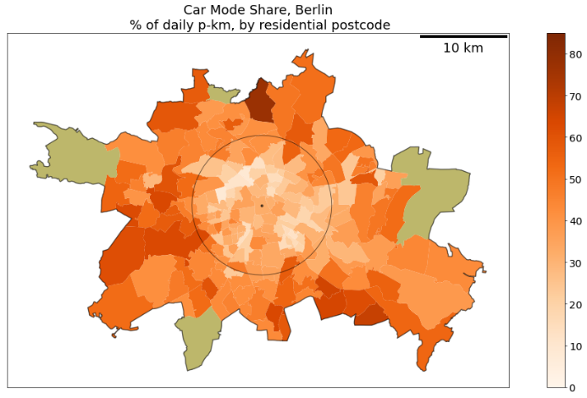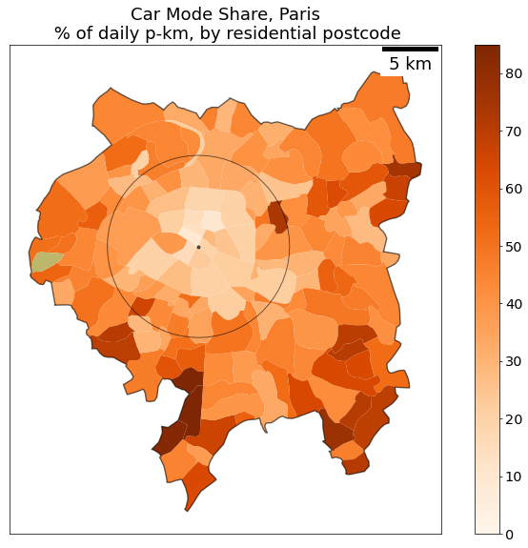
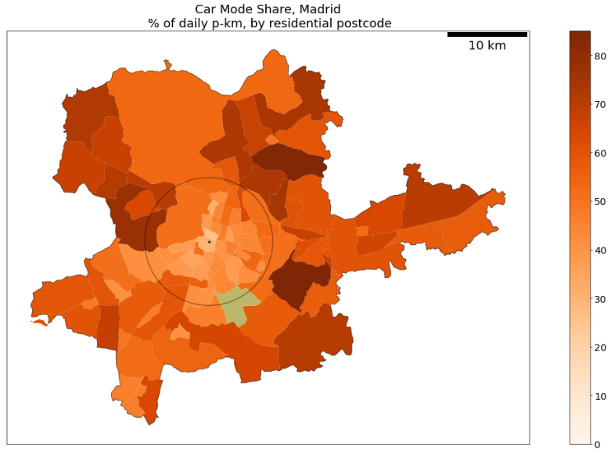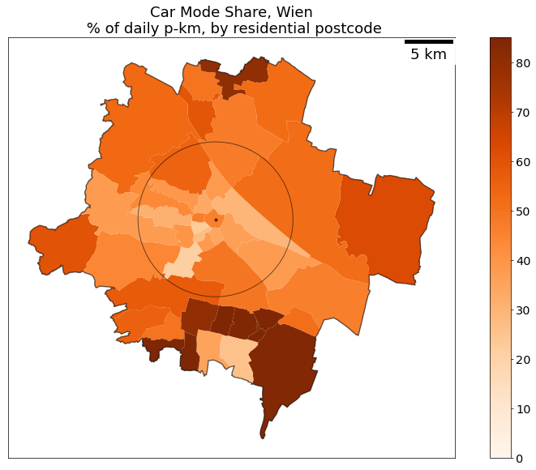
Figure S7 Car mode share by postcode (or similar administrative unit) in four European cities. The city center buffered by a circle of radius 8km are indicated on the maps. Postcodes without data are shown in light-brown.
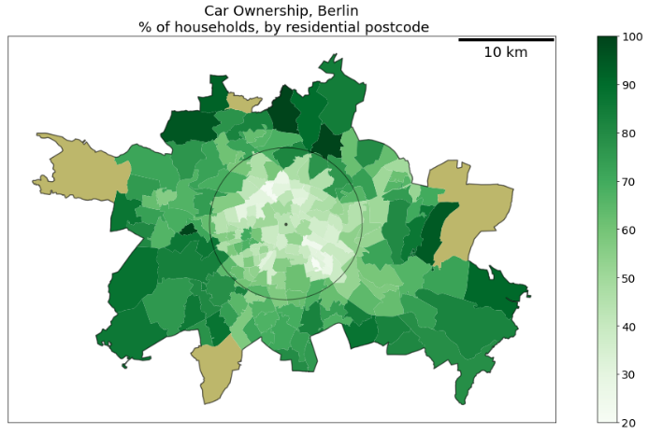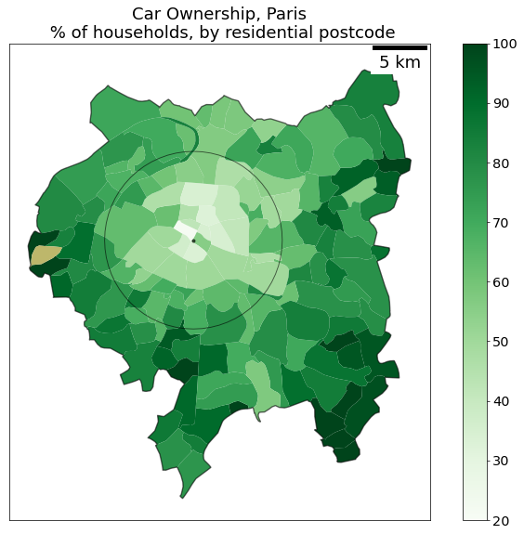
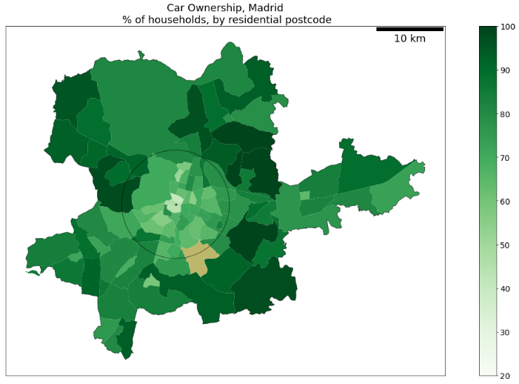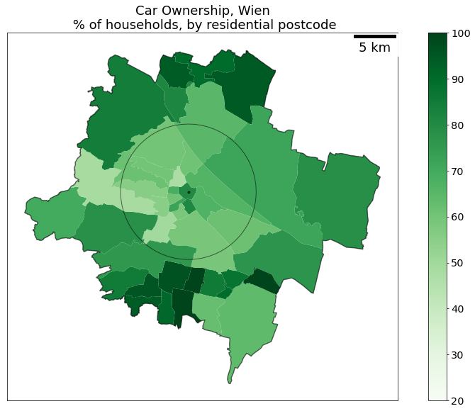
Figure S8 Car ownership rates per household by all modes in four European cities. The city center buffered by a circle of radius 8km are indicated on the maps. Postcodes without data are shown in light-brown.
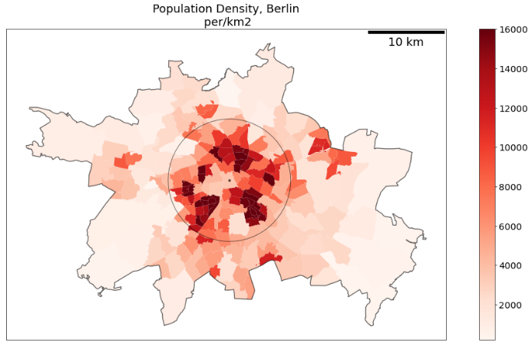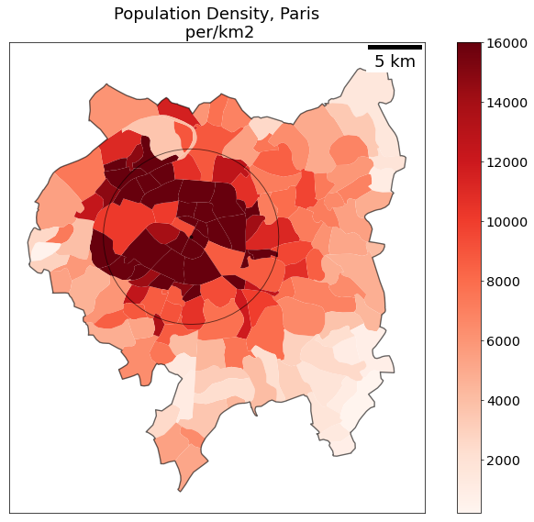
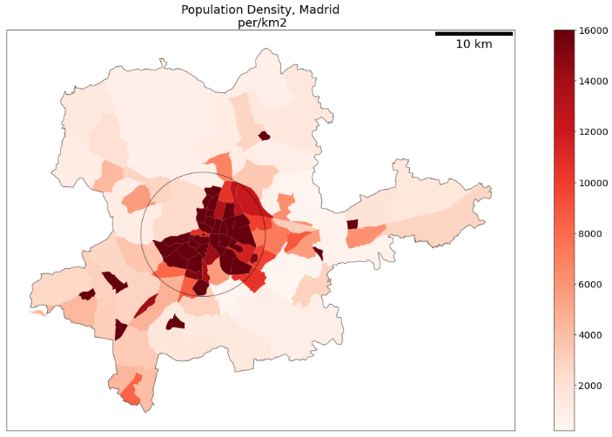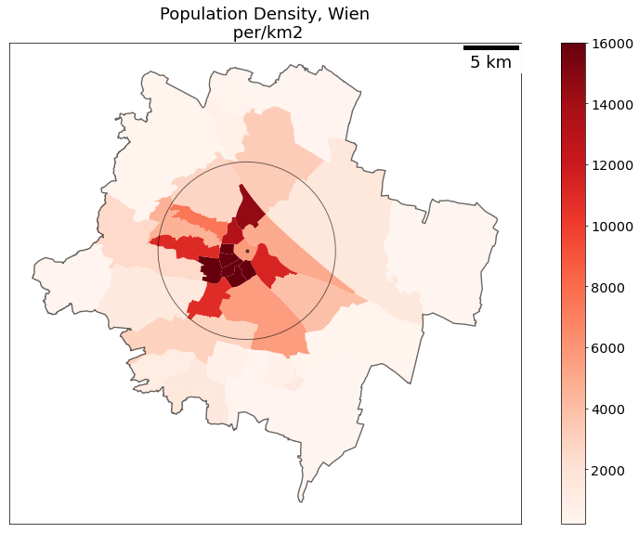
Figure S9 Population density in four European cities. The city center buffered by a circle of radius 8km are indicated on the maps. Postcodes without data are shown in light-brown

Additional results
Figure S10 shows detailed distributions of the effects of the six most important variables in models of trip distance for Berlin, Paris, Madrid, Wien, rest of Germany, and rest of France. Residential distance to center is the most important variable in all locations.
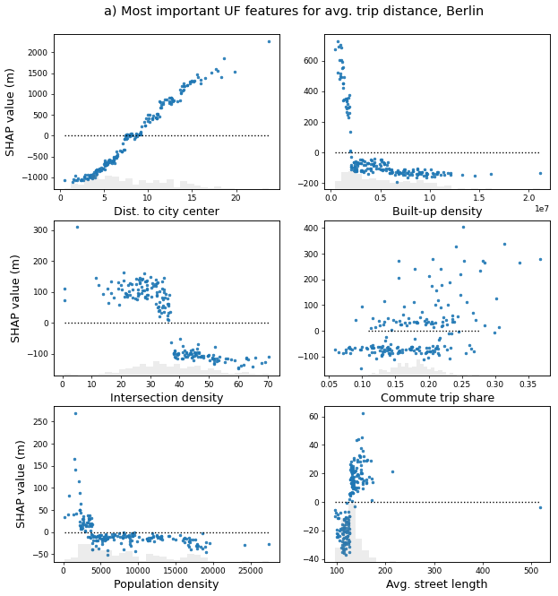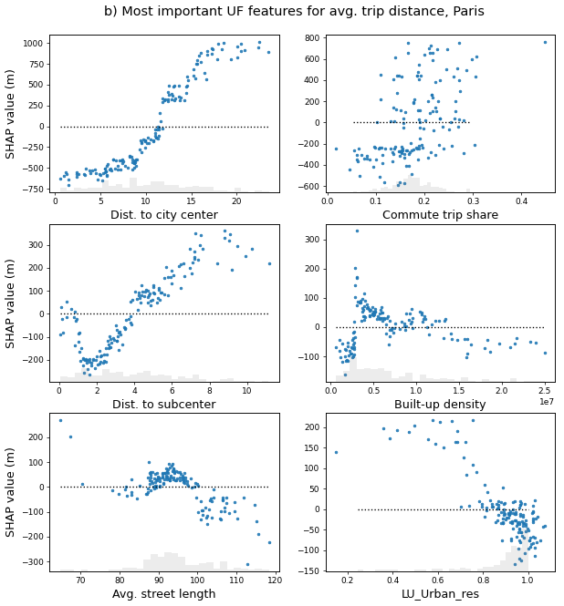
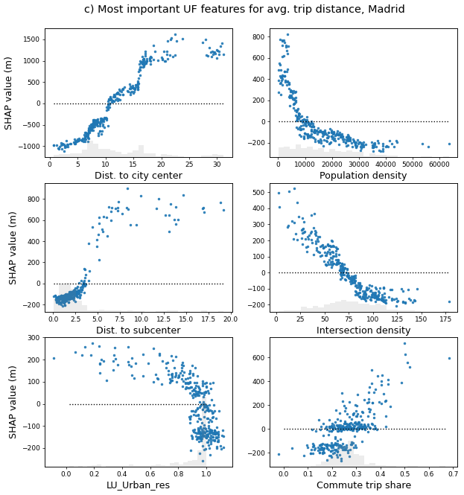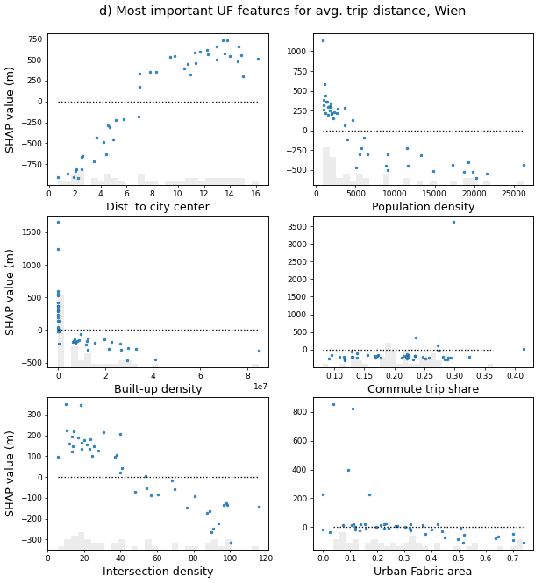
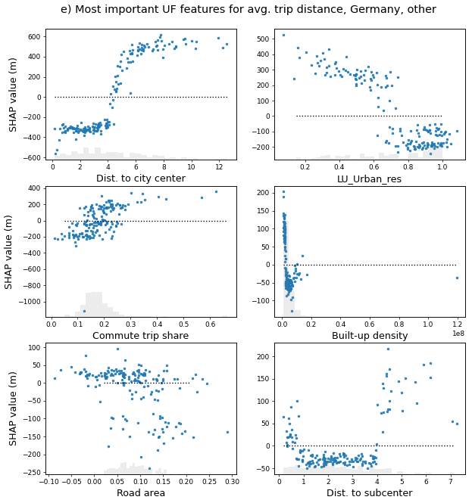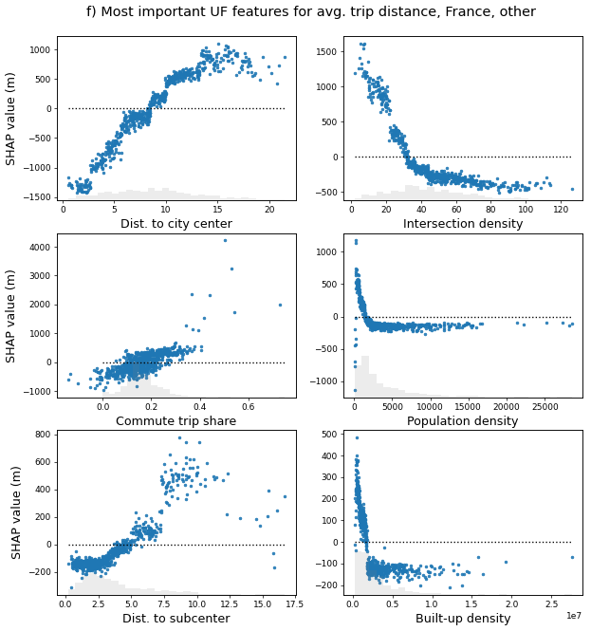
Figure S10 Feature importance SHAP values for urban form features on trip distance in a) Berlin, b) Paris, c) Madrid, d) Wien, e) Rest of Germany, f) Rest of France. The SHAP values on the x-axis show the impact of a feature on trip distance for a certain feature value in a single tree/estimator.
Fig S11 shows the importance of the eight most important variables on mode choice for each mode in Berlin, Paris, Madrid, Wien, rest of Germany, and rest of France. Trip distance and car ownership are the two most important variables overall. Residential walking time to the closest transit stop was only available in the German cities and Wien, and is only found to be an important predictor for car mode choice in Berlin. The availability of parking at trip destinations was only available in French cities and Wien, and is only found to be an important predictor for car mode choice in Wien.
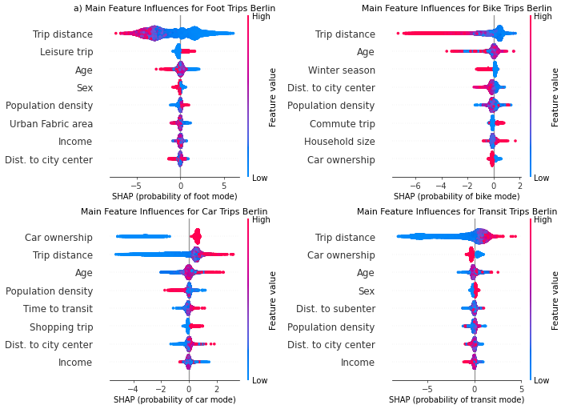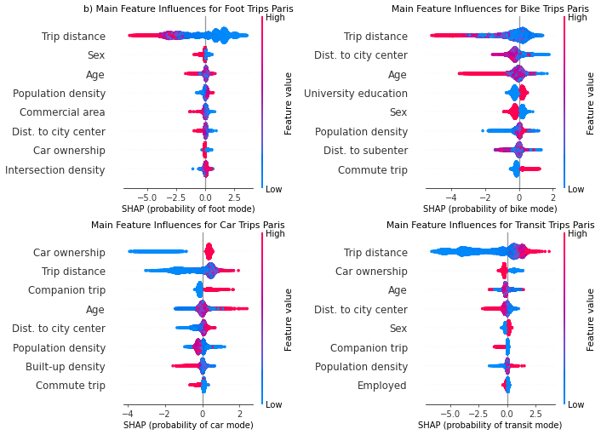
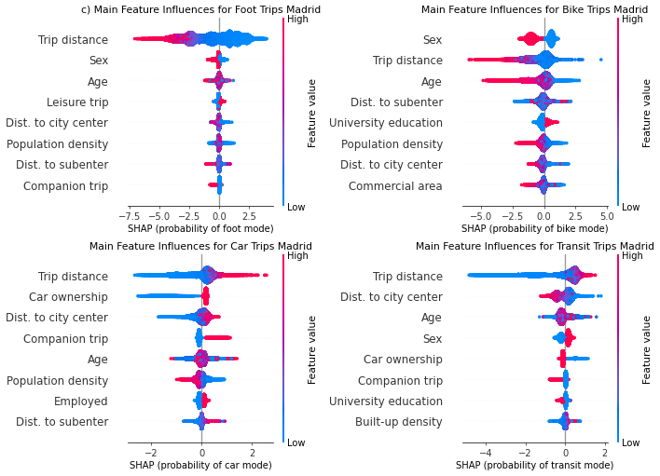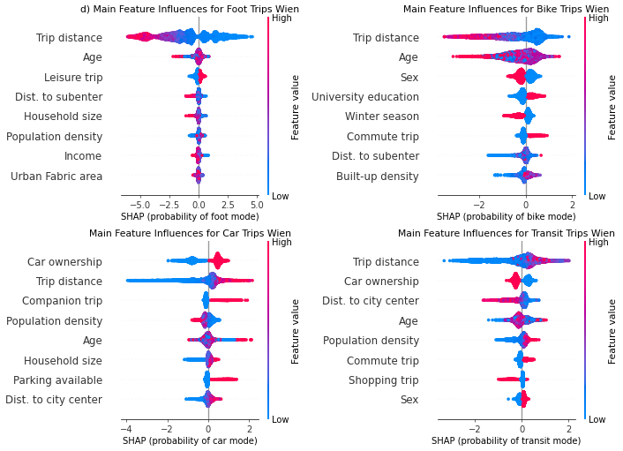
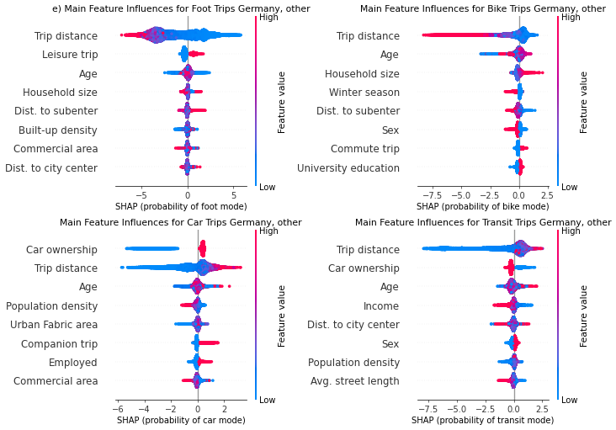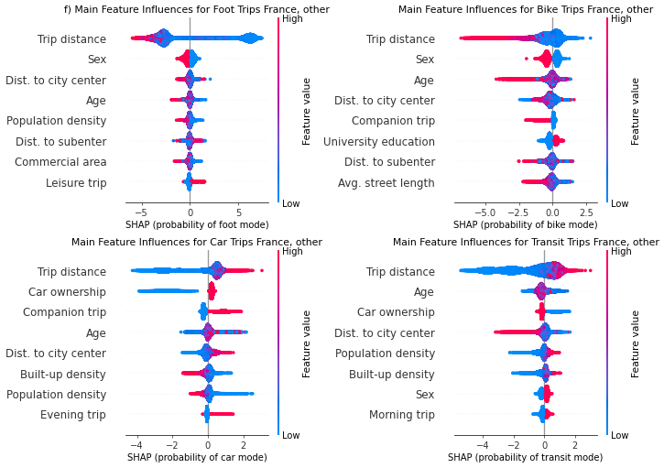
Figure S11 SHAP values for most important features influencing mode choice in a) Berlin, b) Paris, c) Madrid, d) Wien, e) Rest of Germany, f) rest of France. Sex is coded as Male = 0 and Female = 1.
Figure S12 shows influences of the ten most important variables influencing car ownership in Berlin, Paris, rest of Germany, and rest of France (Clermont and Toulouse). Household income, size, residential distance to city center, and max householder age of high importance across locations. Streets per node (i.e. intersection), a metric of street network connectivity, is an urban feature which is sometimes of high importance, especially outside of the large cities of Berlin and Paris.
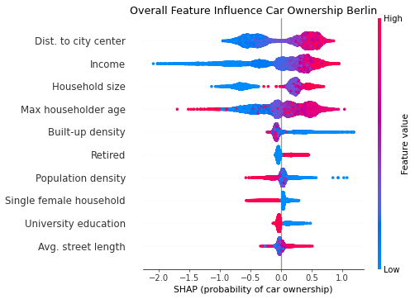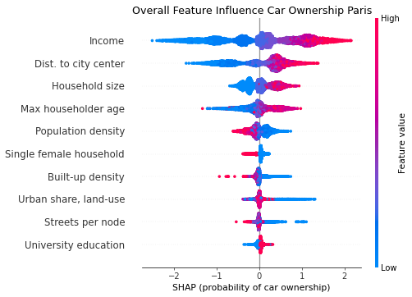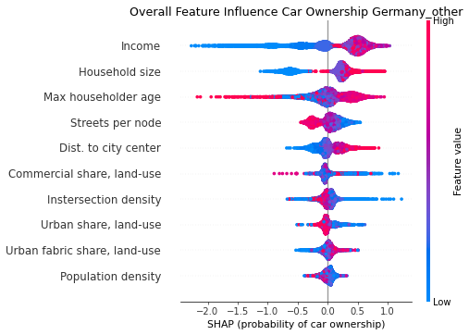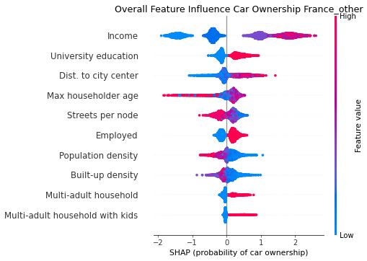
Figure S12 SHAP values for most important features influencing car ownership in a) Berlin, b) Paris, c) Rest of Germany, d) rest of France (only Clermont and Toulouse)
Figure S13 shows detailed distributions of feature influences for selected features influencing household car ownership in Berlin, Paris, rest of Germany, and rest of France. Features selected include the most important socioeconomic and urban form features for car ownership. Binary variables such as existence of householders with university education are omitted from the figure.
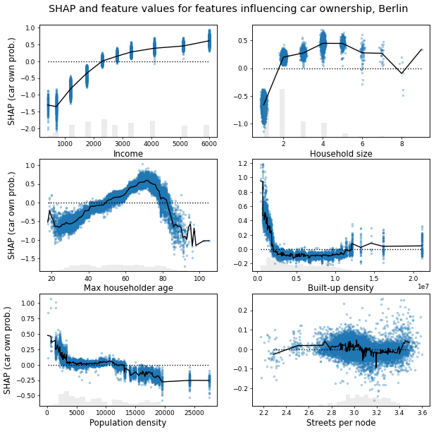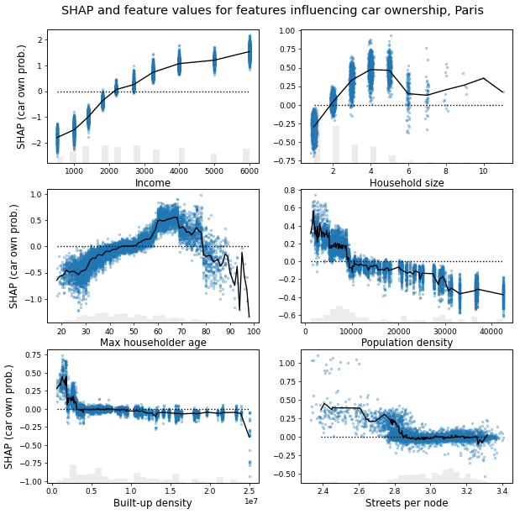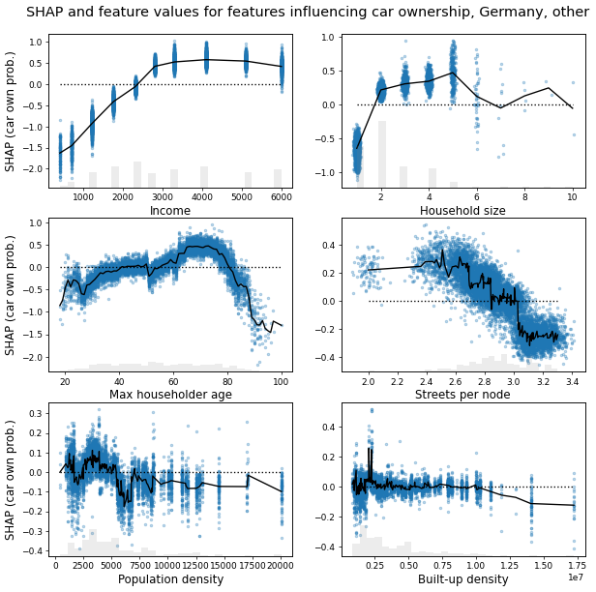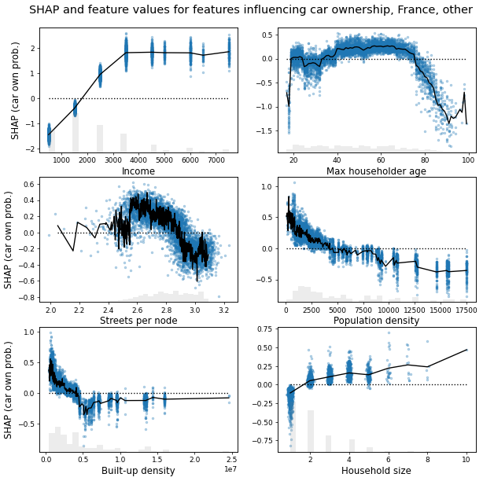
Figure S13 Variation of SHAP values for selected features in models of car ownership in a) Berlin, b) Paris, c) rest of Germany, d) rest of France (only Clermont and Toulouse).
Figure S14 shows a simplified network diagram summarizing influences of household and personal socioeconomic and demographic variables, residential urban form, and travel purpose on the three outcome variables in our analysis. We assume a connection between household characteristics and choice of residential location (including distance to city center and distance to subcenter), and a connection between residential location and urban form. These relationship are not modelled however; we do not estimate which parameters are important for households in deciding where to live, and distance to center and subcenter are modelled directly as urban form features with potential influence on the outcome variable. Further, trip distance and mode choice mechanistically define trip GHG emissions, but we do not explicitly model emissions as an outcome variable here.
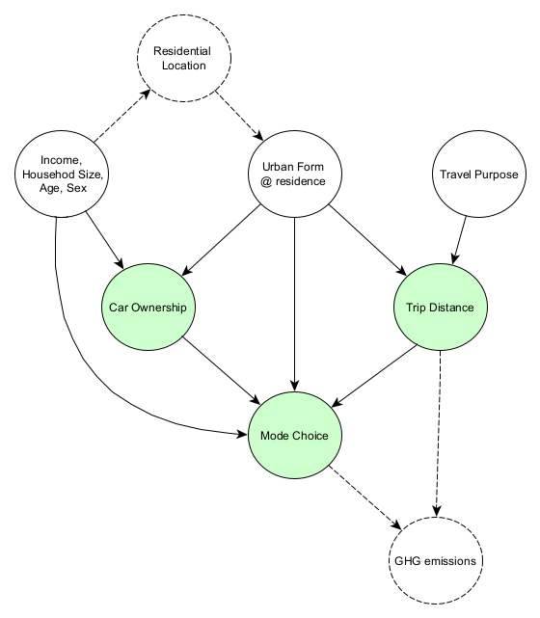
Figure S14 Network graph showing most important linkages identified between feature variable groups, and target variables (shaded in green). Hypothesized or assumed relationships not explicitly modeled are shown with dotted lines

References

Ding, C., Cao, X. (Jason), & Næss, P. (2018). Applying gradient boosting decision trees to examine non-linear effects of the built environment on driving distance in Oslo. Transportation Research Part A: Policy and Practice, 110, 107–117. https://doi.org/10.1016/j.tra.2018.02.009
Ding, C., Cao, X., & Liu, C. (2019). How does the station-area built environment influence Metrorail ridership? Using gradient boosting decision trees to identify non-linear thresholds. Journal of Transport Geography, 77. https://doi.org/10.1016/j.jtrangeo.2019.04.011
Ding, C., Liu, T., Cao, X., & Tian, L. (2022). Illustrating nonlinear effects of built environment attributes on housing renters’ transit commuting. Transportation Research Part D: Transport and Environment, 112, 103503. https://doi.org/10.1016/j.trd.2022.103503
Hagenauer, J., & Helbich, M. (2017). A comparative study of machine learning classifiers for modeling travel mode choice. Expert Systems with Applications, 78, 273–282. https://doi.org/10.1016/j.eswa.2017.01.057
Hillel, T., Bierlaire, M., Elshafie, M. Z. E. B., & Jin, Y. (2021). A systematic review of machine learning classification methodologies for modelling passenger mode choice. Journal of Choice Modelling, 38, 100221. https://doi.org/10.1016/j.jocm.2020.100221
Kim, E.-J. (2021). Analysis of Travel Mode Choice in Seoul Using an Interpretable Machine Learning Approach. Journal of Advanced Transportation, 2021, 1–13. https://doi.org/10.1155/2021/6685004
Leroutier, M., & Quirion, P. (2022). Tackling car emissions in urban areas: Shift, Avoid, Improve. SocArXiv. https://doi.org/10.31235/osf.io/f5kmd
Liu, J., Wang, B., & Xiao, L. (2021). Non-linear associations between built environment and active travel for working and shopping: An extreme gradient boosting approach. Journal of Transport Geography, 92, 103034. https://doi.org/10.1016/j.jtrangeo.2021.103034
Métropole Européenne de Lille. (2017). Enquête Déplacements 2016. https://www.lillemetropole.fr/sites/default/files/2018-09/20170404_rapport_final_ED2016_light.pdf
SMTC de l’agglomération clermontoise. (2013). Atlas pratique des déplacements Clermont Val d’Allier. https://side.developpement-durable.gouv.fr/ACCIDR/doc/SYRACUSE/384388/atlas-pratique-des-deplacements-clermont-val-d-allier
Tao, T., & Næss, P. (2022). Exploring nonlinear built environment effects on driving with a mixed-methods approach. Transportation Research Part D: Transport and Environment, 111, 103443. https://doi.org/10.1016/j.trd.2022.103443
Tisséo-SMTC. (2013). Les déplacements dans la Grande Agglomération Toulousaine. https://www.tisseo.fr/sites/default/files/Enquete_menage_deplacement.pdf
Tomschy, R., Herry, M., Sammer, G., Klemenschitz, R., Riegler, S., Follmer, R., Gruschwitz, D., Josef, F., Gensasz, S., Kirnbauer, R., & Spiegel, T. (2016). Österreich unterwegs 2013/2014. Ergebnisbericht zur österreichweiten Mobilitätserhebung „Österreich unterwegs 2013/2014“. Bundesministerium für Verkehr, Innovation und Technologie. https://www.bmk.gv.at/dam/jcr:fbe20298-a4cf-46d9-bbee-01ad771a7fda/oeu_2013-2014_Ergebnisbericht.pdf
Wagner, F., Milojevic-Dupont, N., Franken, L., Zekar, A., Thies, B., Koch, N., & Creutzig, F. (2022). Using explainable machine learning to understand how urban form shapes sustainable mobility. Transportation Research Part D: Transport and Environment, 111, 103442. https://doi.org/10.1016/j.trd.2022.103442
Wang, F., & Ross, C. L. (2018). Machine Learning Travel Mode Choices: Comparing the Performance of an Extreme Gradient Boosting Model with a Multinomial Logit Model. Transportation Research Record: Journal of the Transportation Research Board, 2672(47), 35–45. https://doi.org/10.1177/0361198118773556
Wu, X., Tao, T., Cao, J., Fan, Y., & Ramaswami, A. (2019). Examining threshold effects of built environment elements on travel-related carbon-dioxide emissions. Transportation Research Part D: Transport and Environment, 75, 1–12. https://doi.org/10.1016/j.trd.2019.08.018
Zhang, W., Zhao, Y., (Jason) Cao, X., Lu, D., & Chai, Y. (2020). Nonlinear effect of accessibility on car ownership in Beijing: Pedestrian-scale neighborhood planning. Transportation Research Part D: Transport and Environment, 86, 102445. https://doi.org/10.1016/j.trd.2020.102445

